Annexure – I - (Organization Chart)
Annexure – II - (Citizen Charter)
Annexure – III- (Map of the Office Location)
Annexure – IV- (Responsibilities of Unit/Division)
Annexure –V (Seniority list of all cadres containing other
Information also)

- Information about liquor / vends
- Information about Finance Division
- Catering
- Garden of Five Senses
- Engineering Division
- Planning Division
- Events
- PR & Publicity
- (Office Orders)
- BoardSection of DTTDC

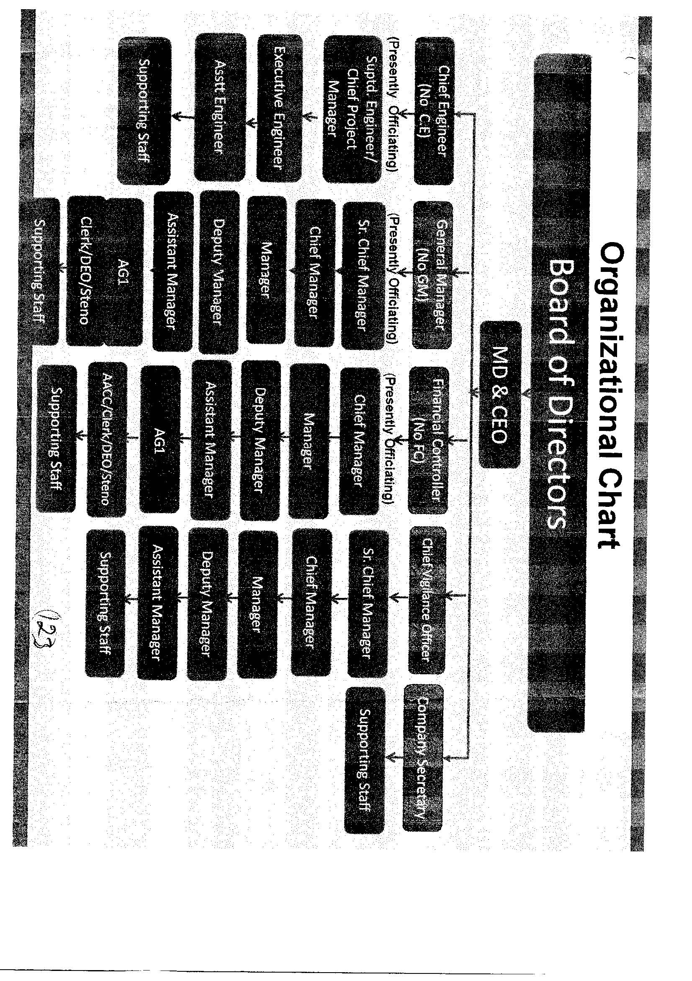
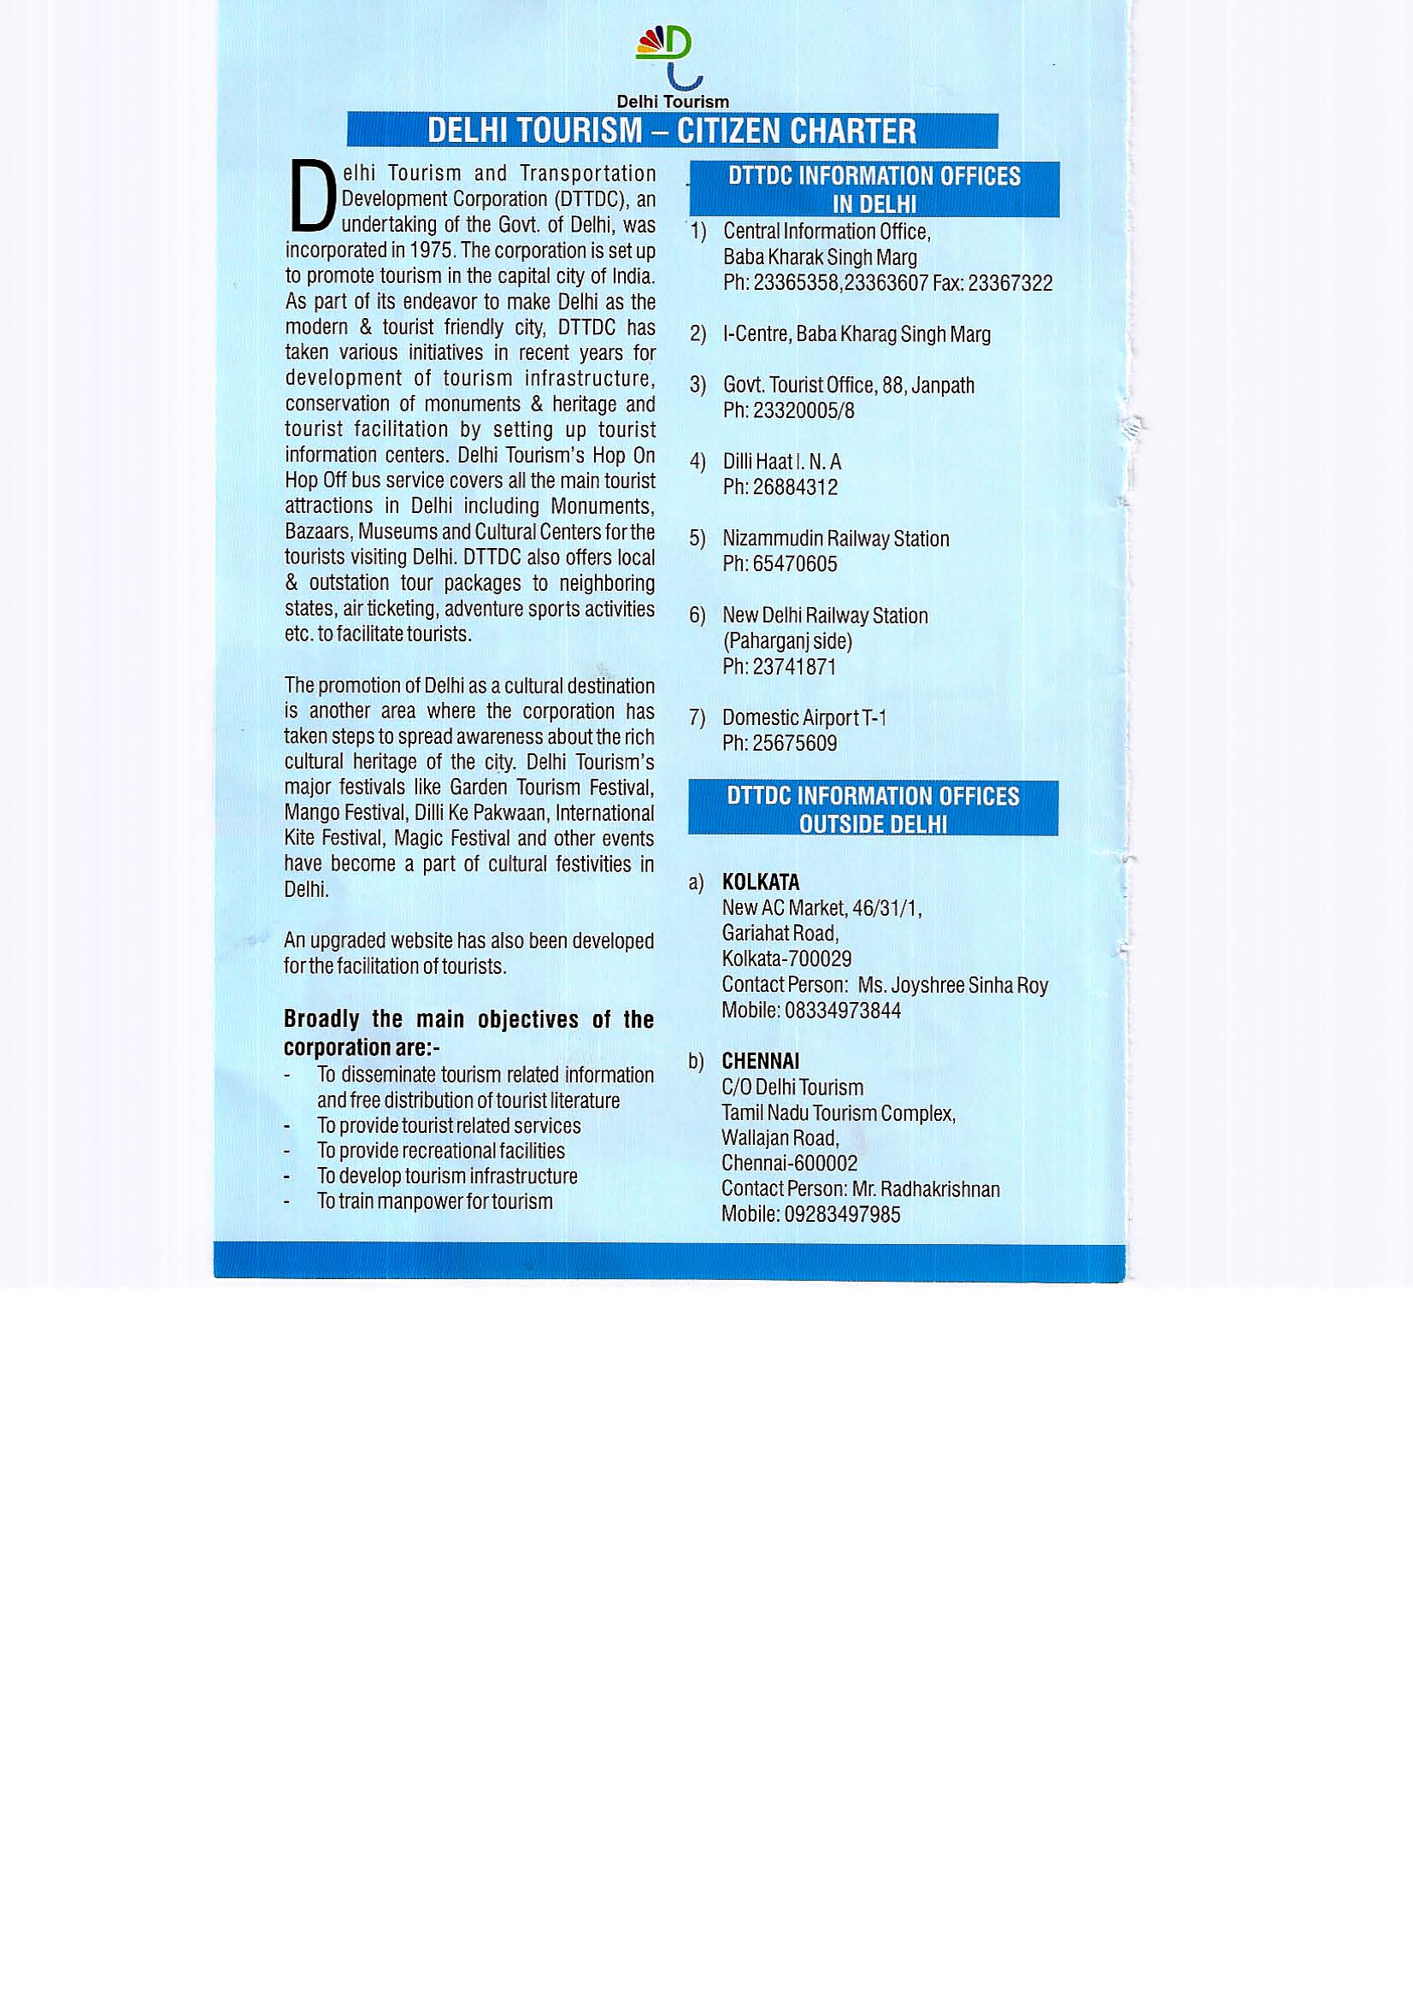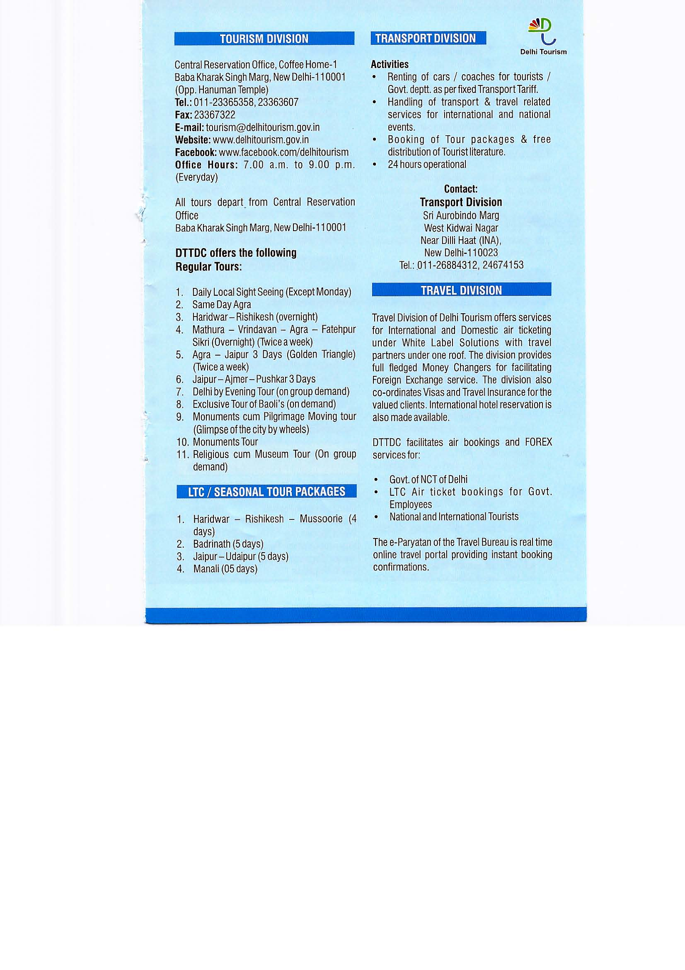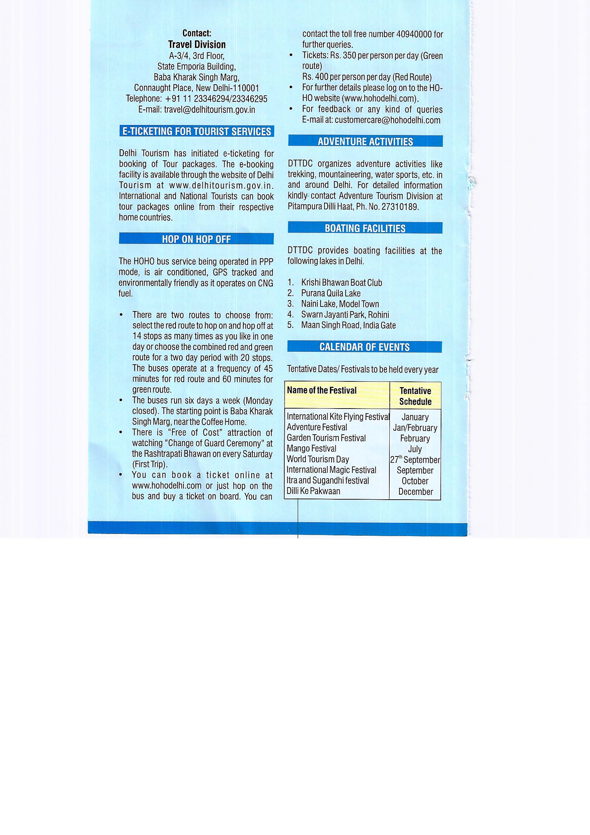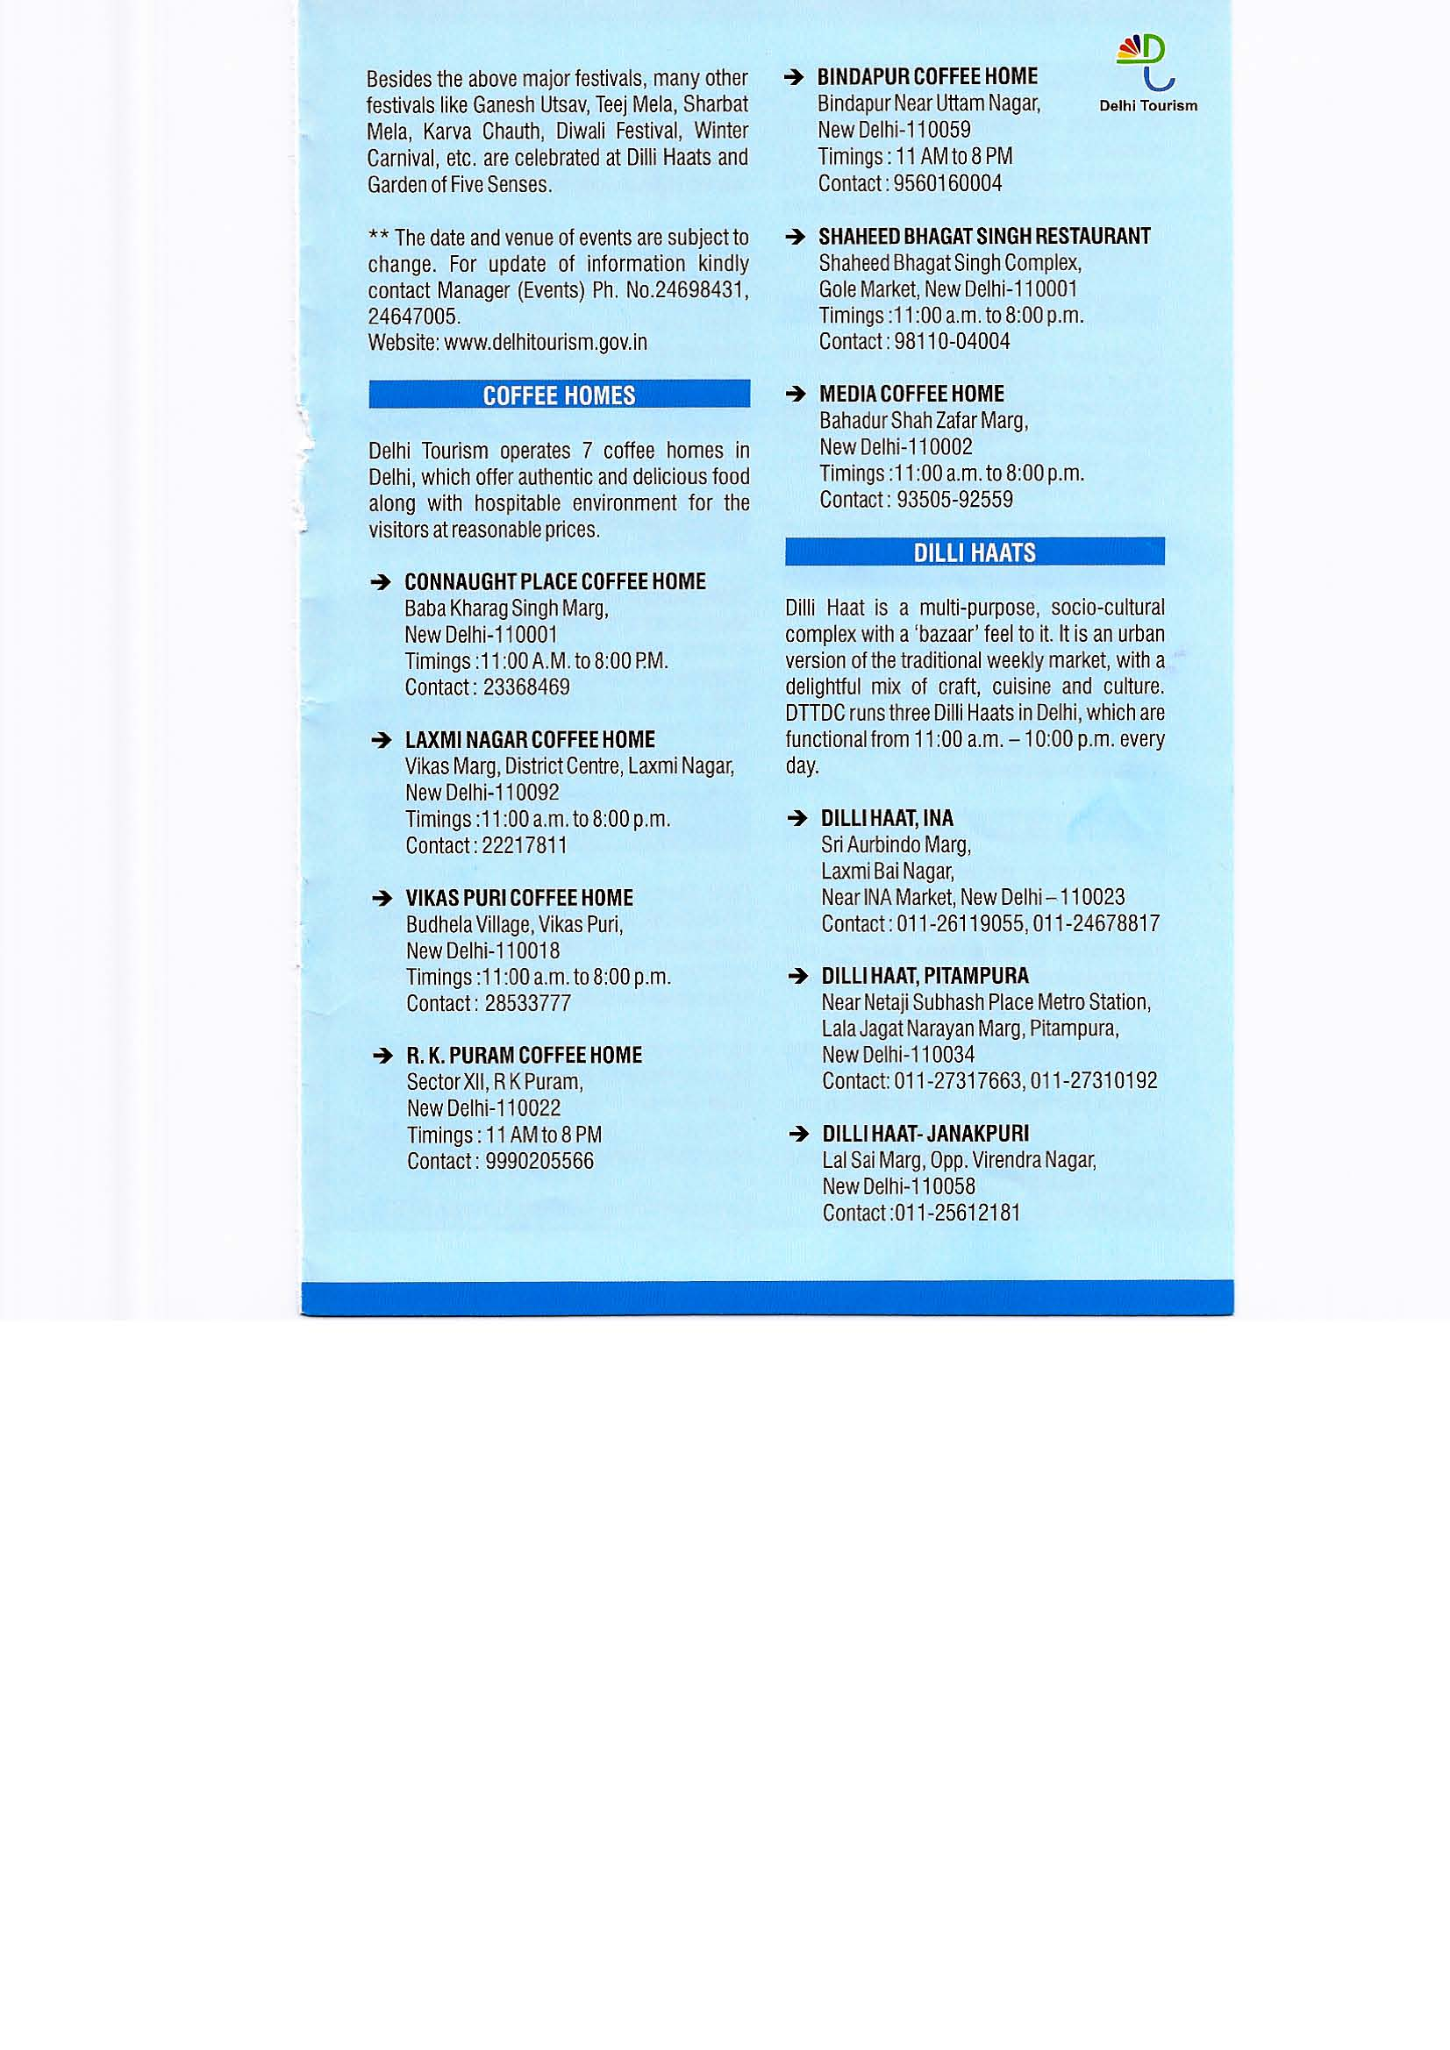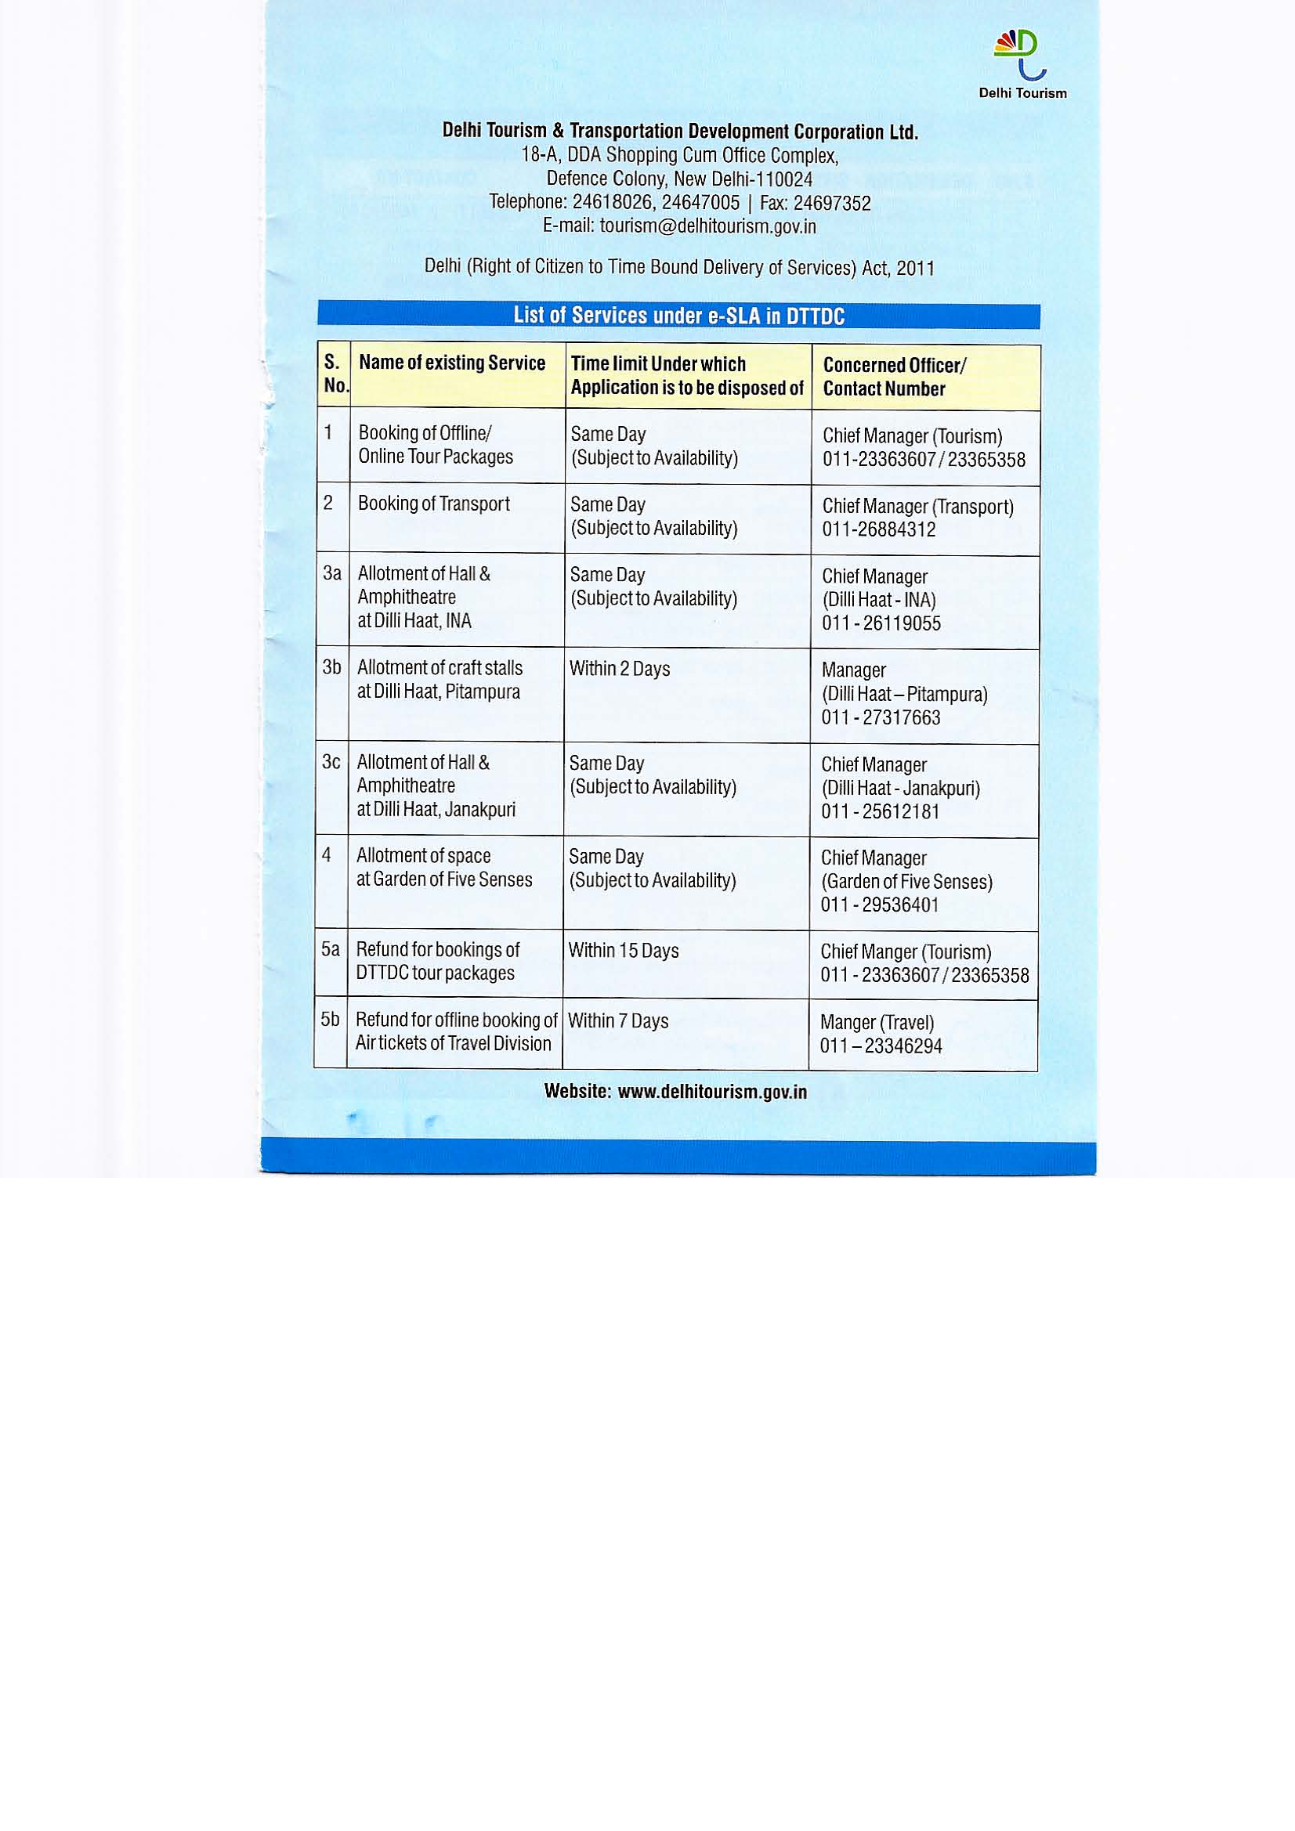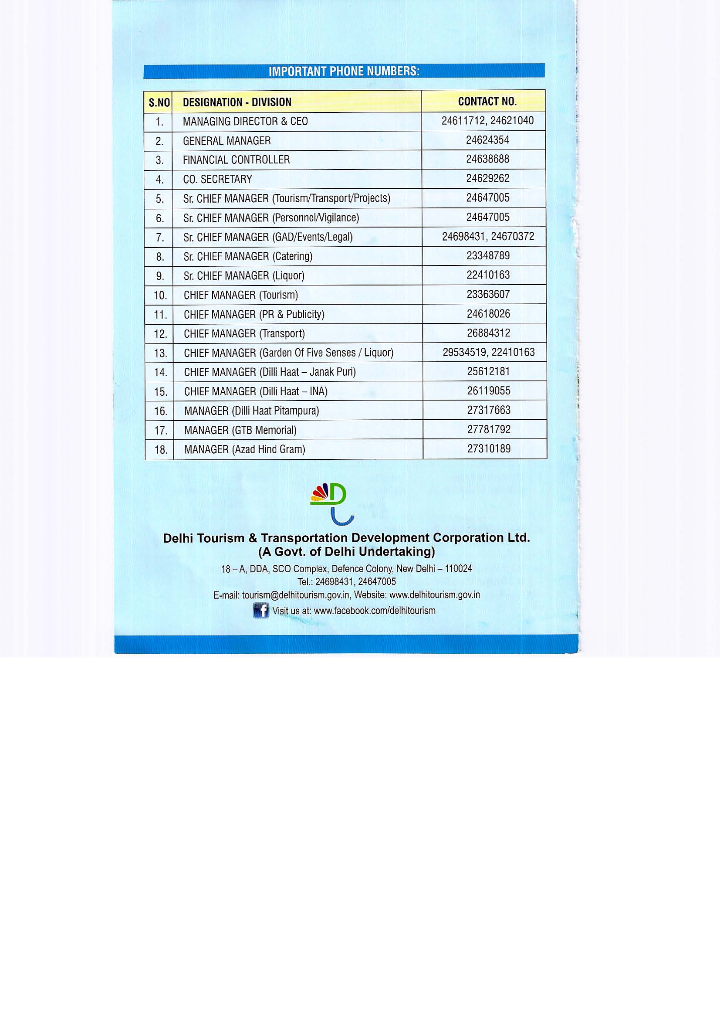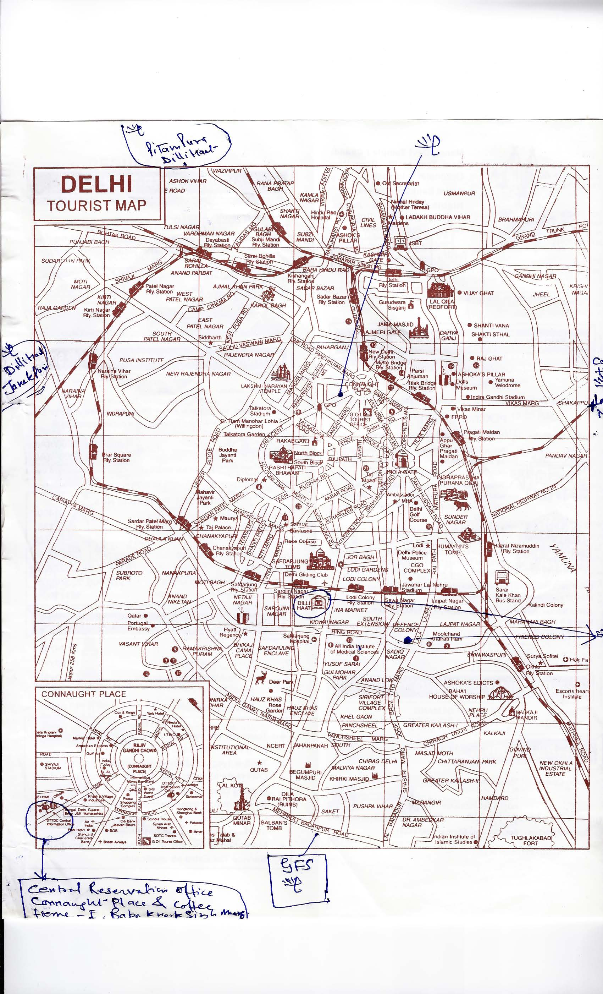
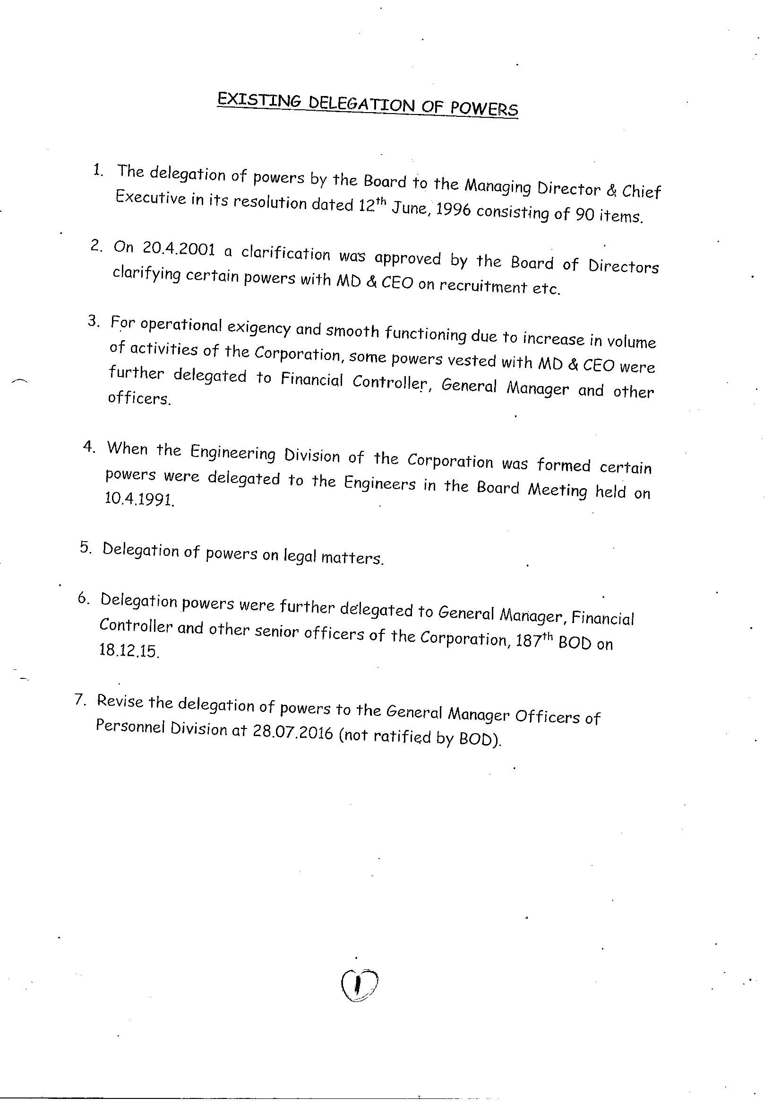
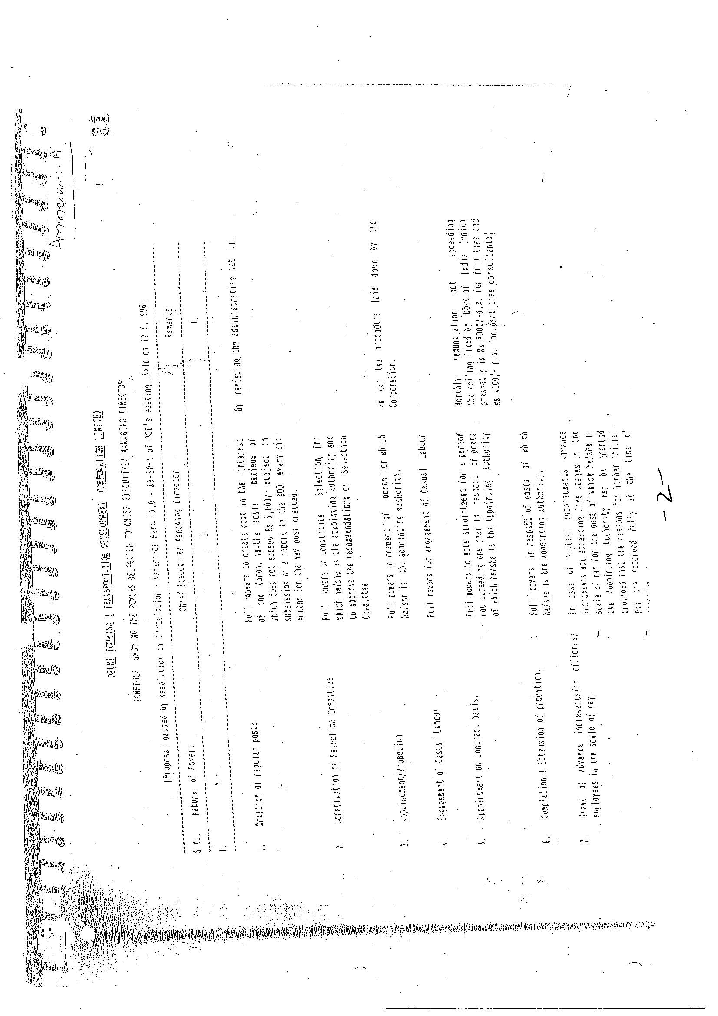
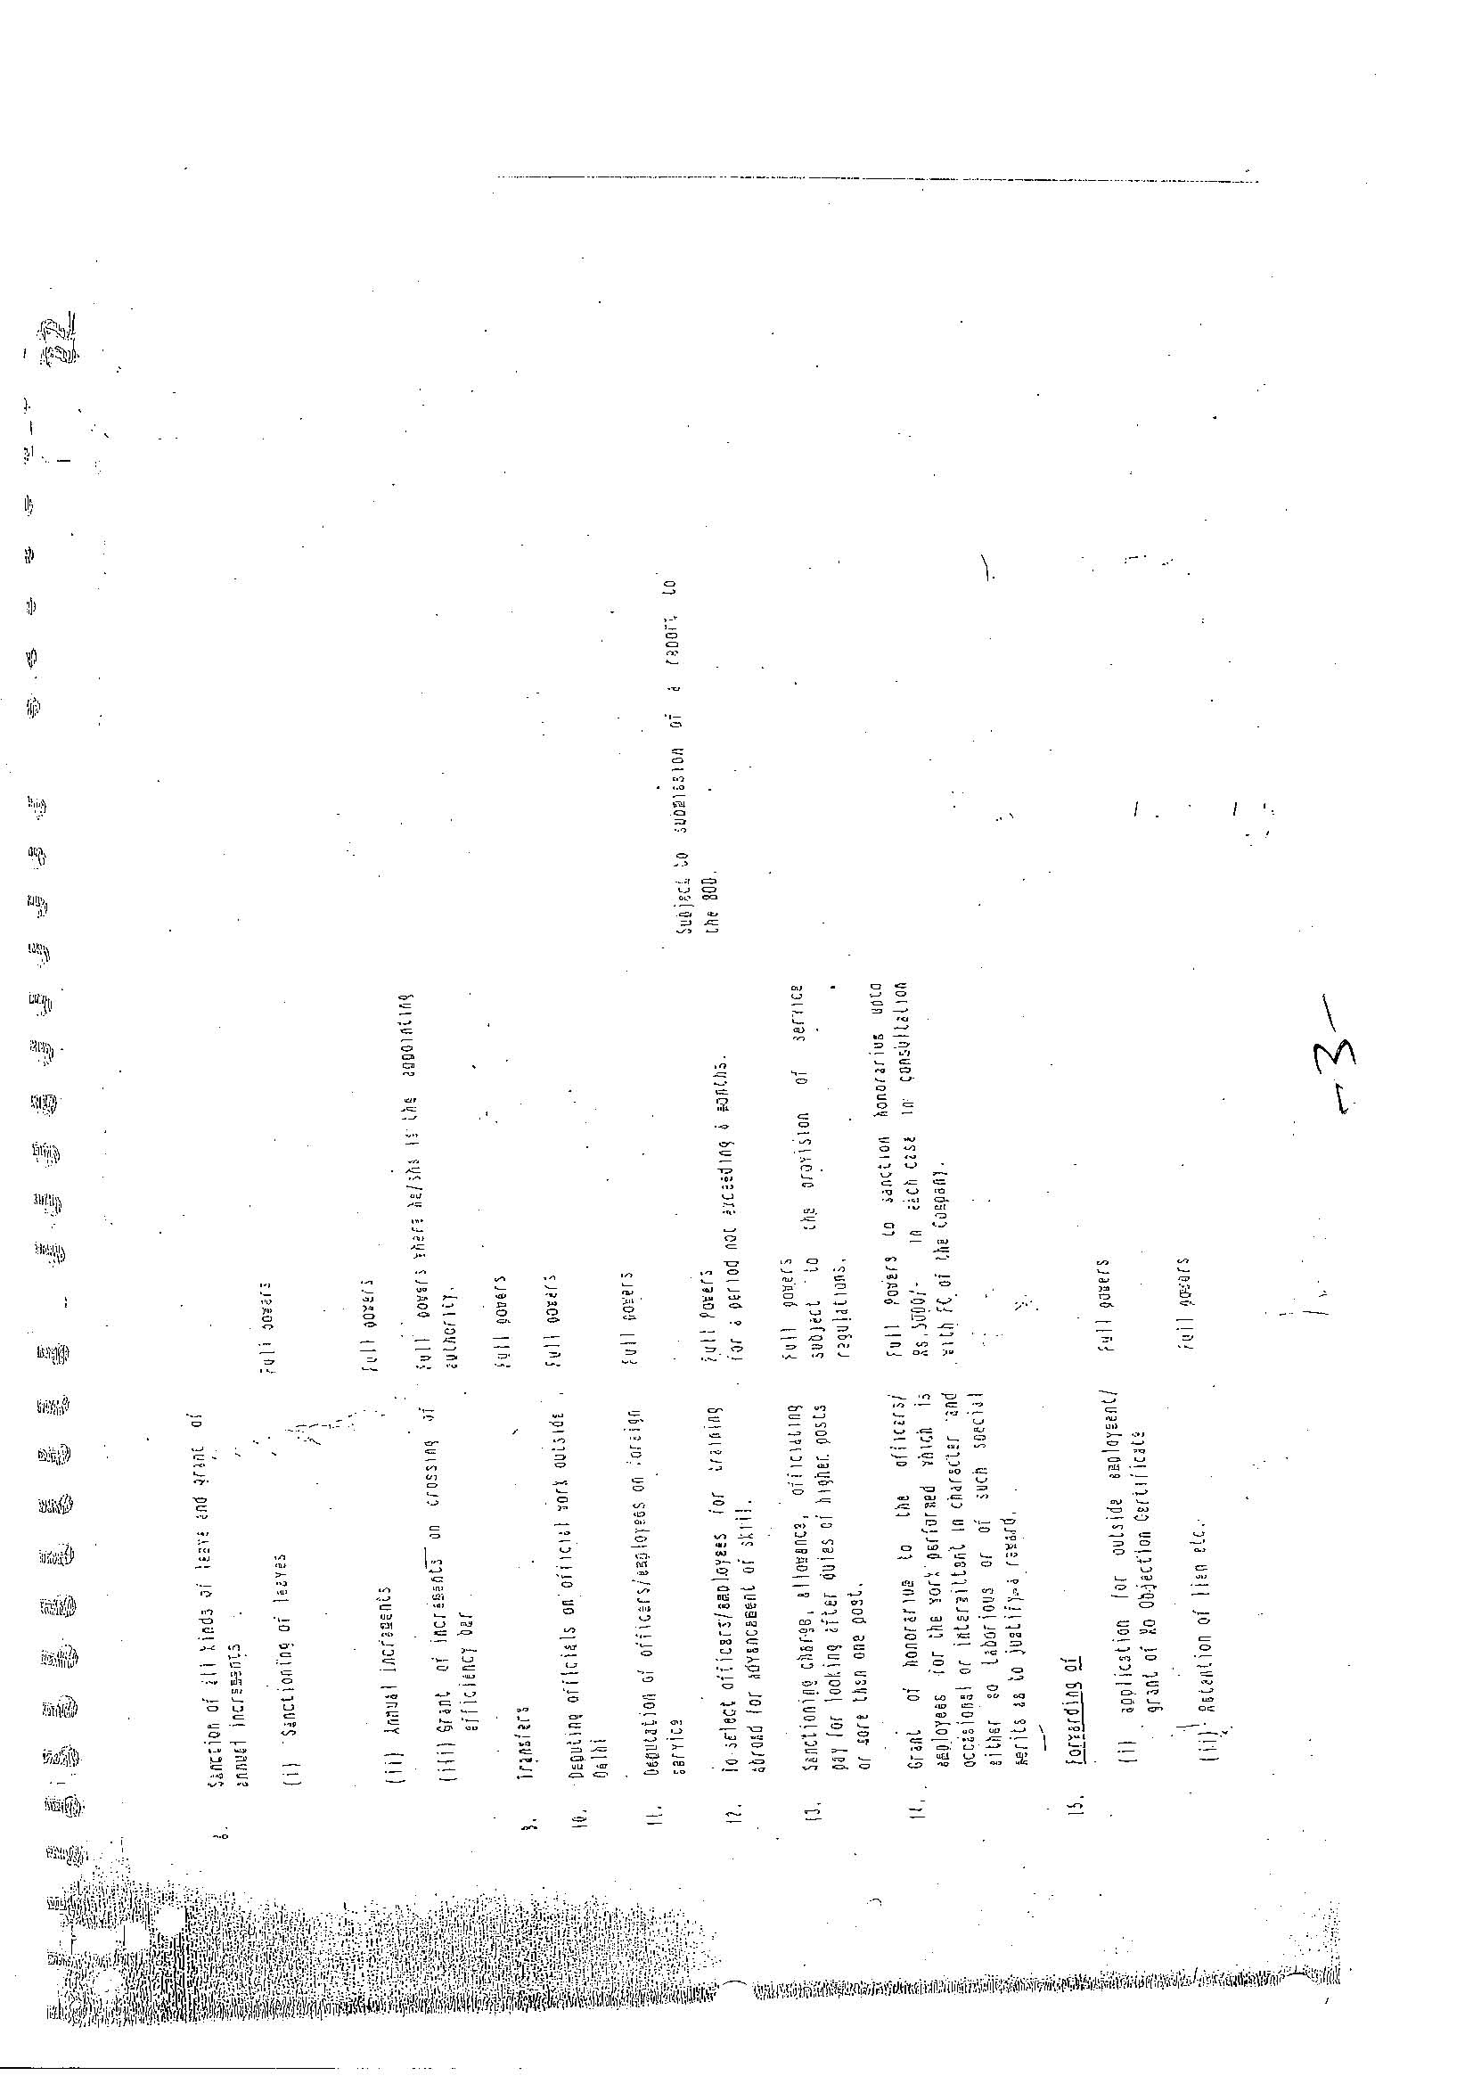
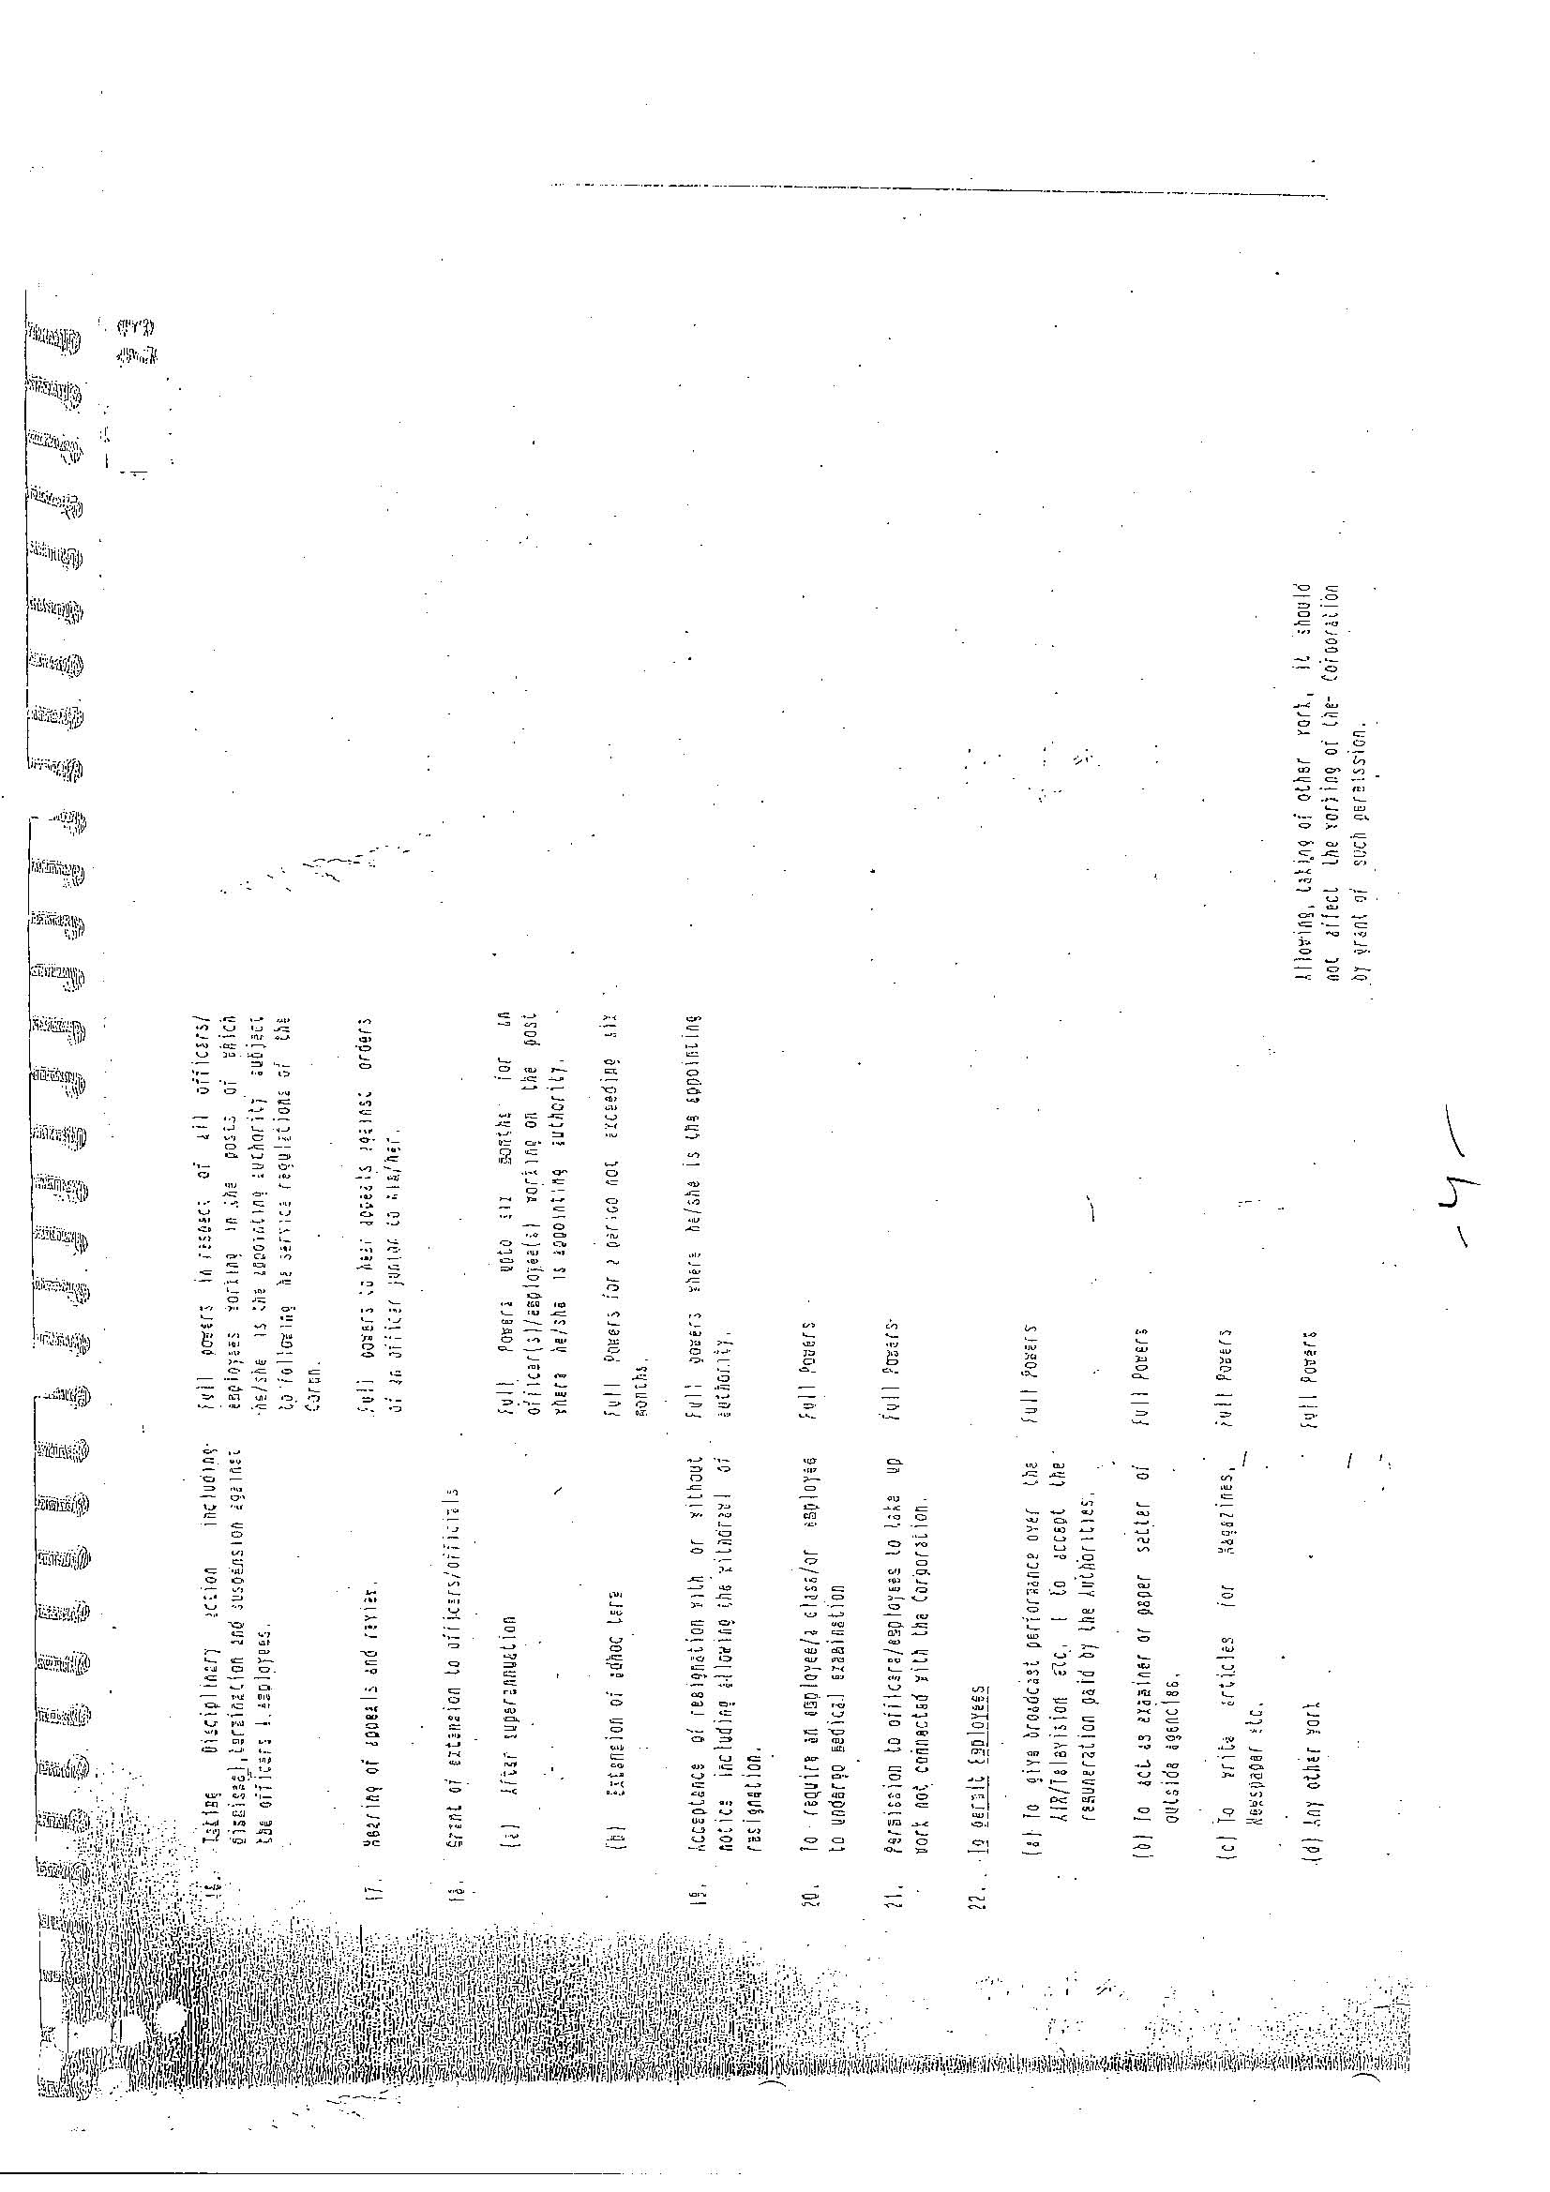
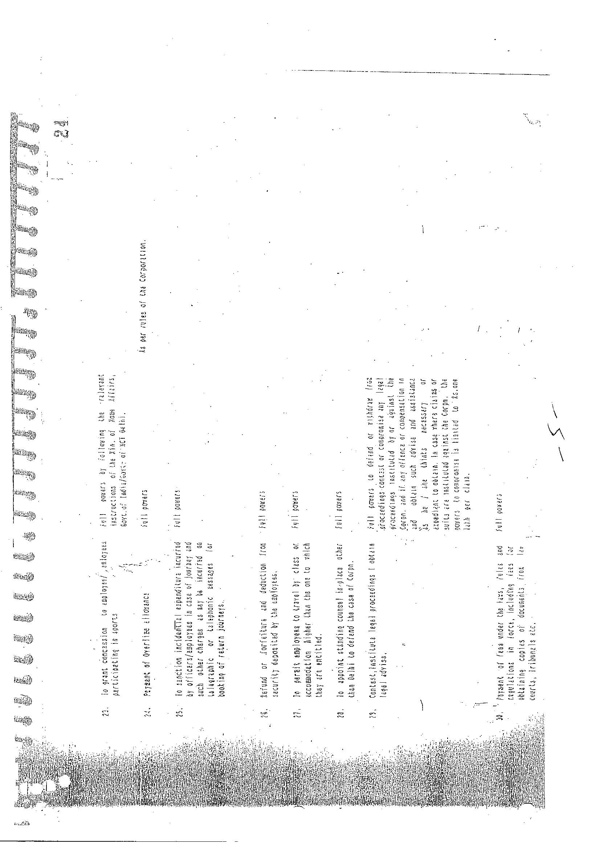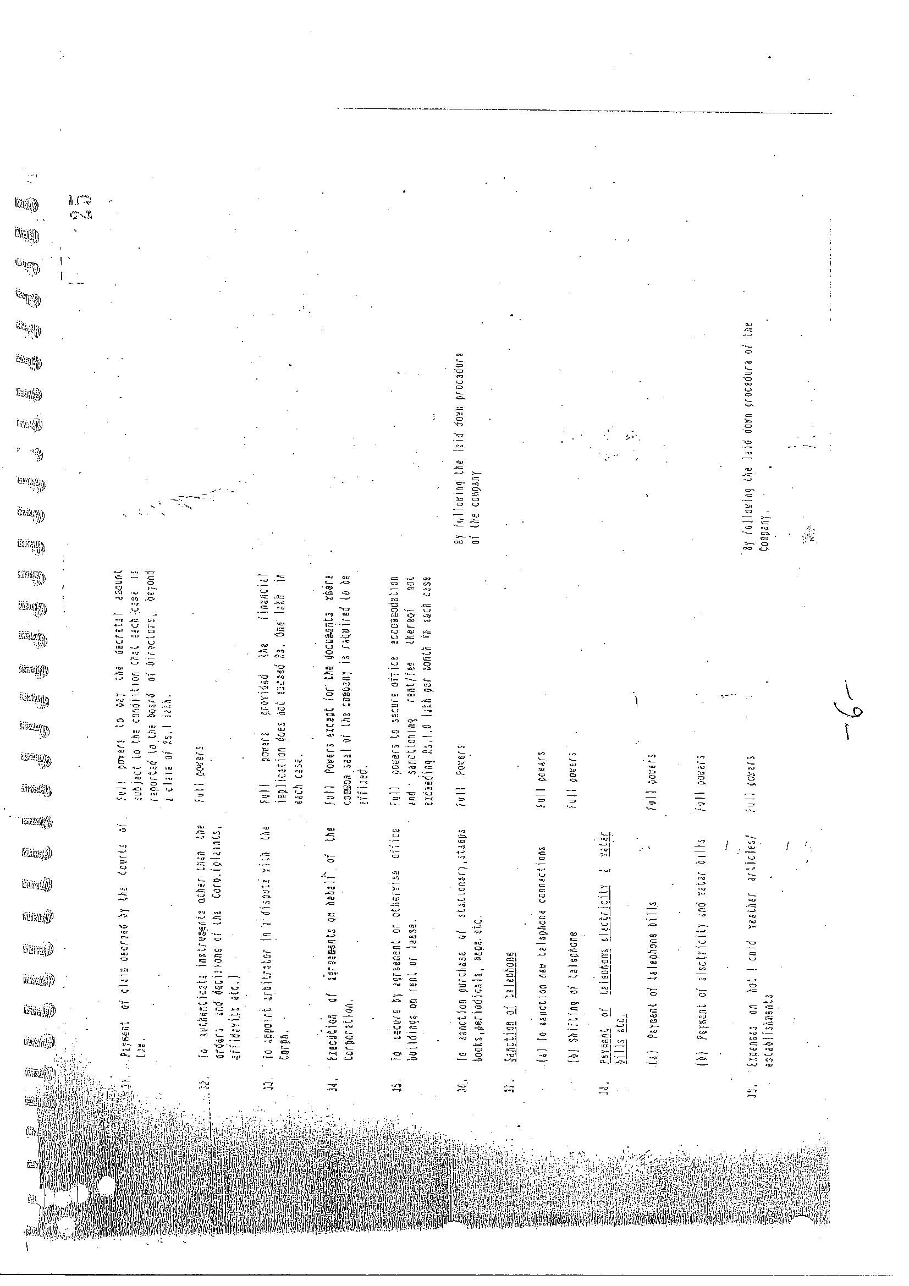
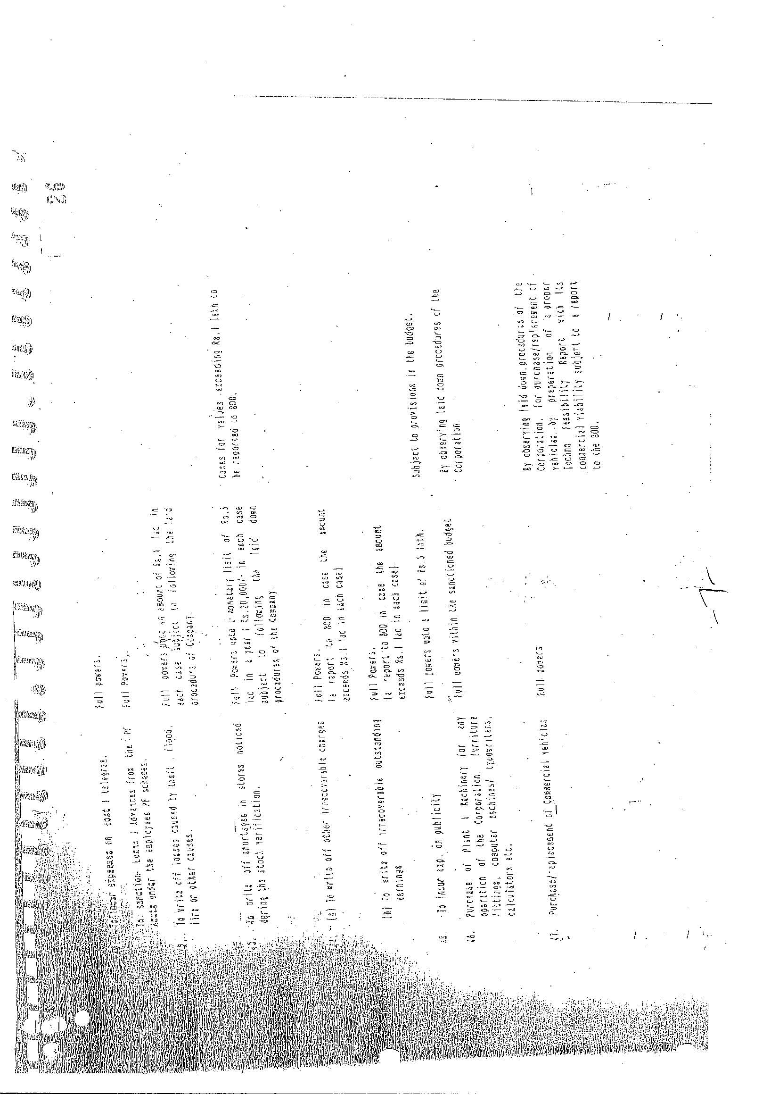
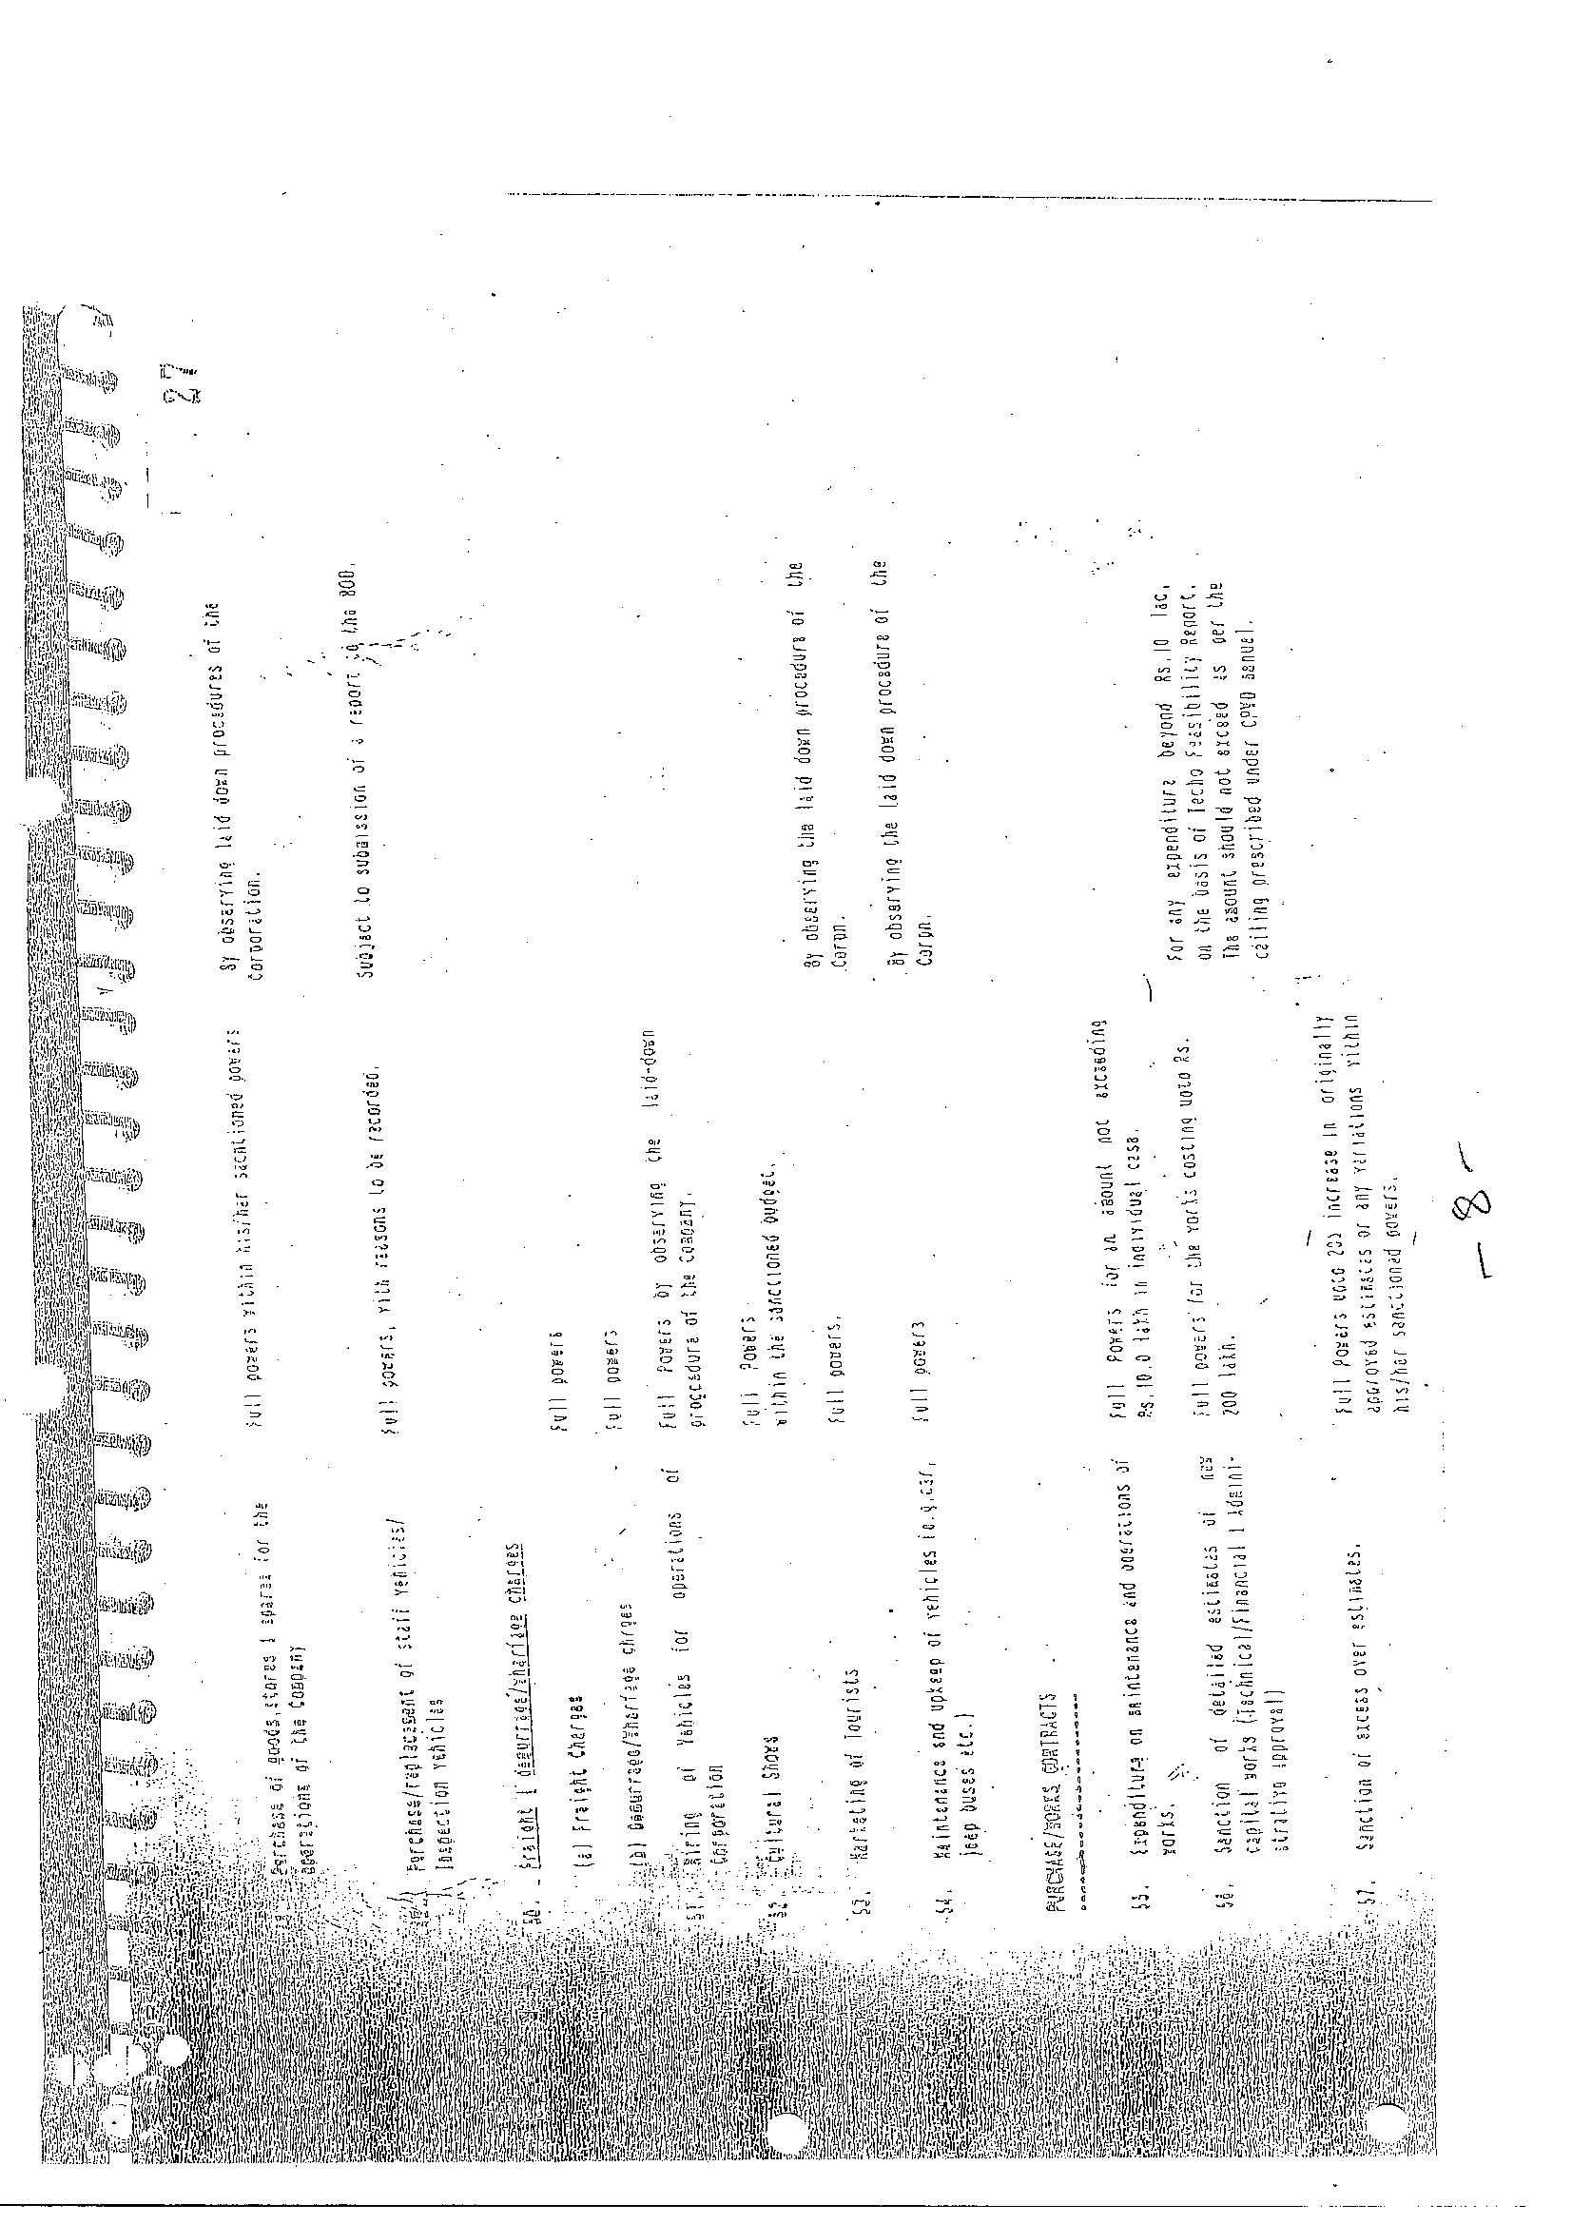
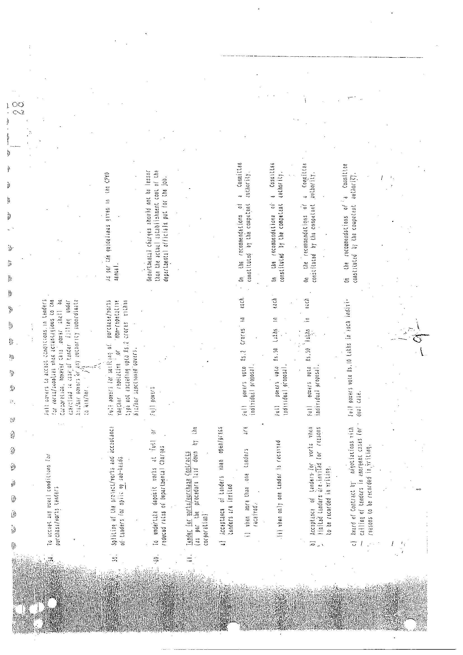
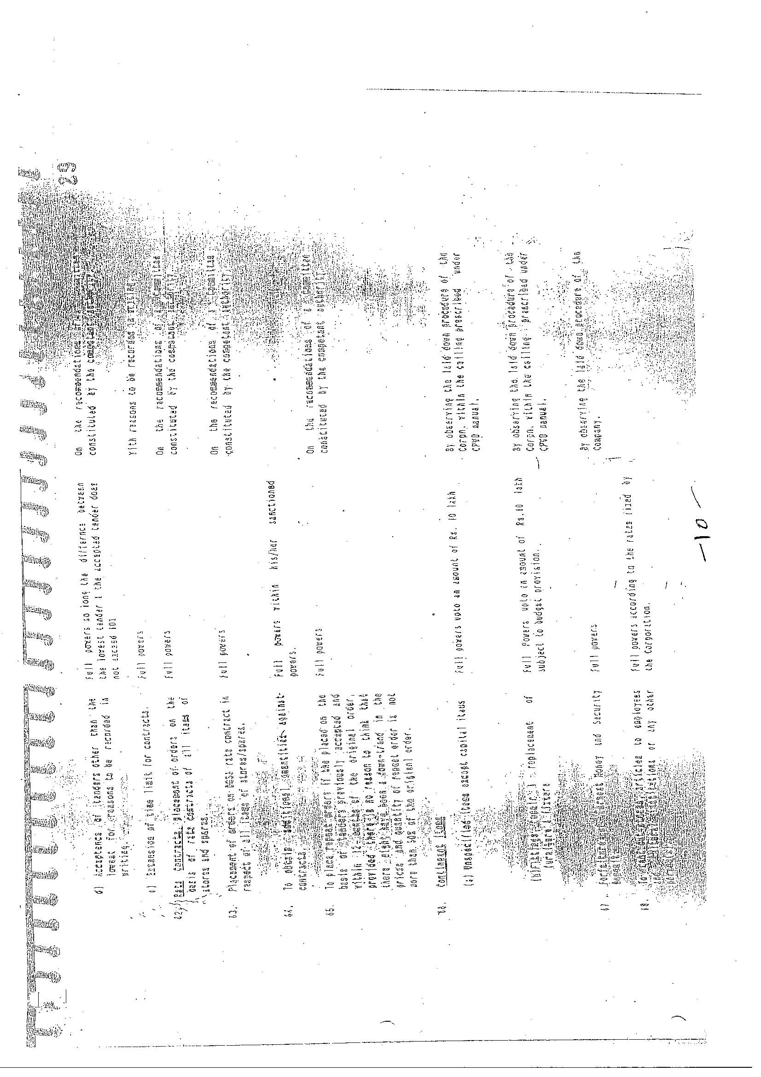
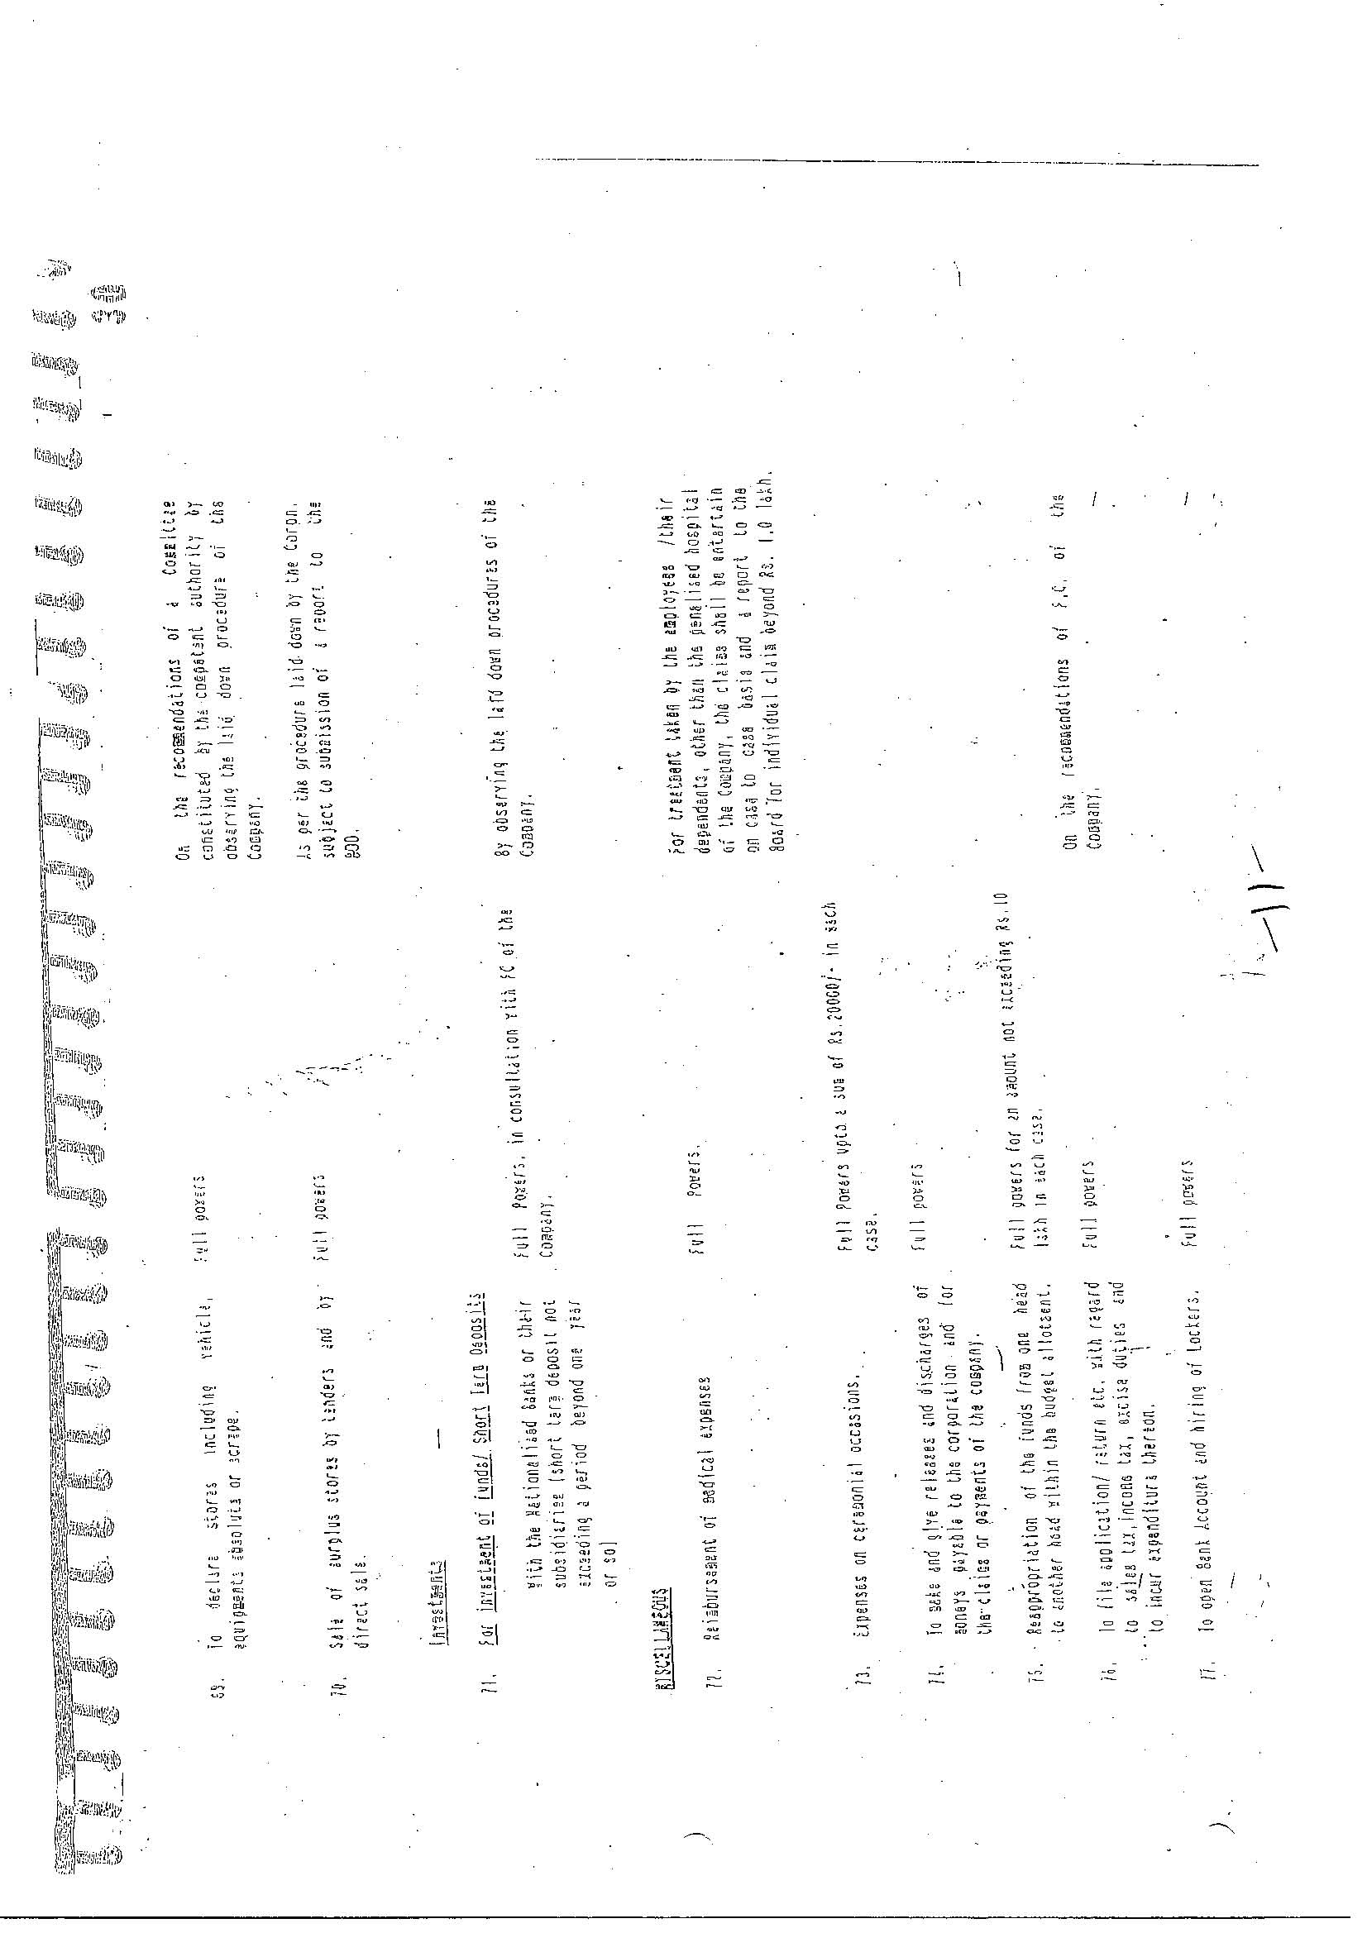
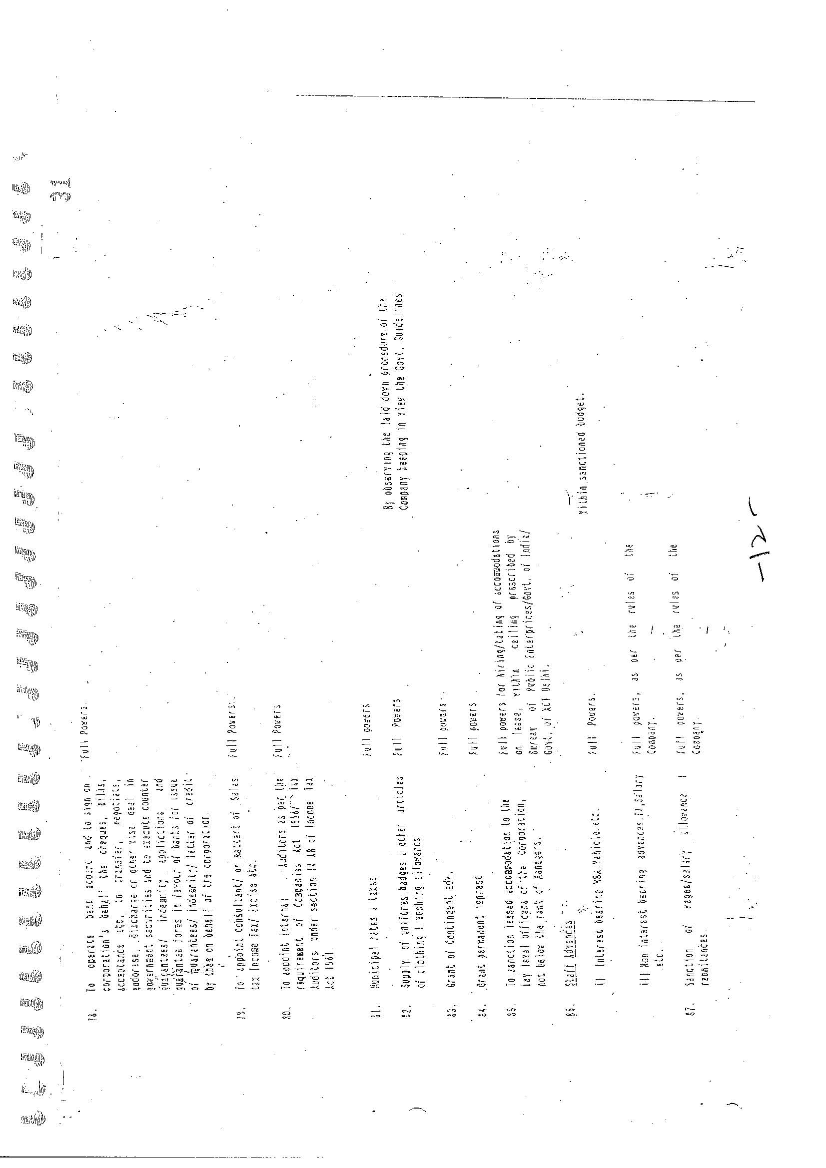
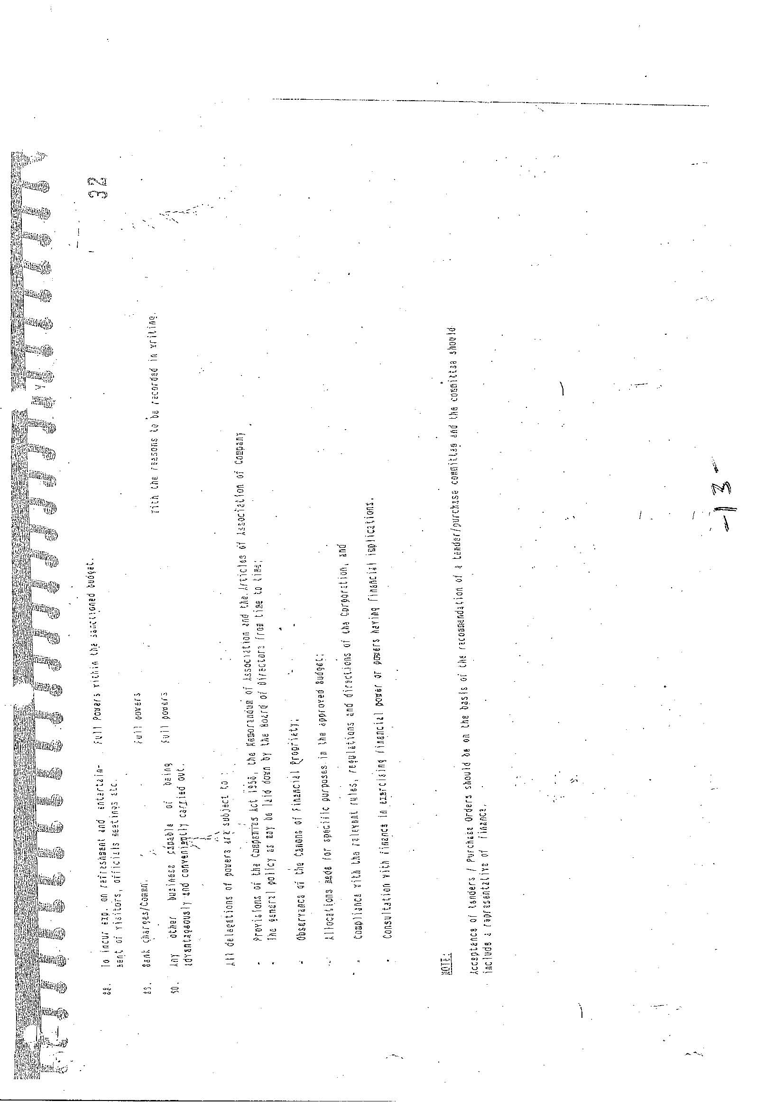
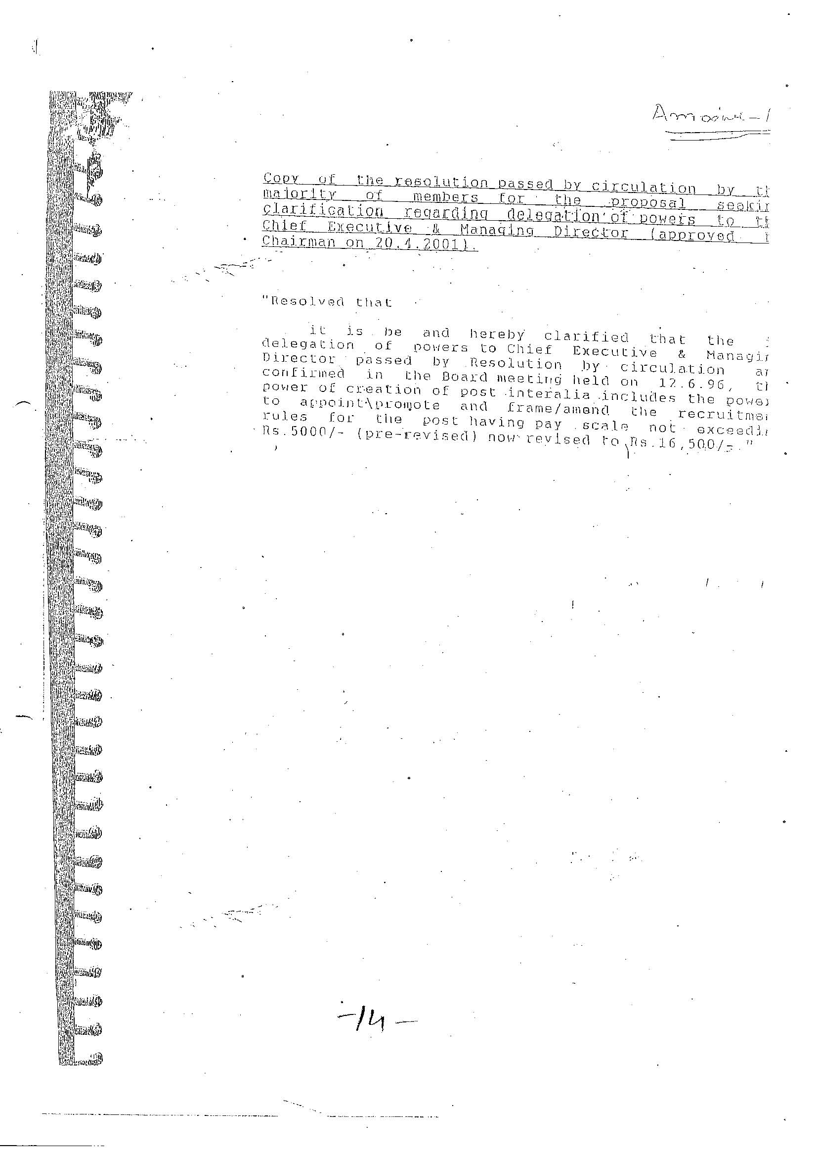
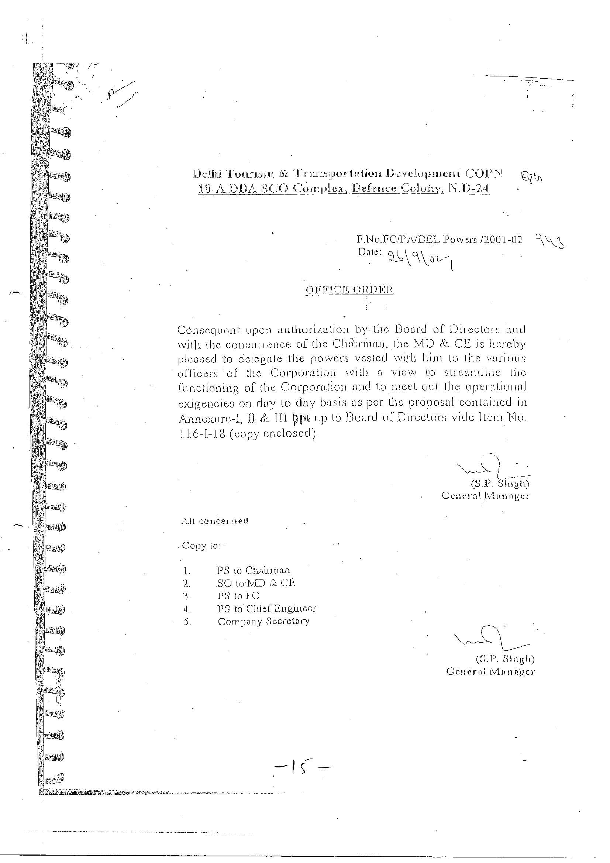
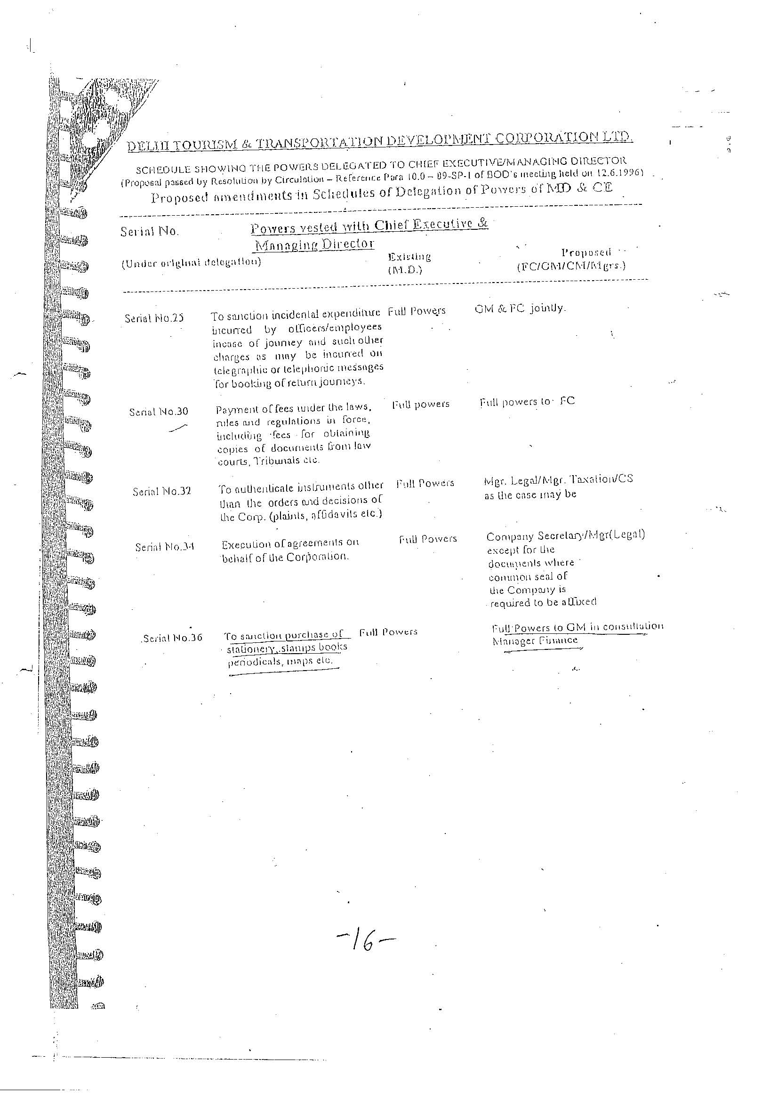
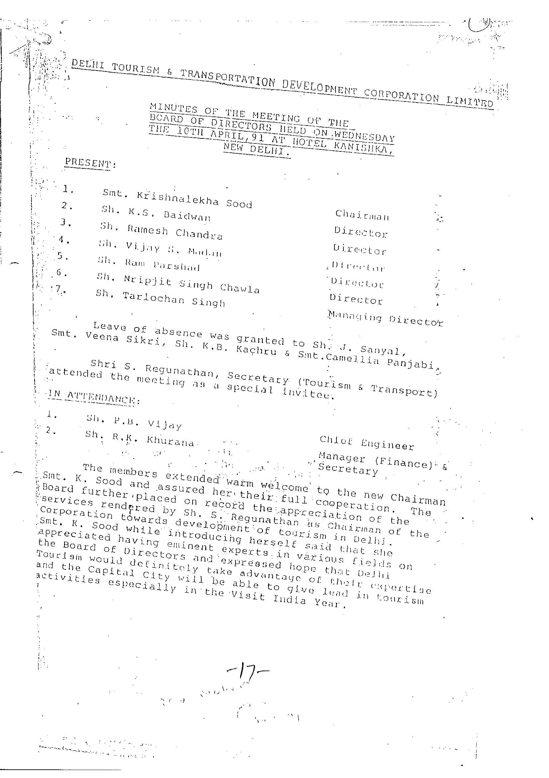
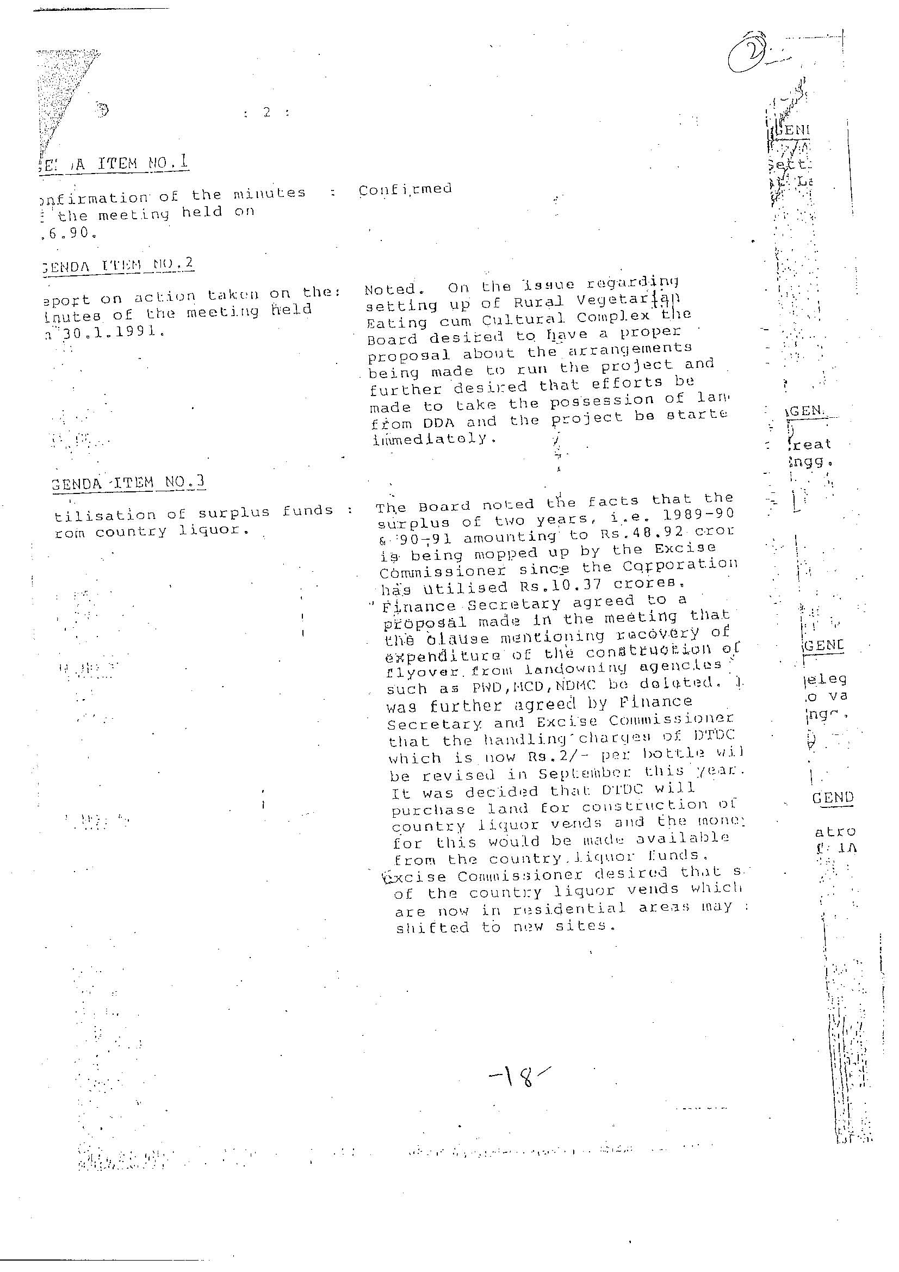
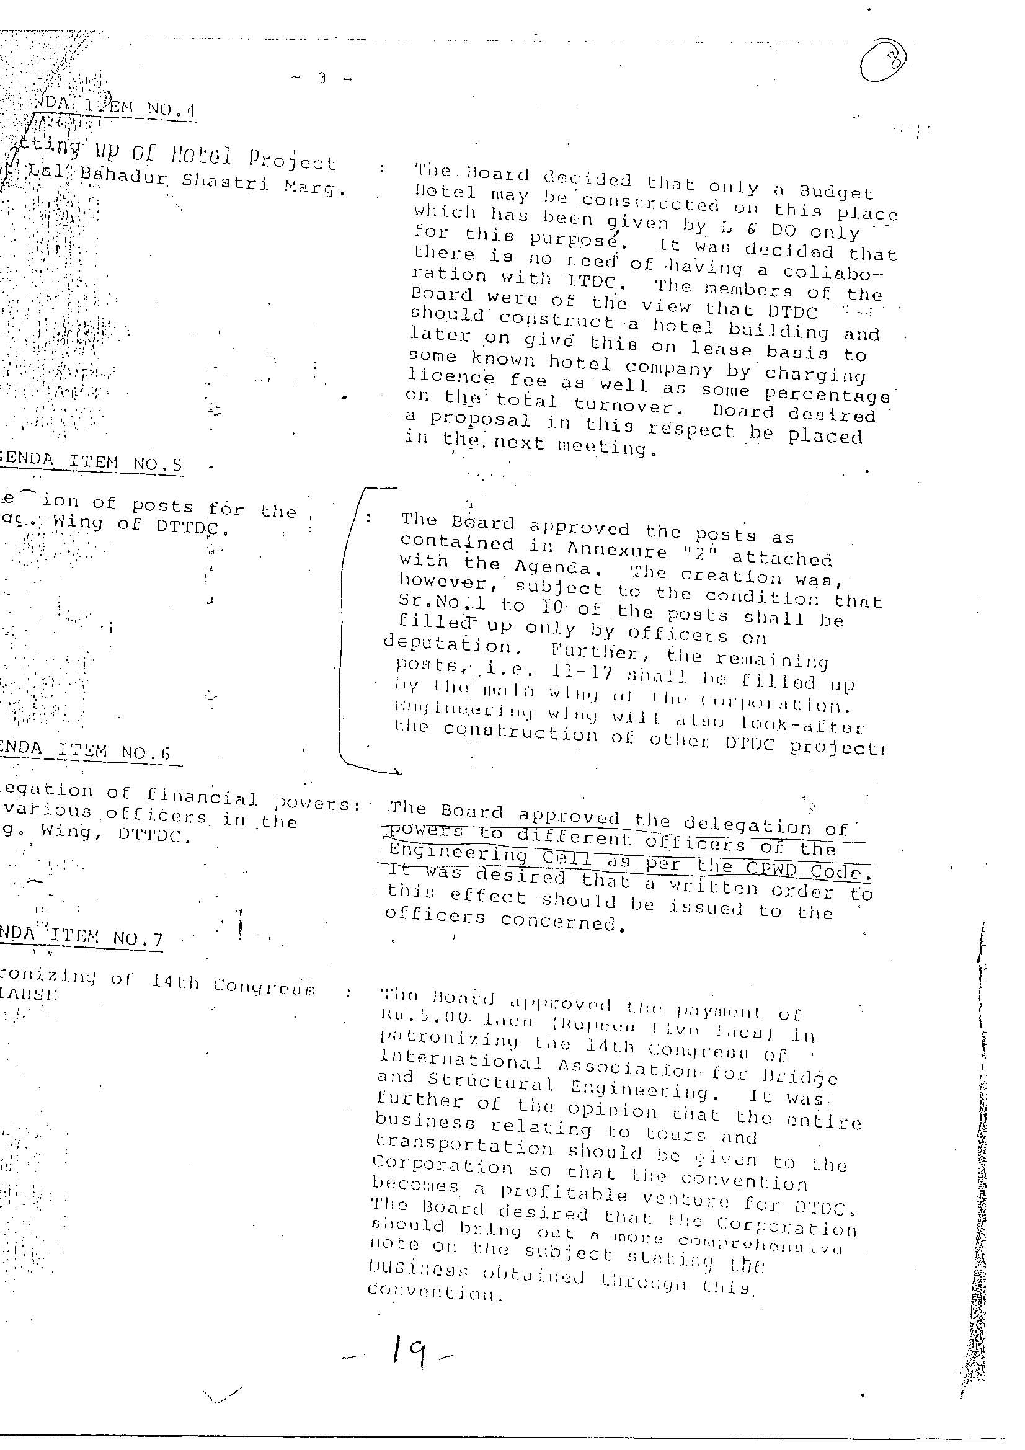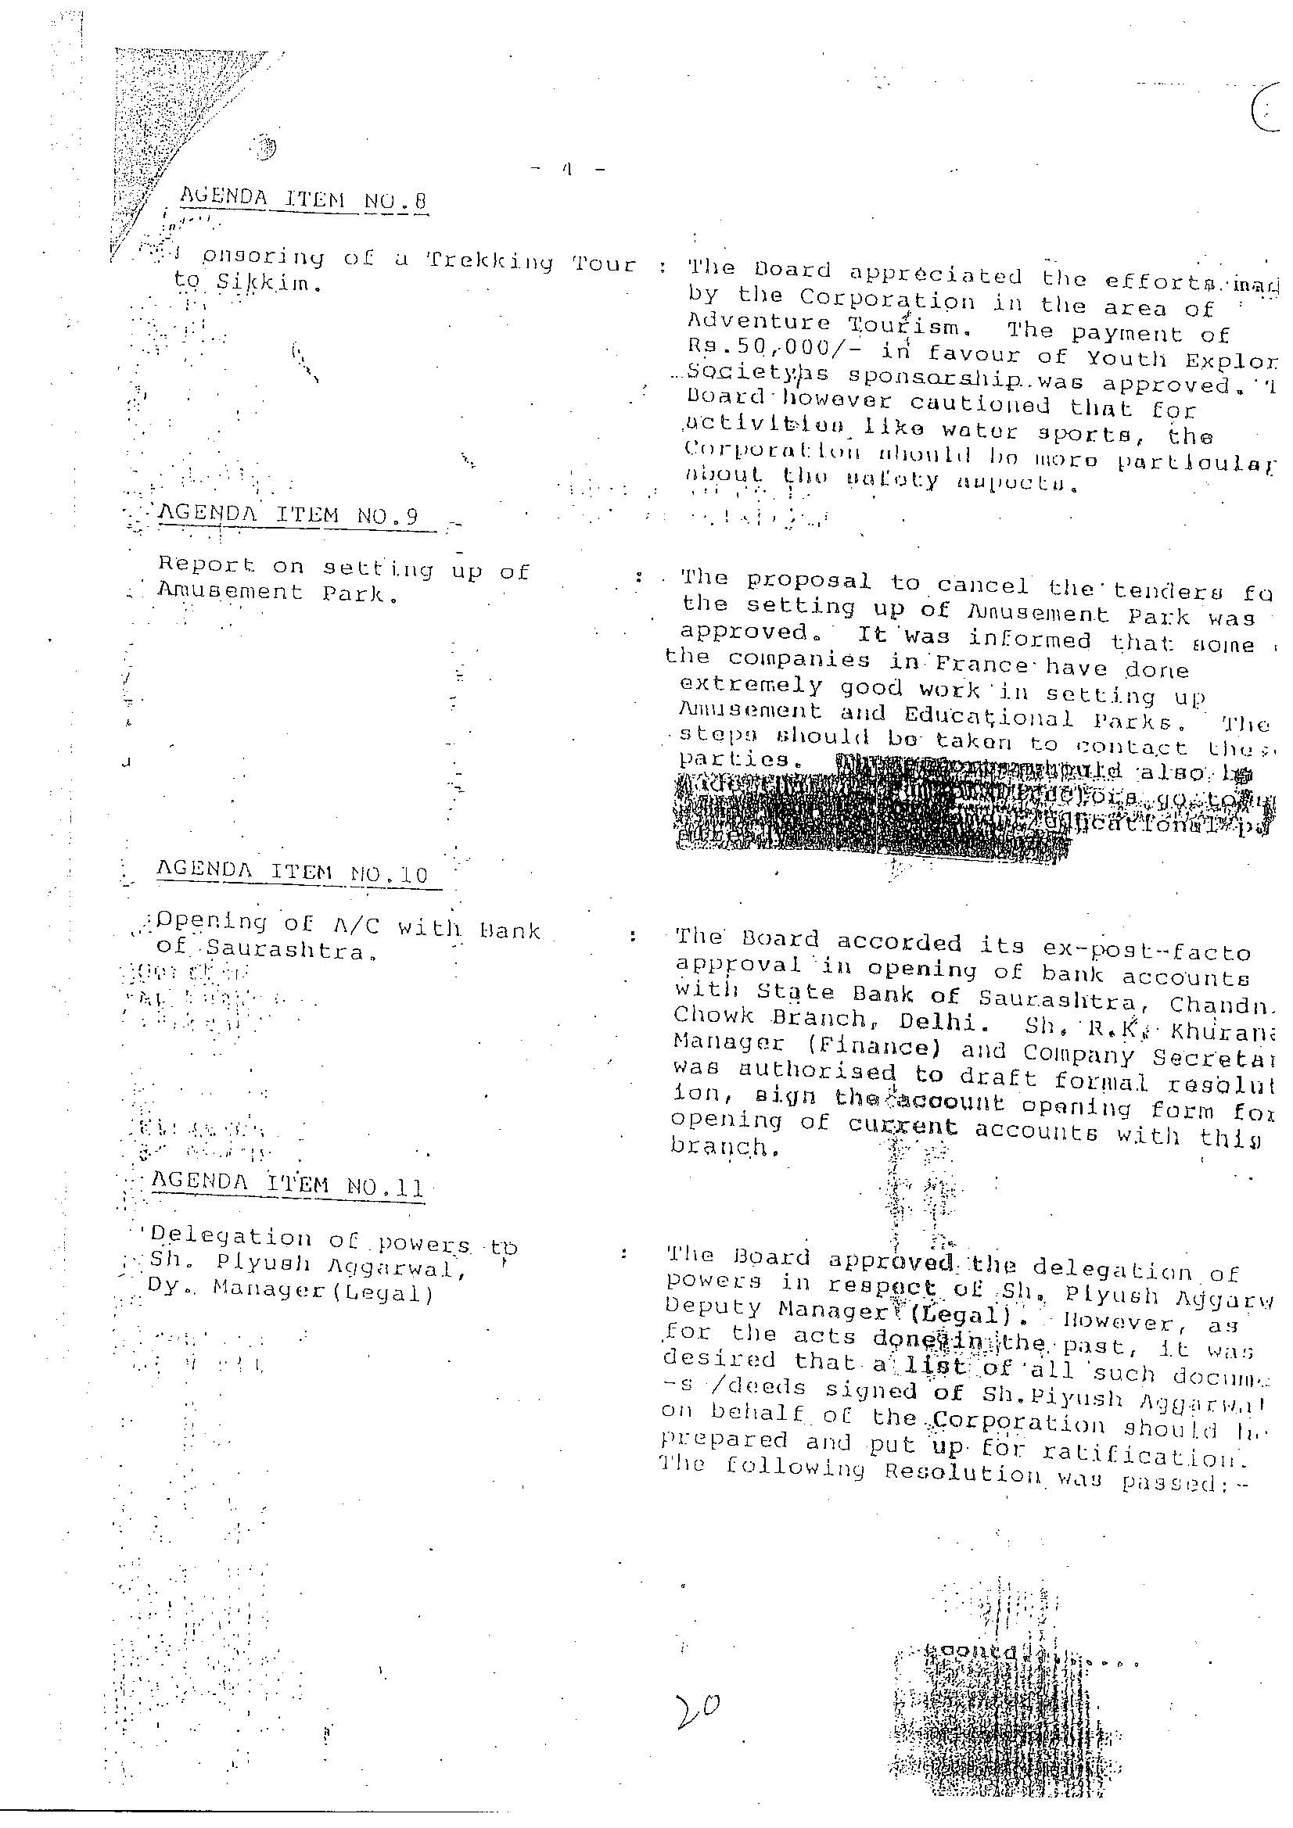
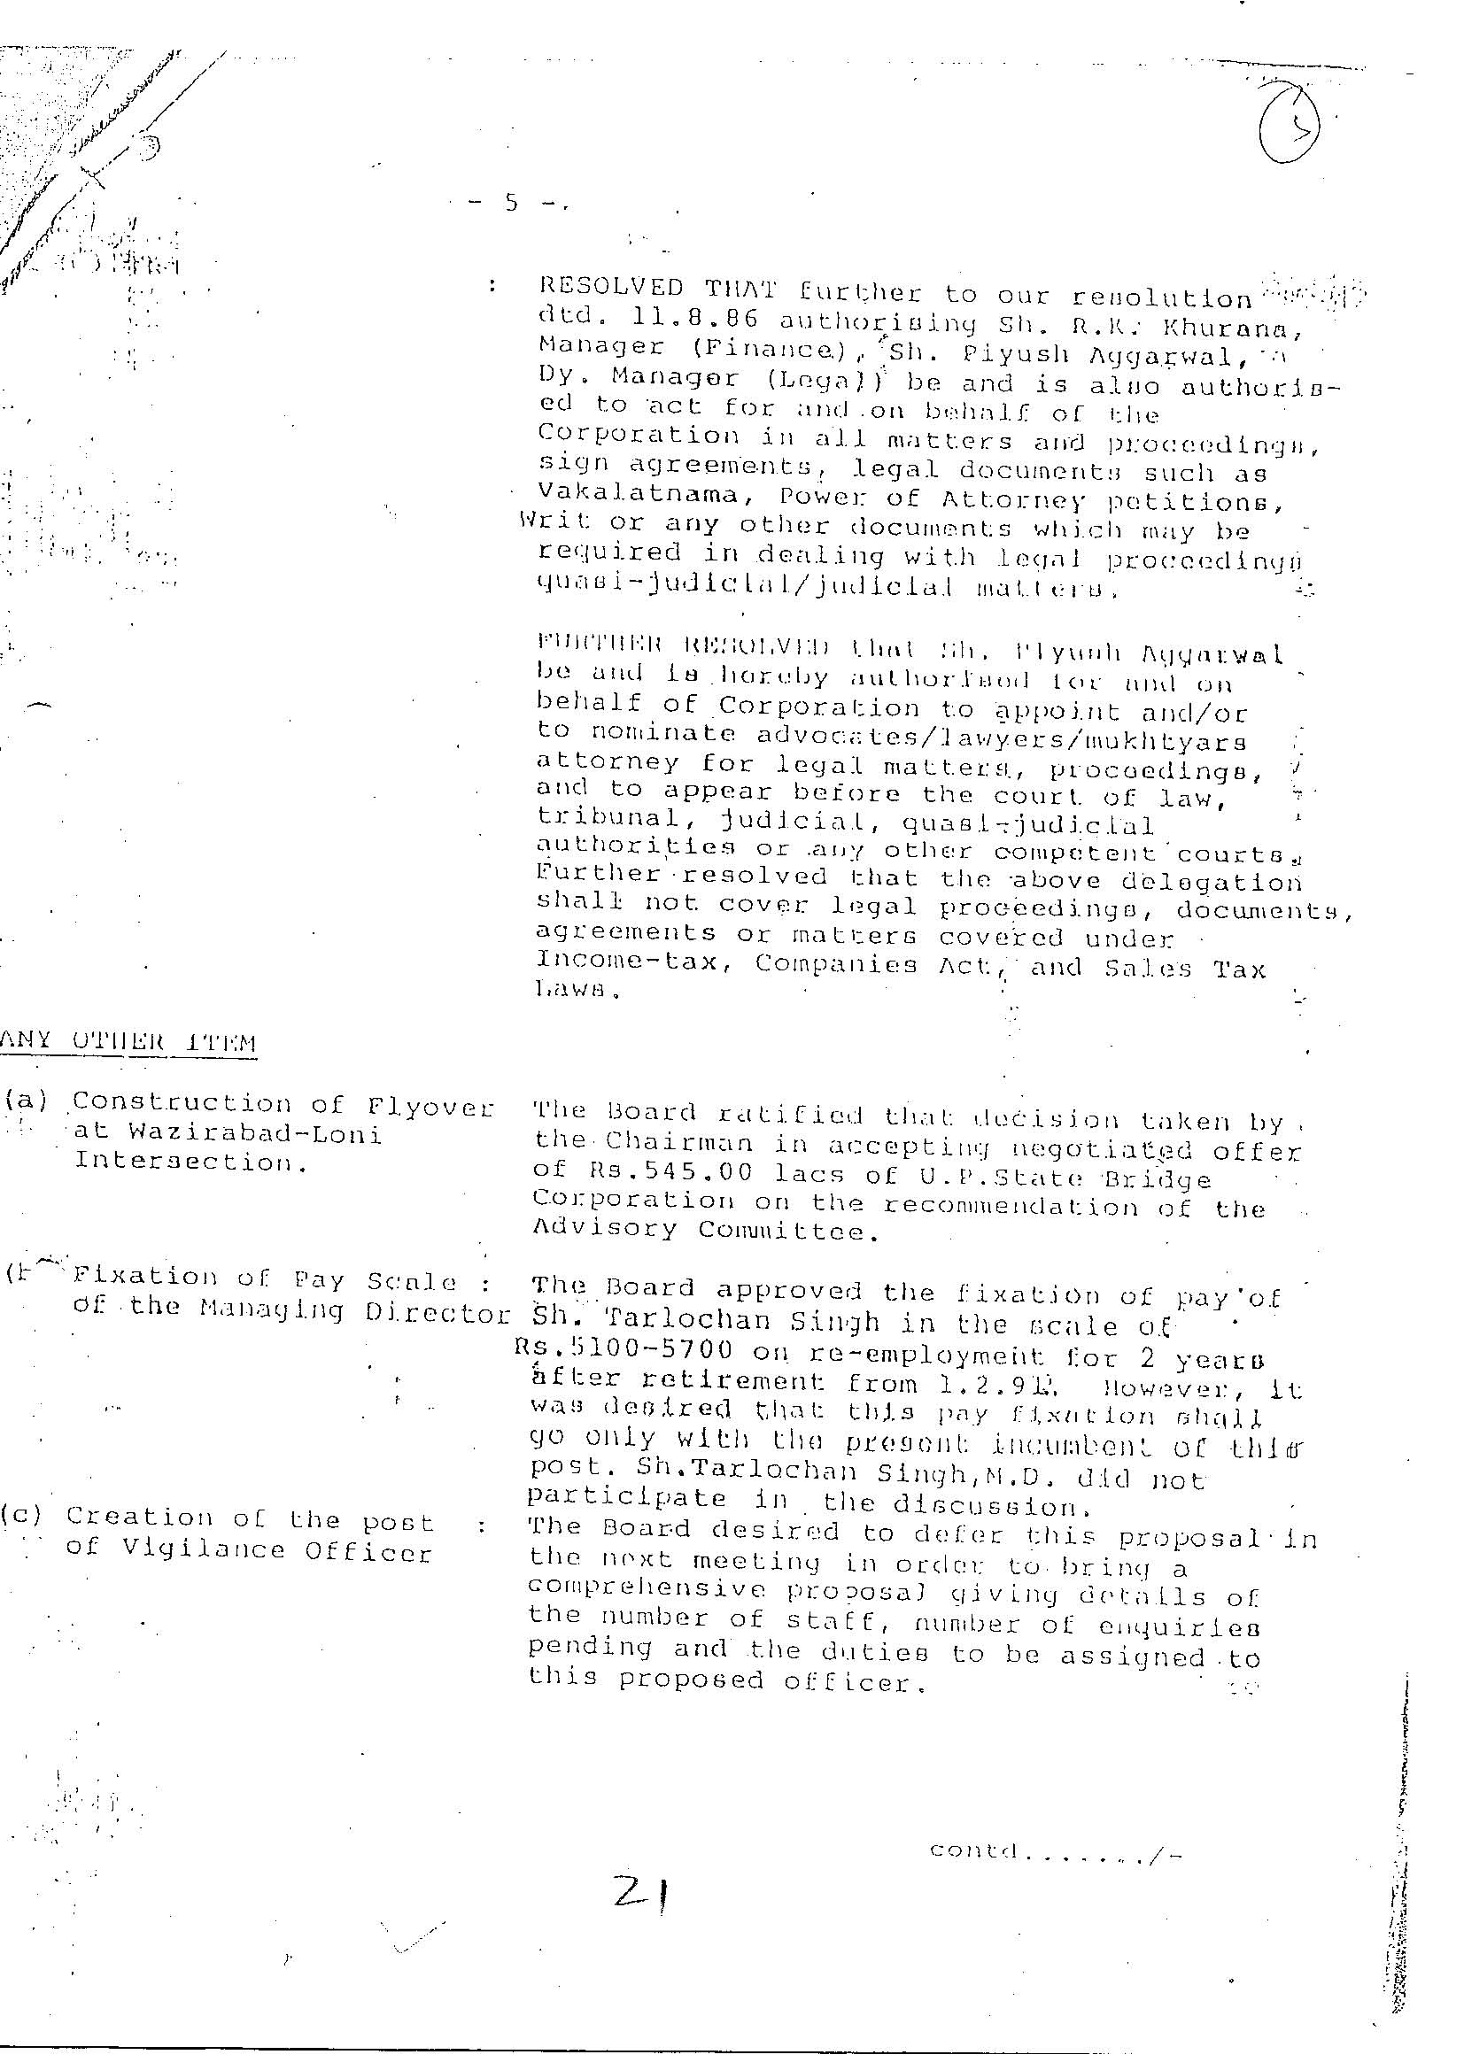
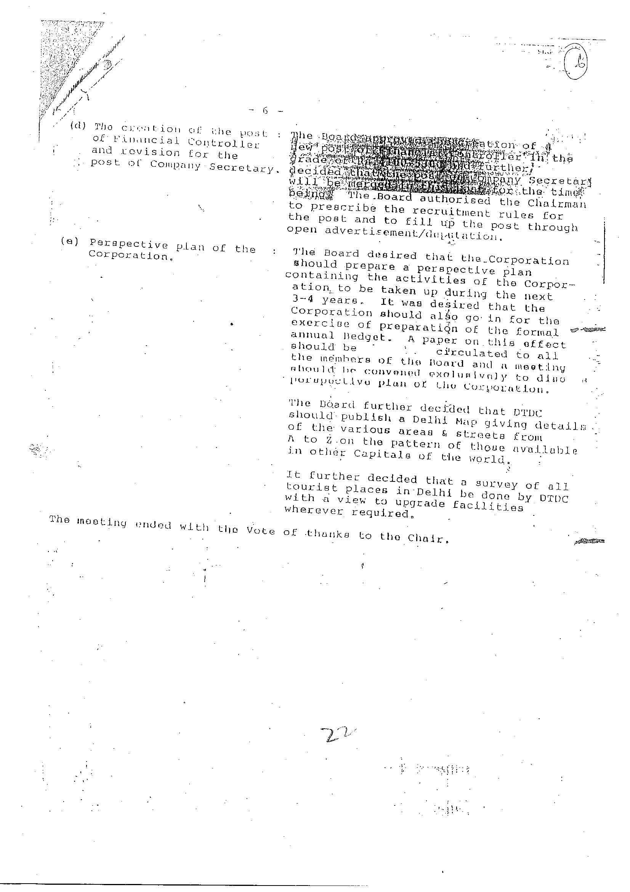
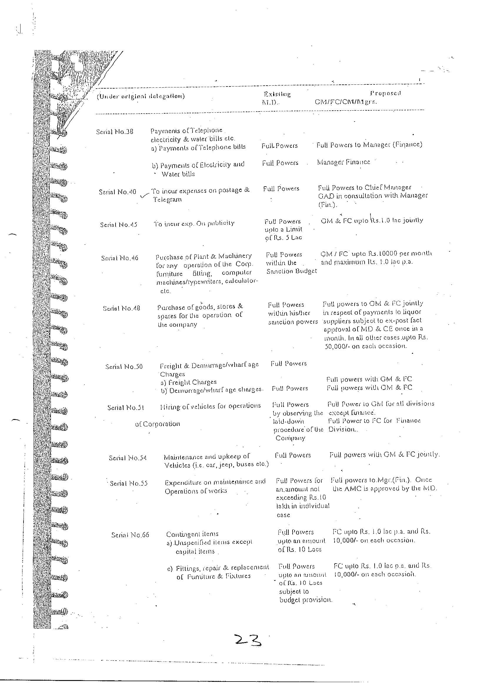
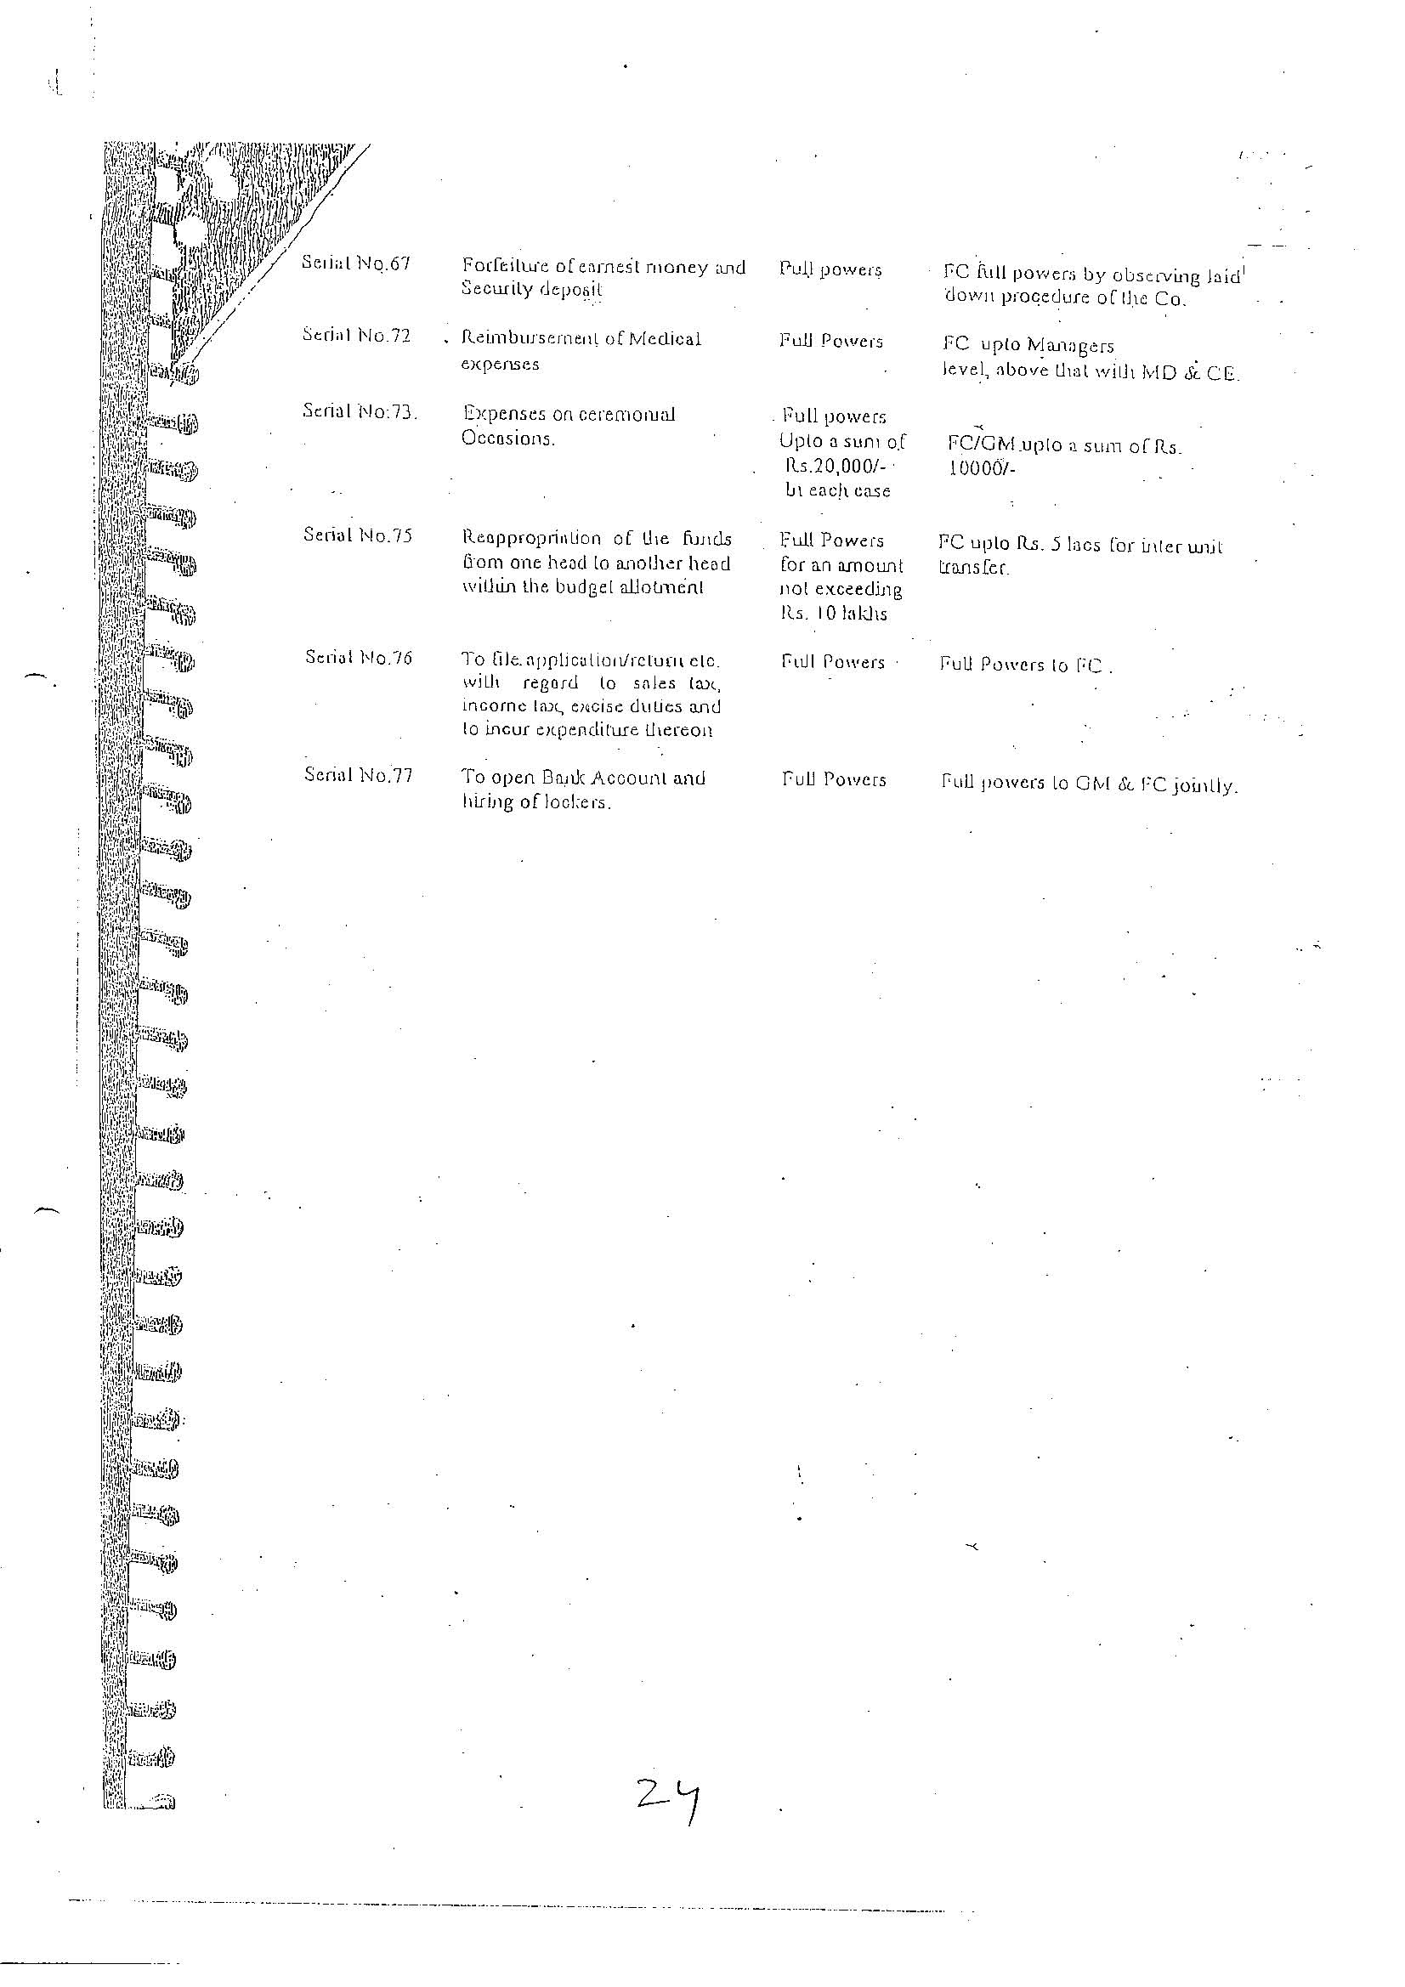
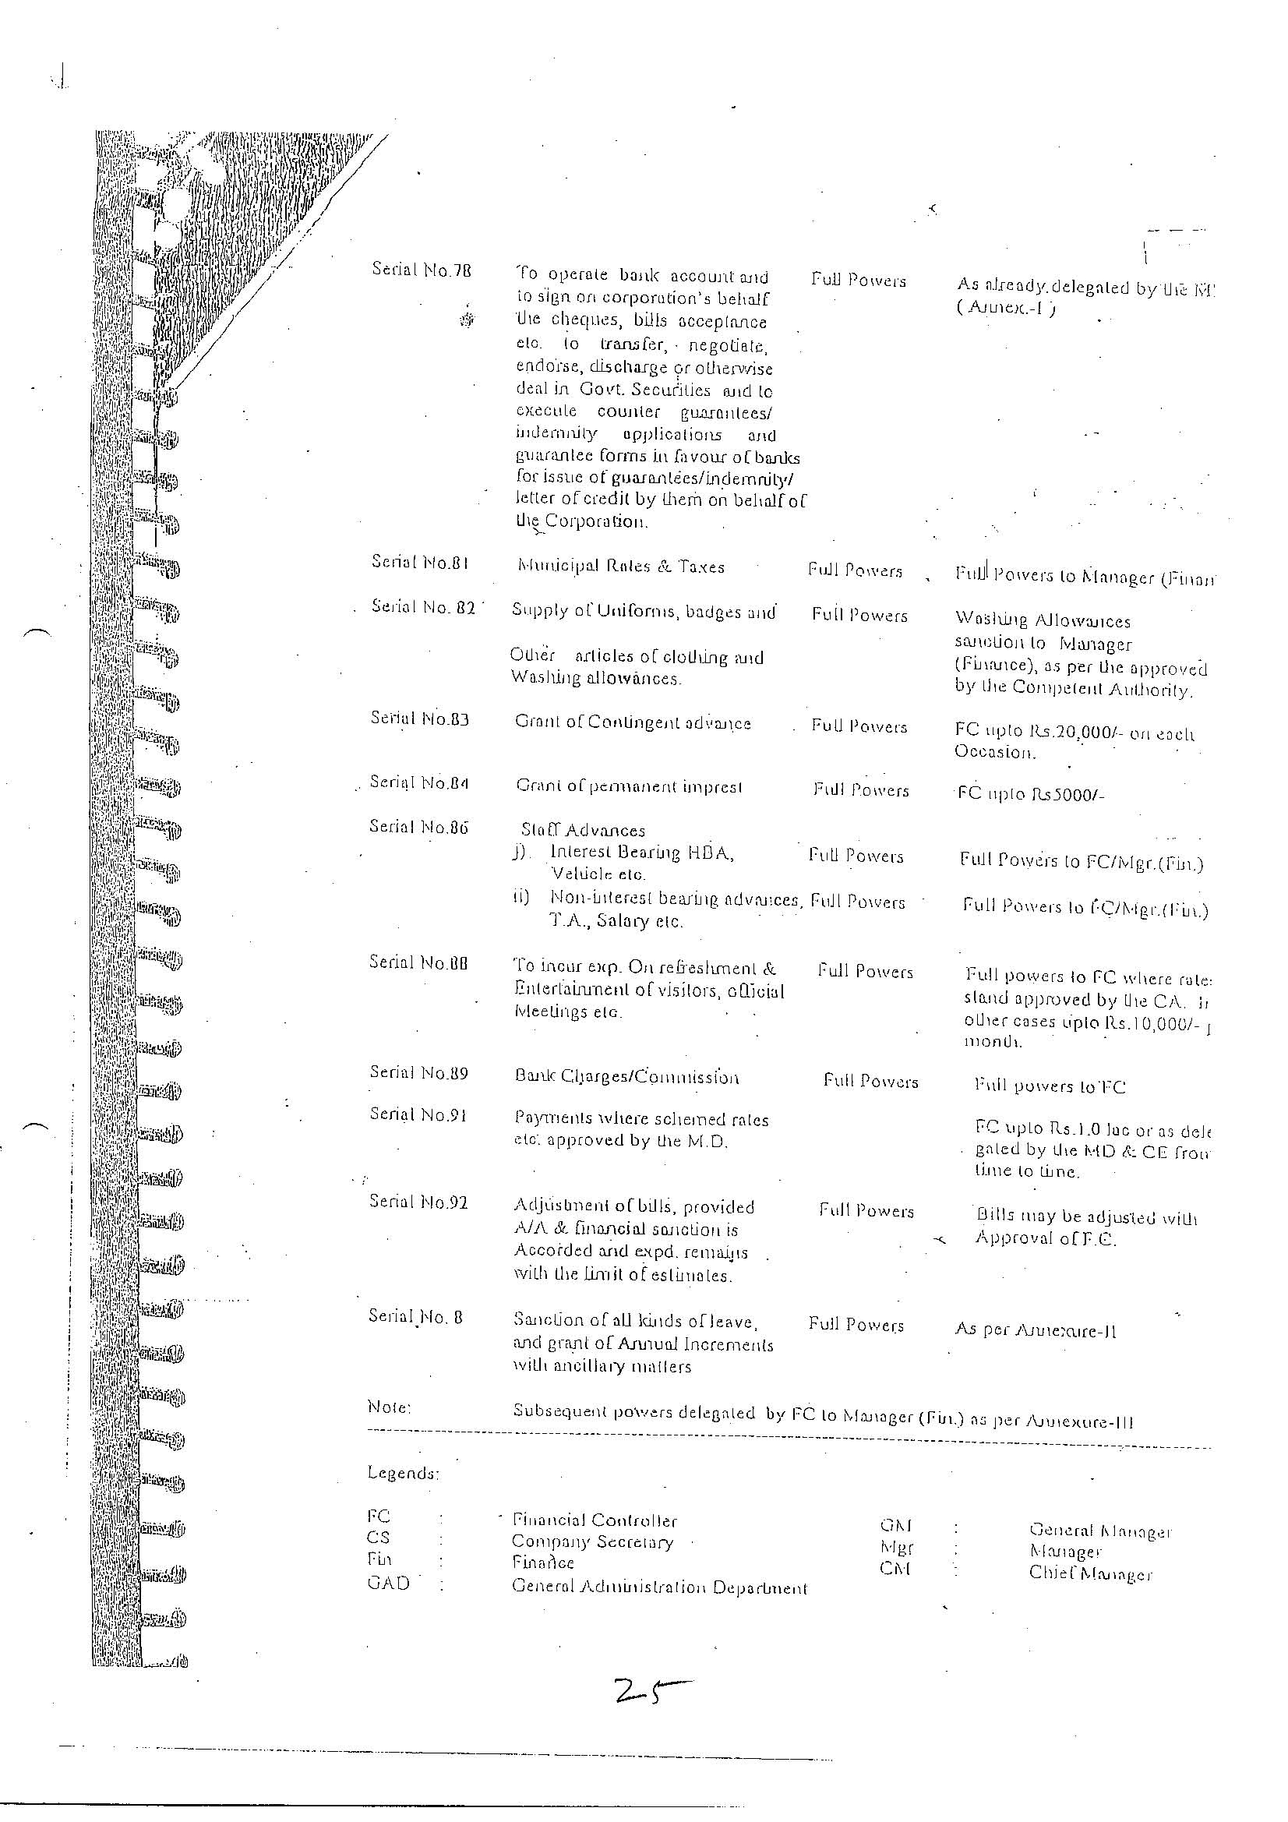
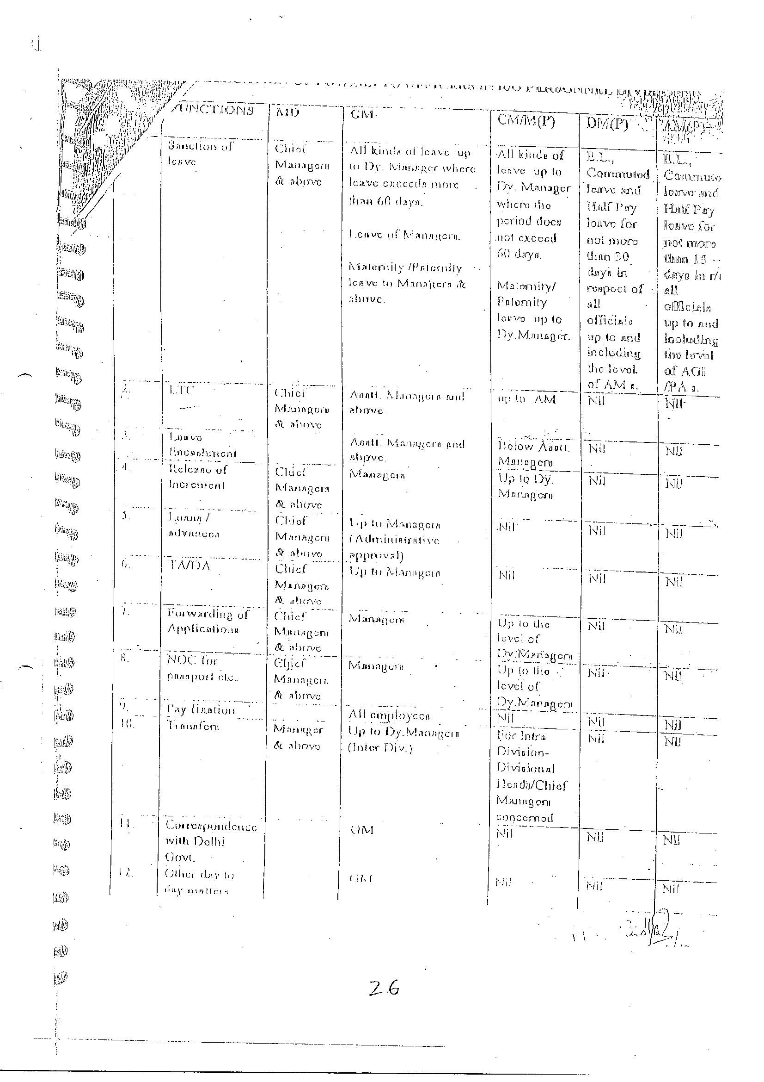
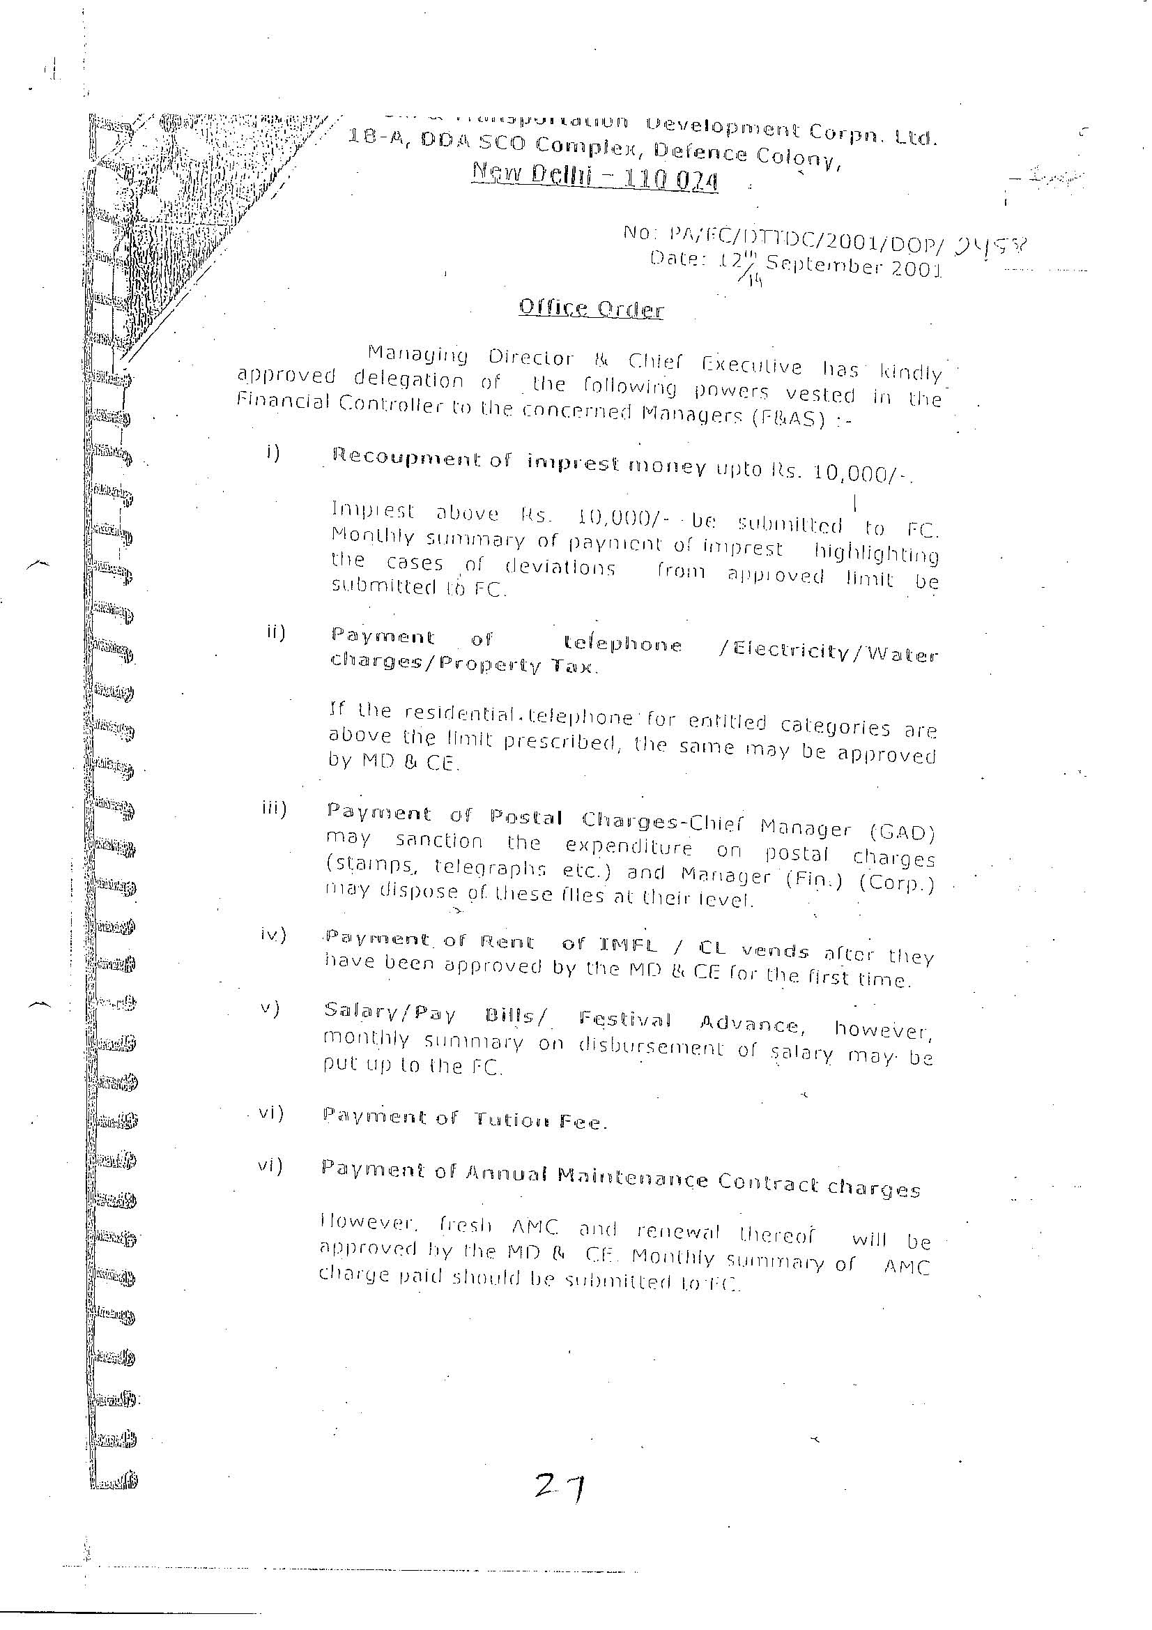
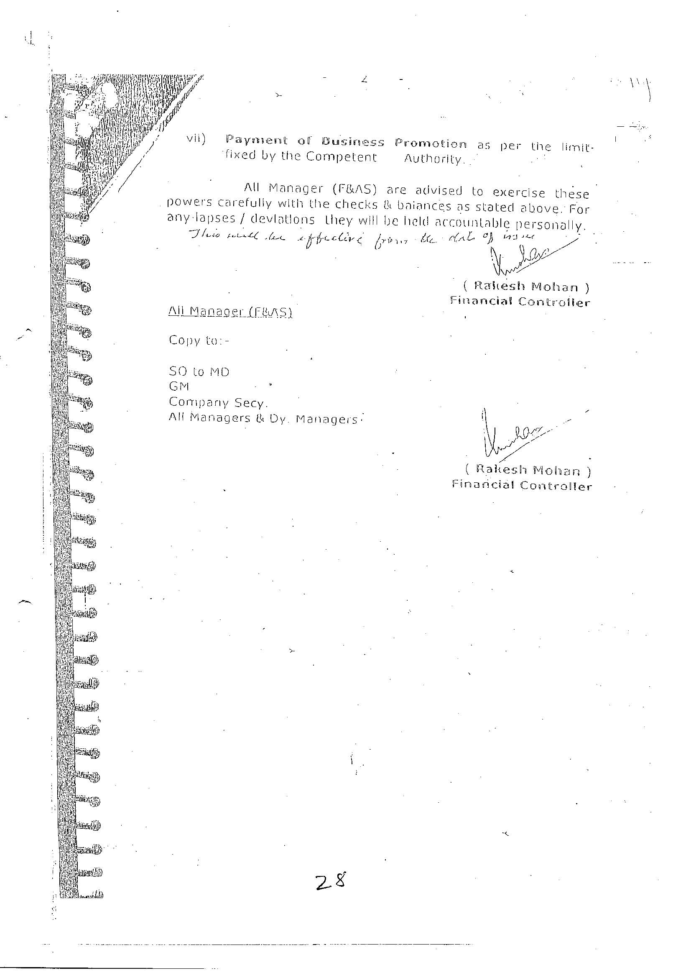
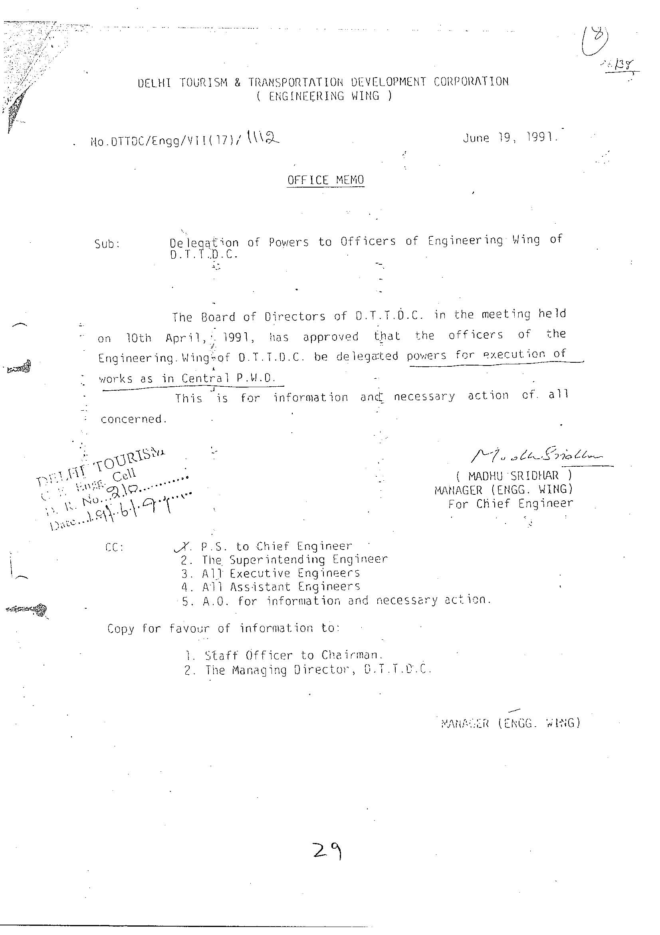
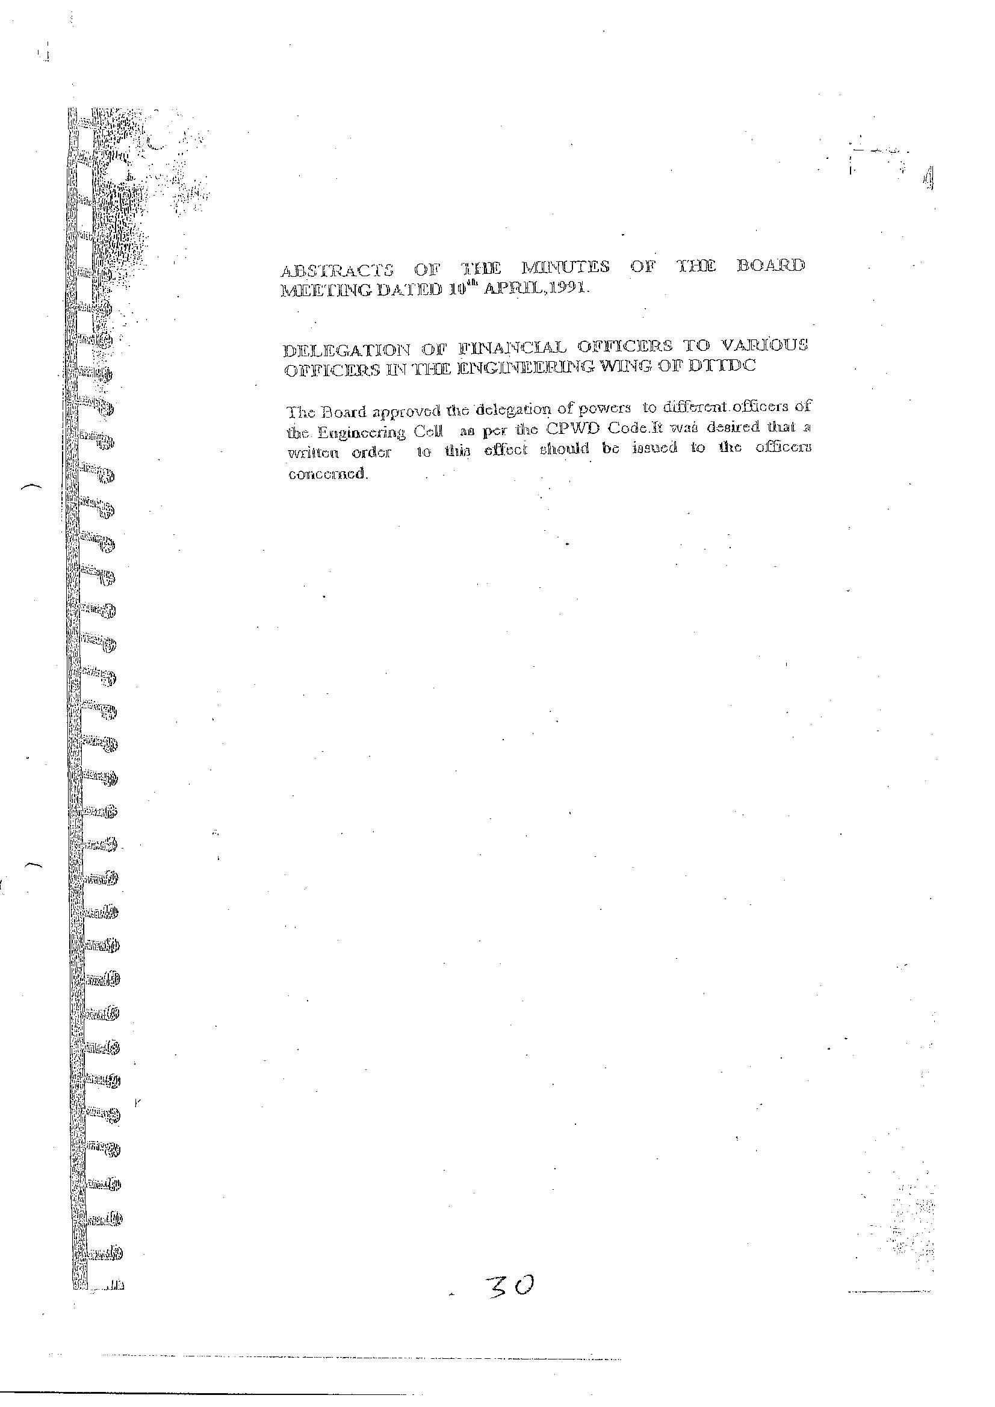
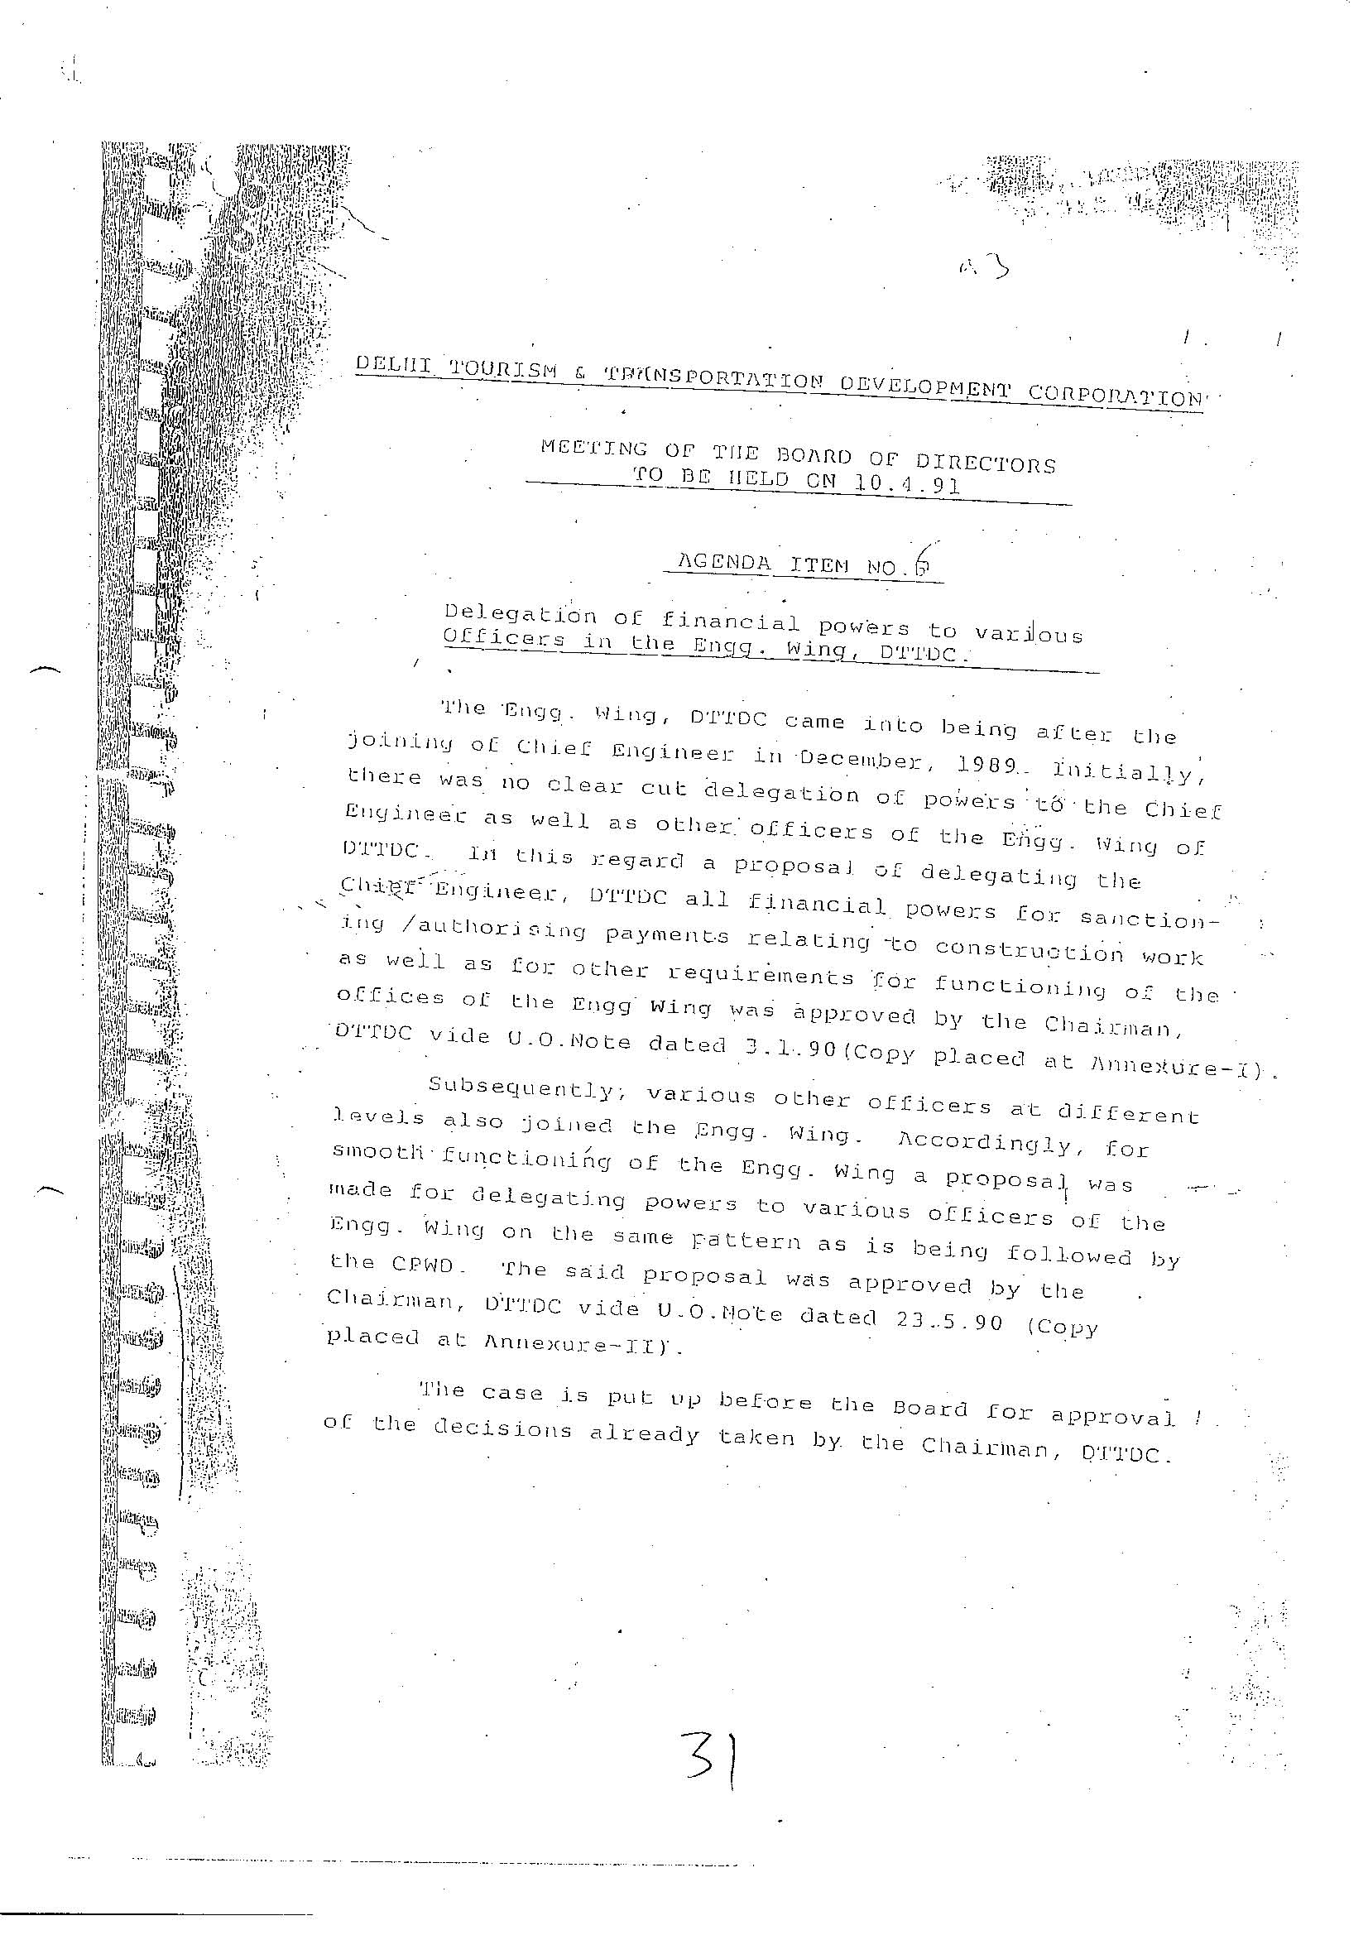
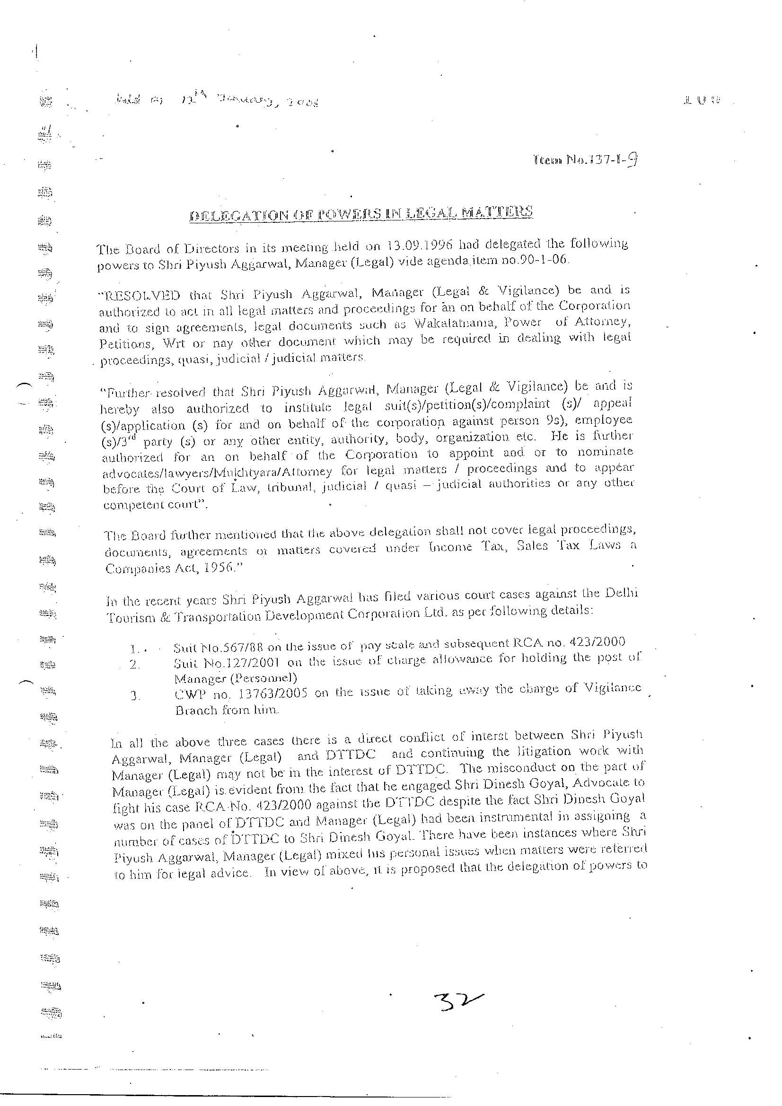
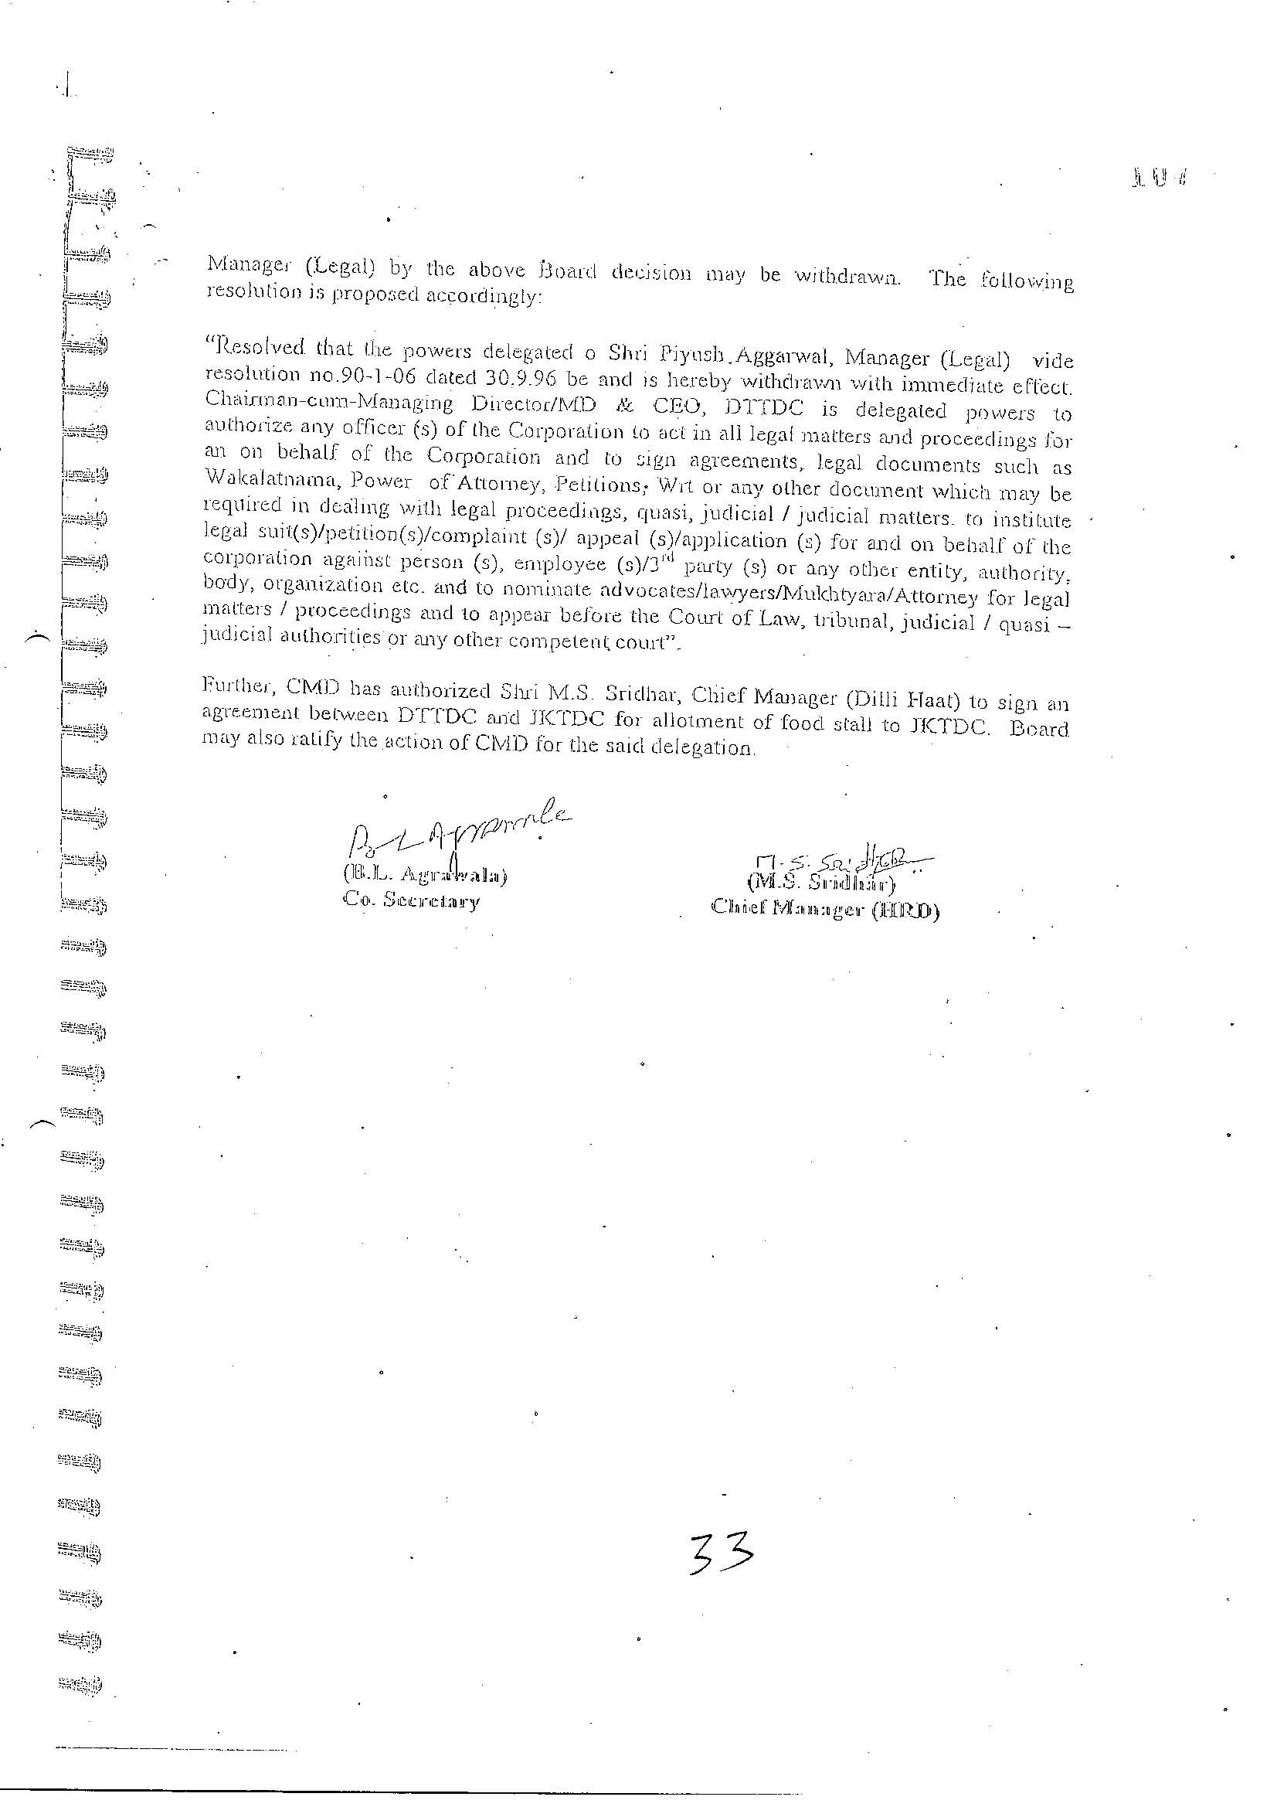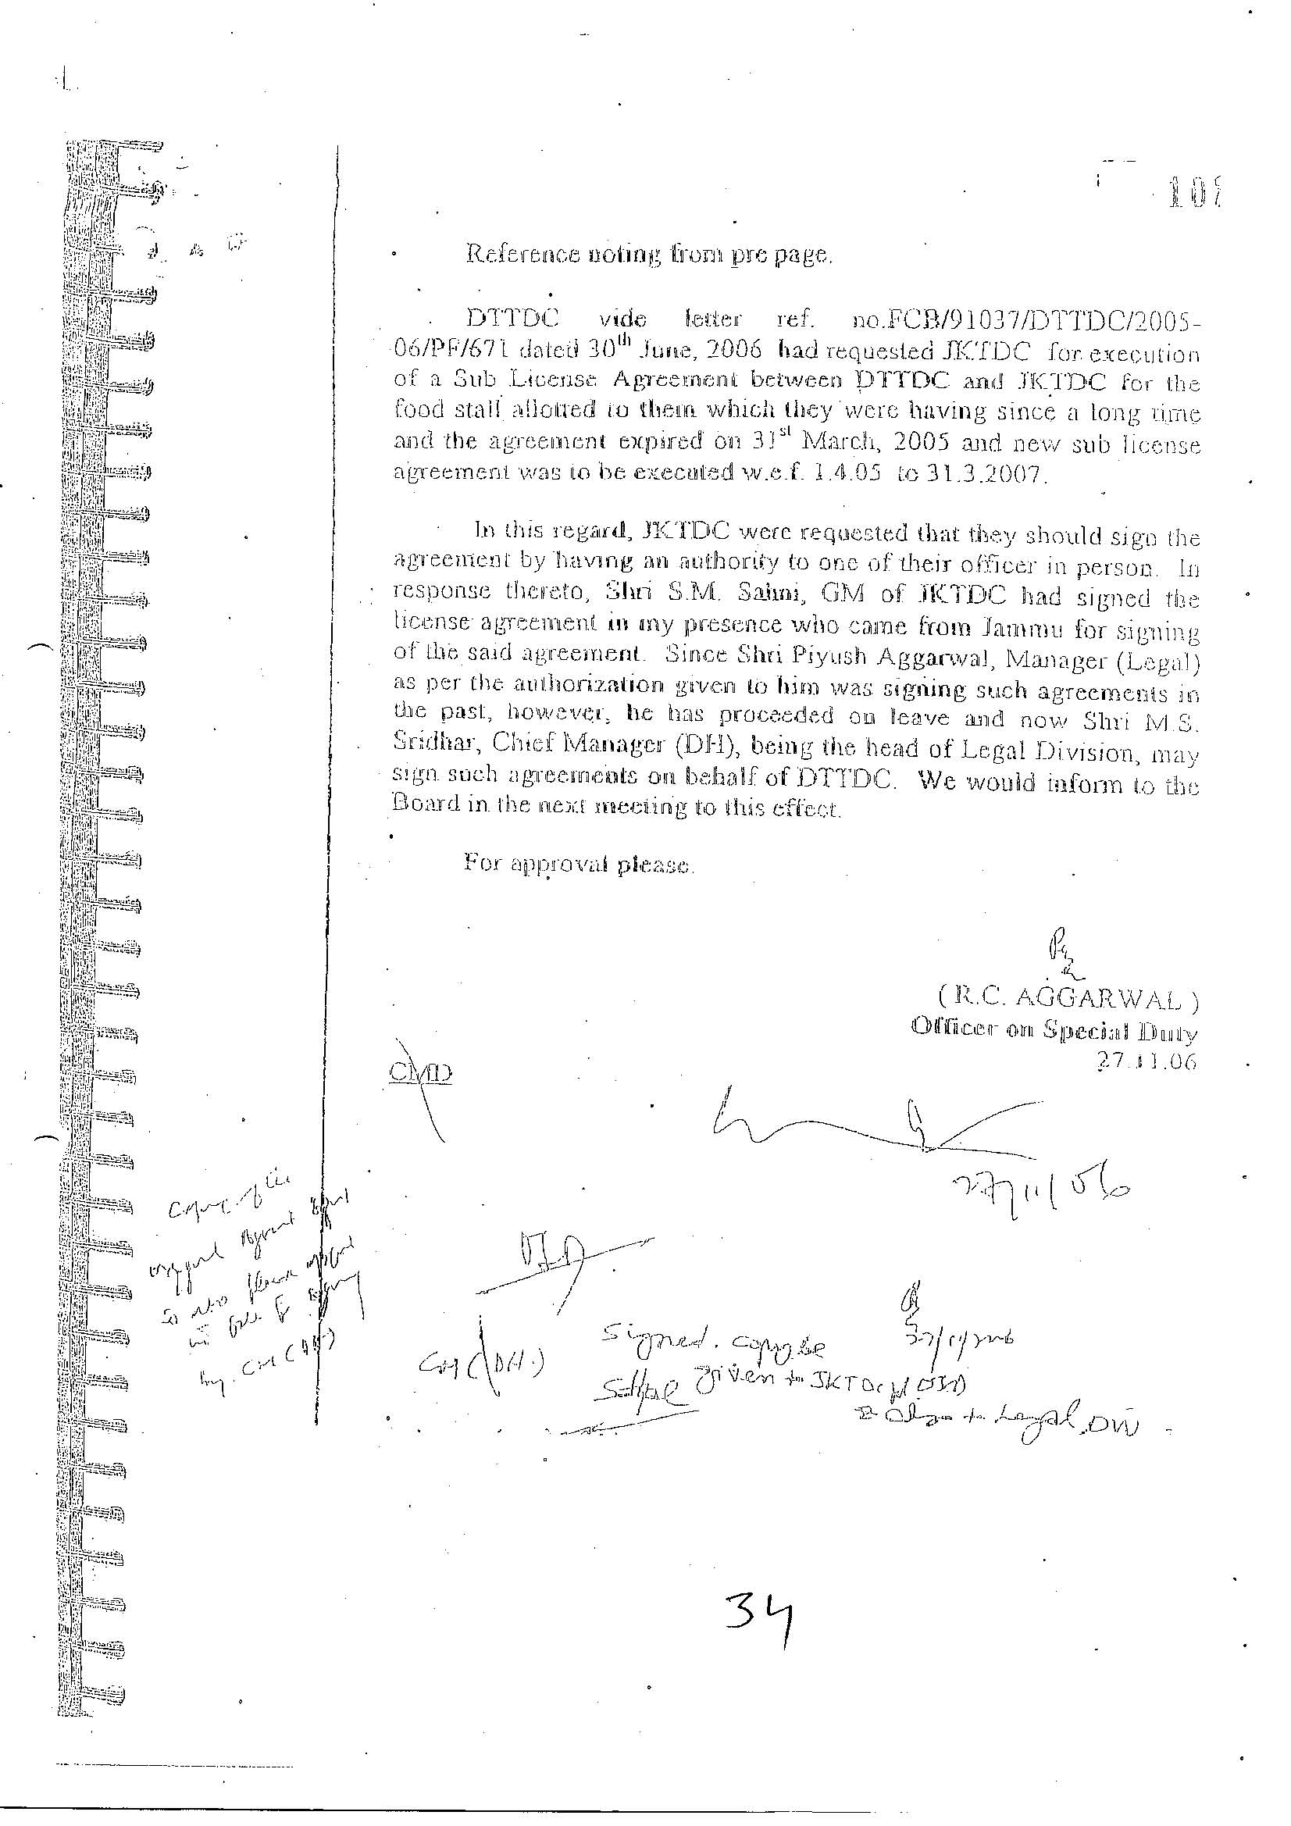
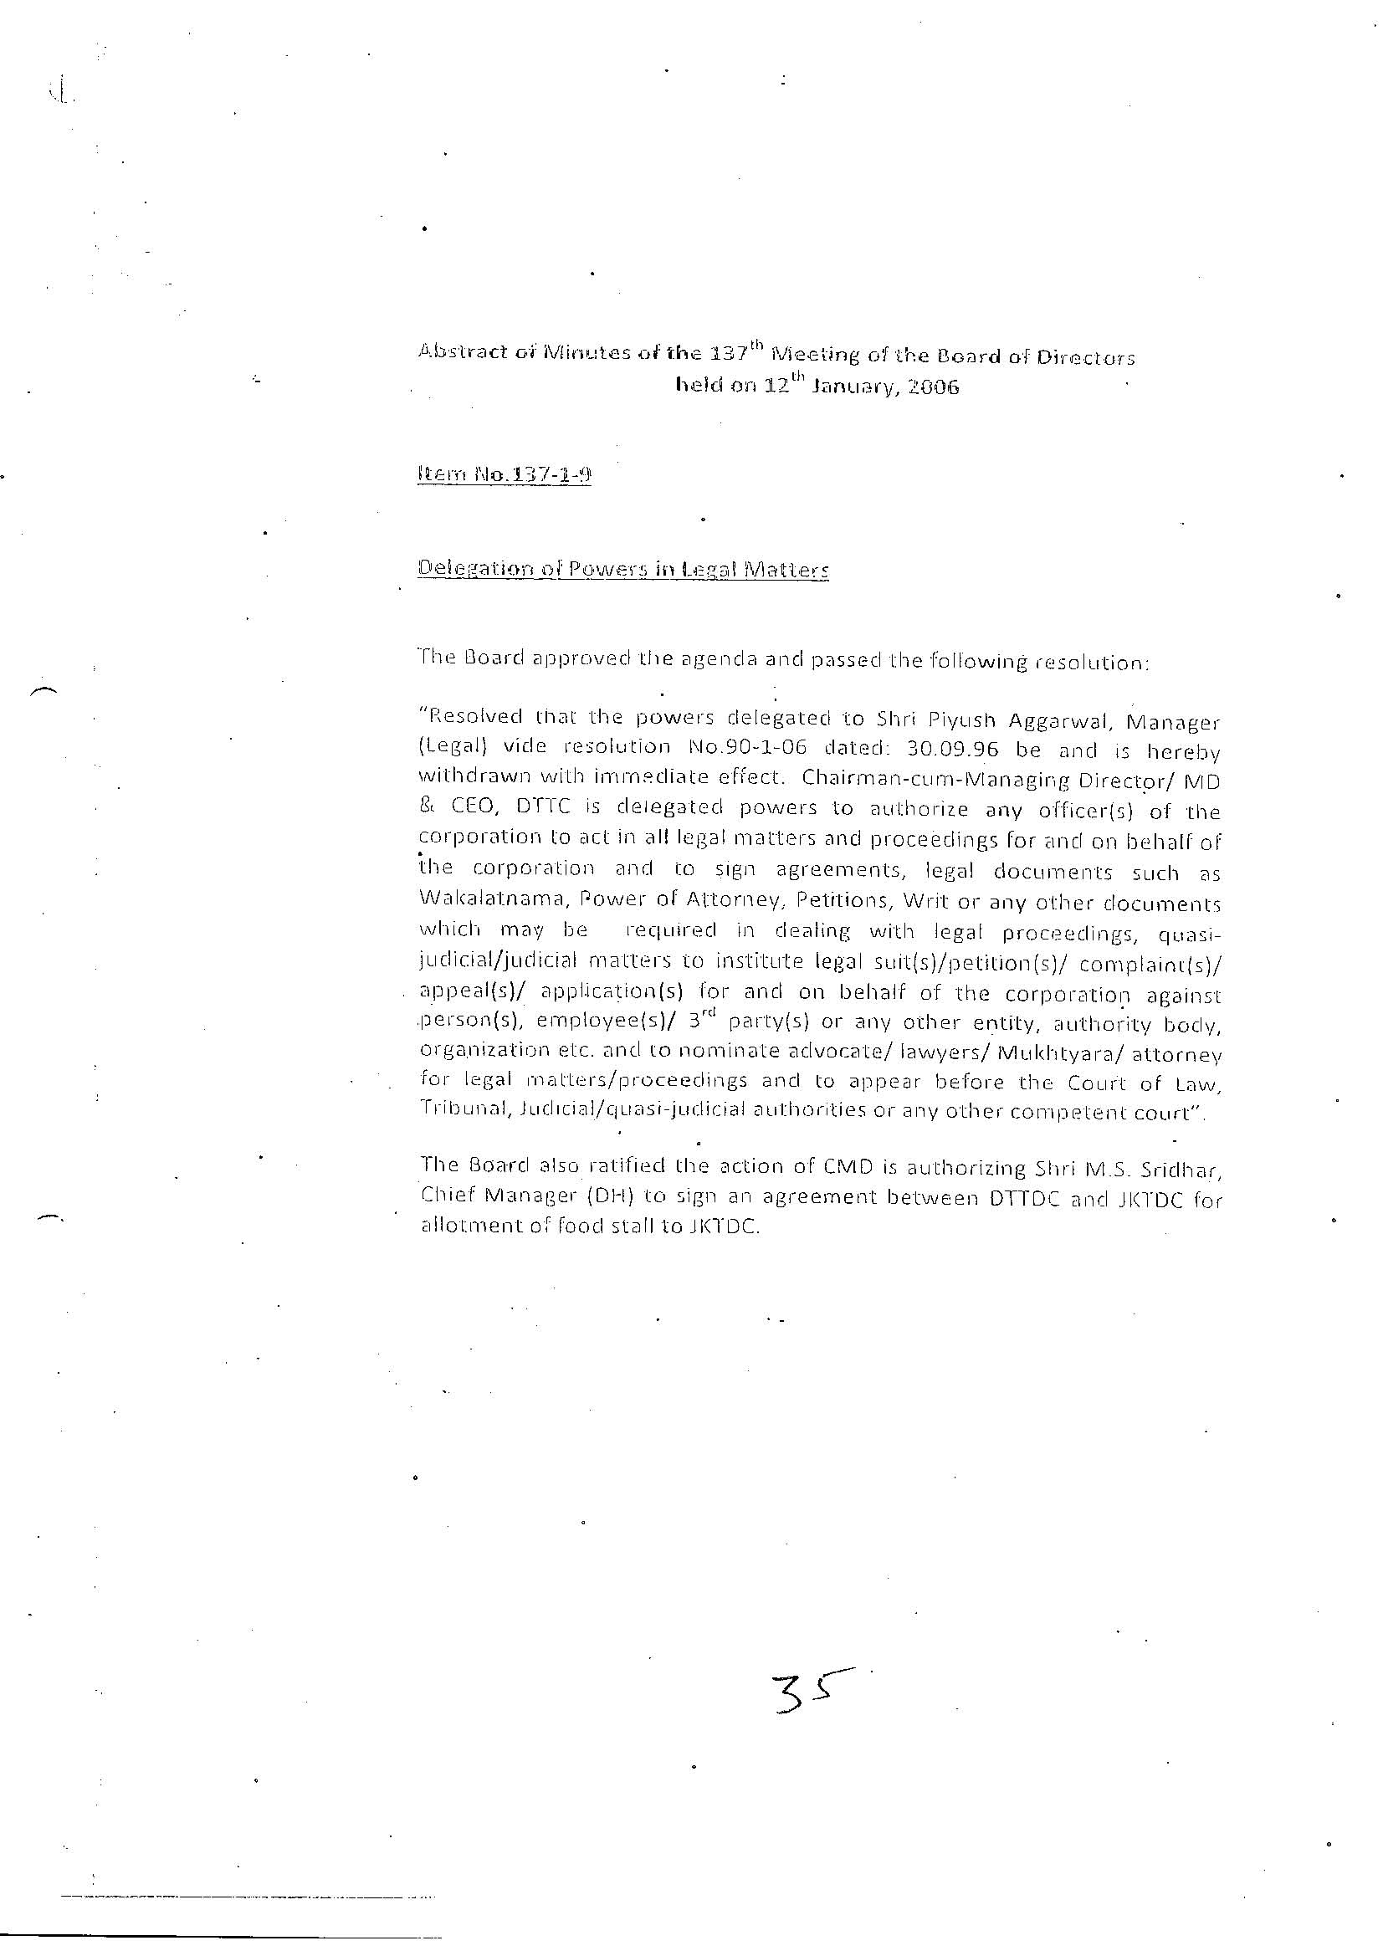
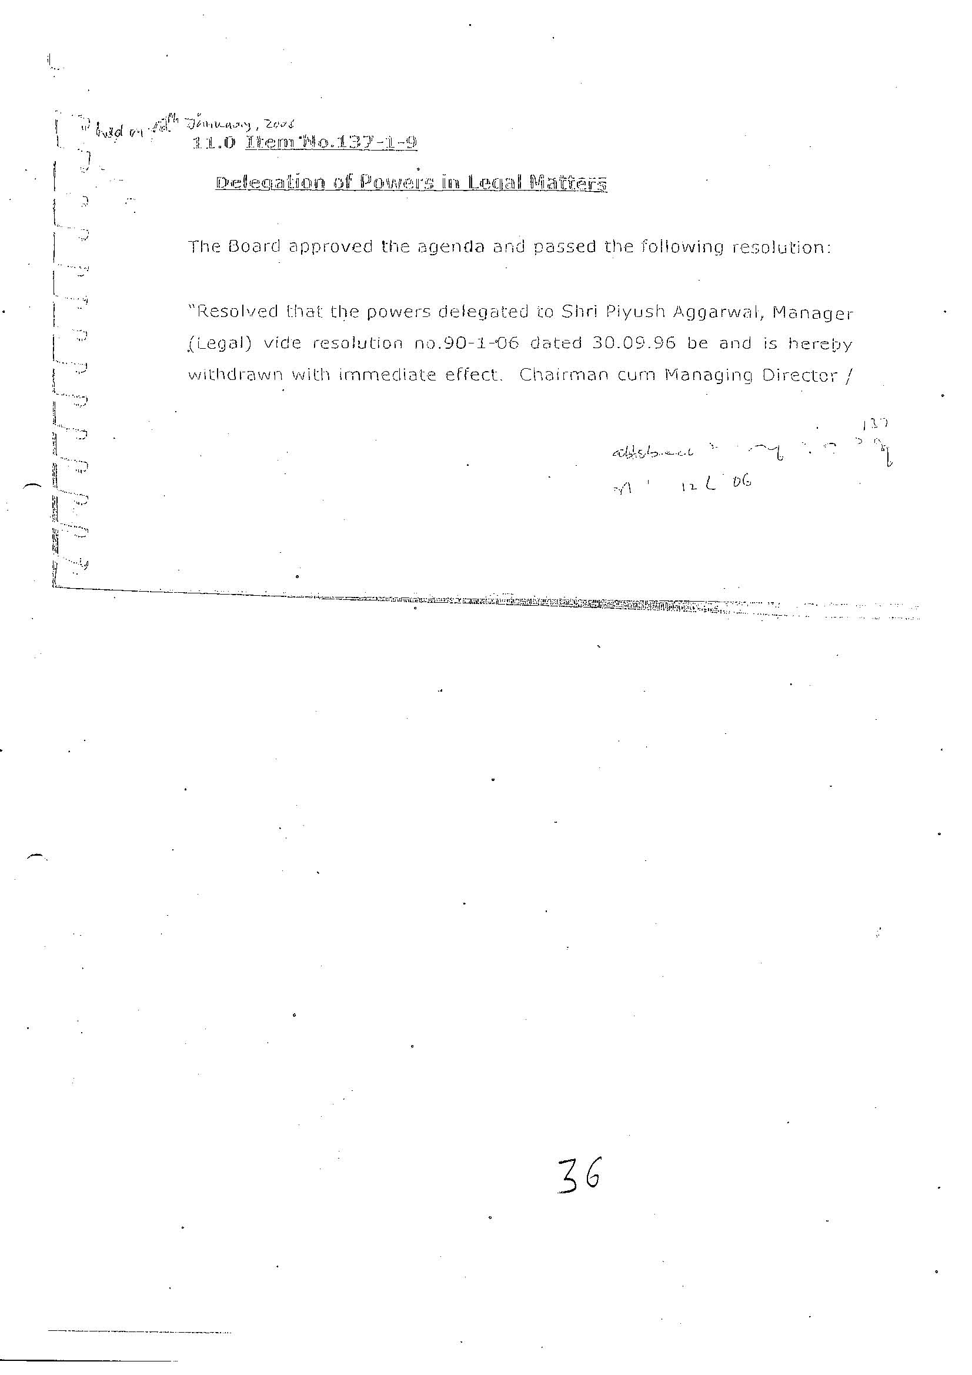
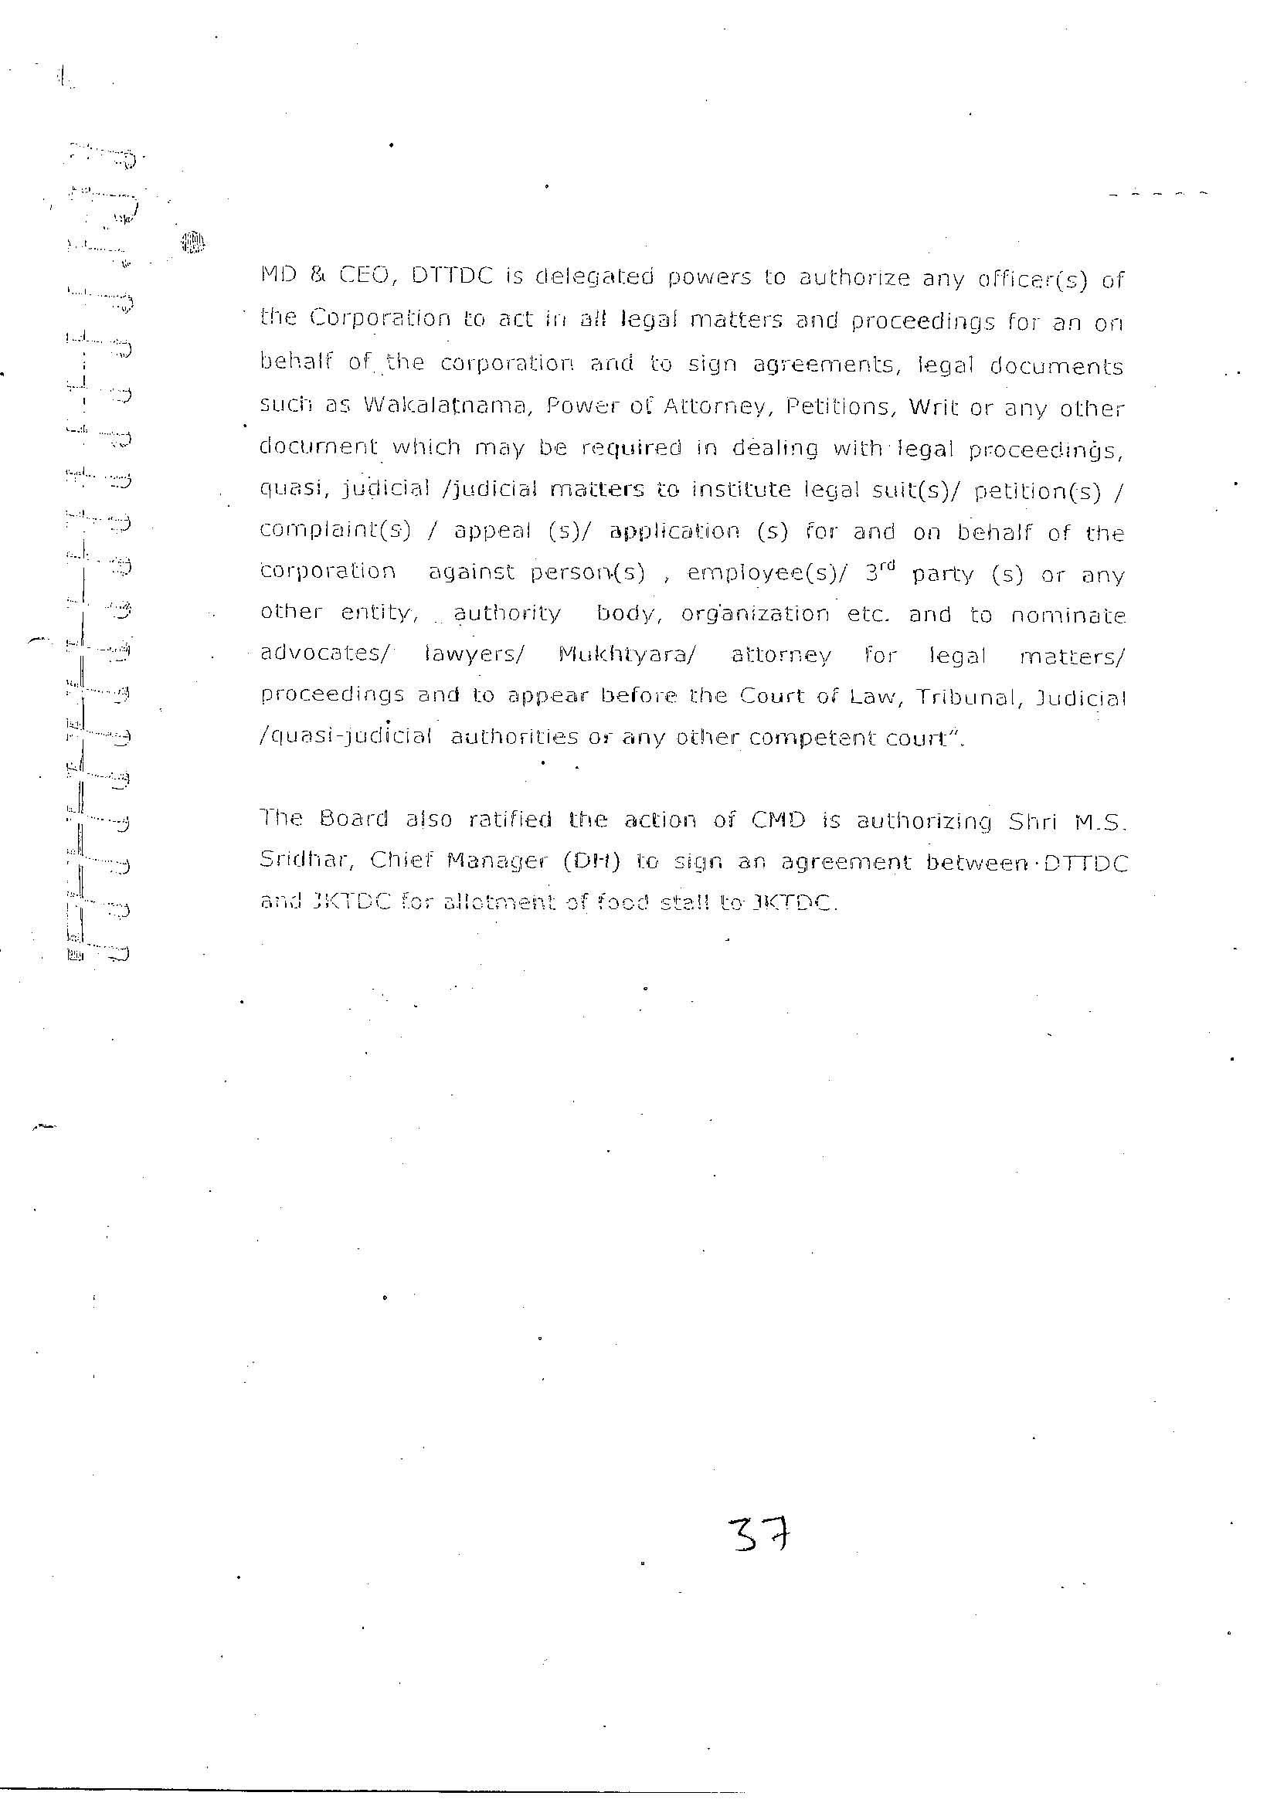
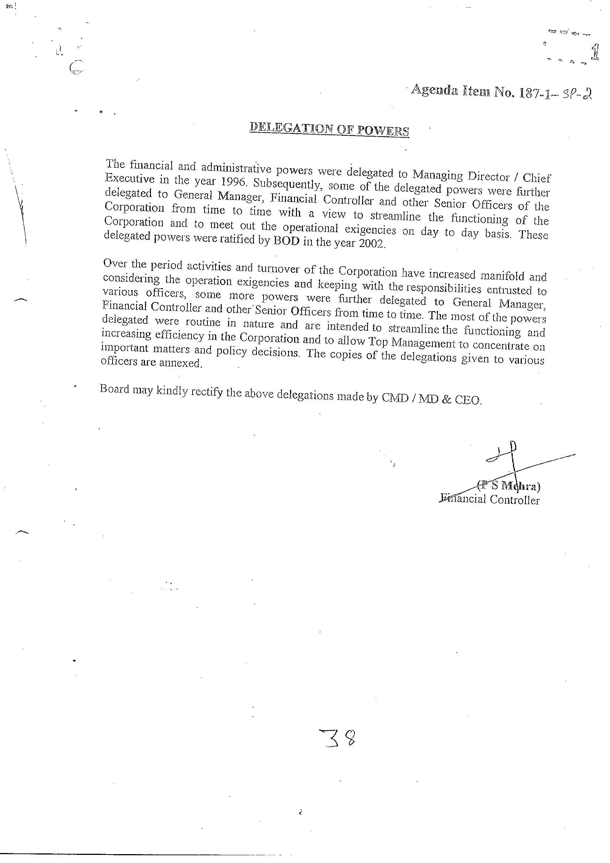
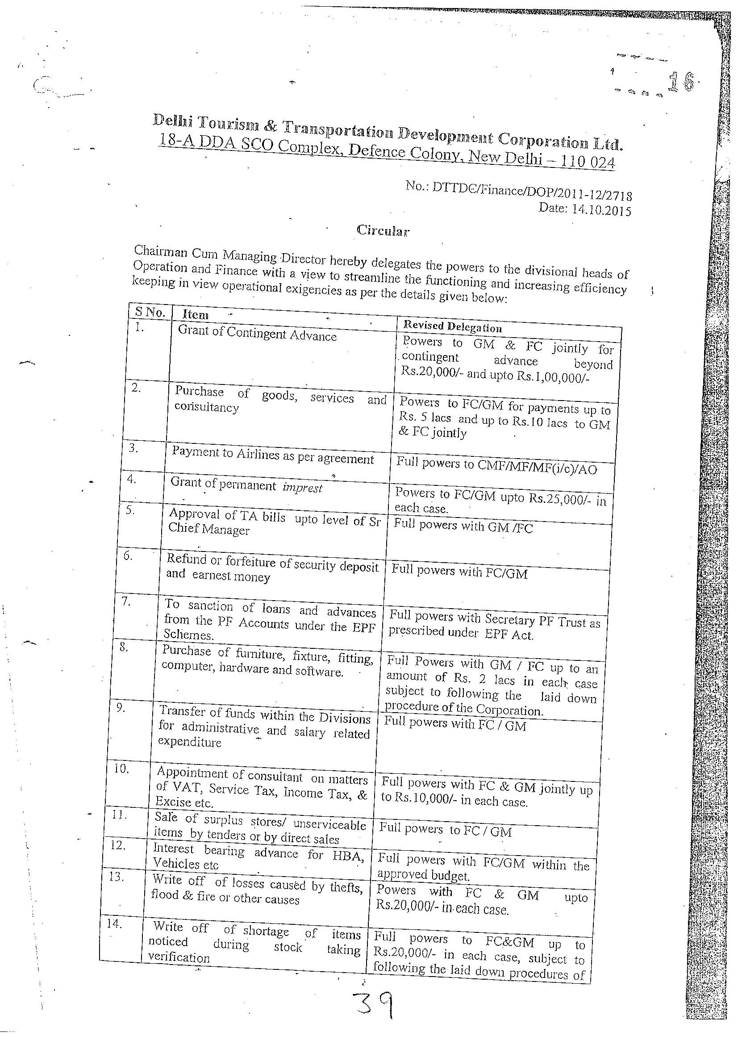
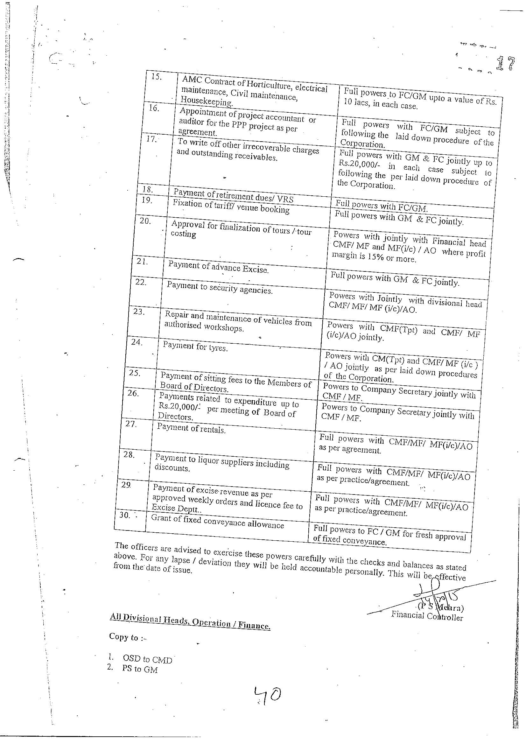
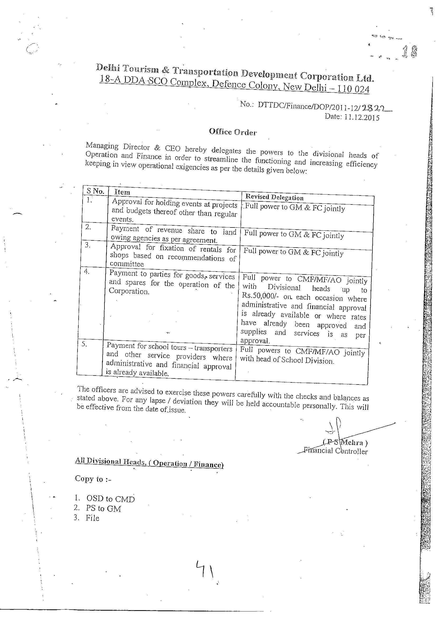
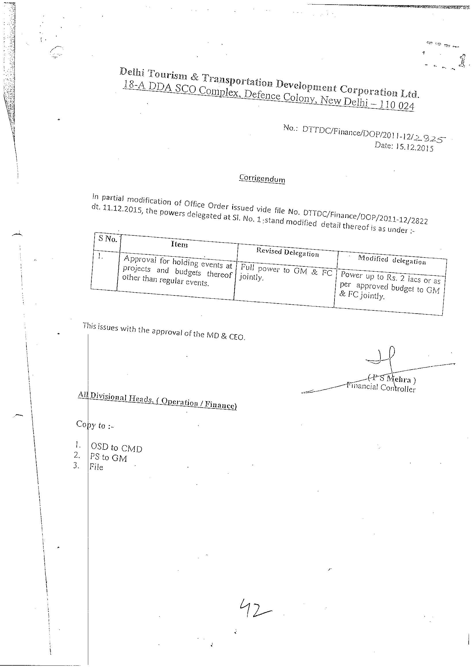
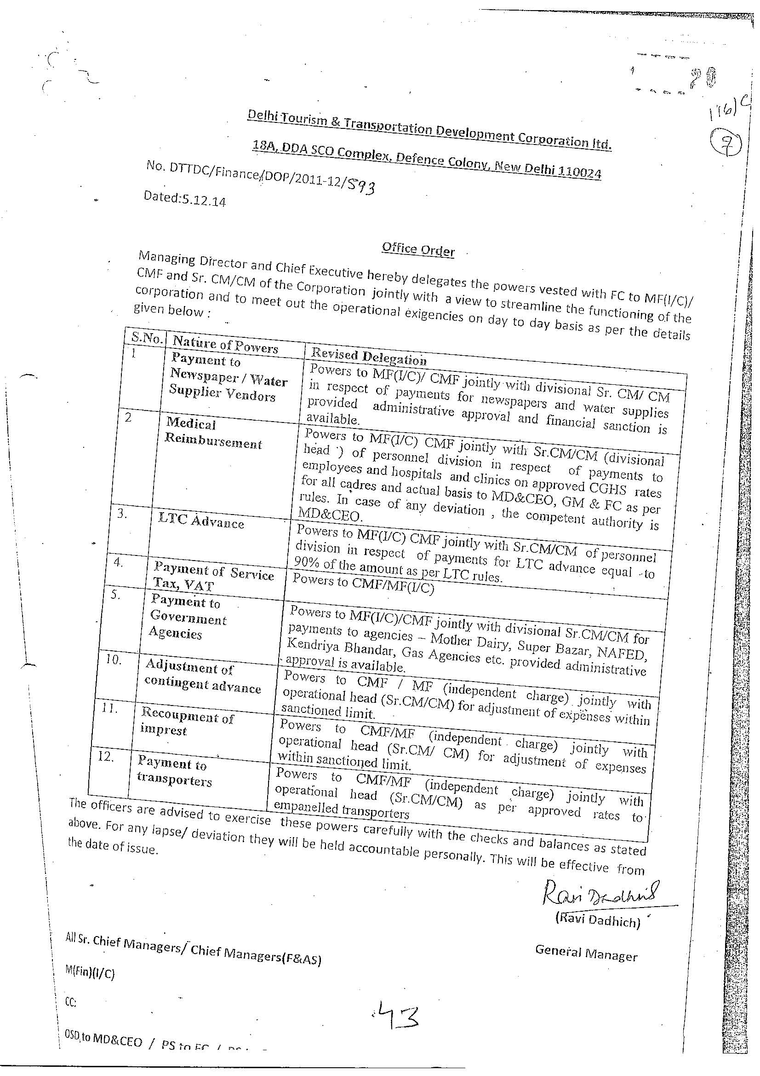
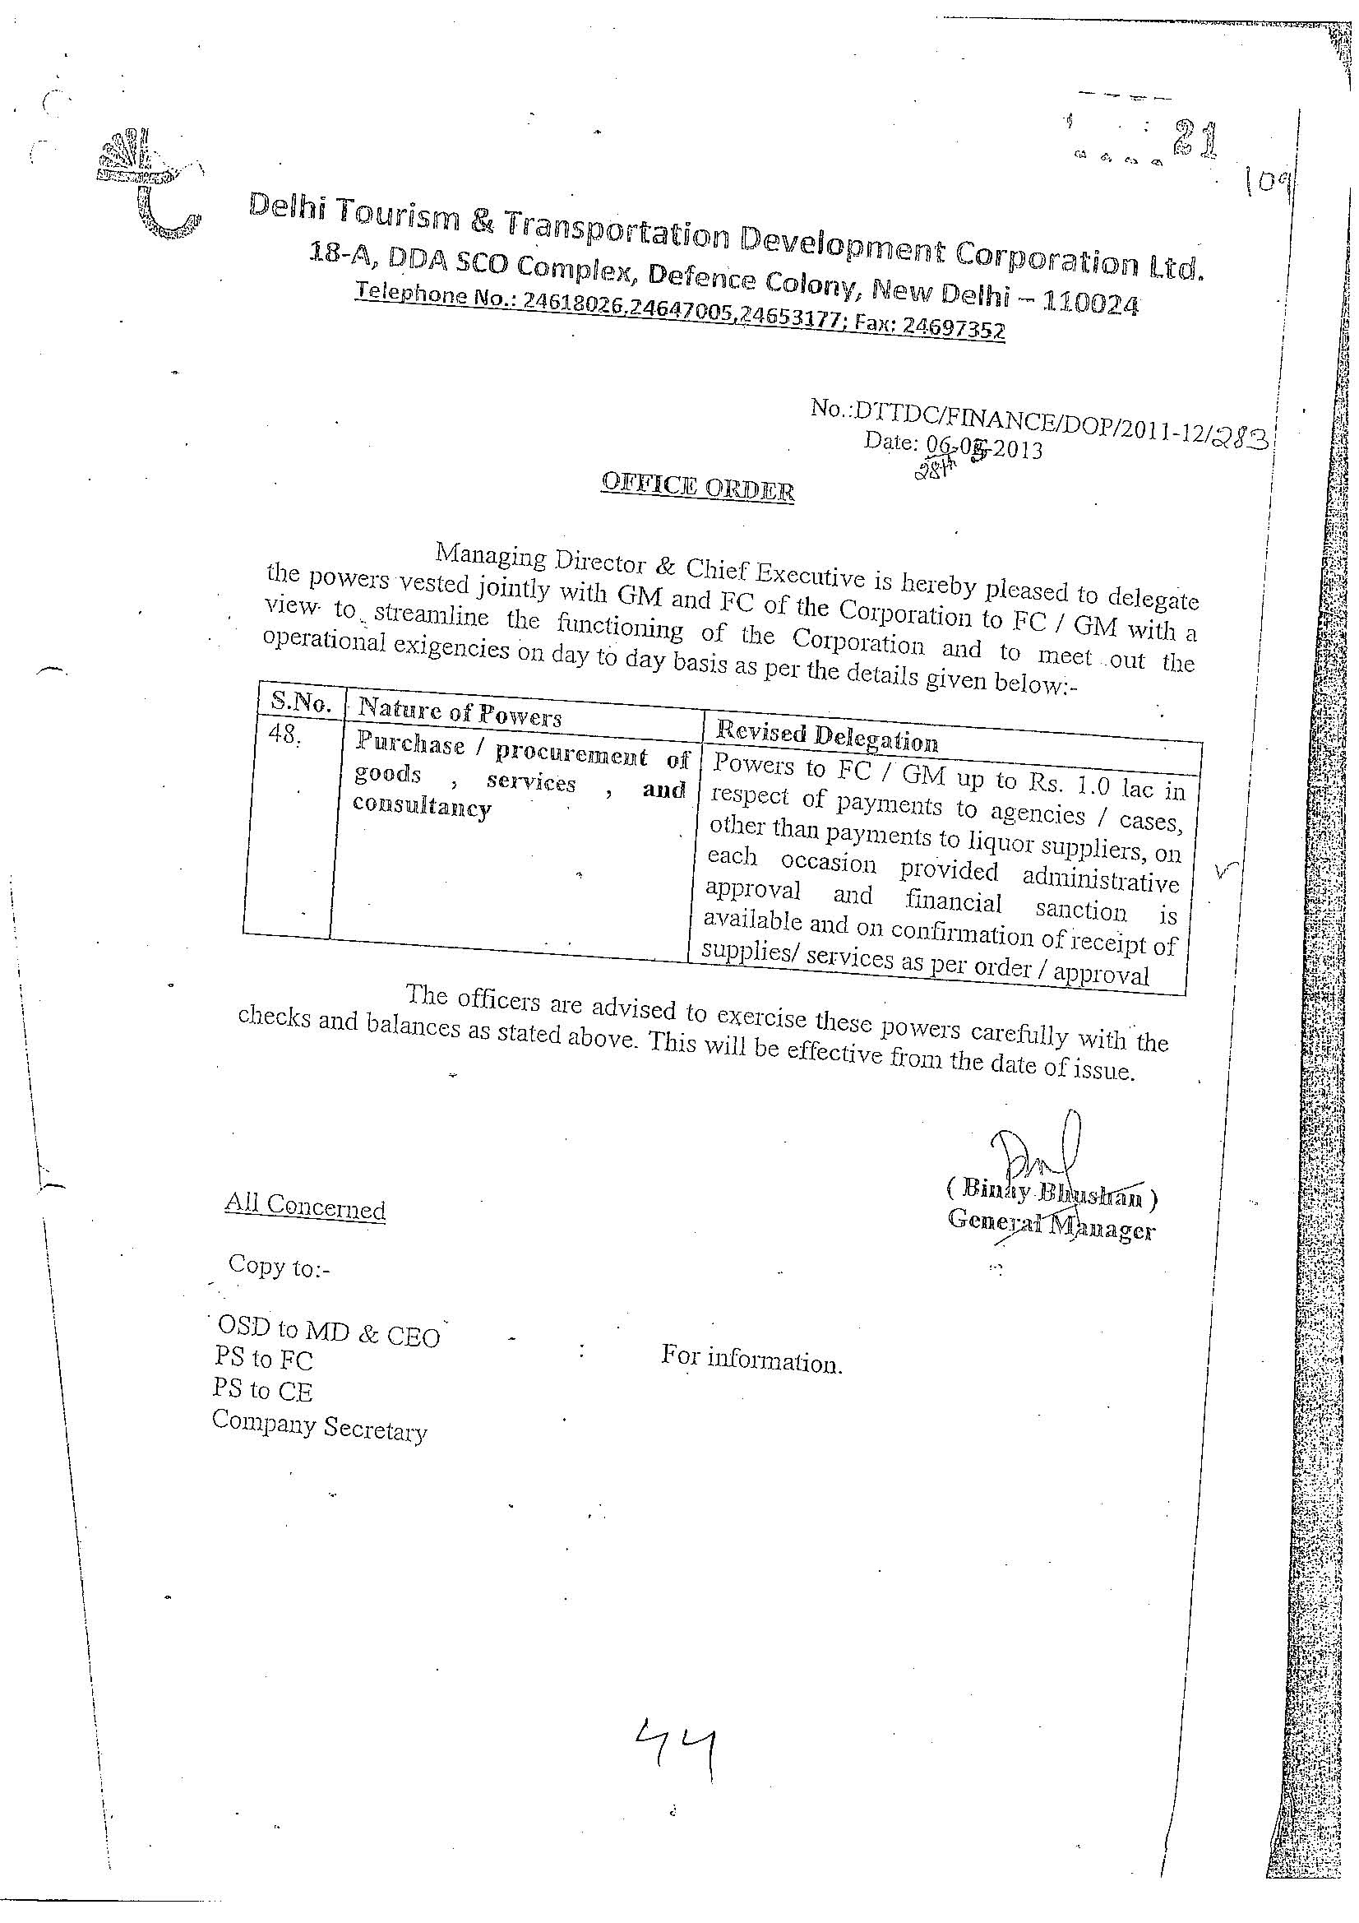
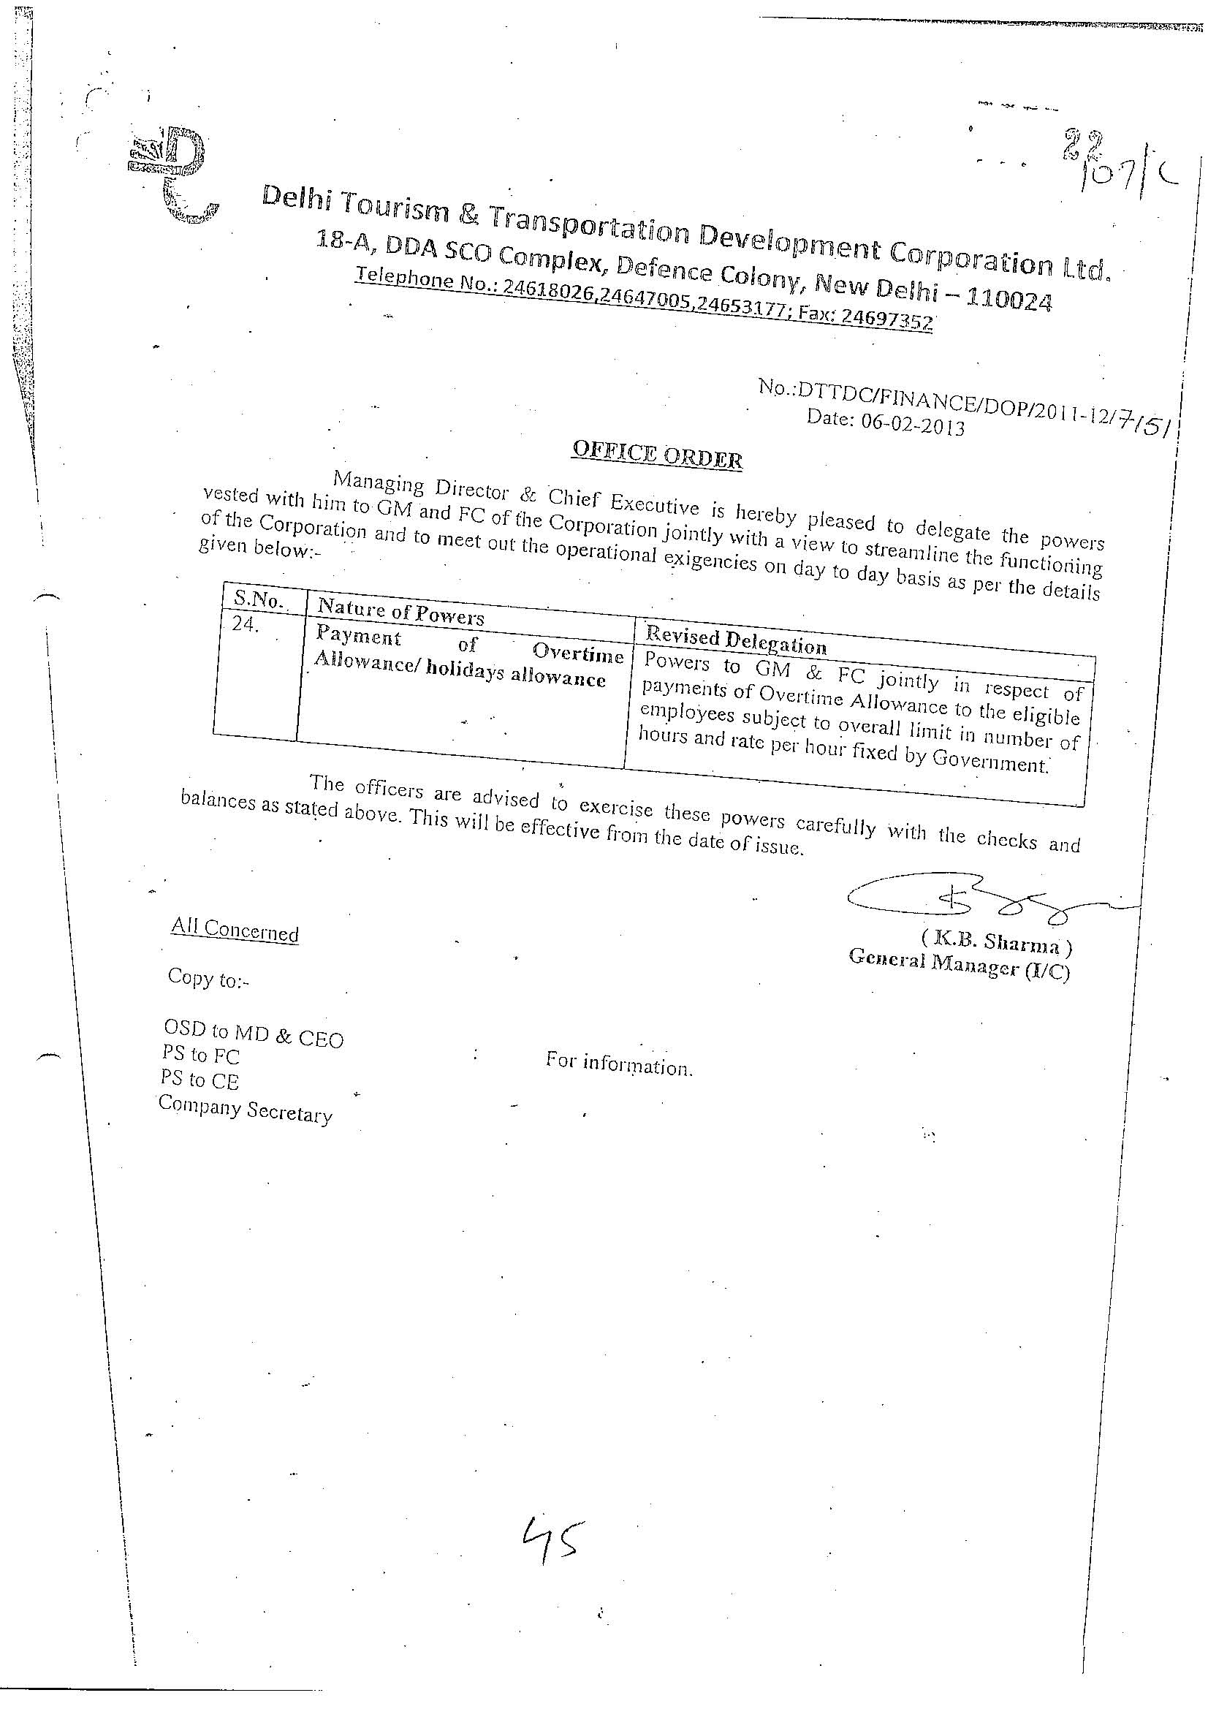
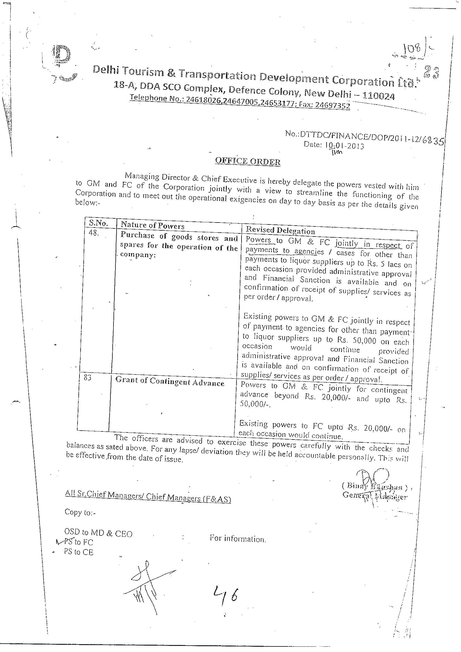
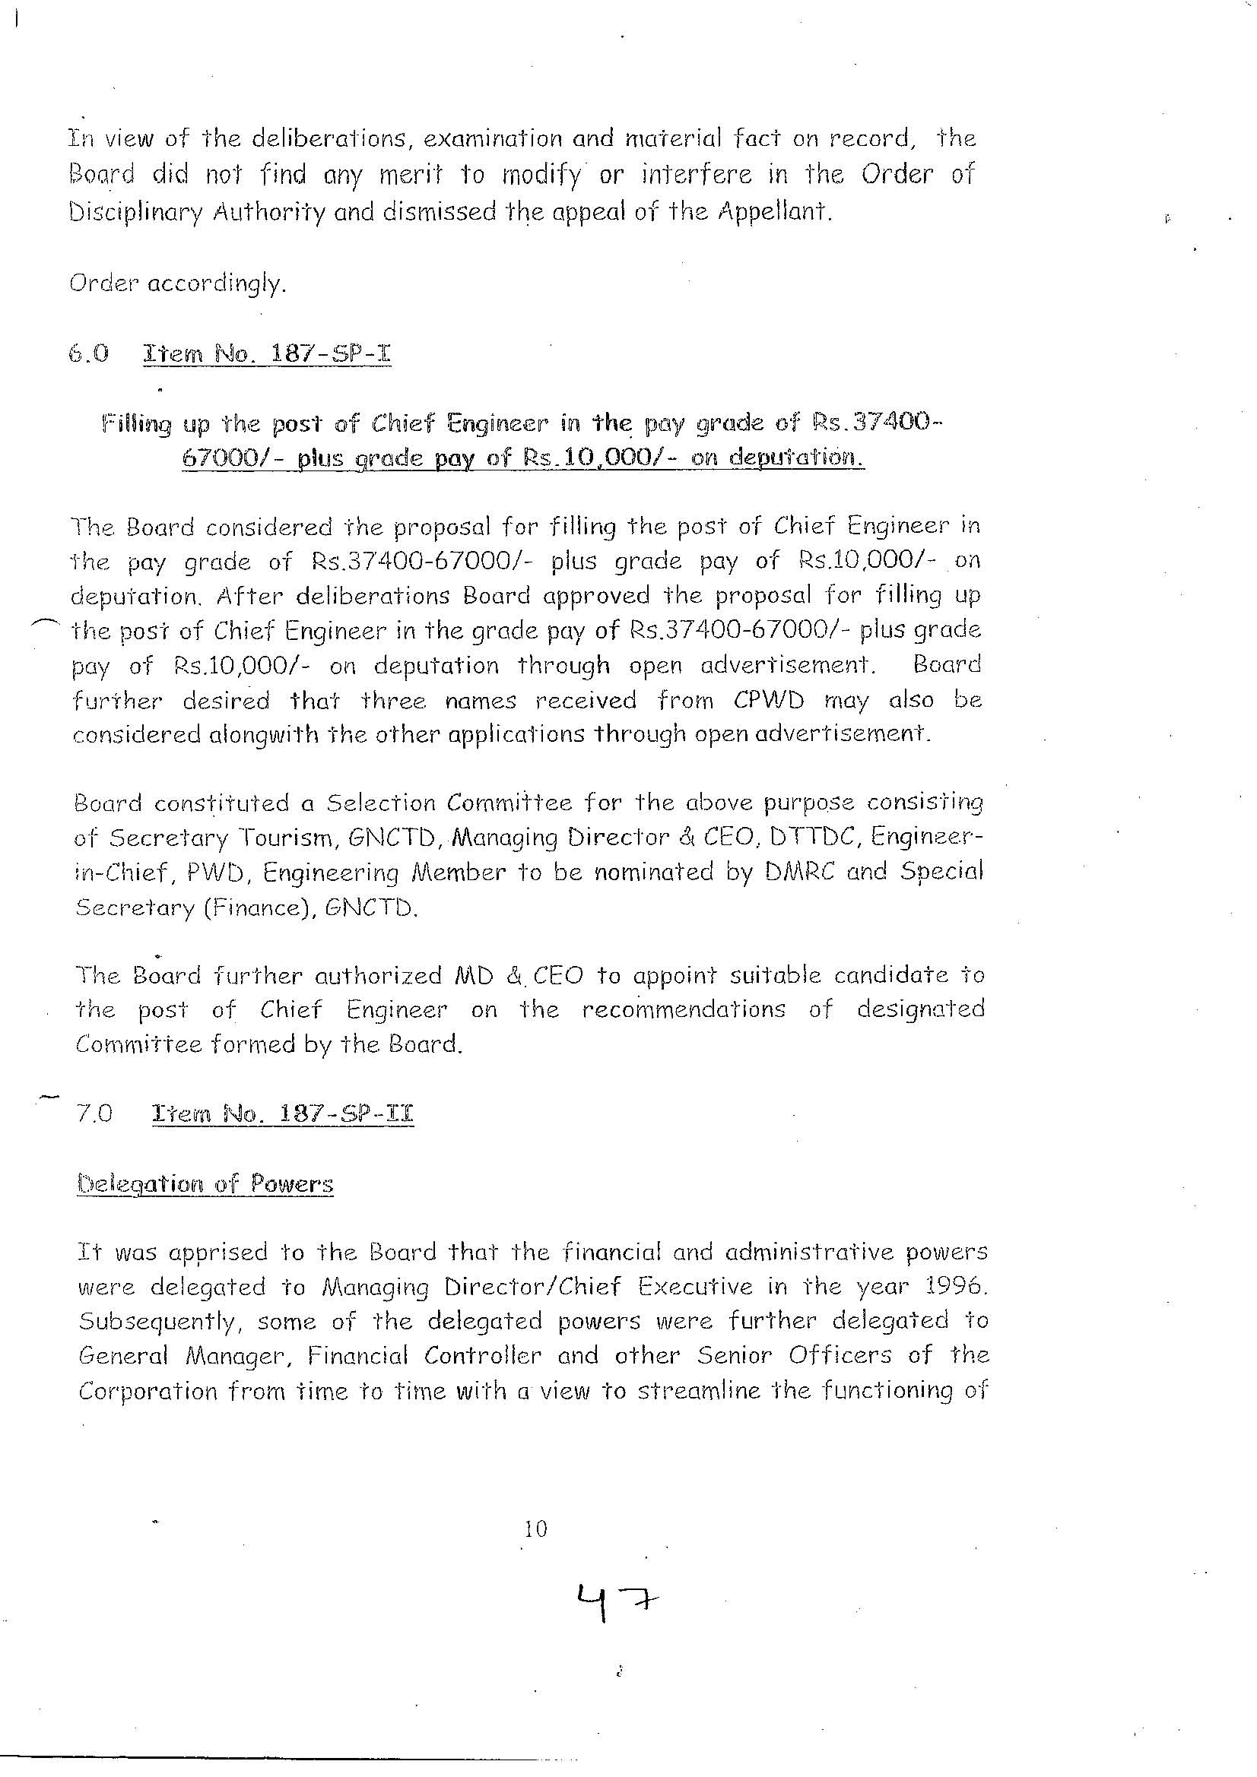
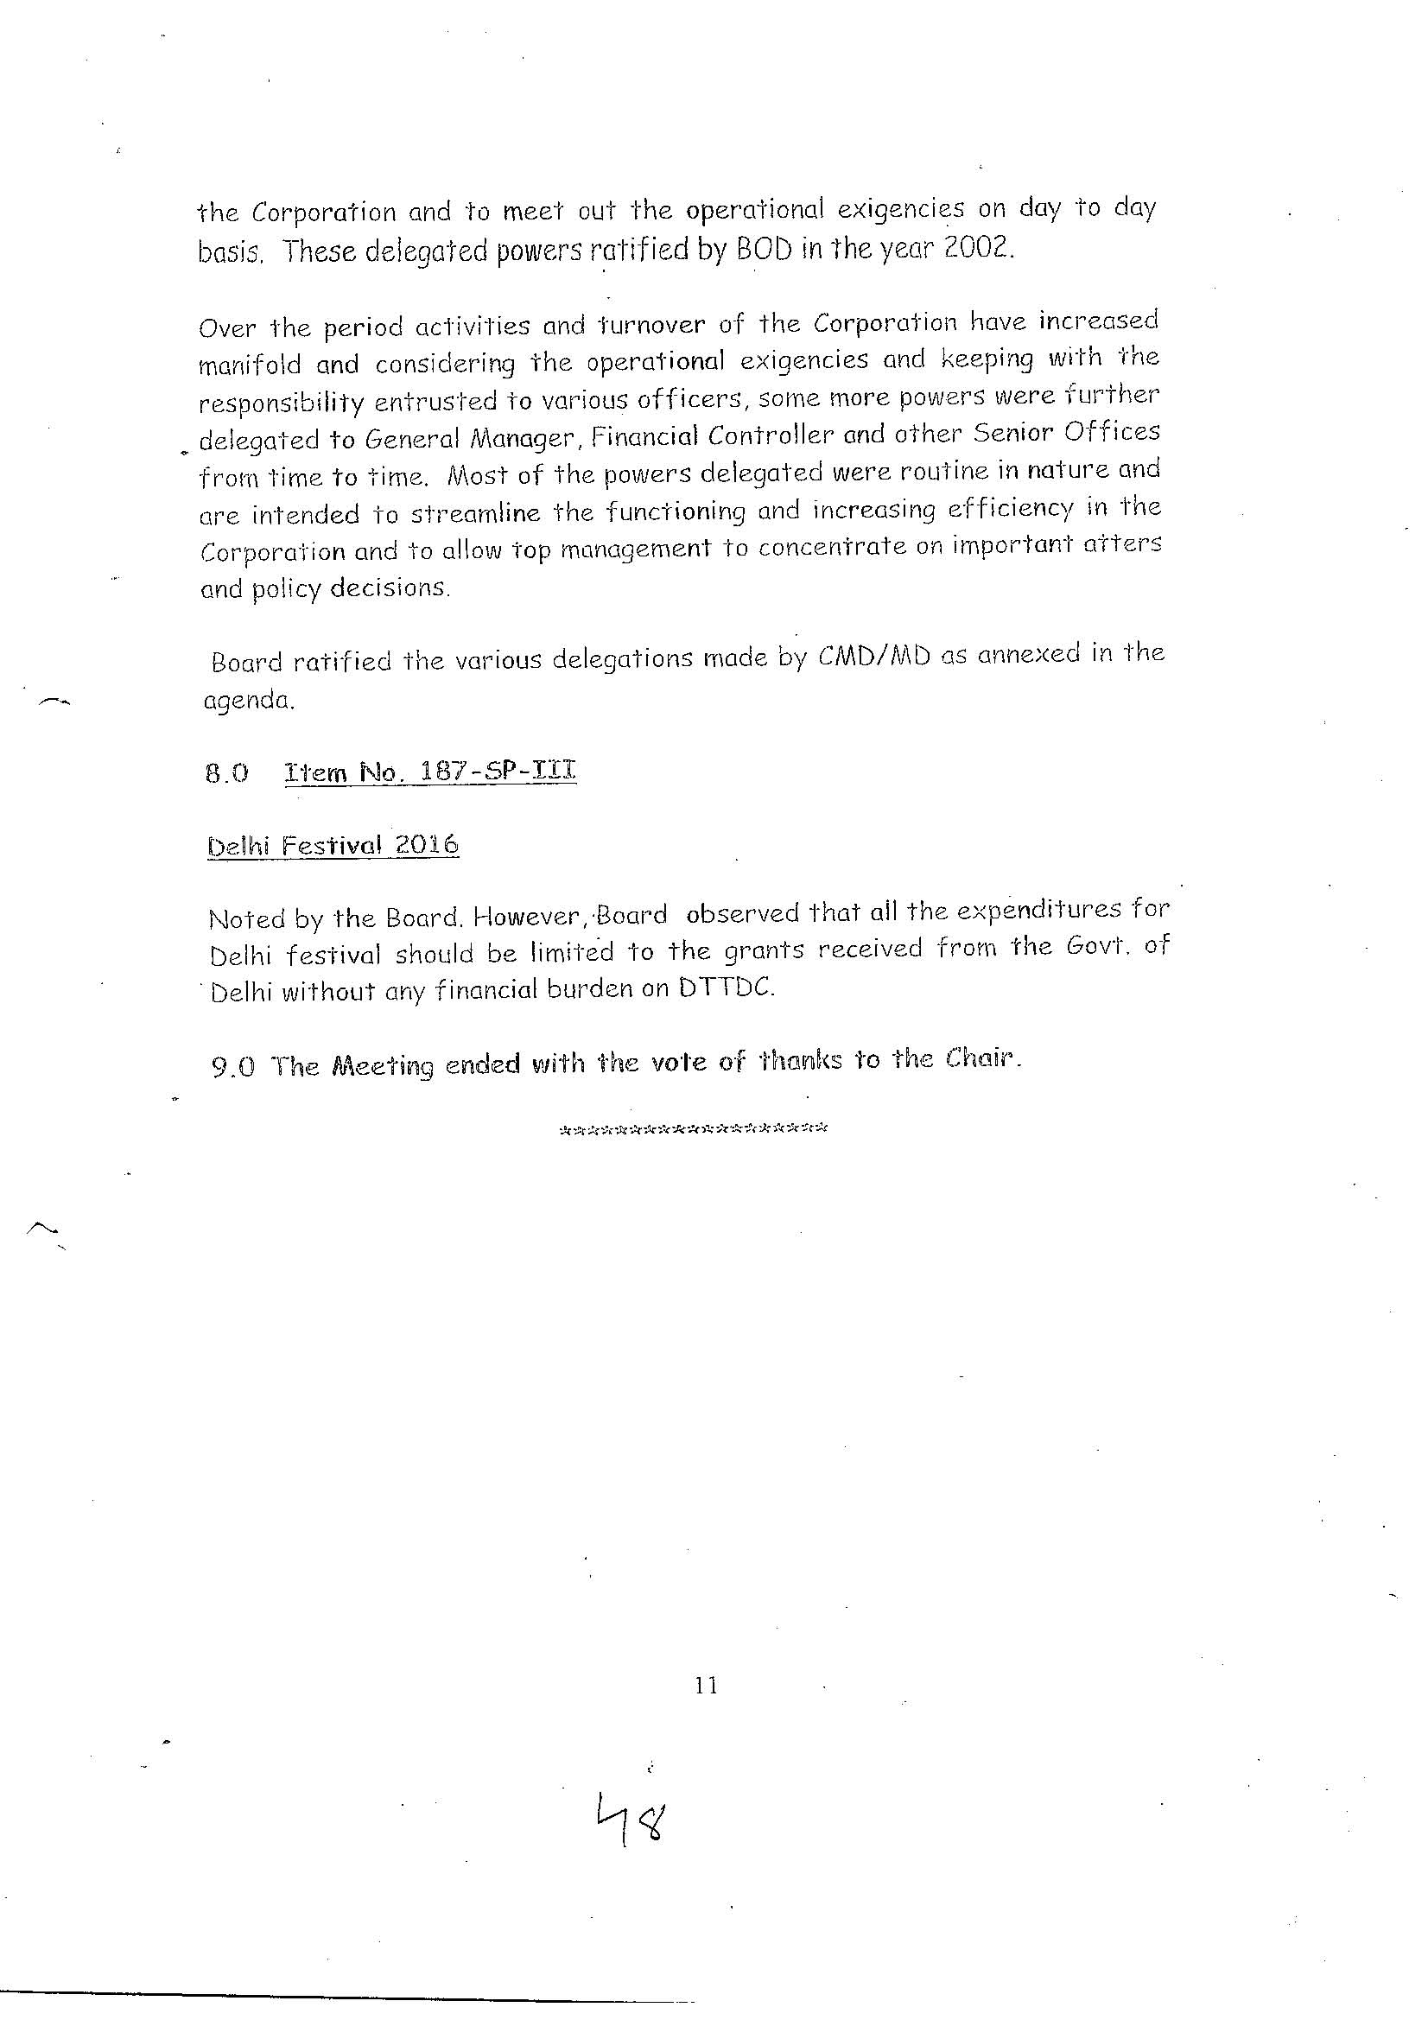
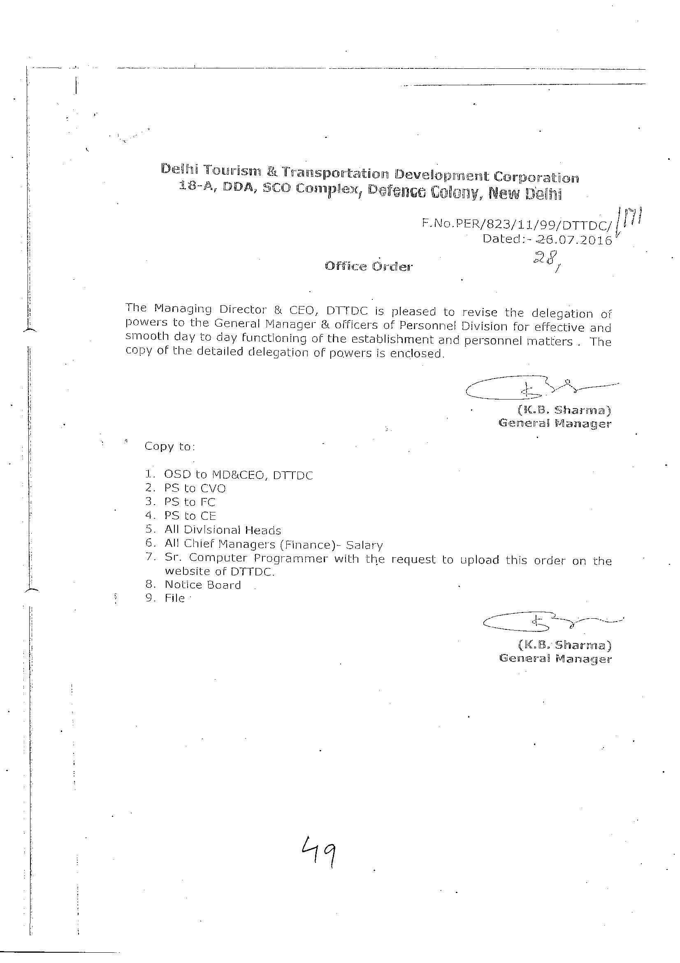
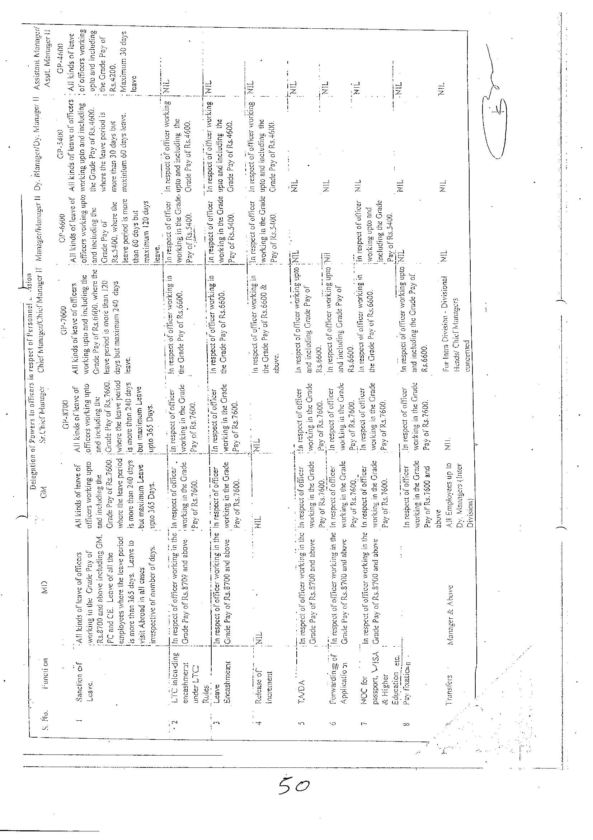
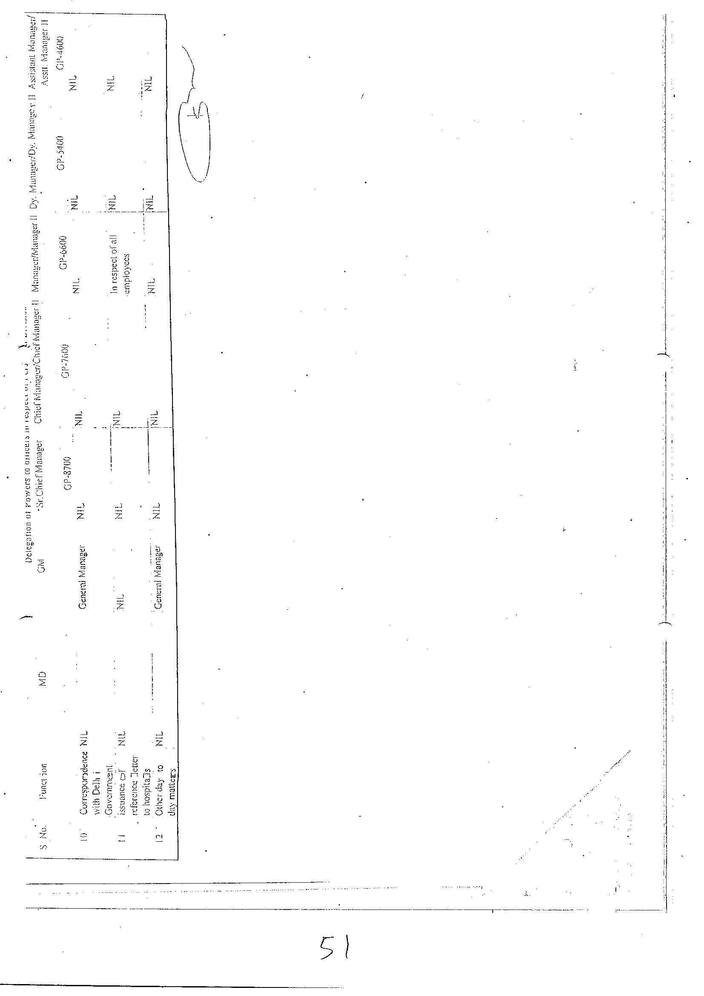
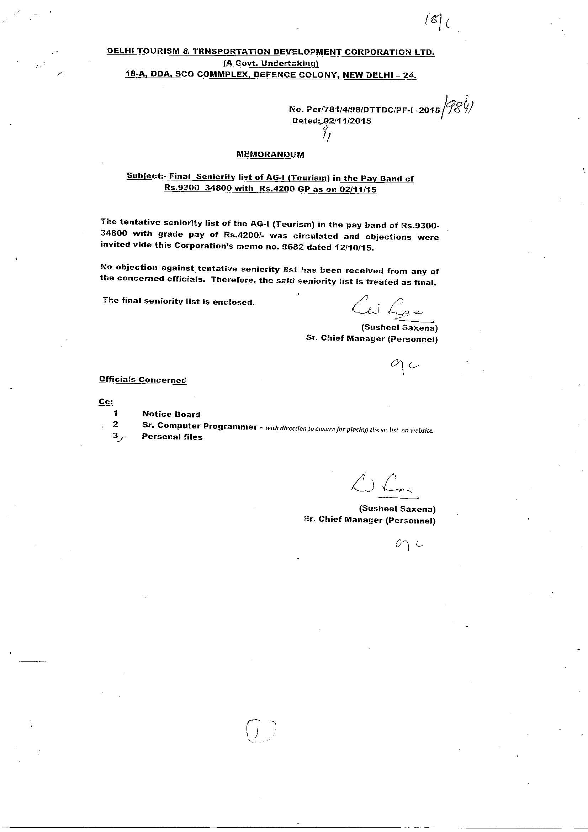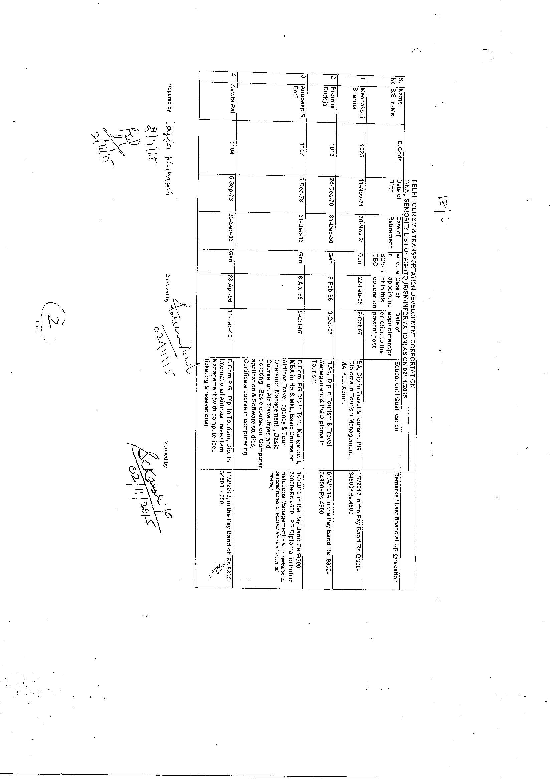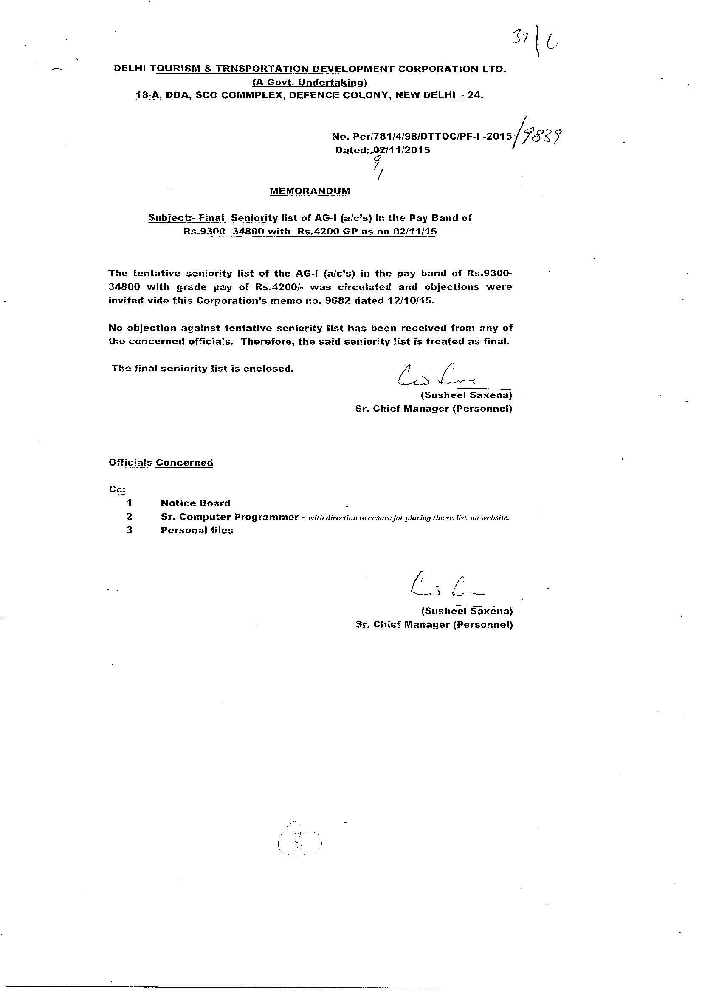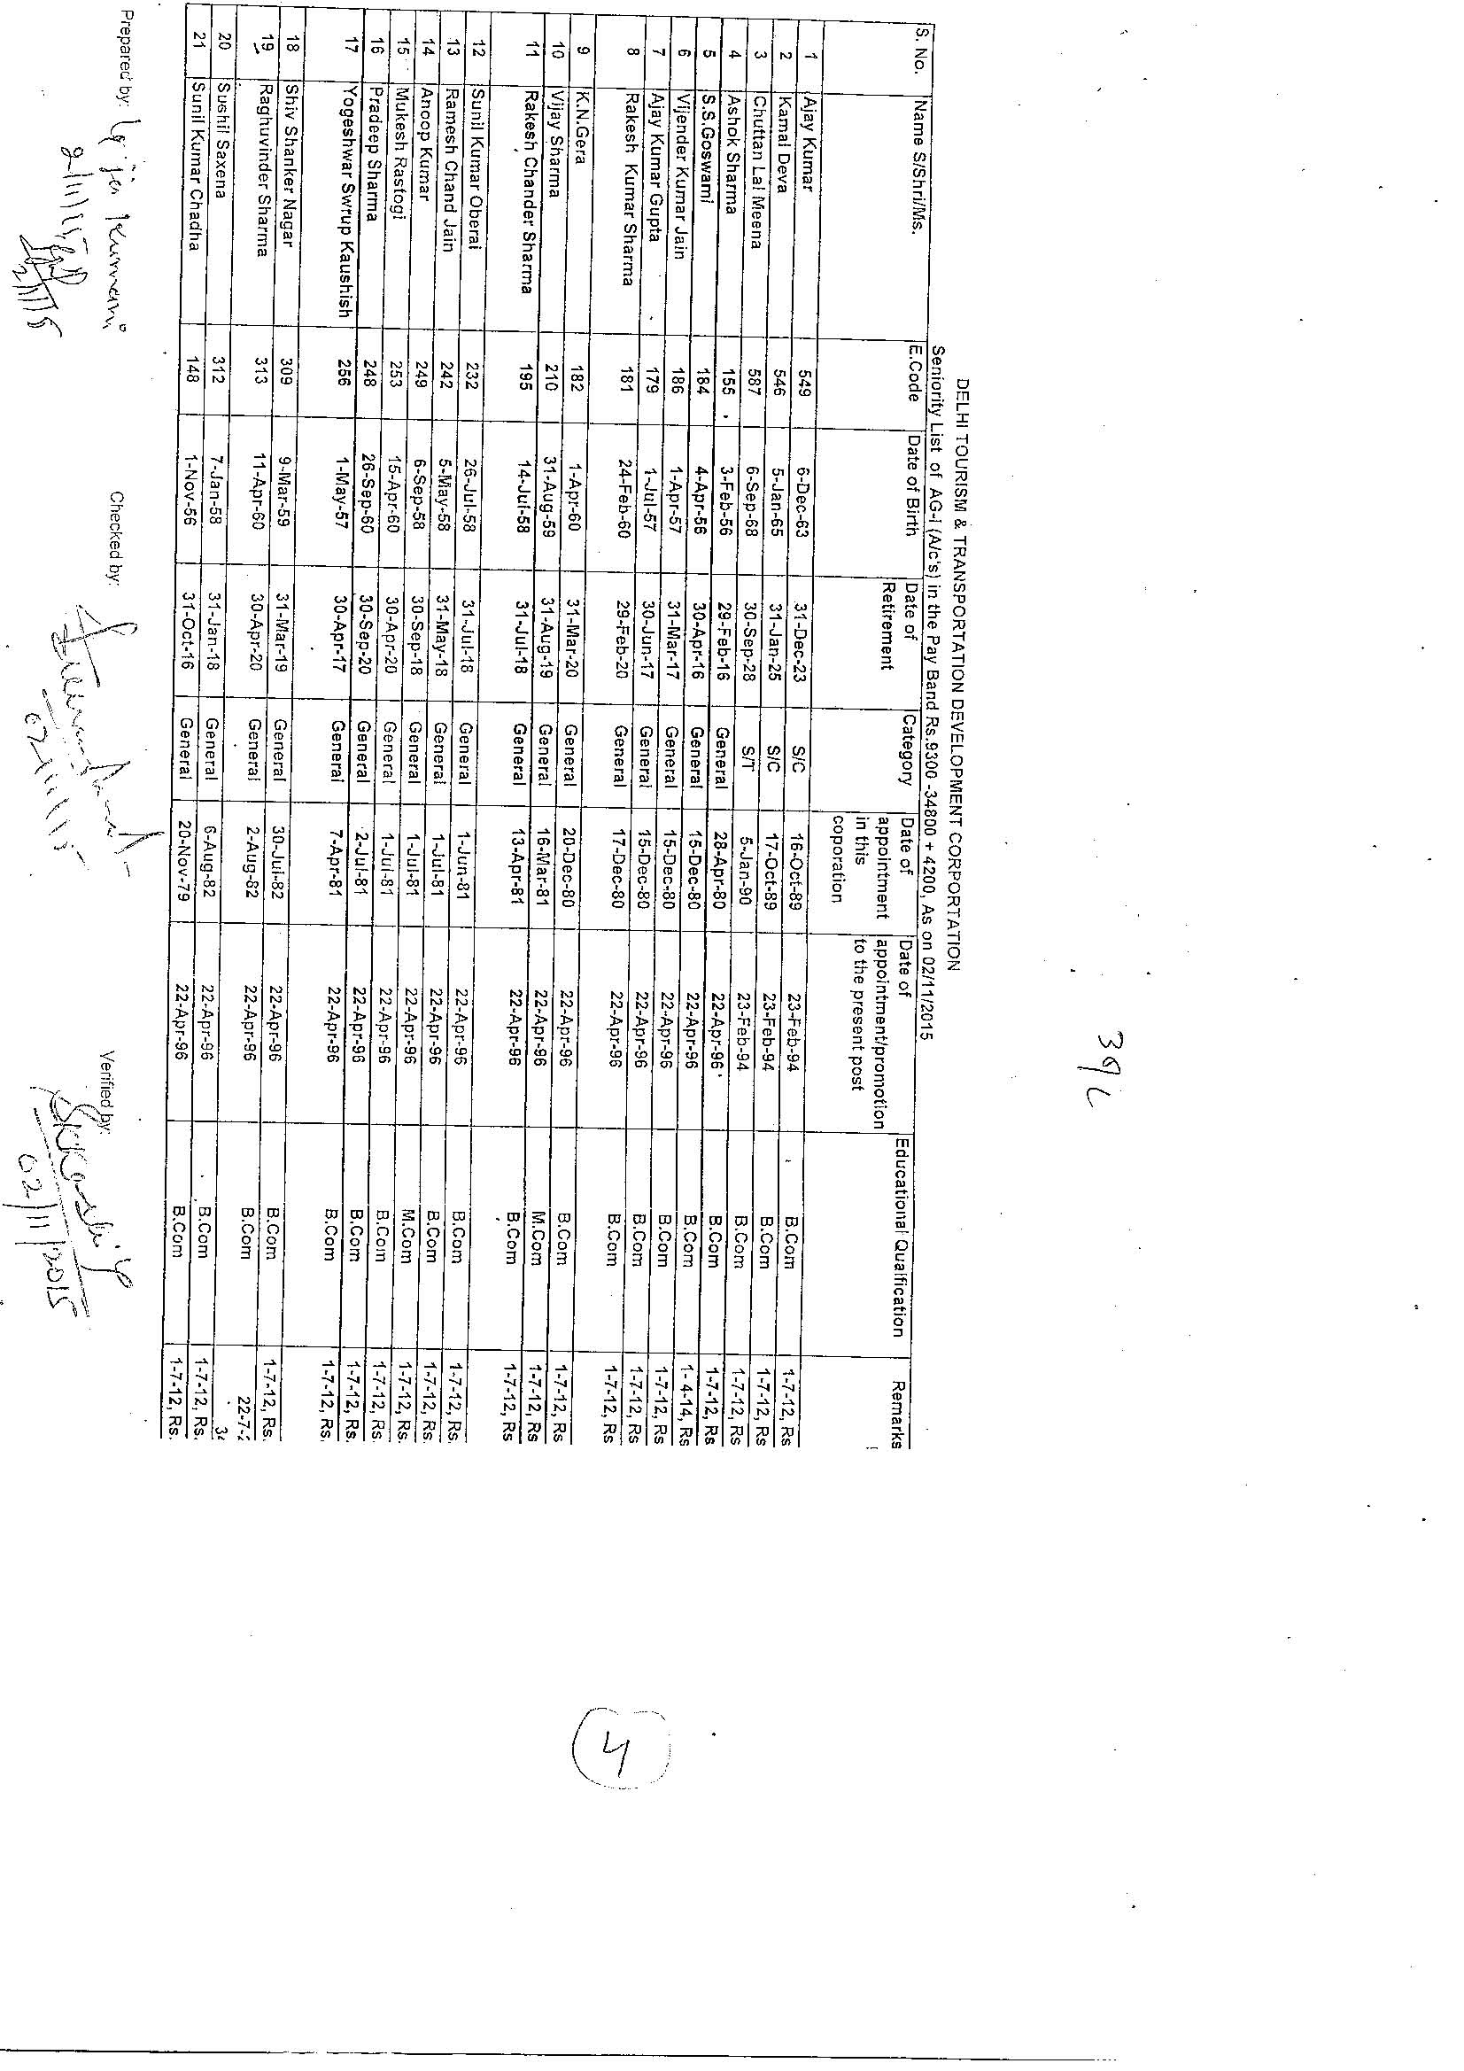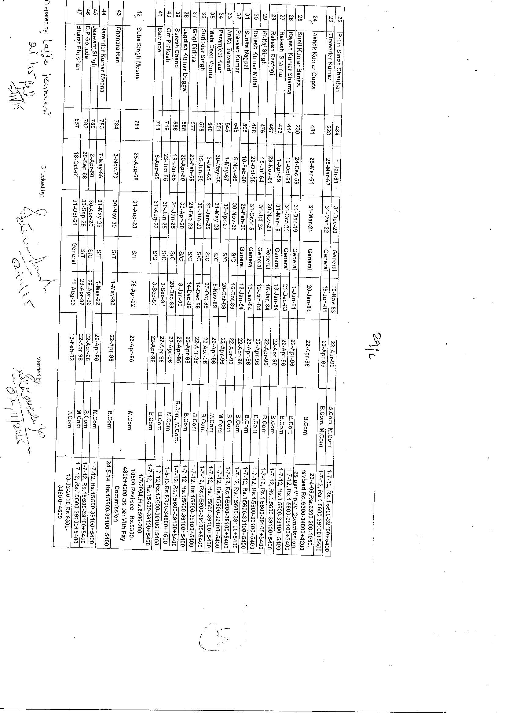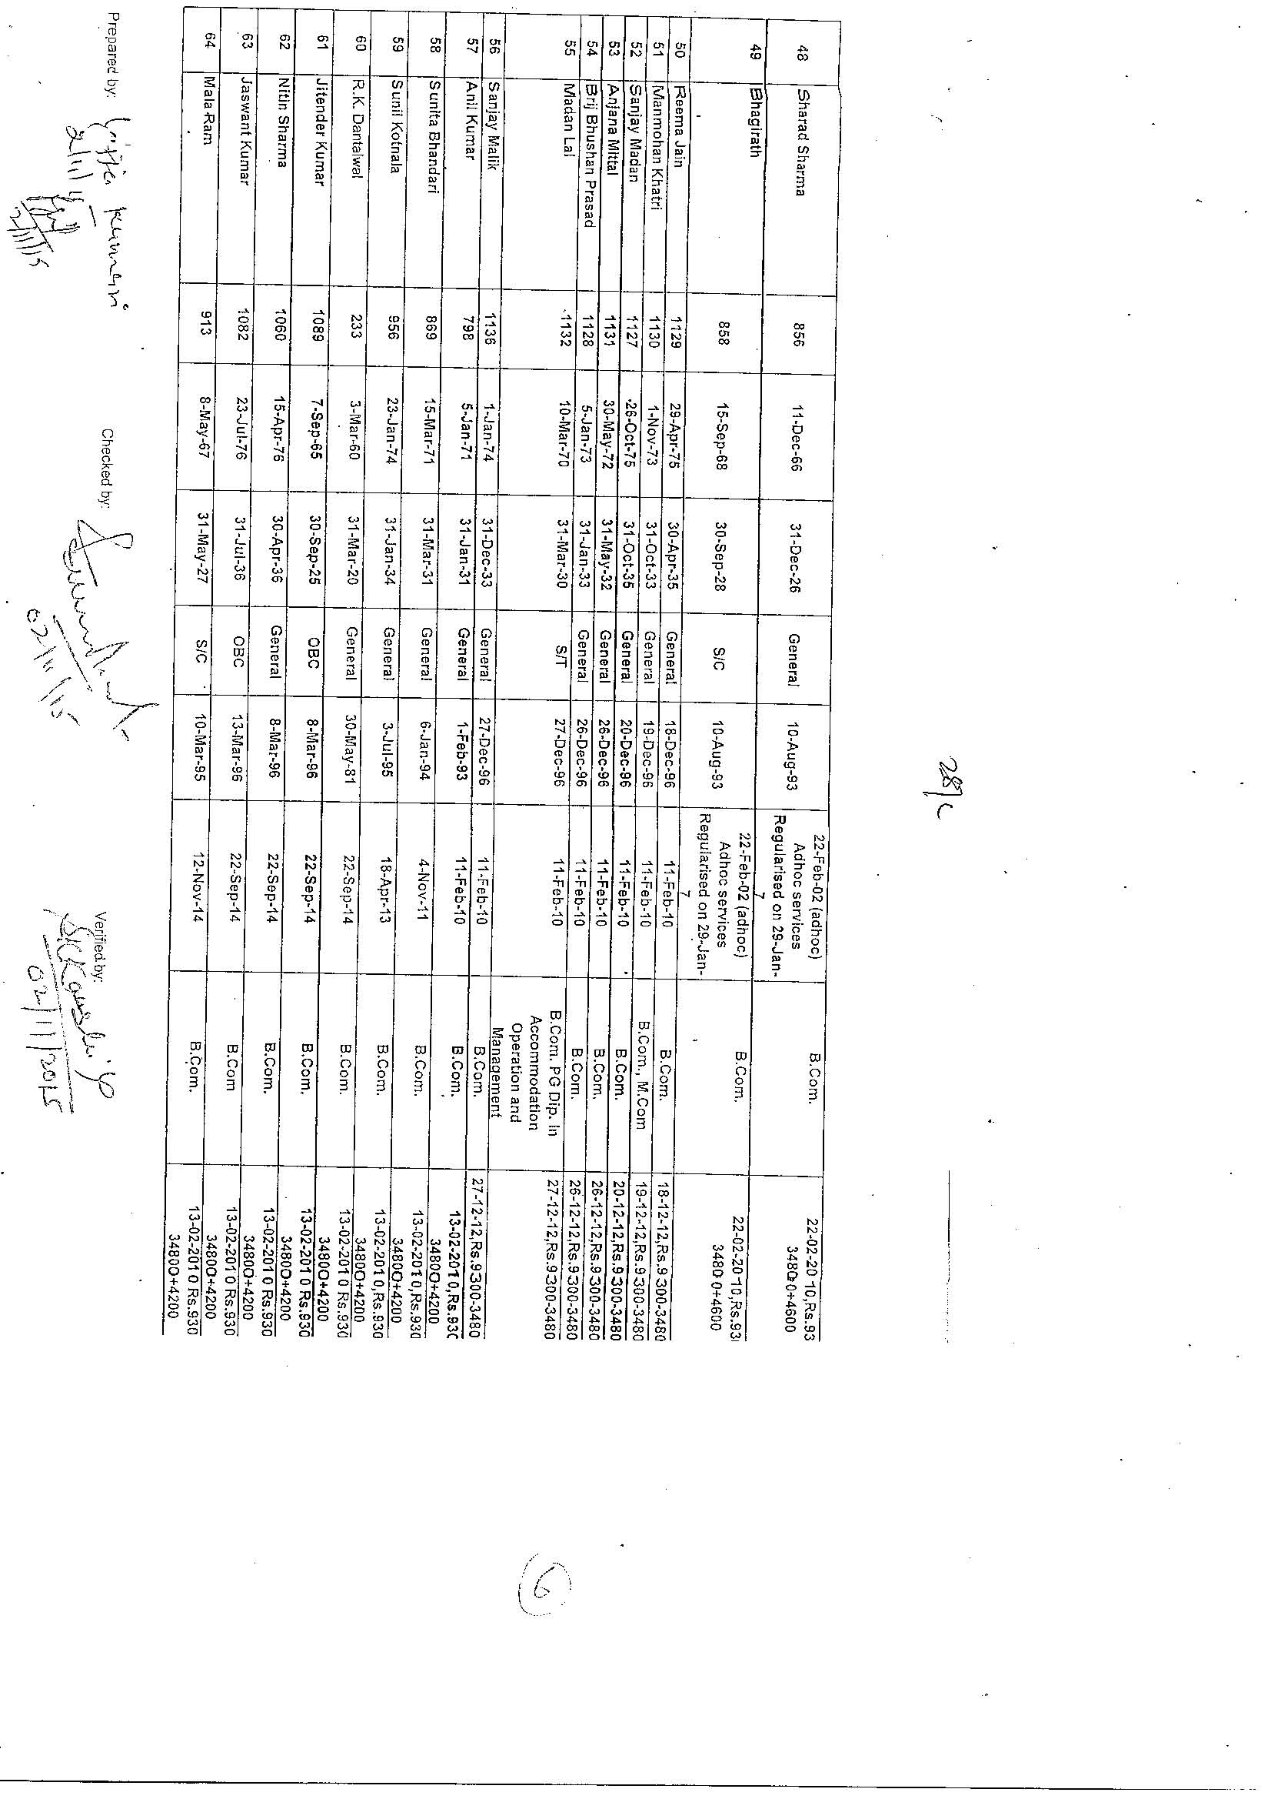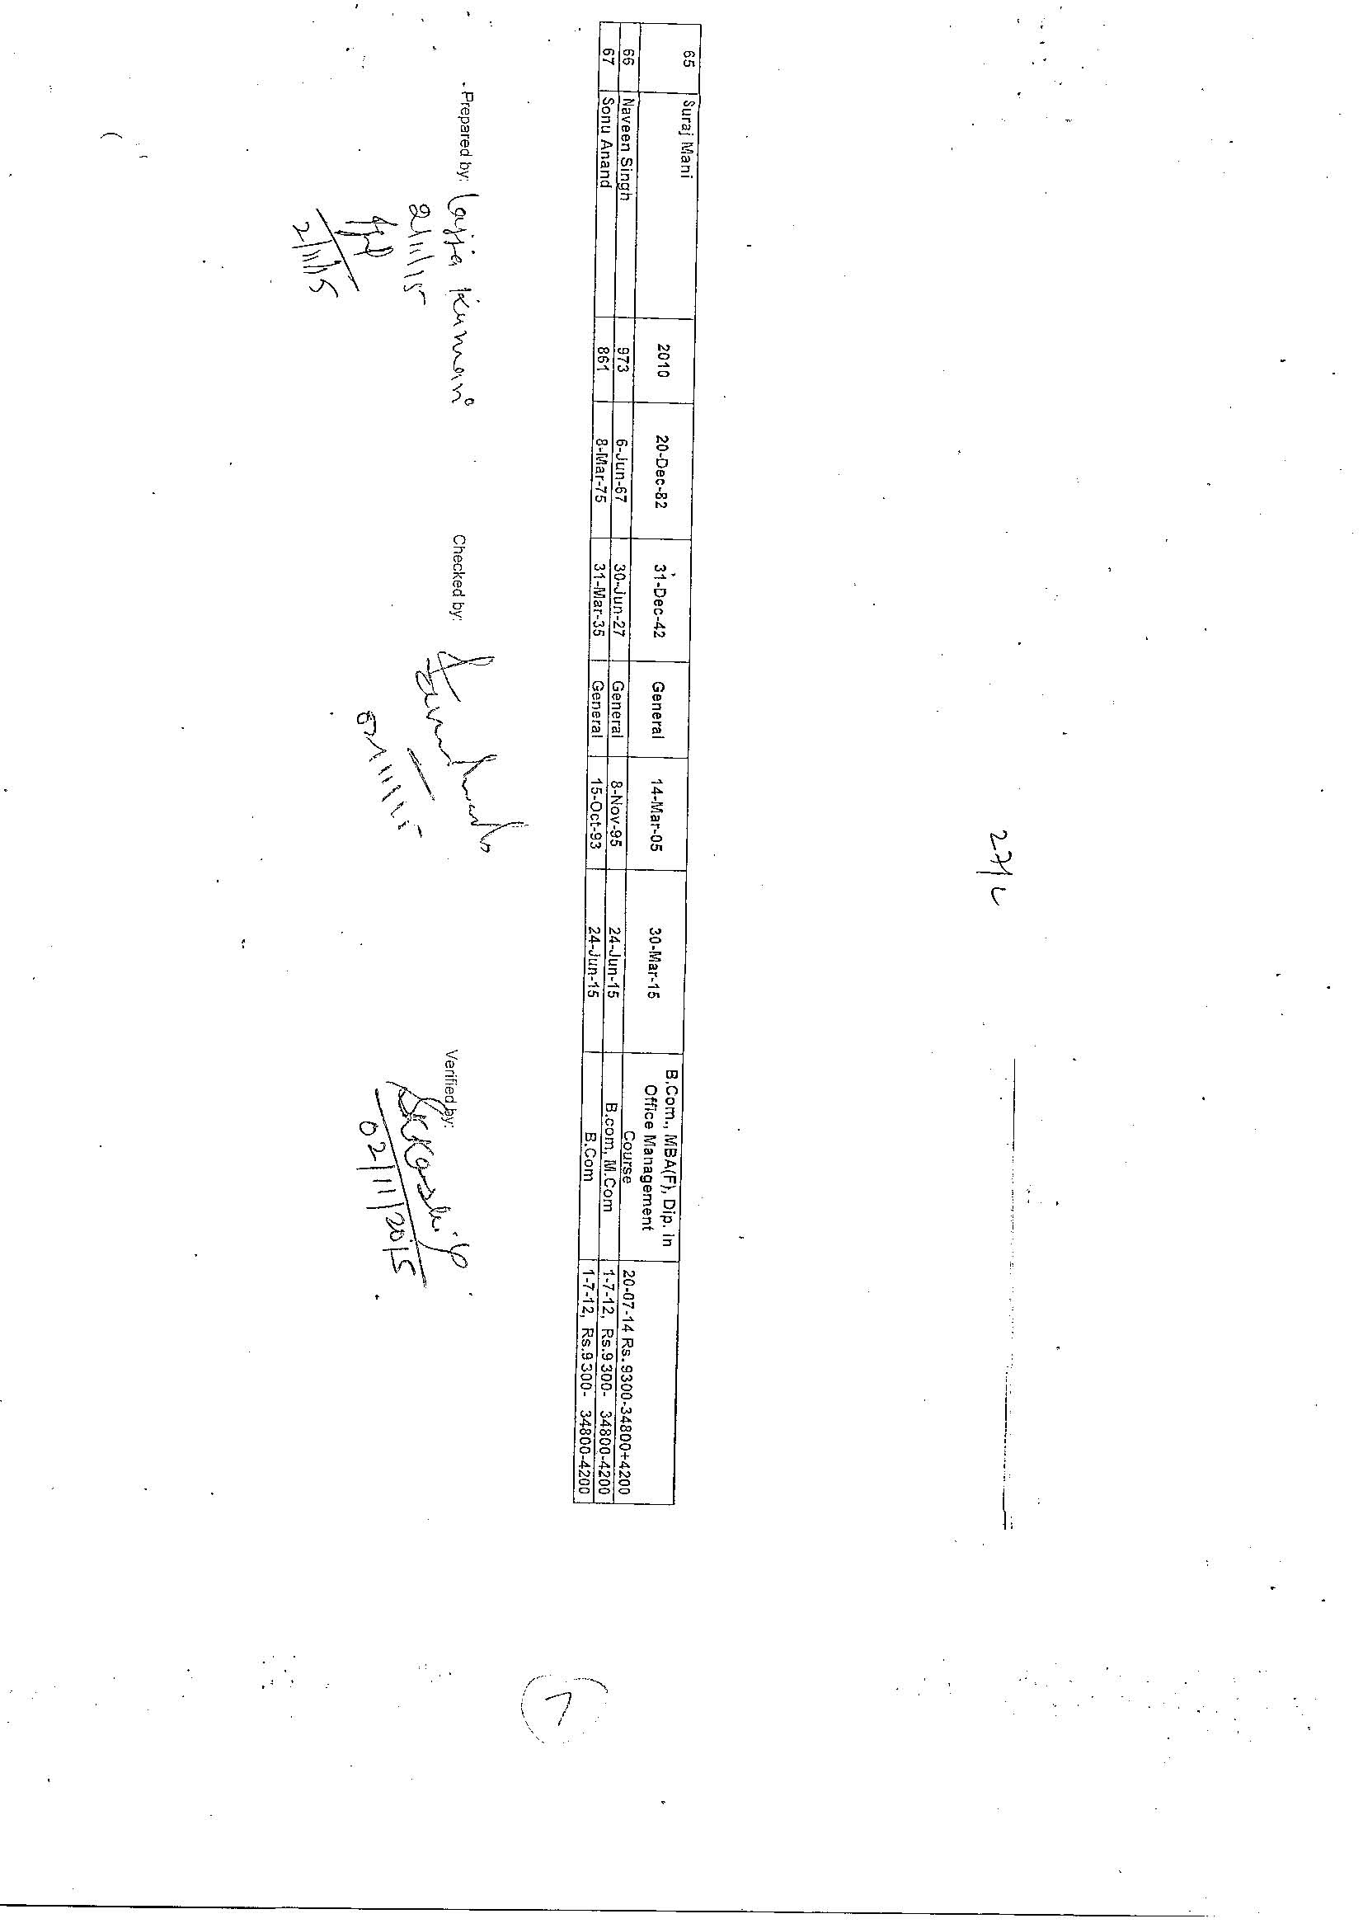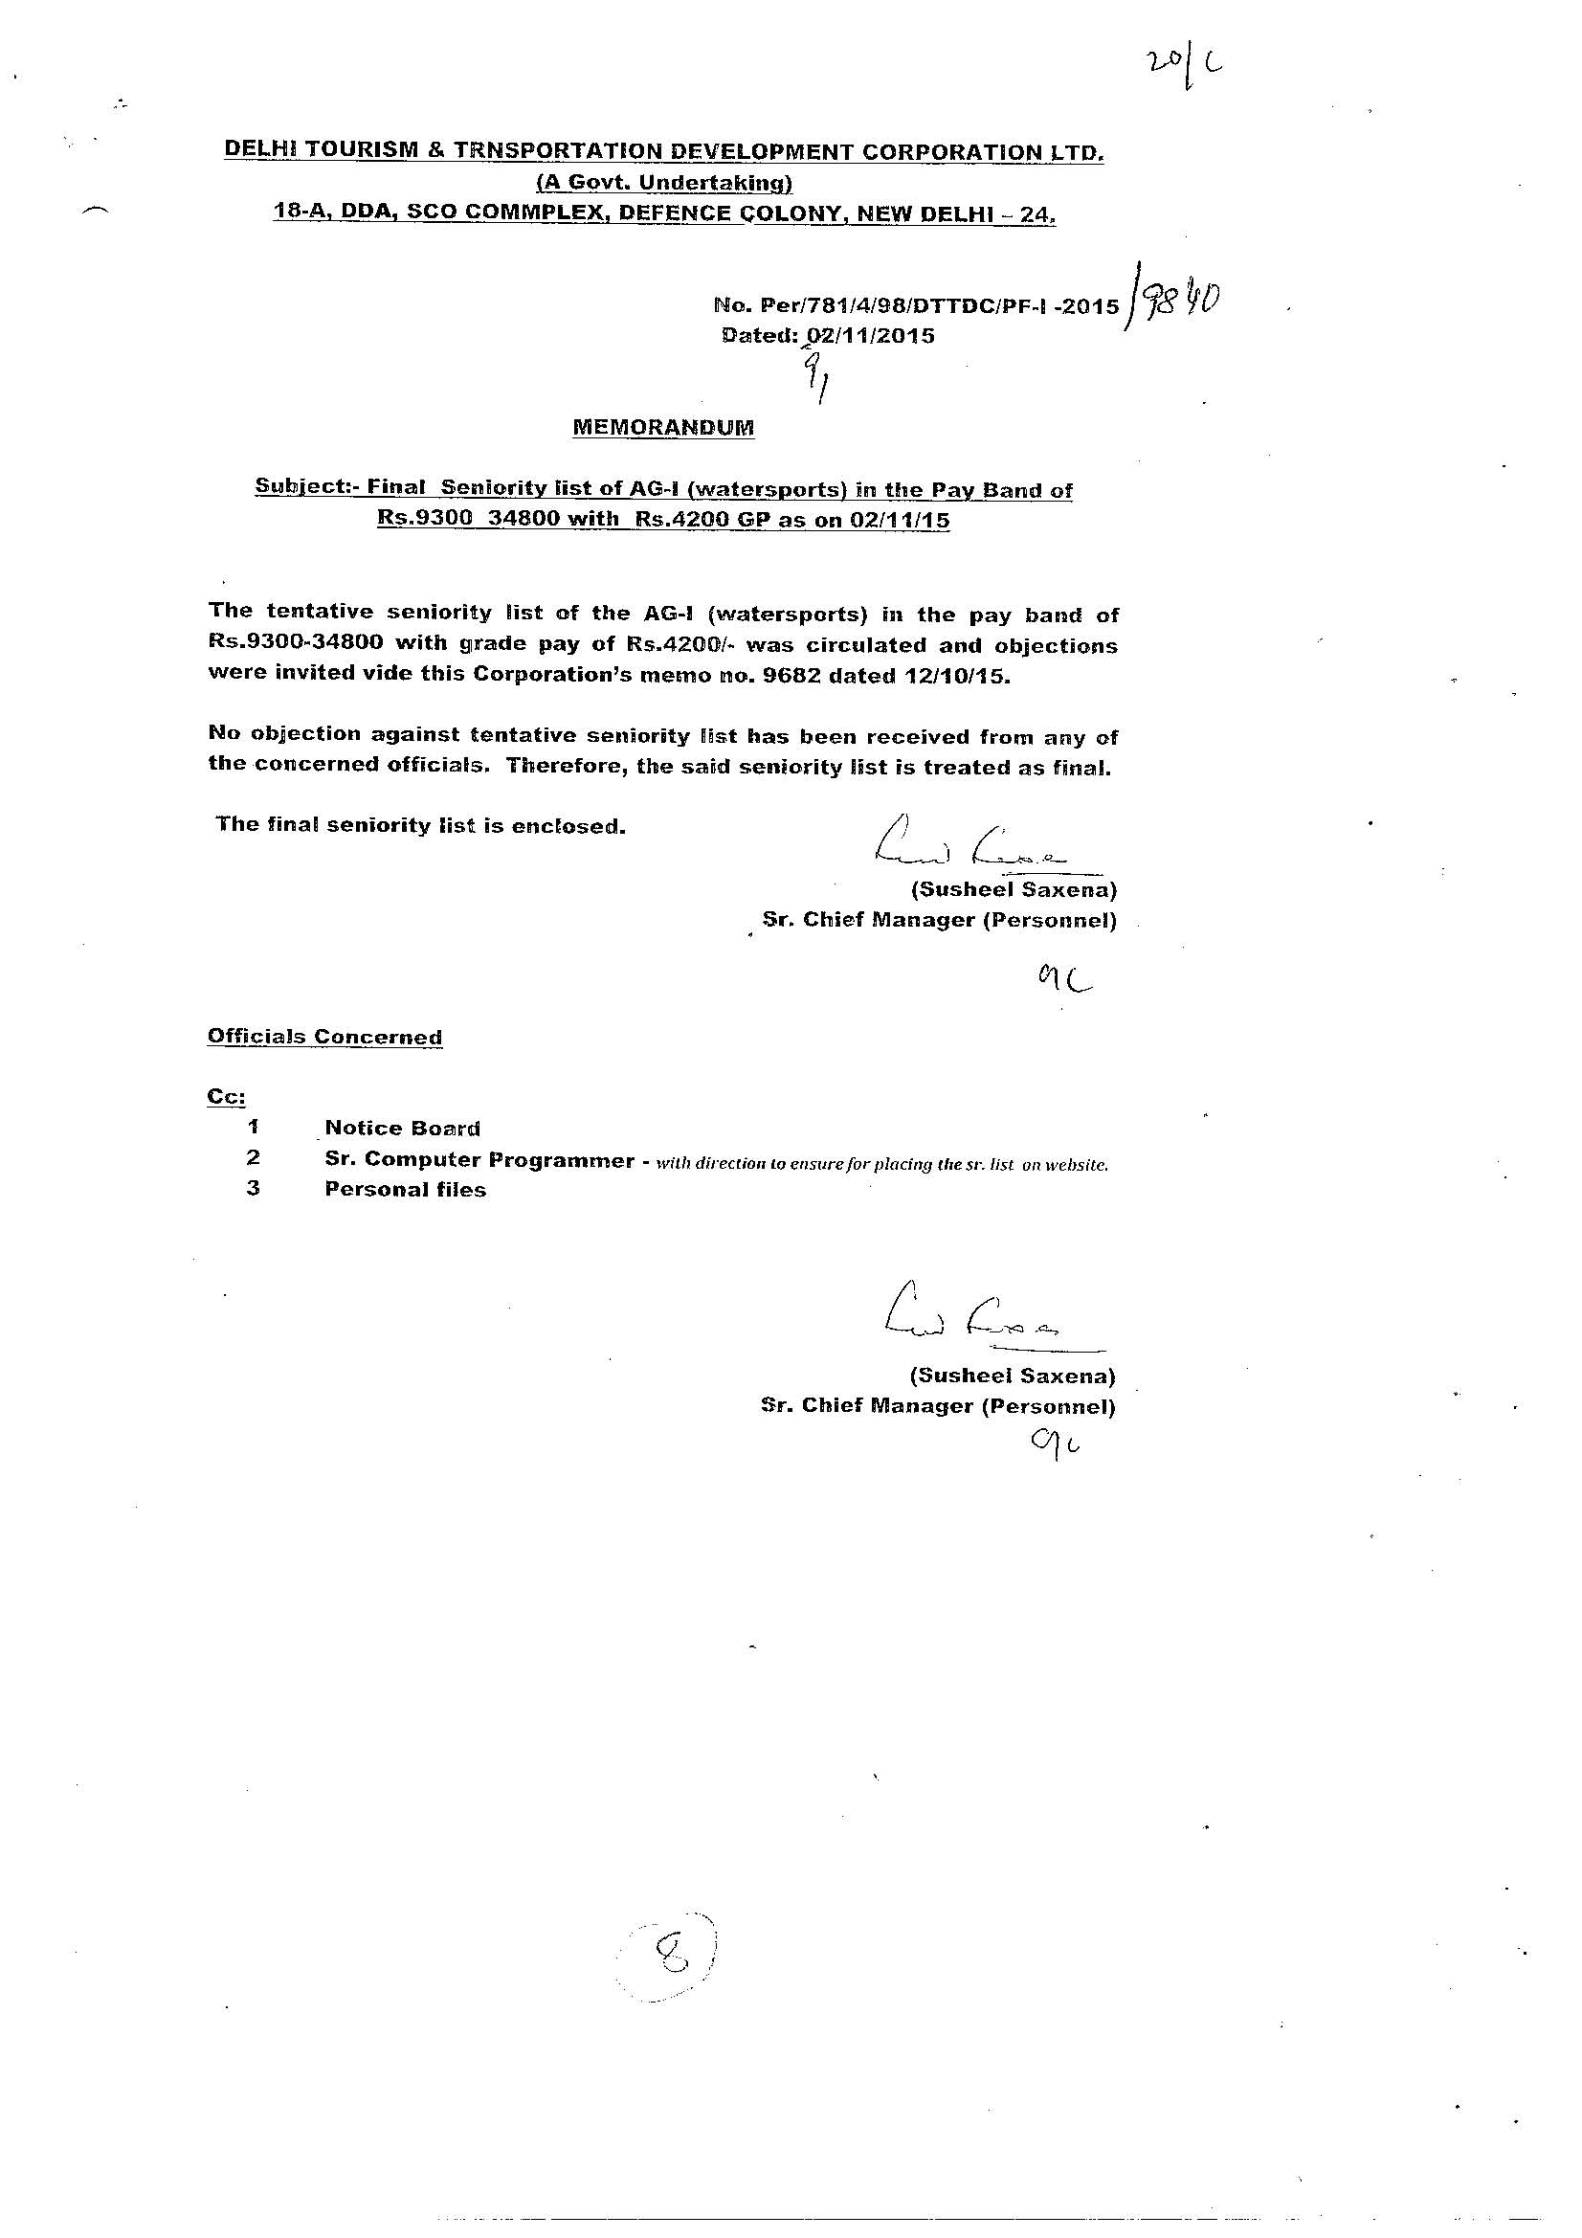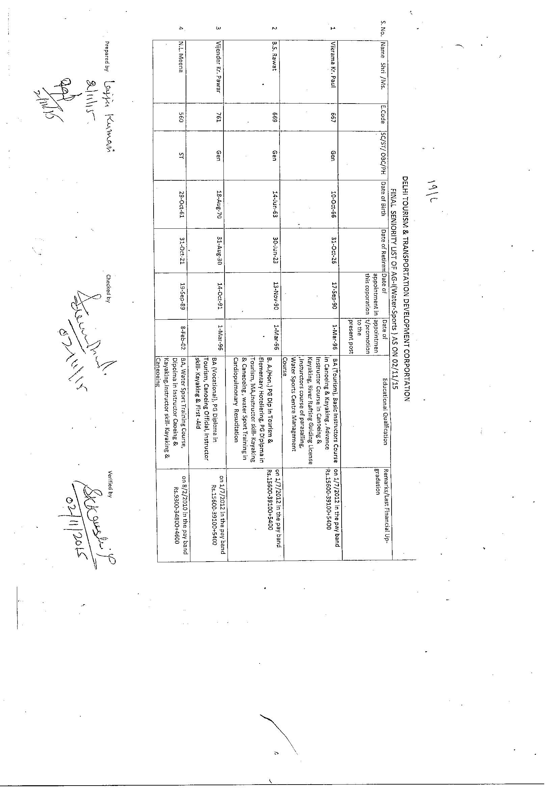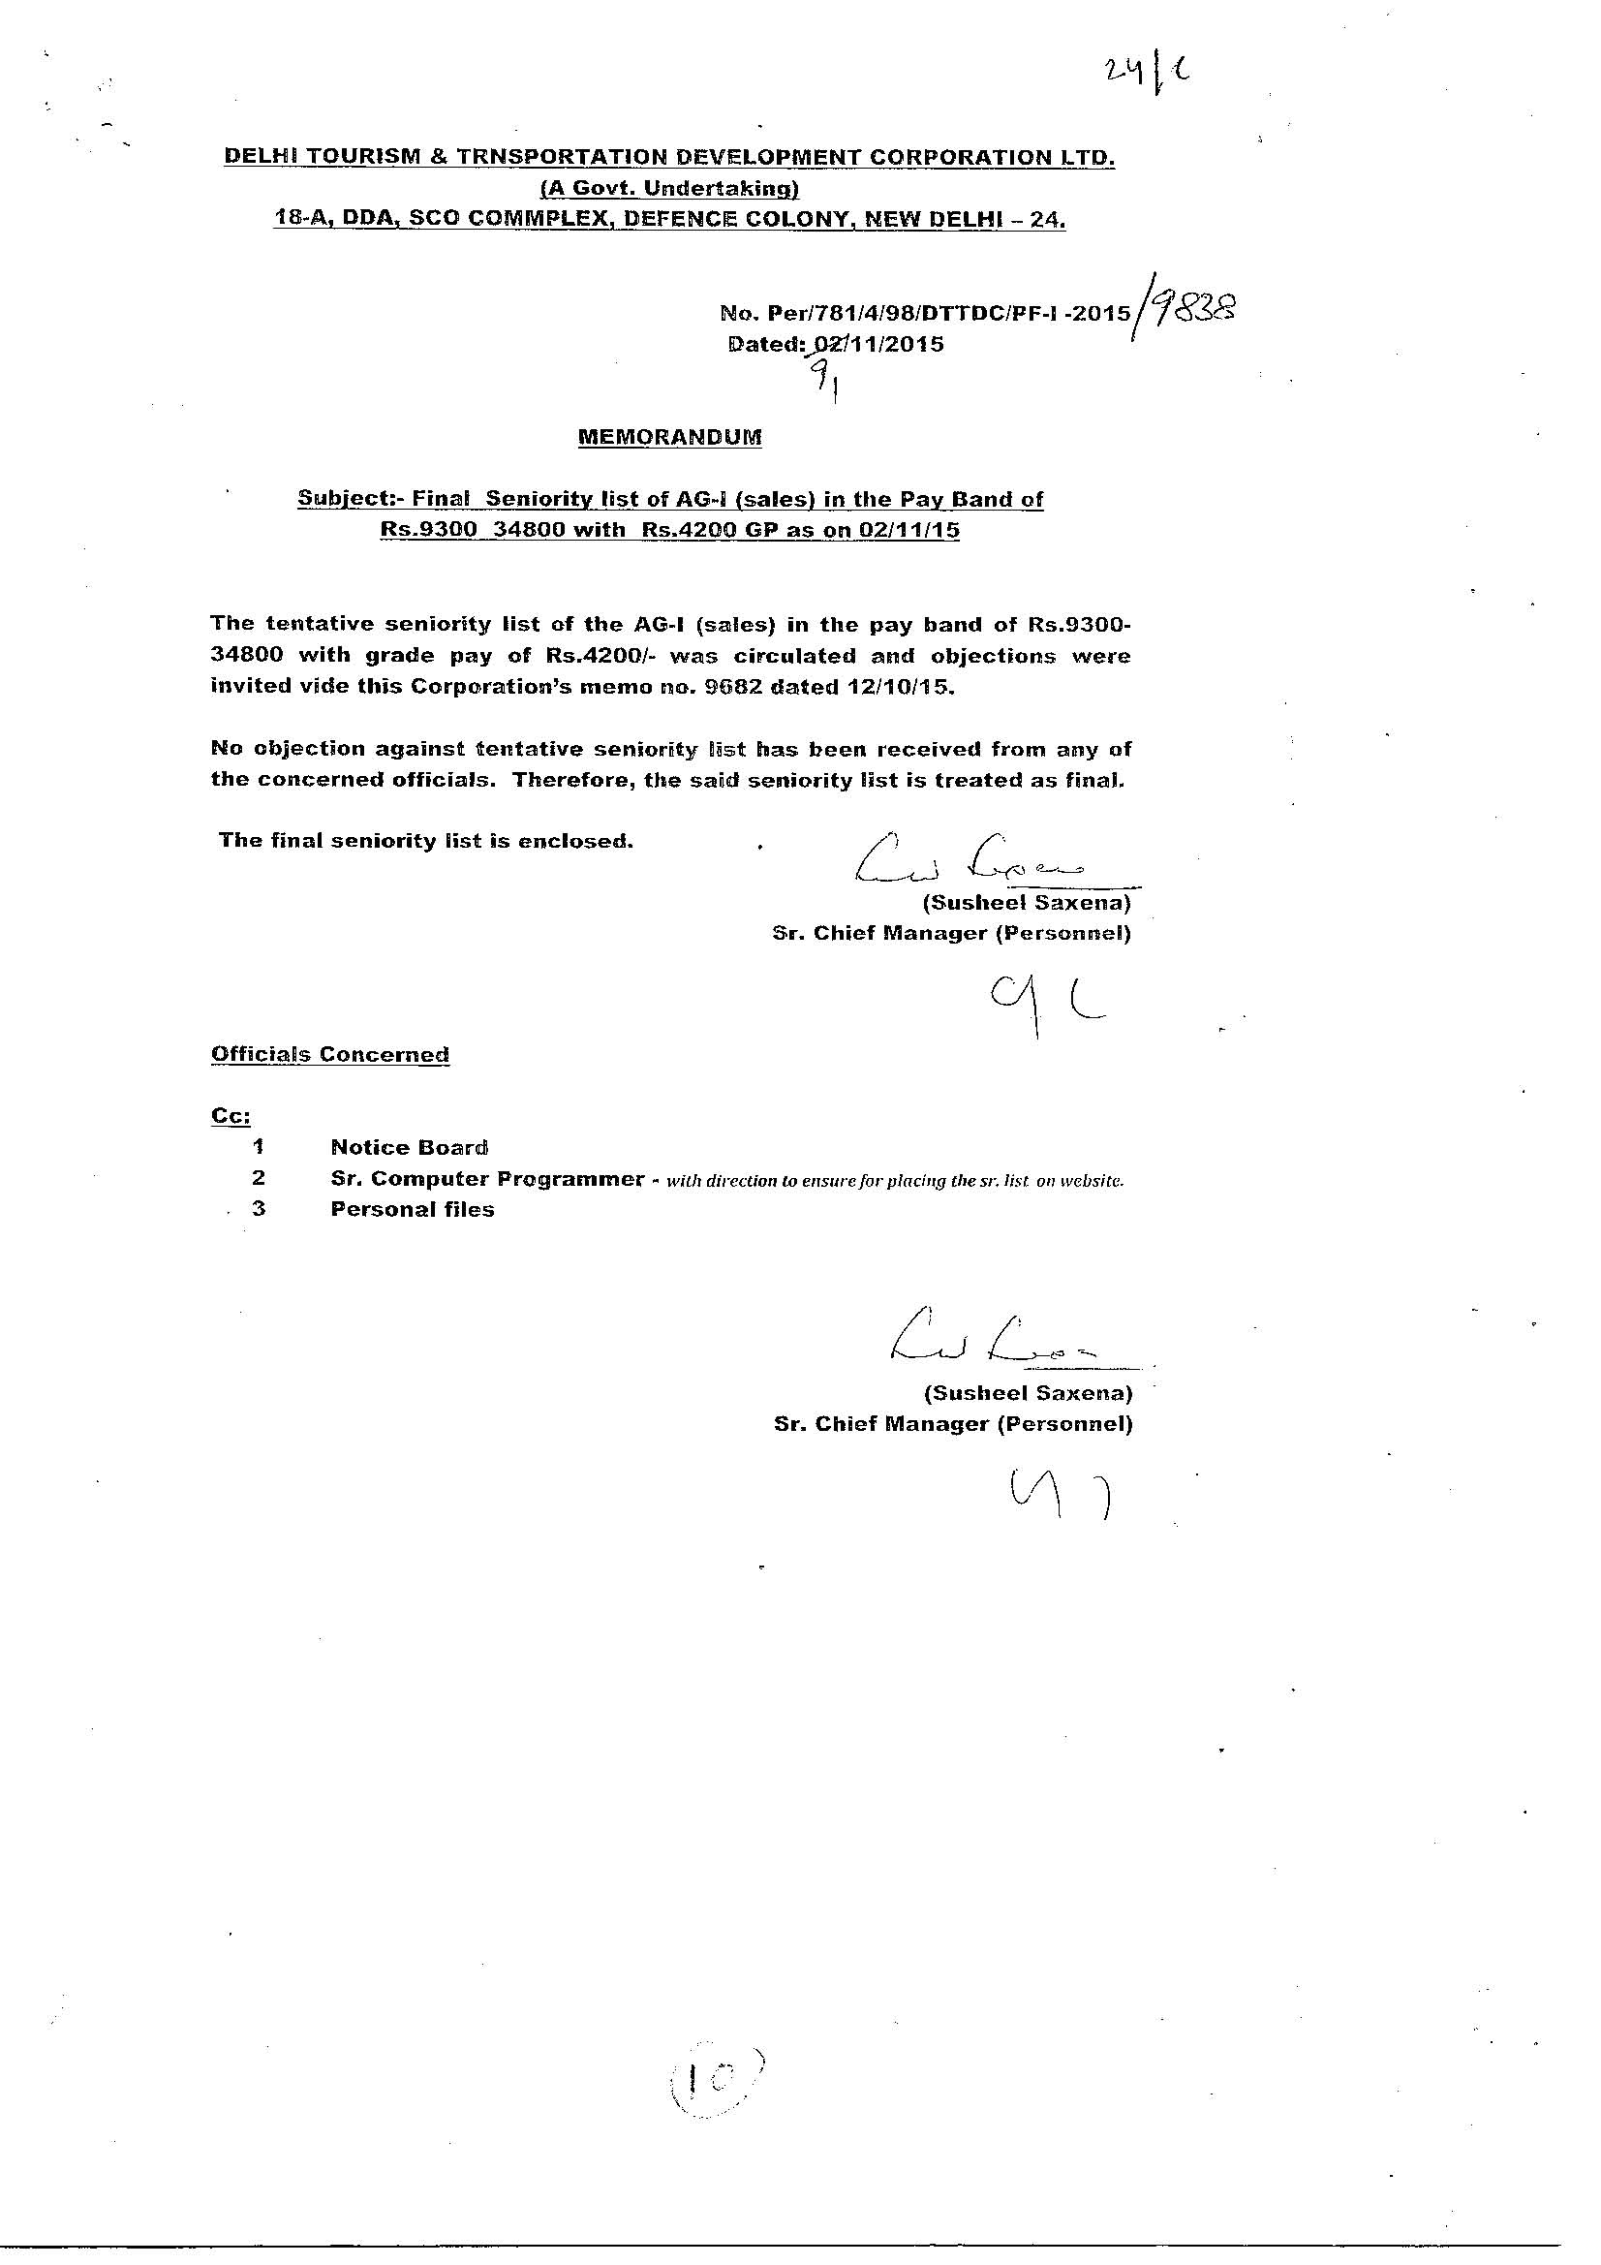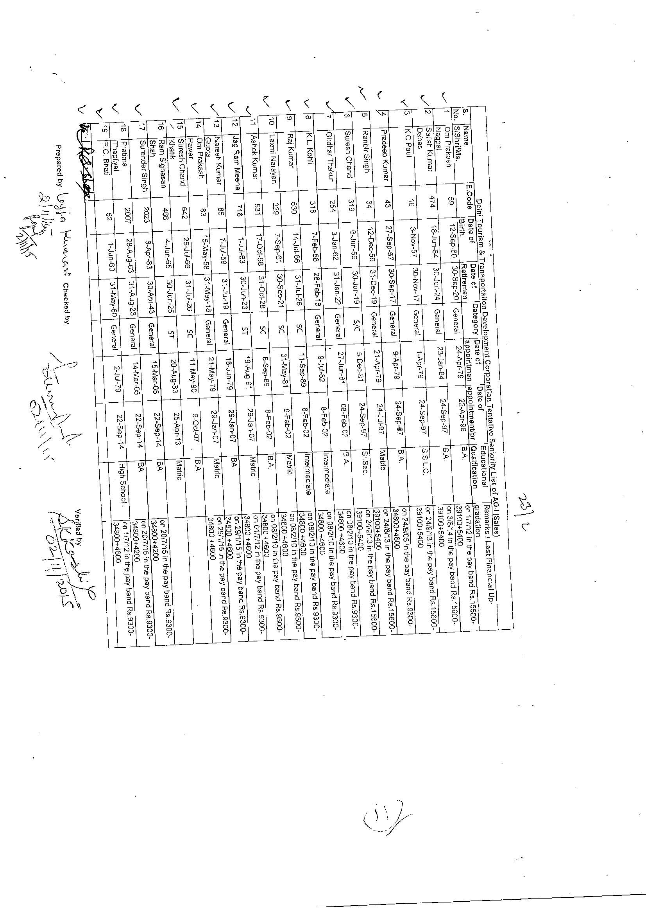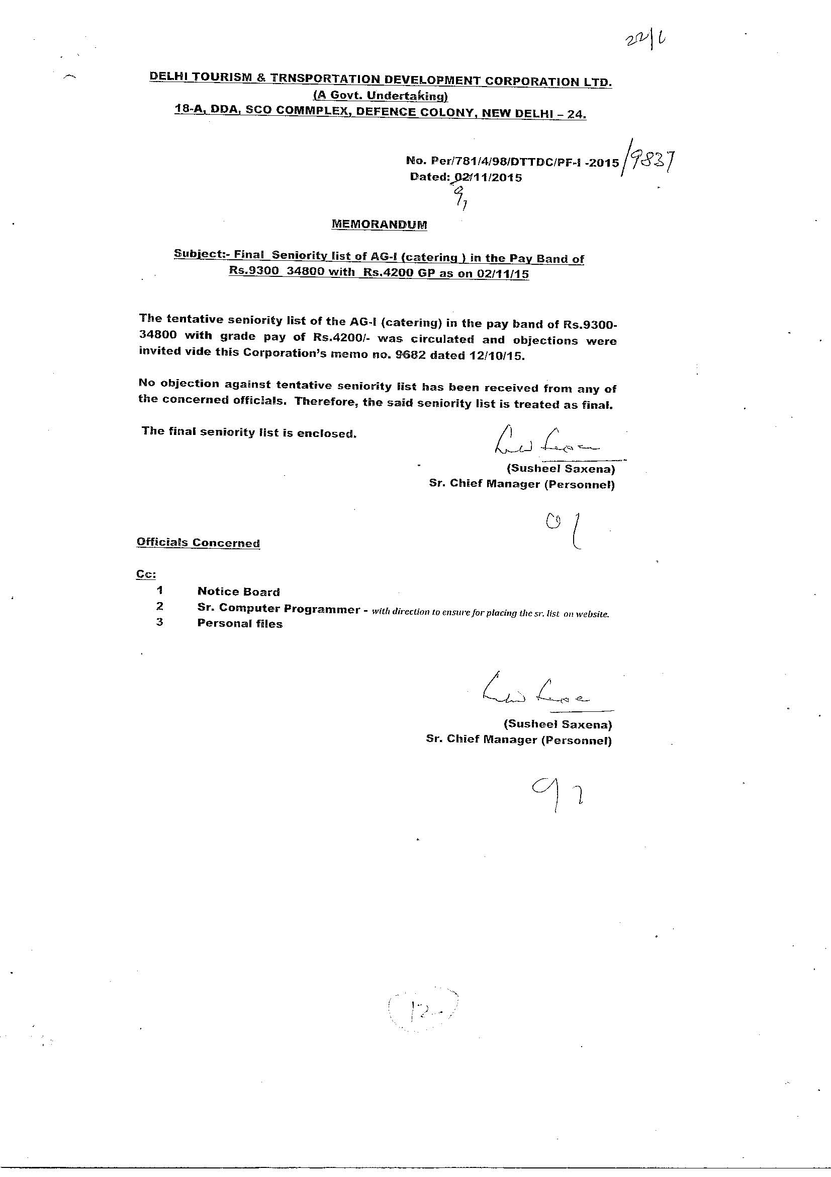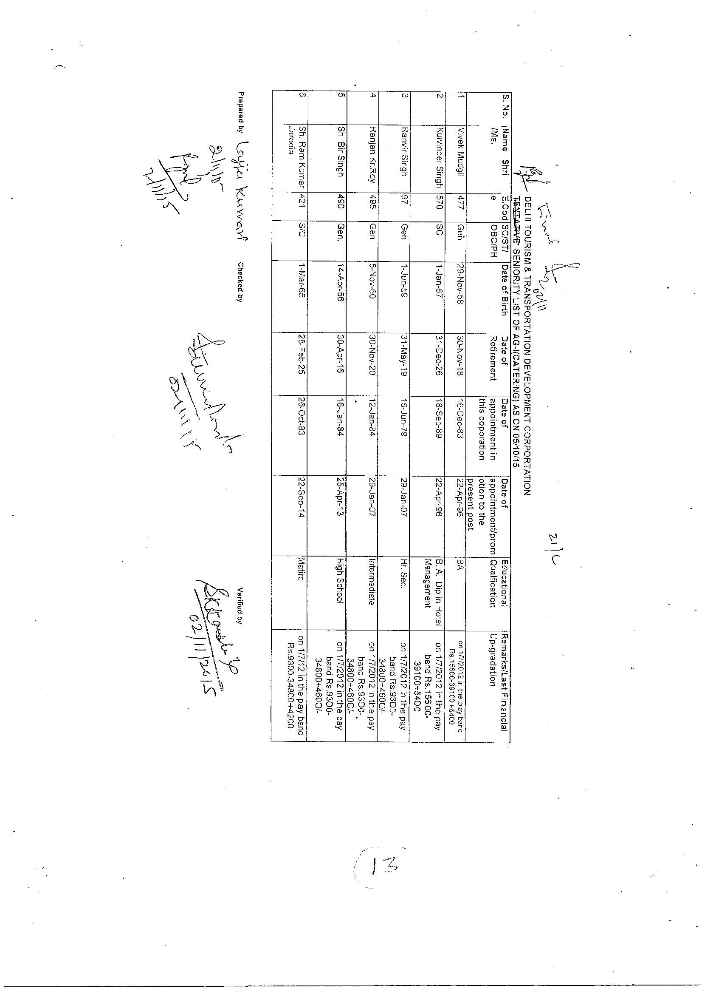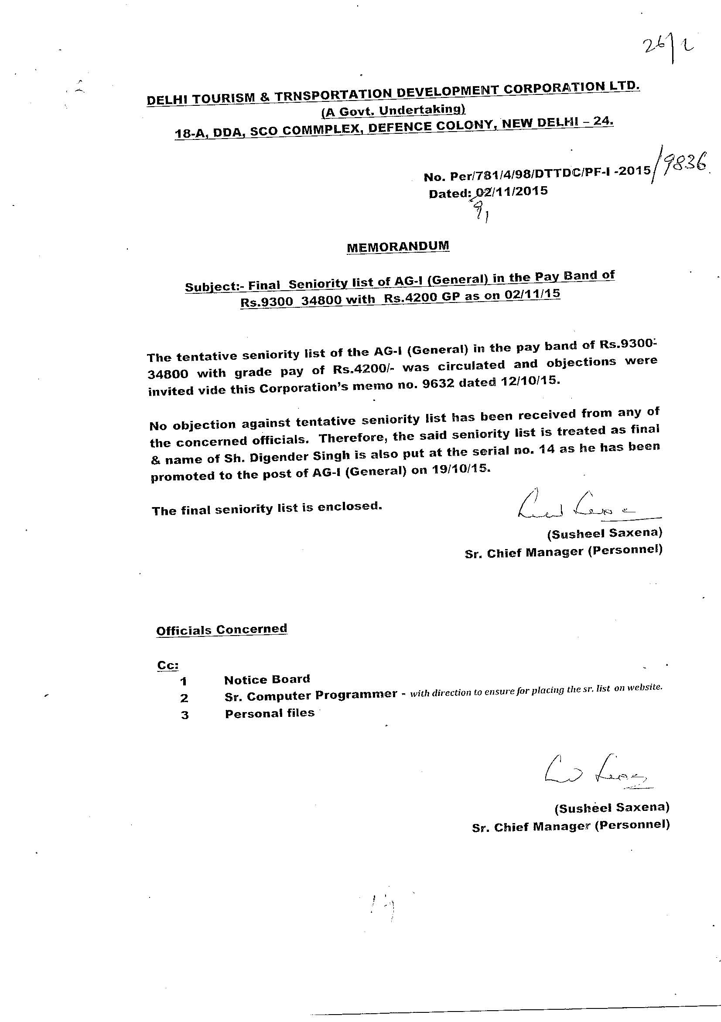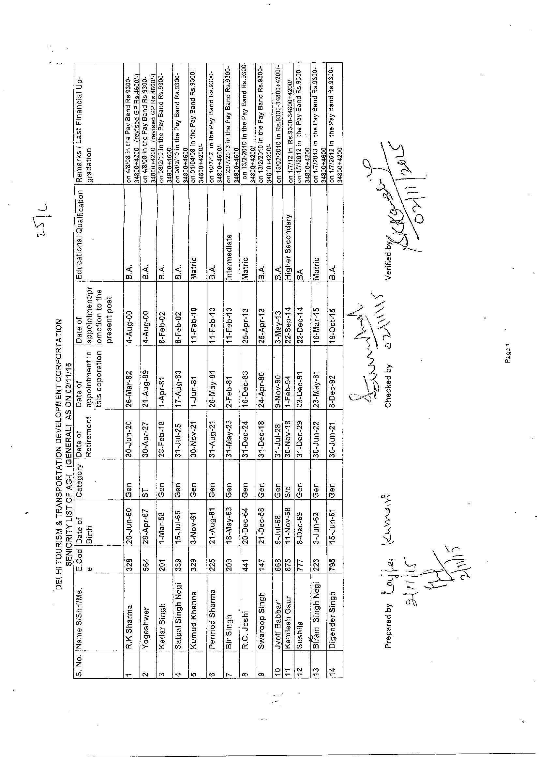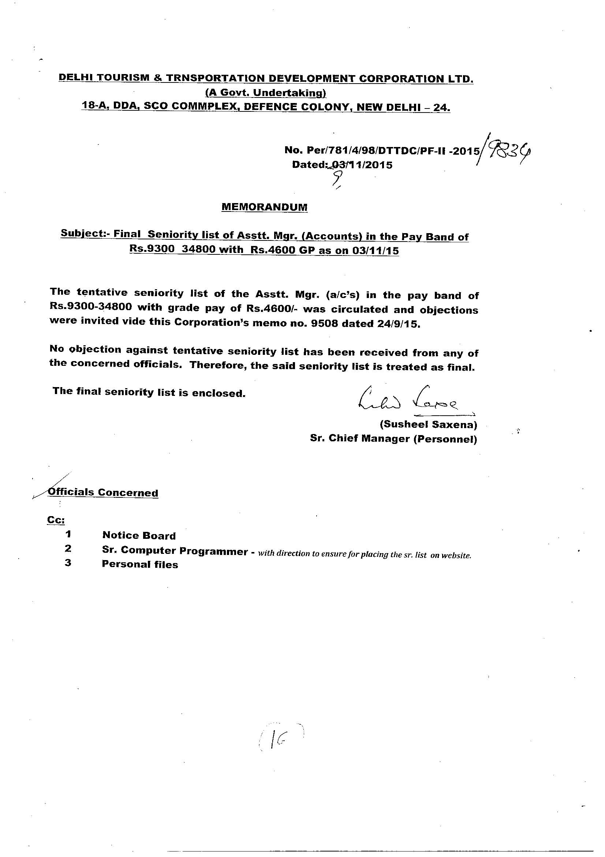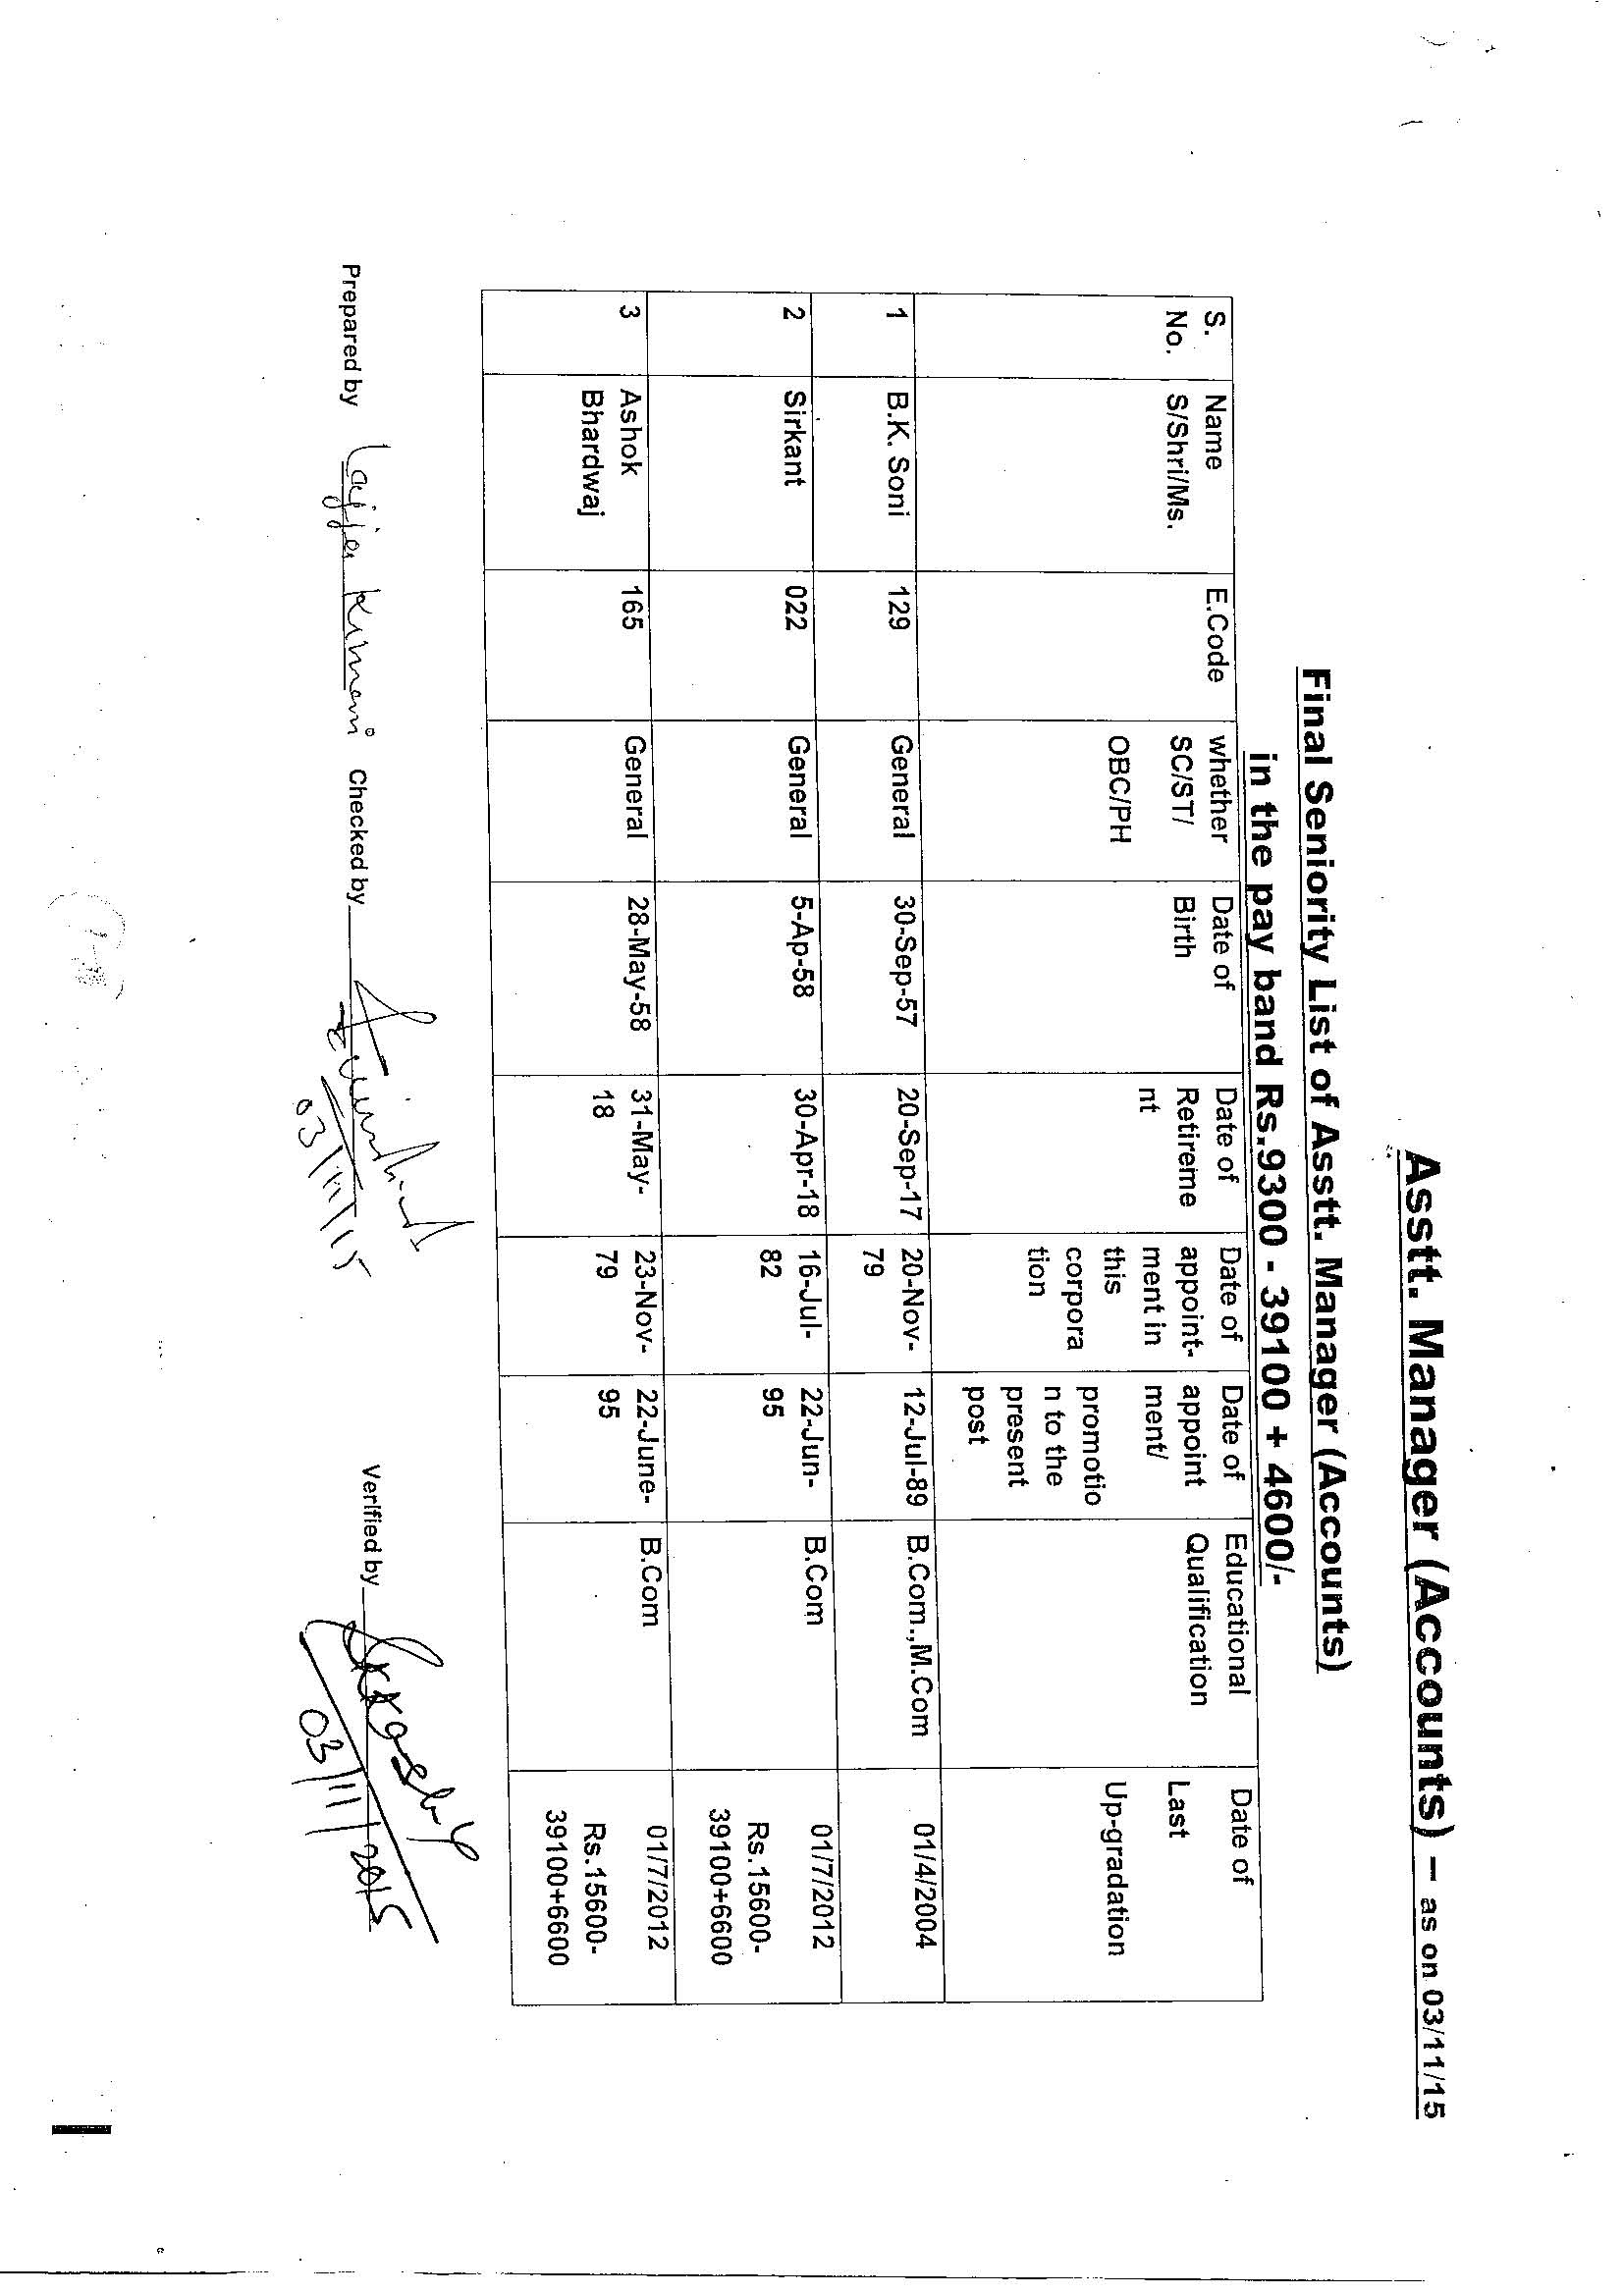
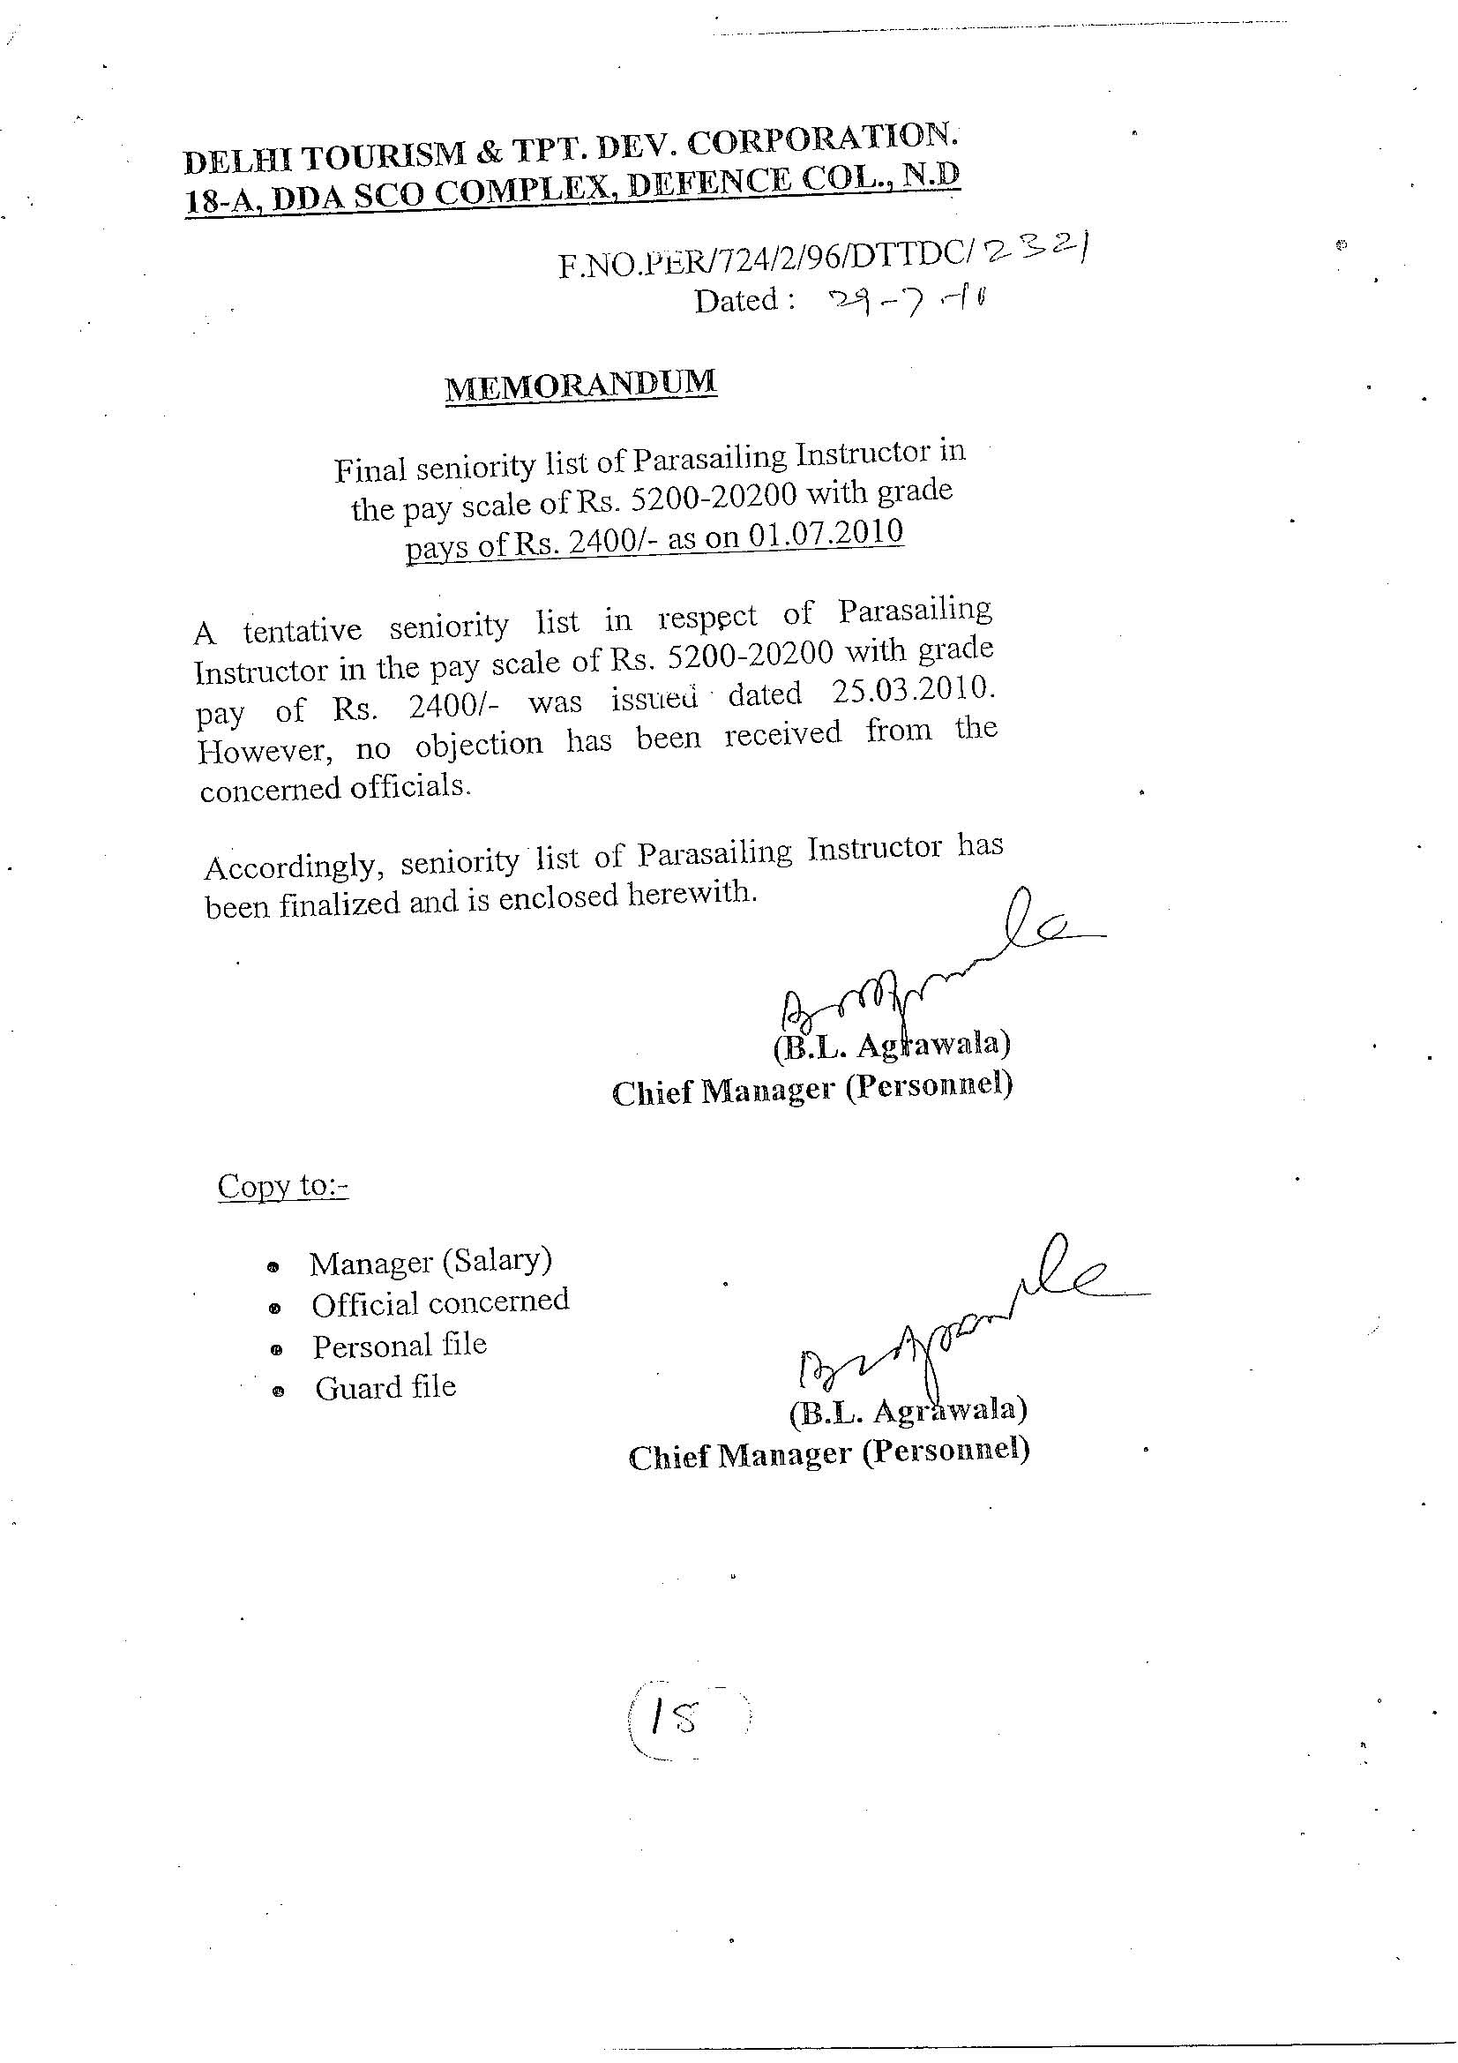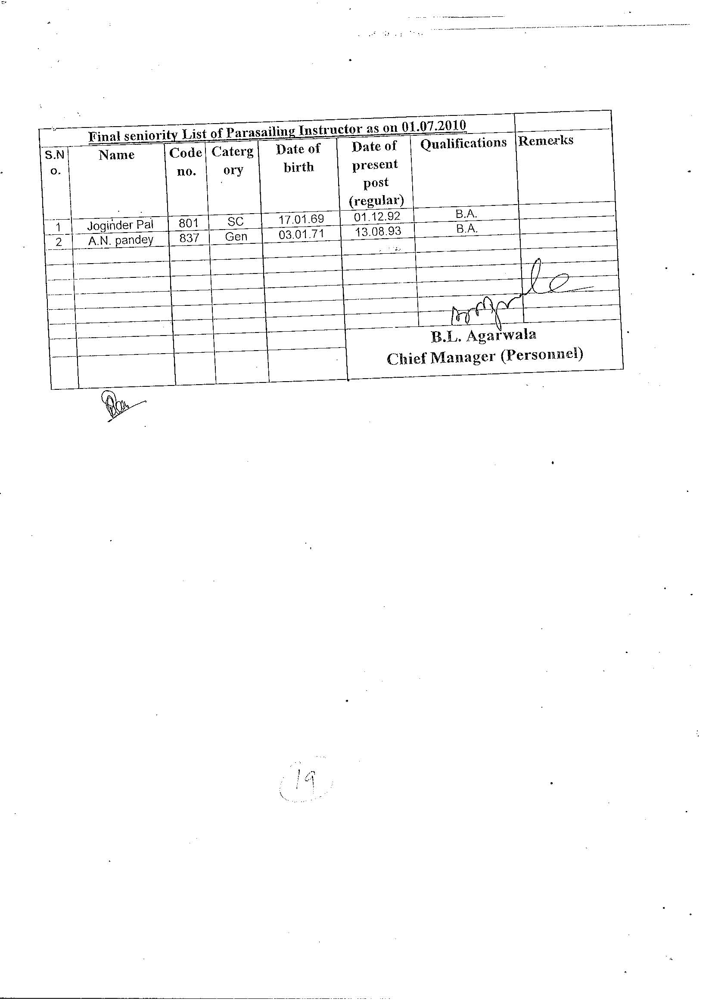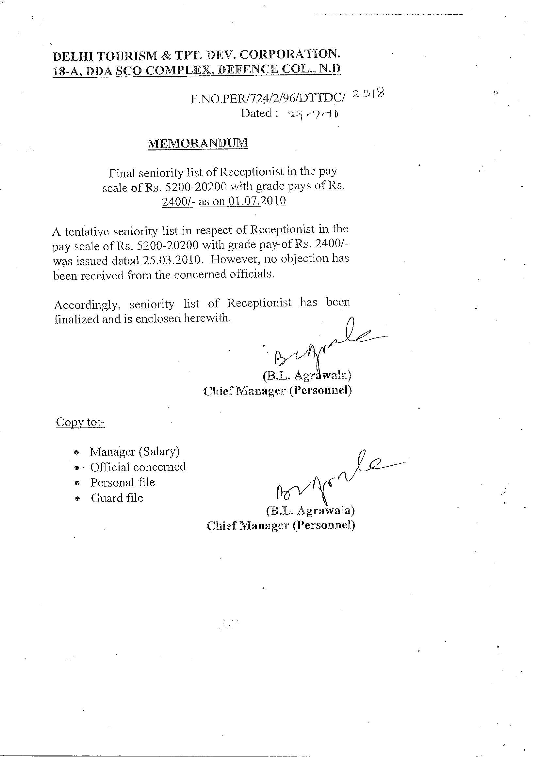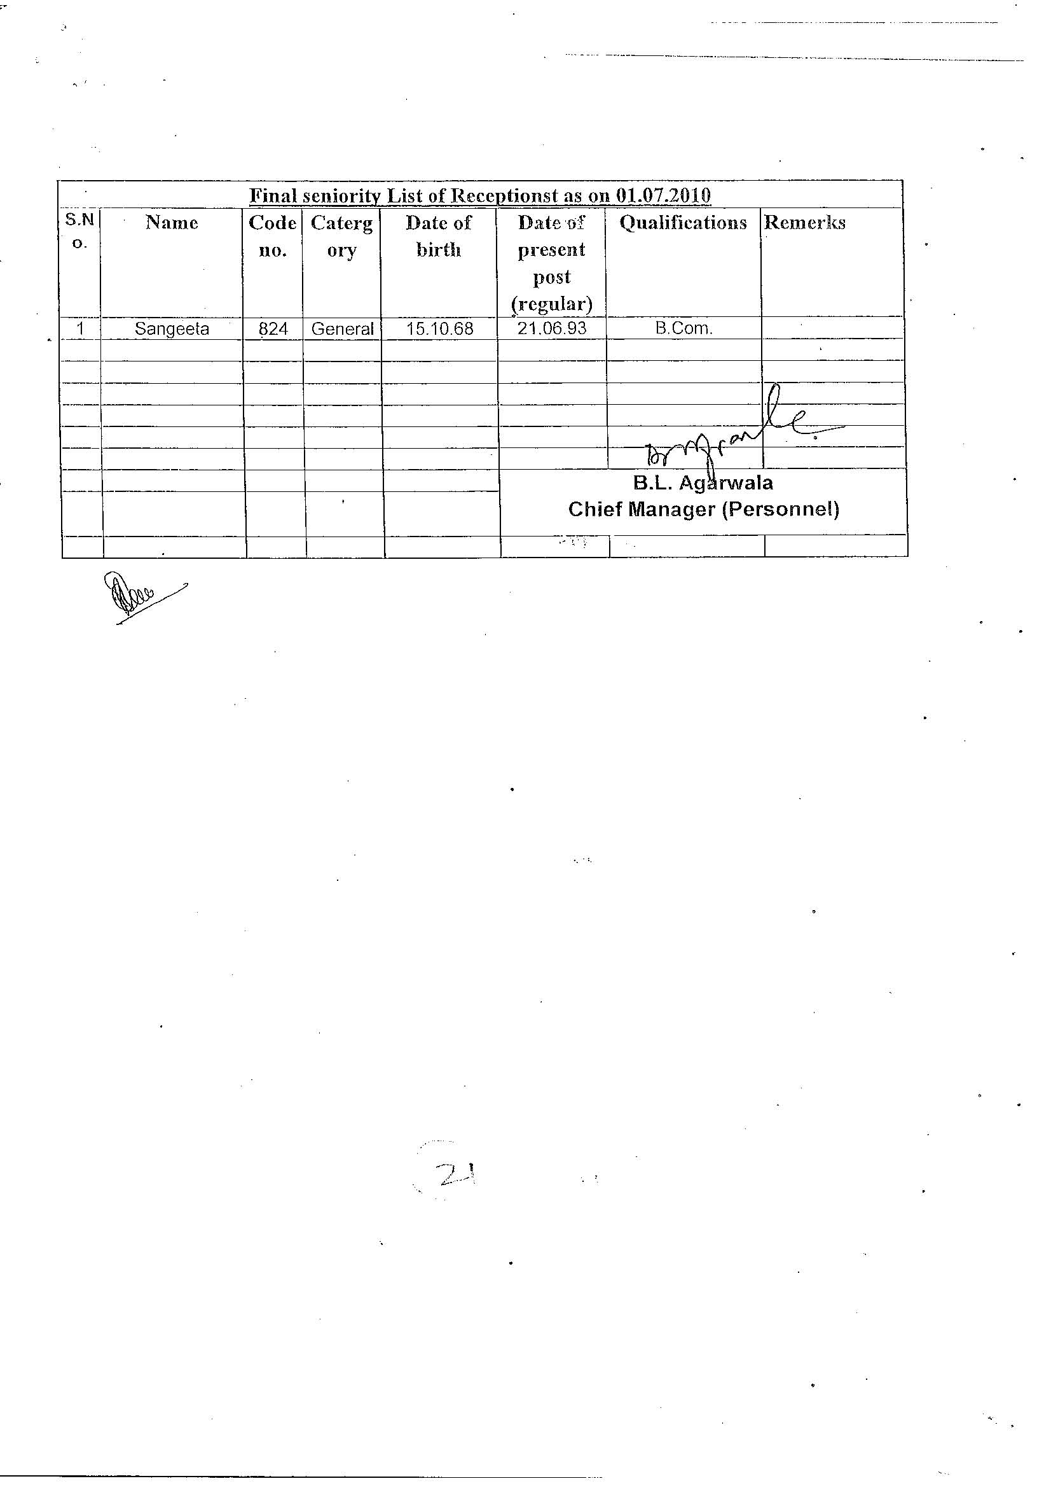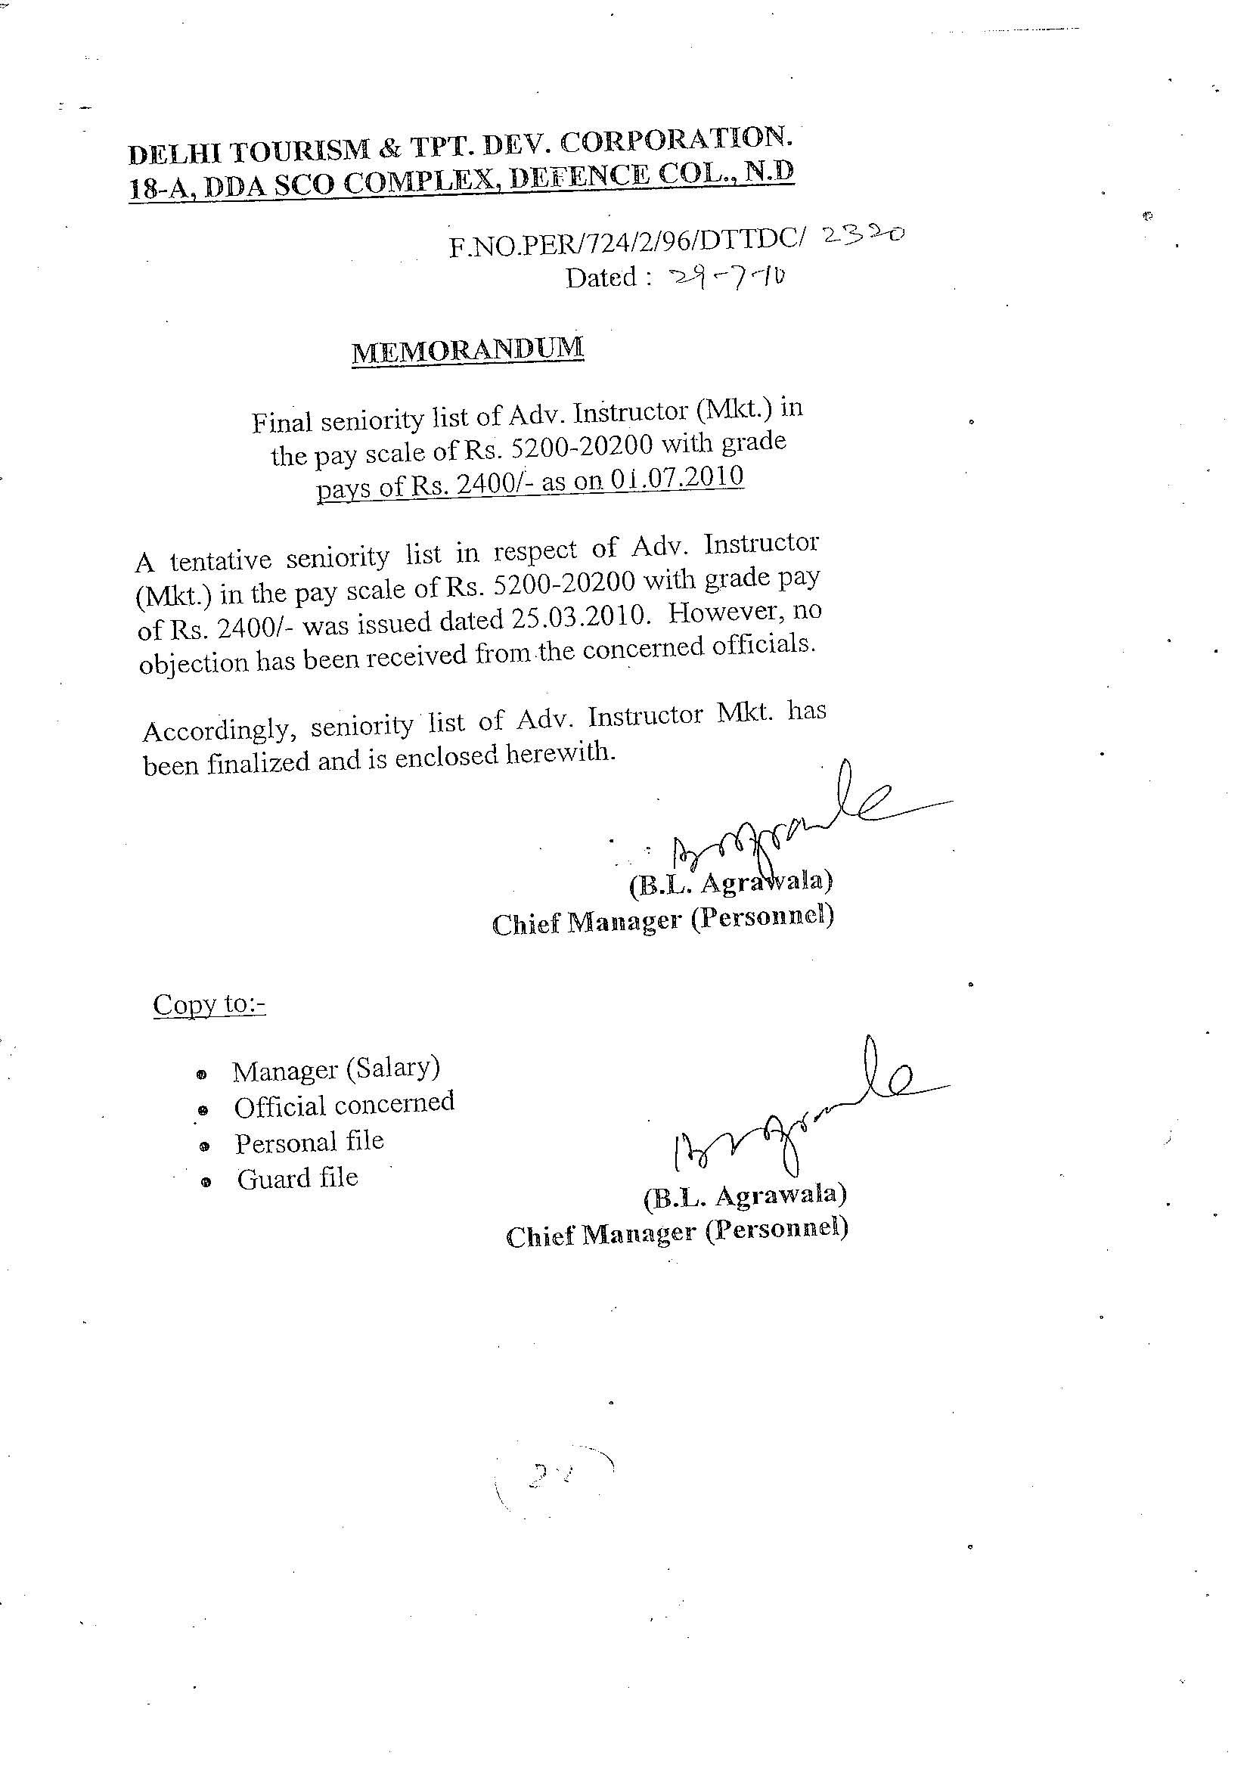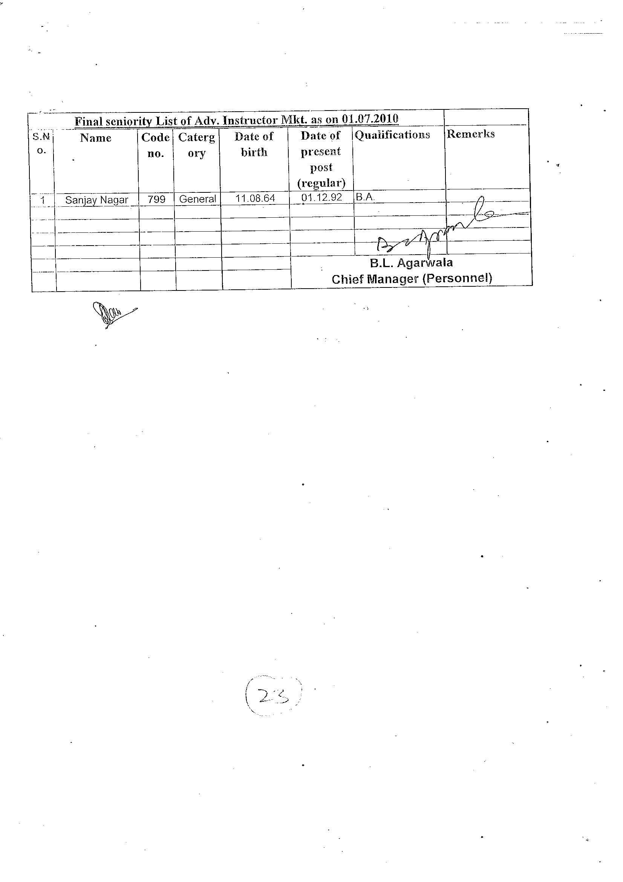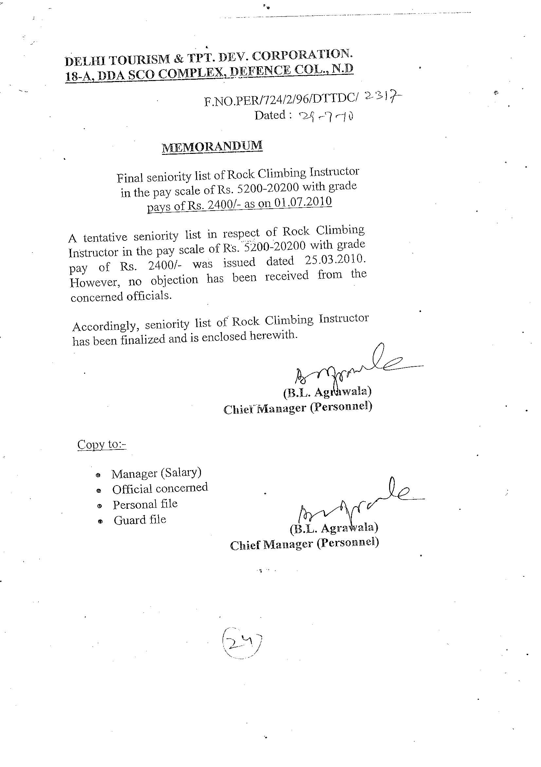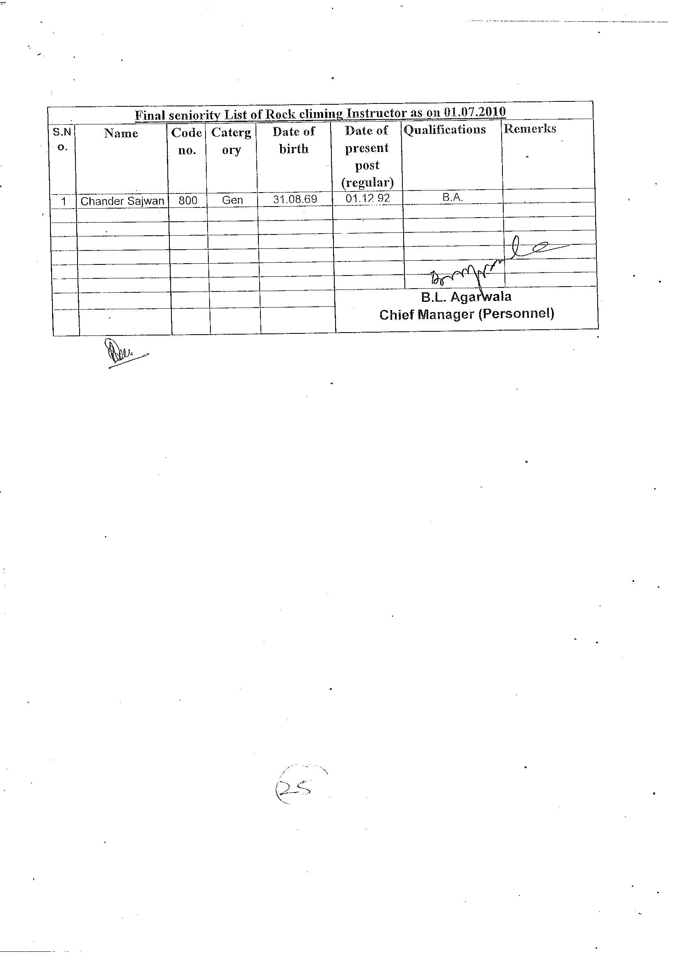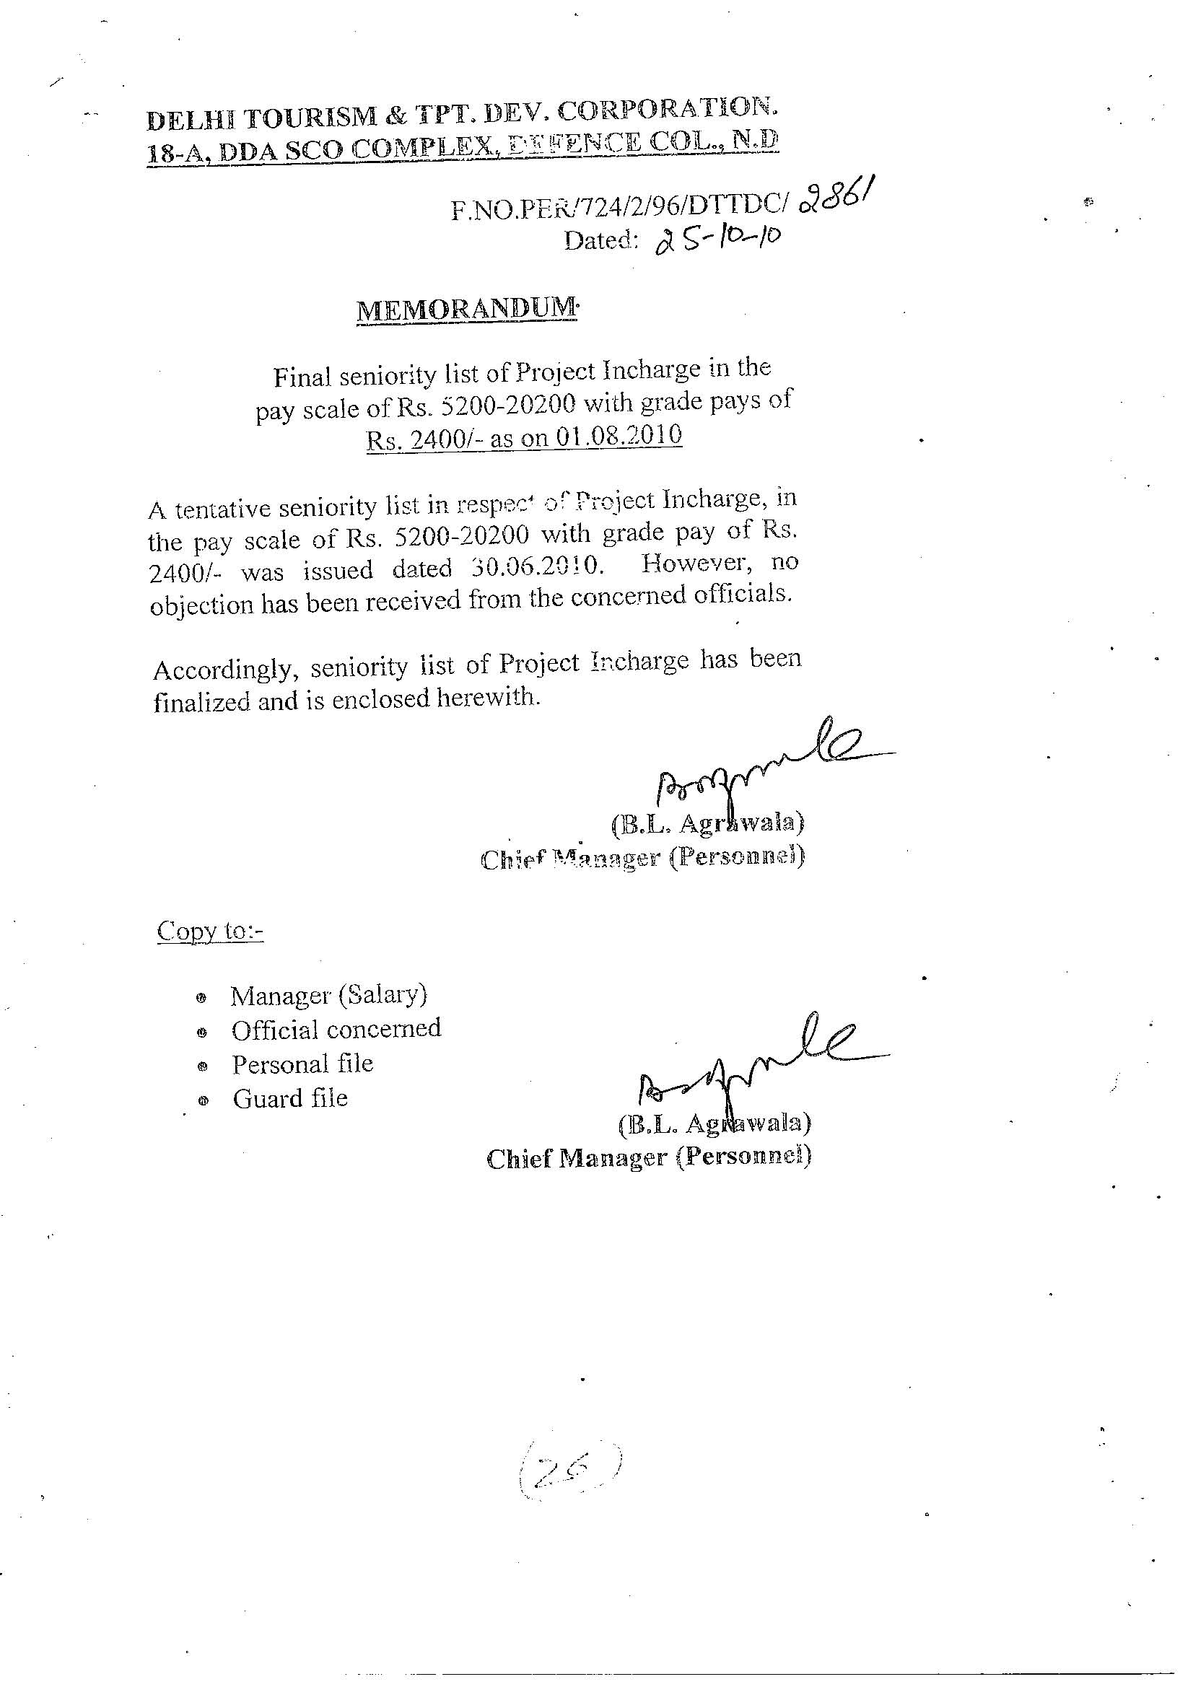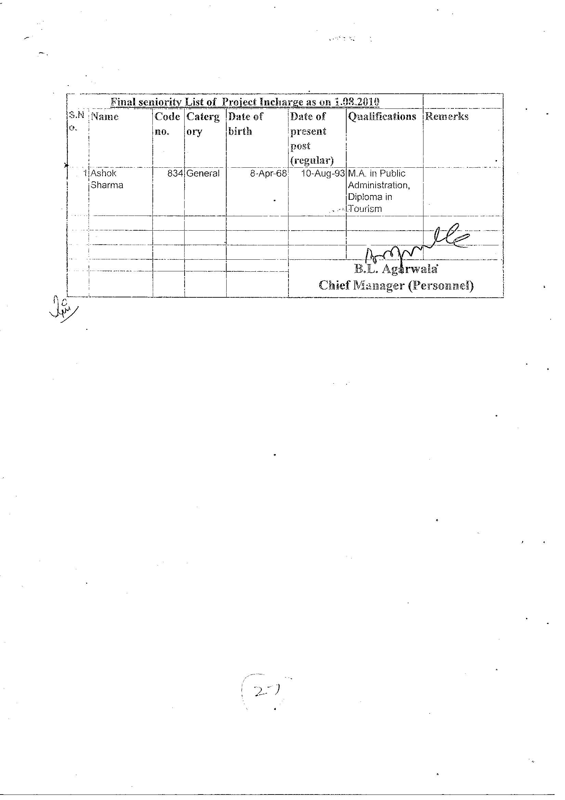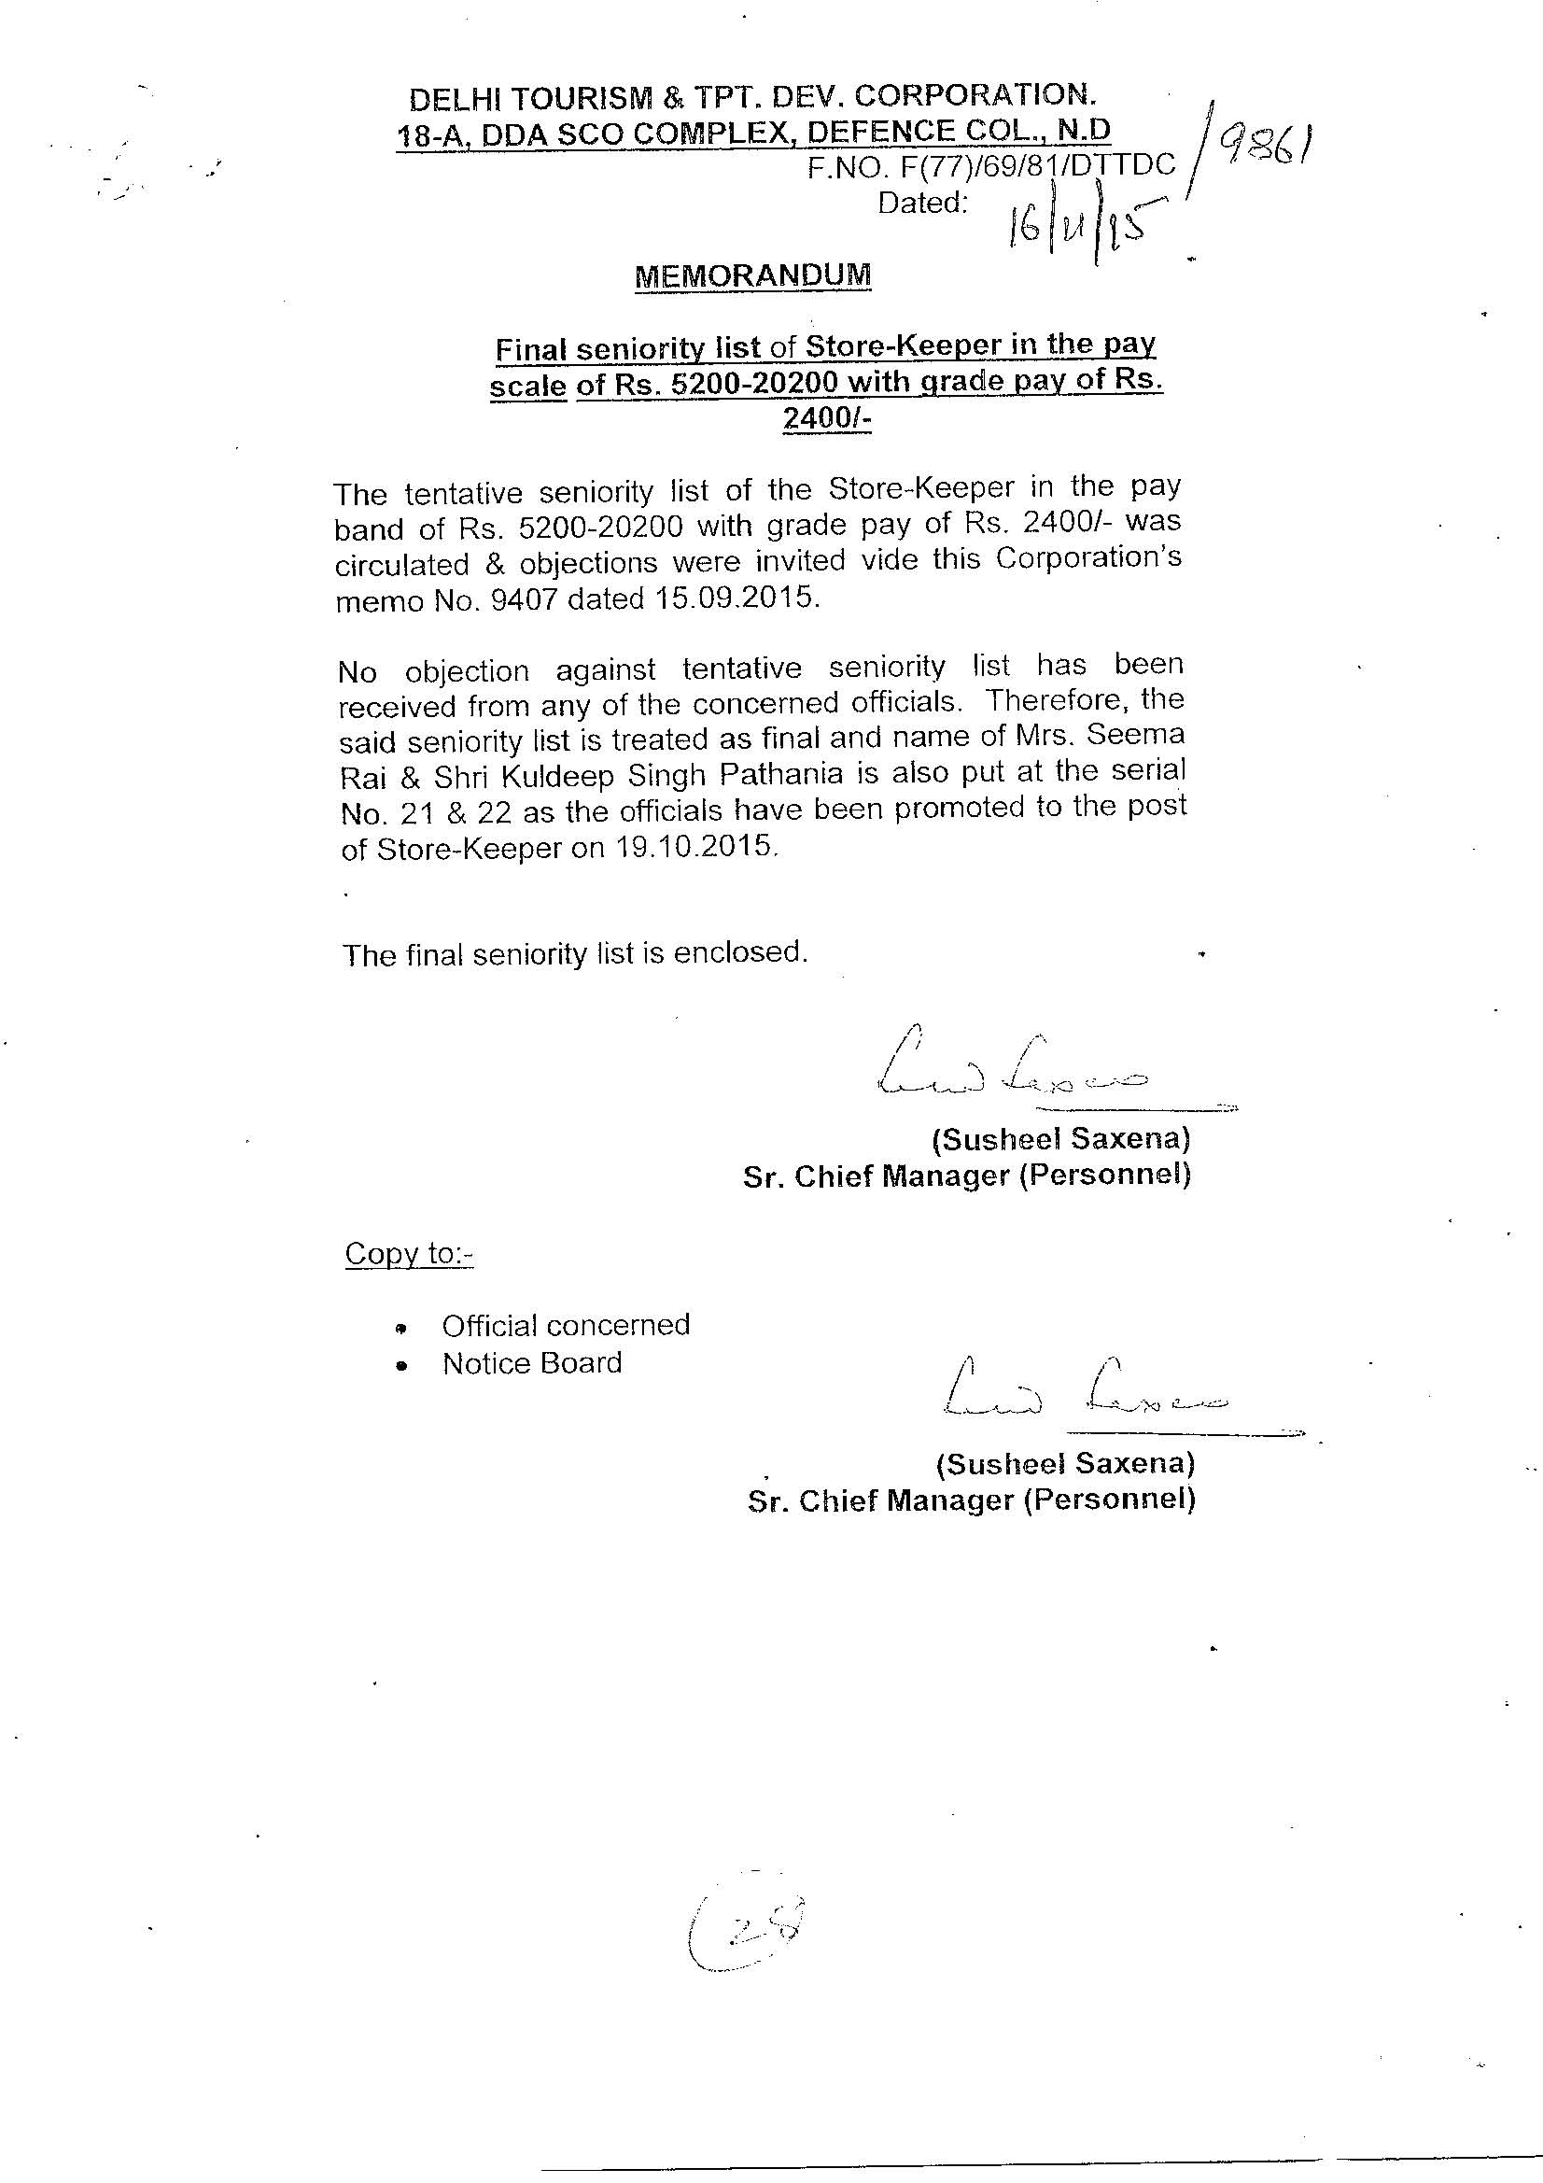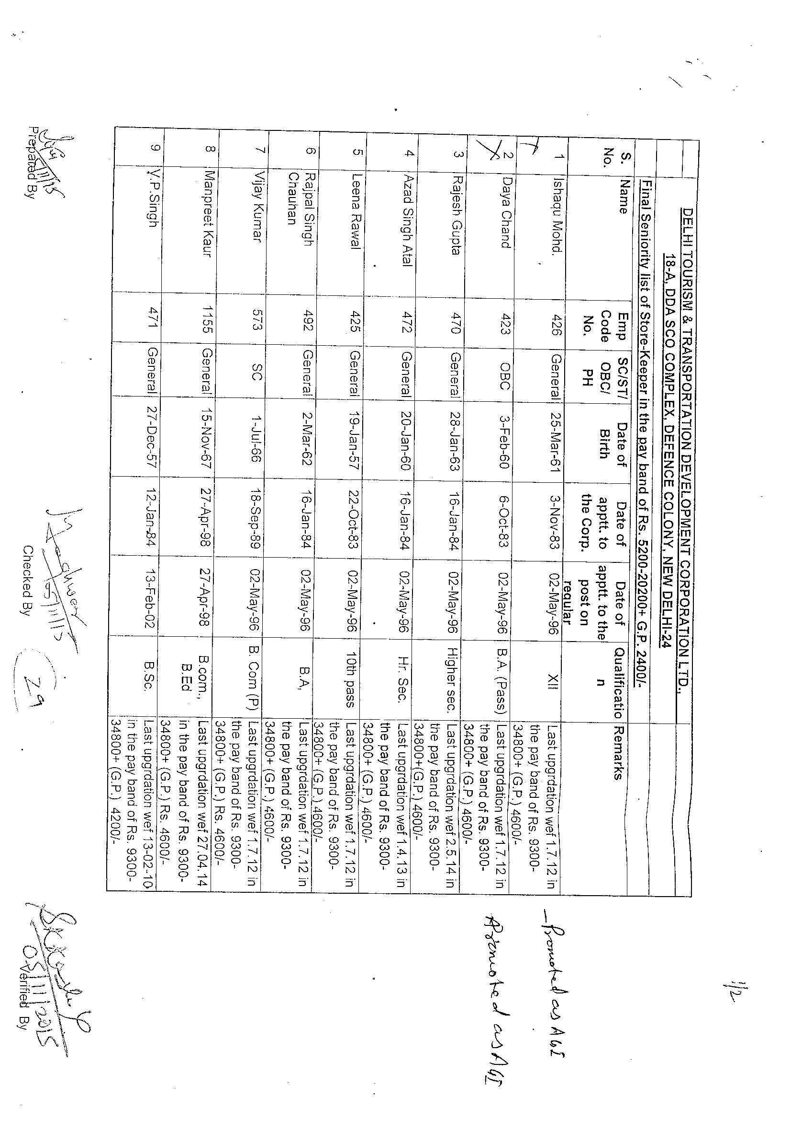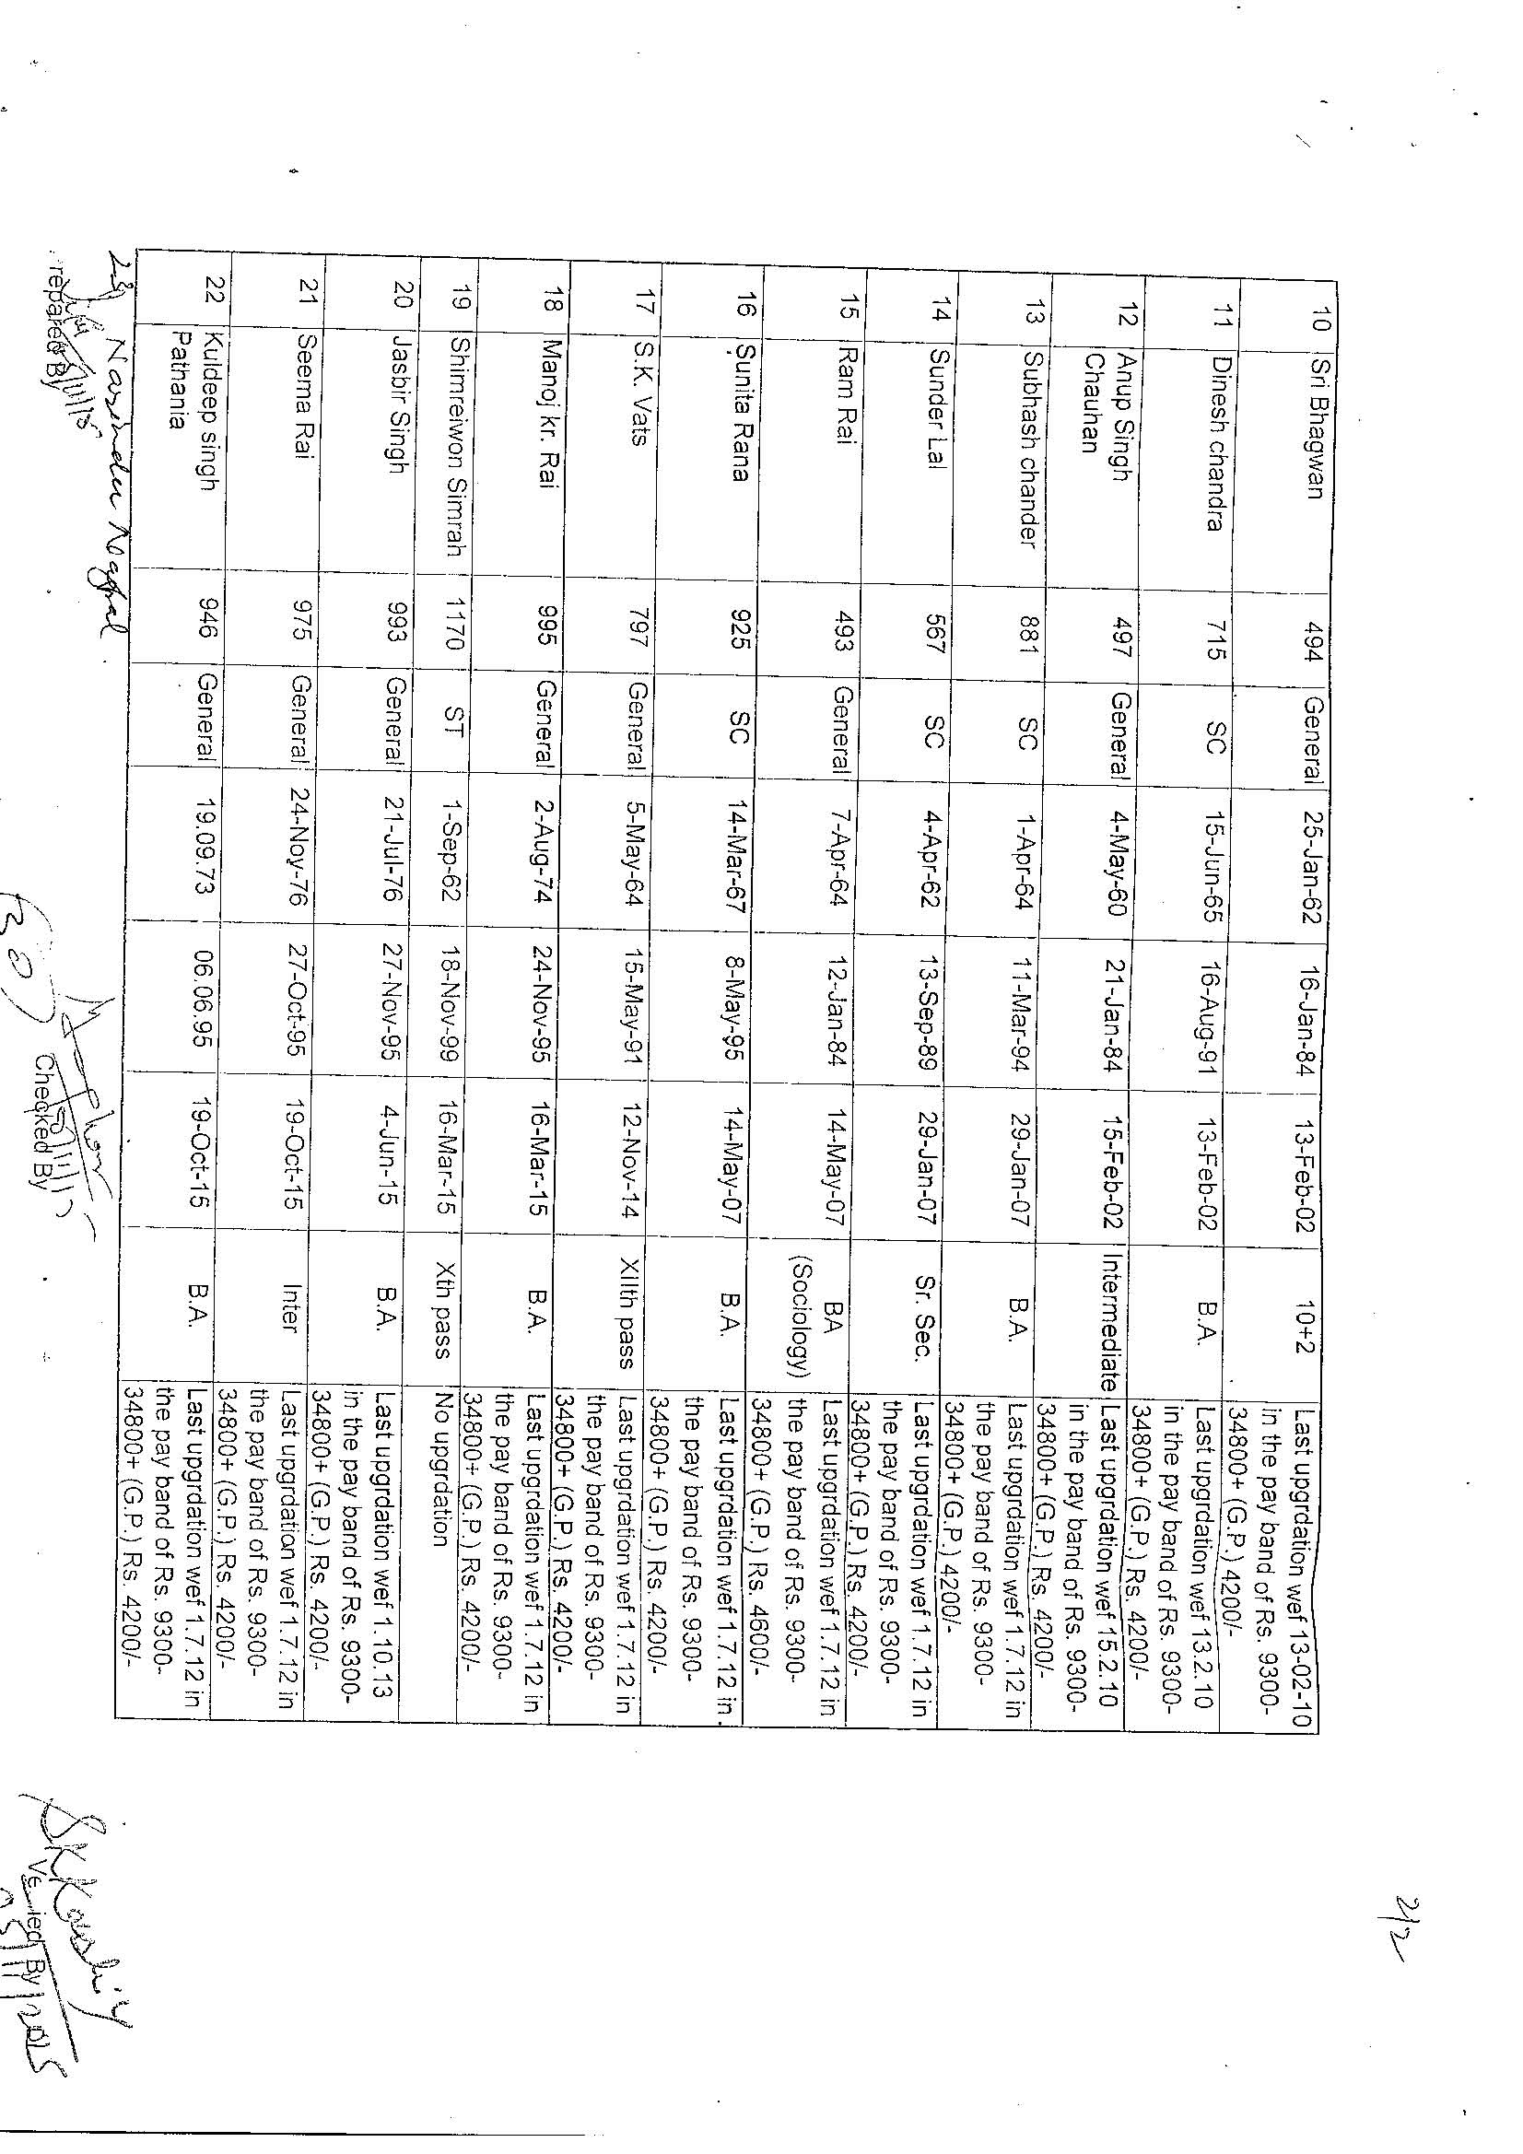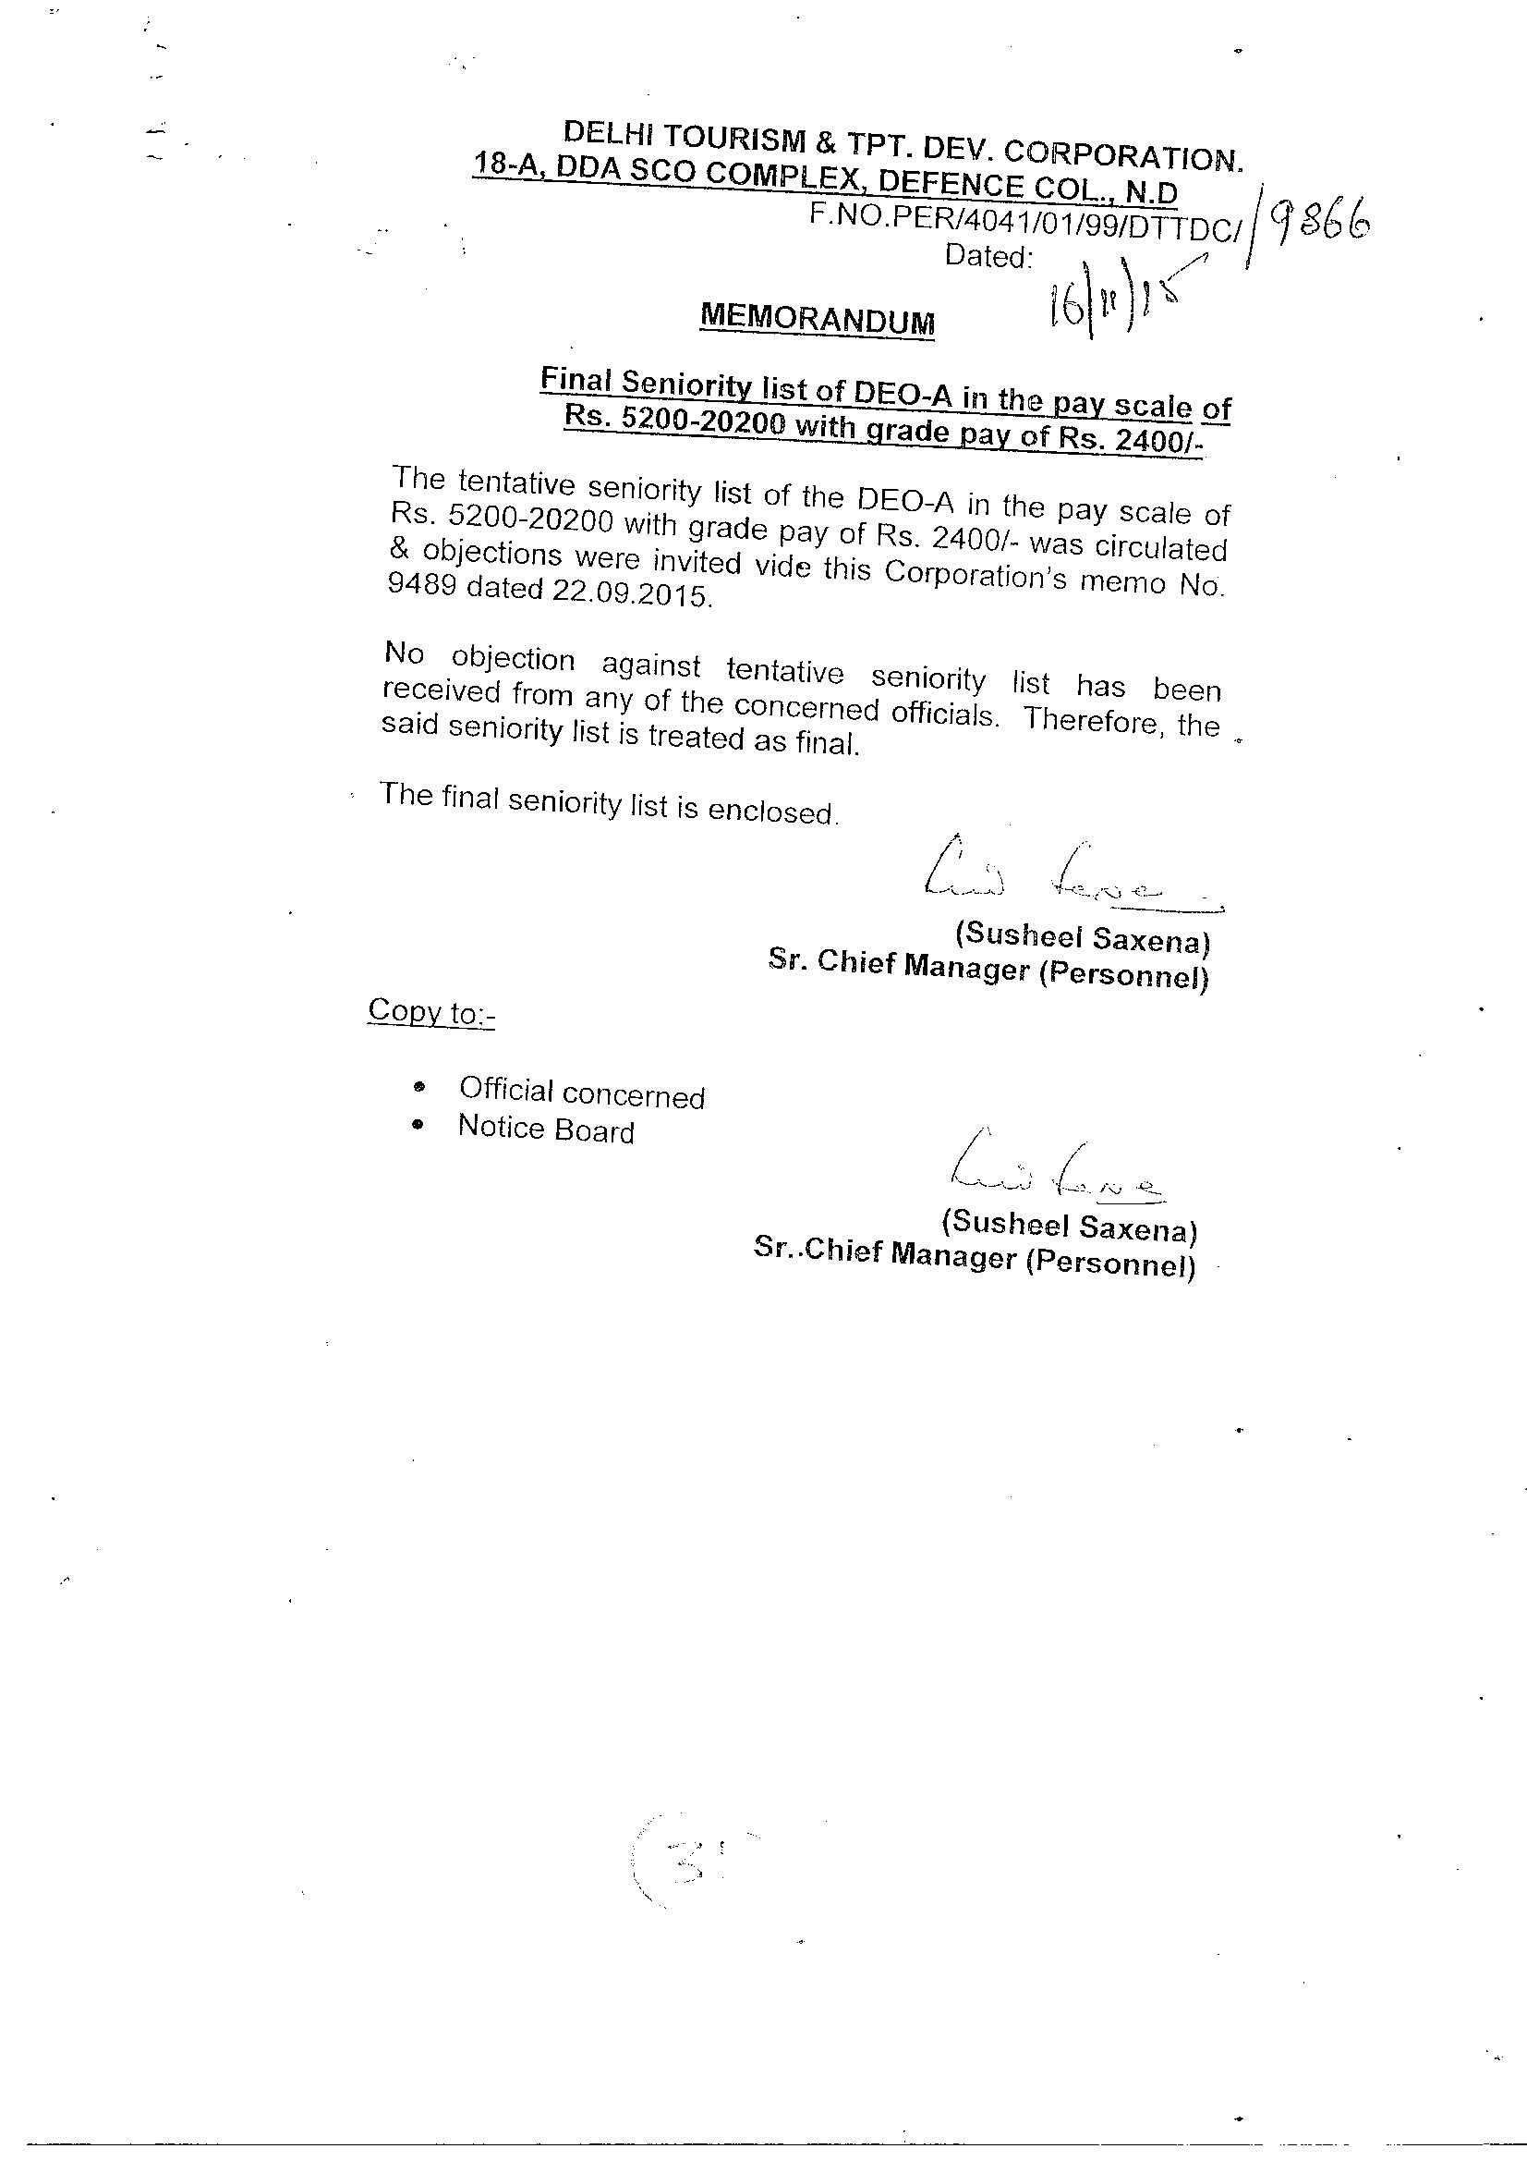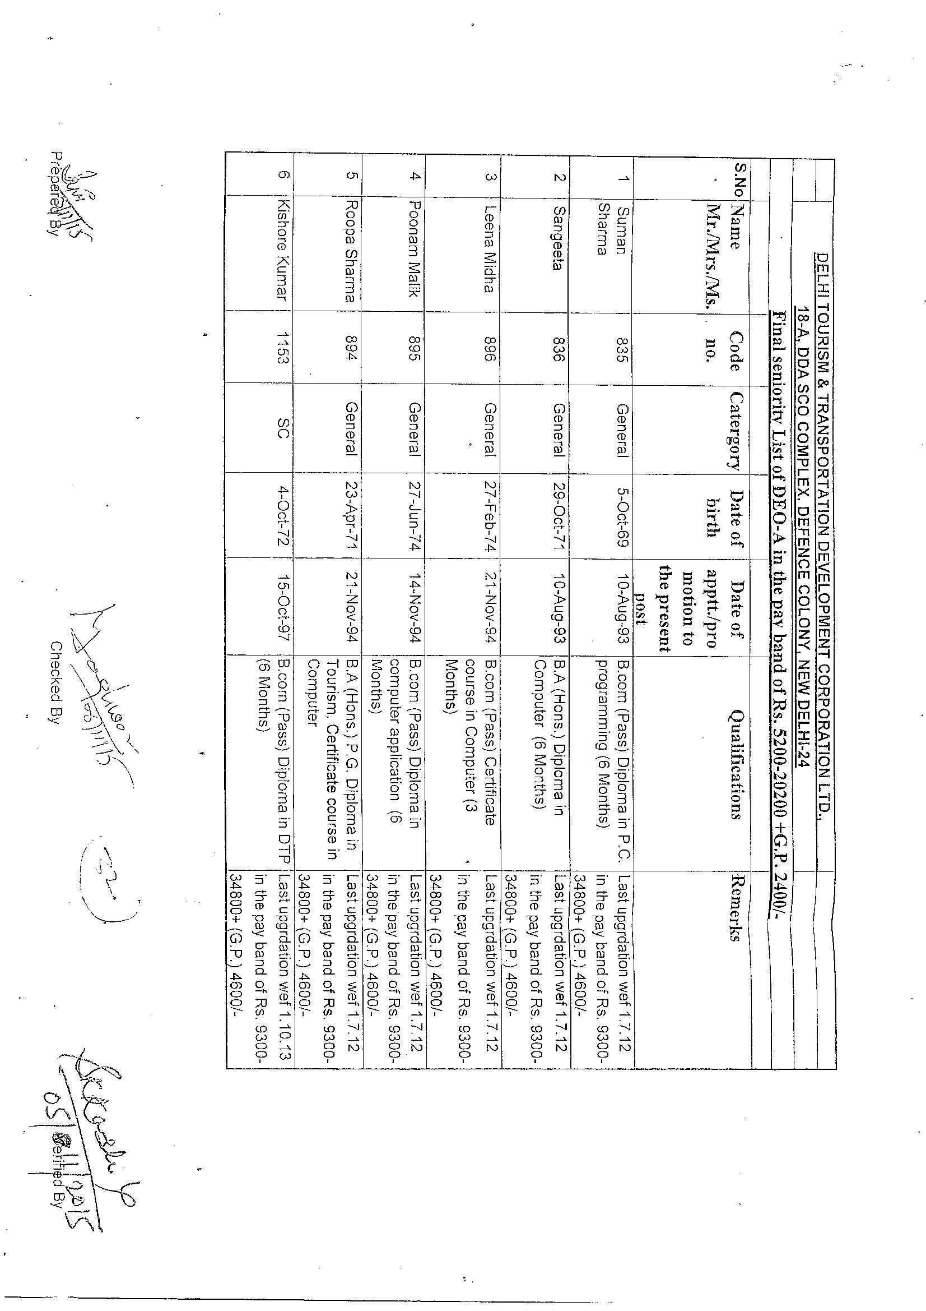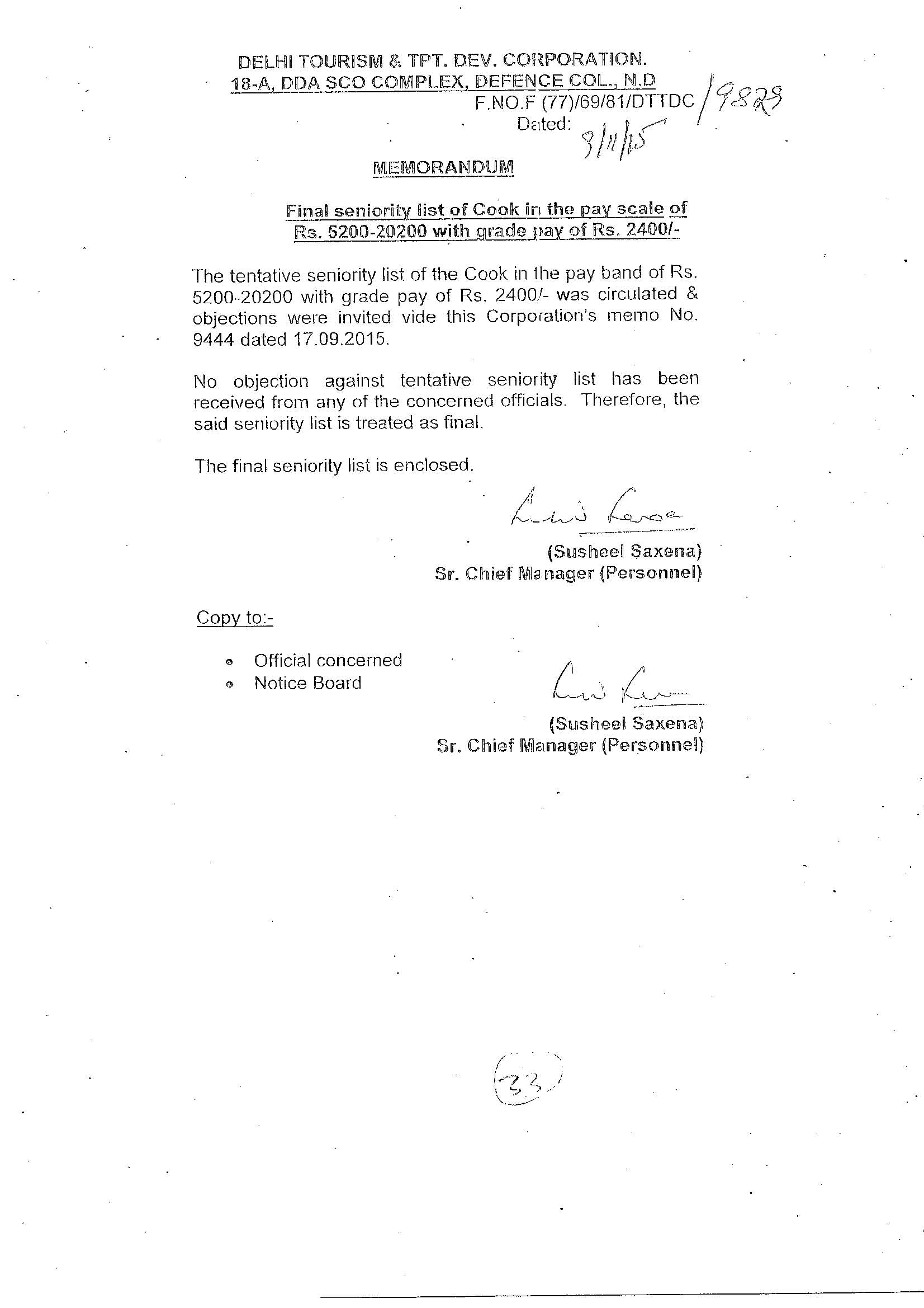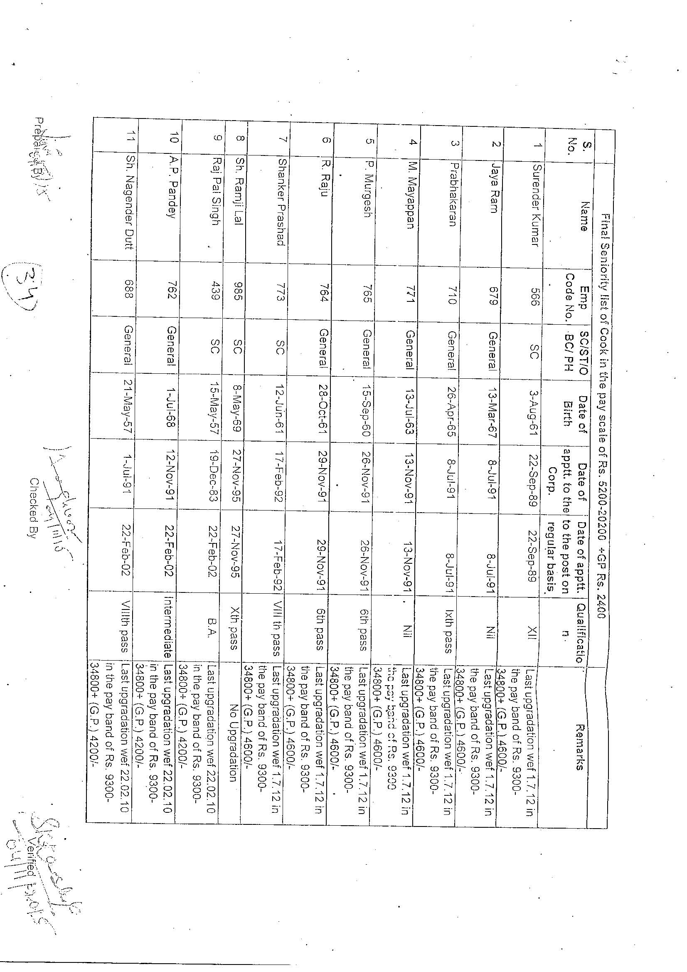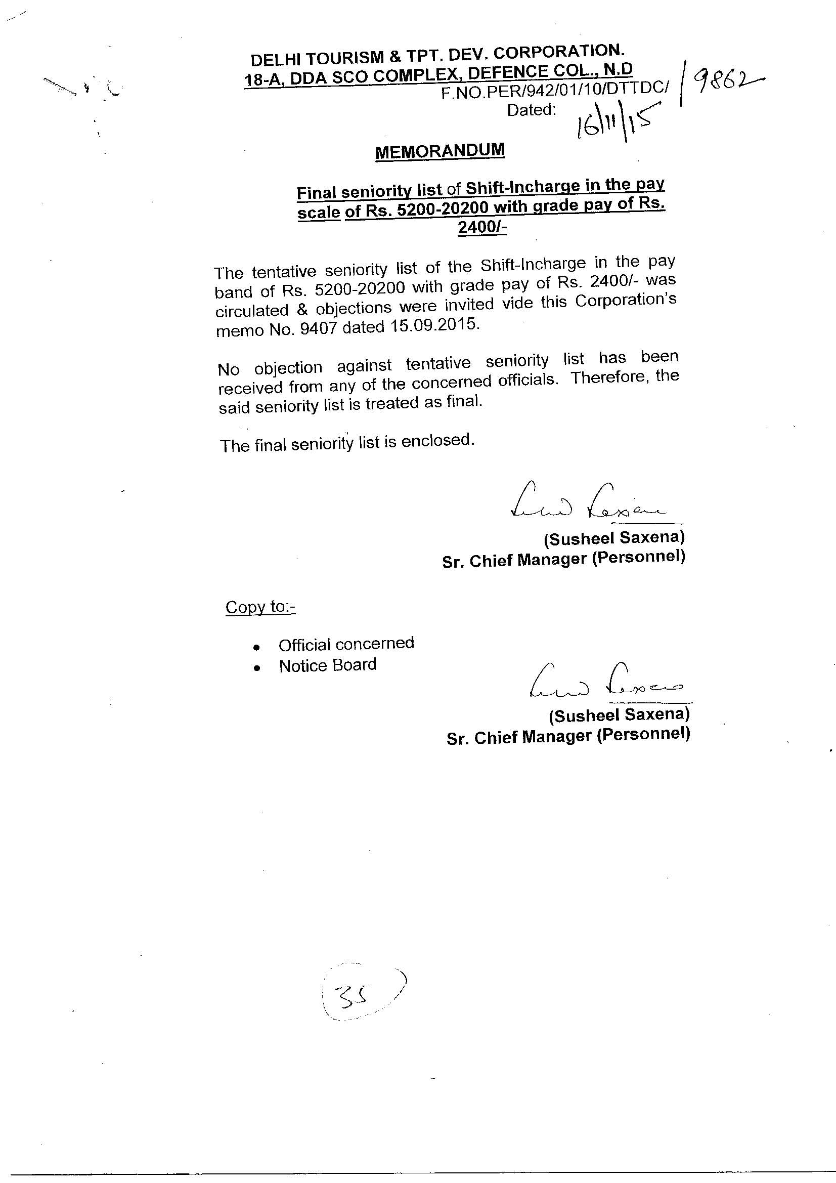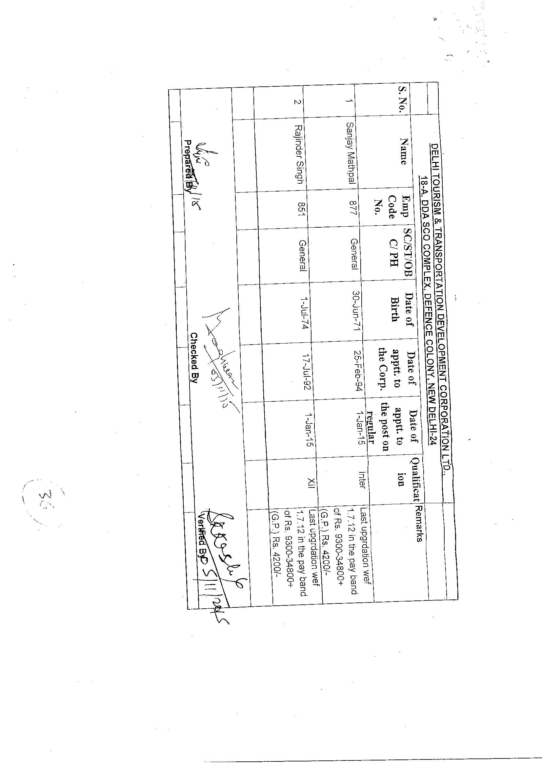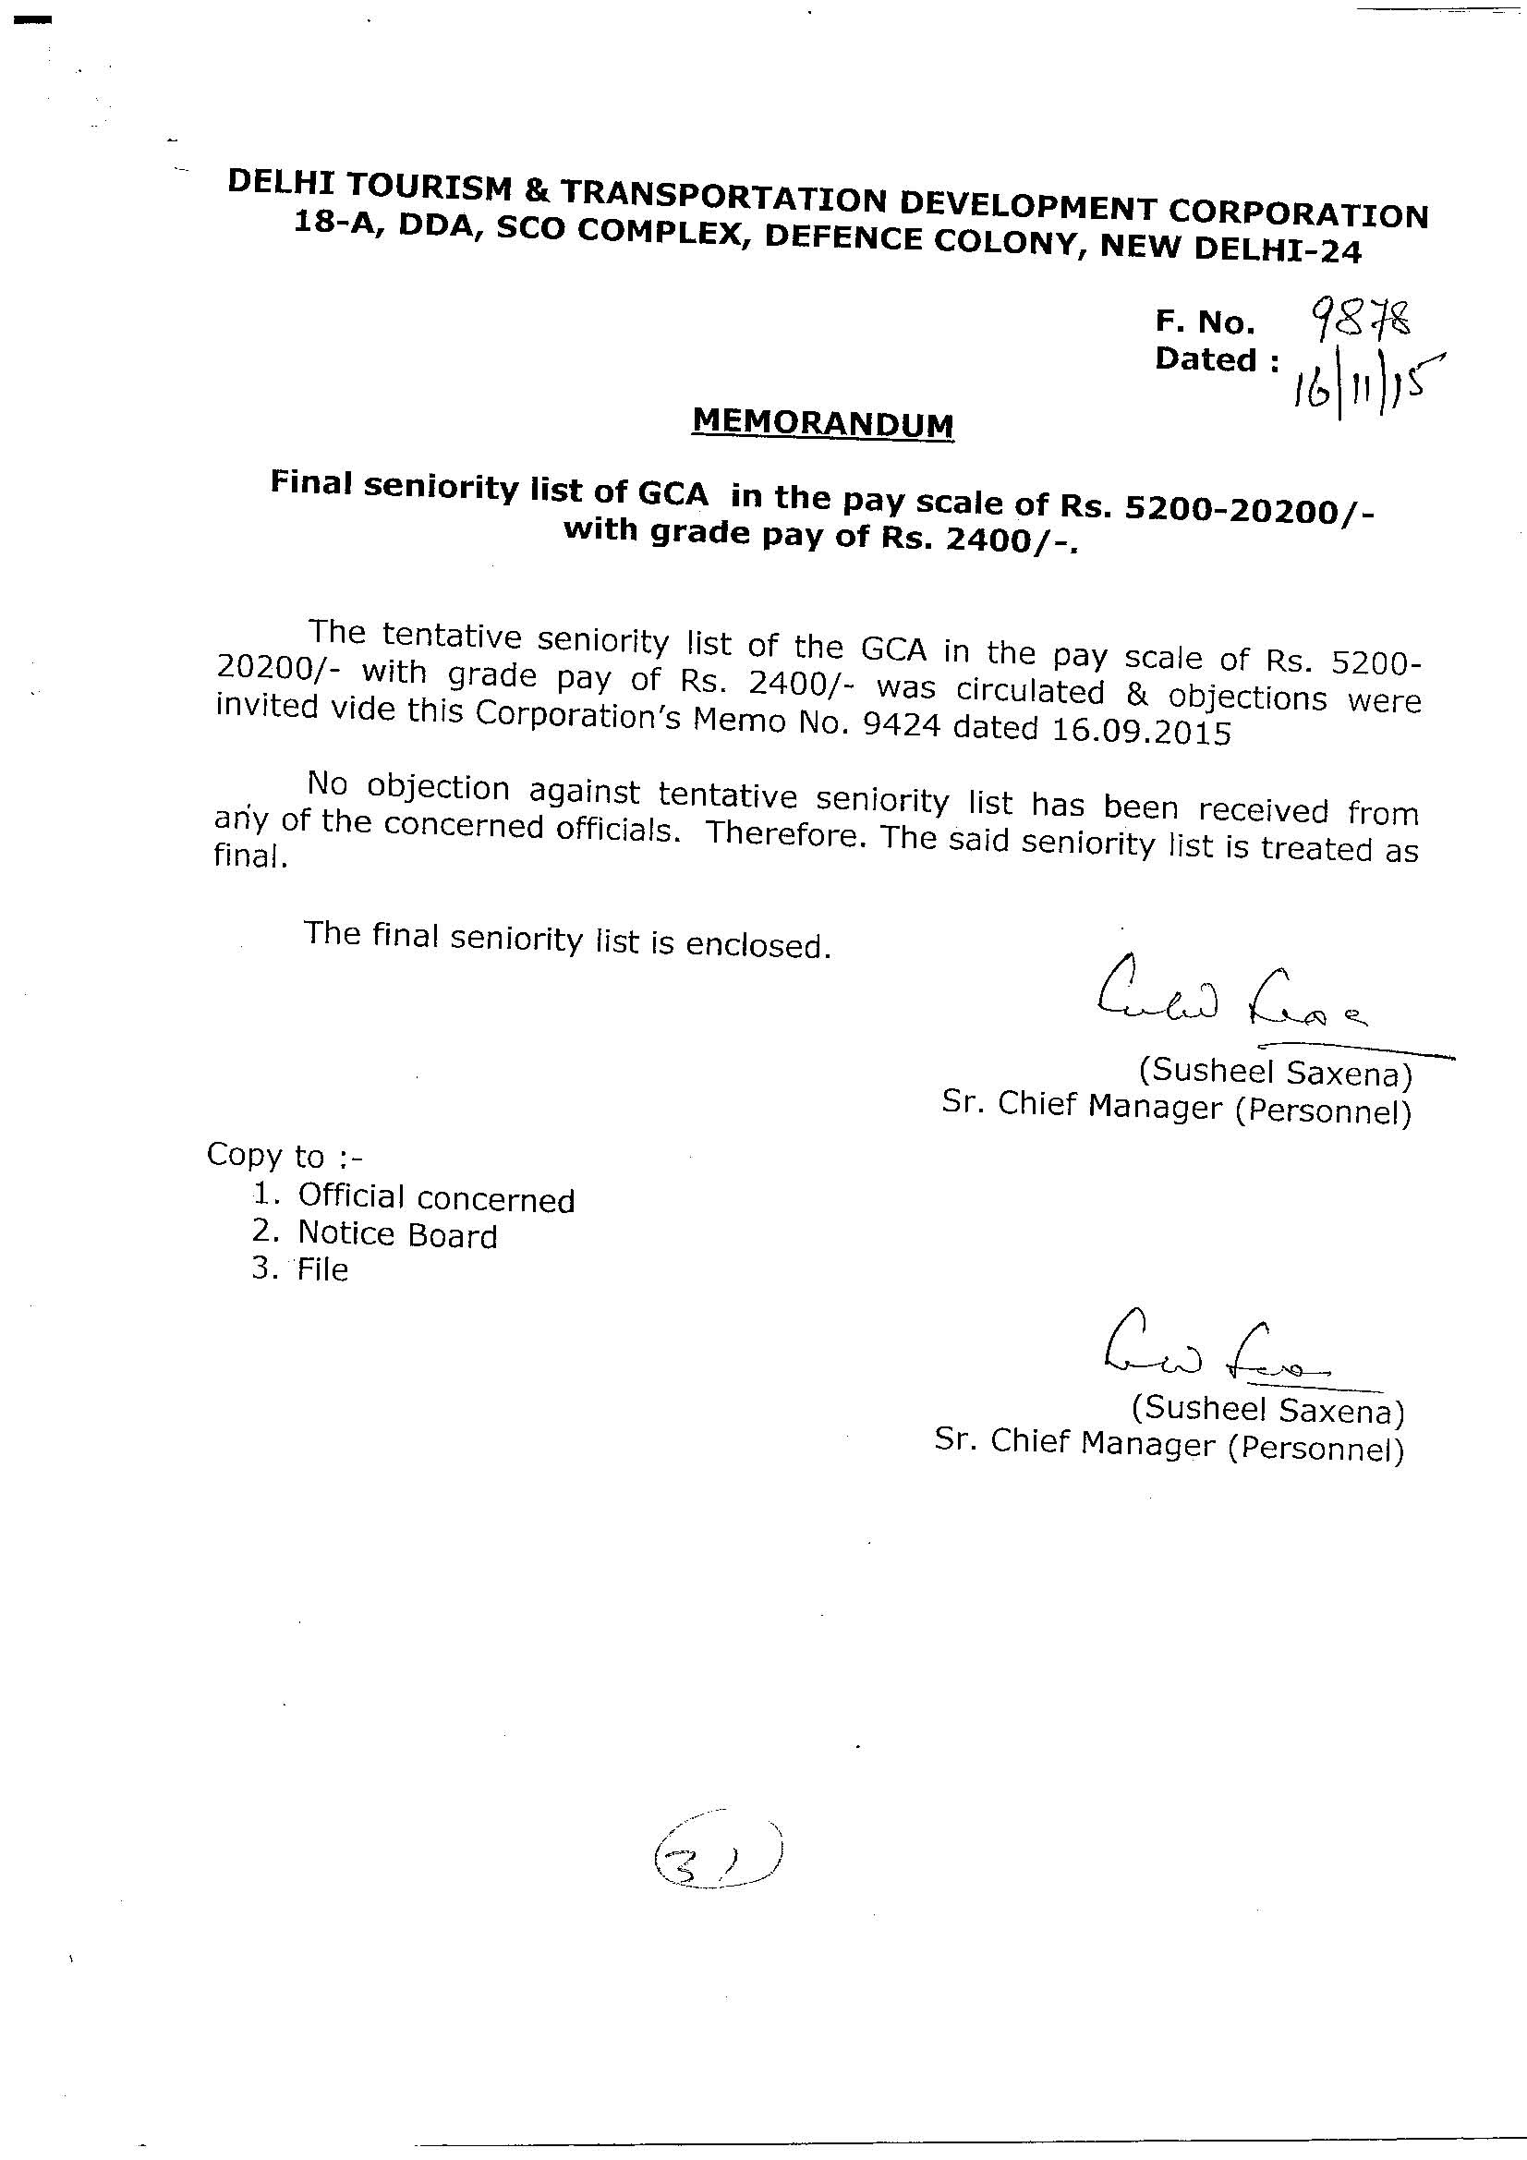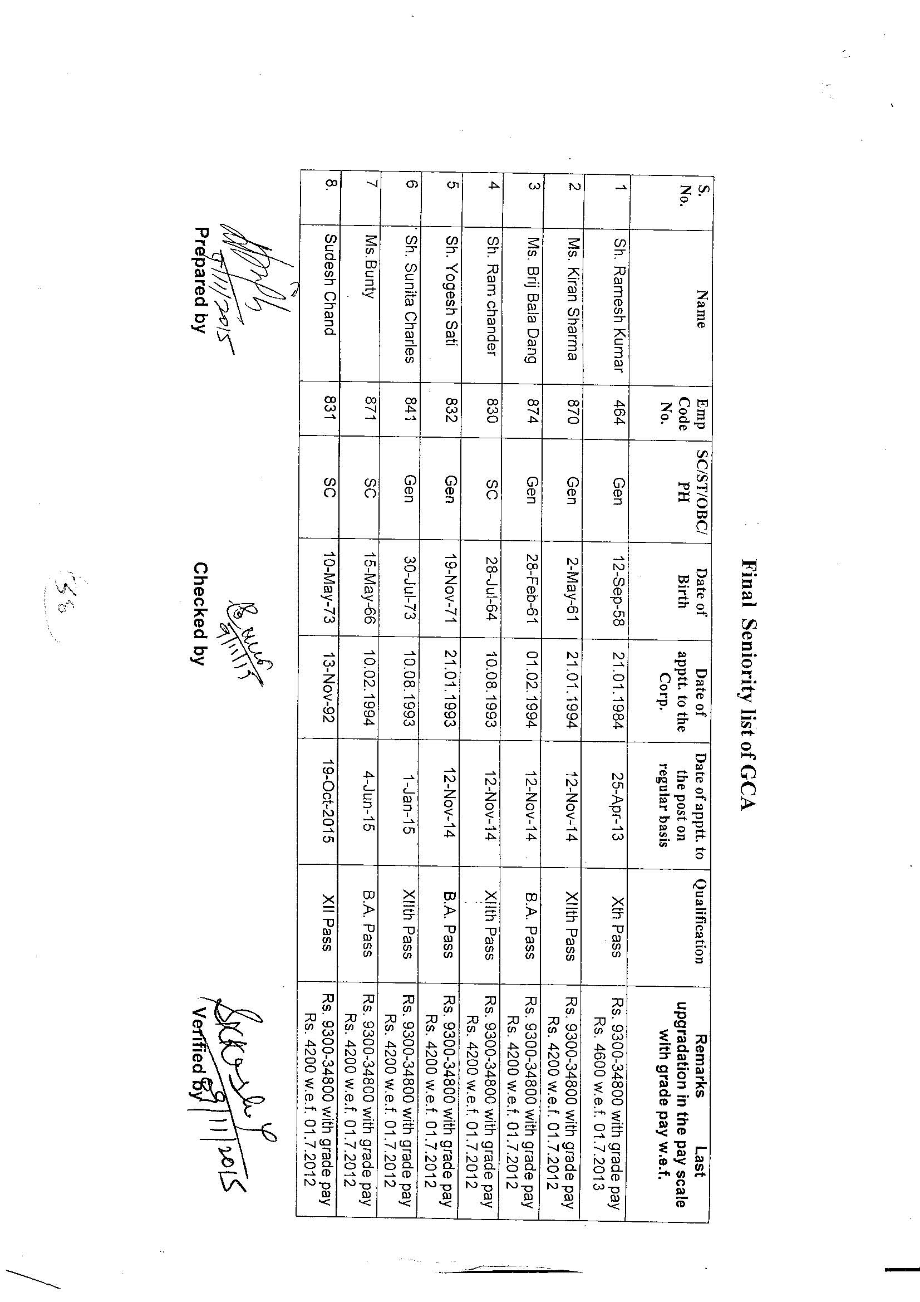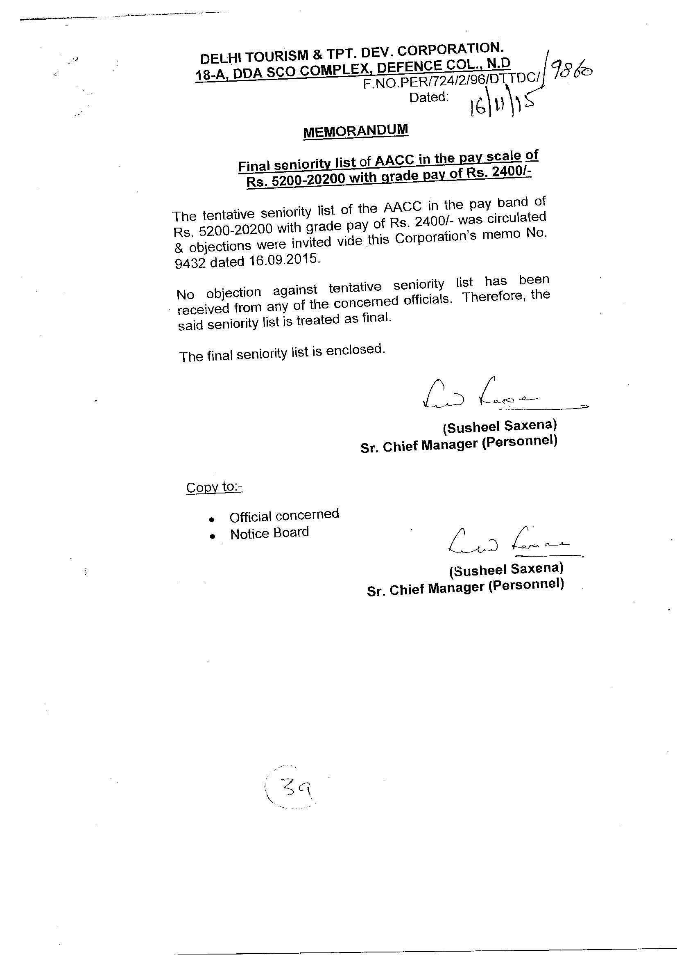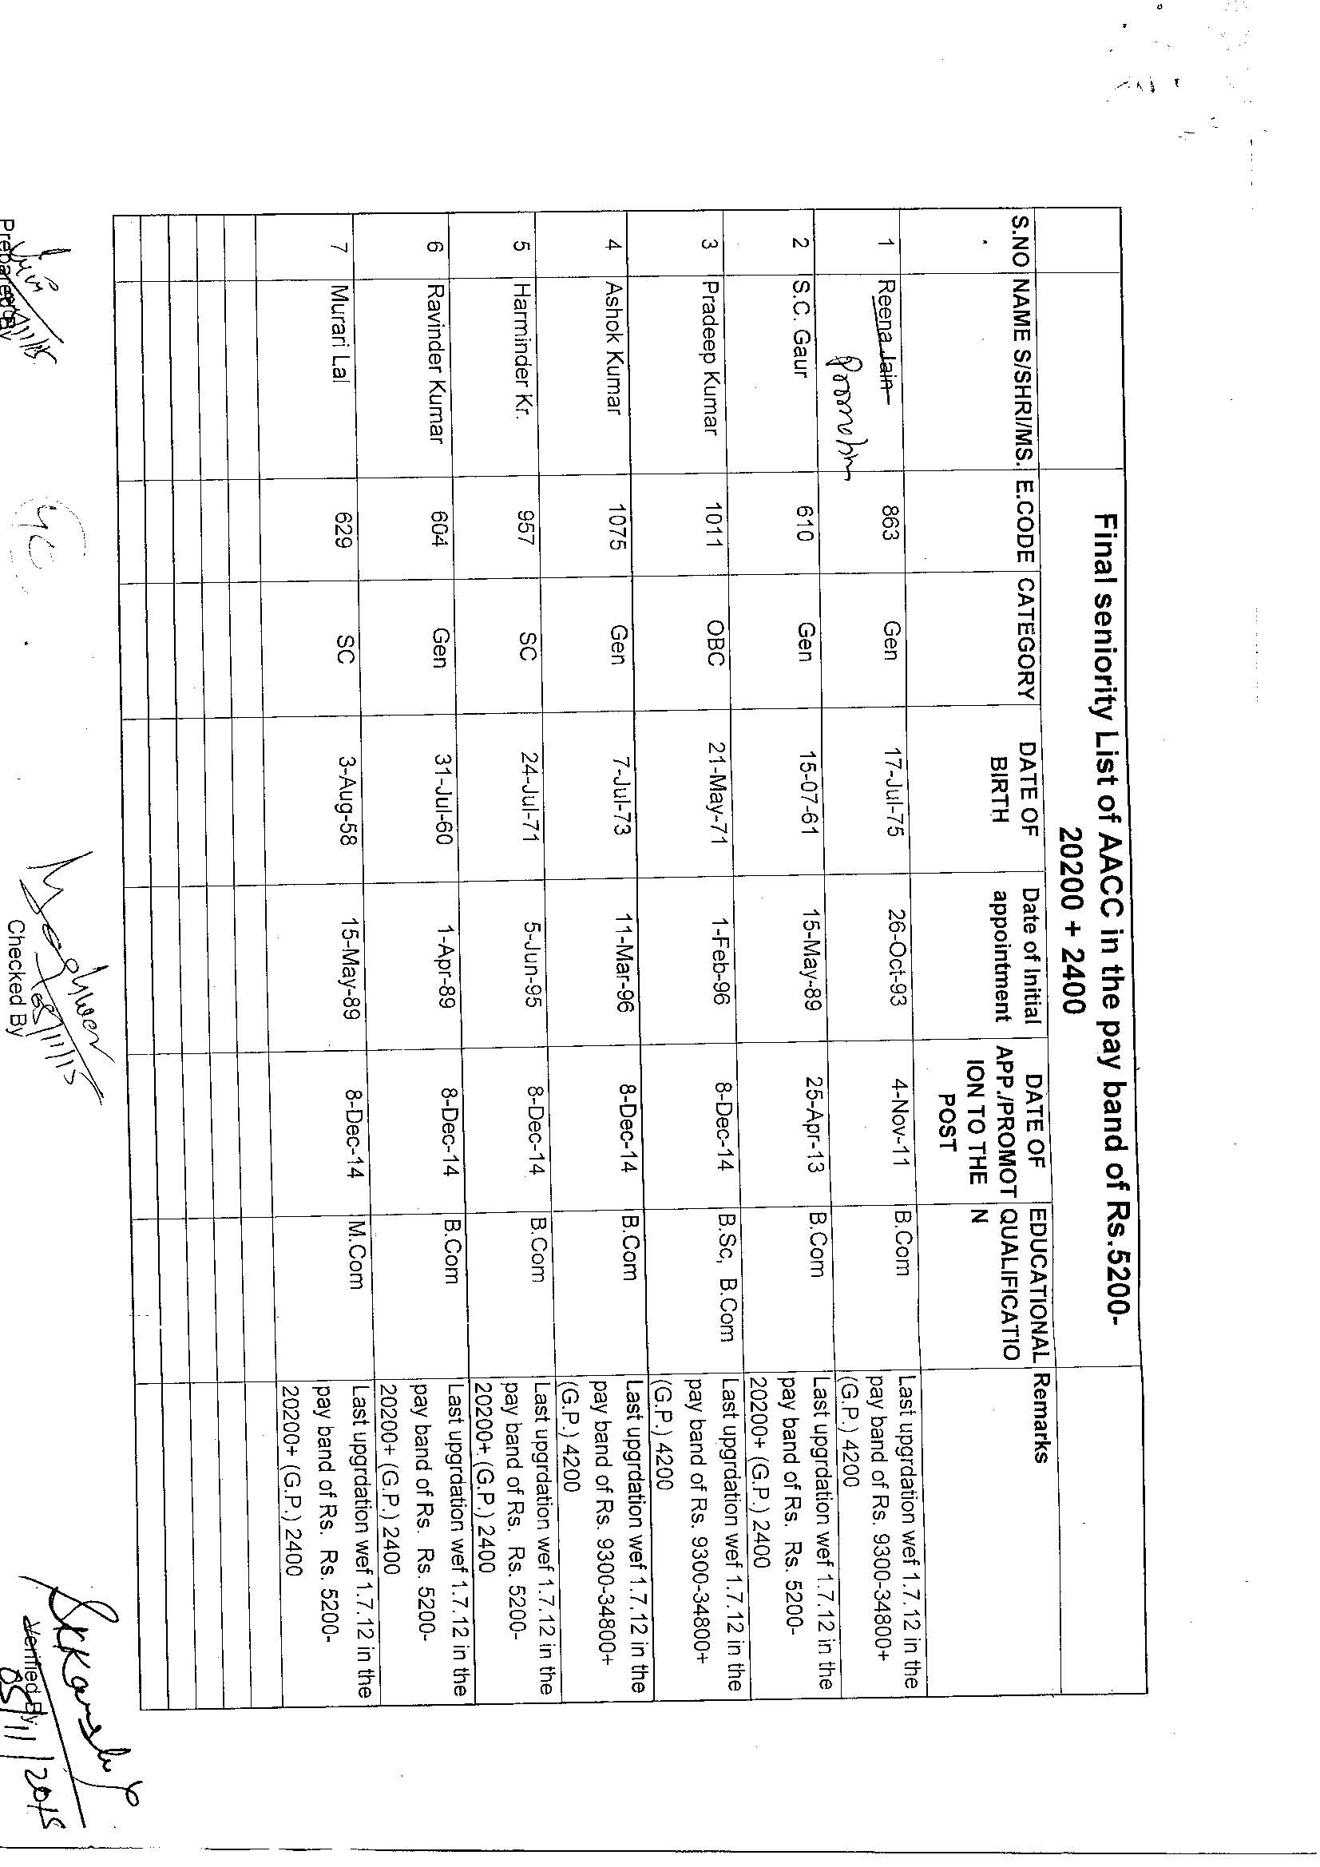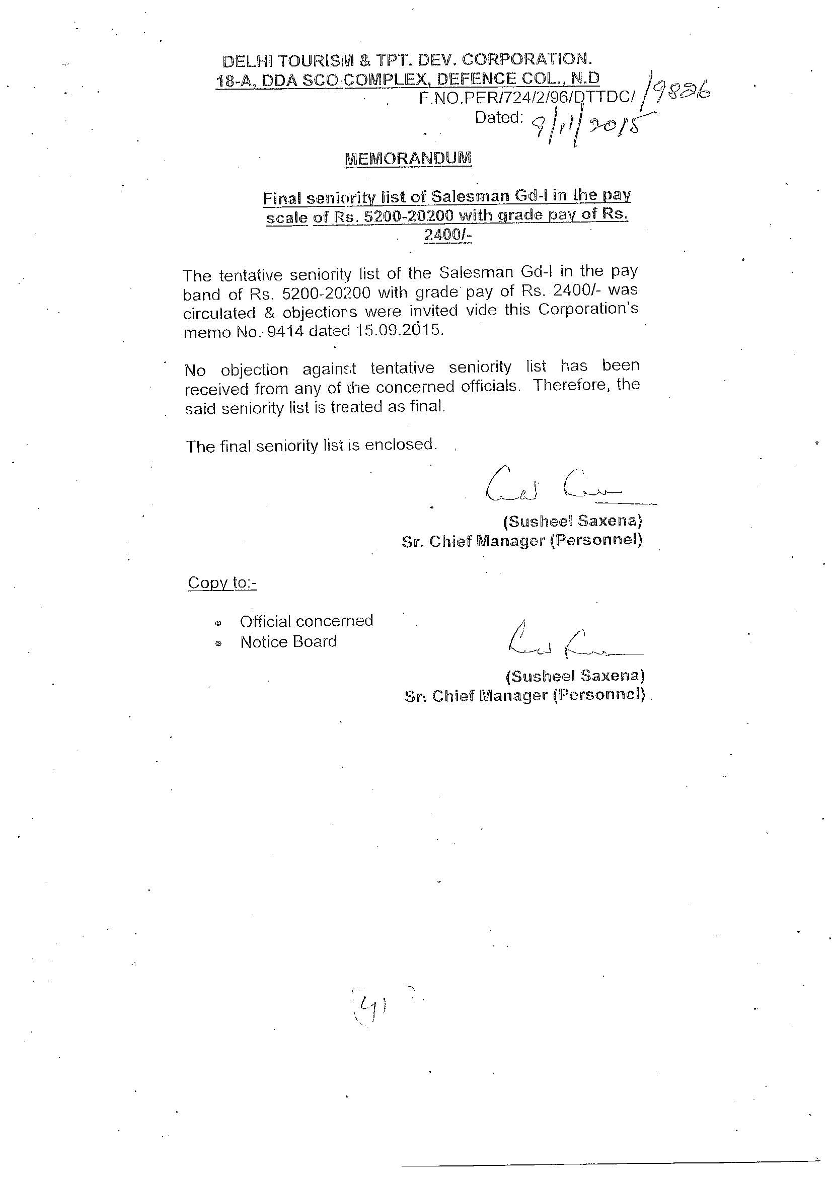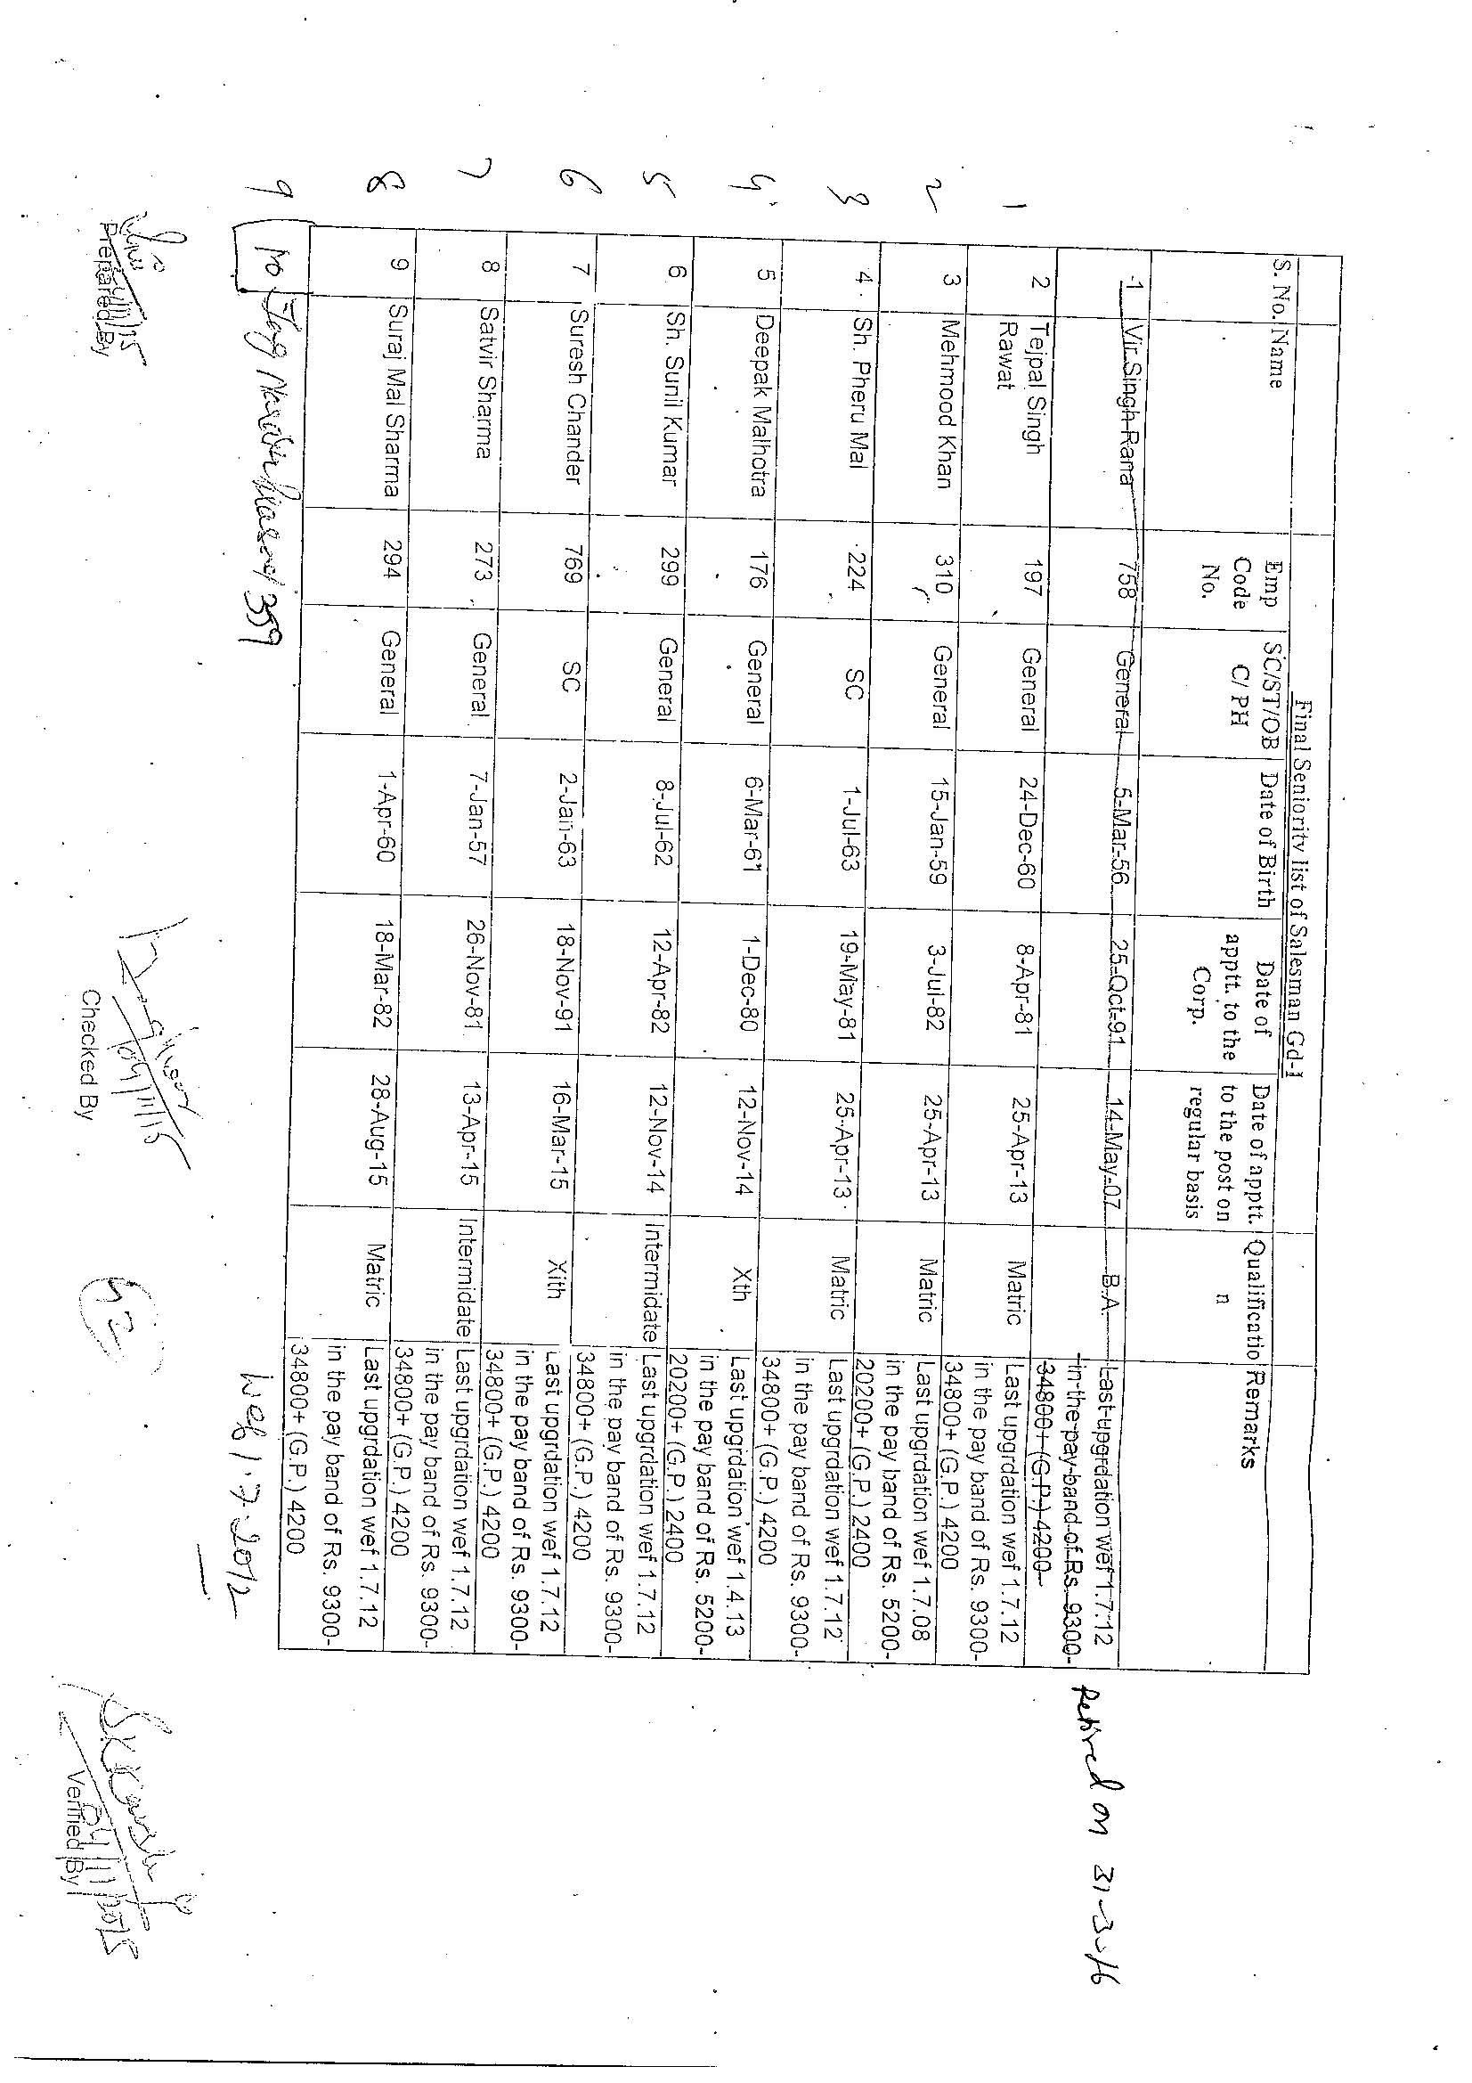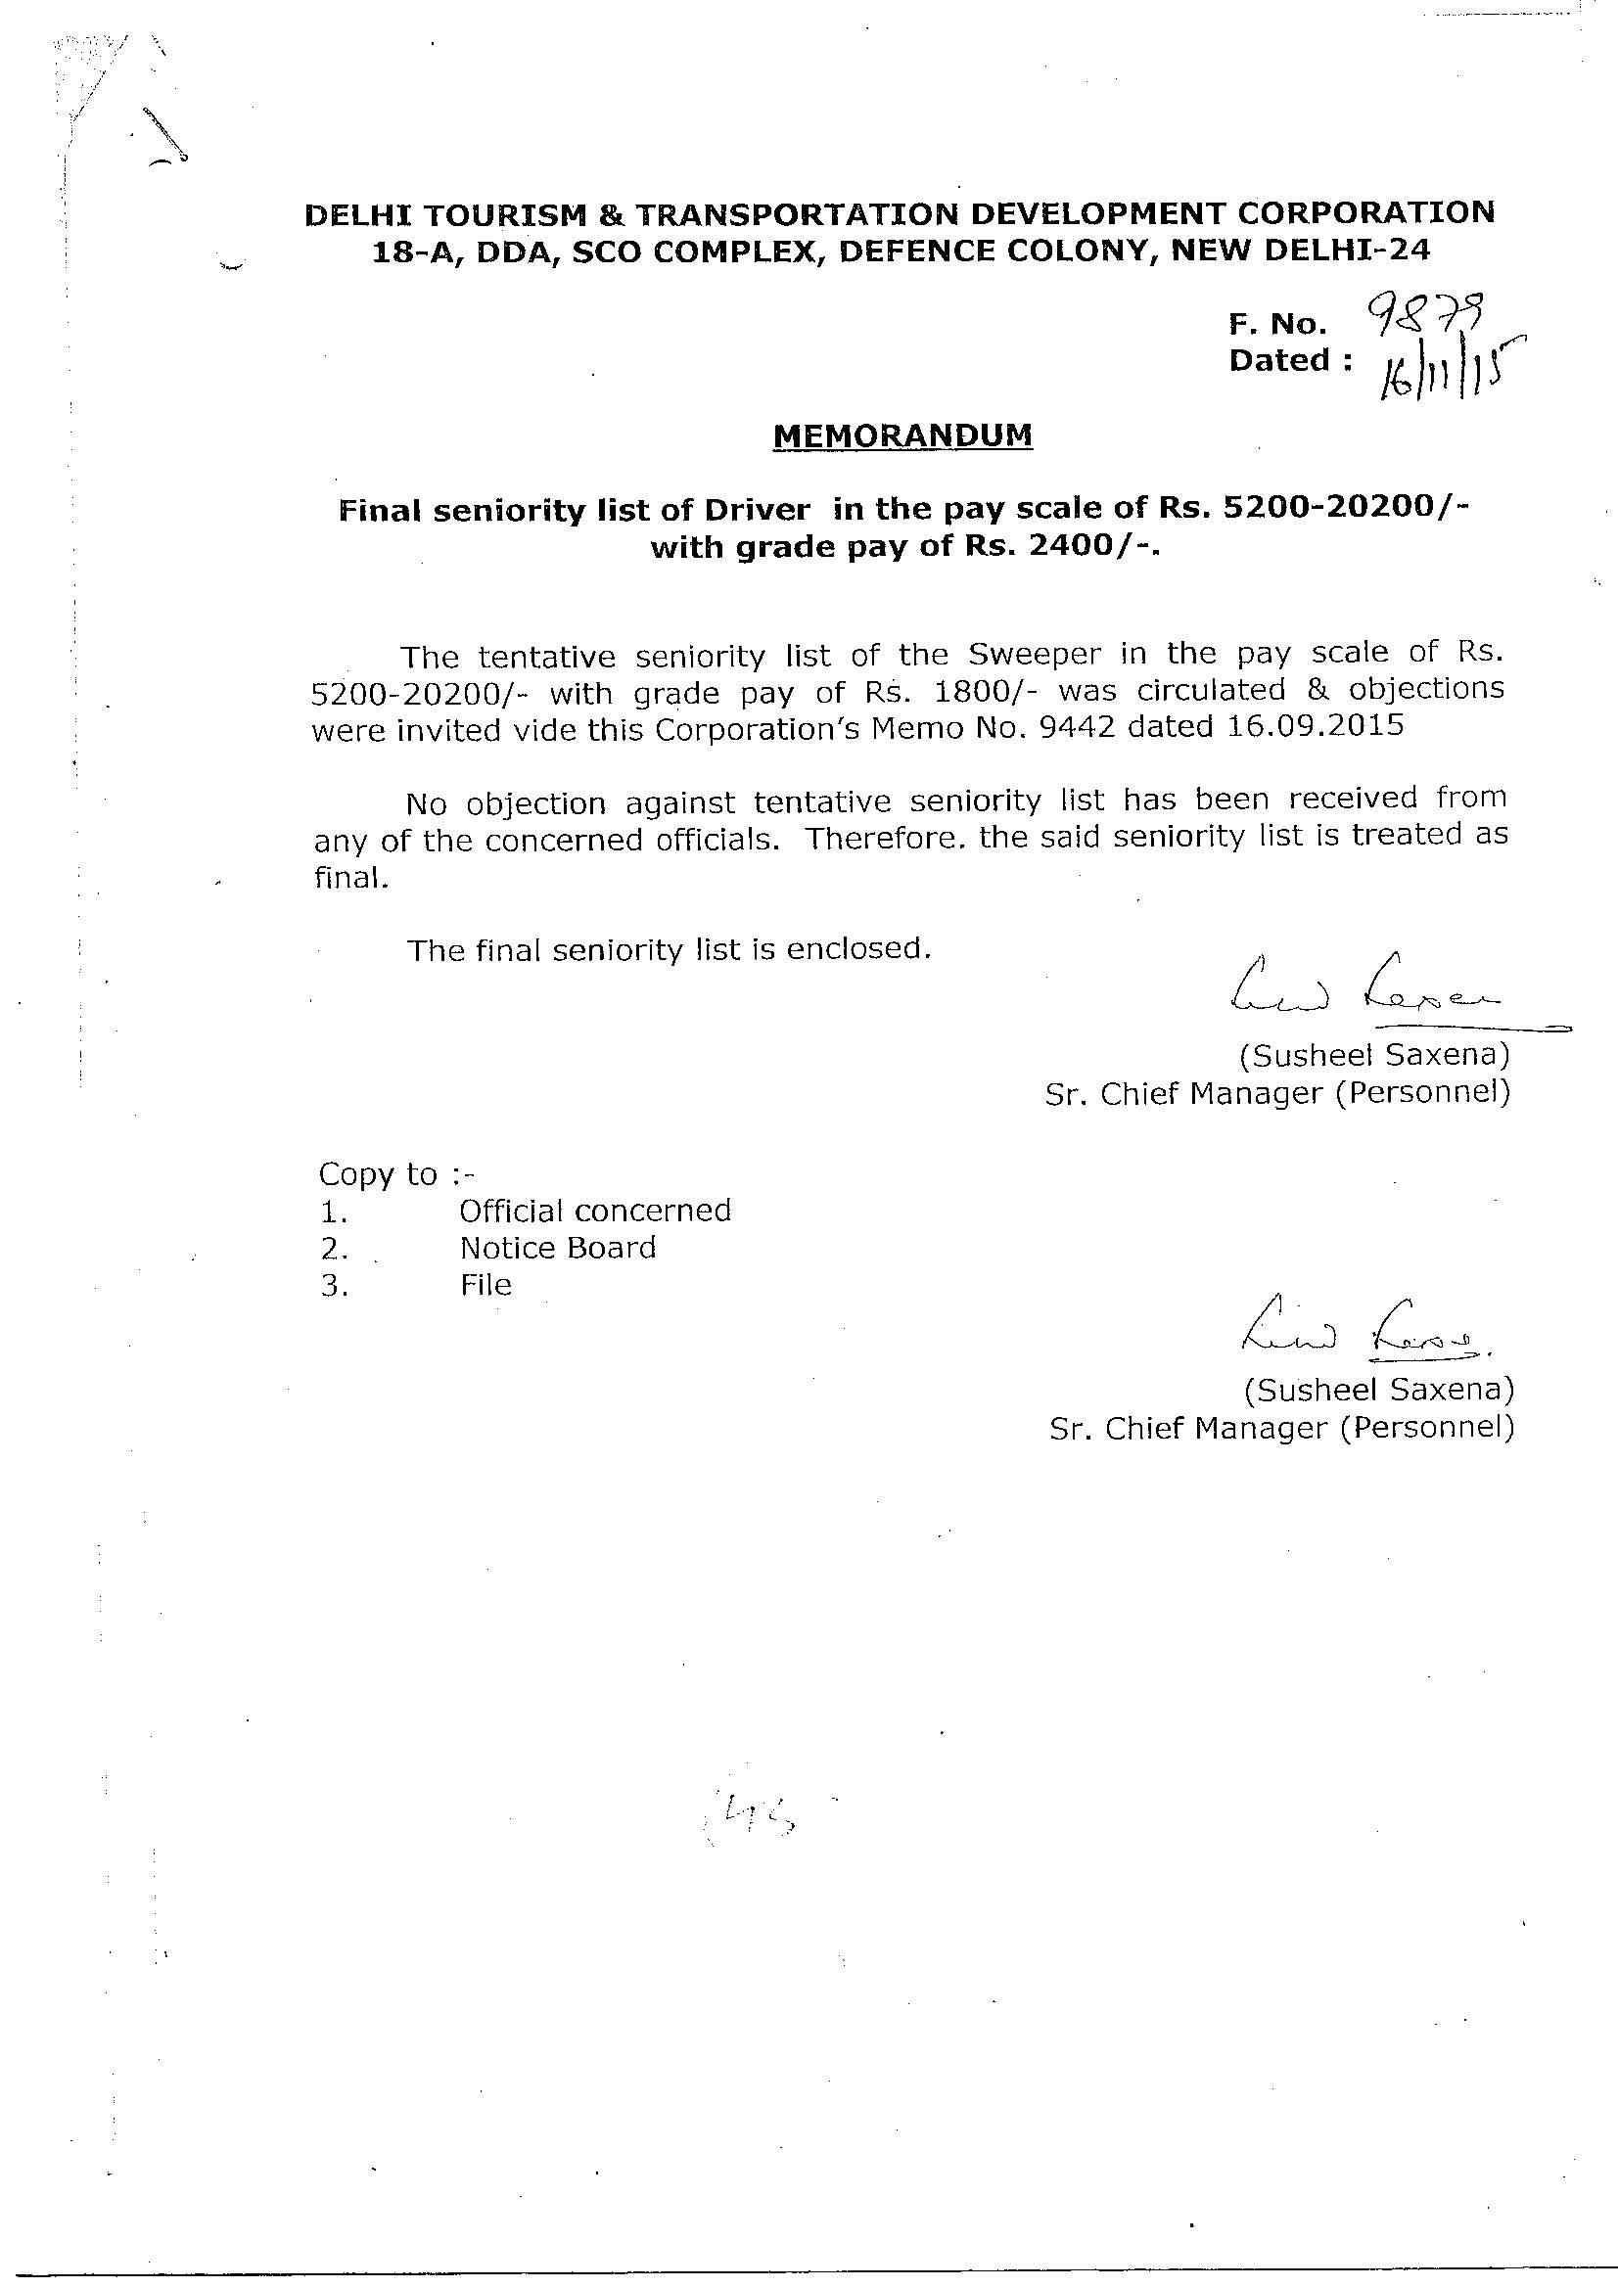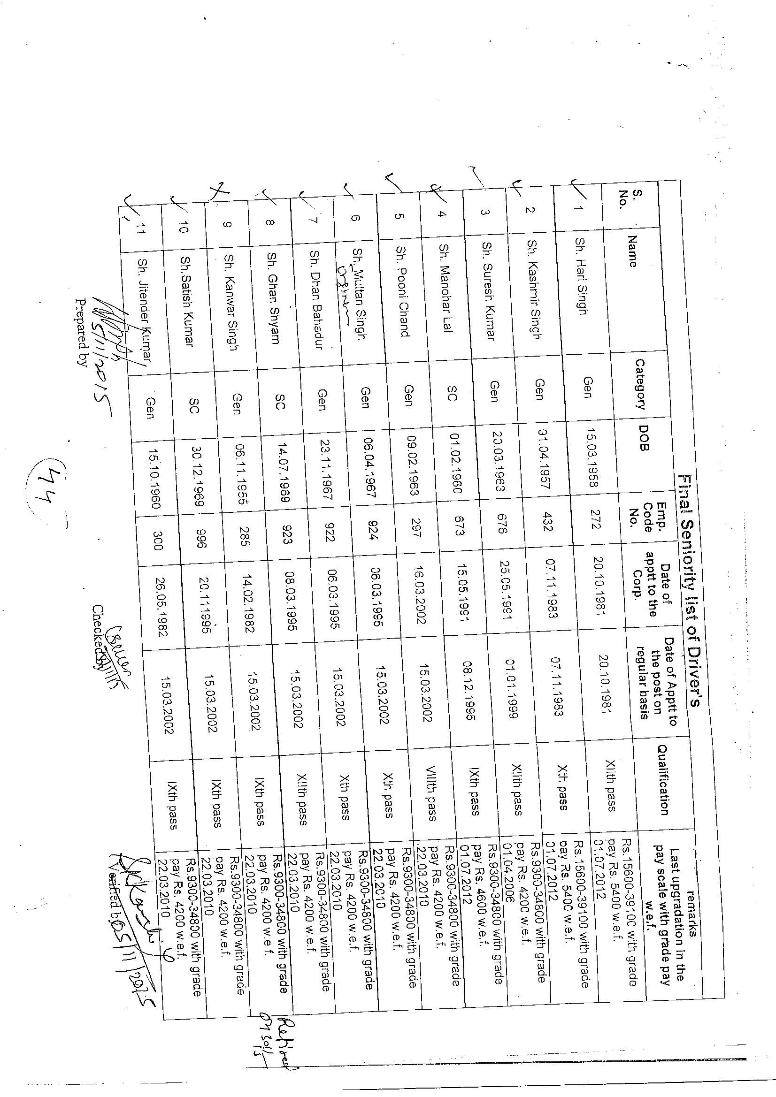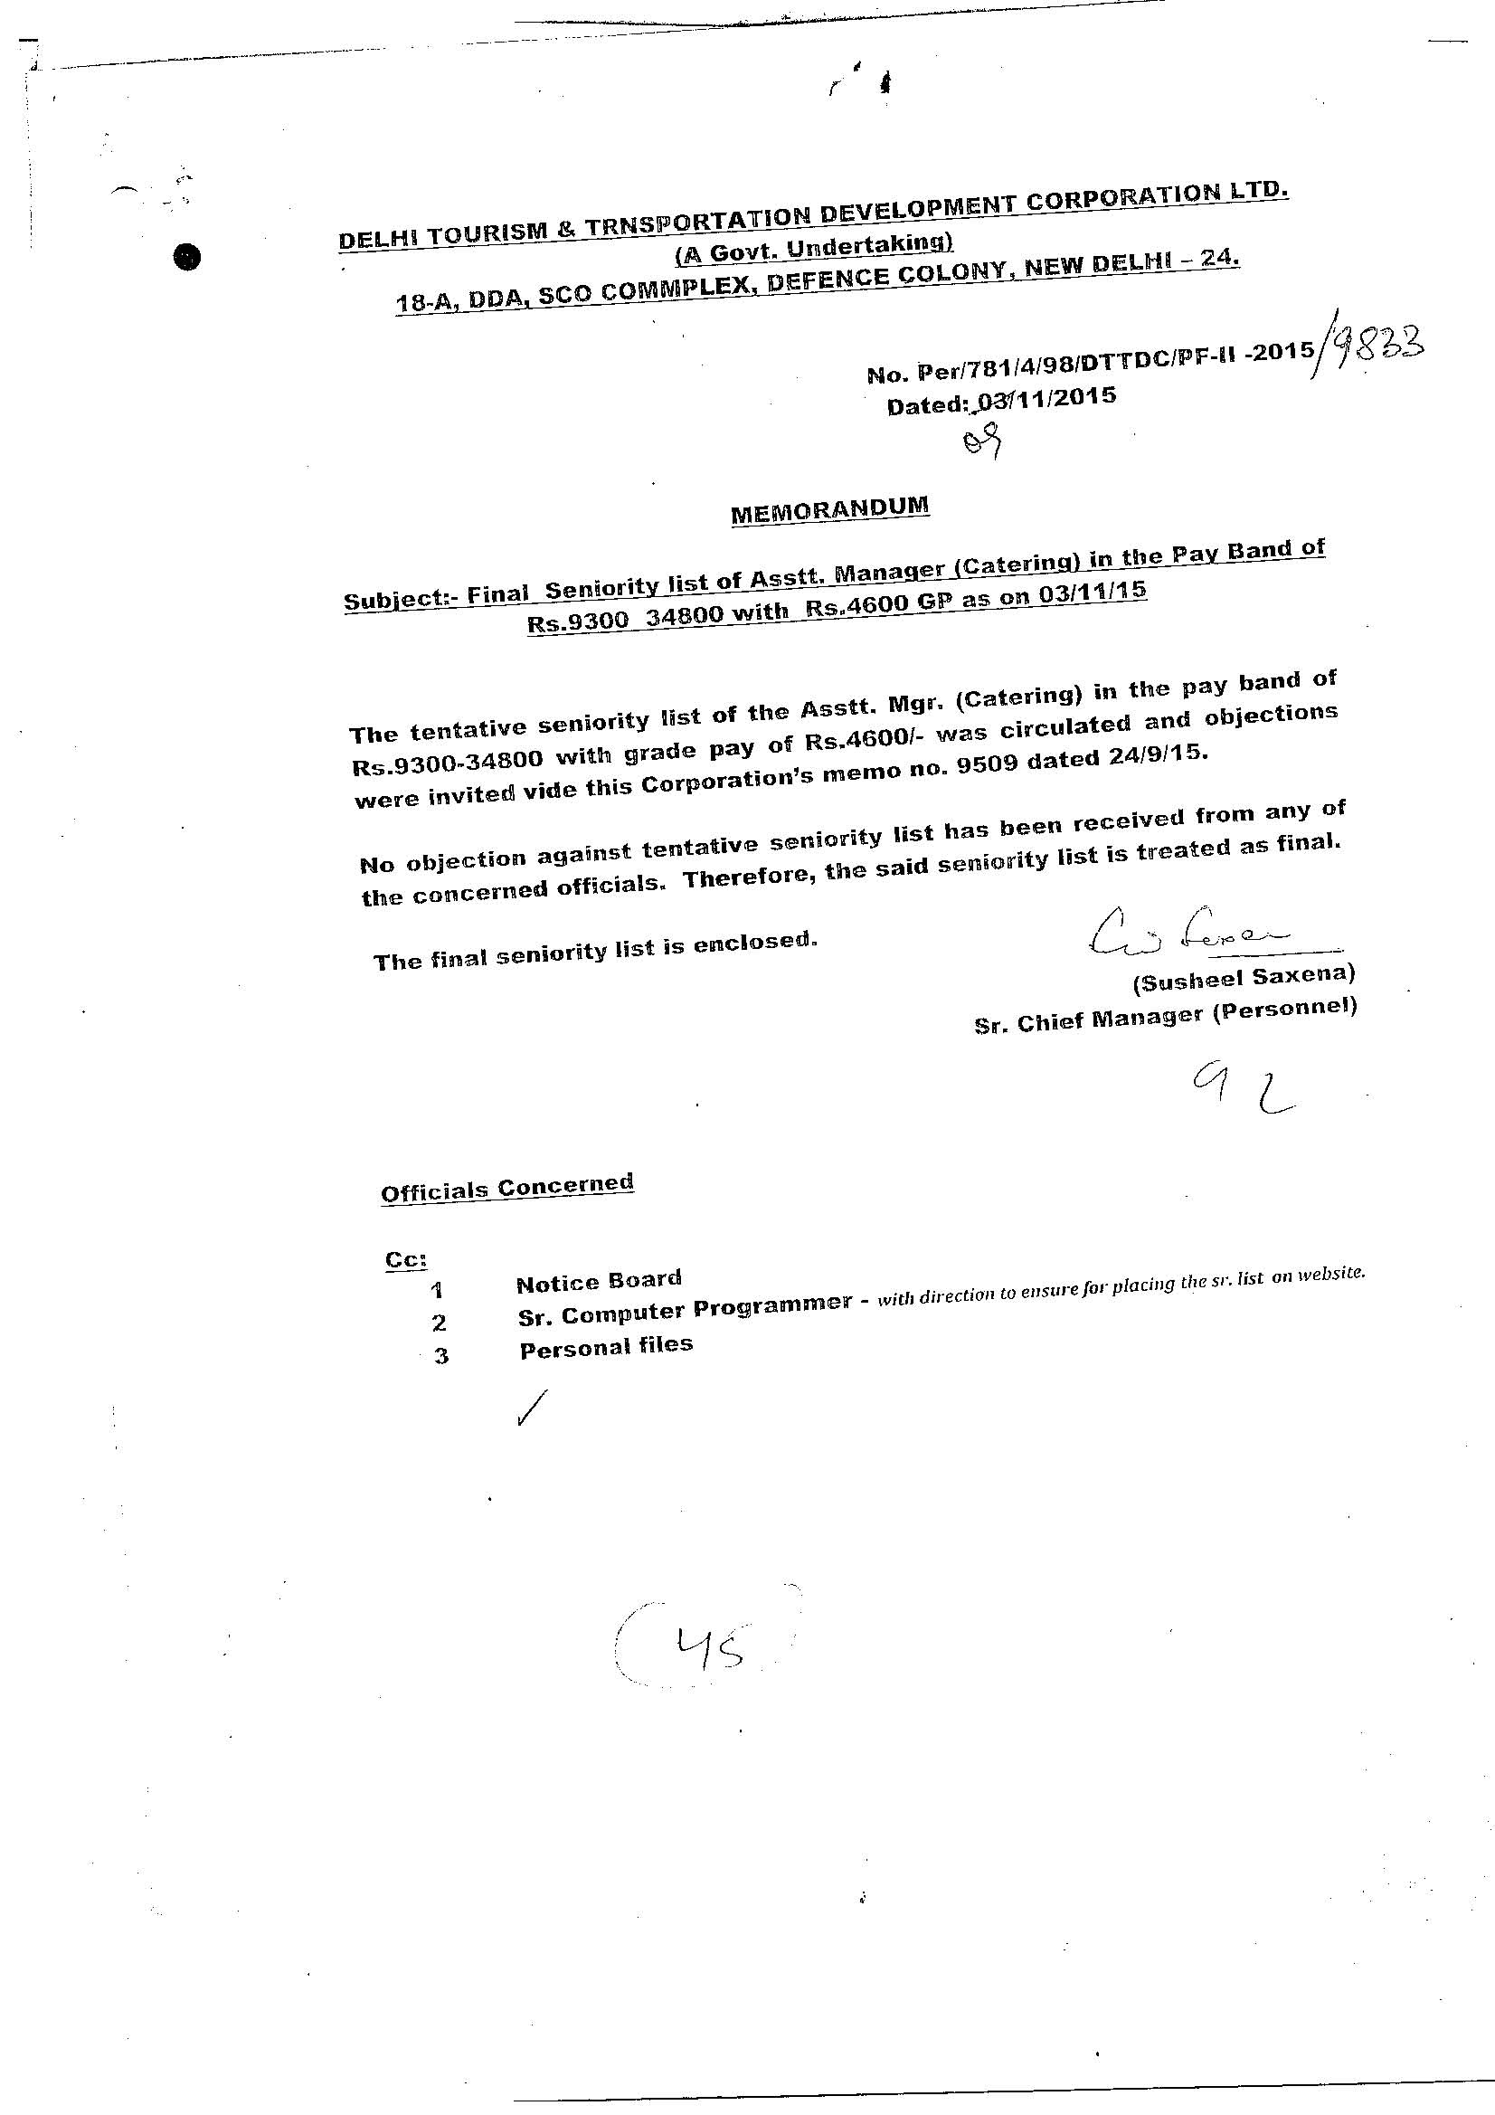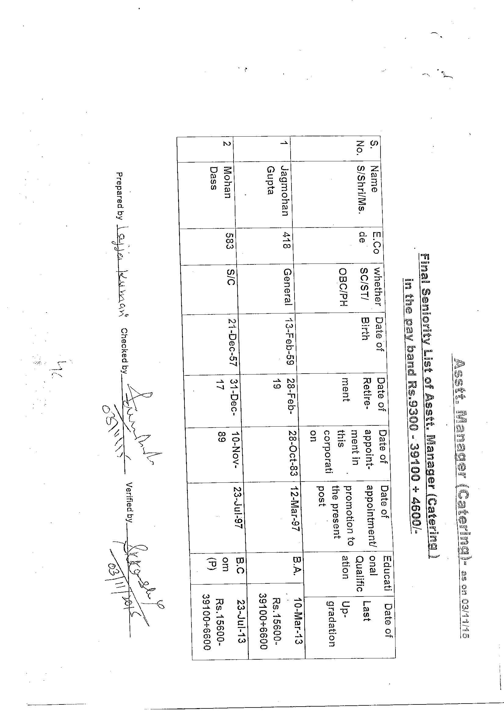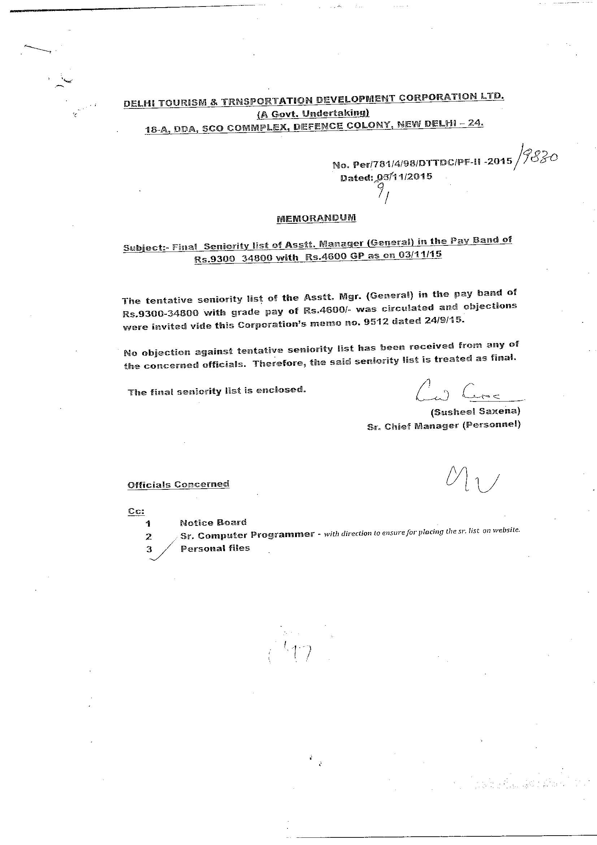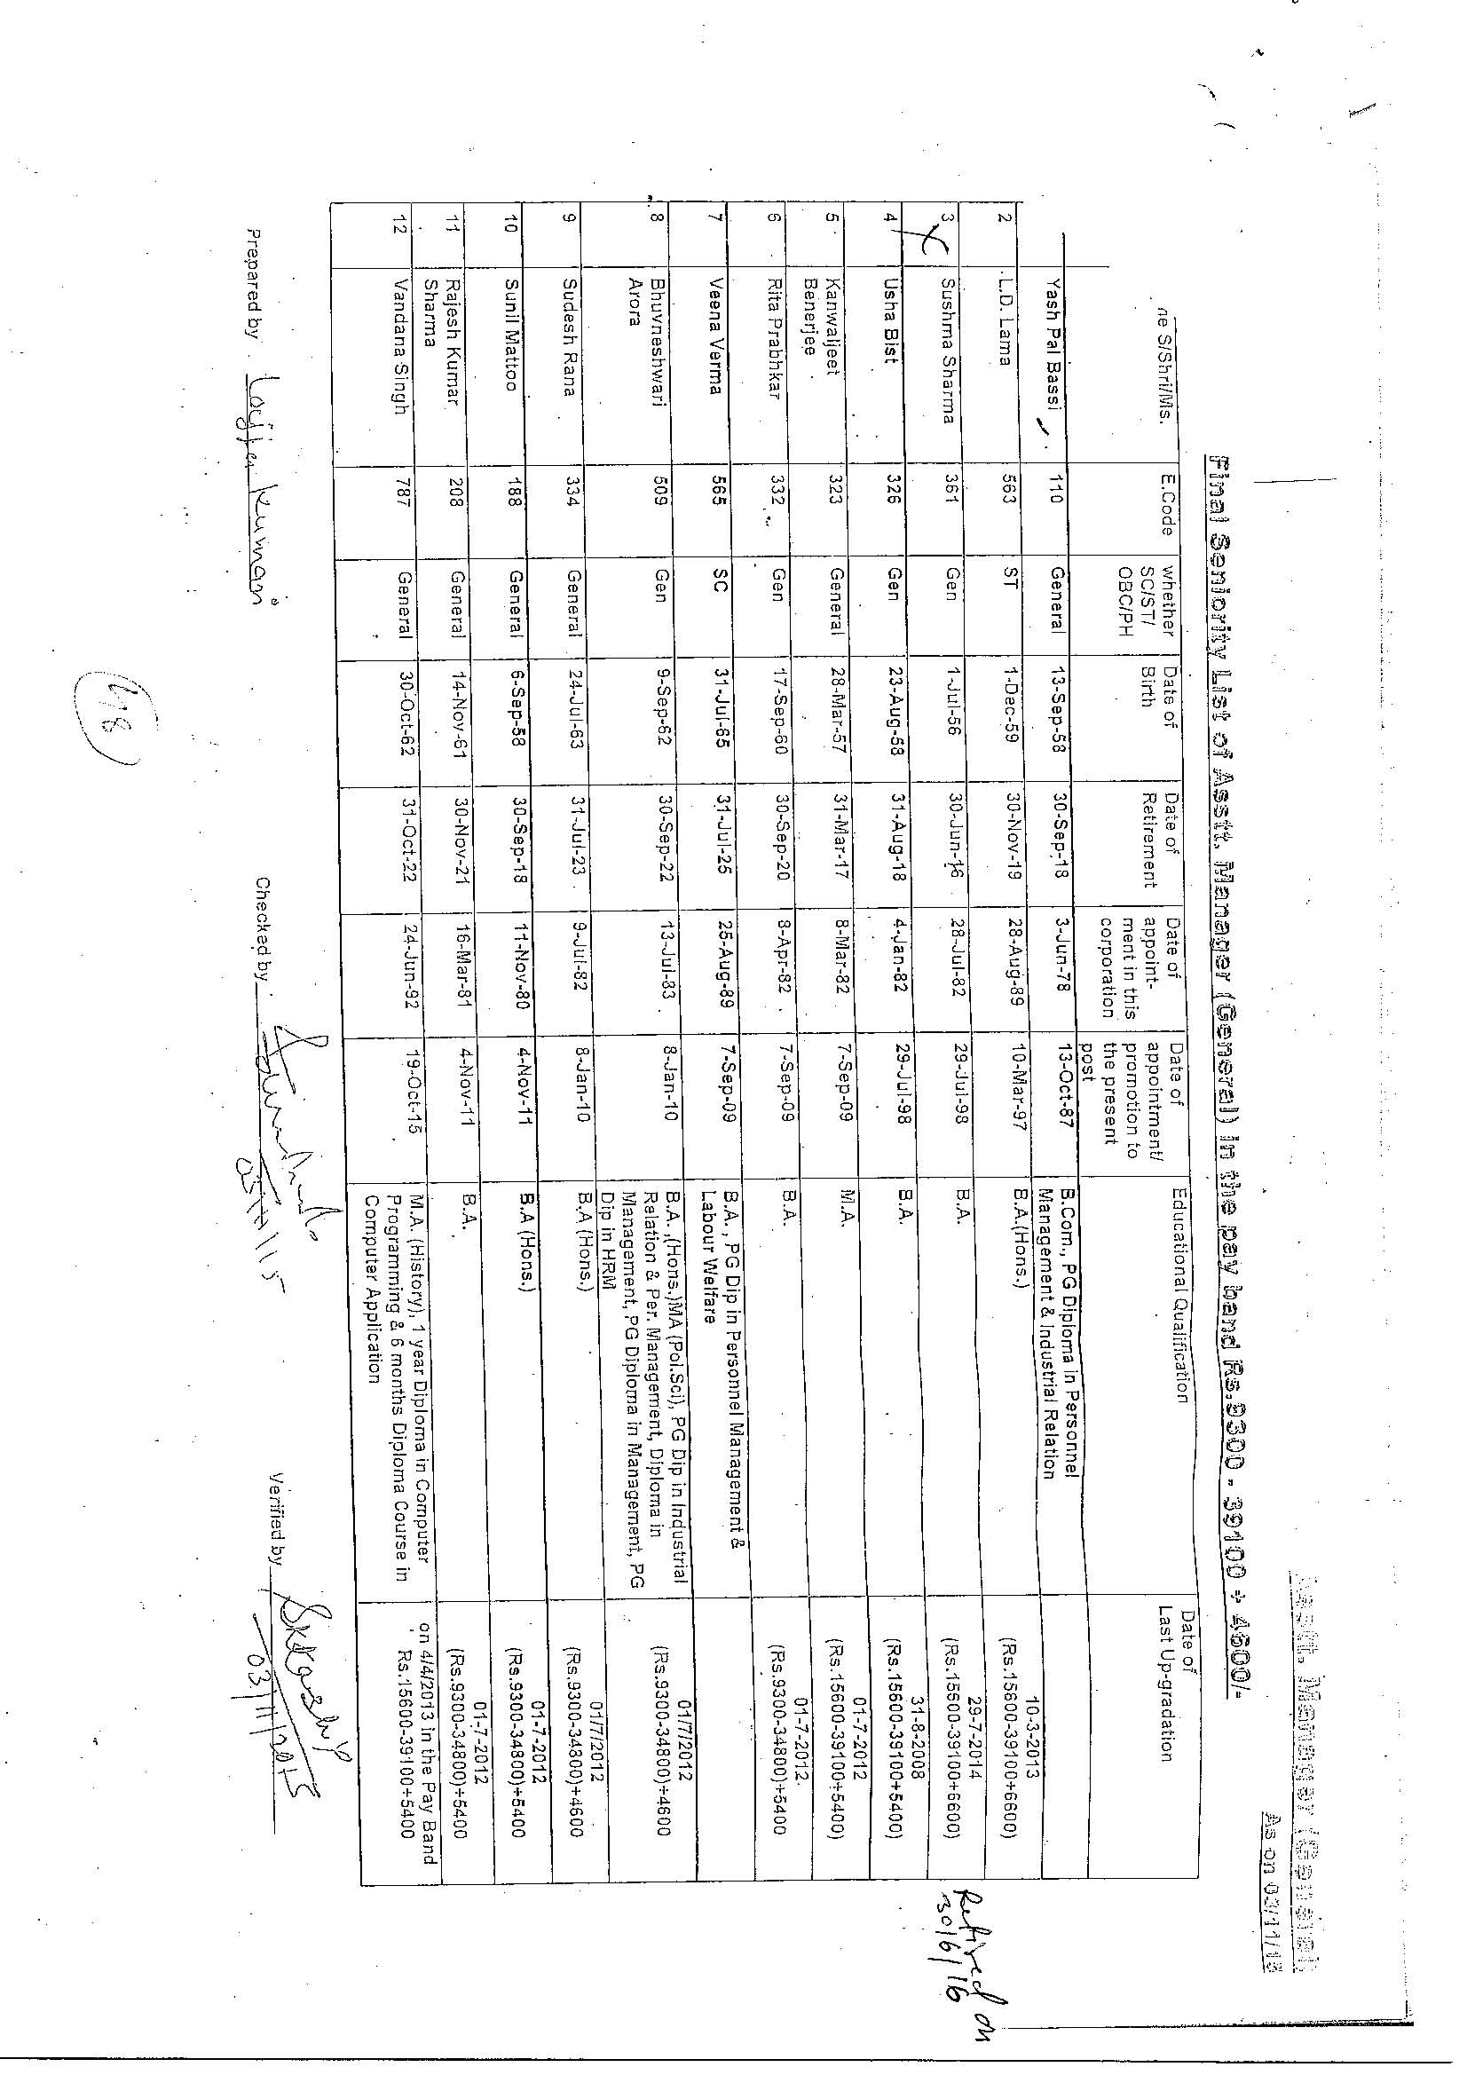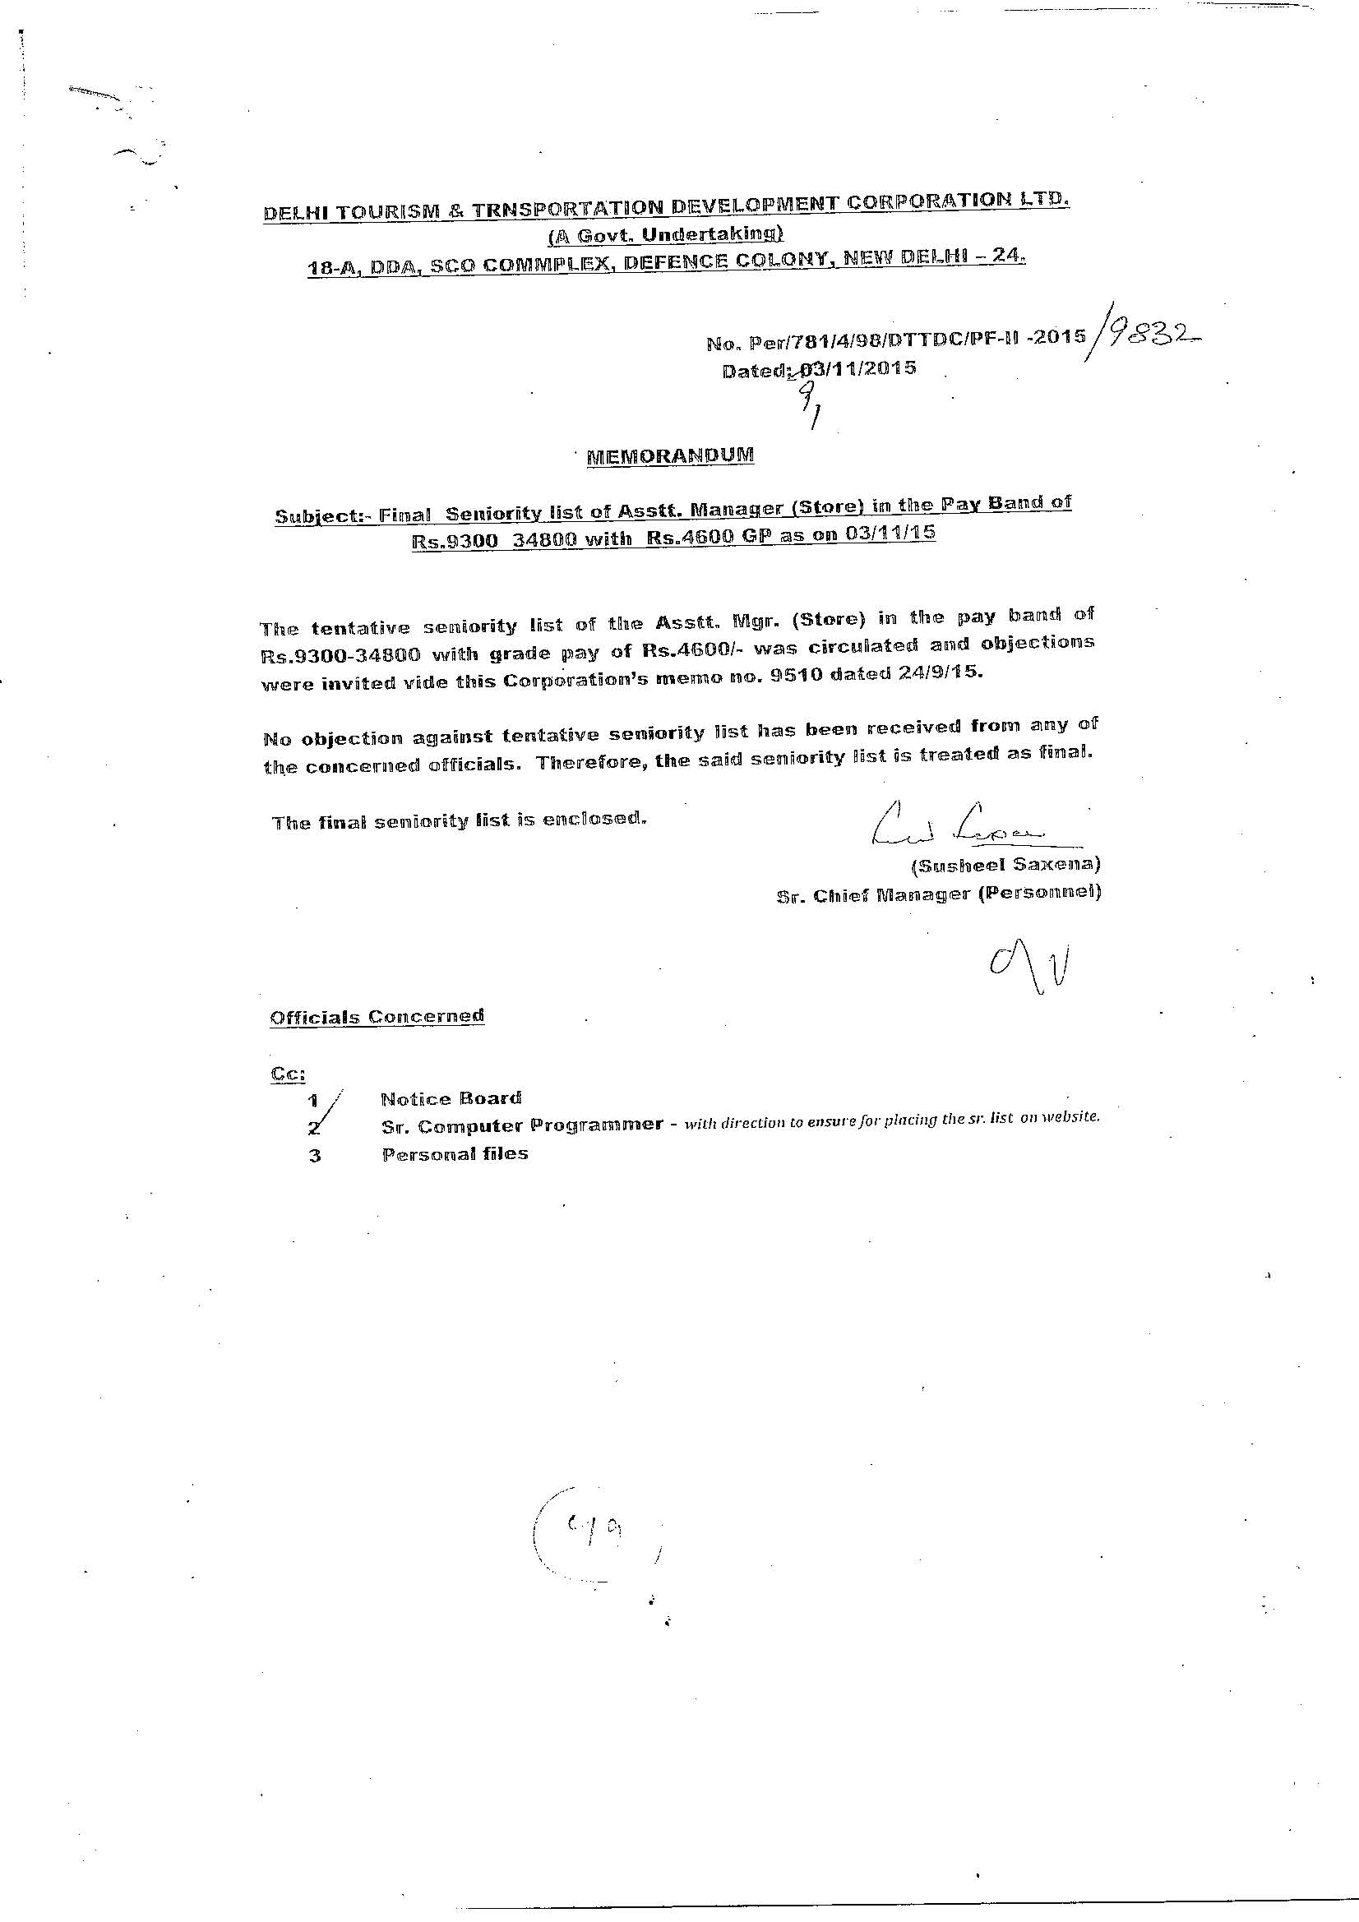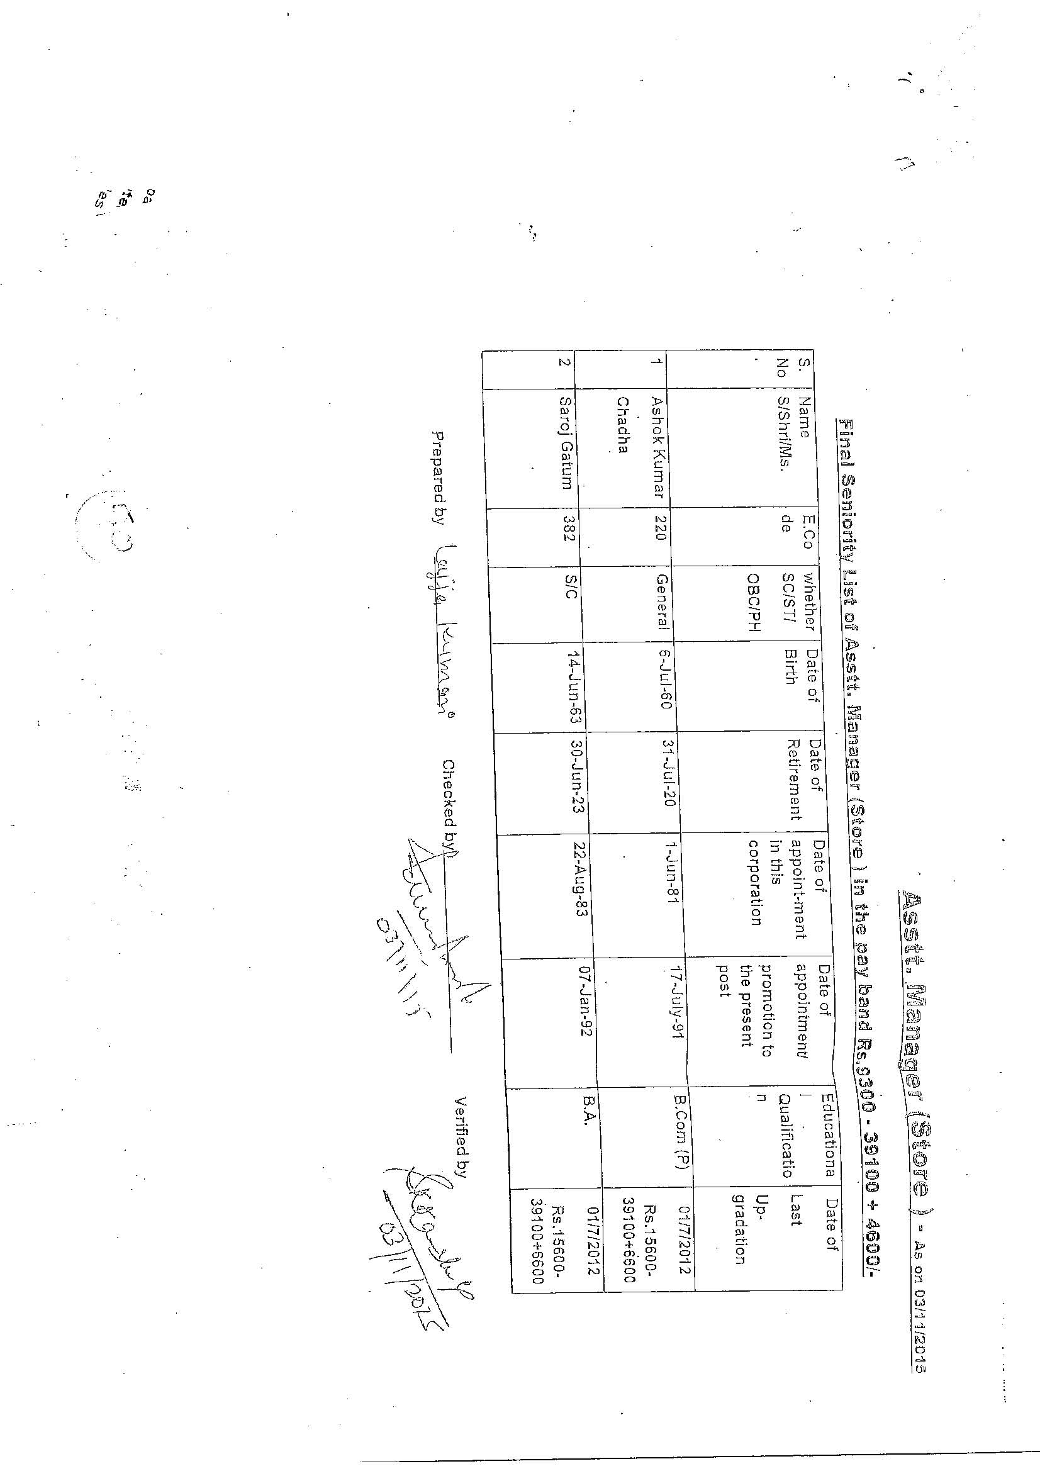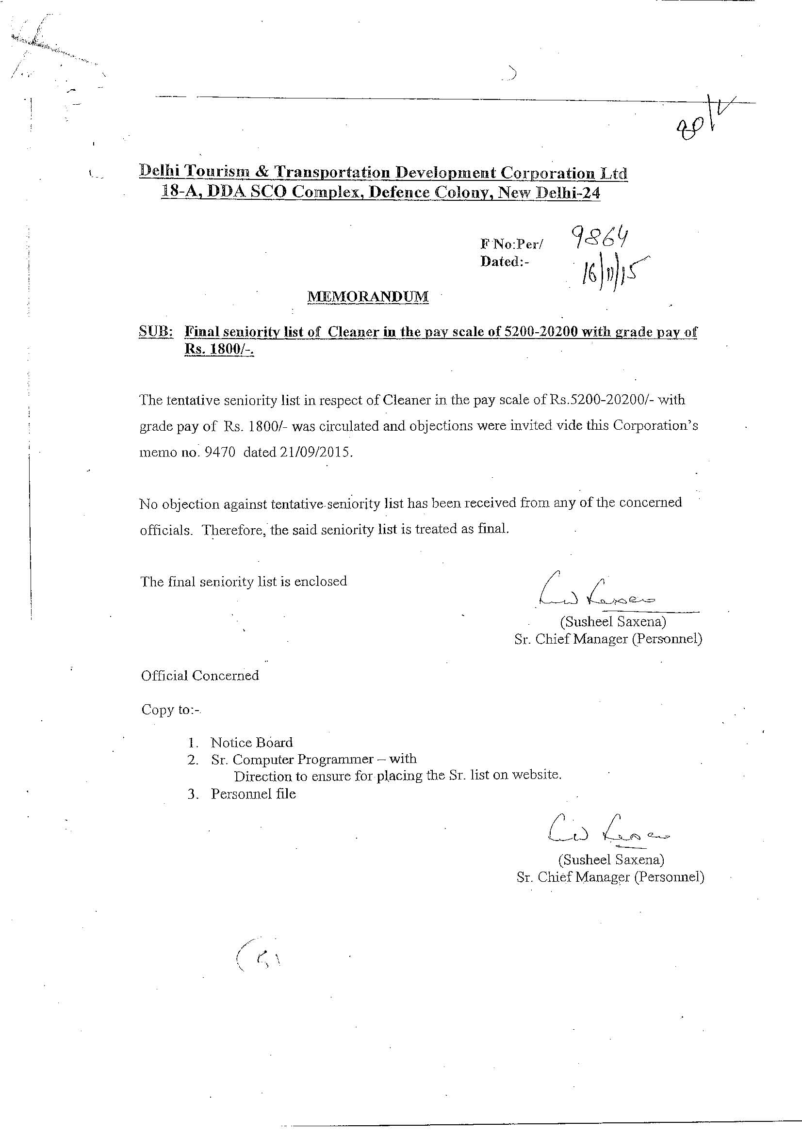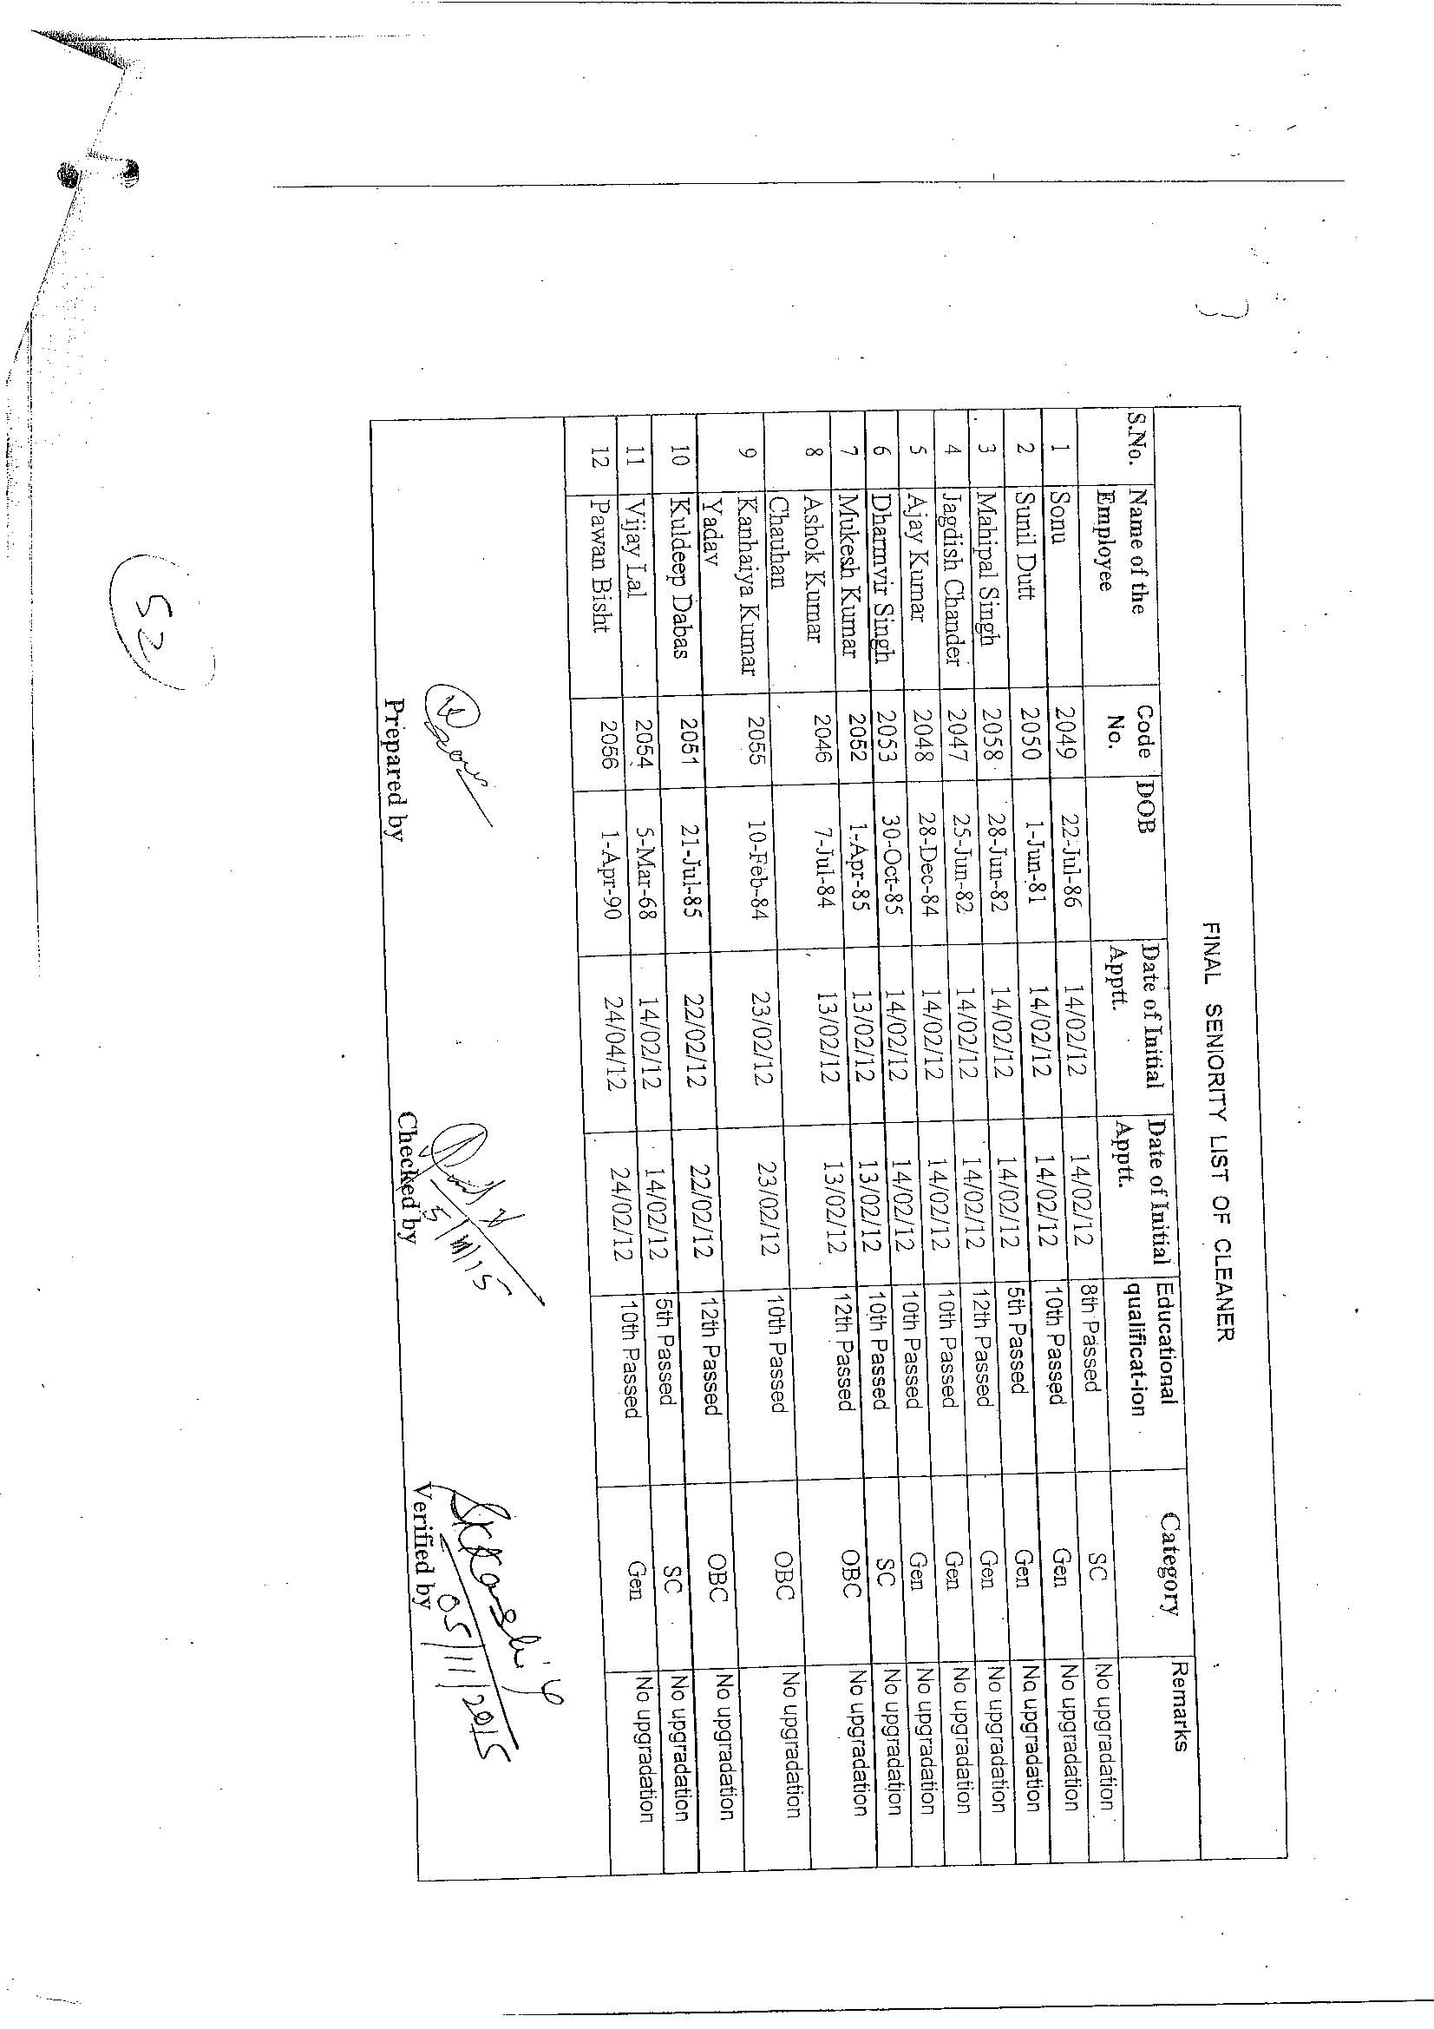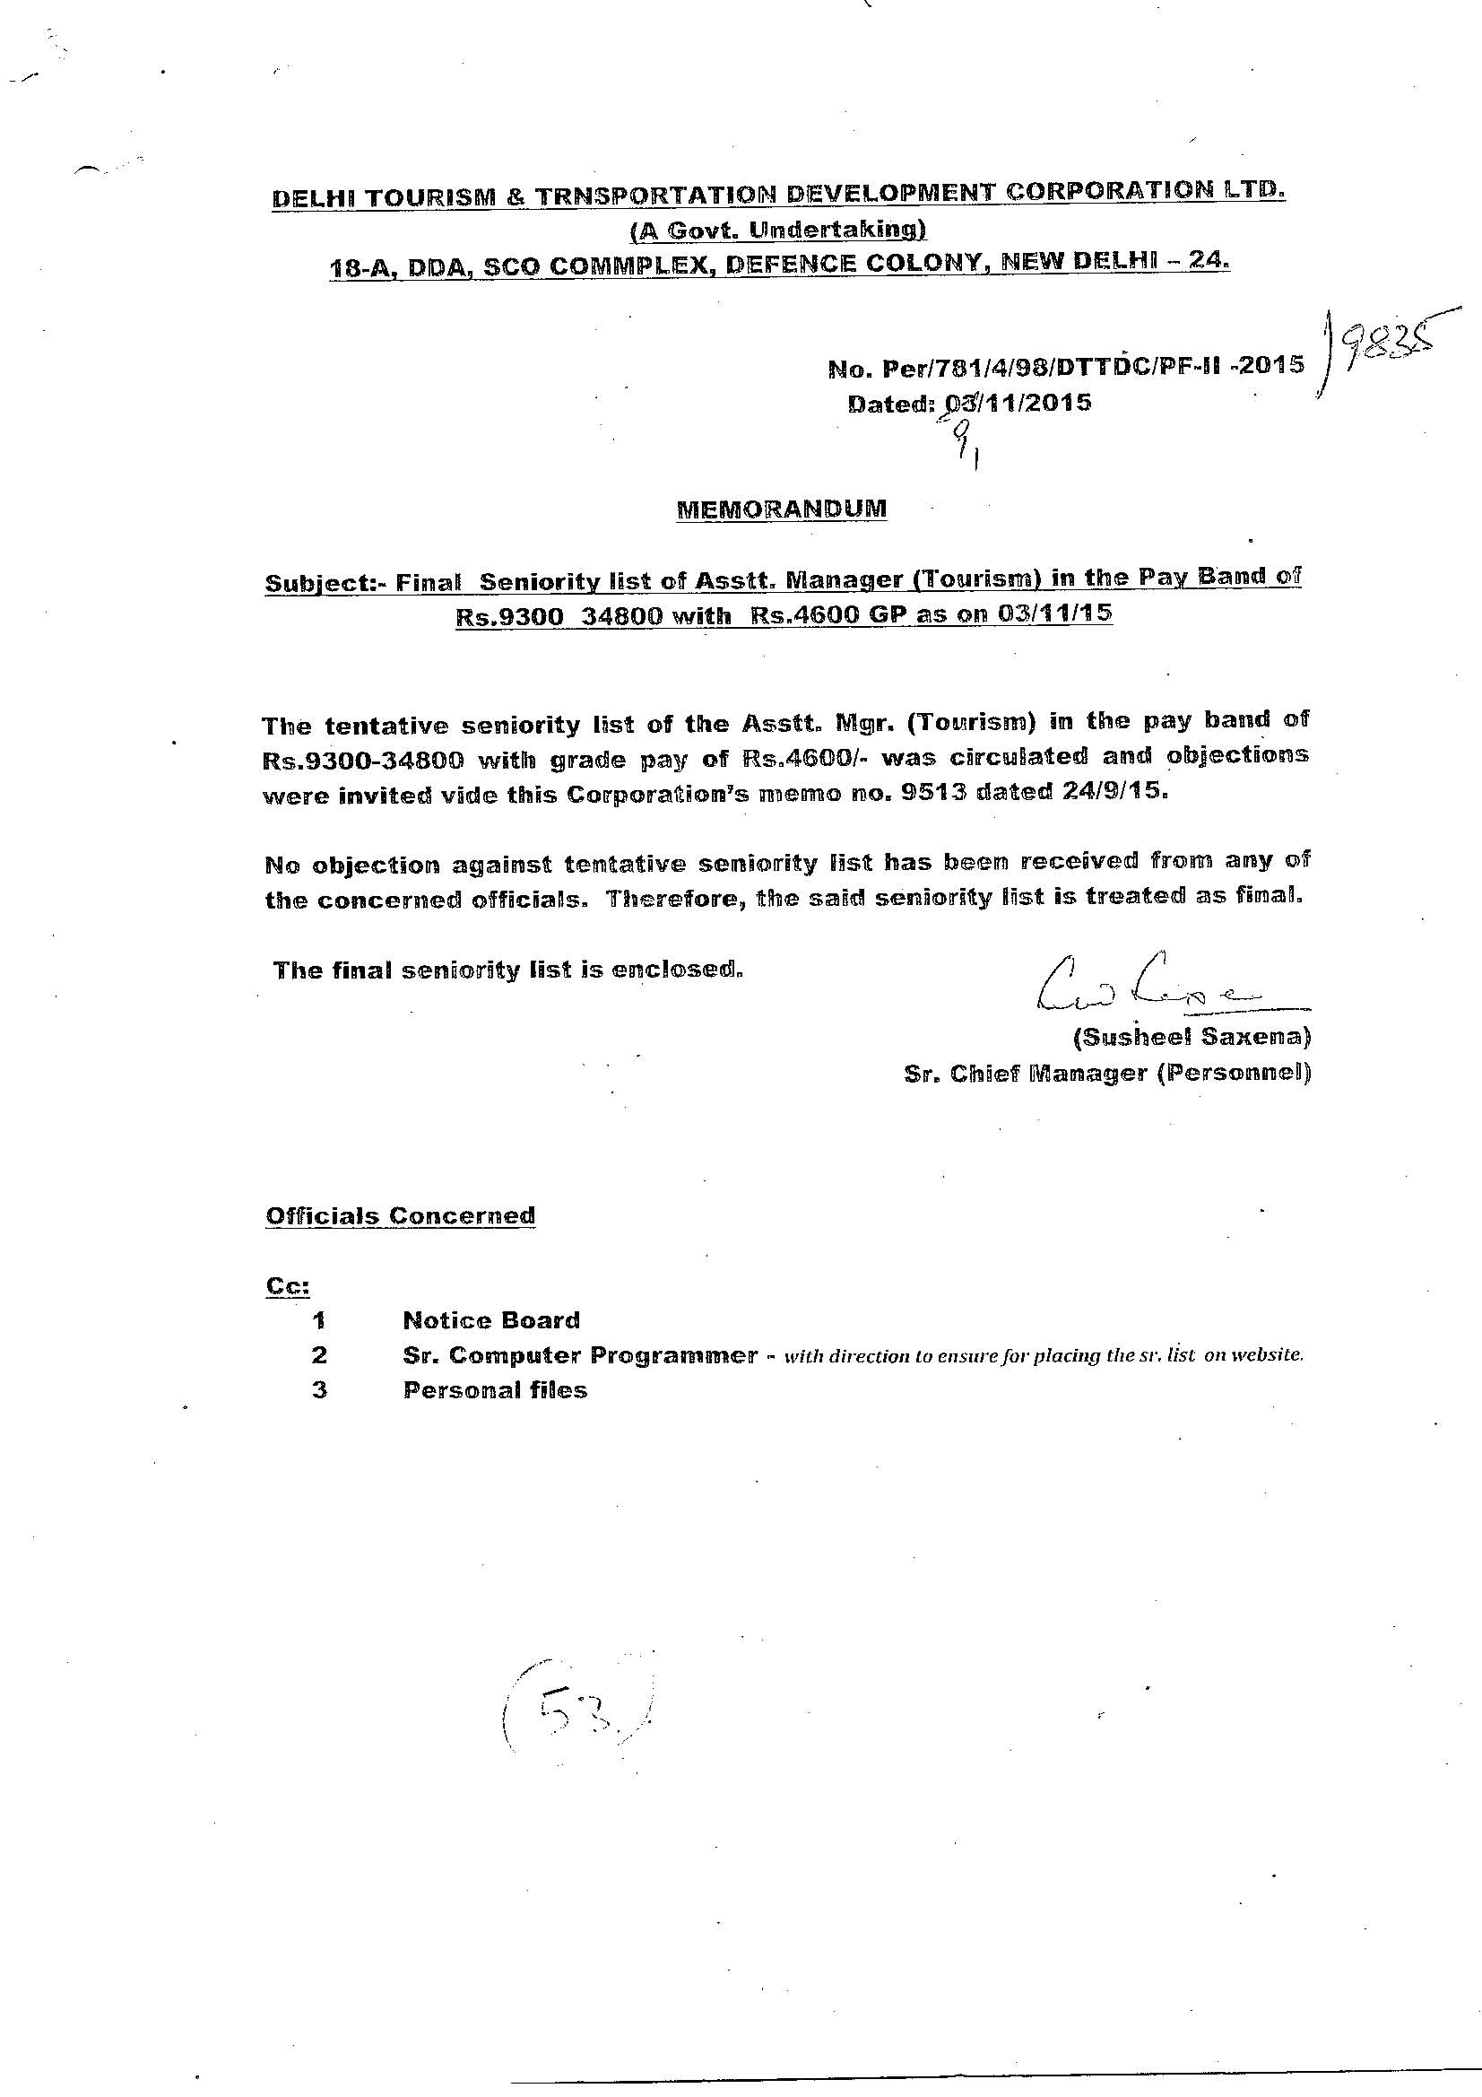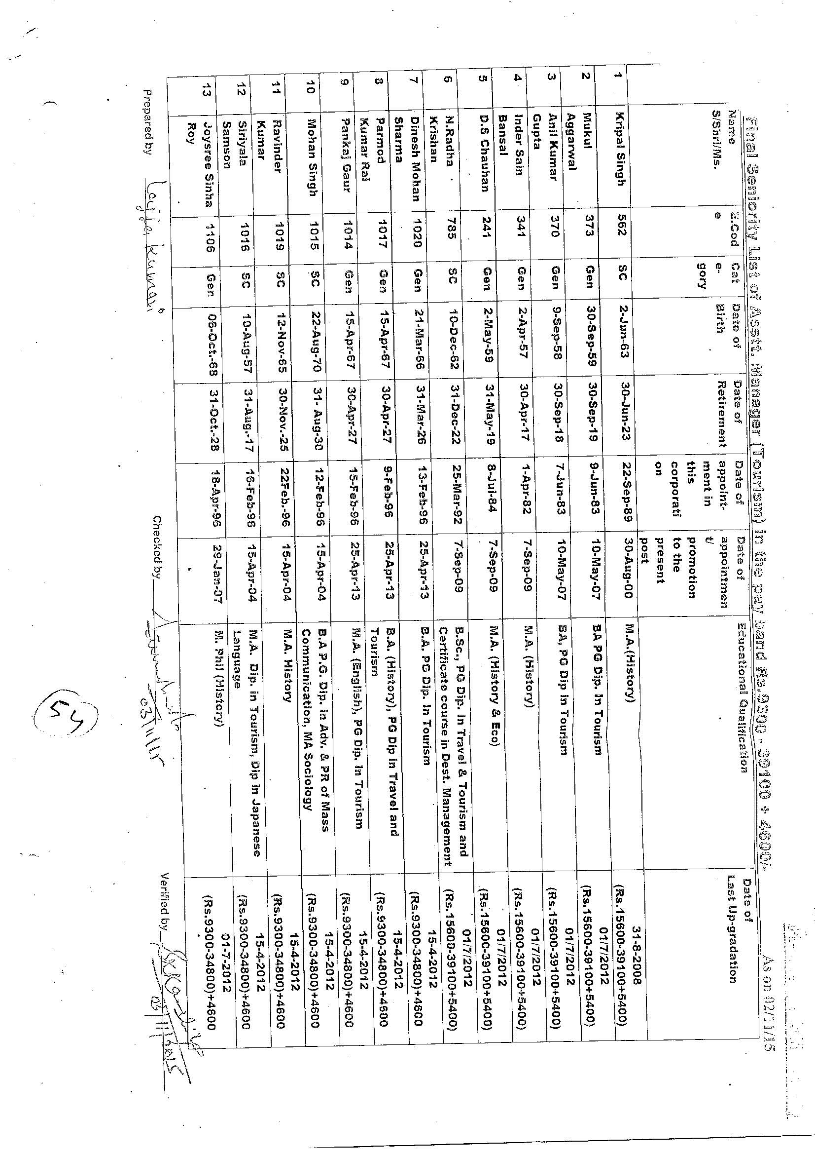
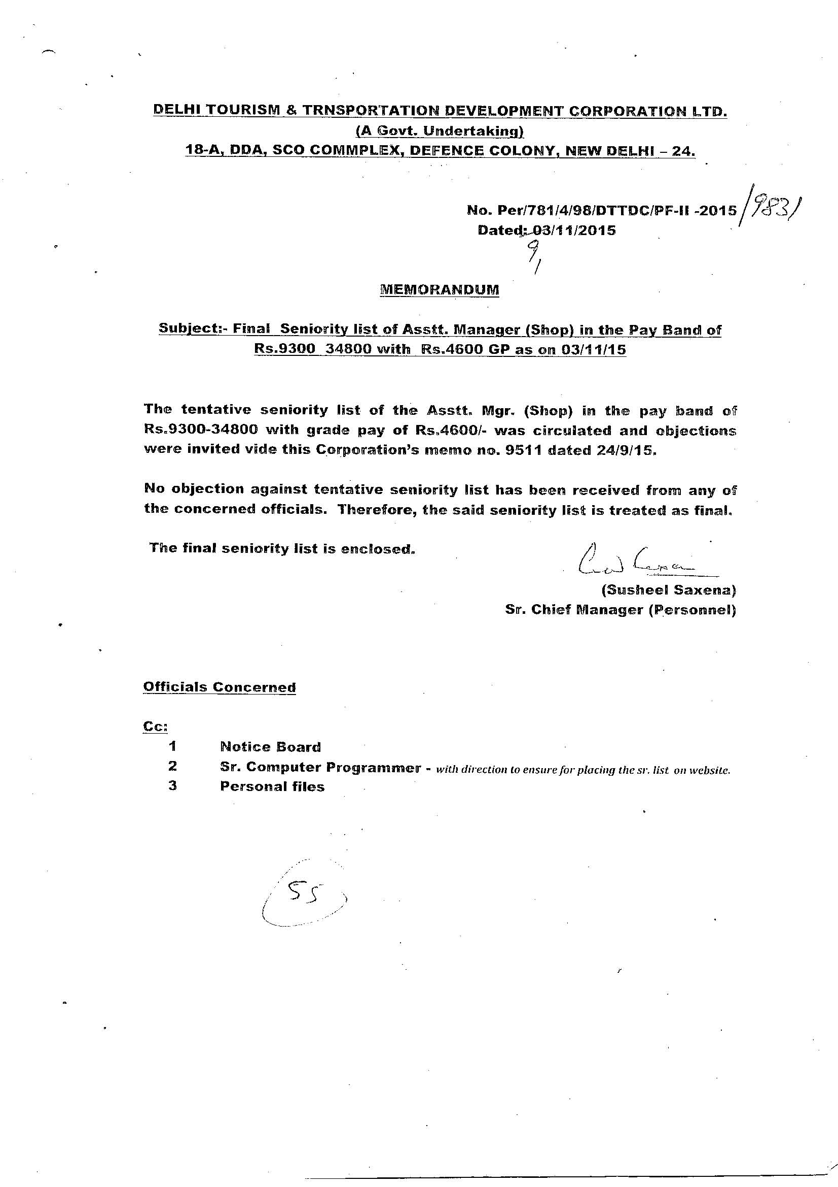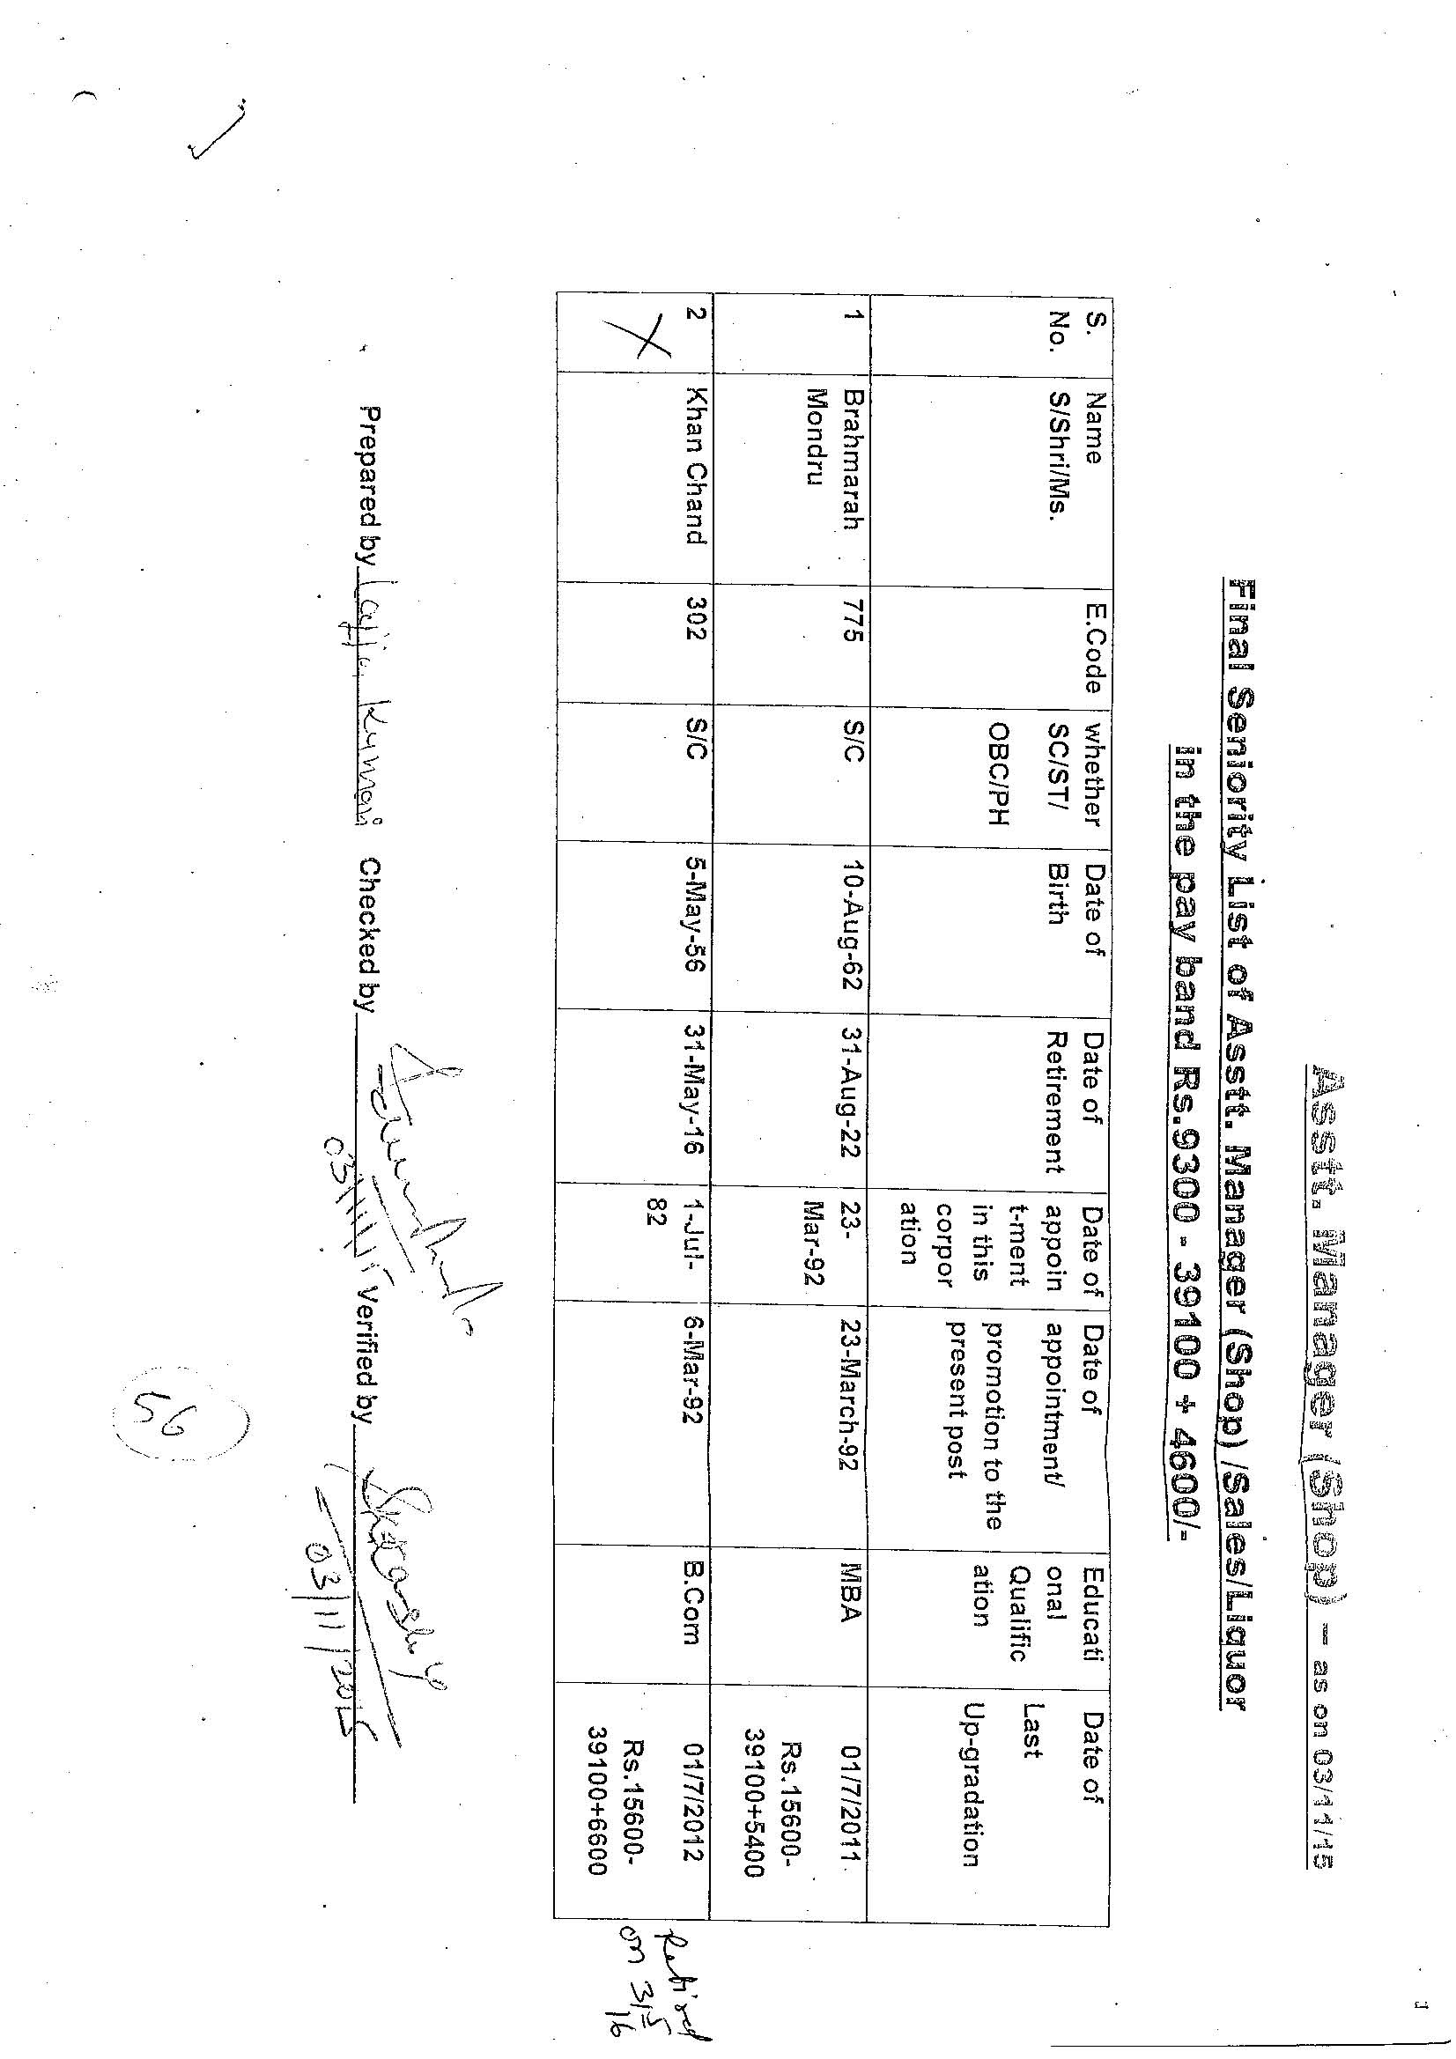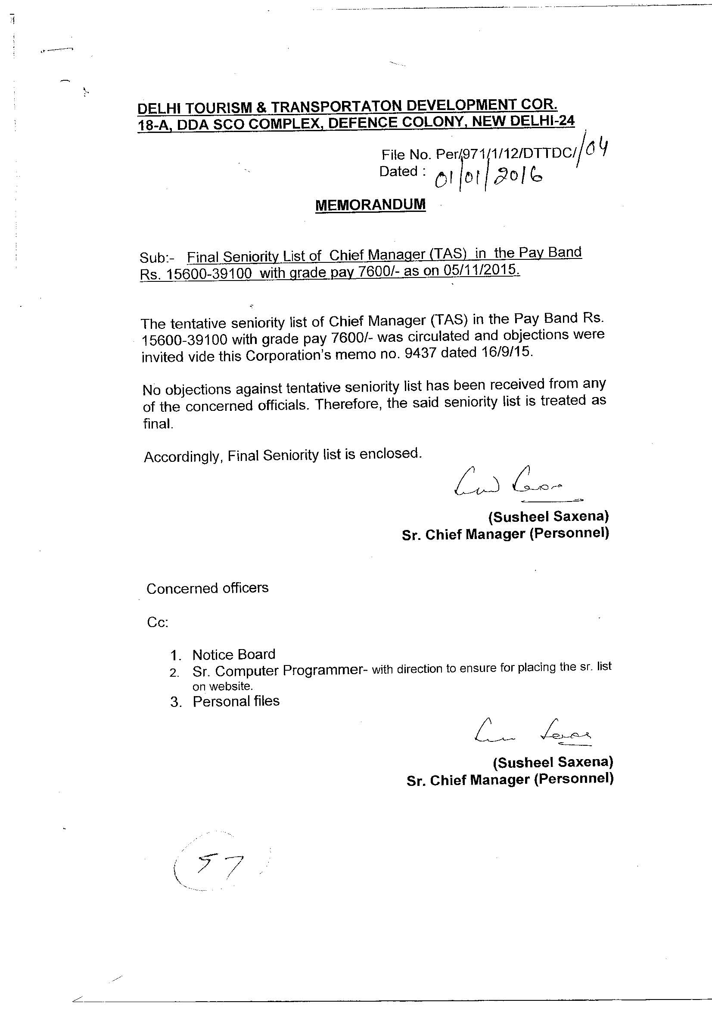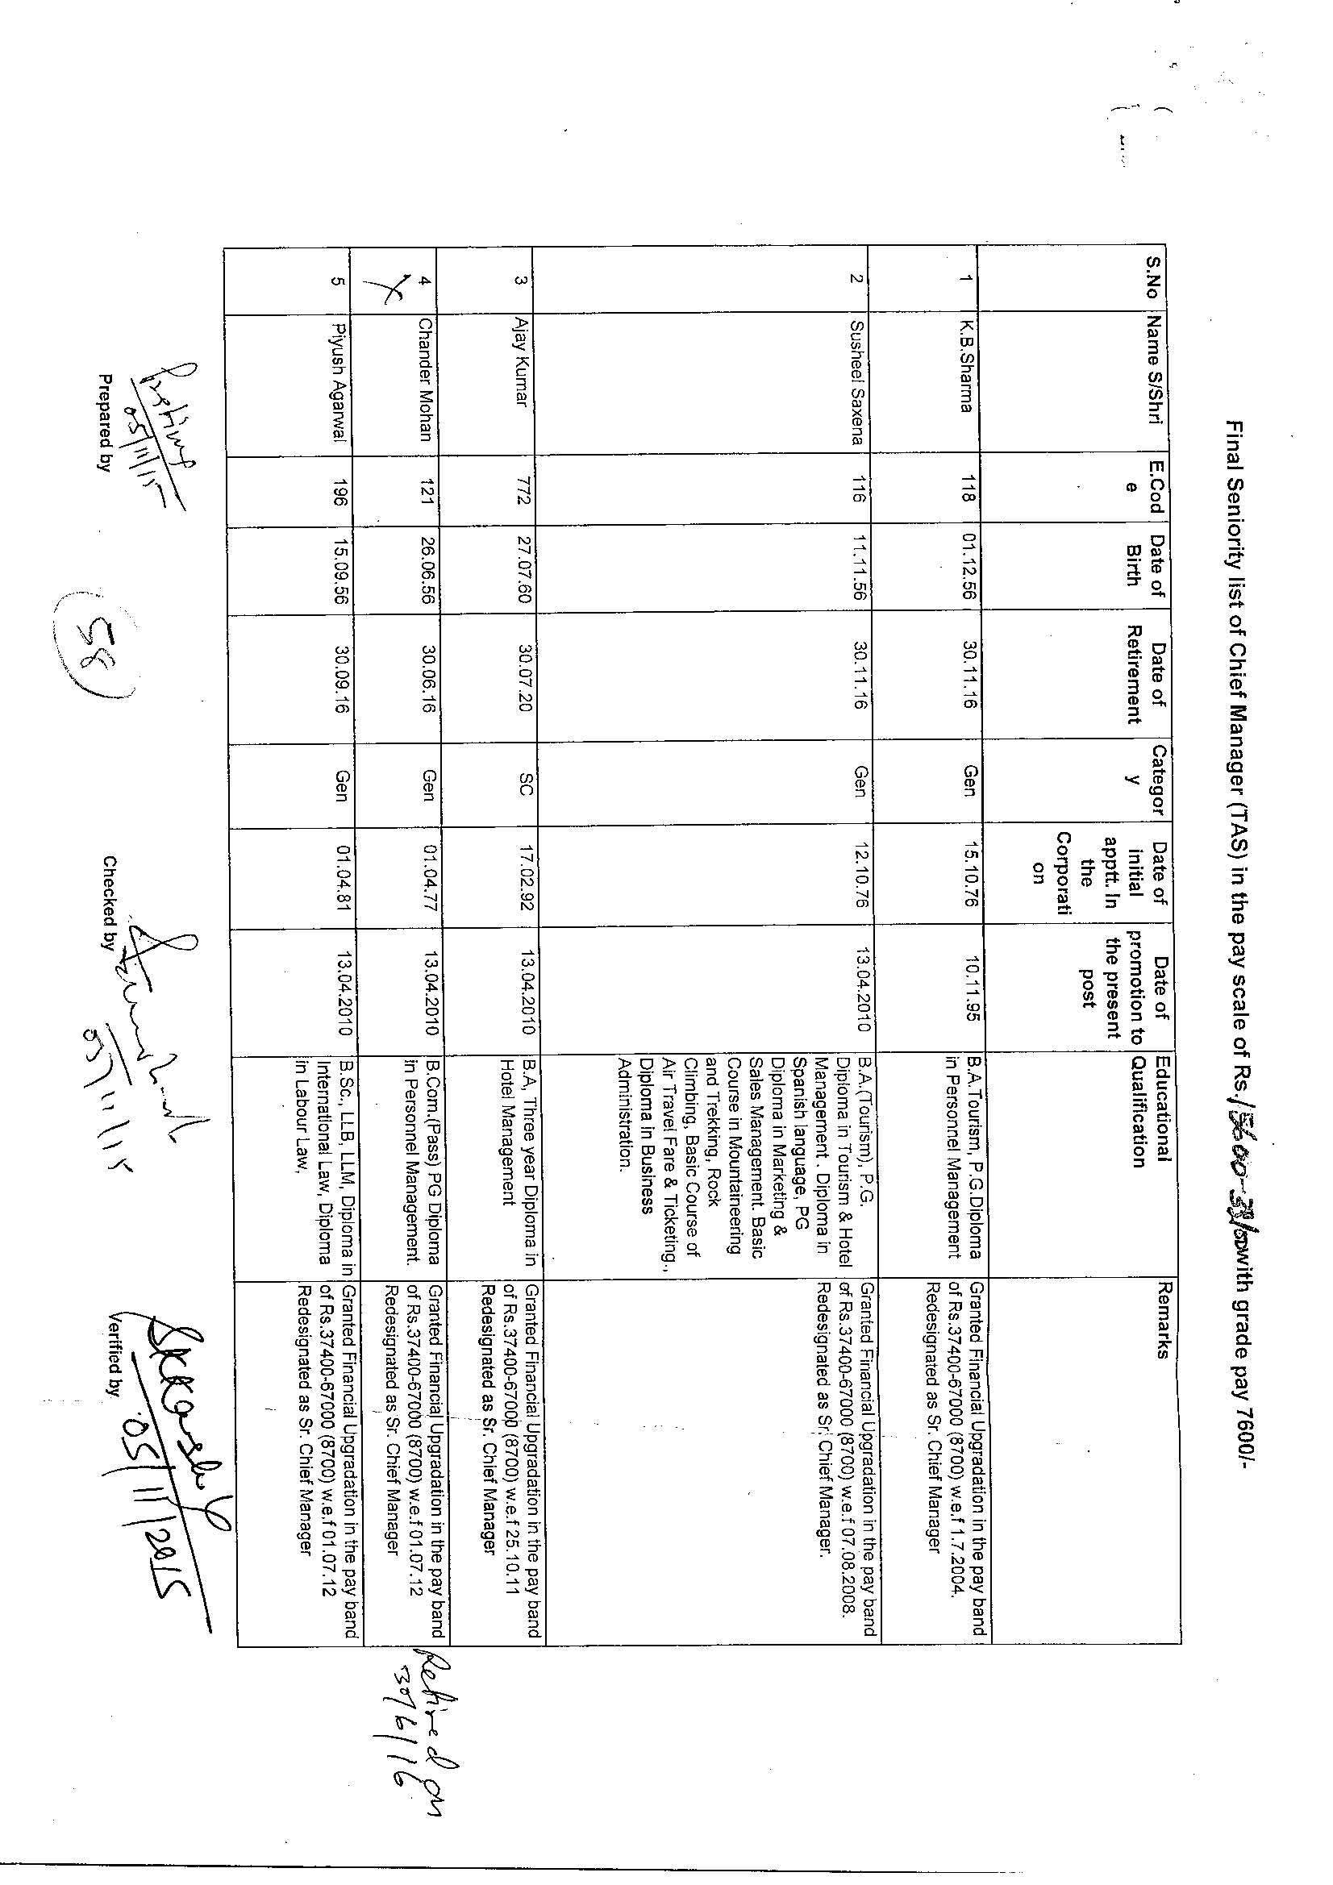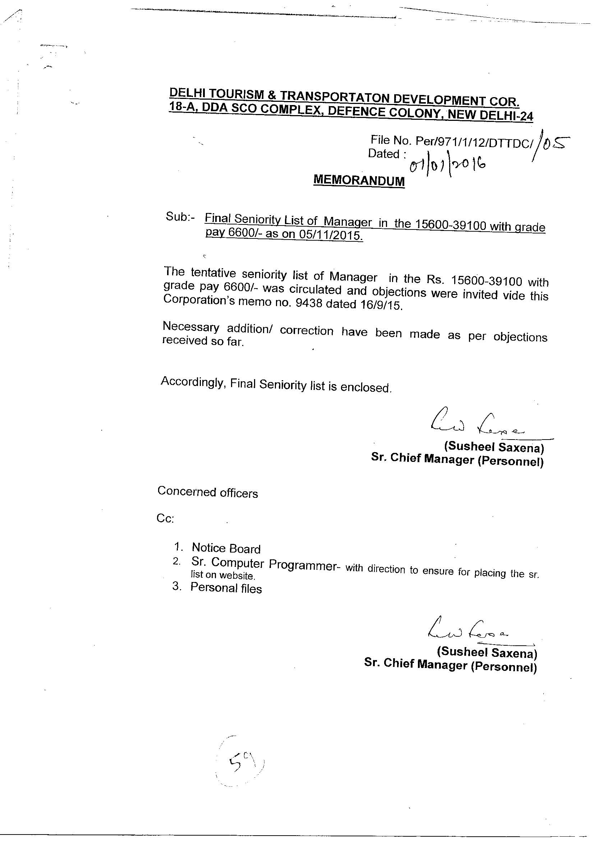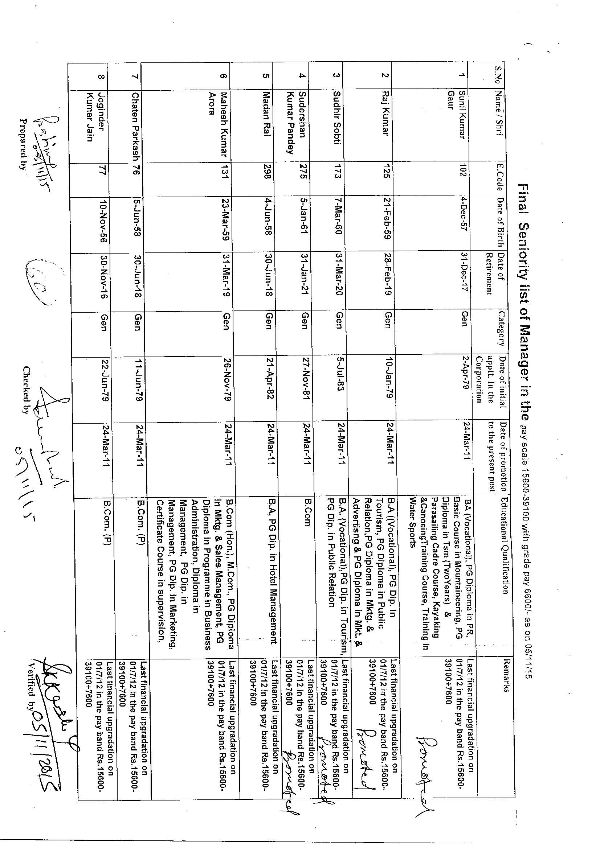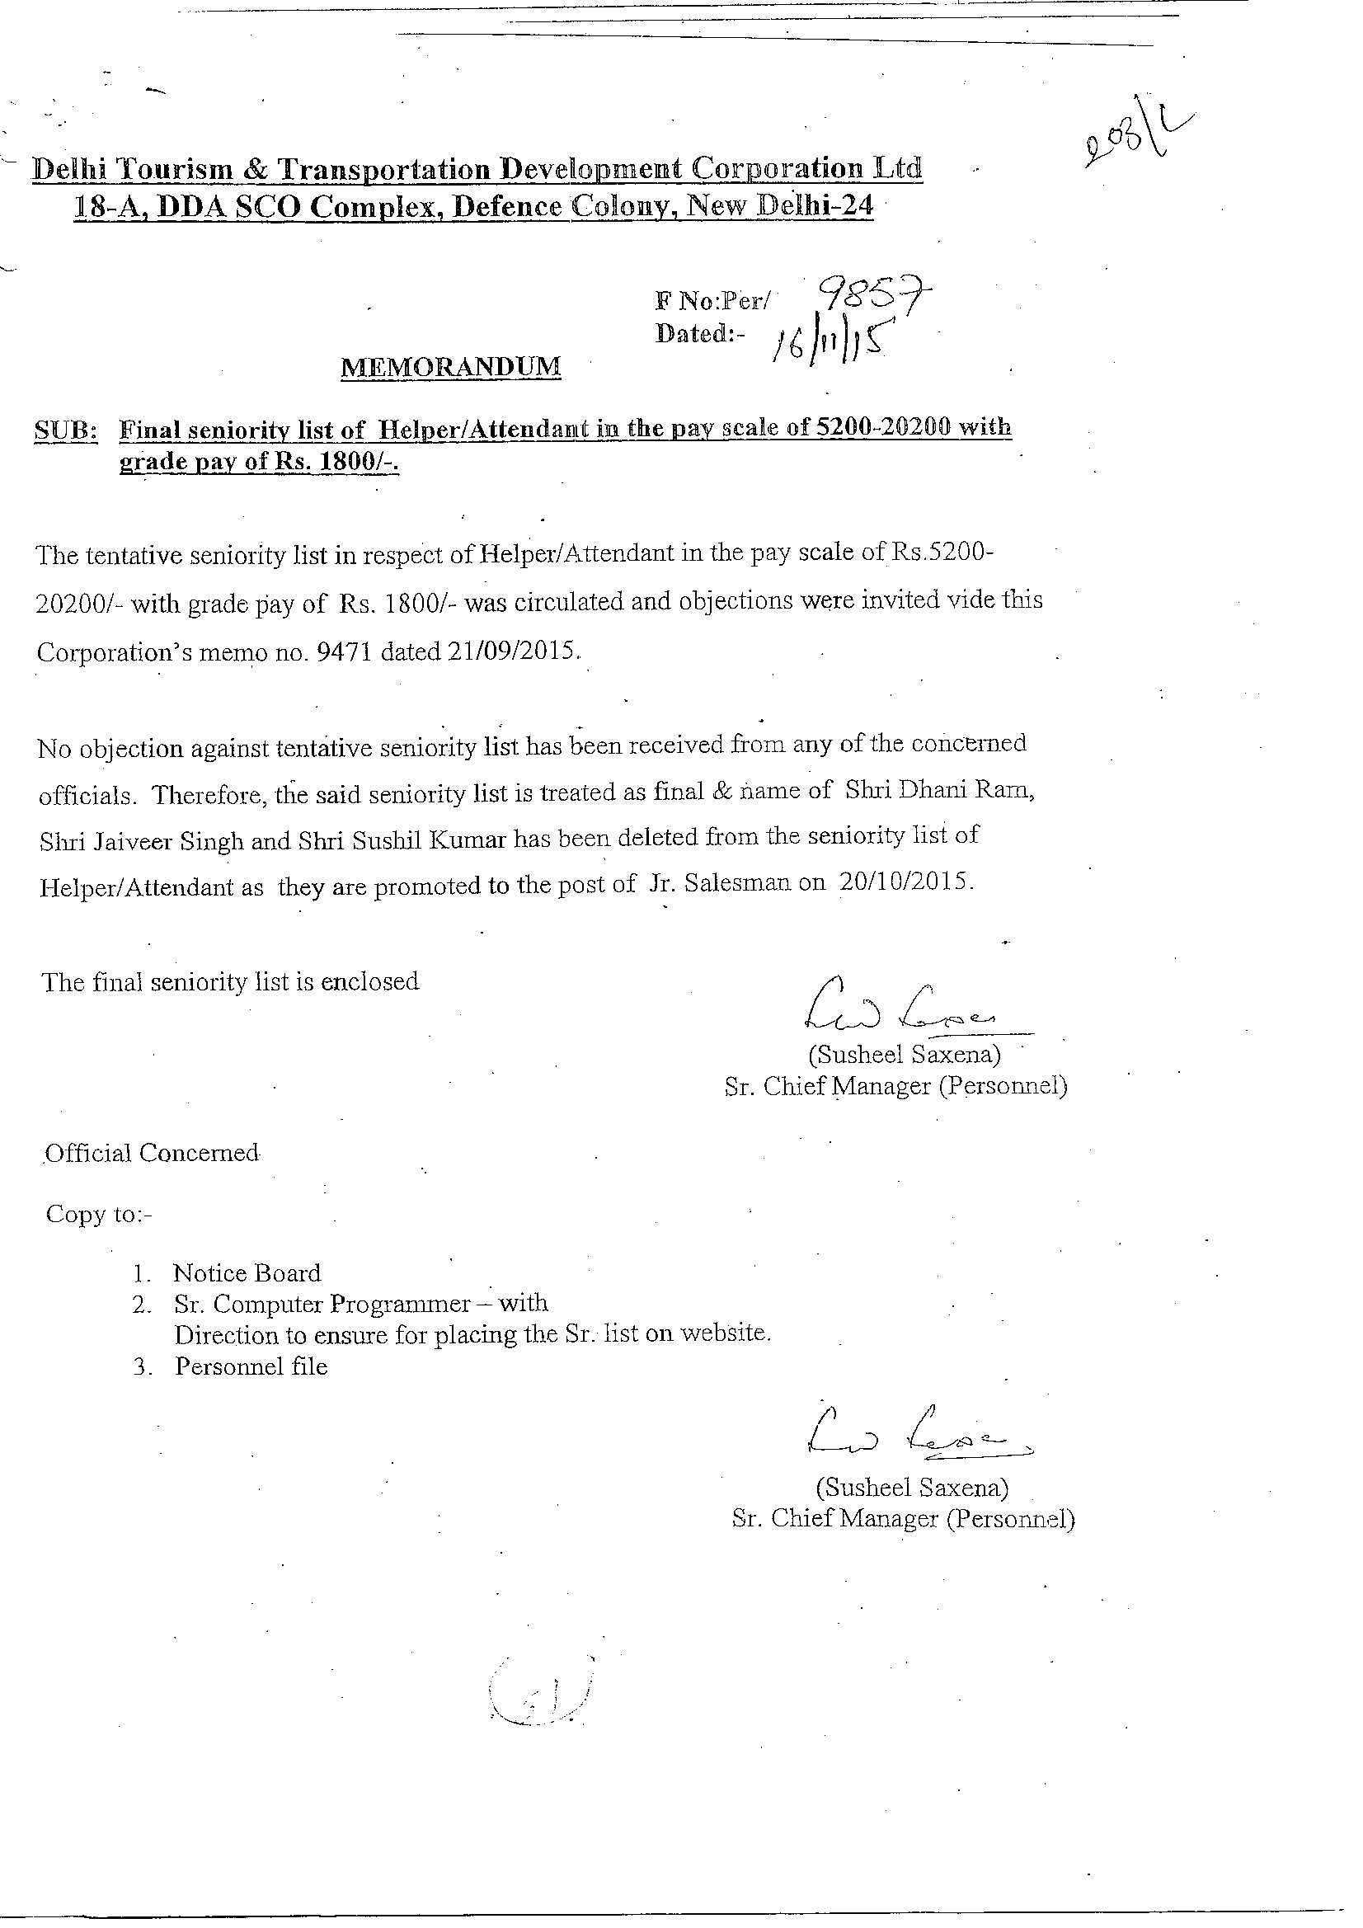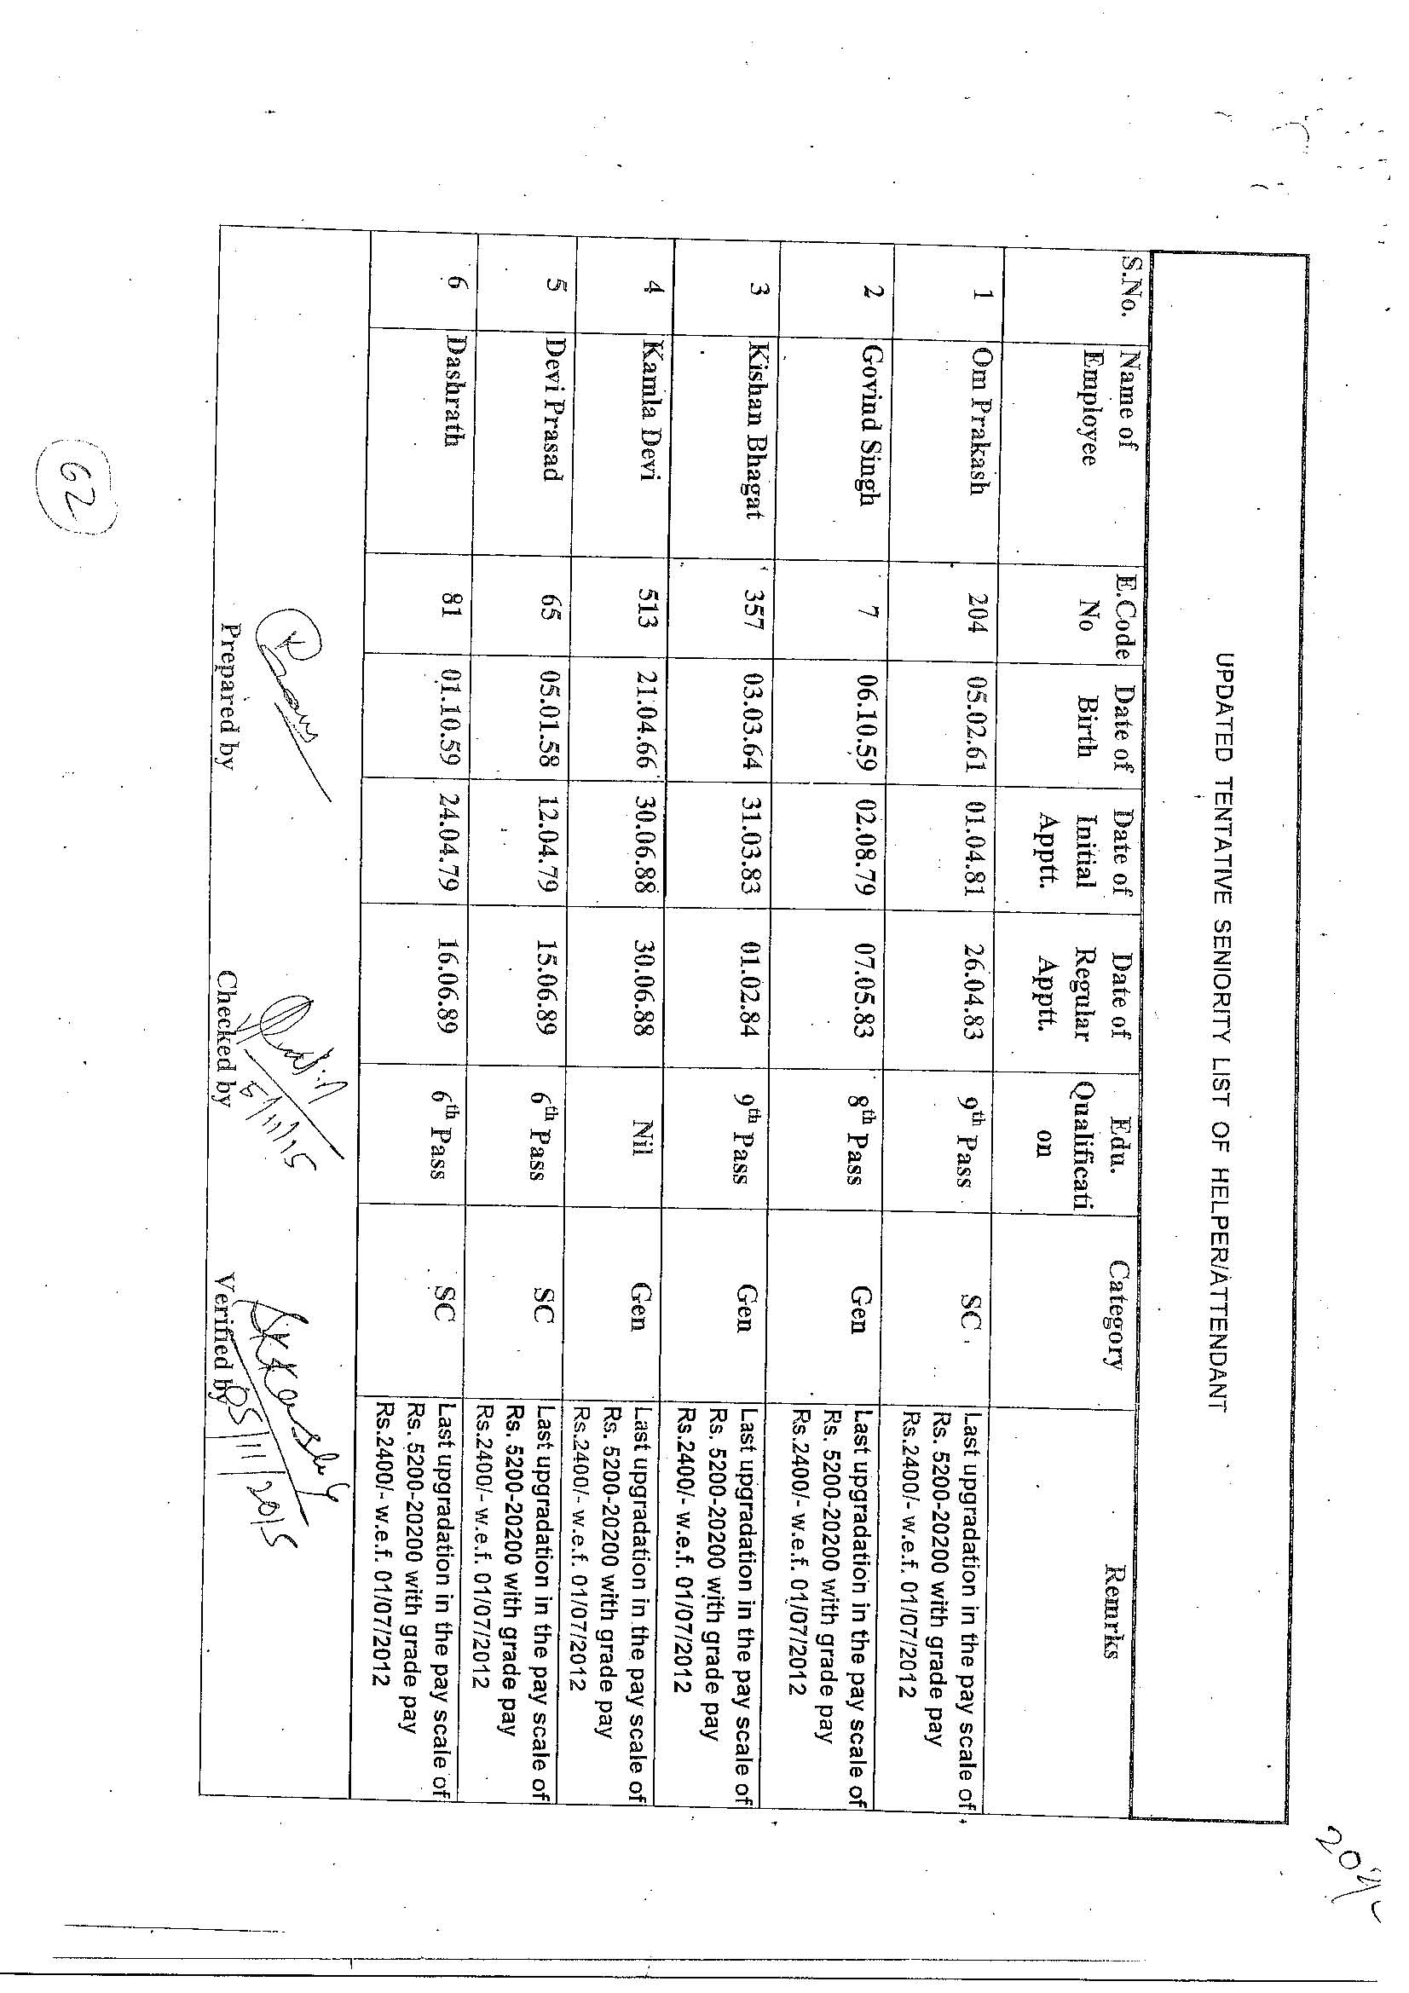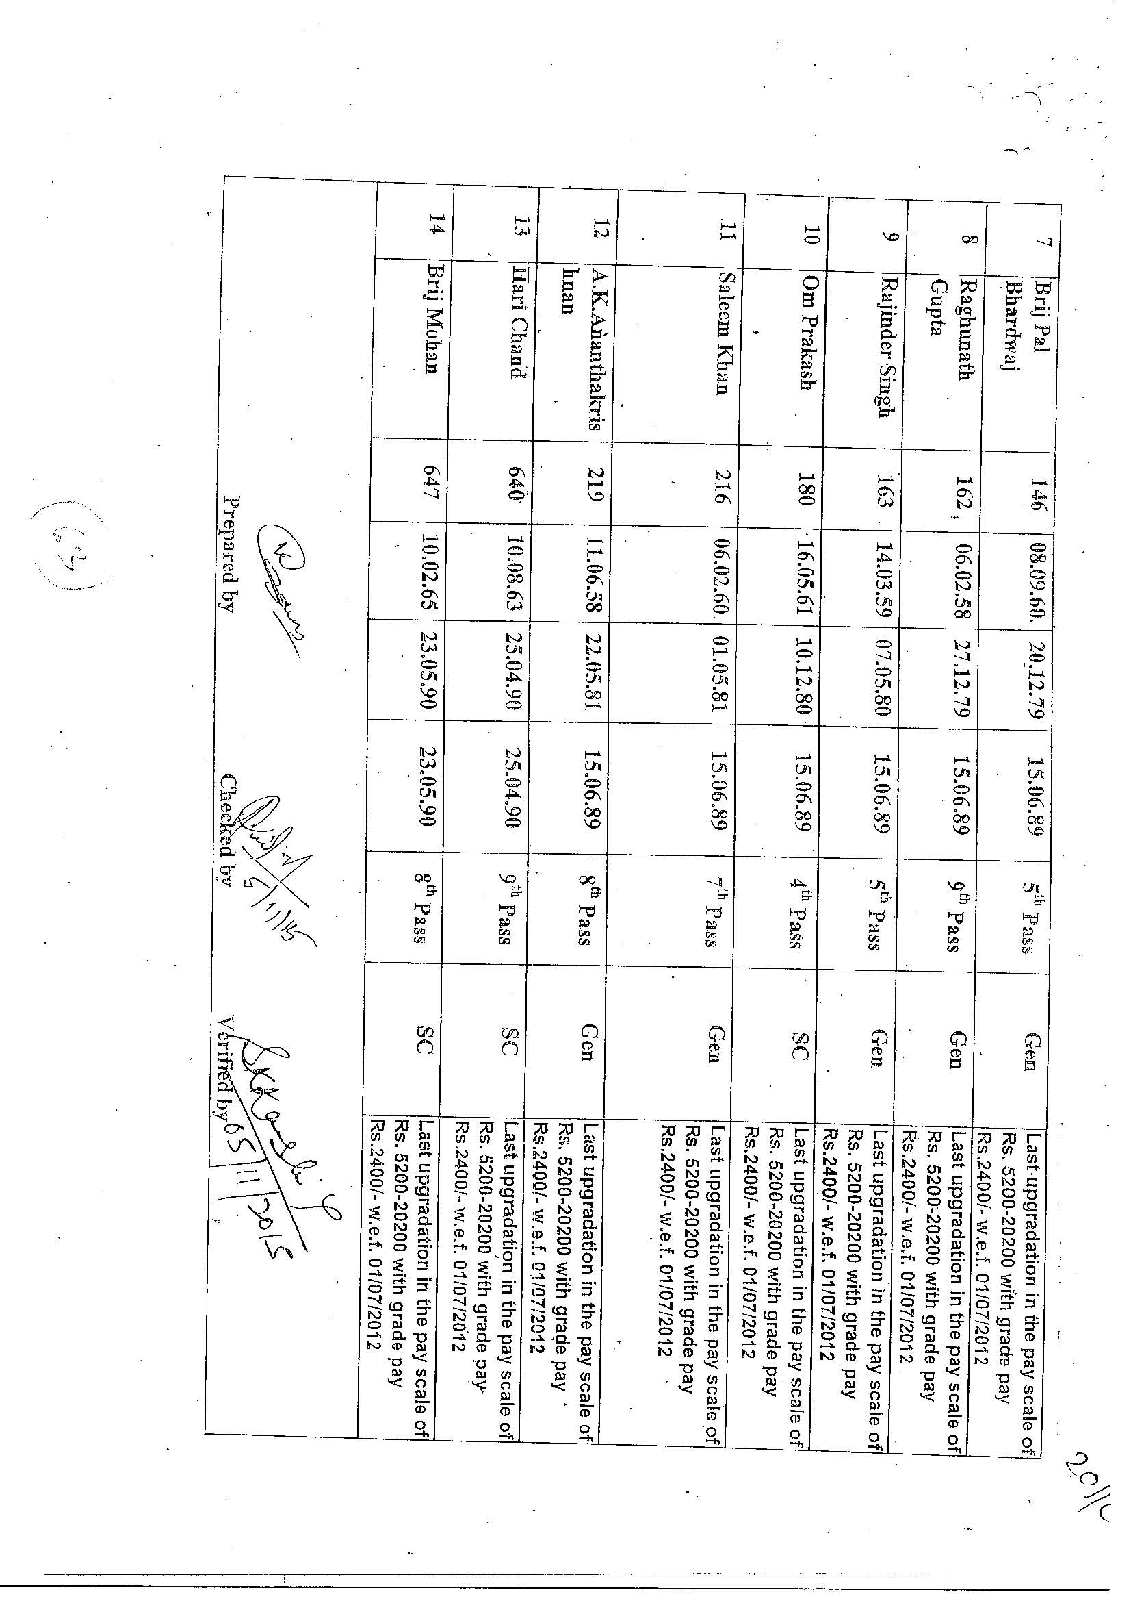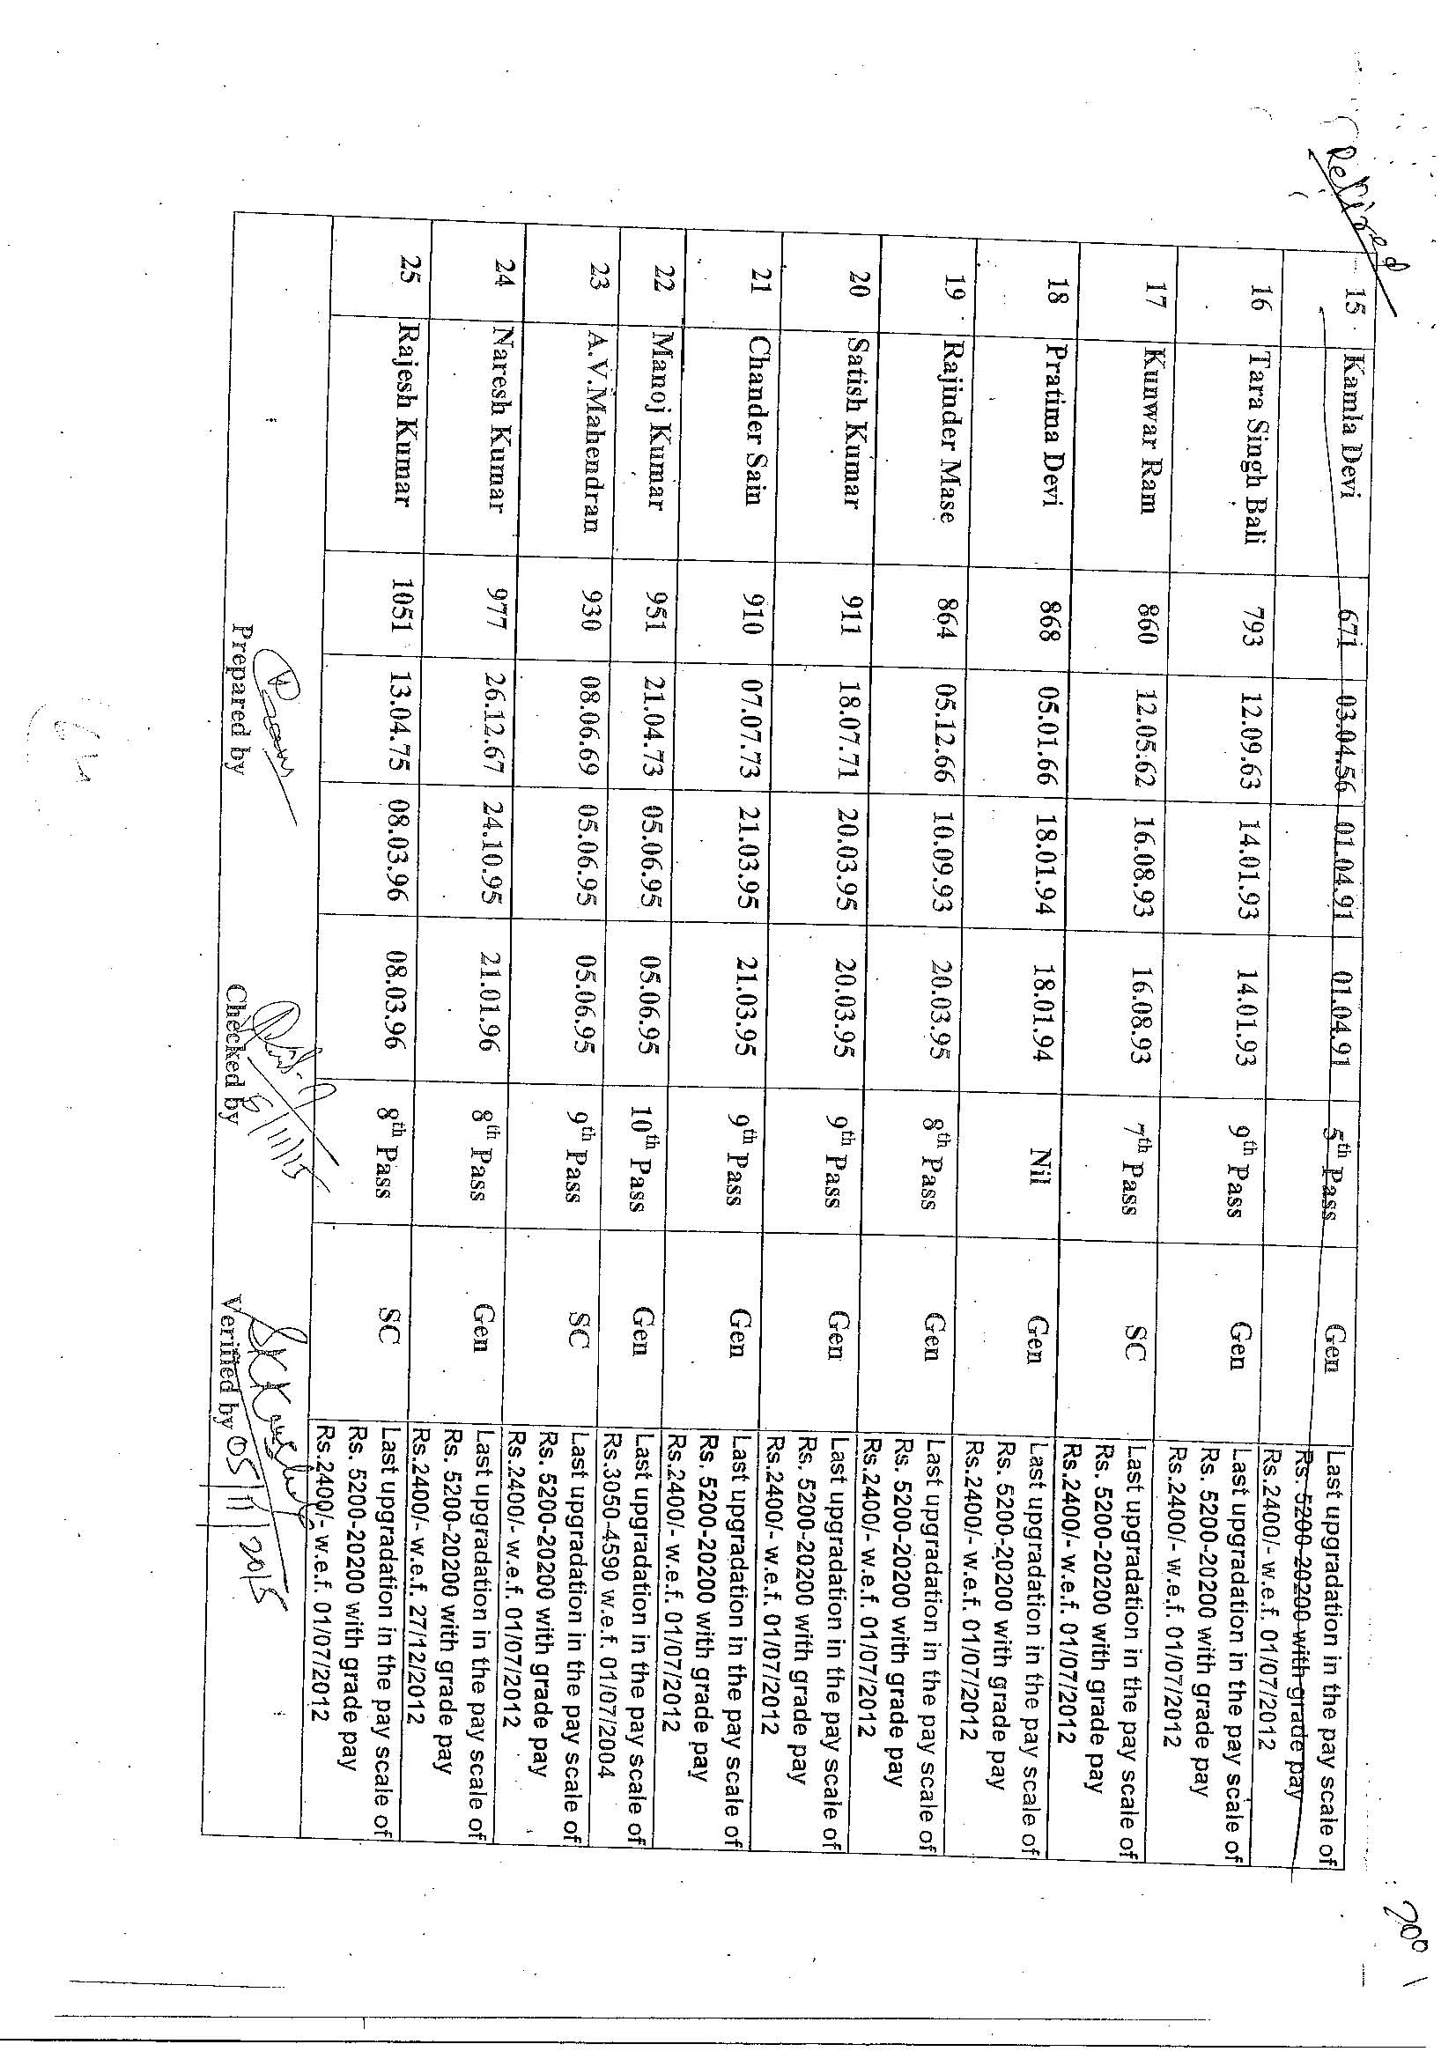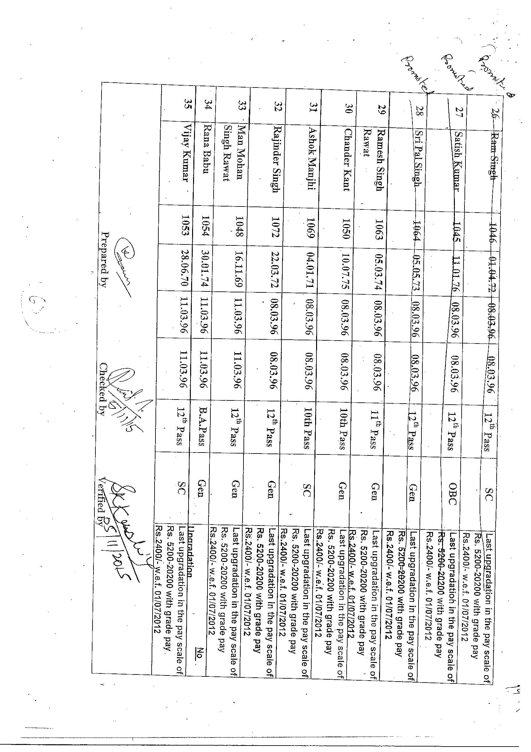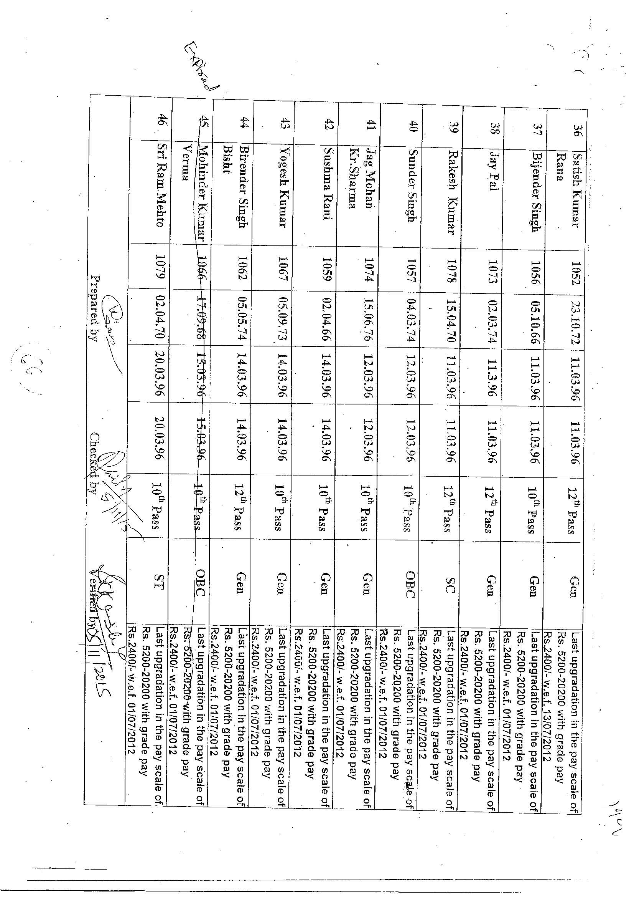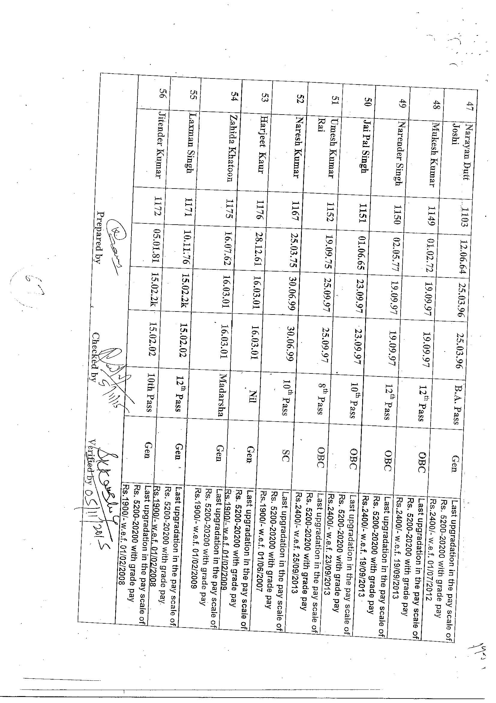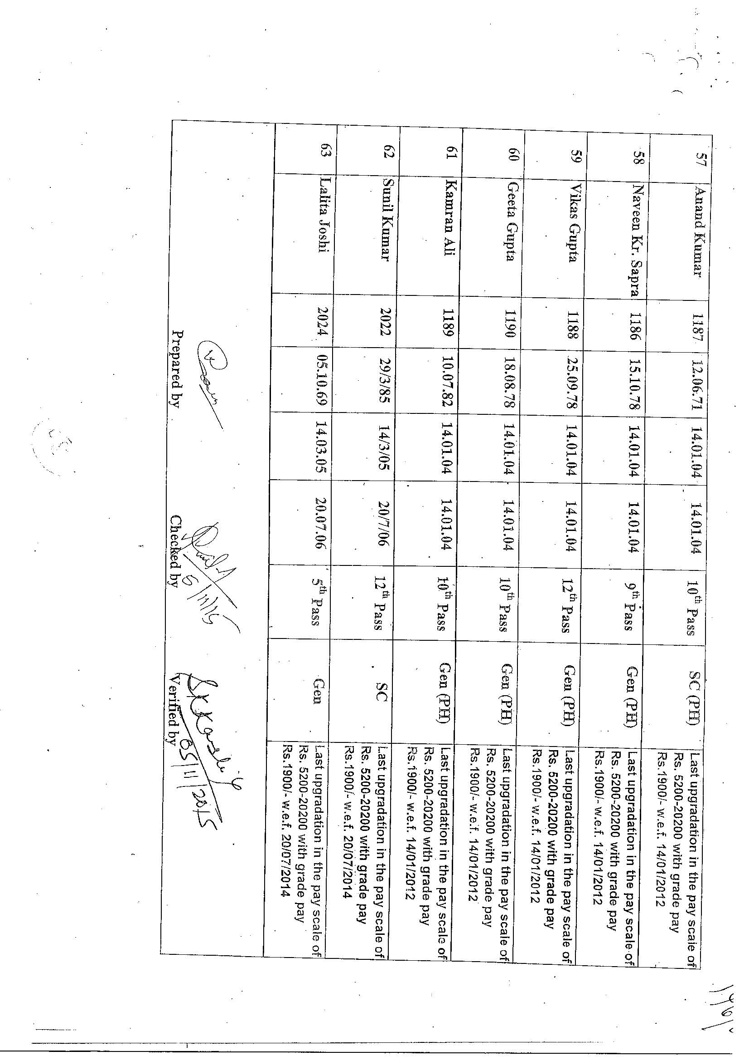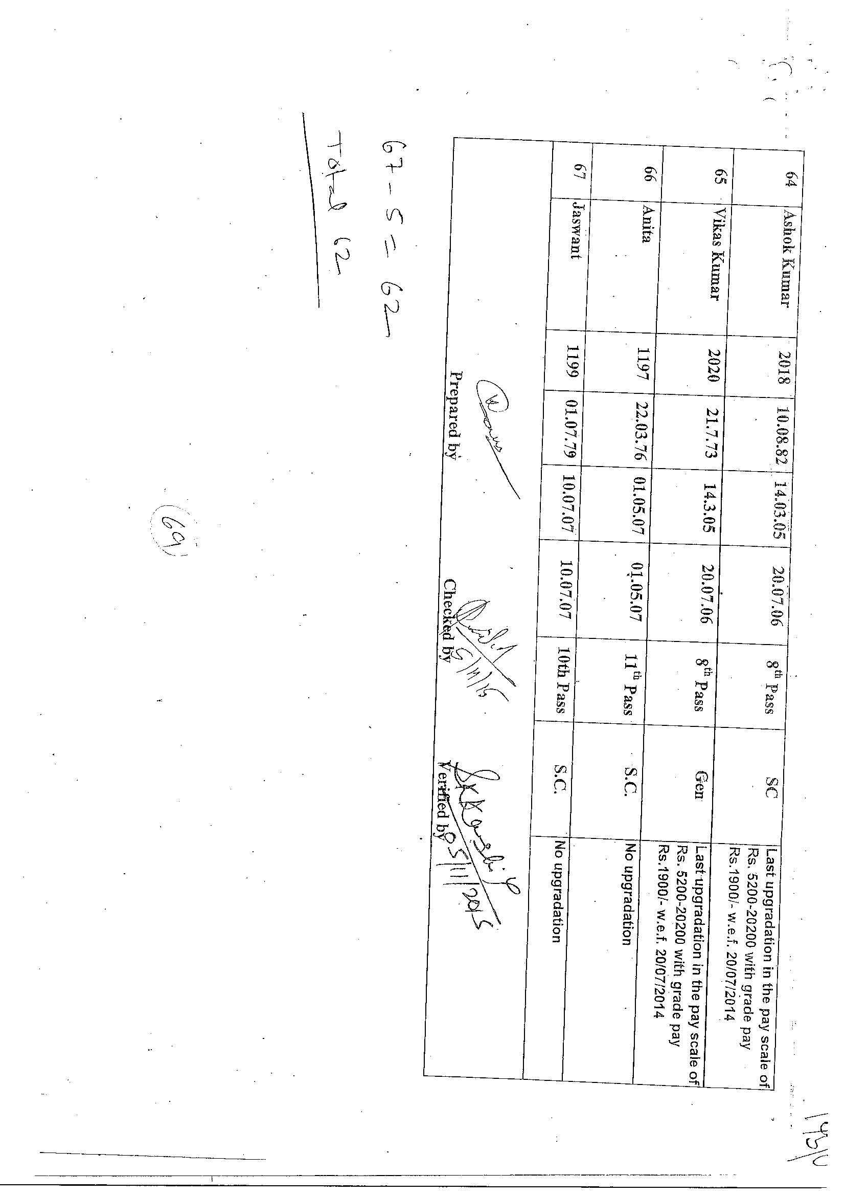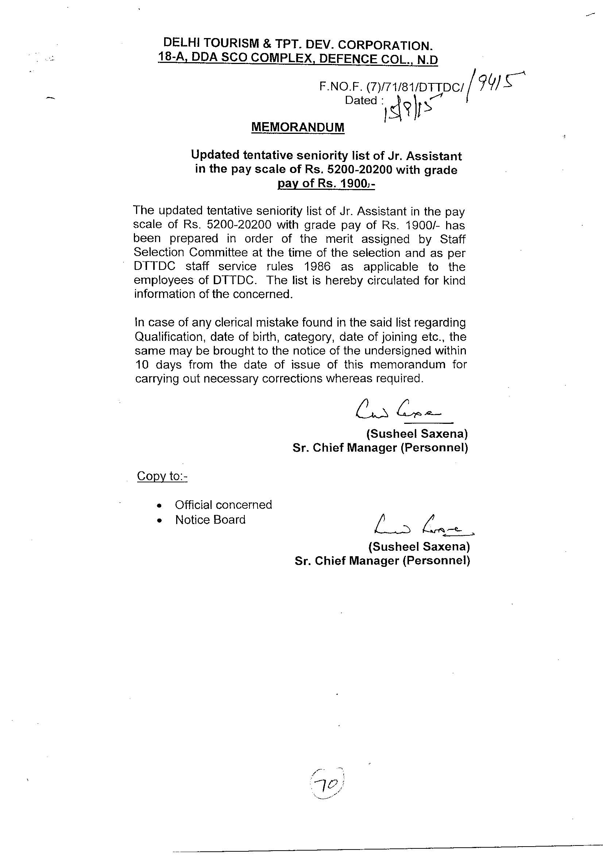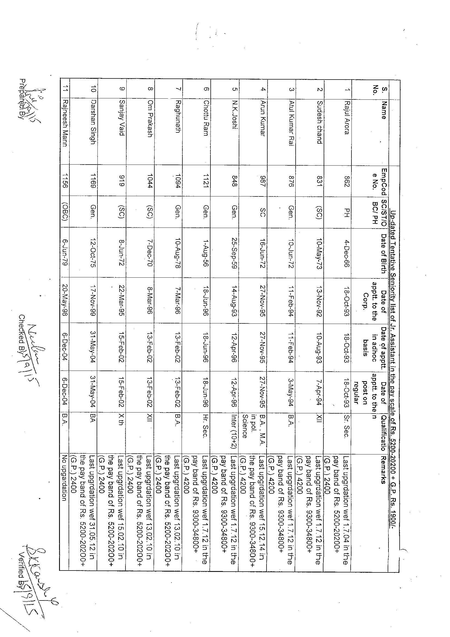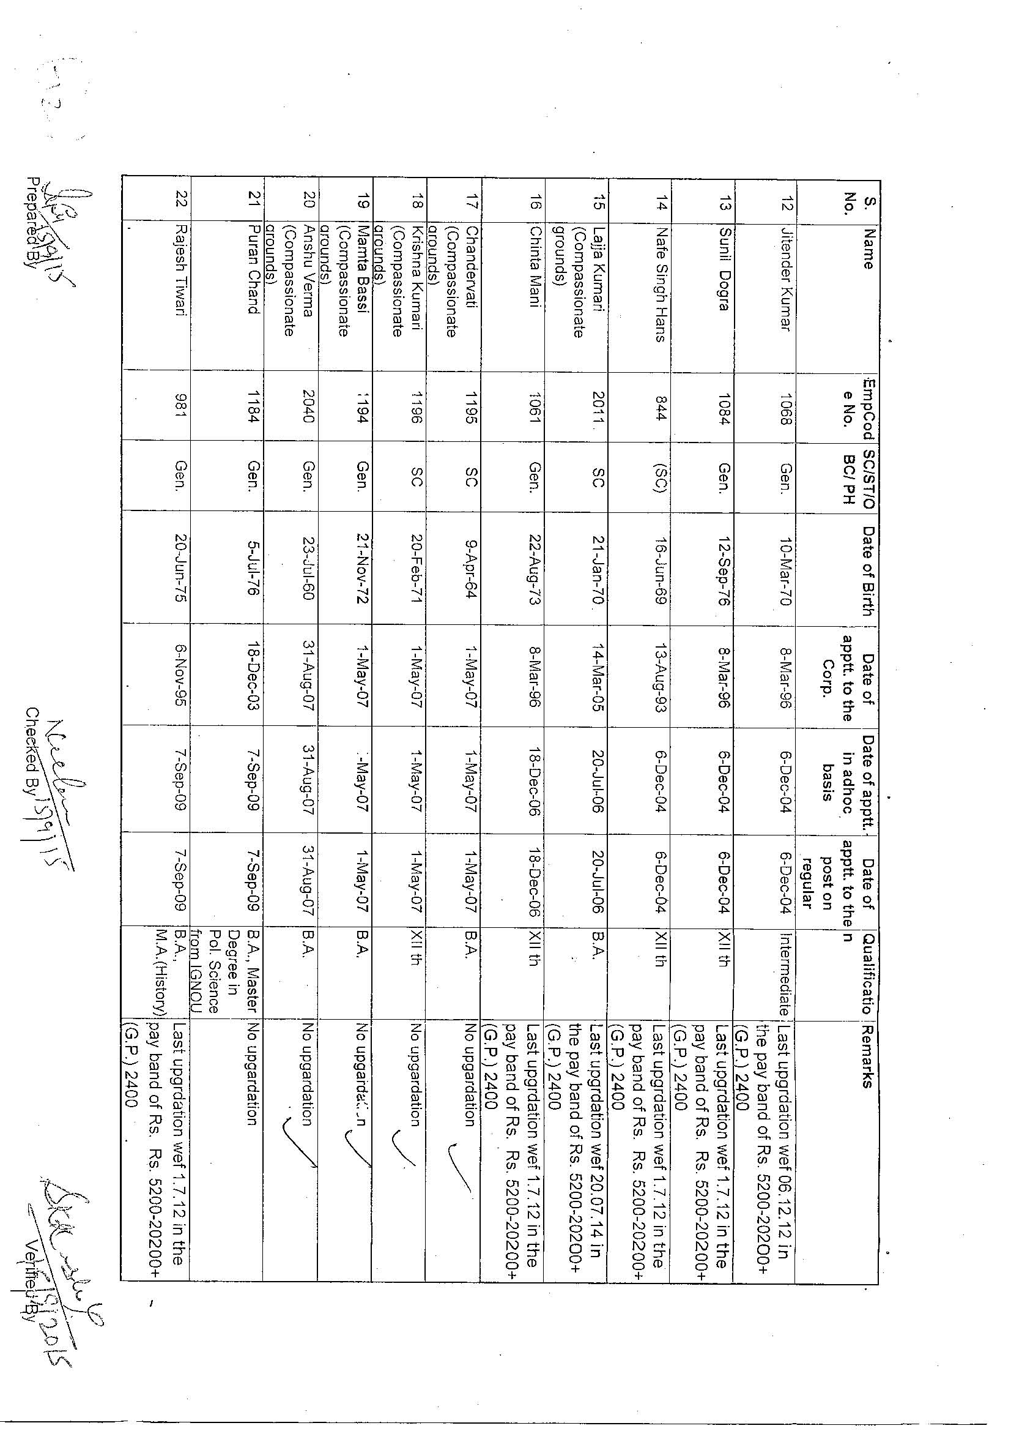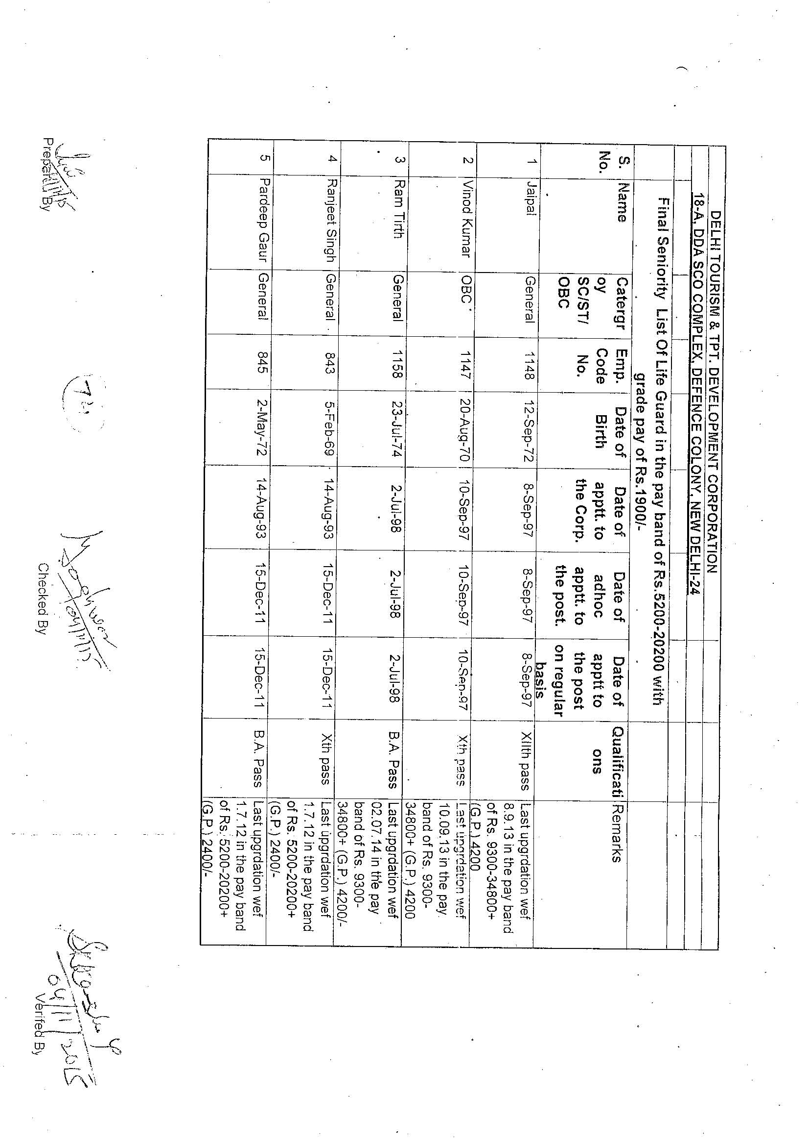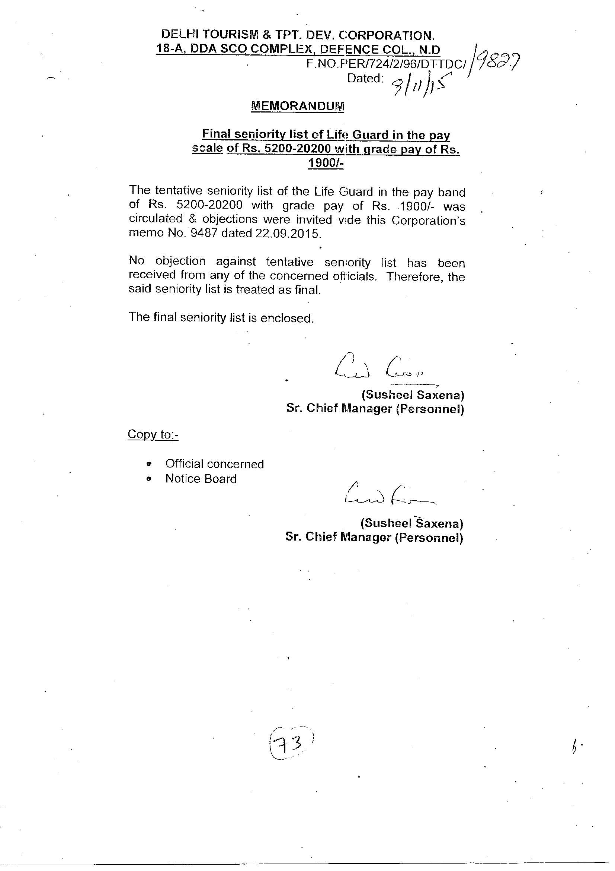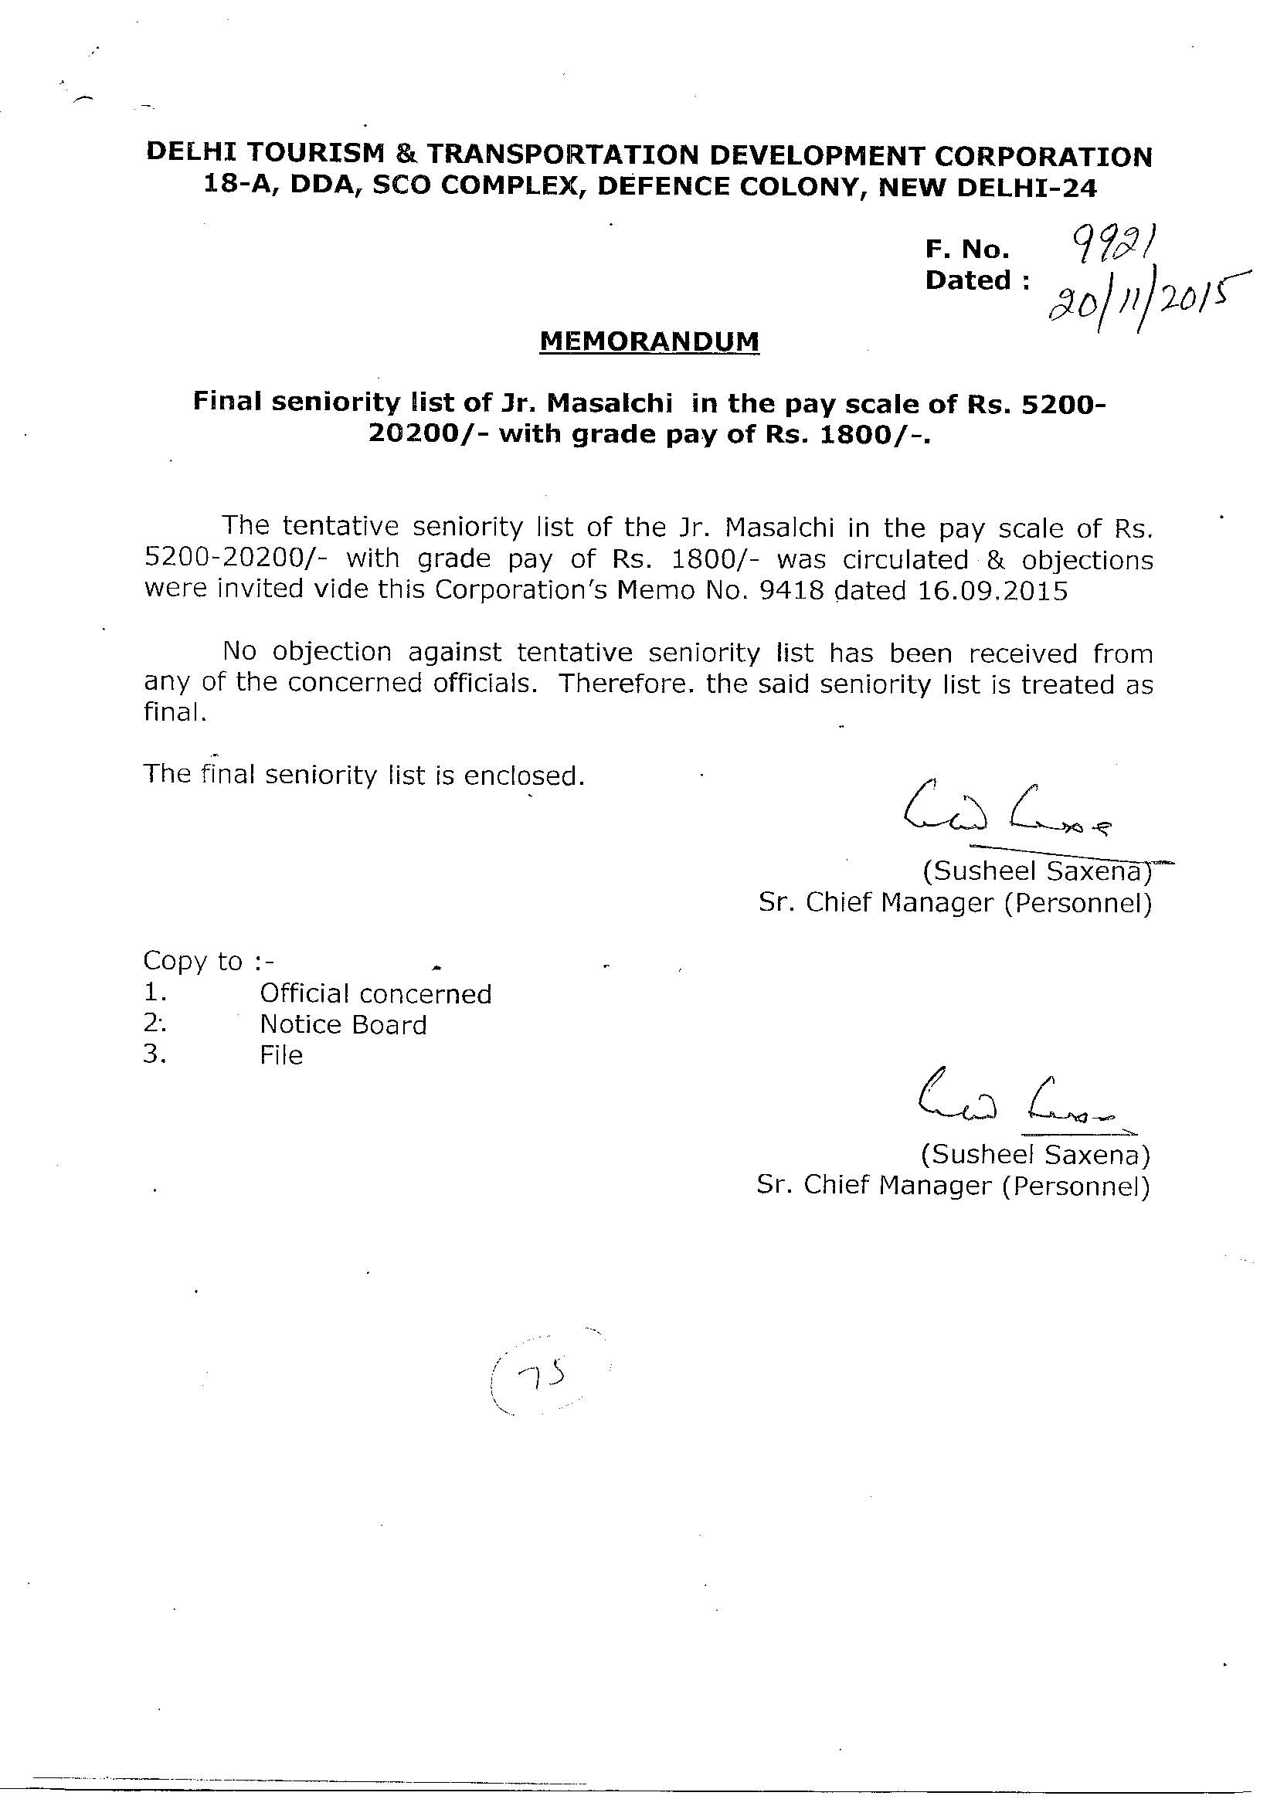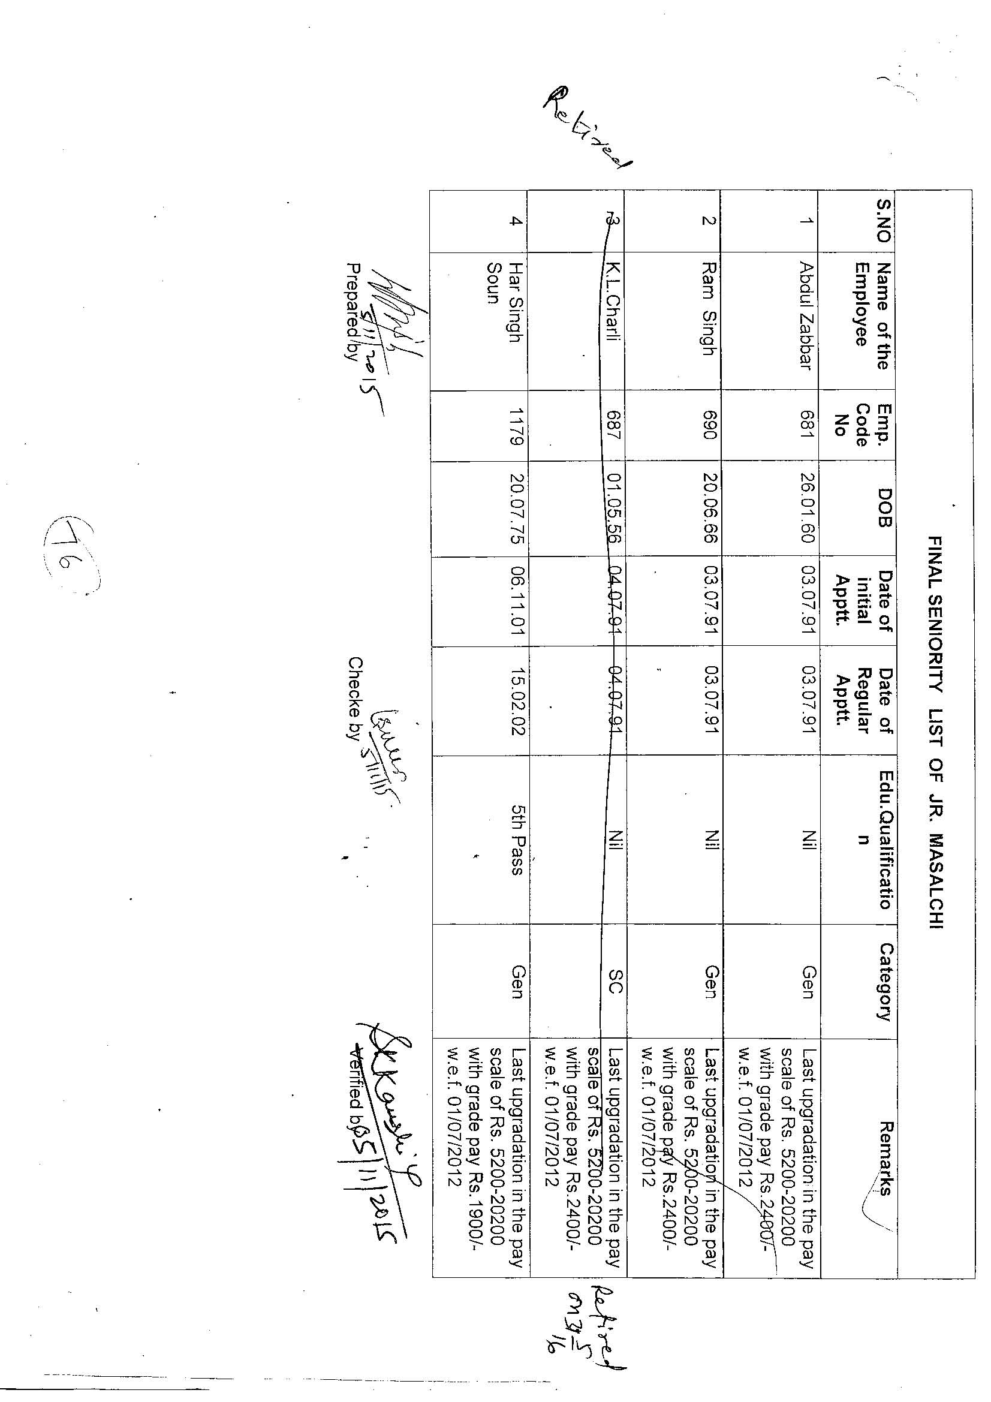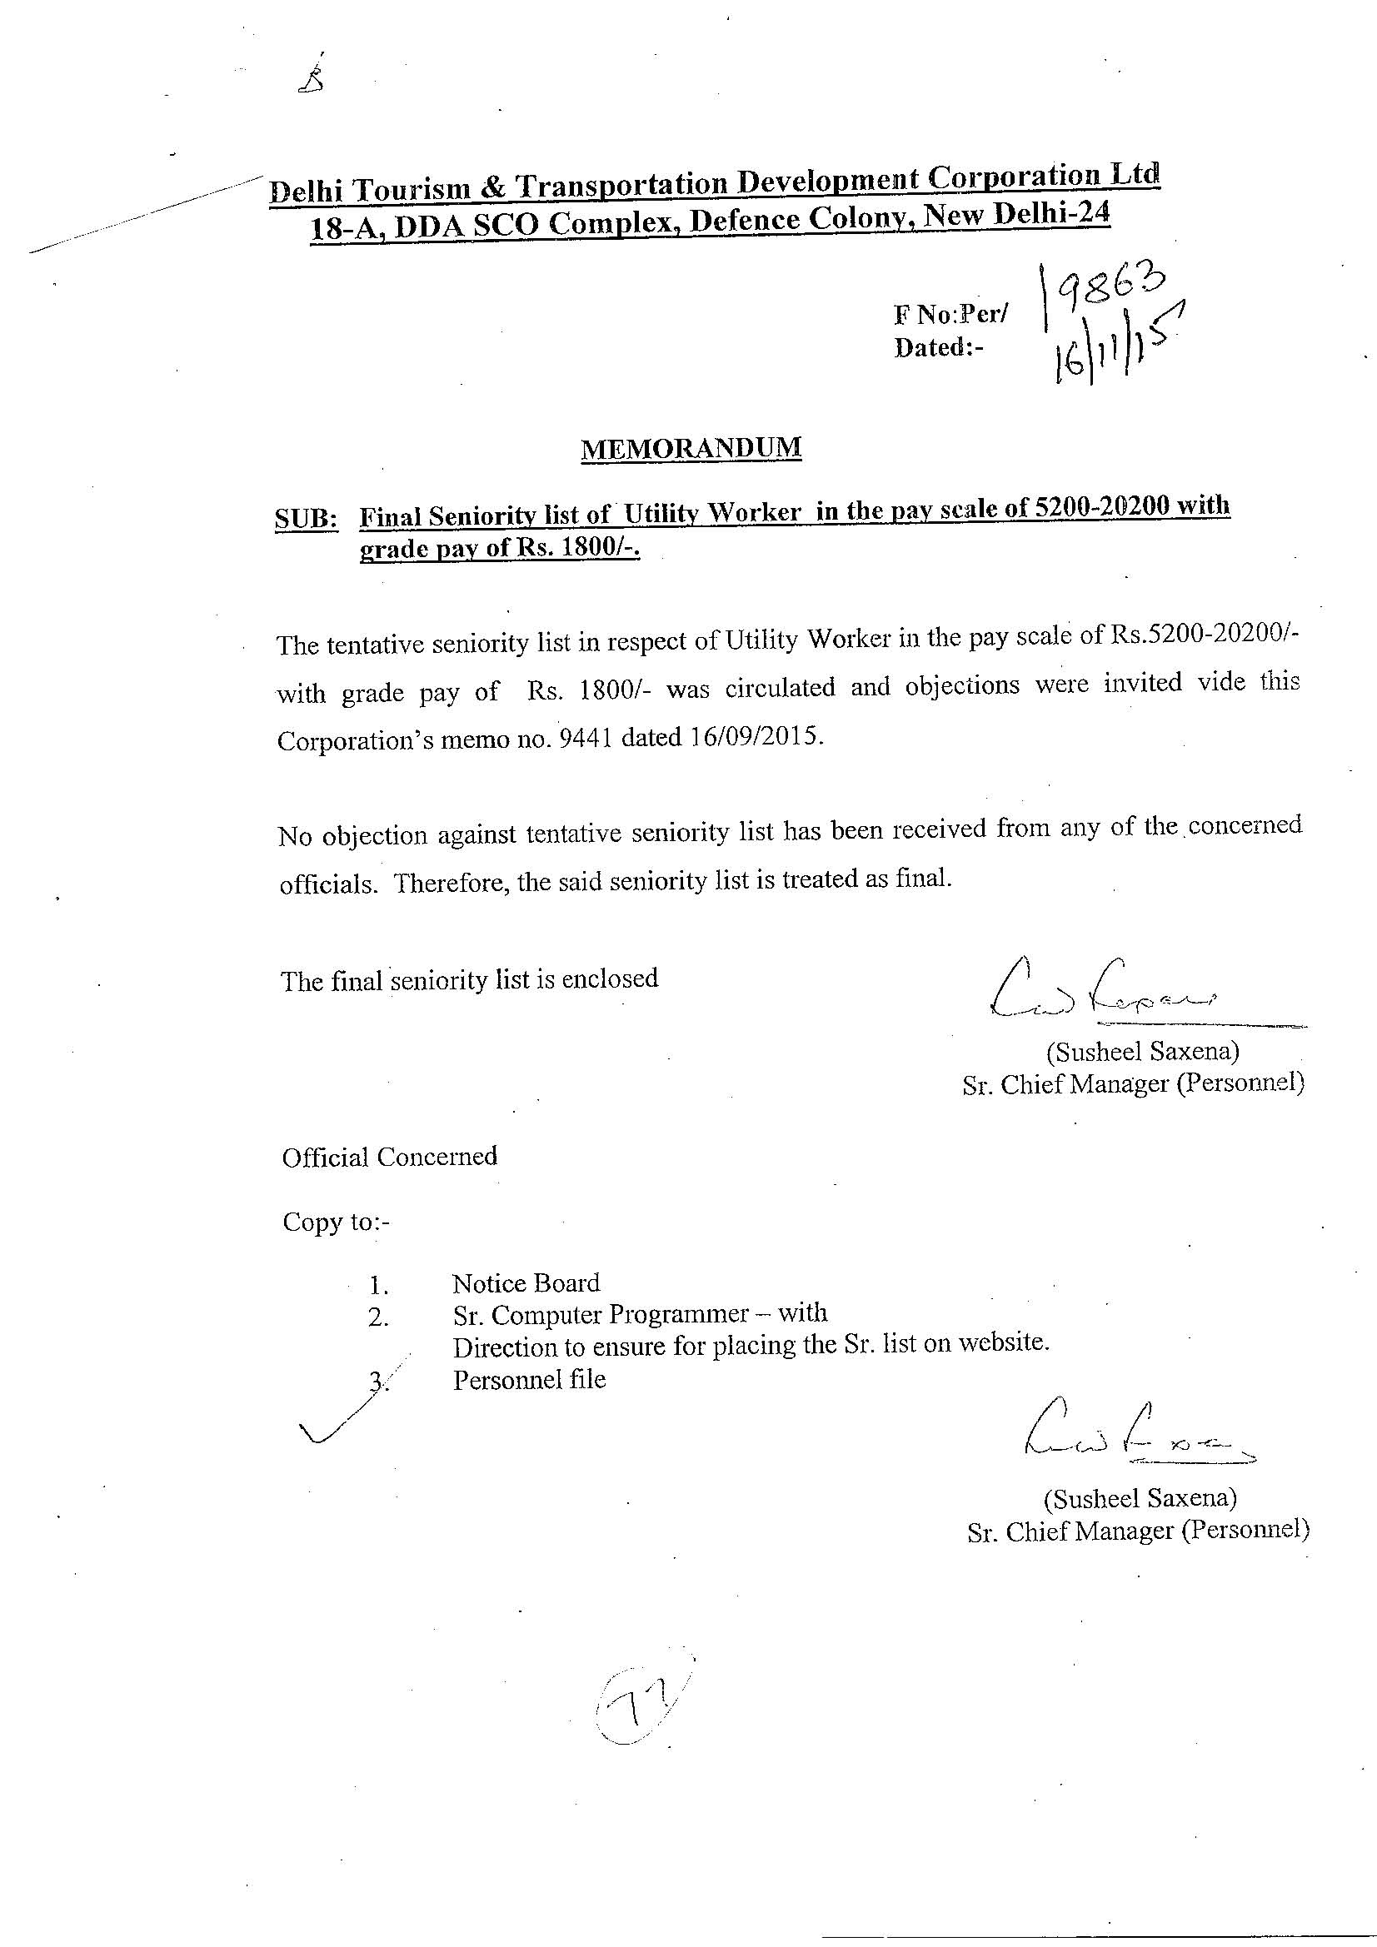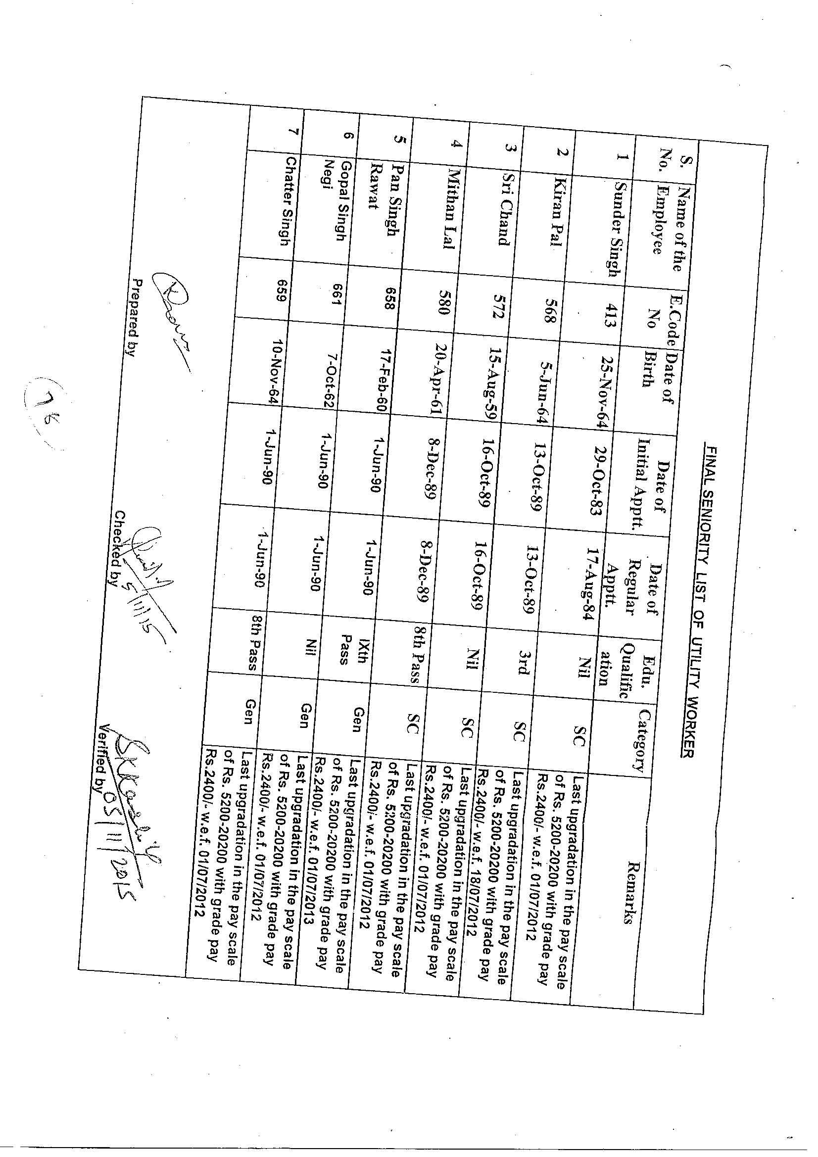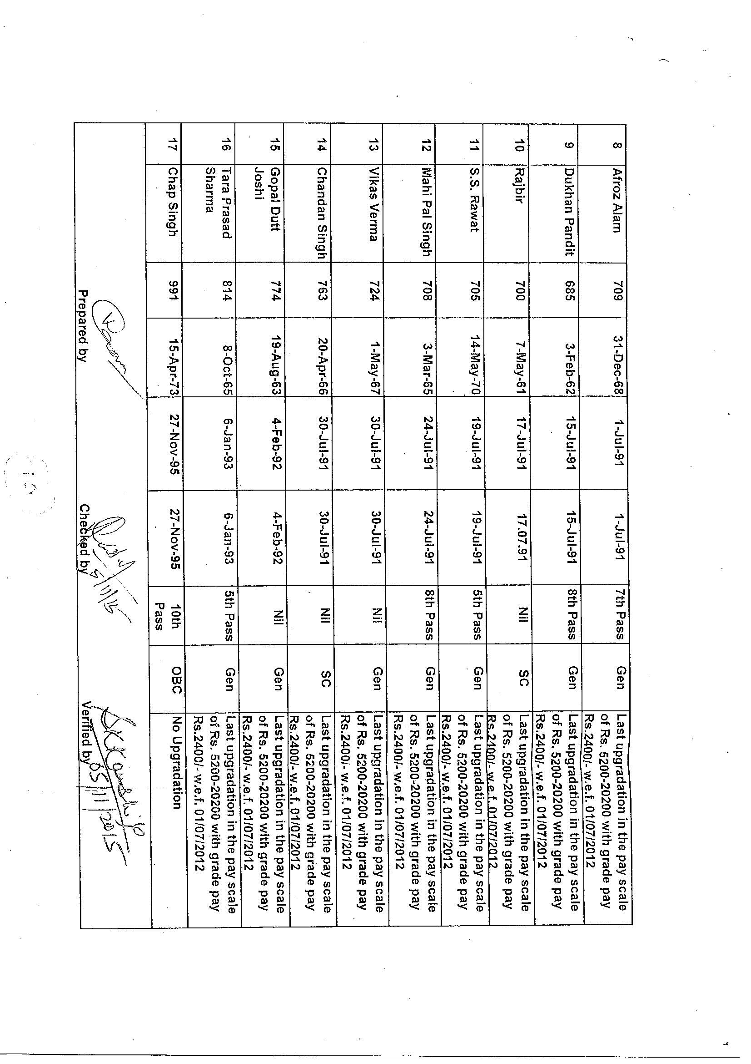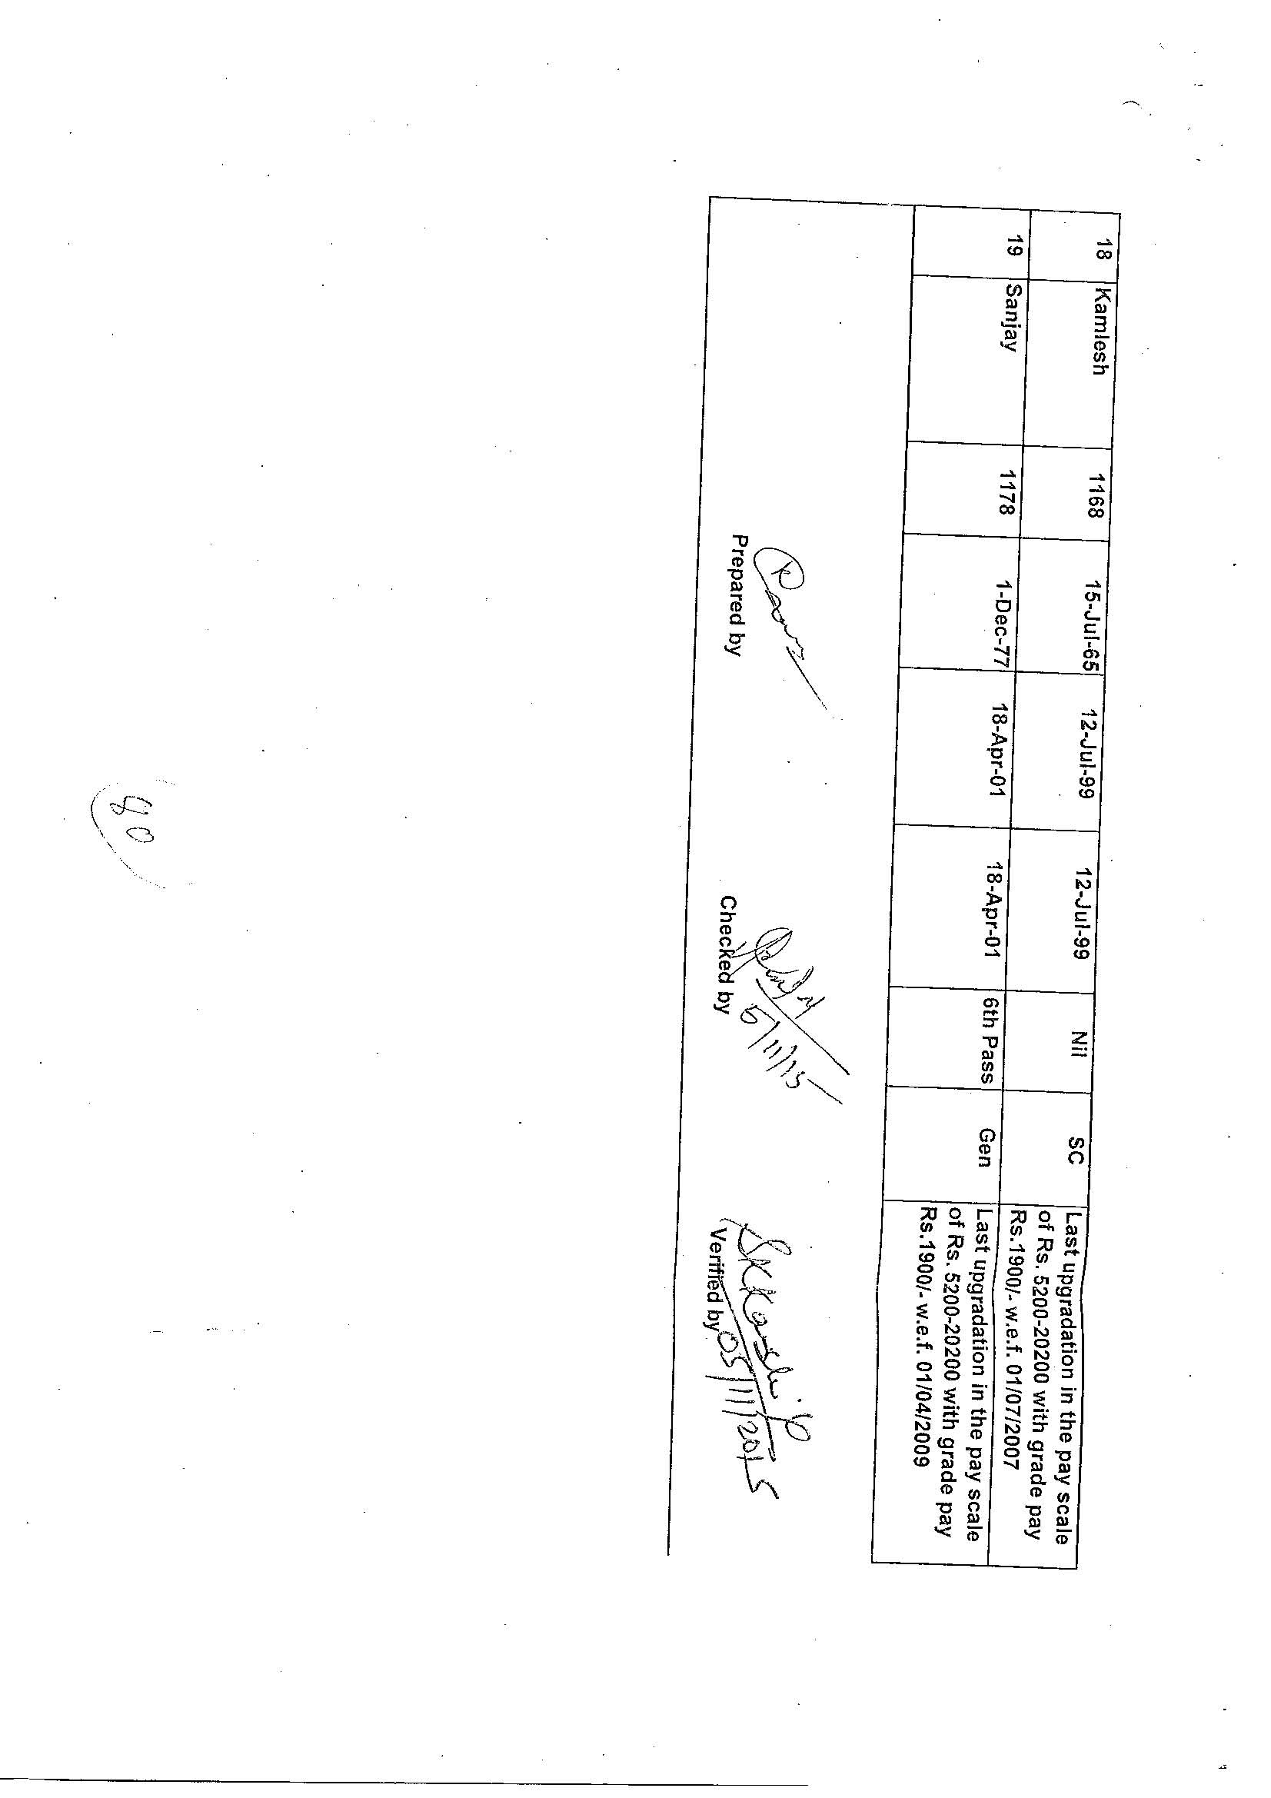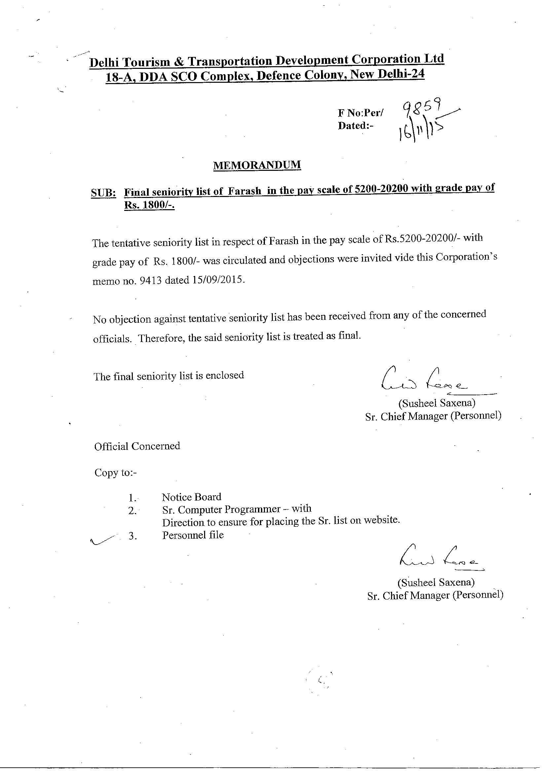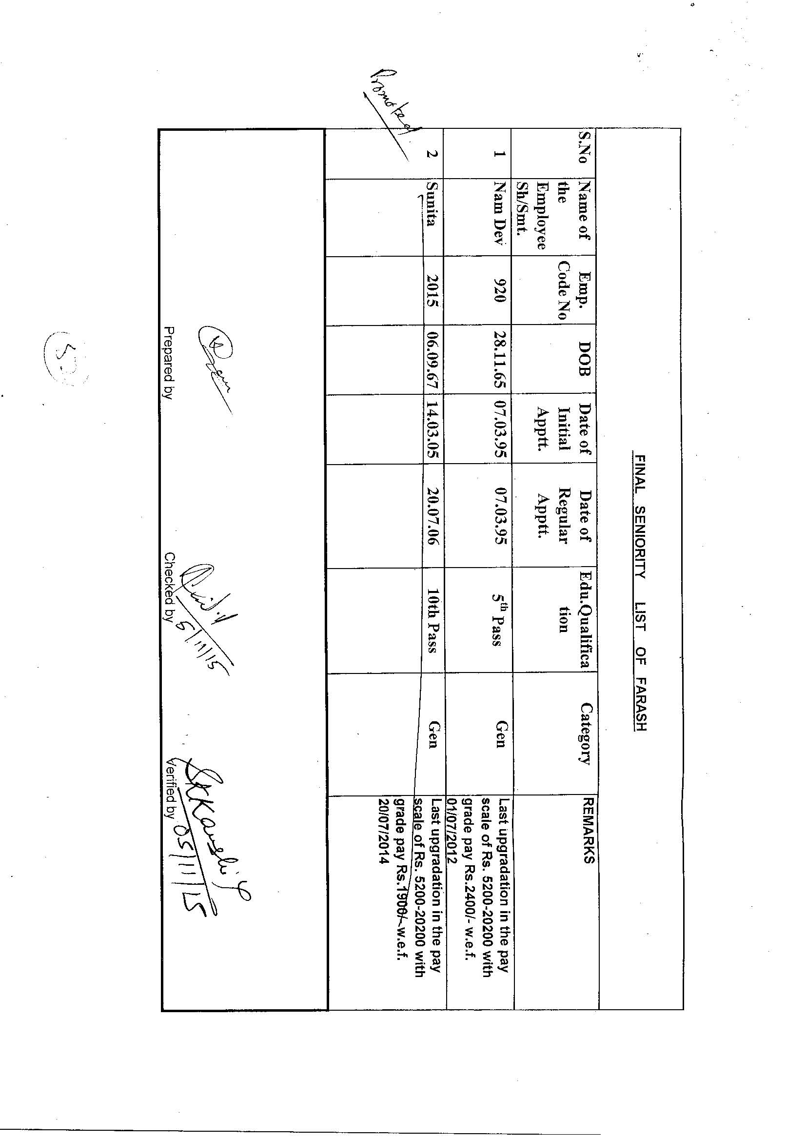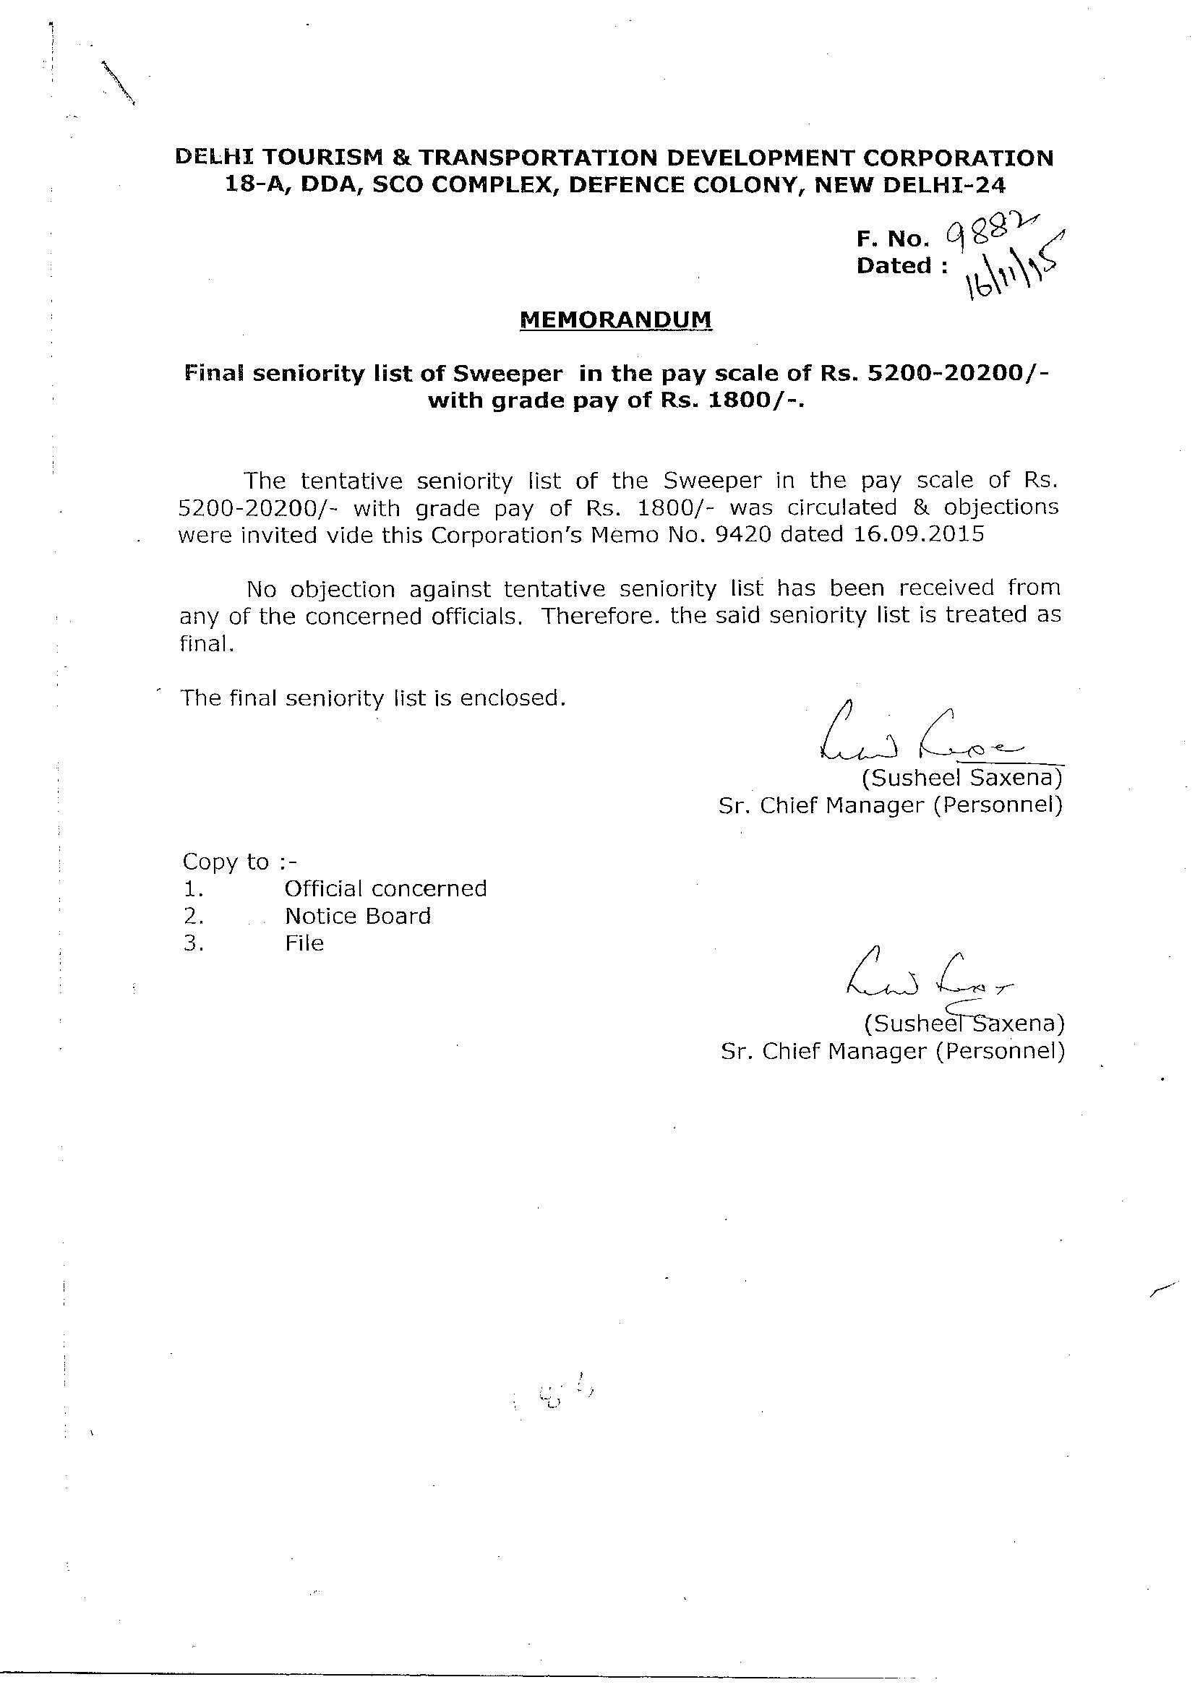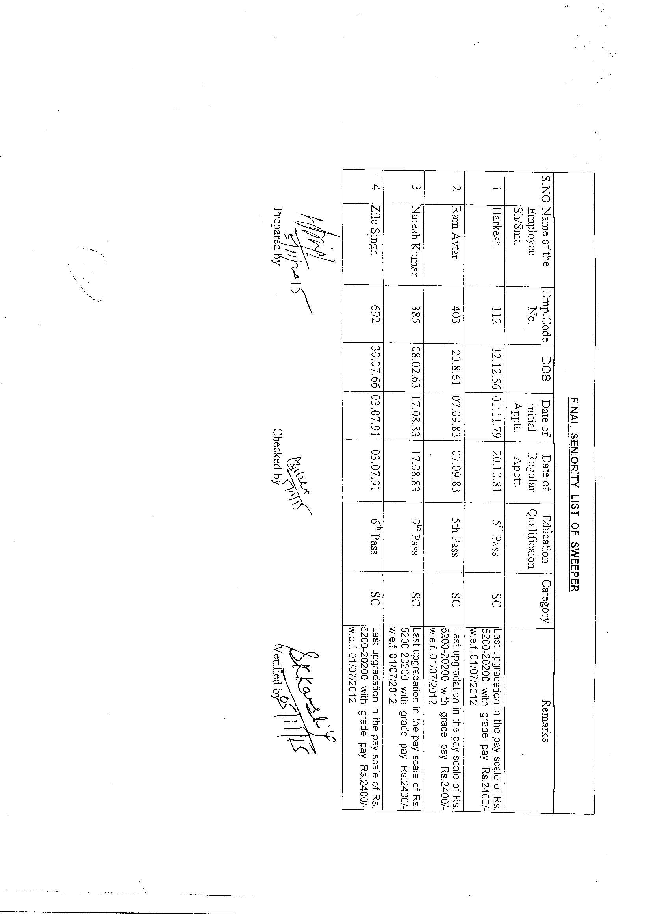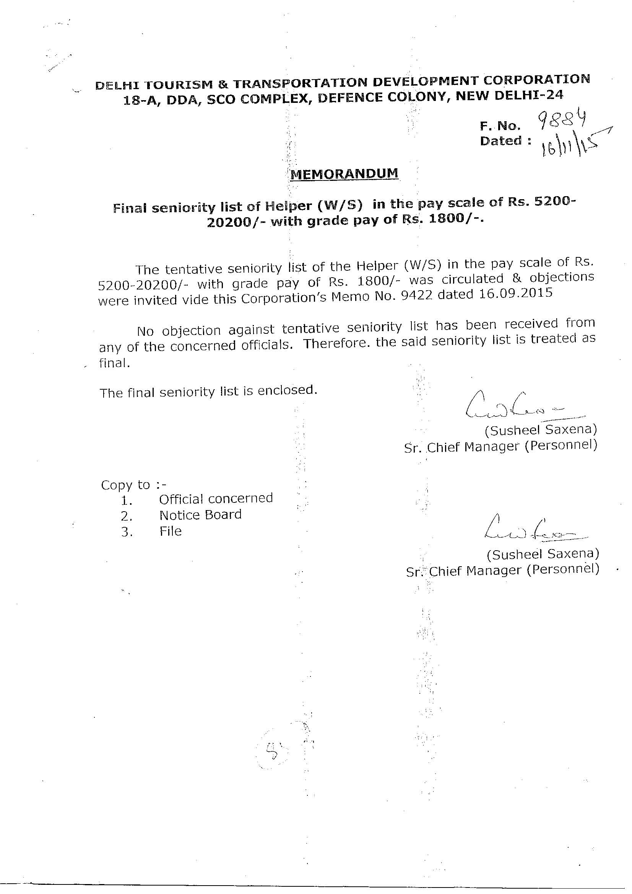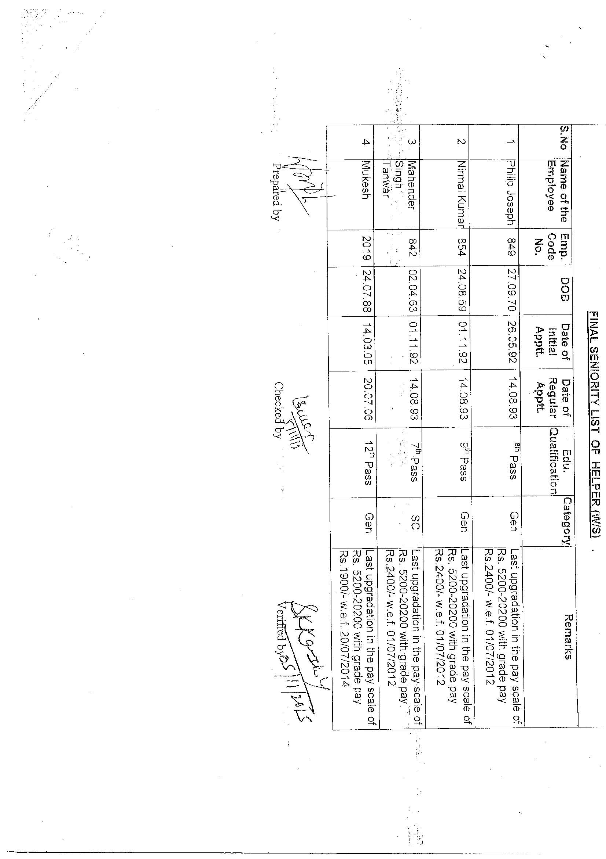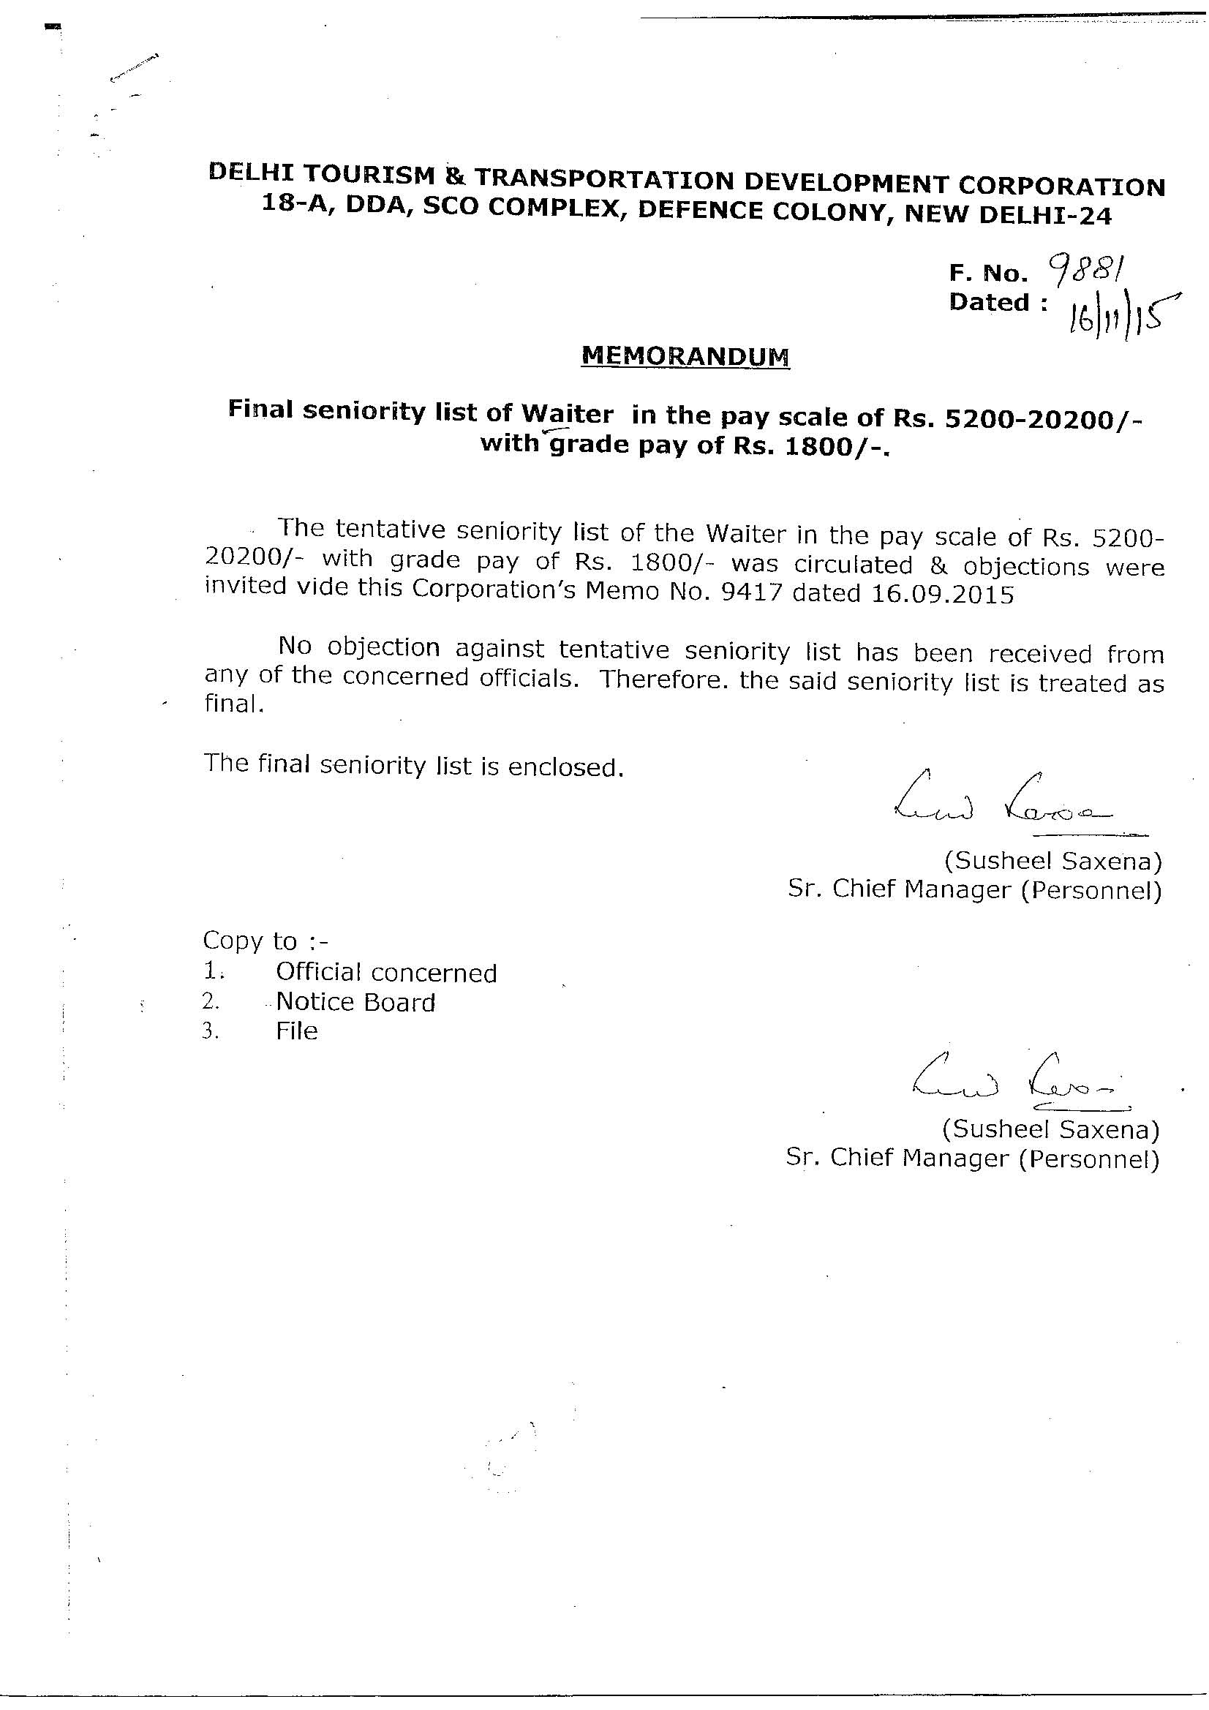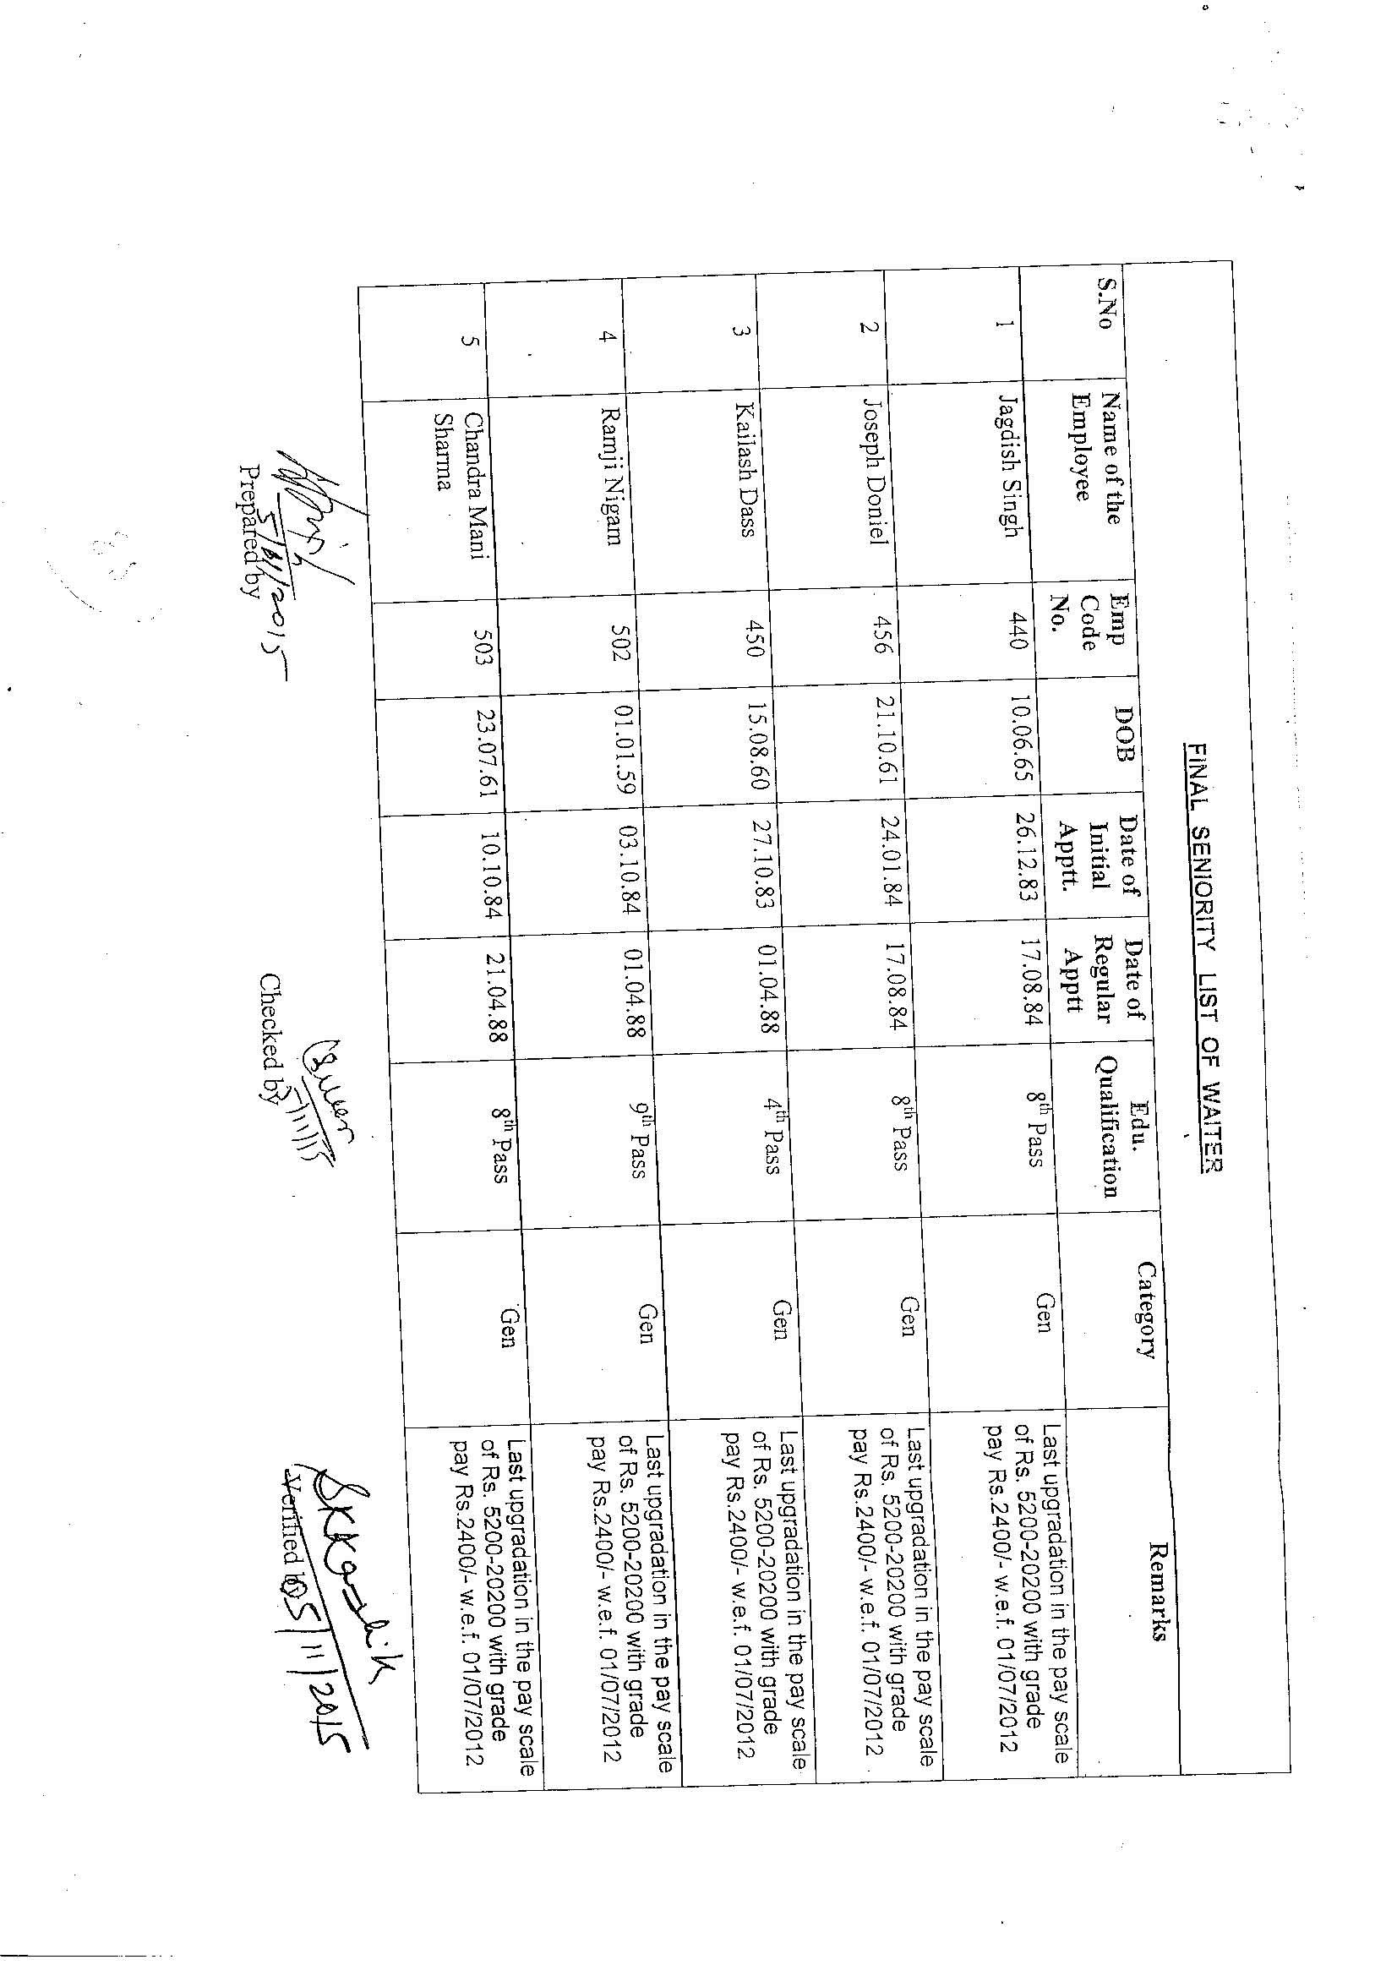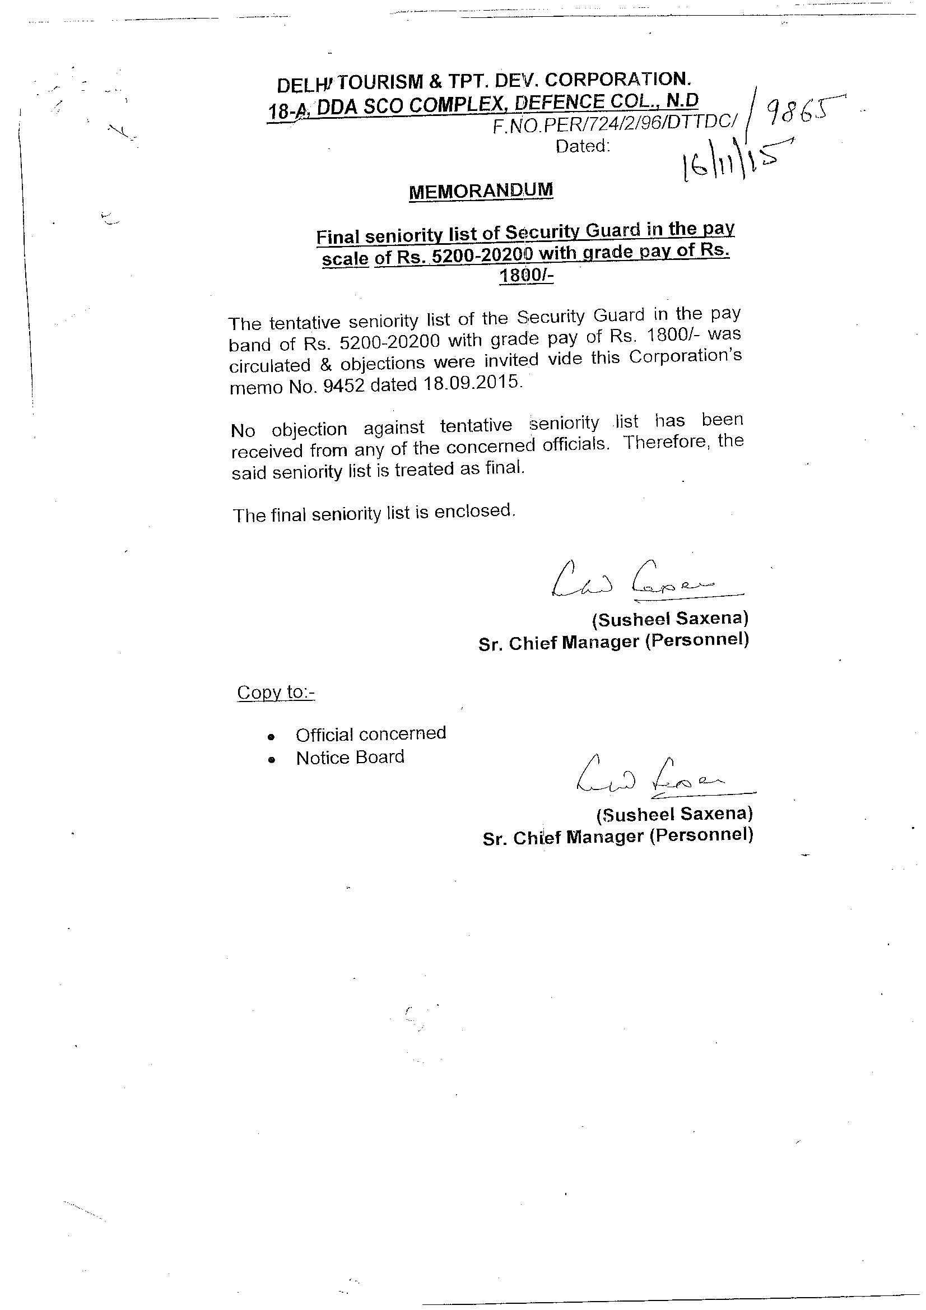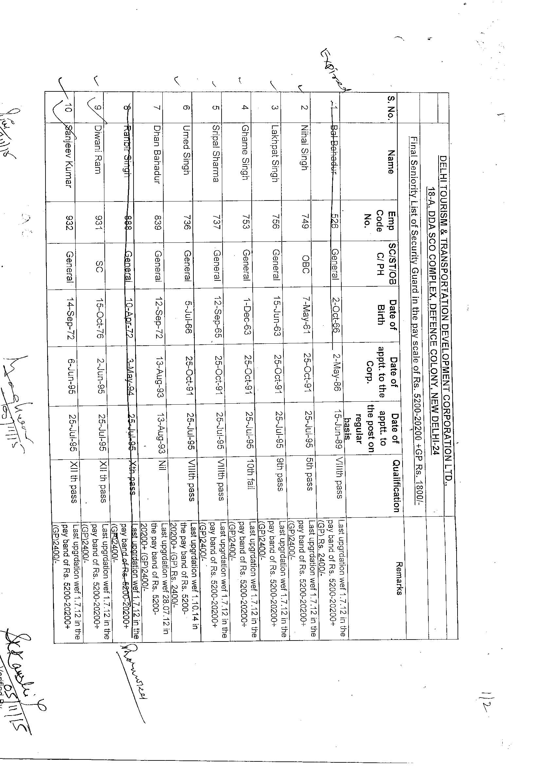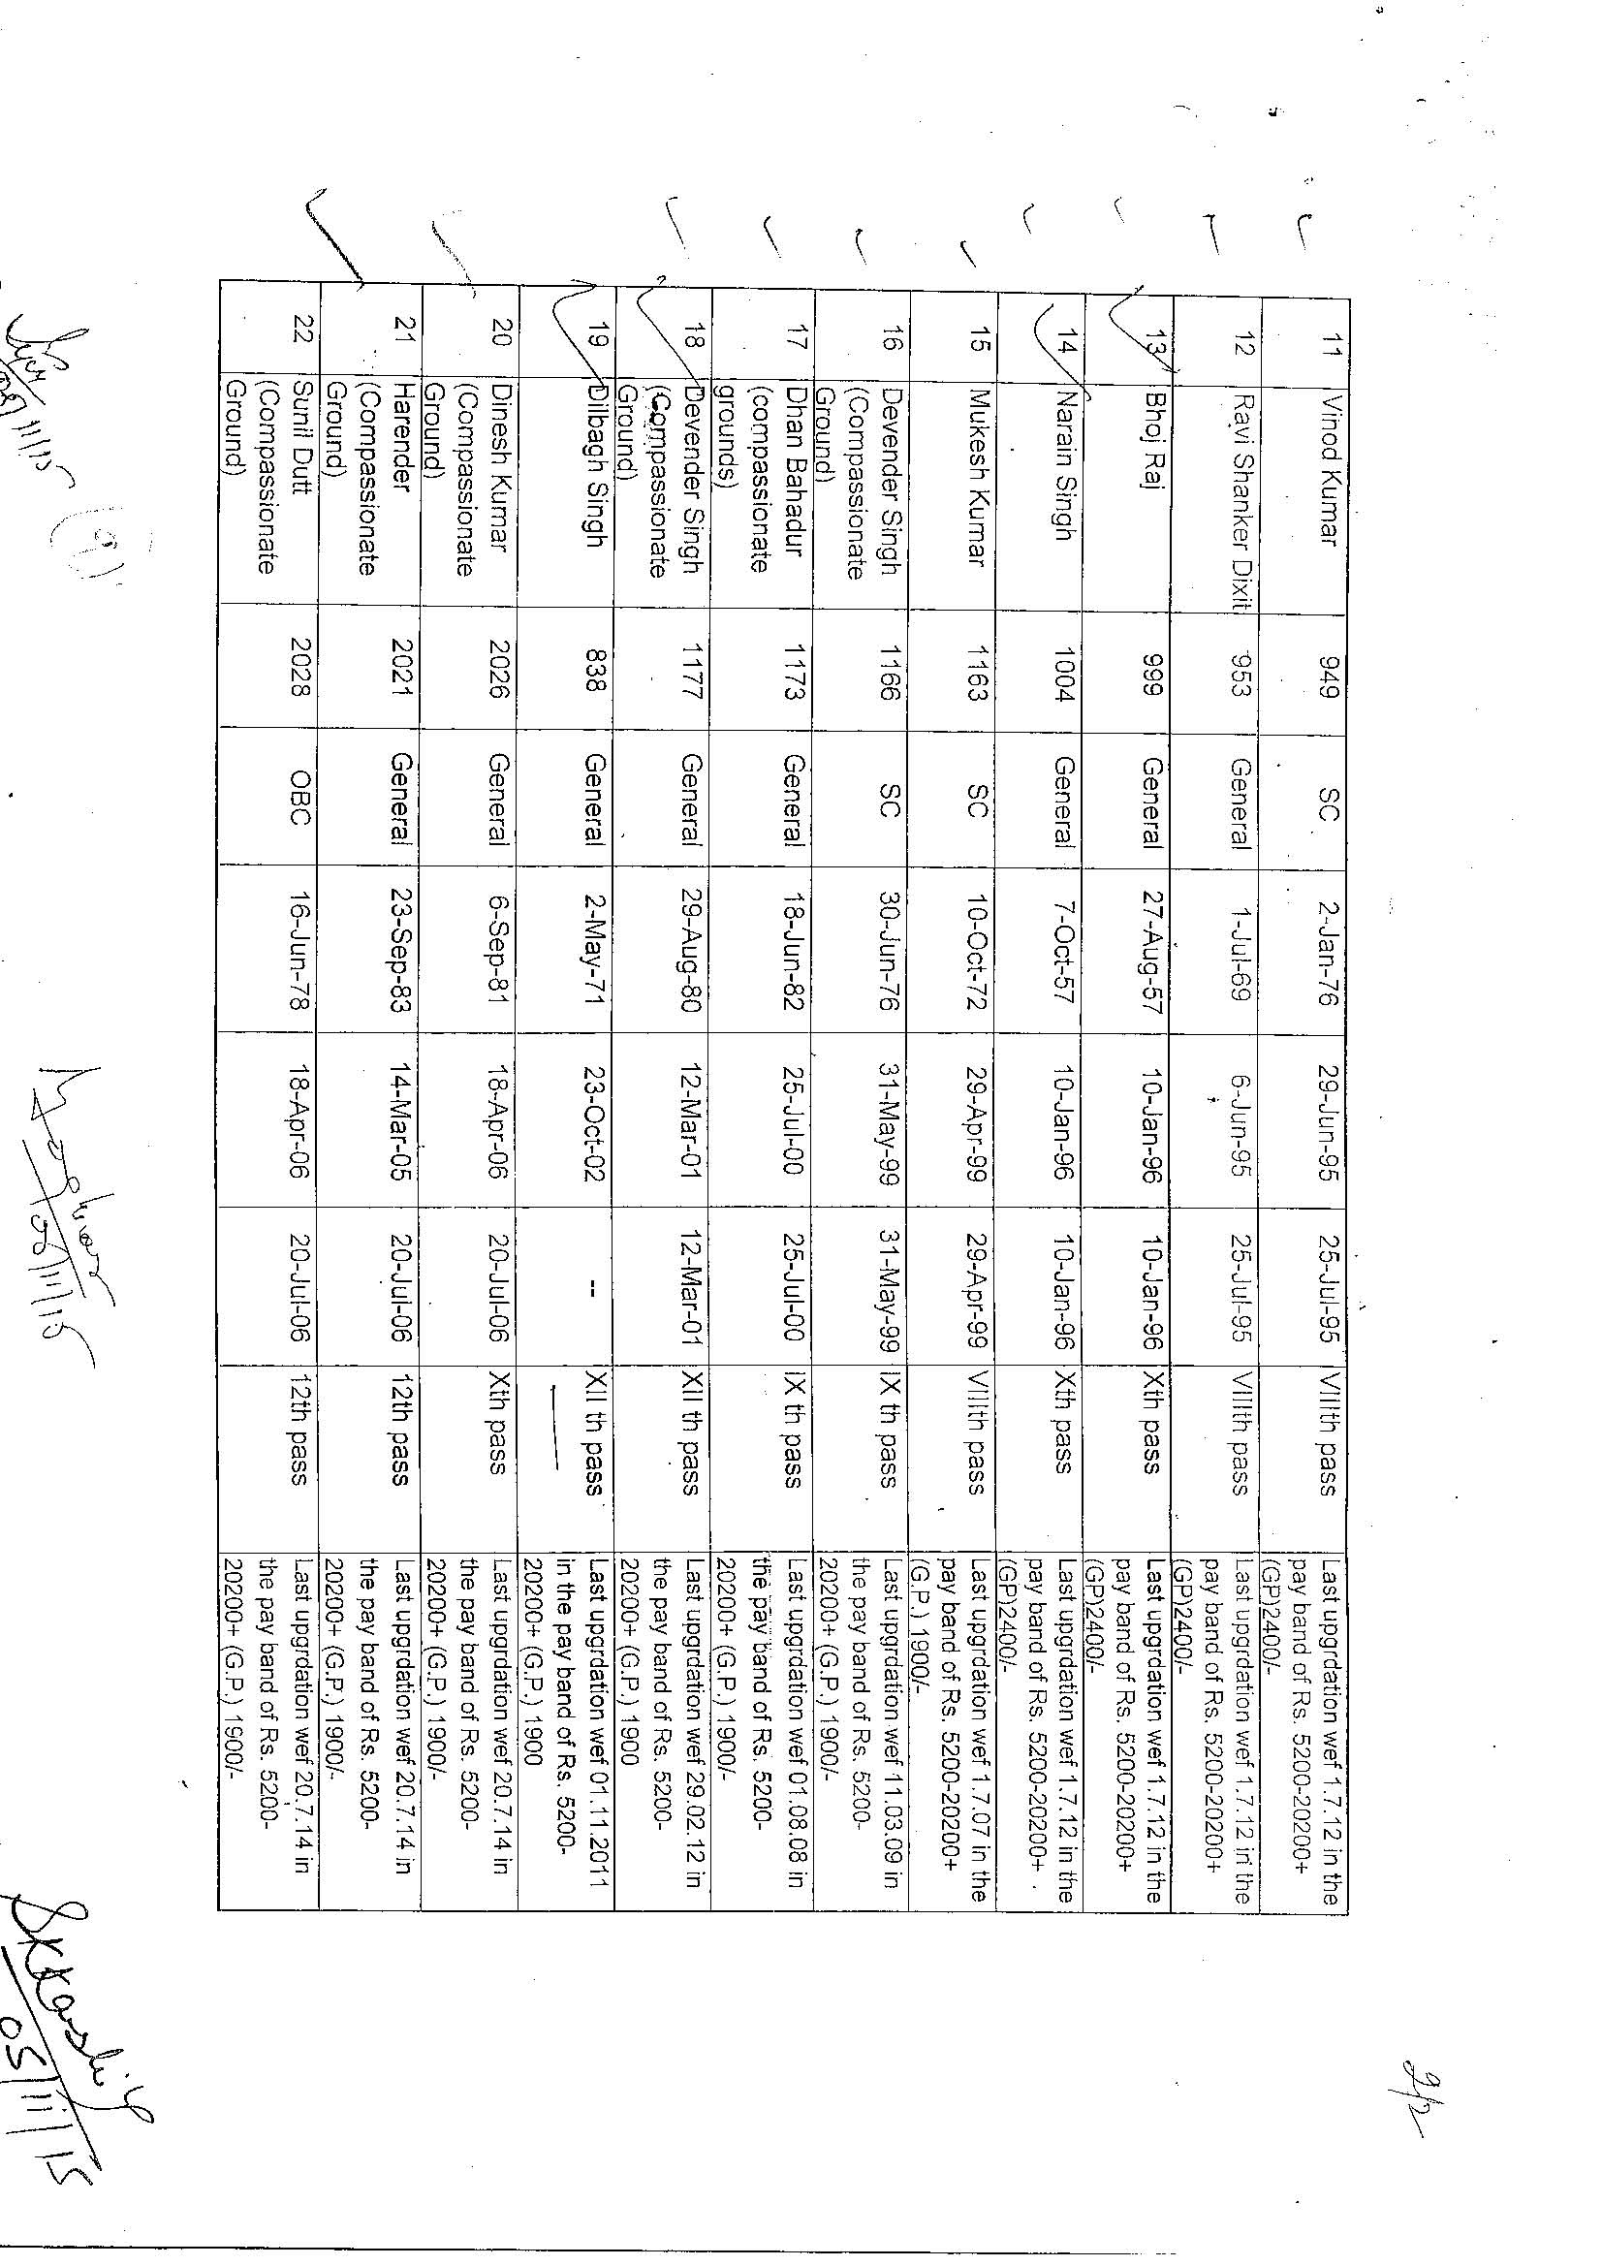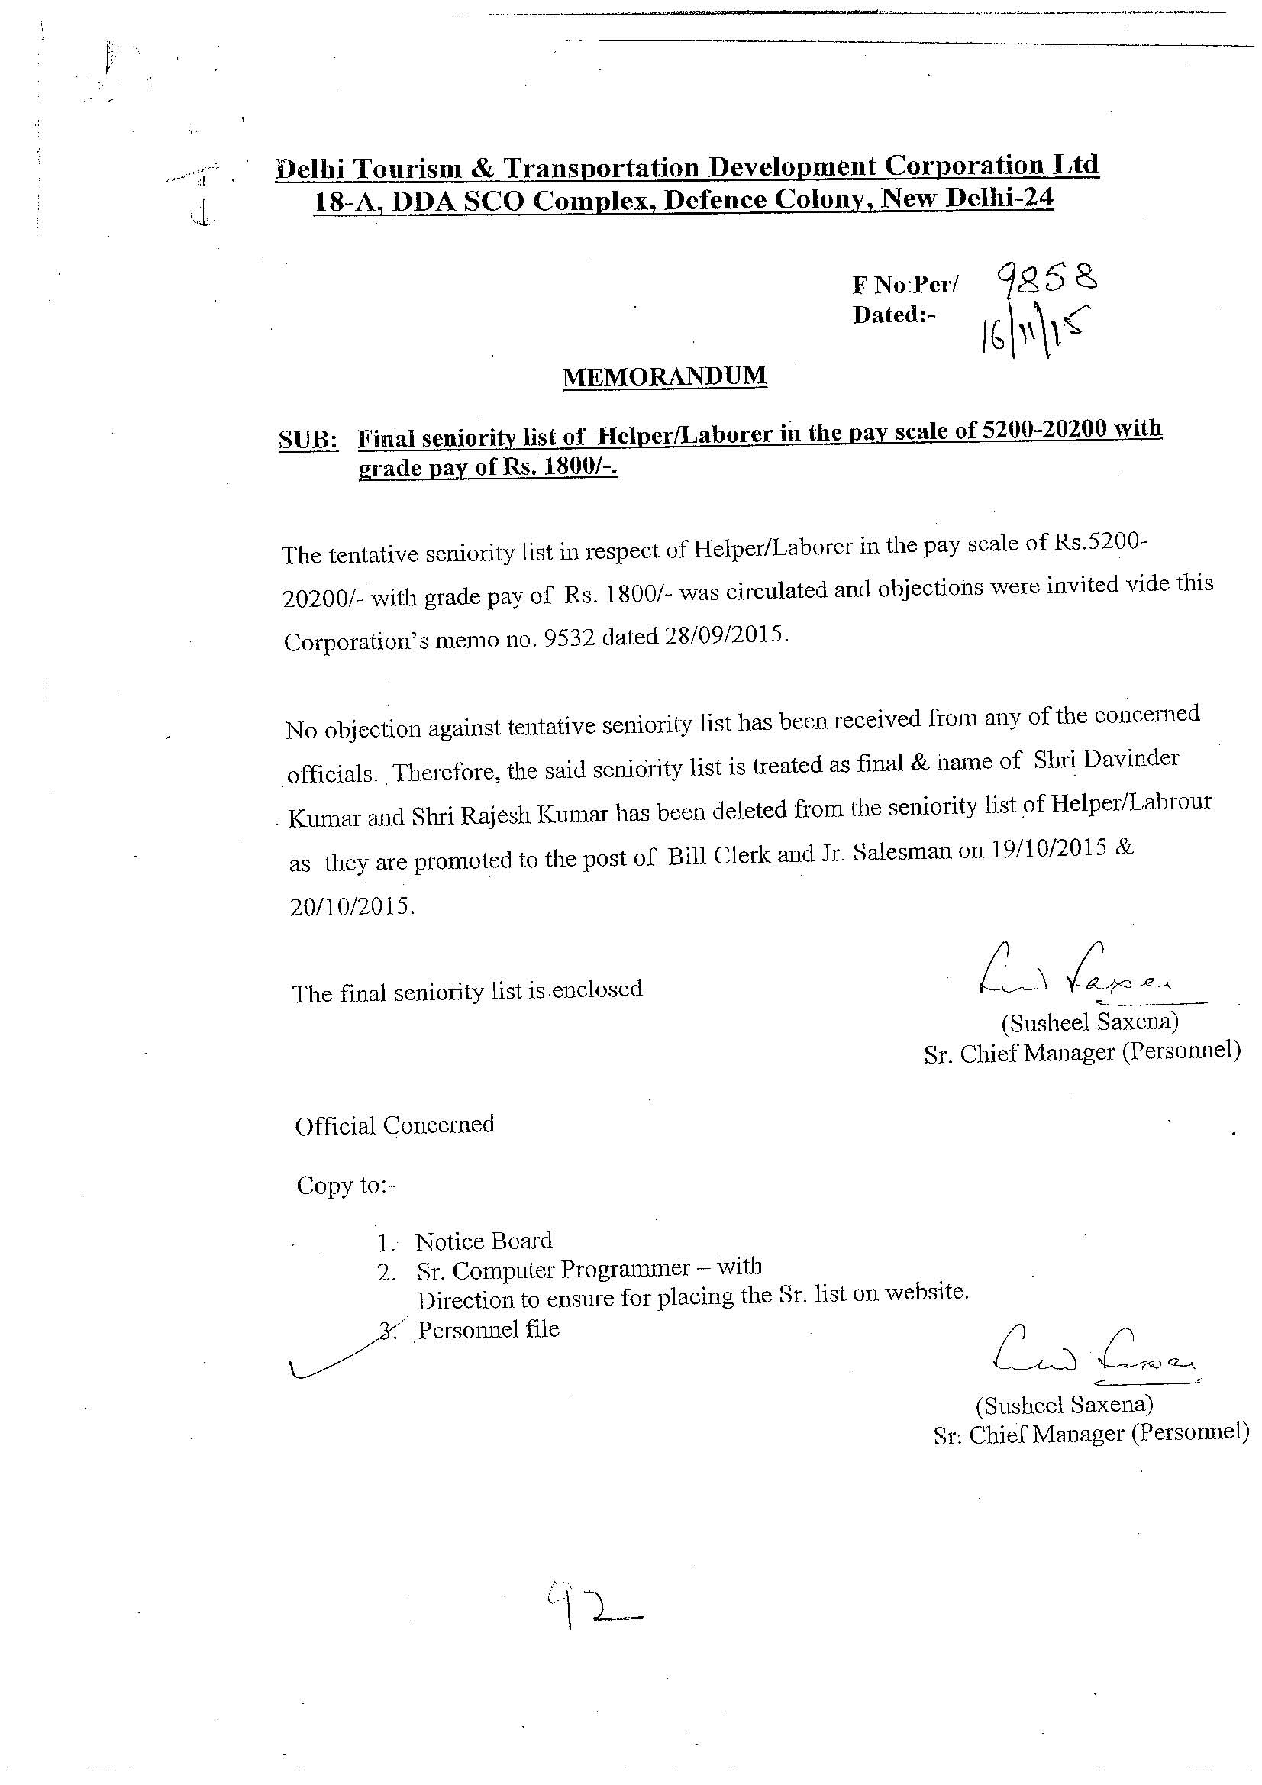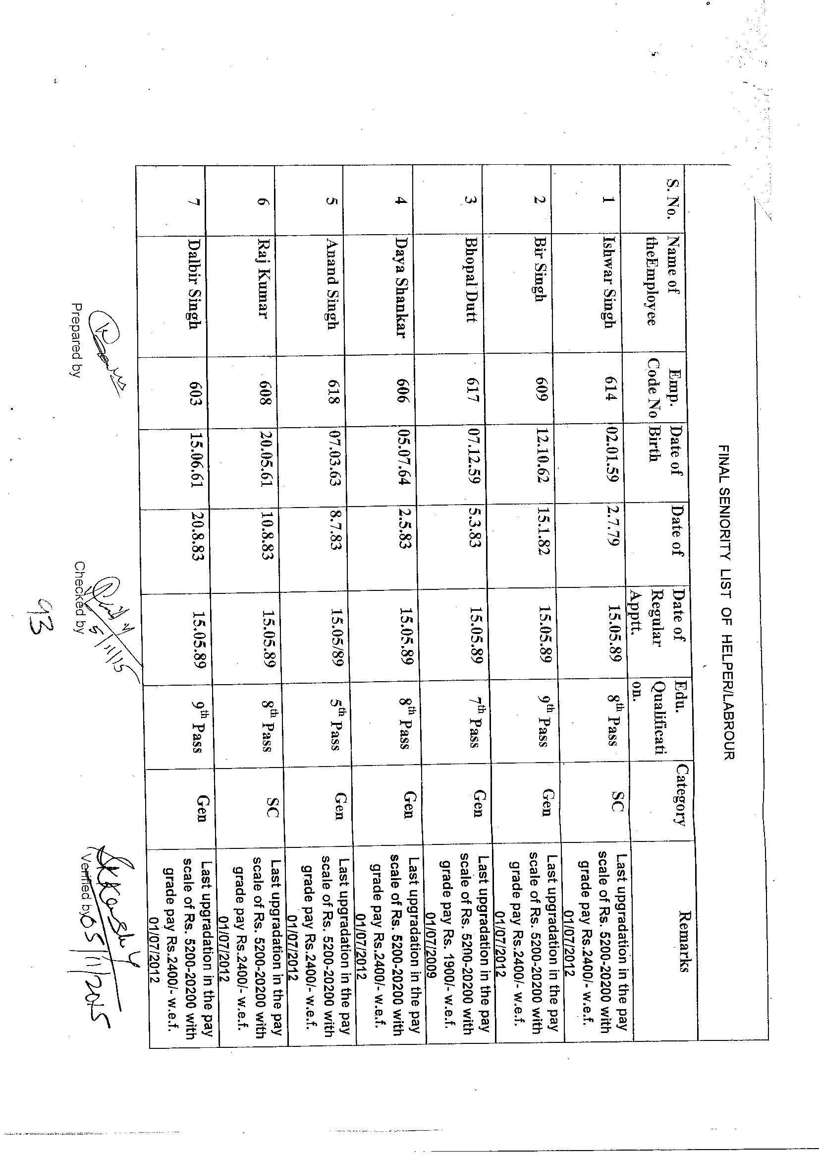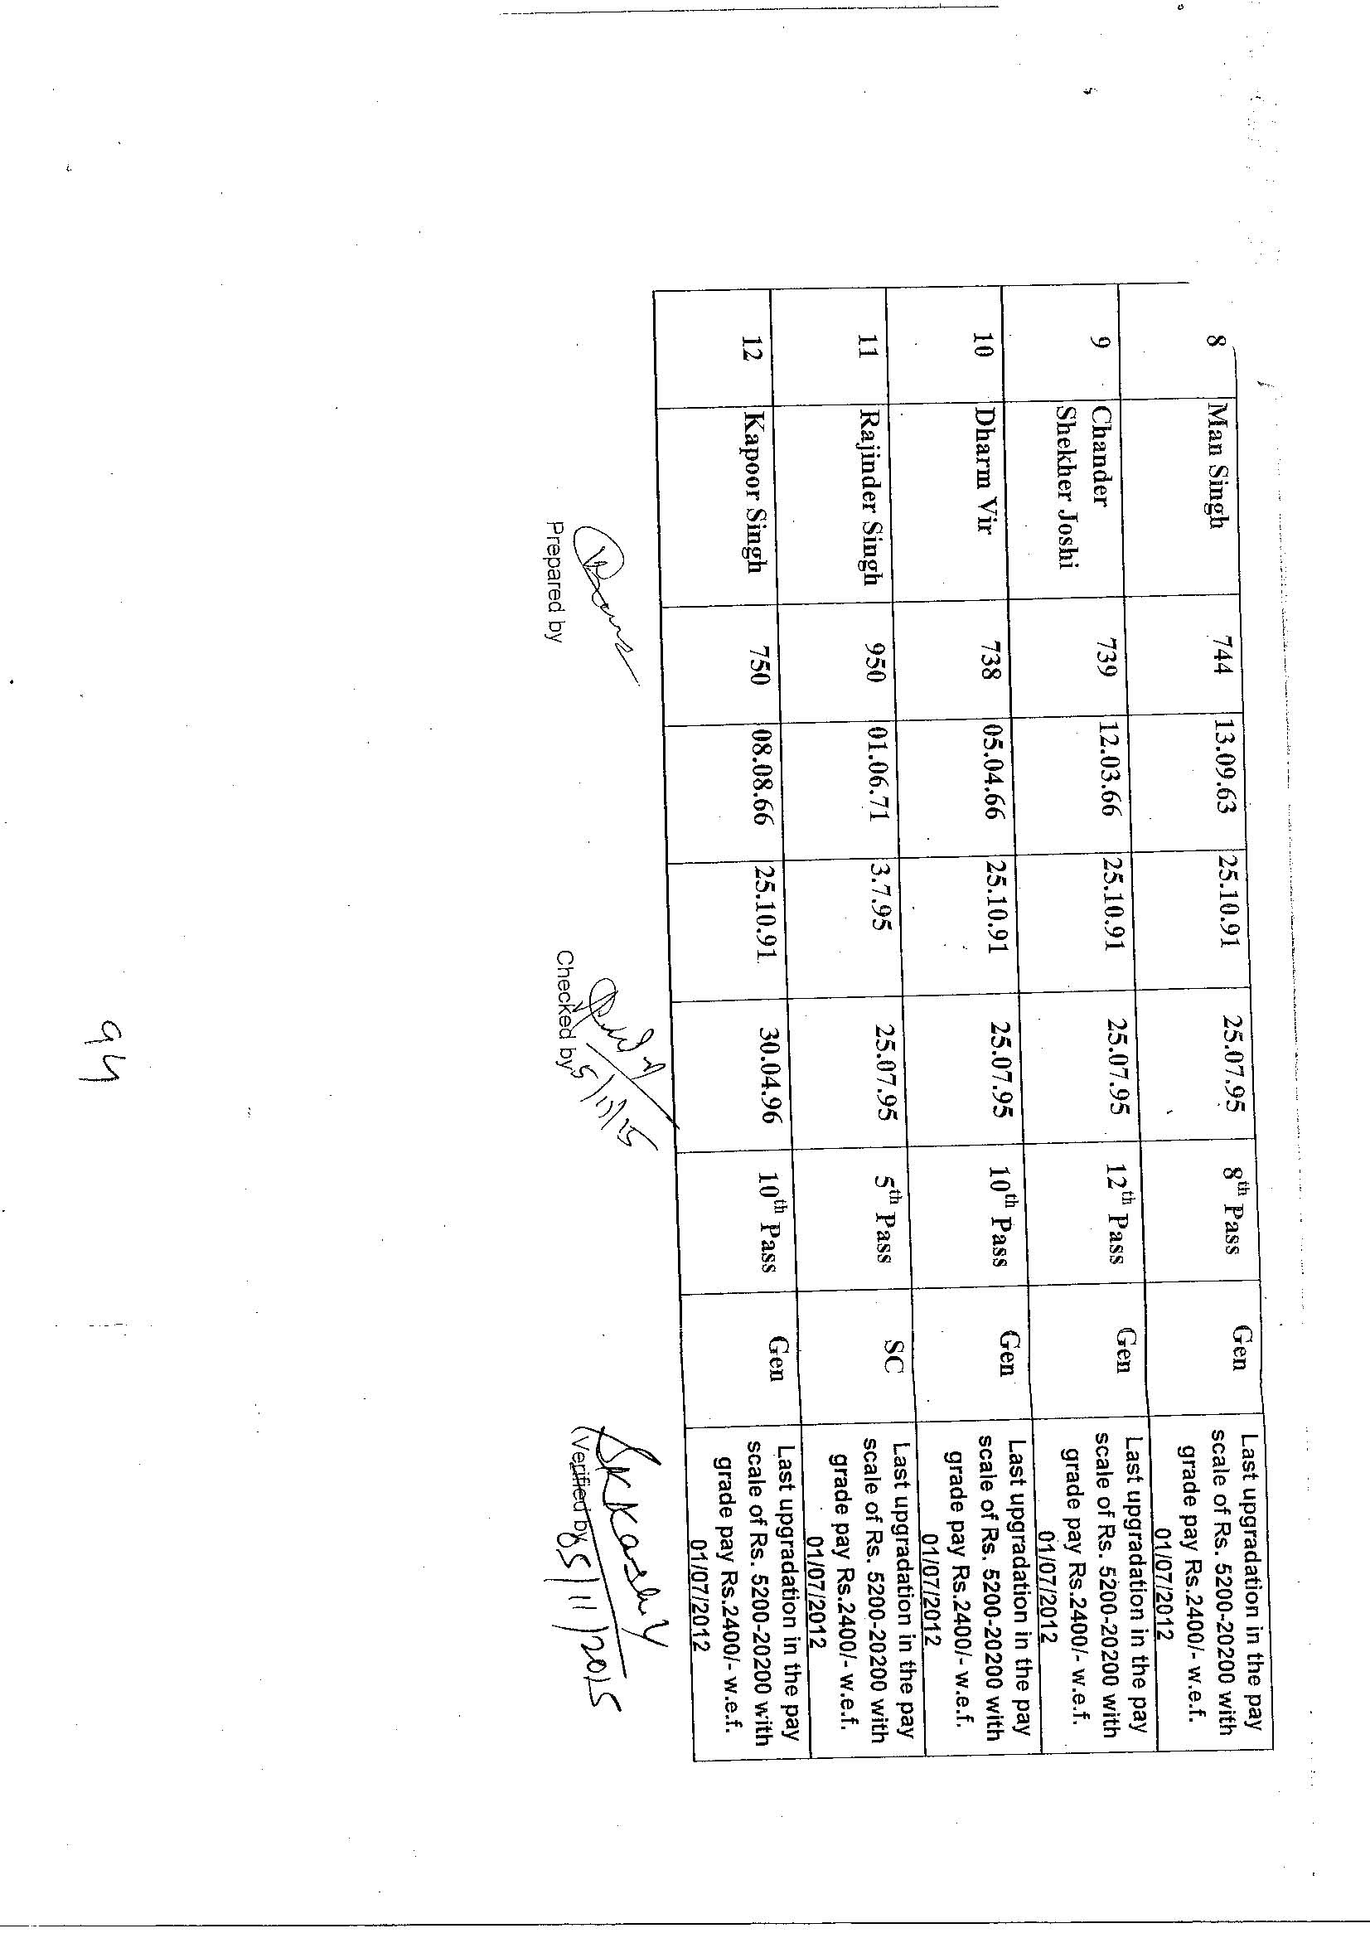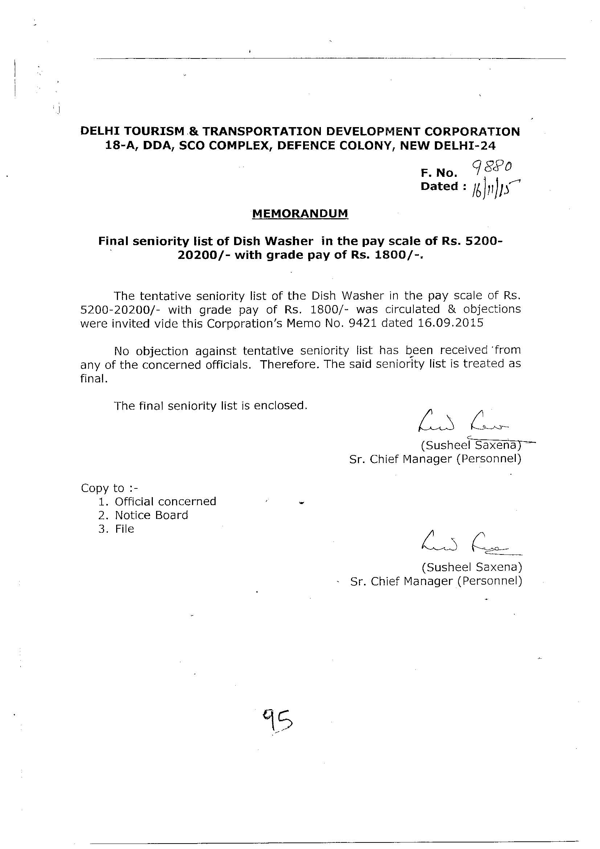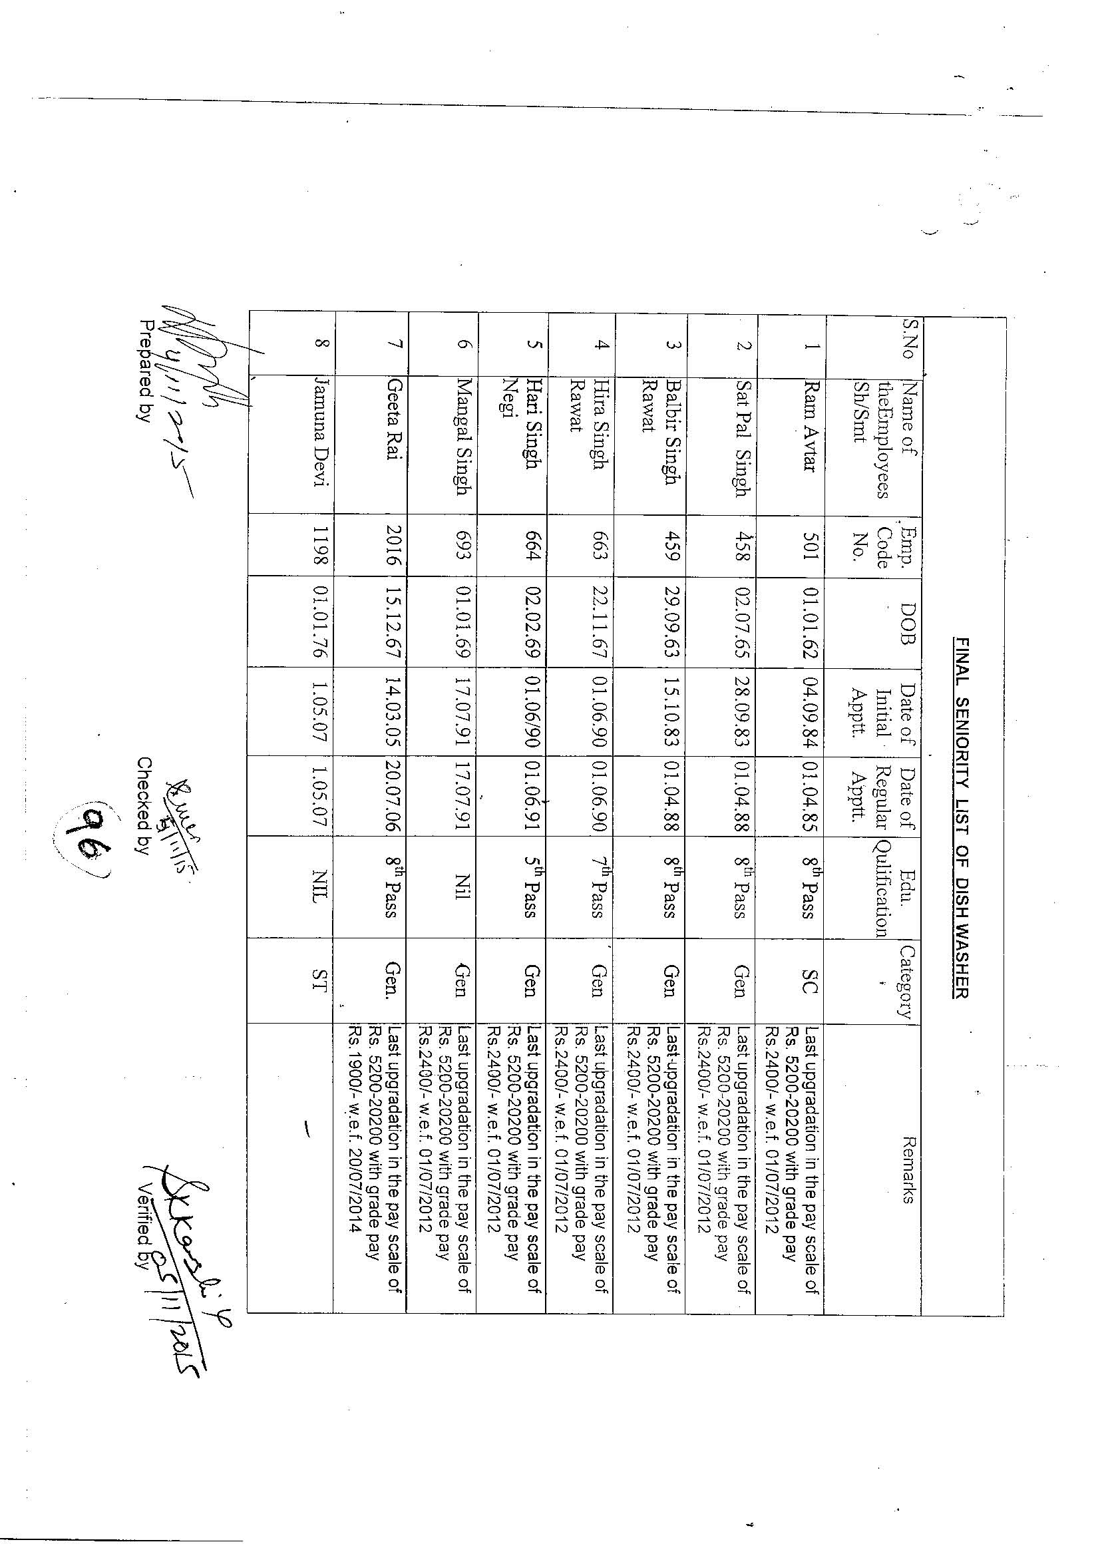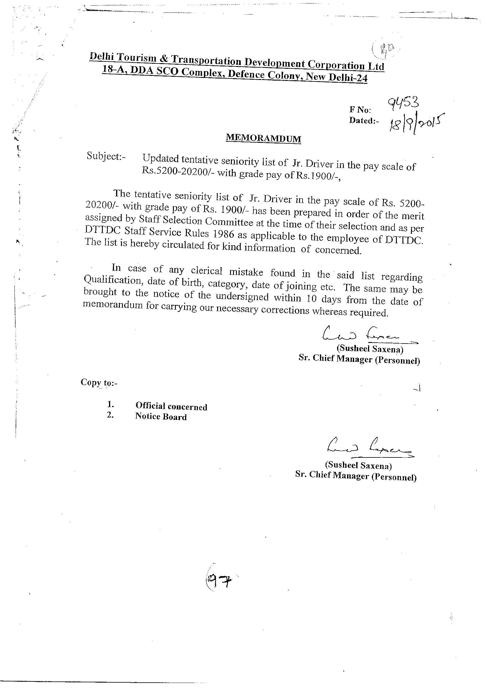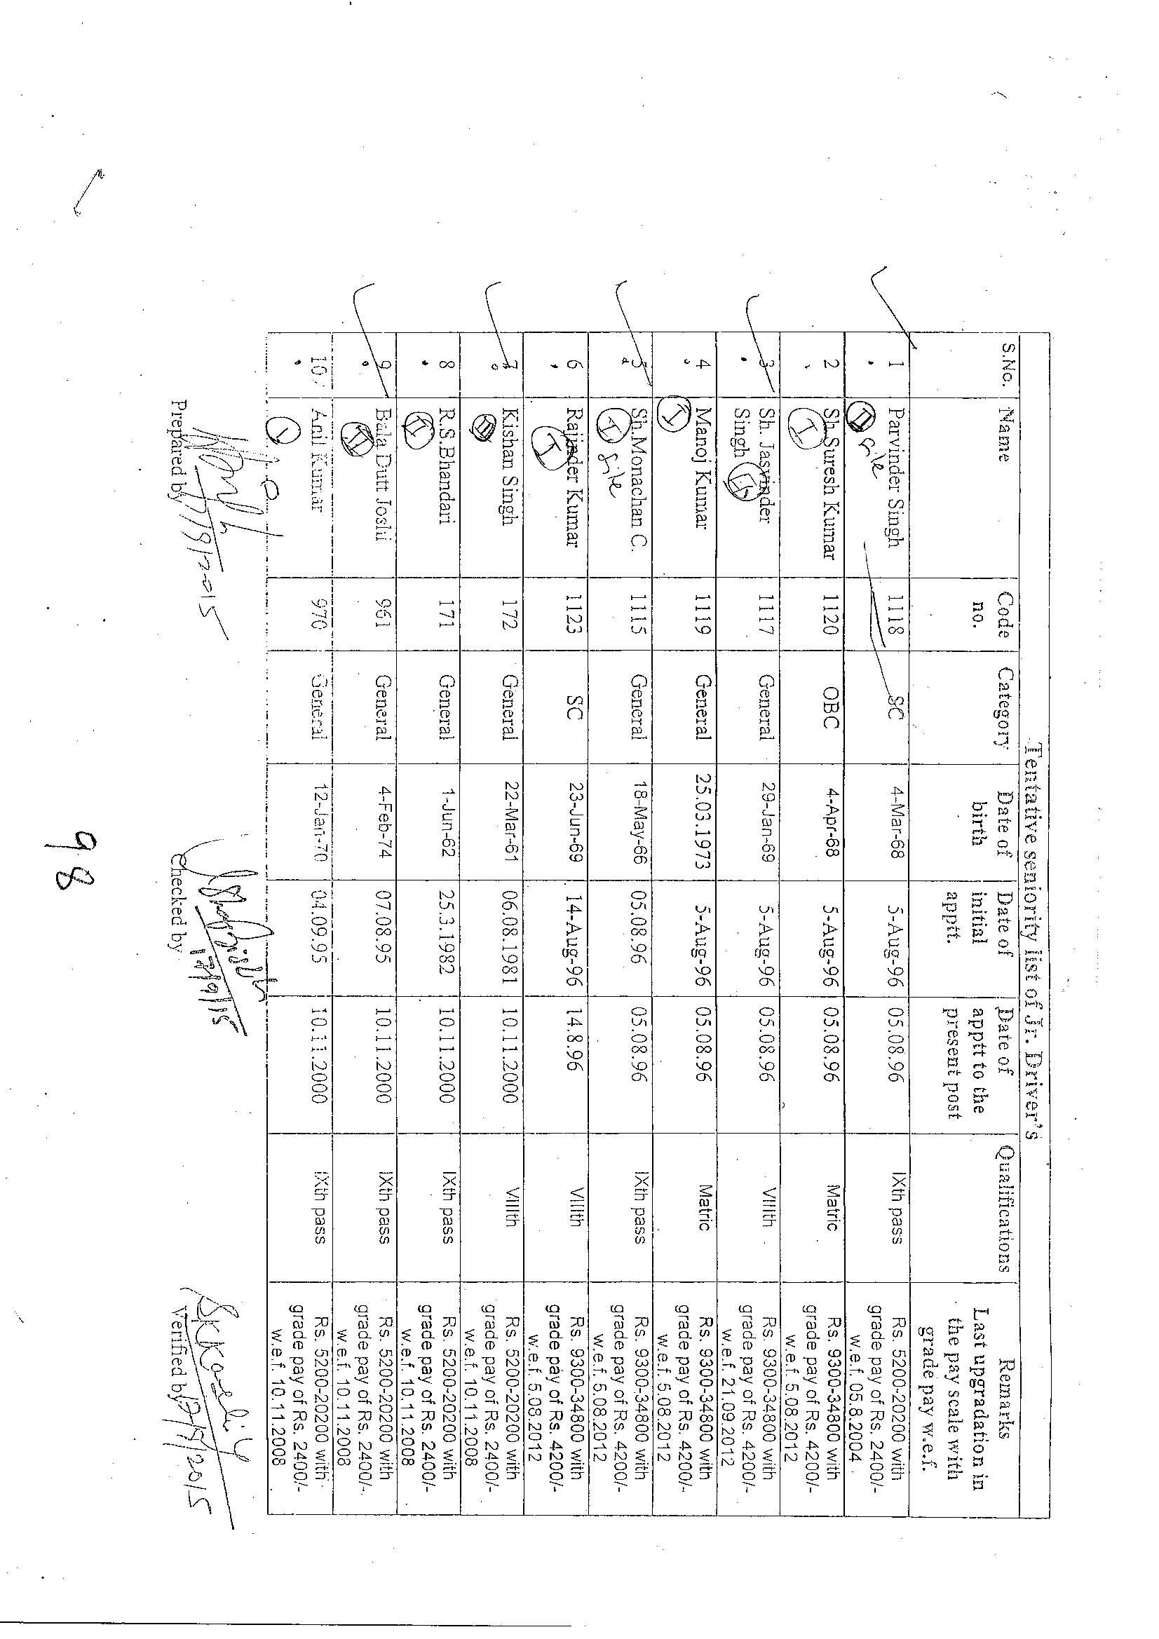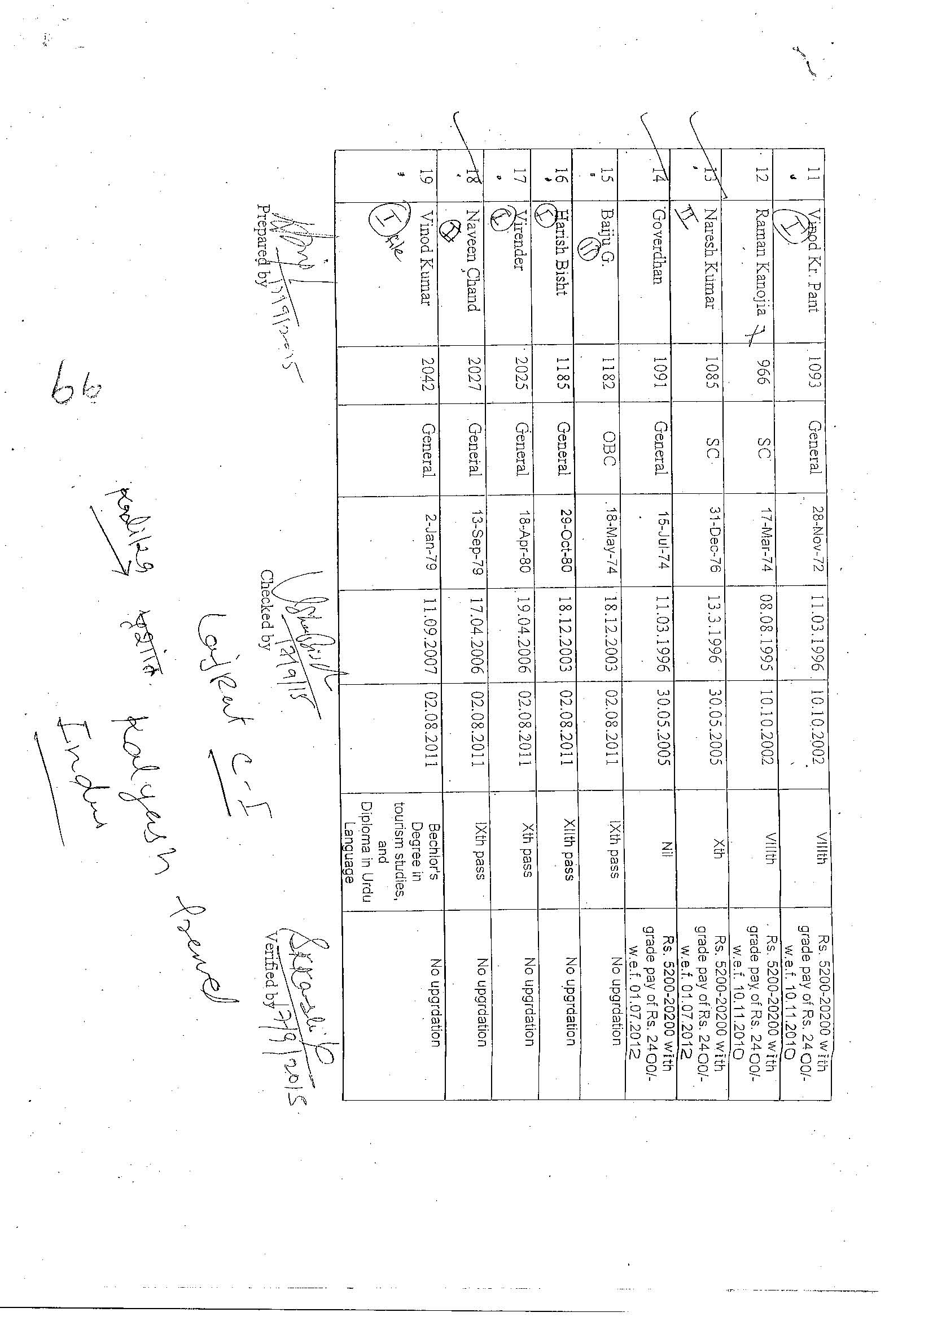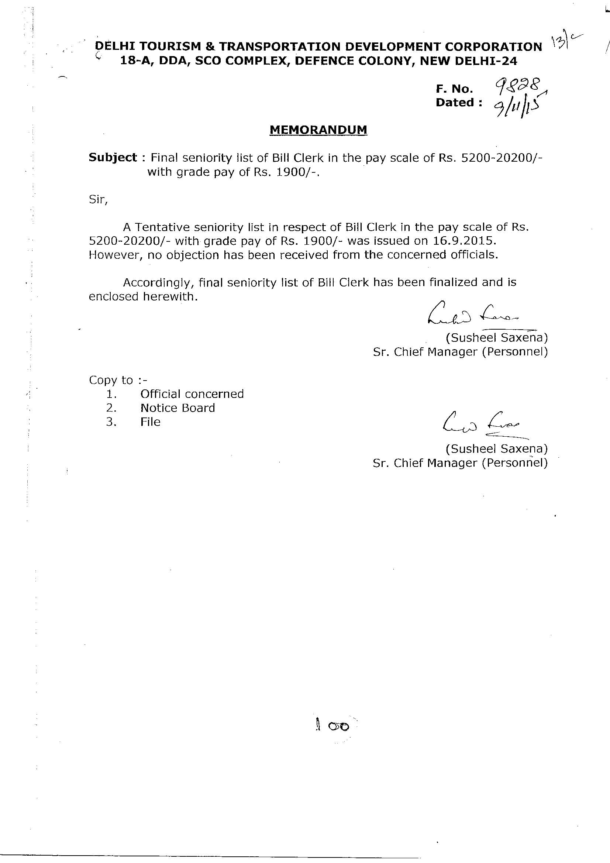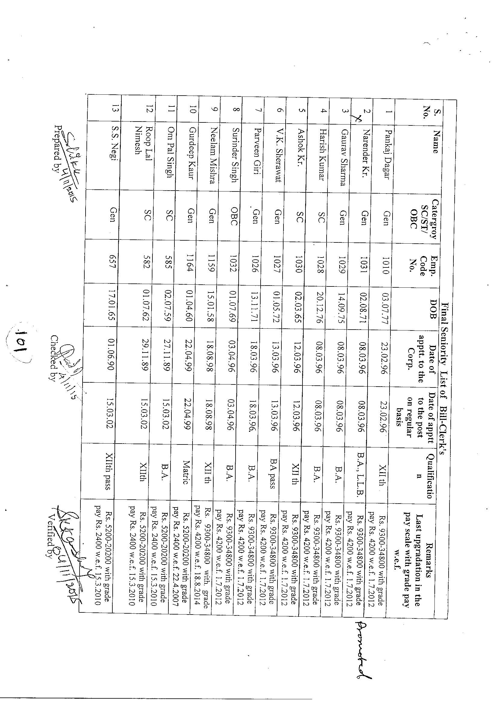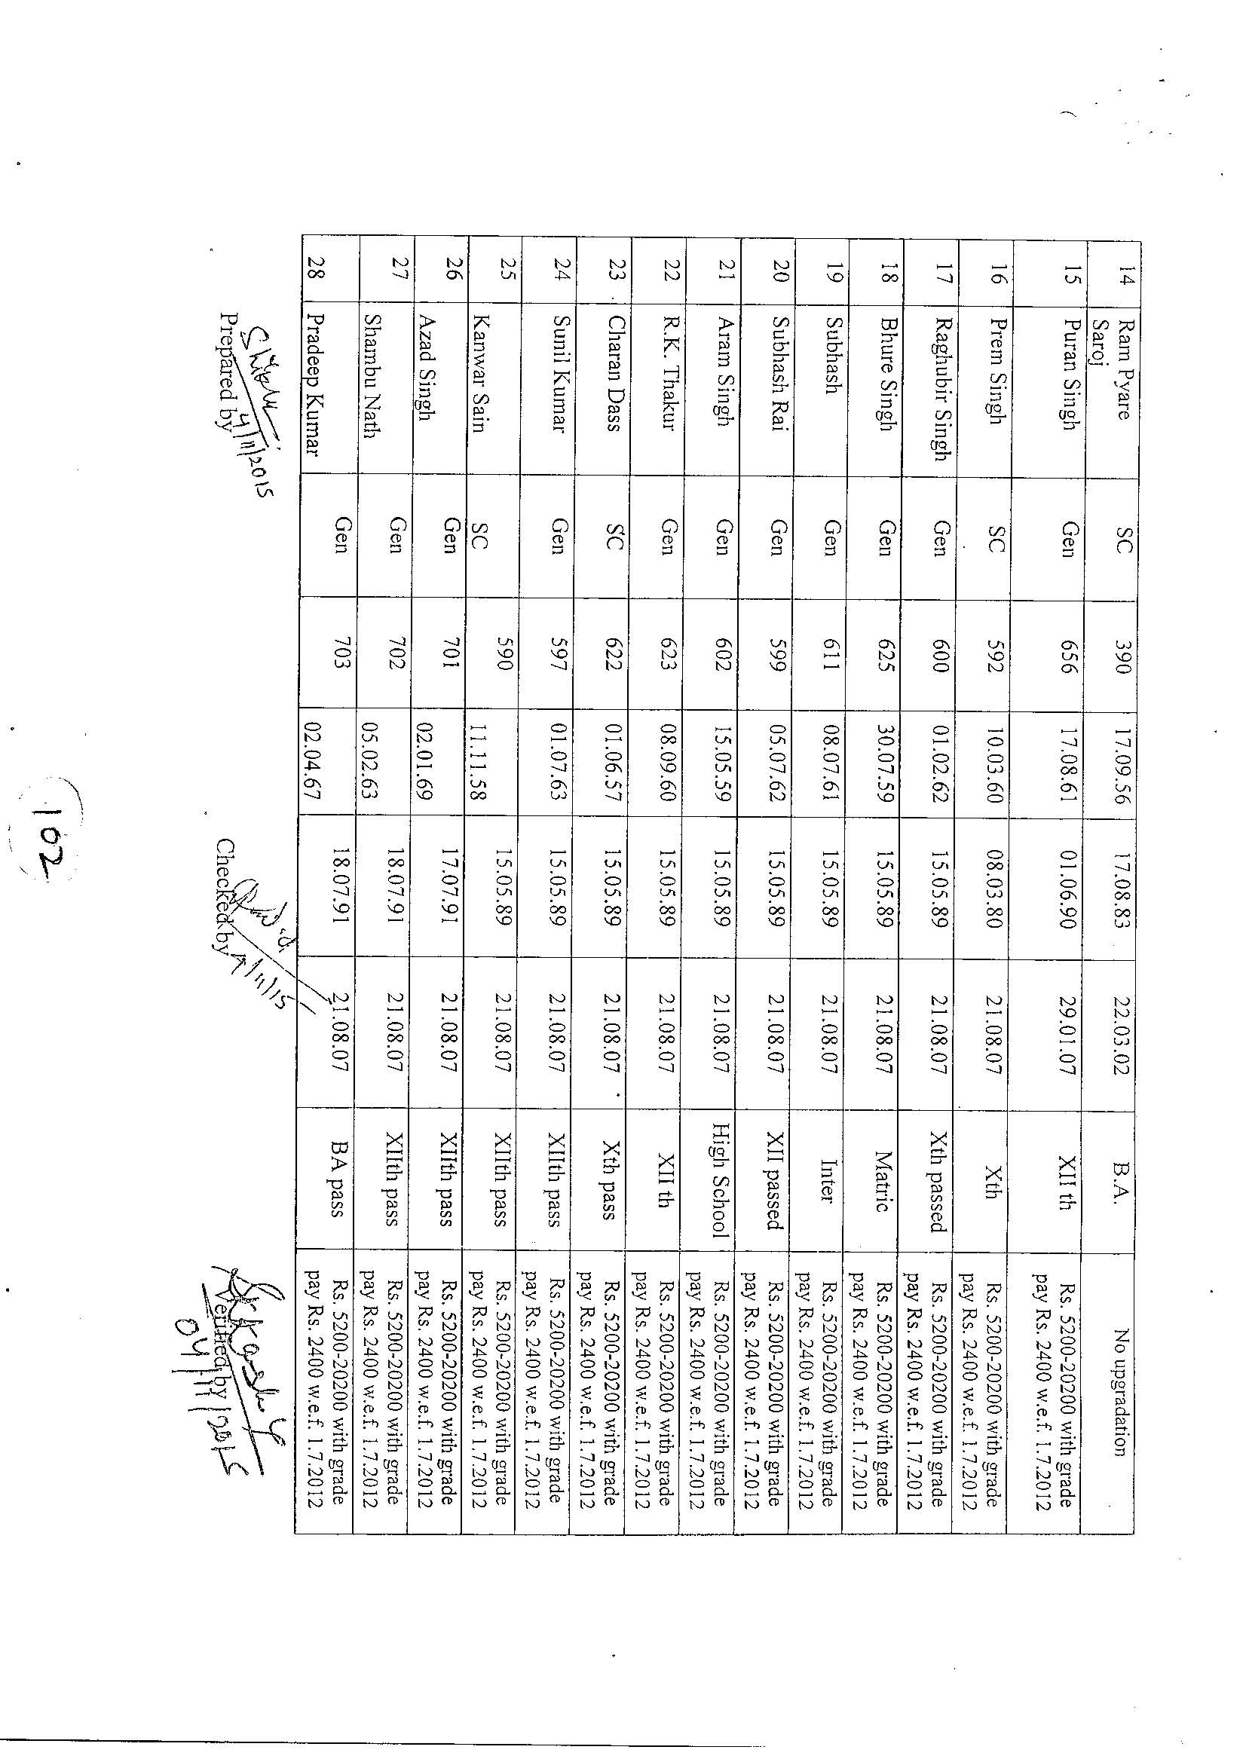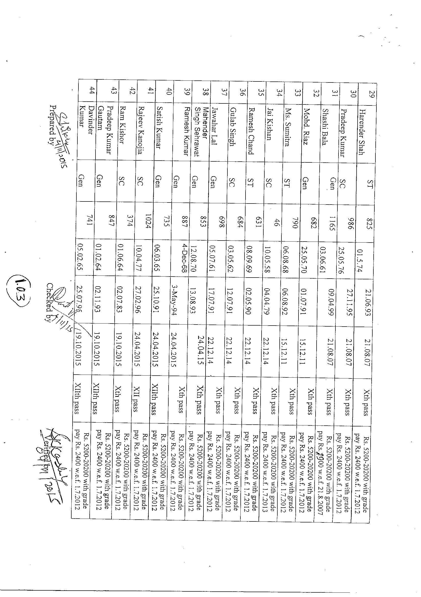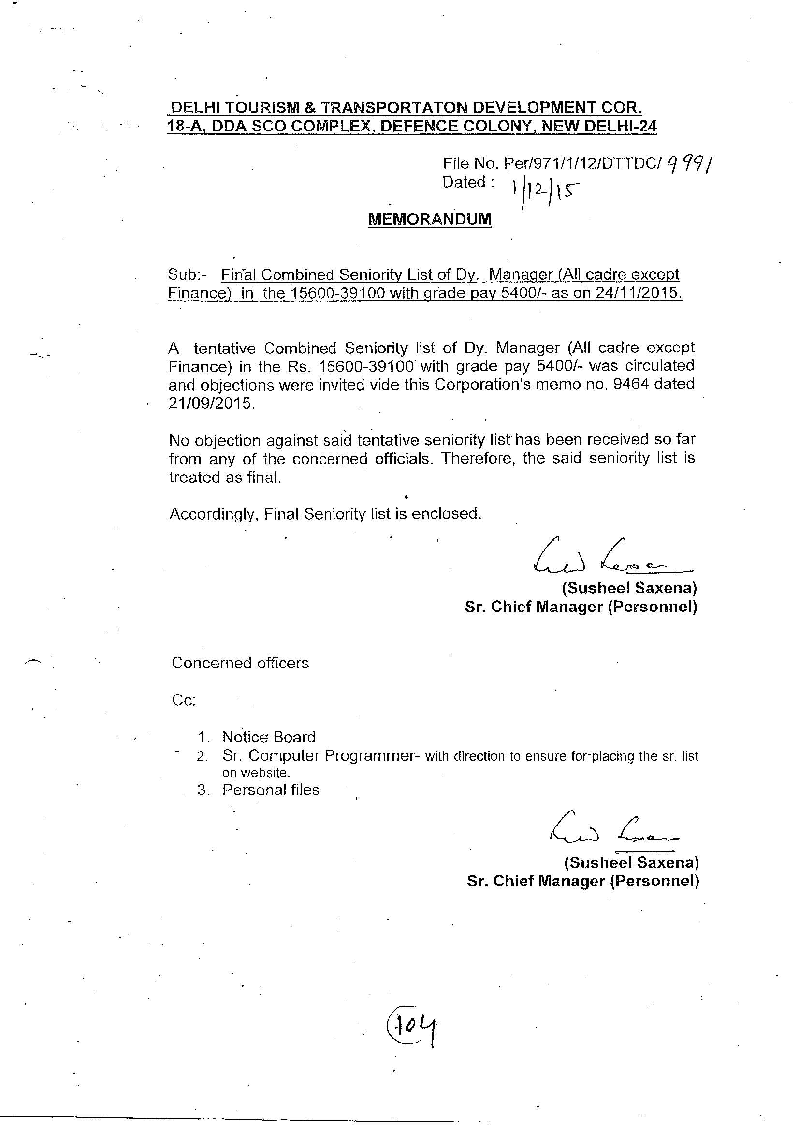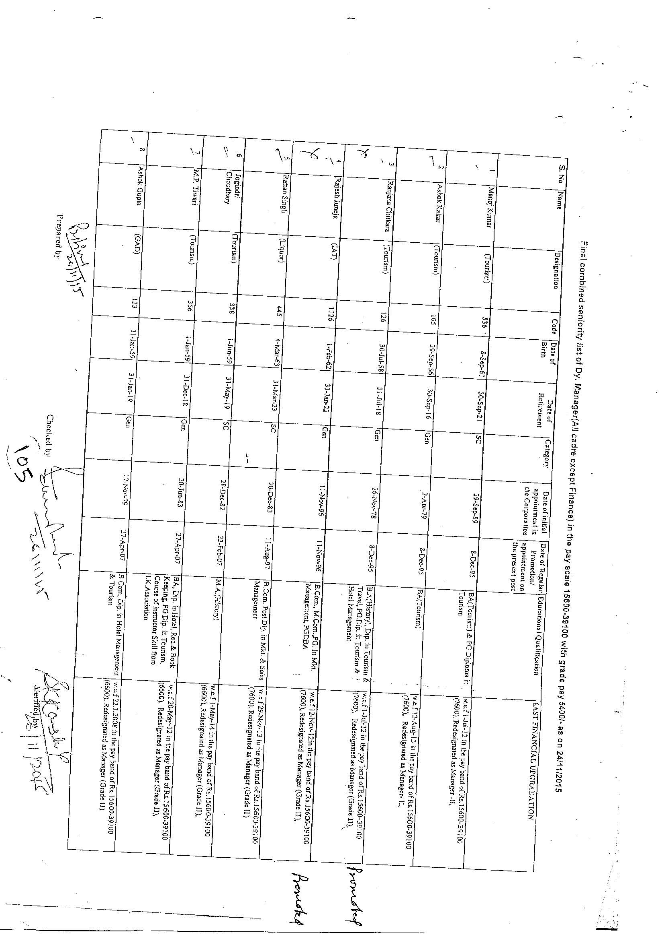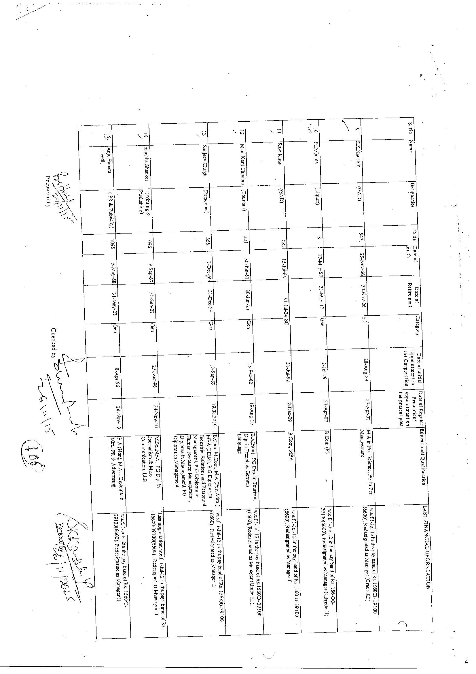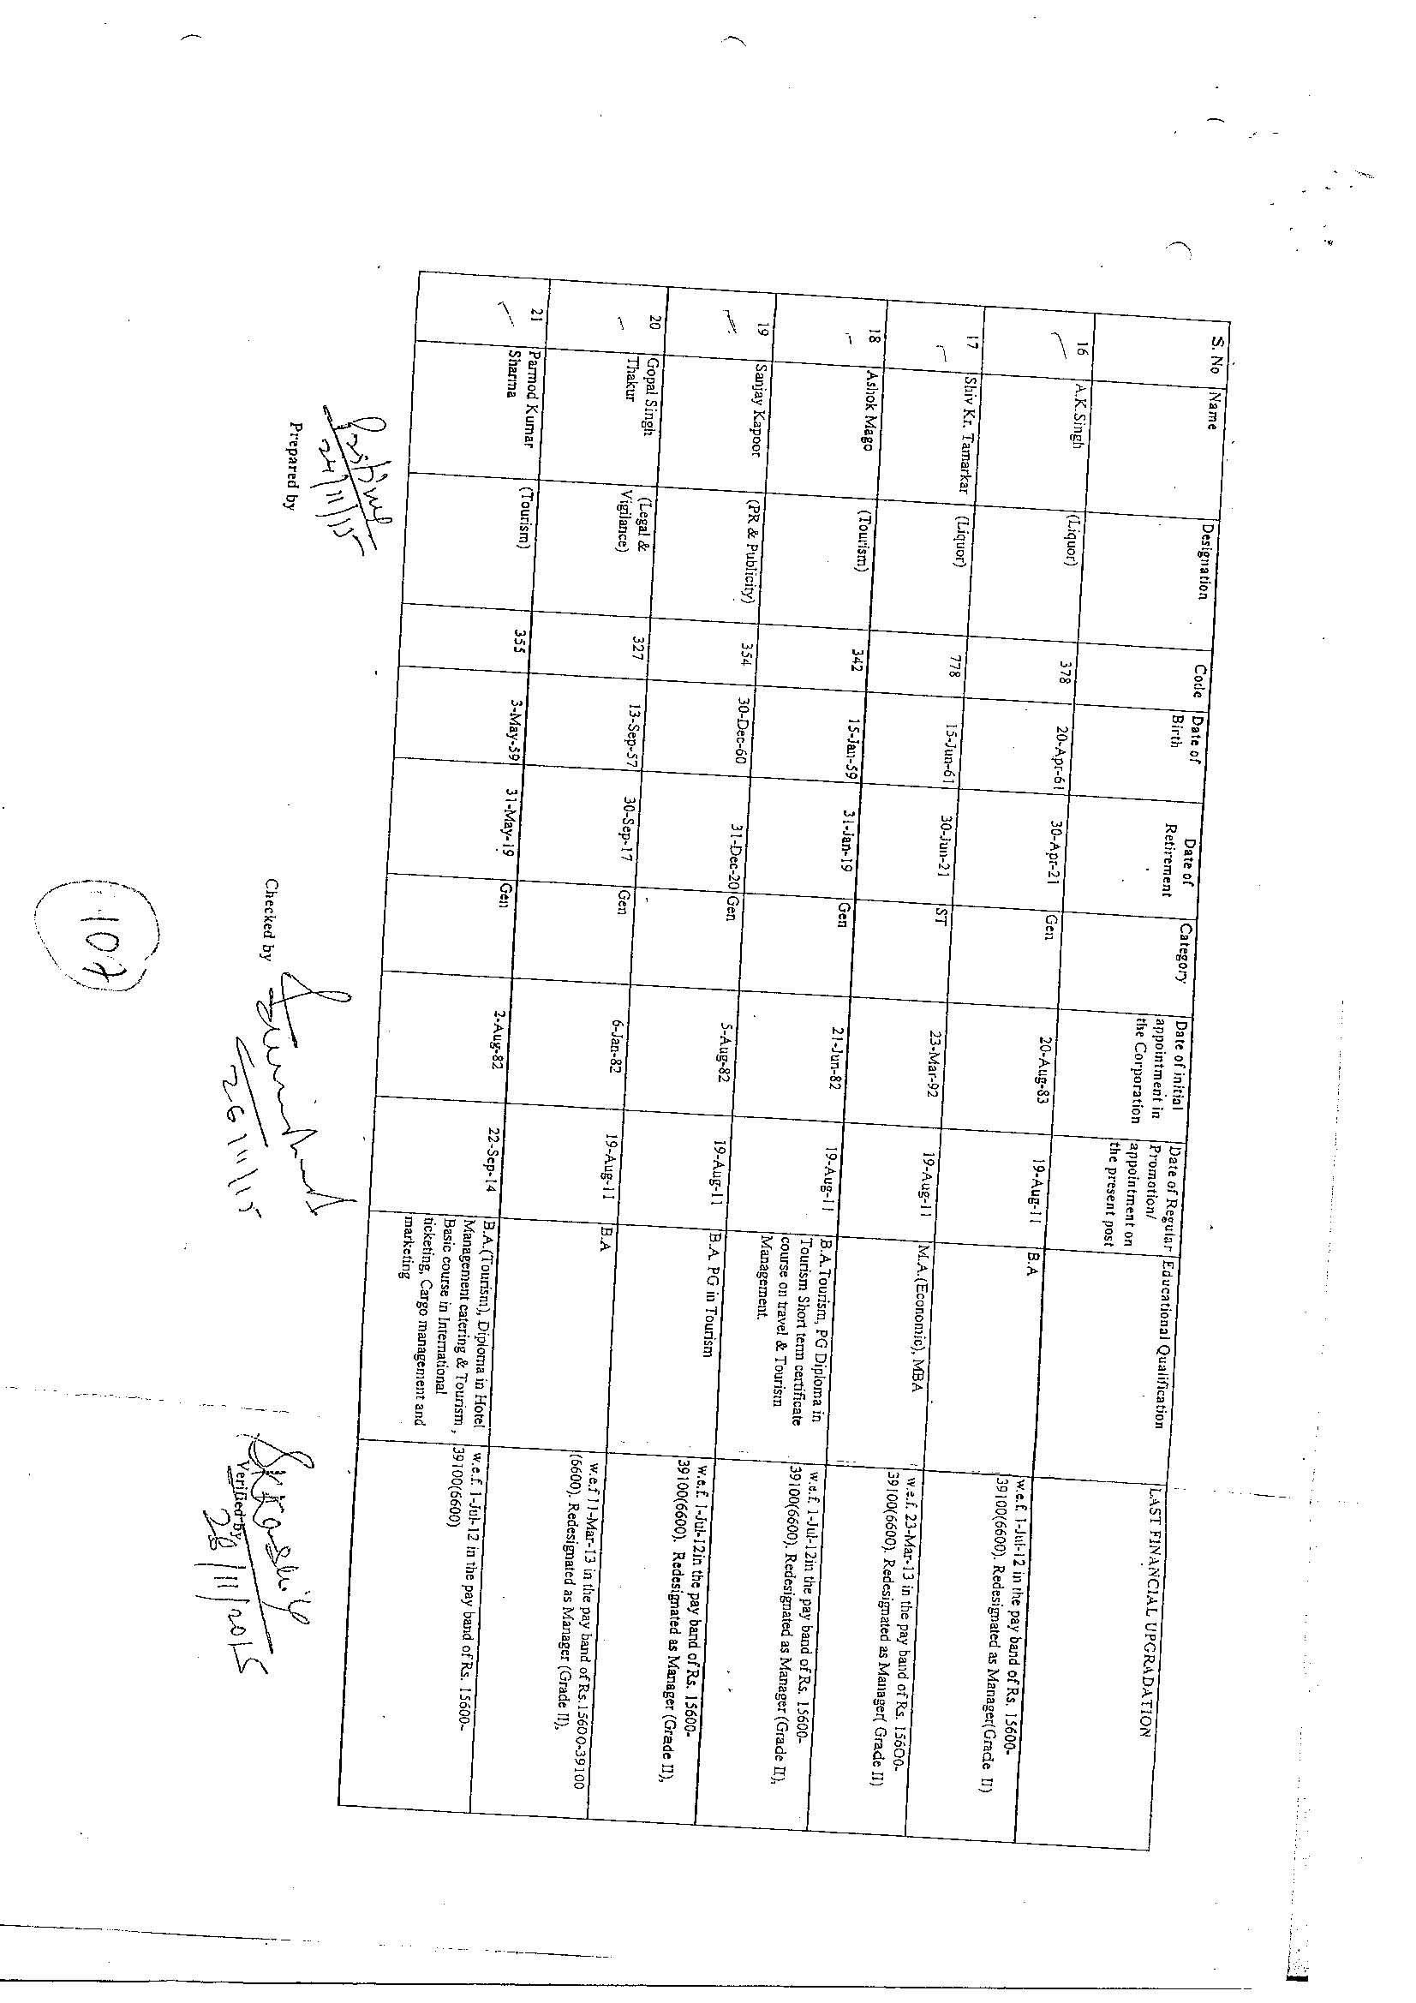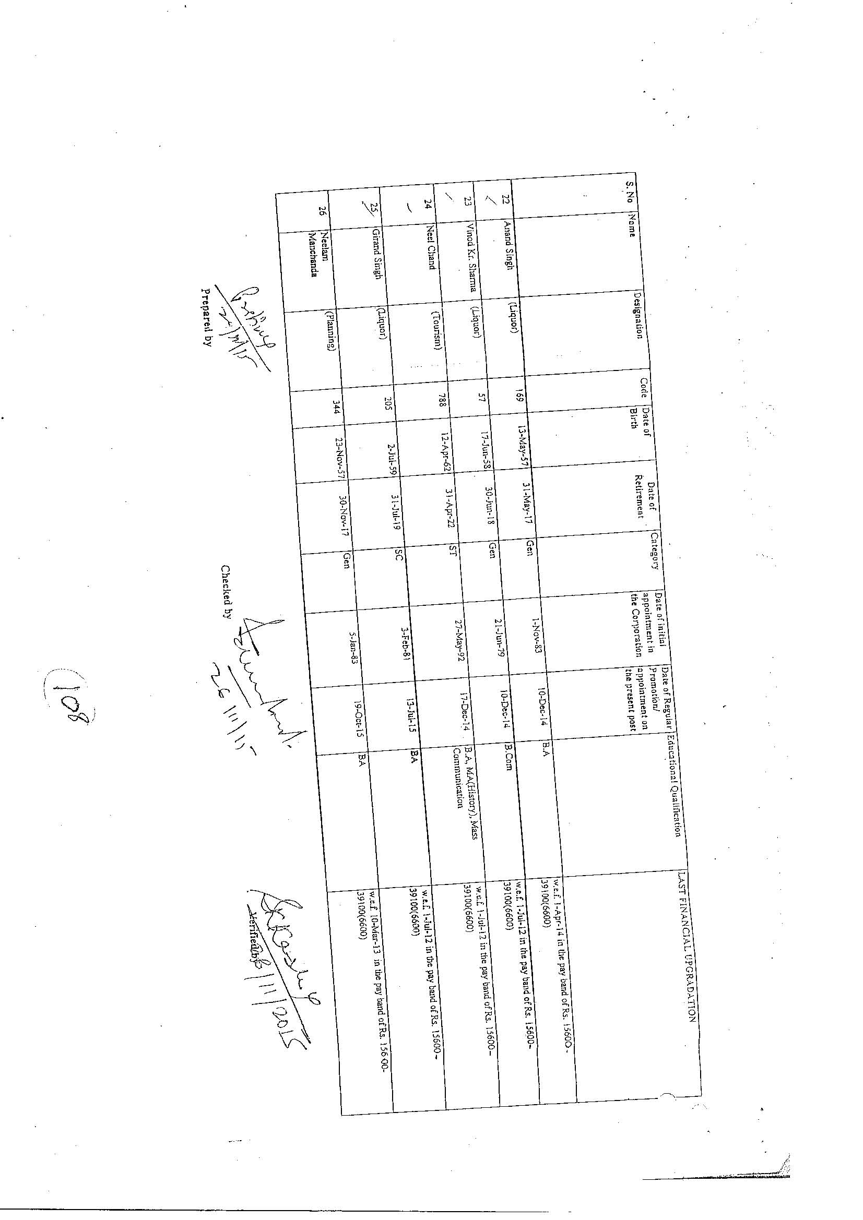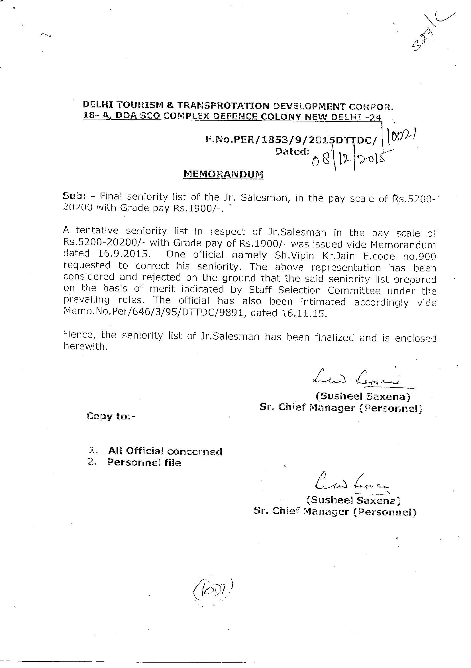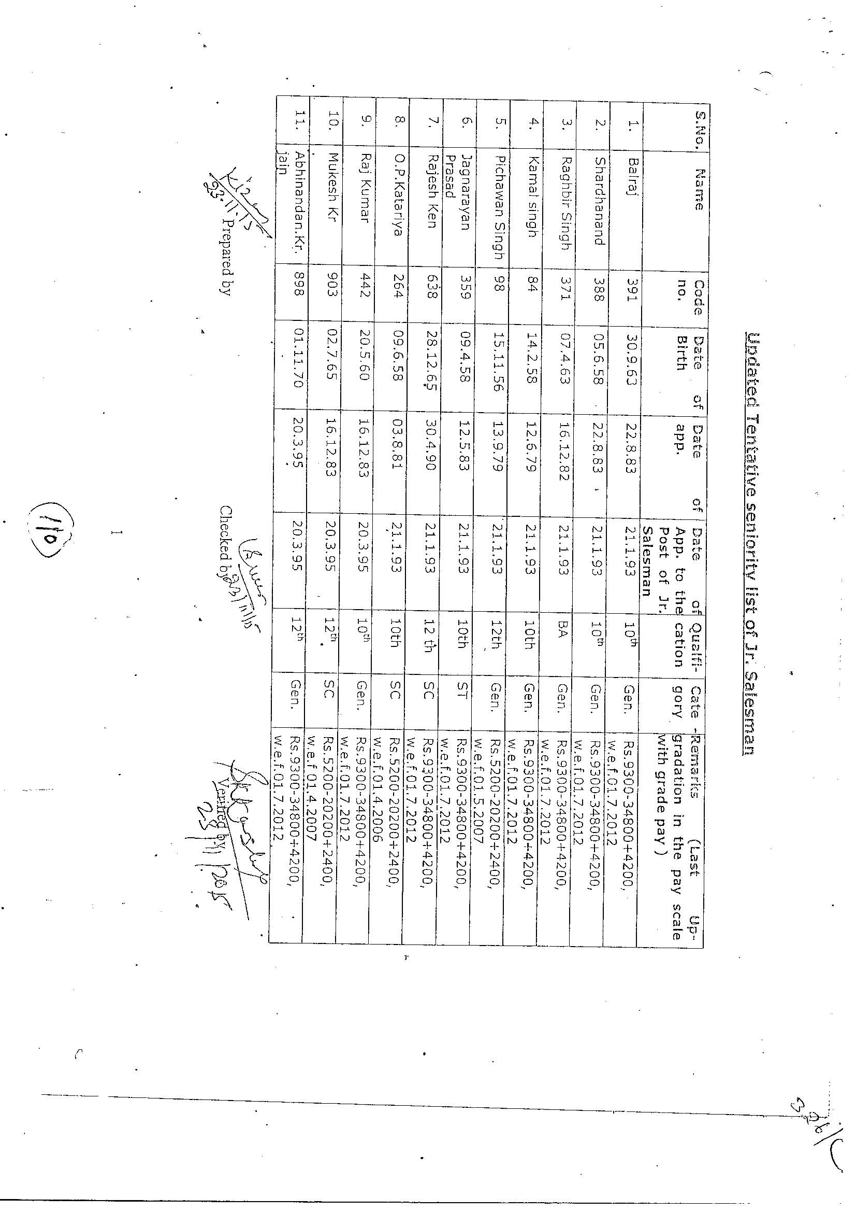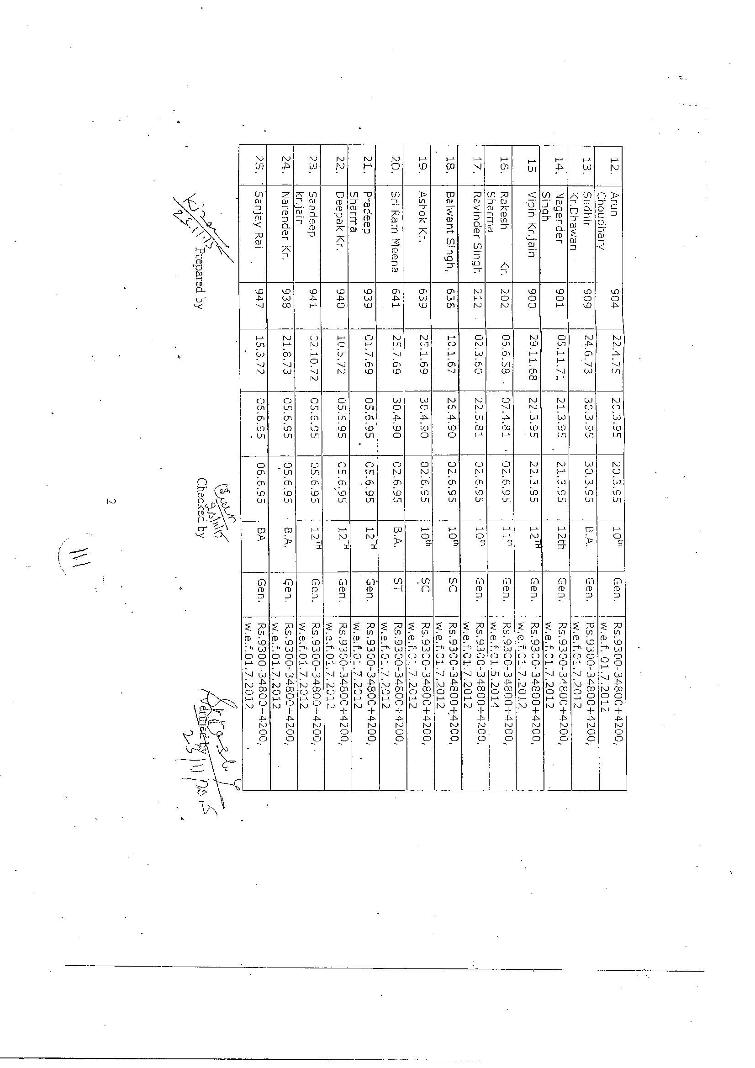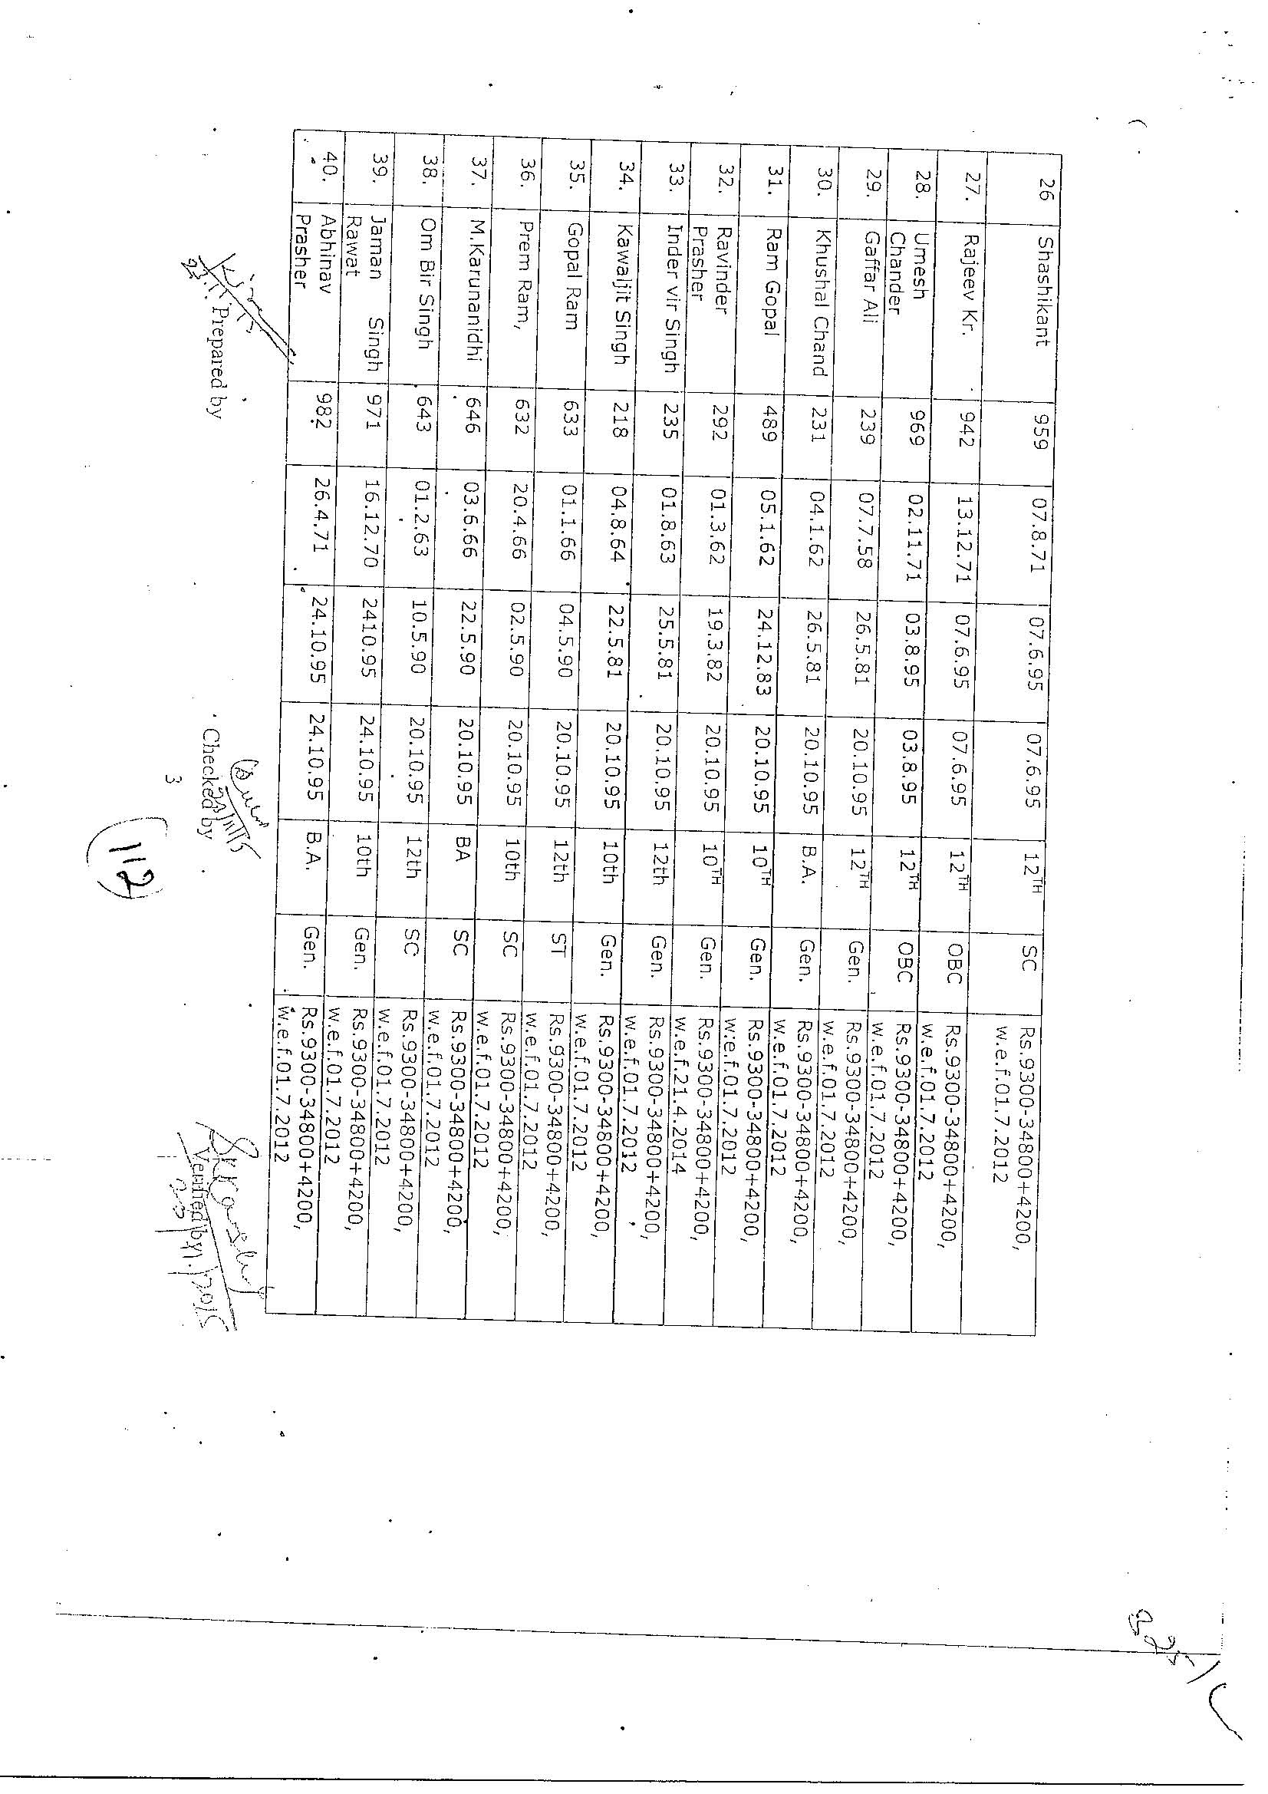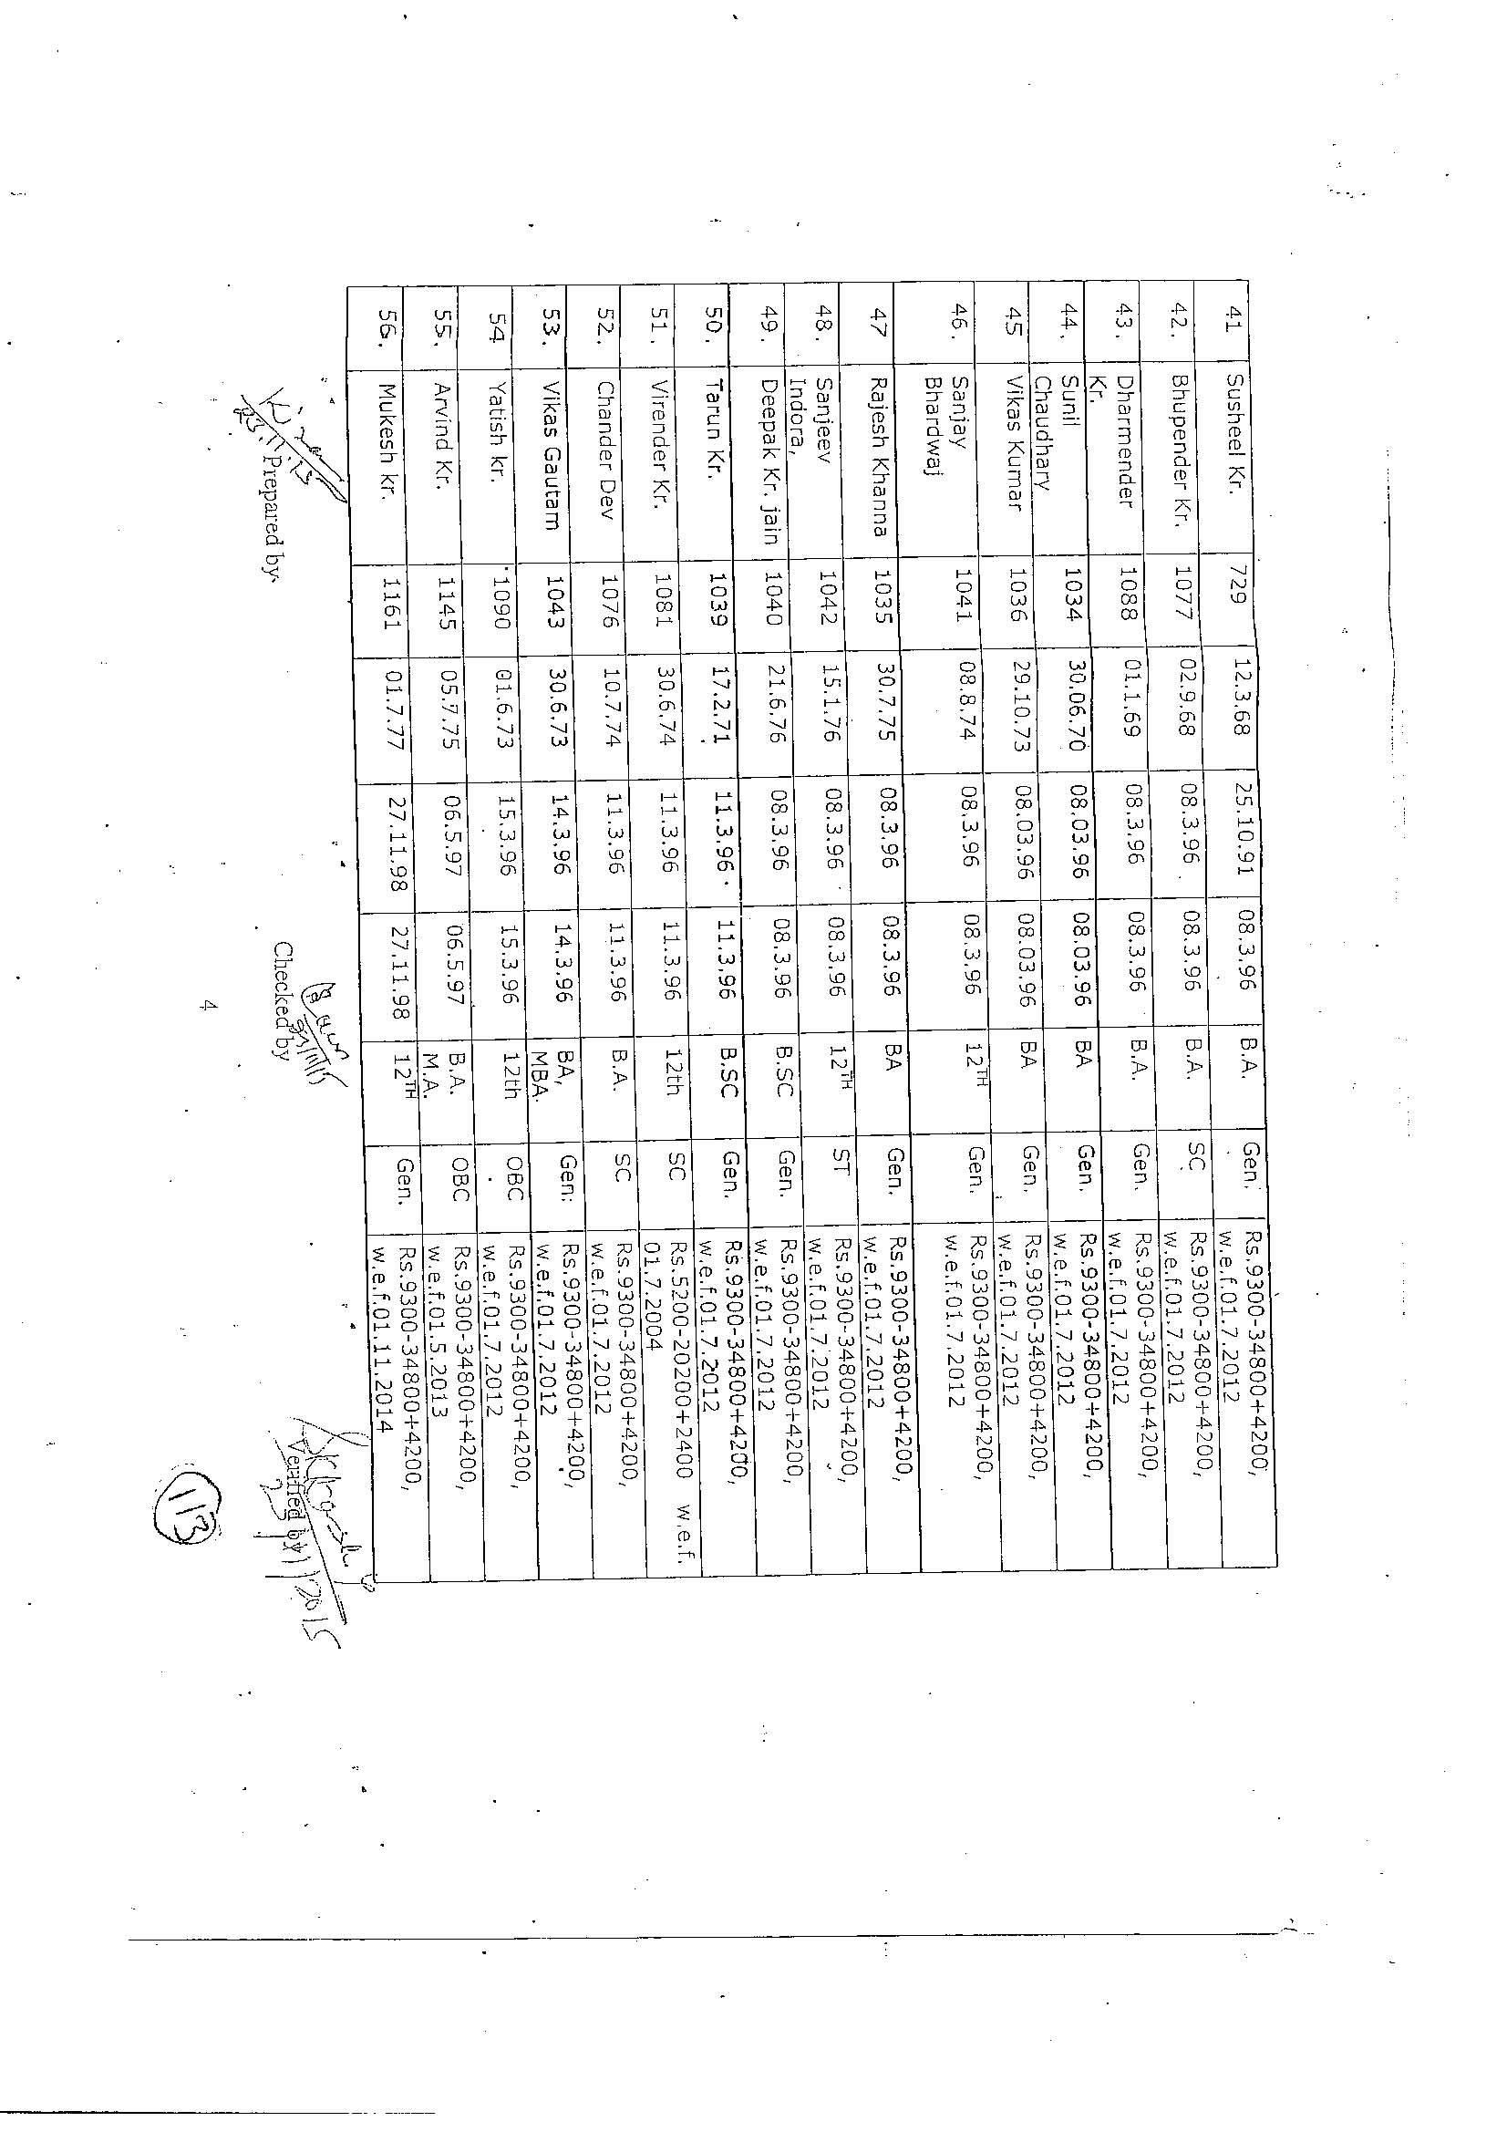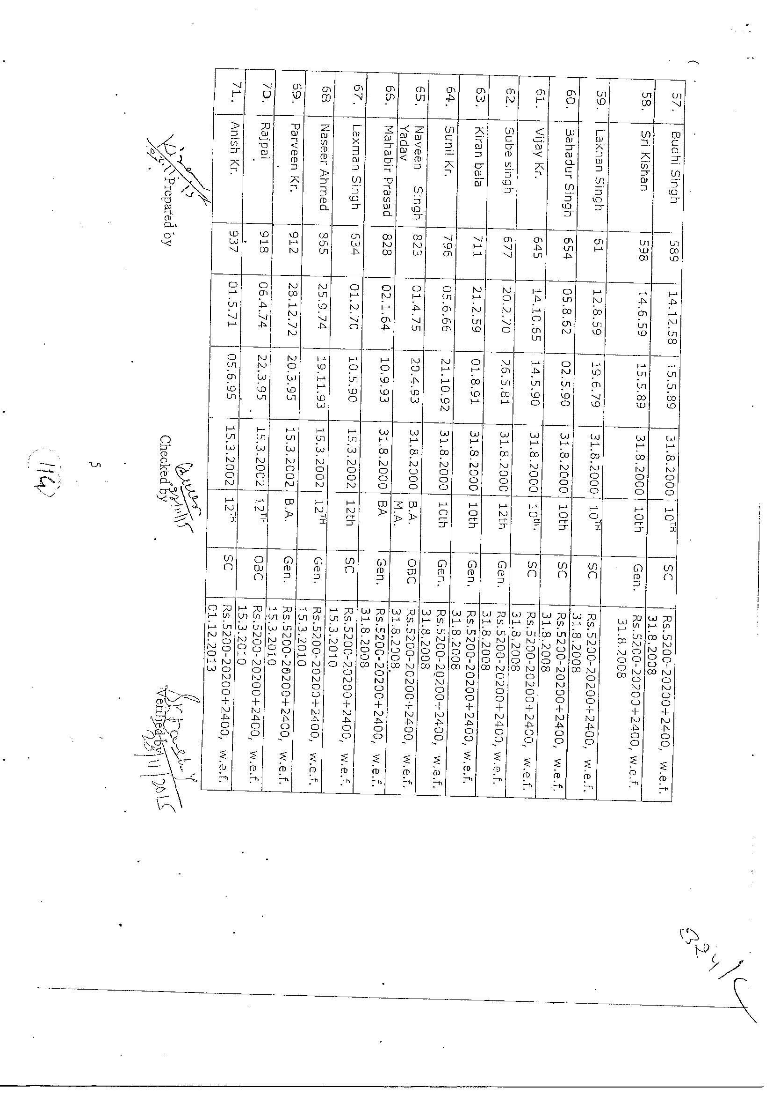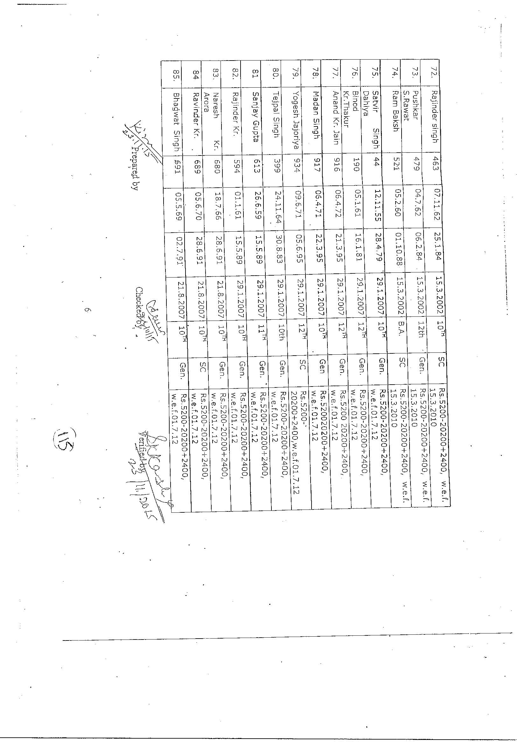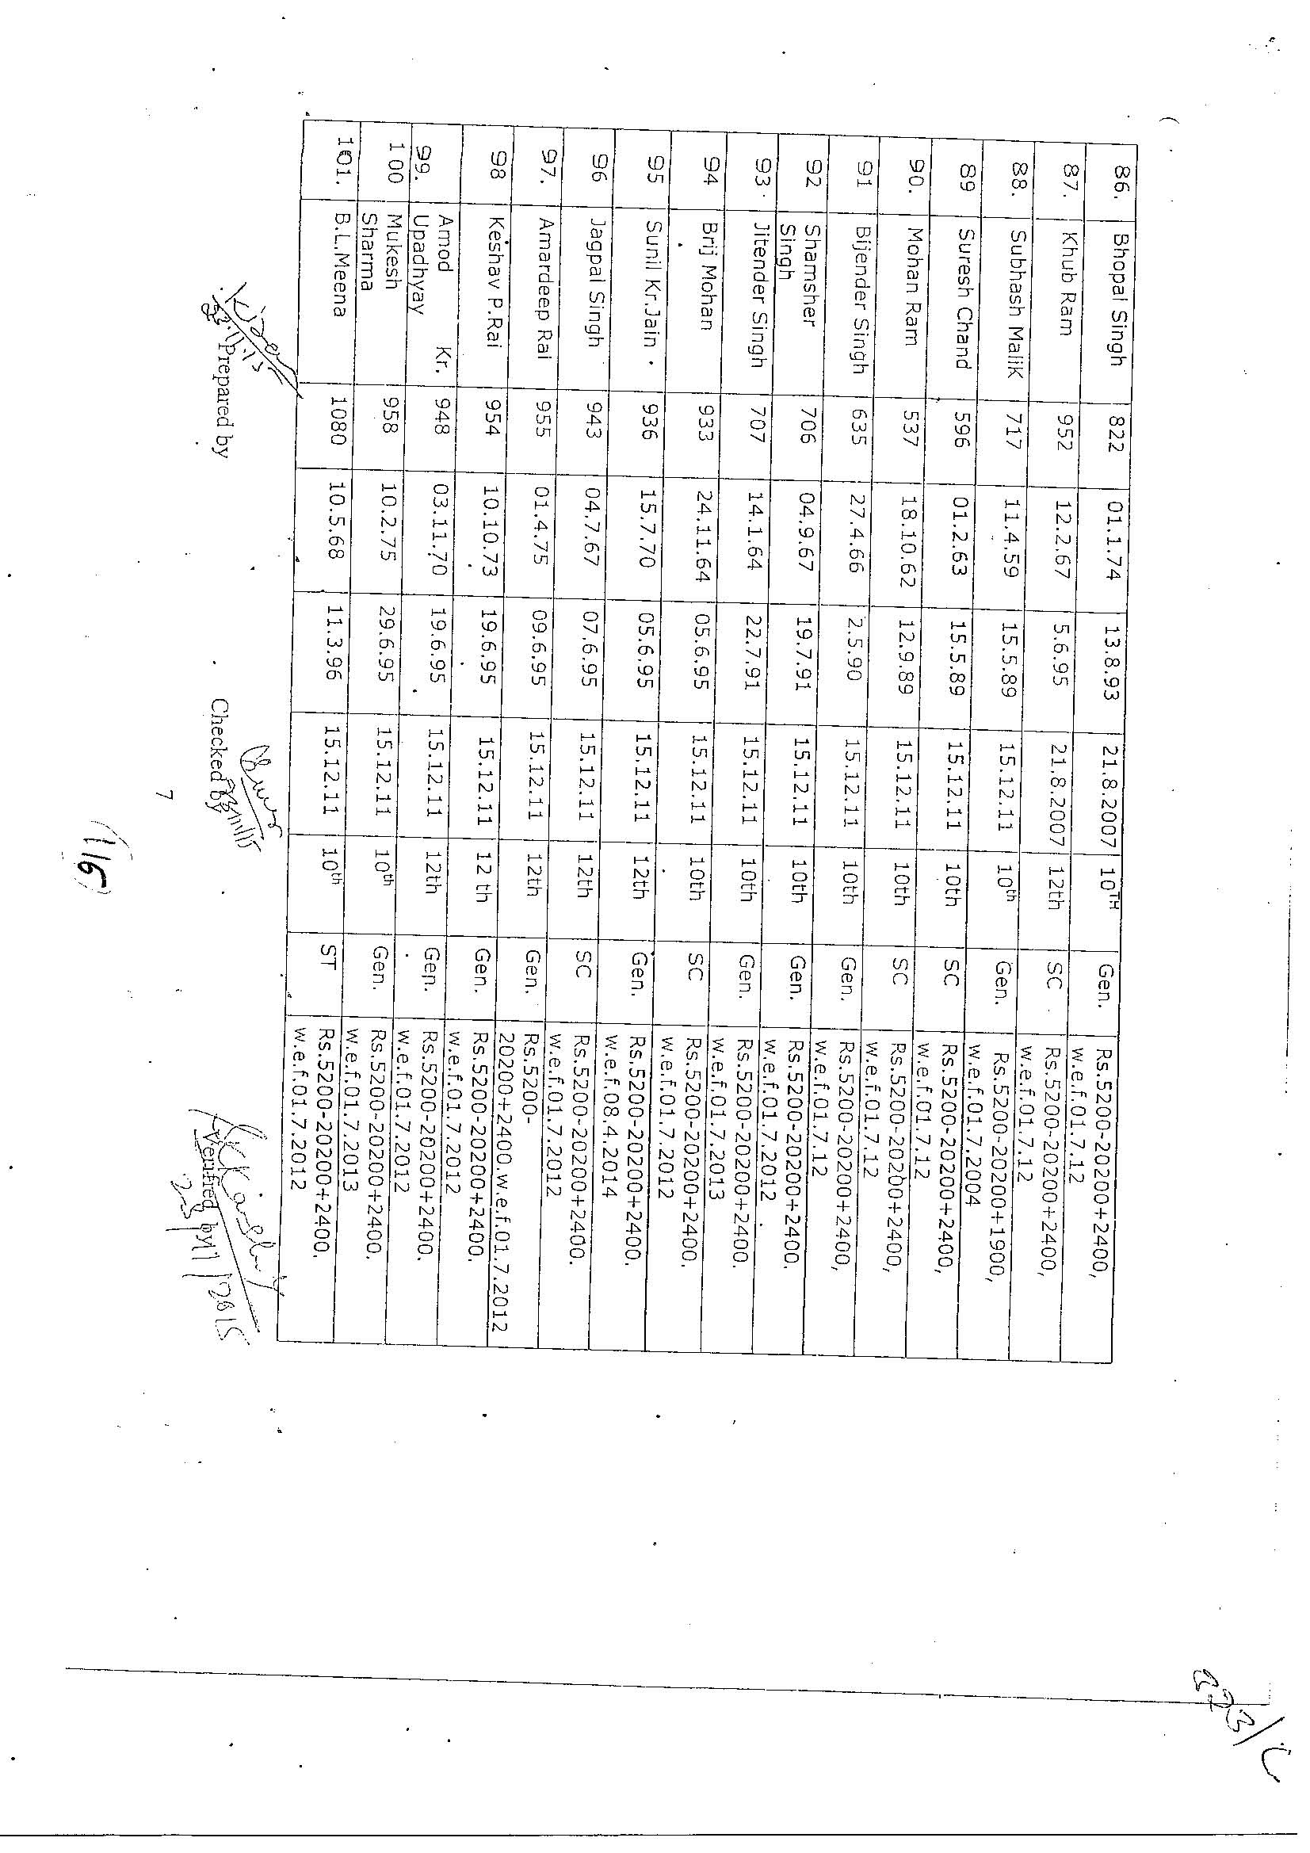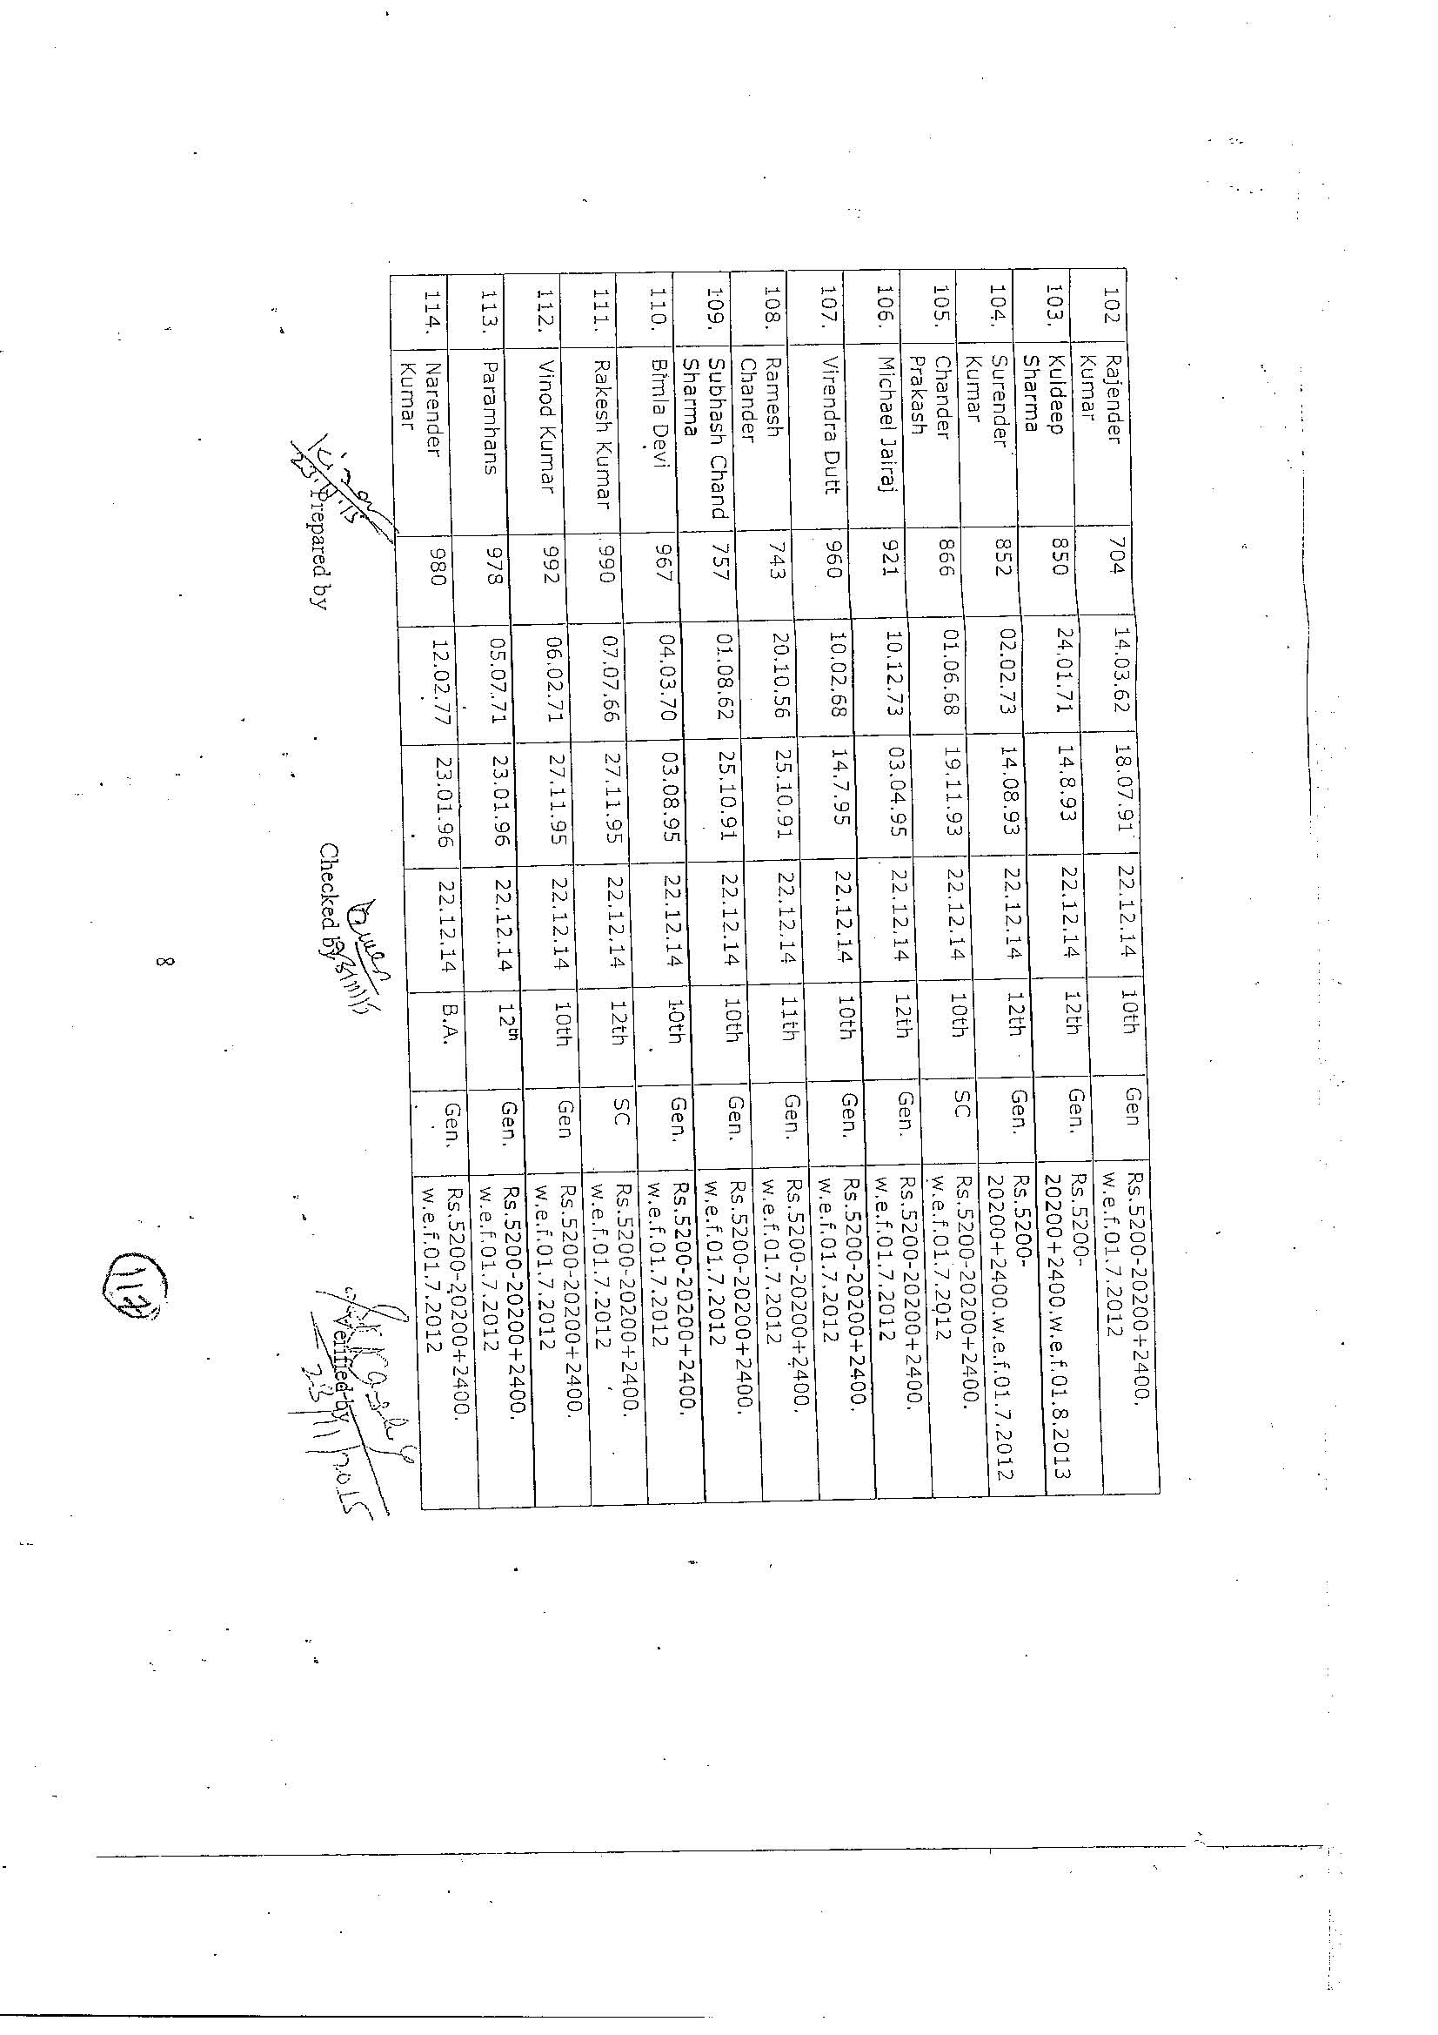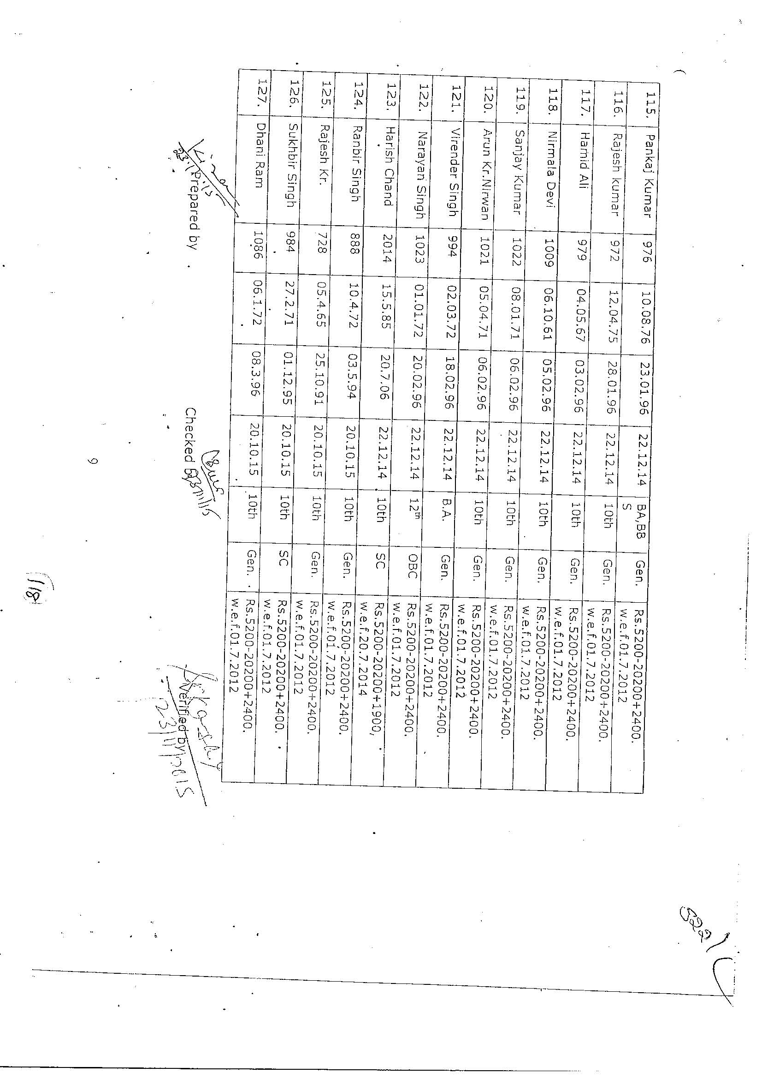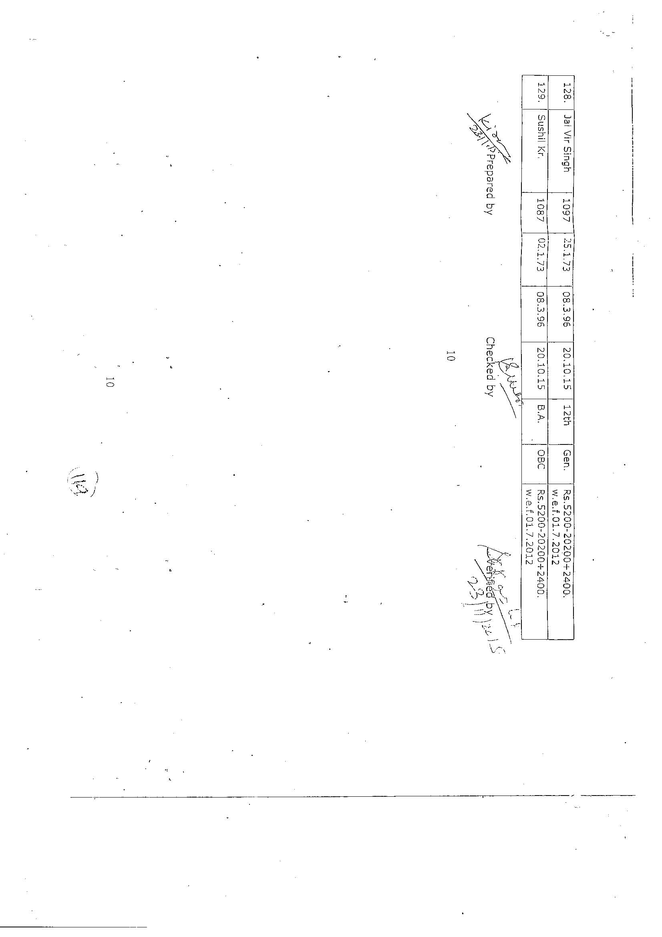
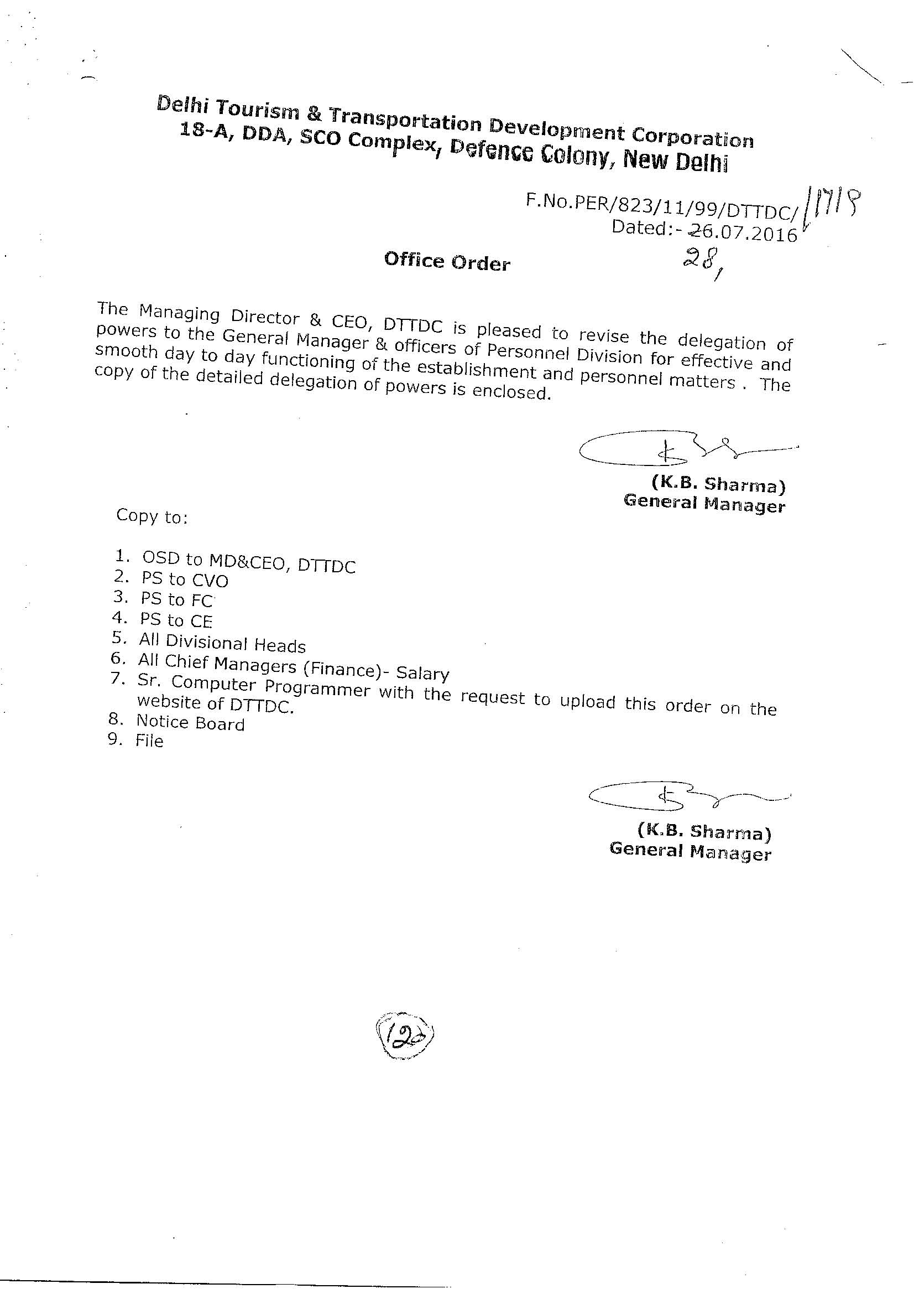
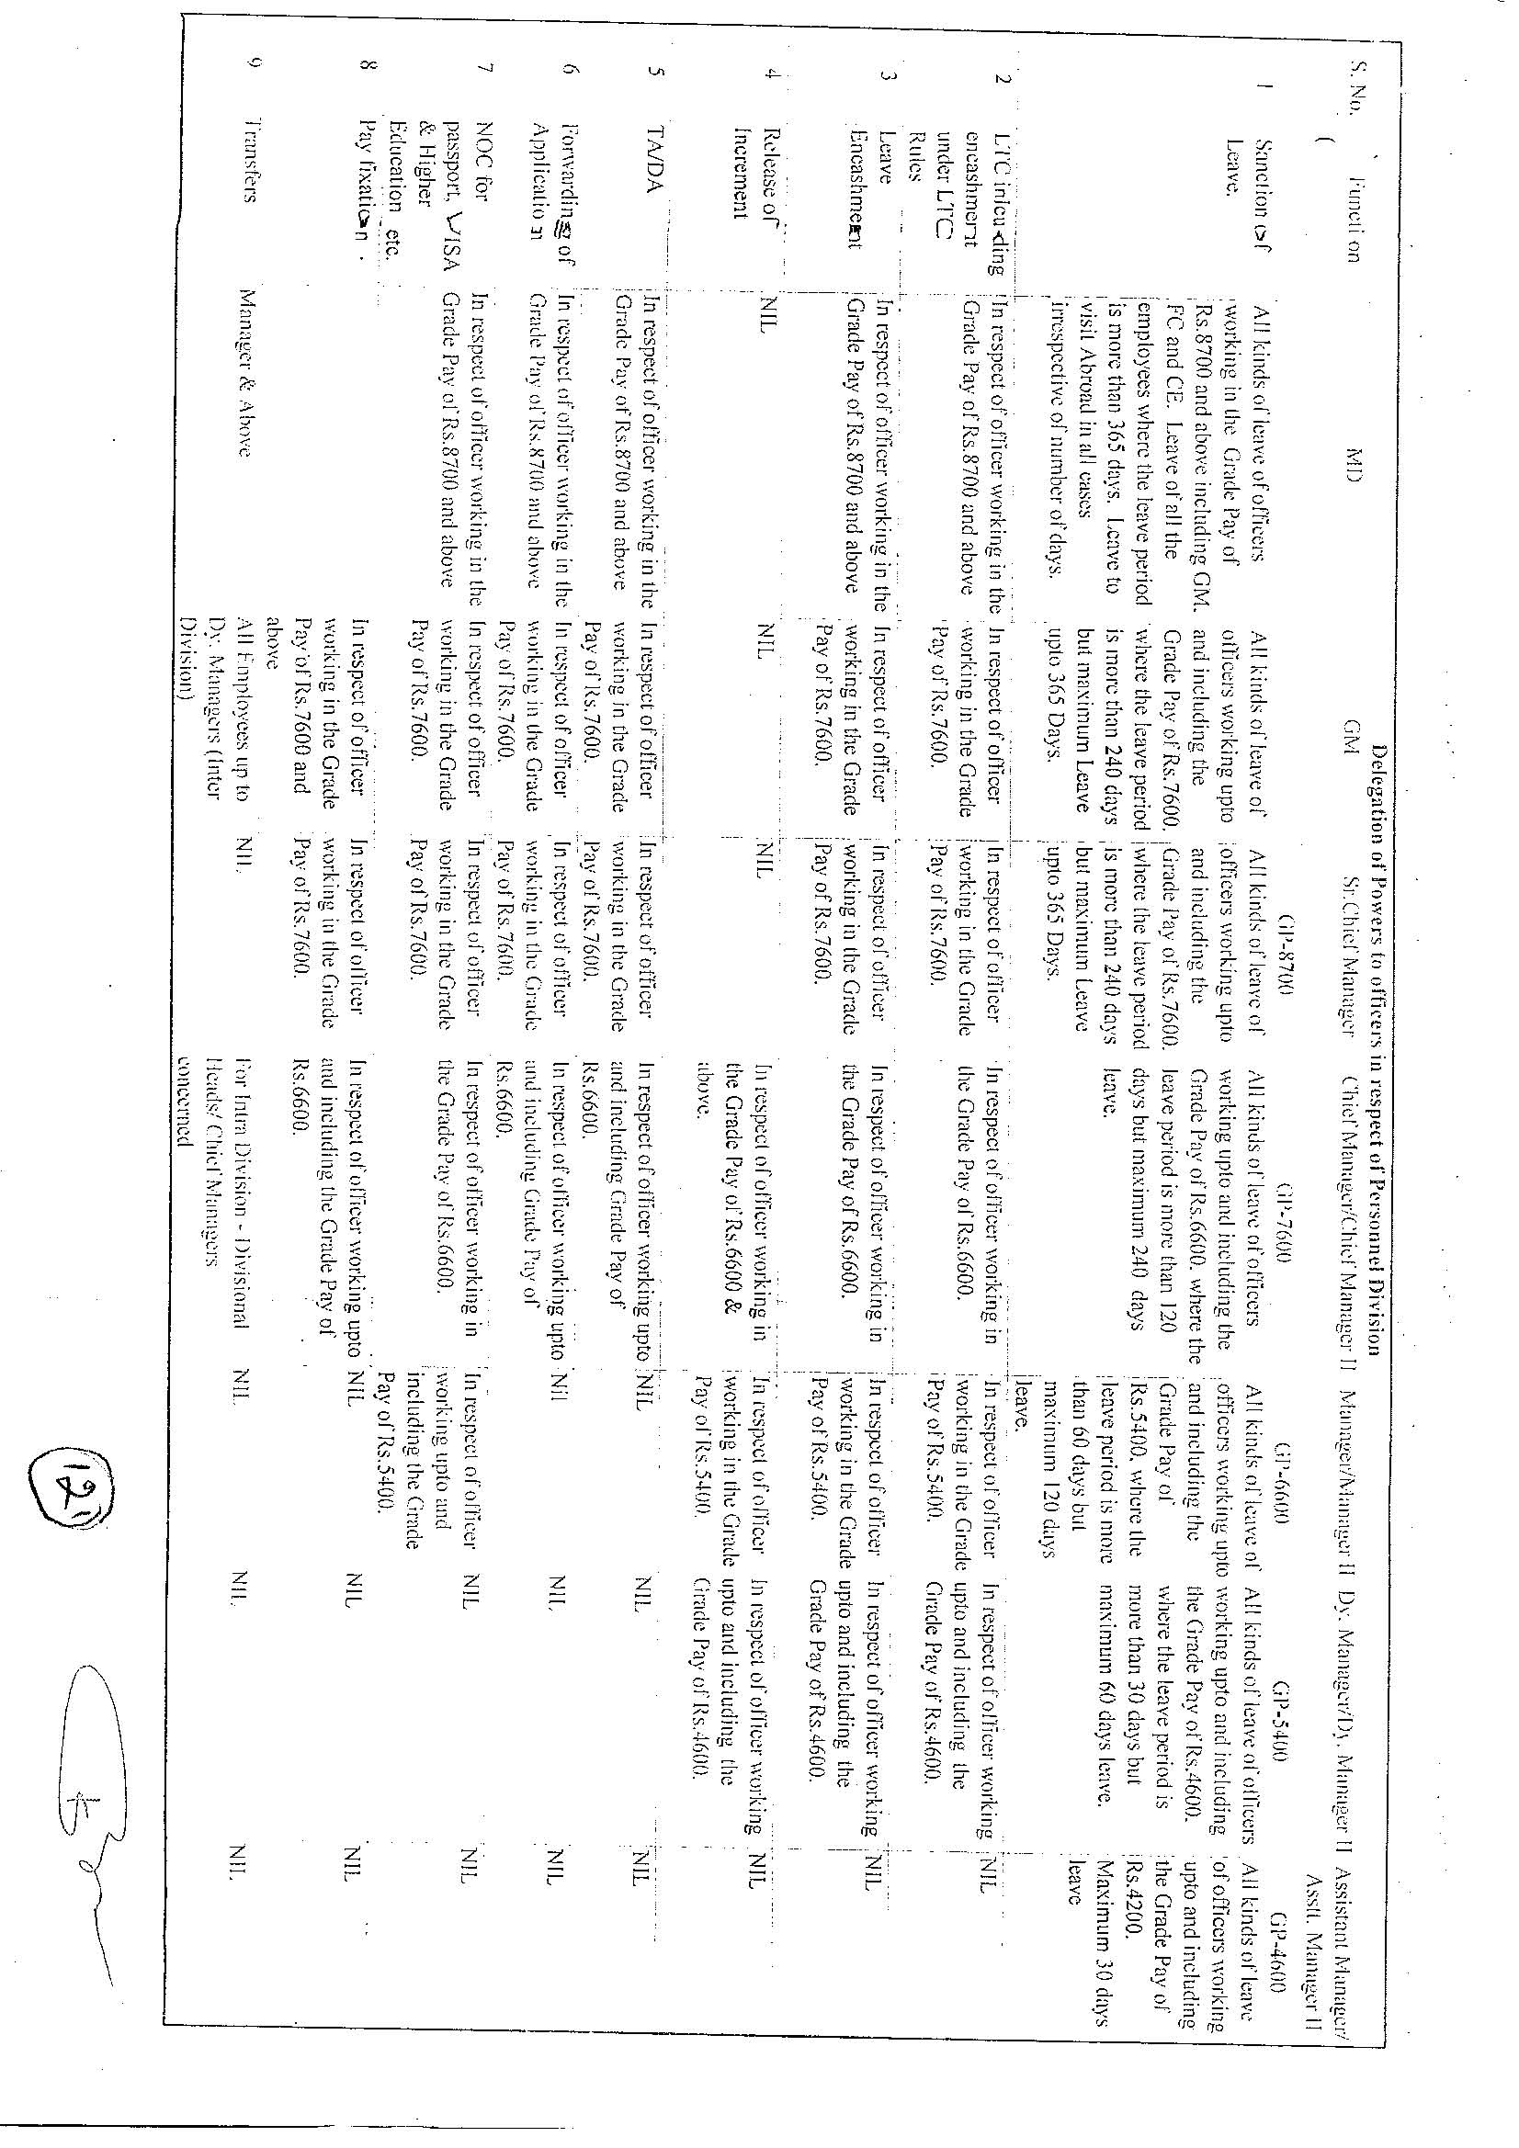
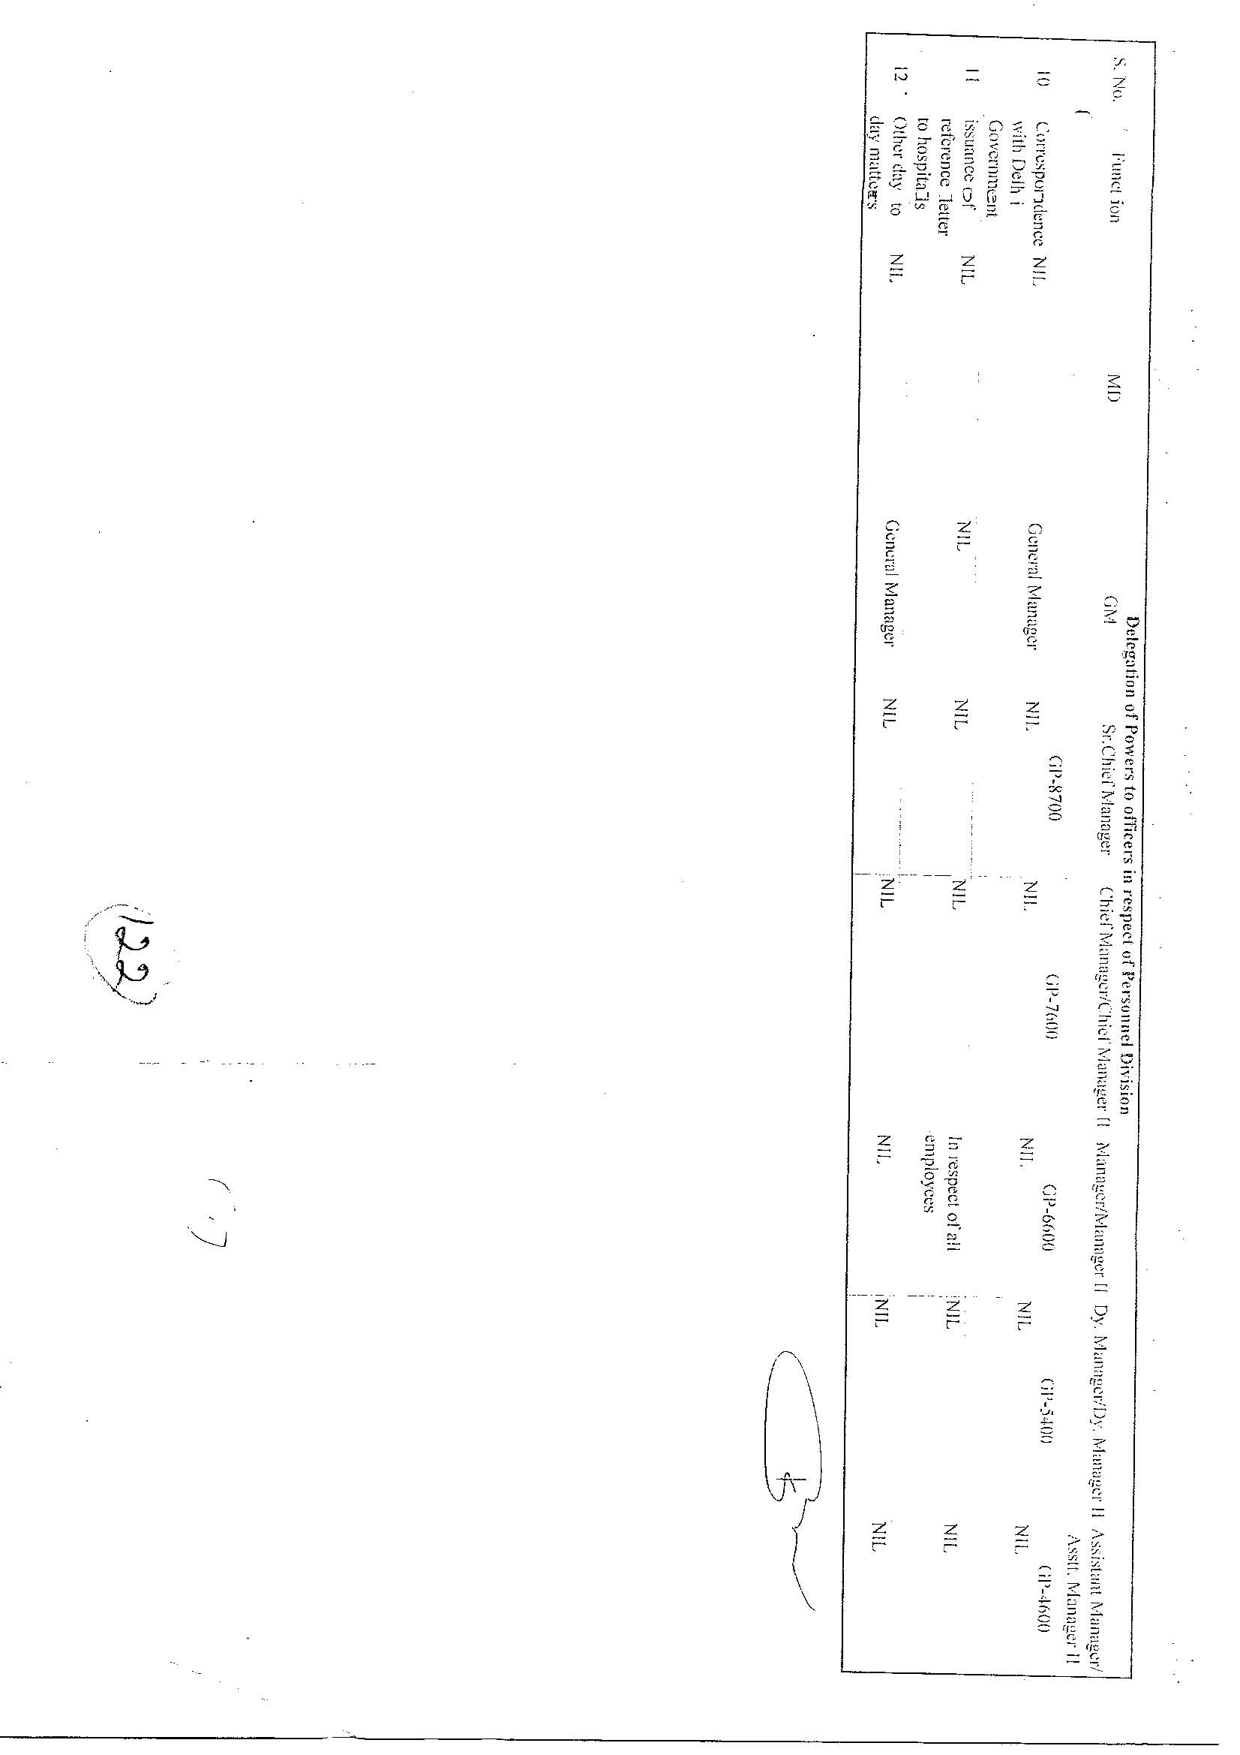
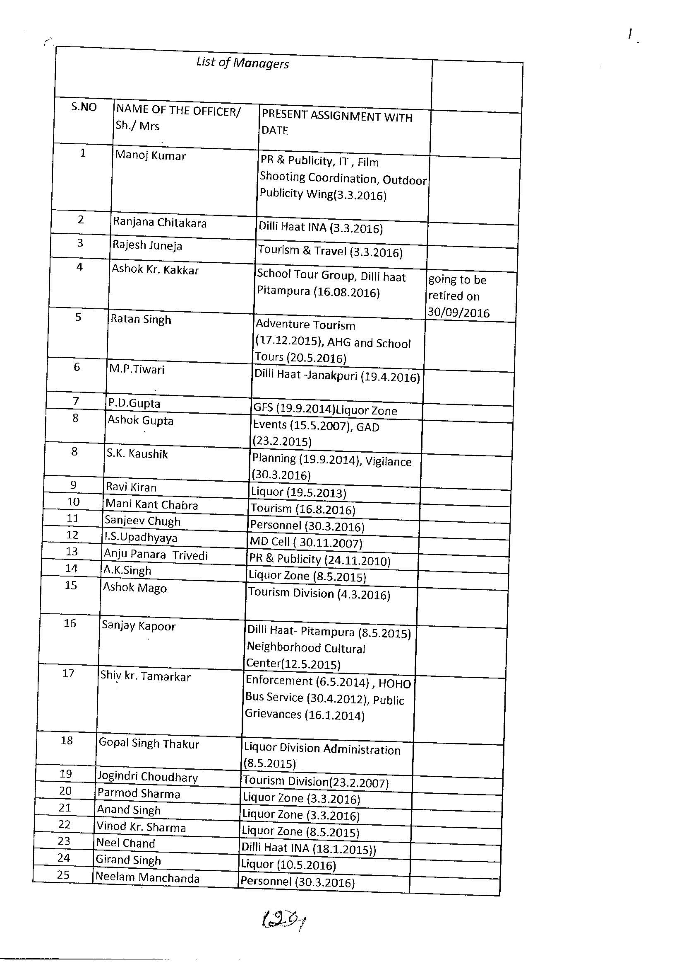
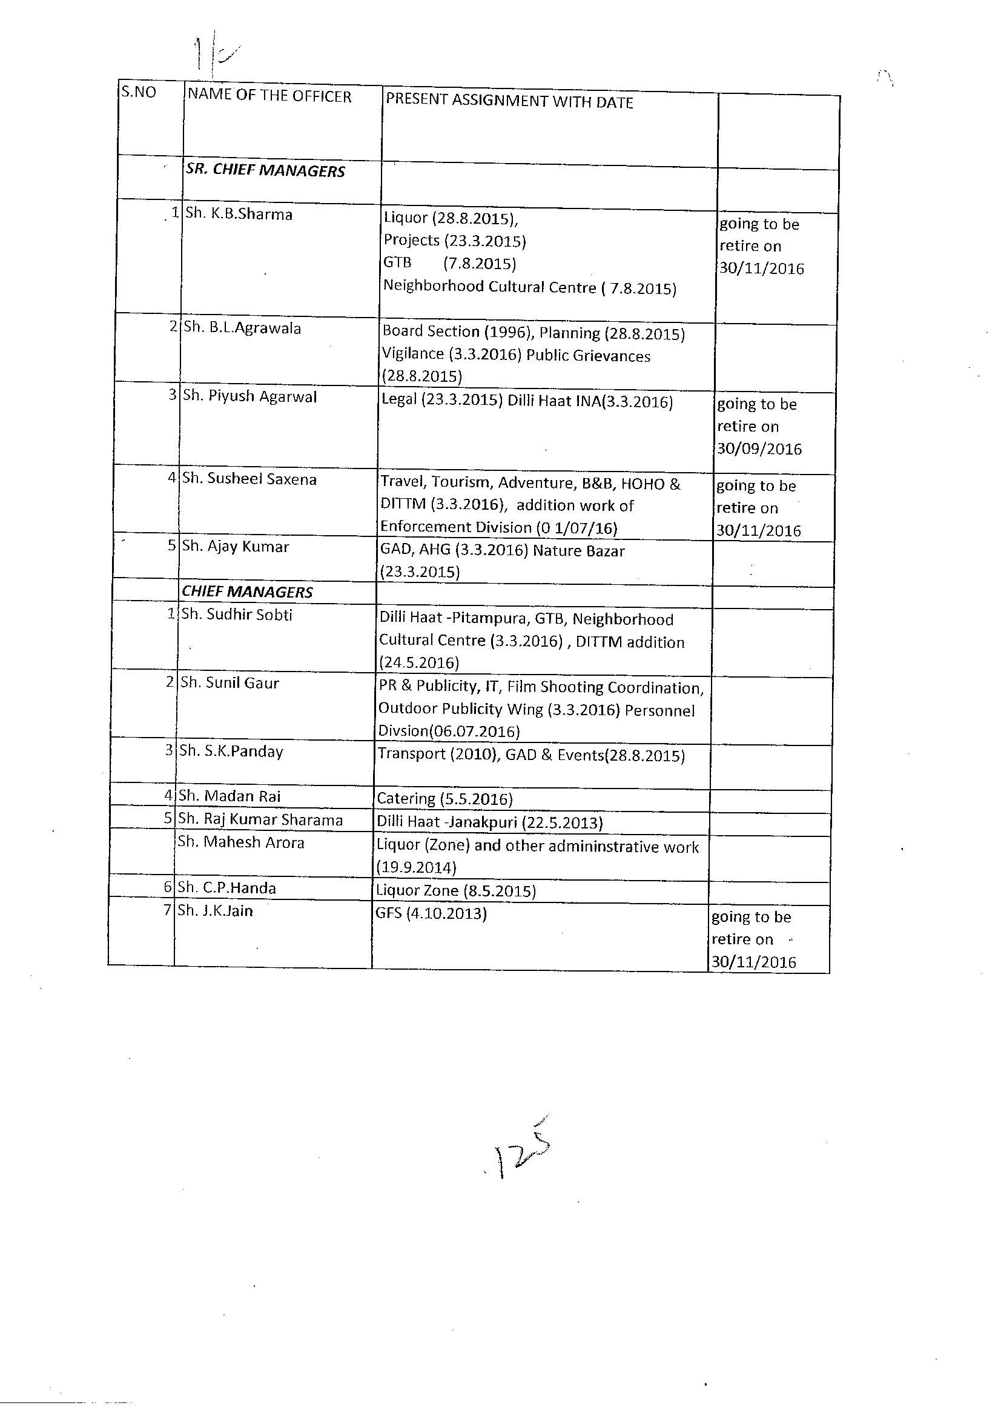
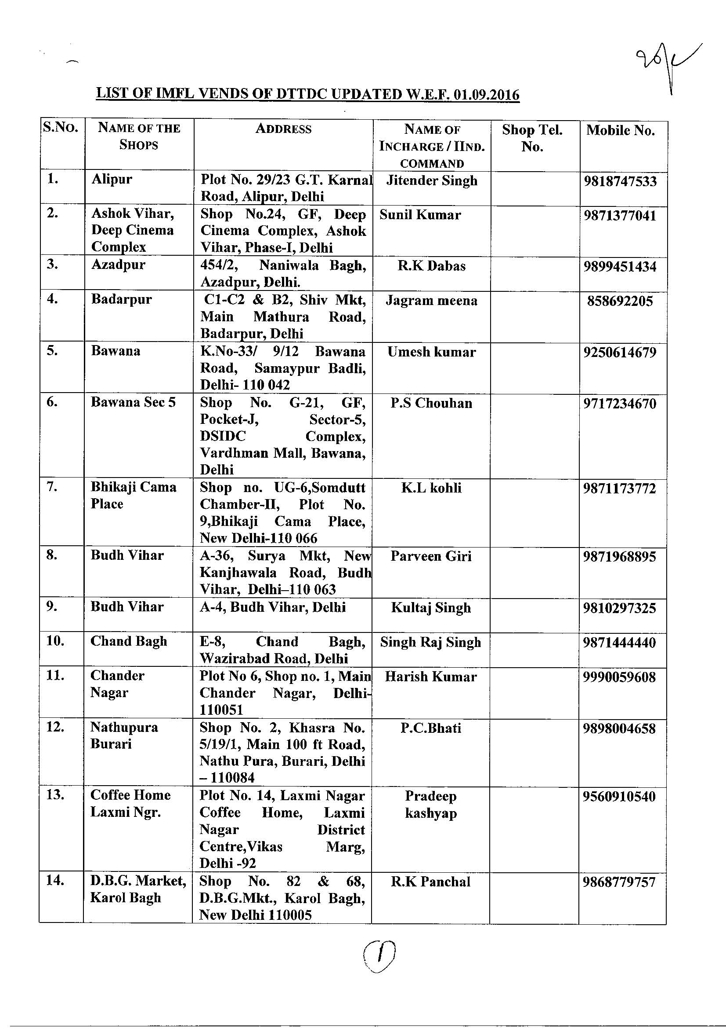
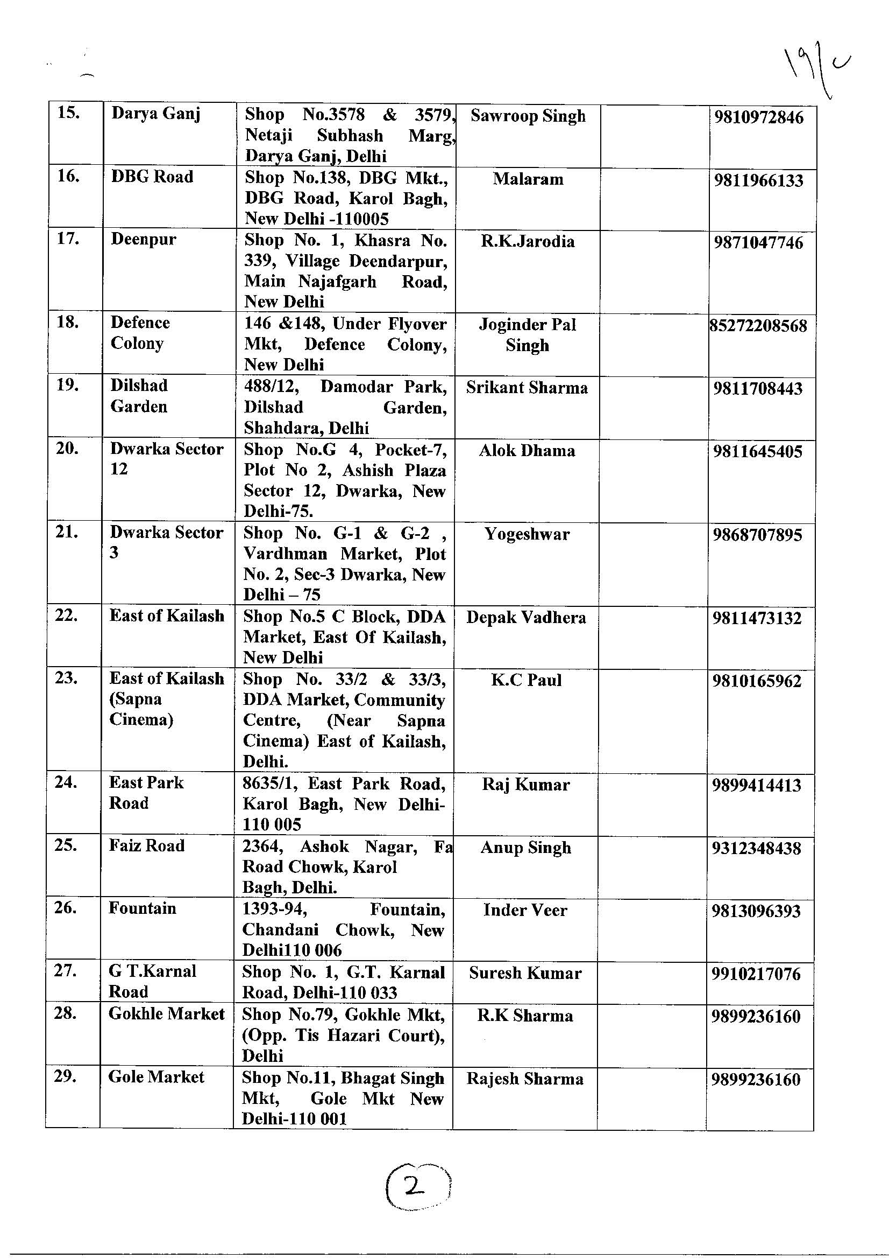
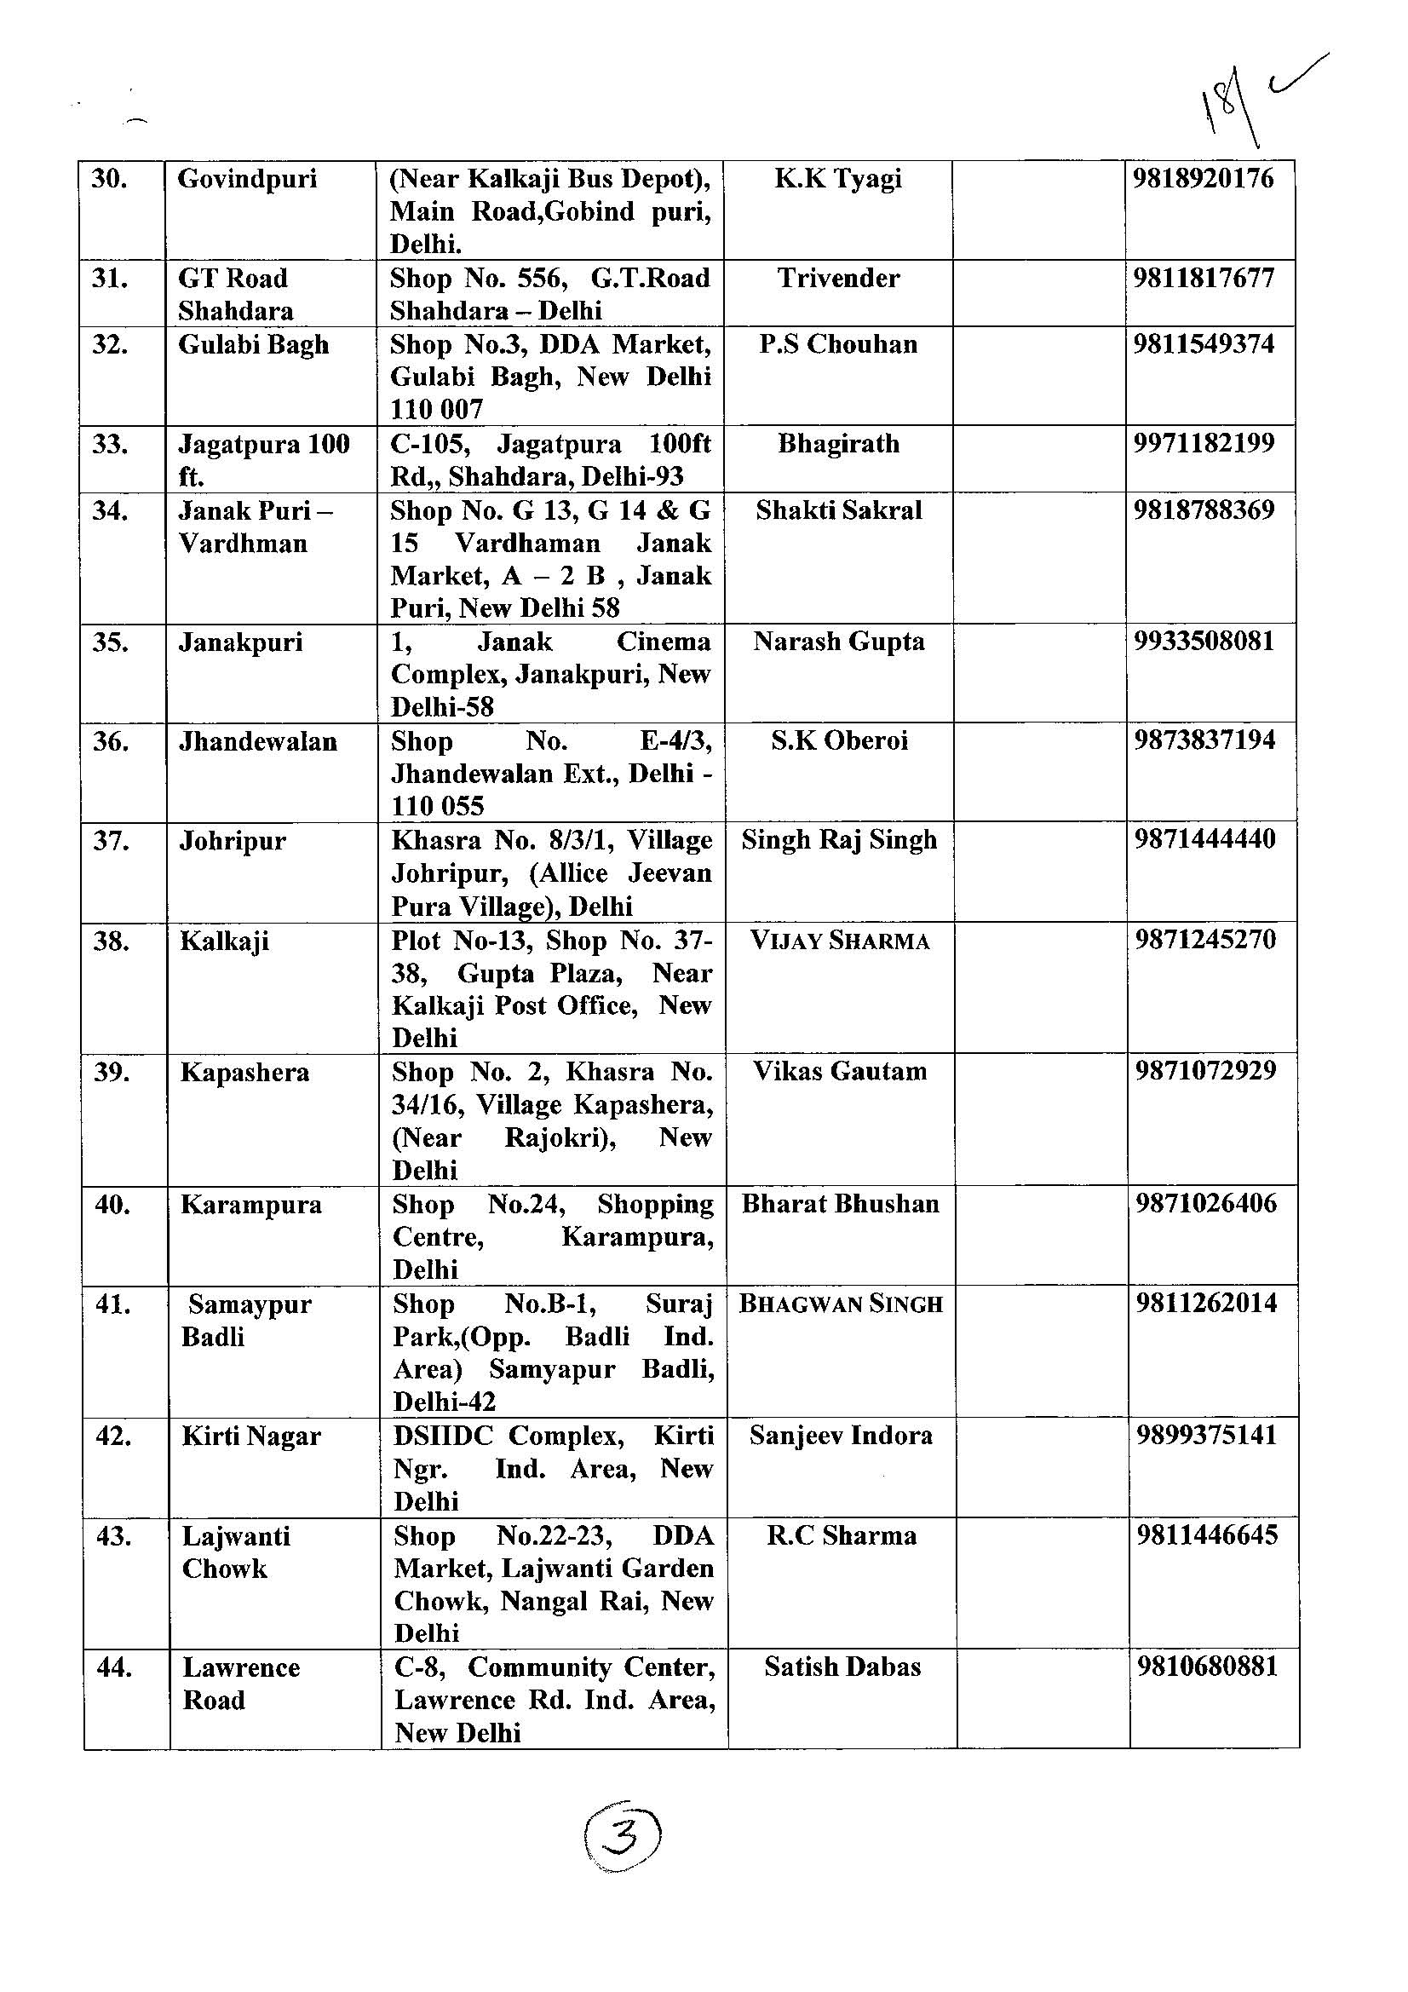
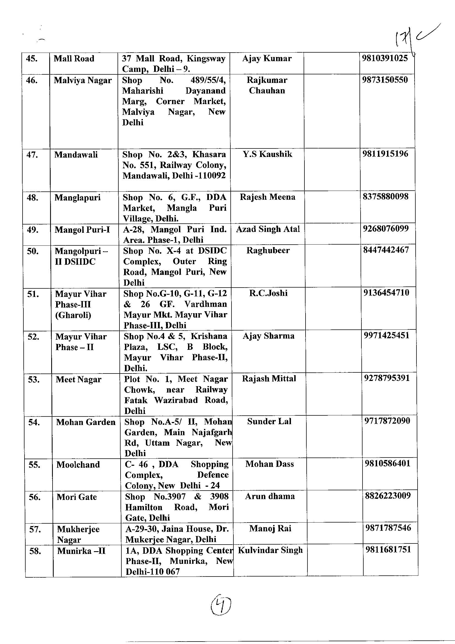
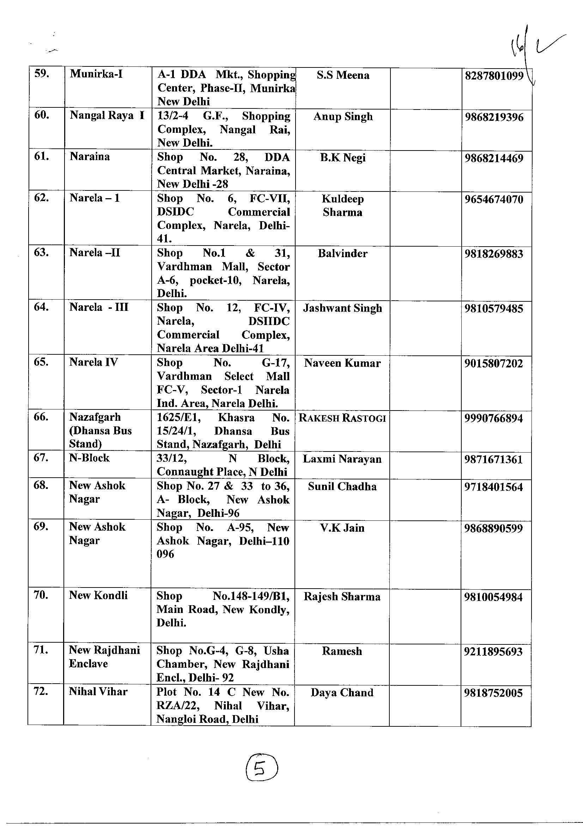
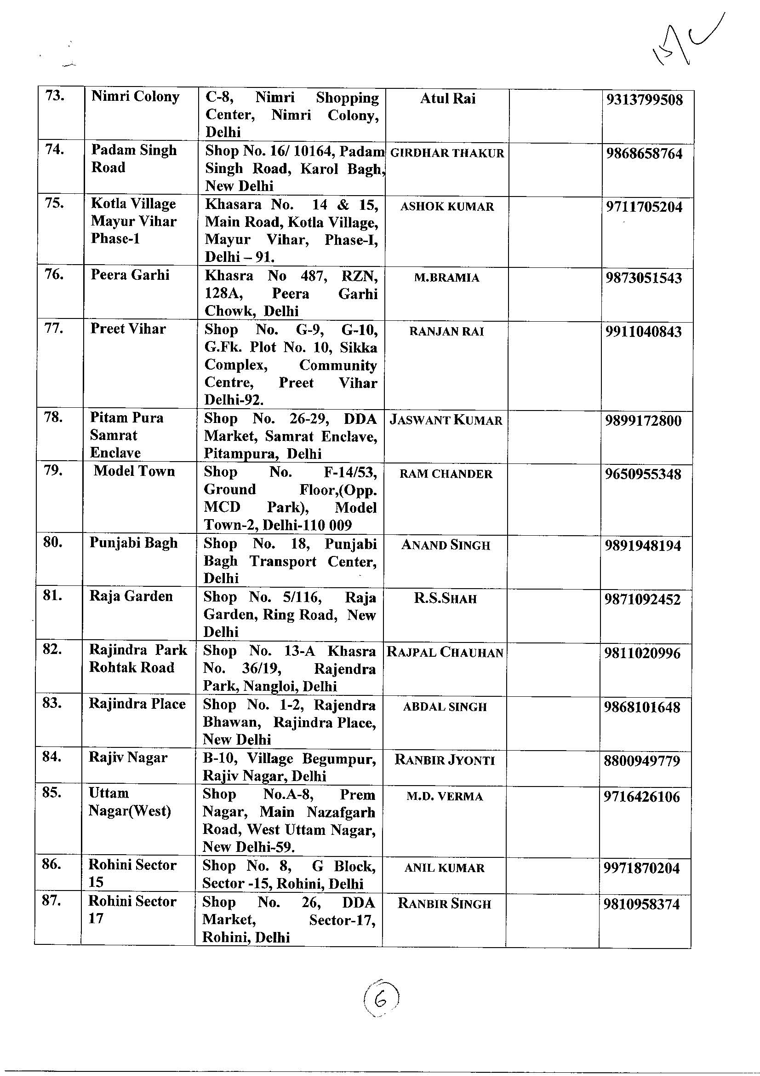
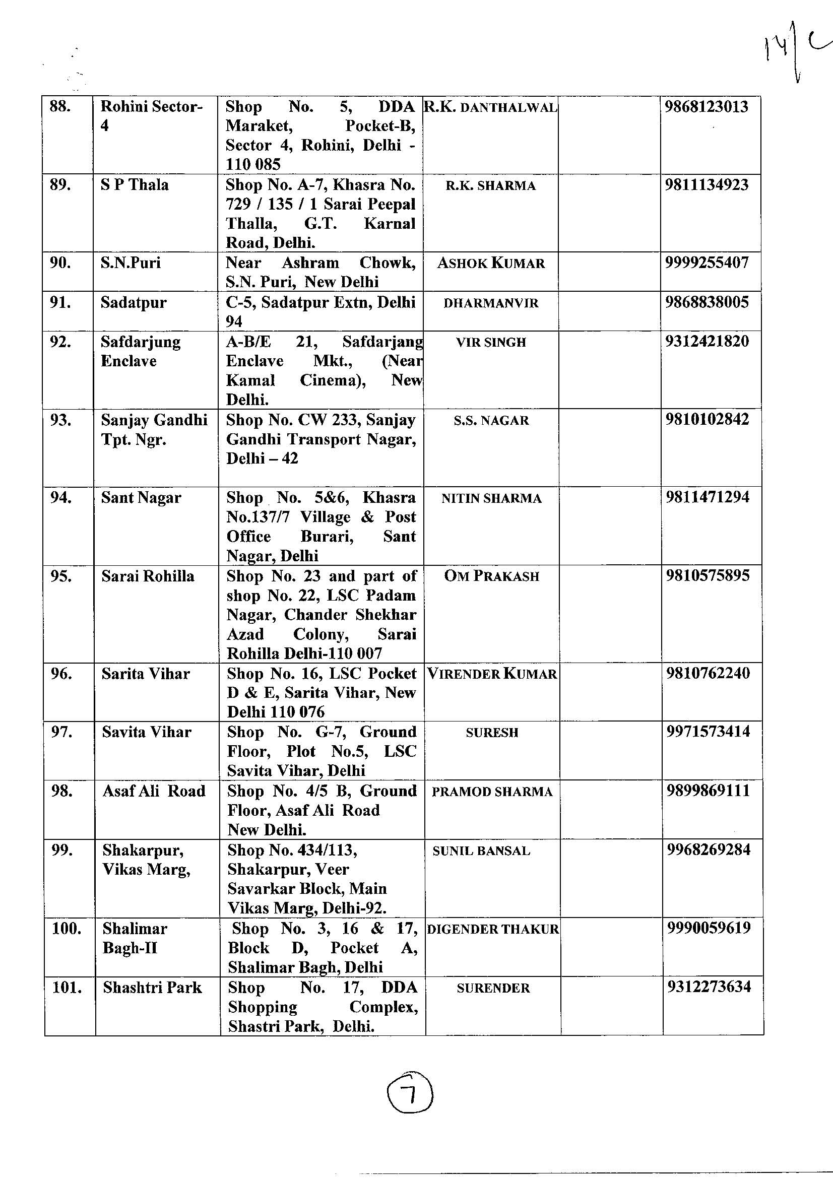
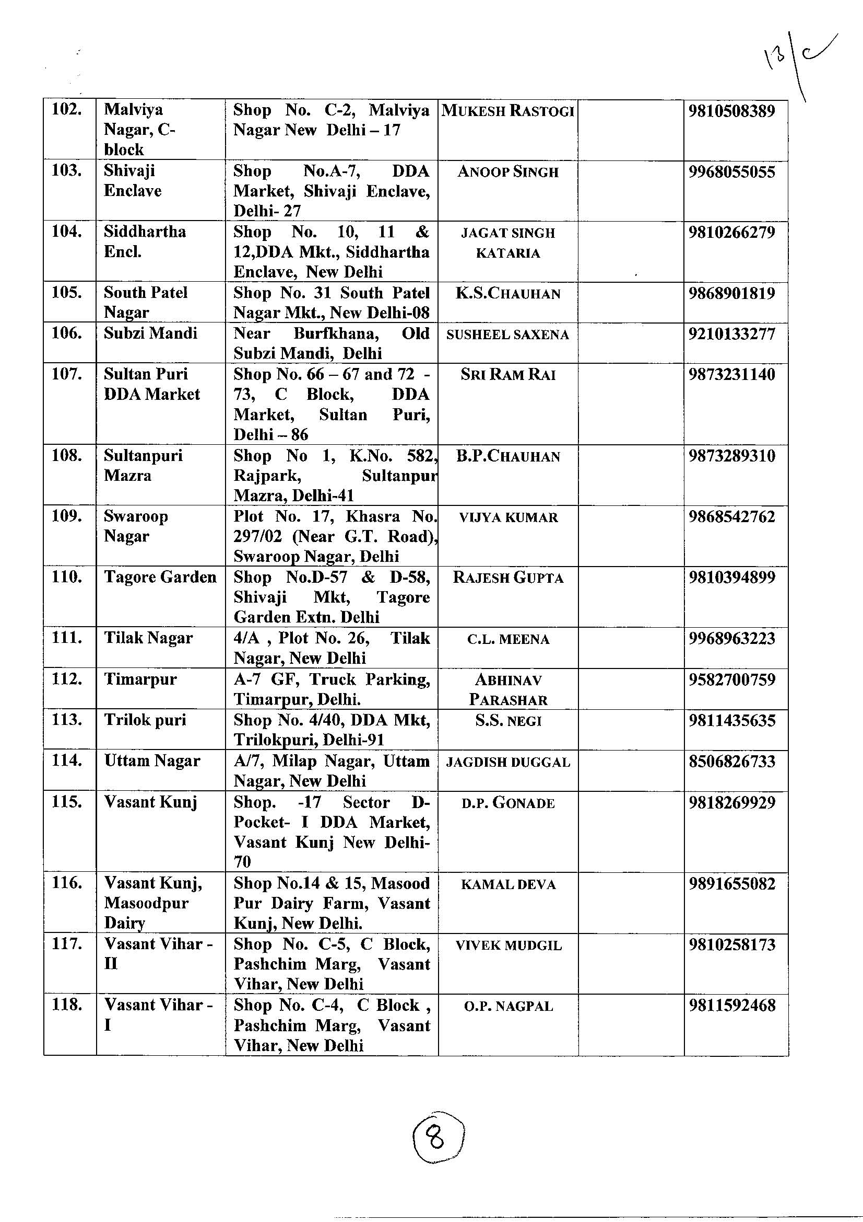
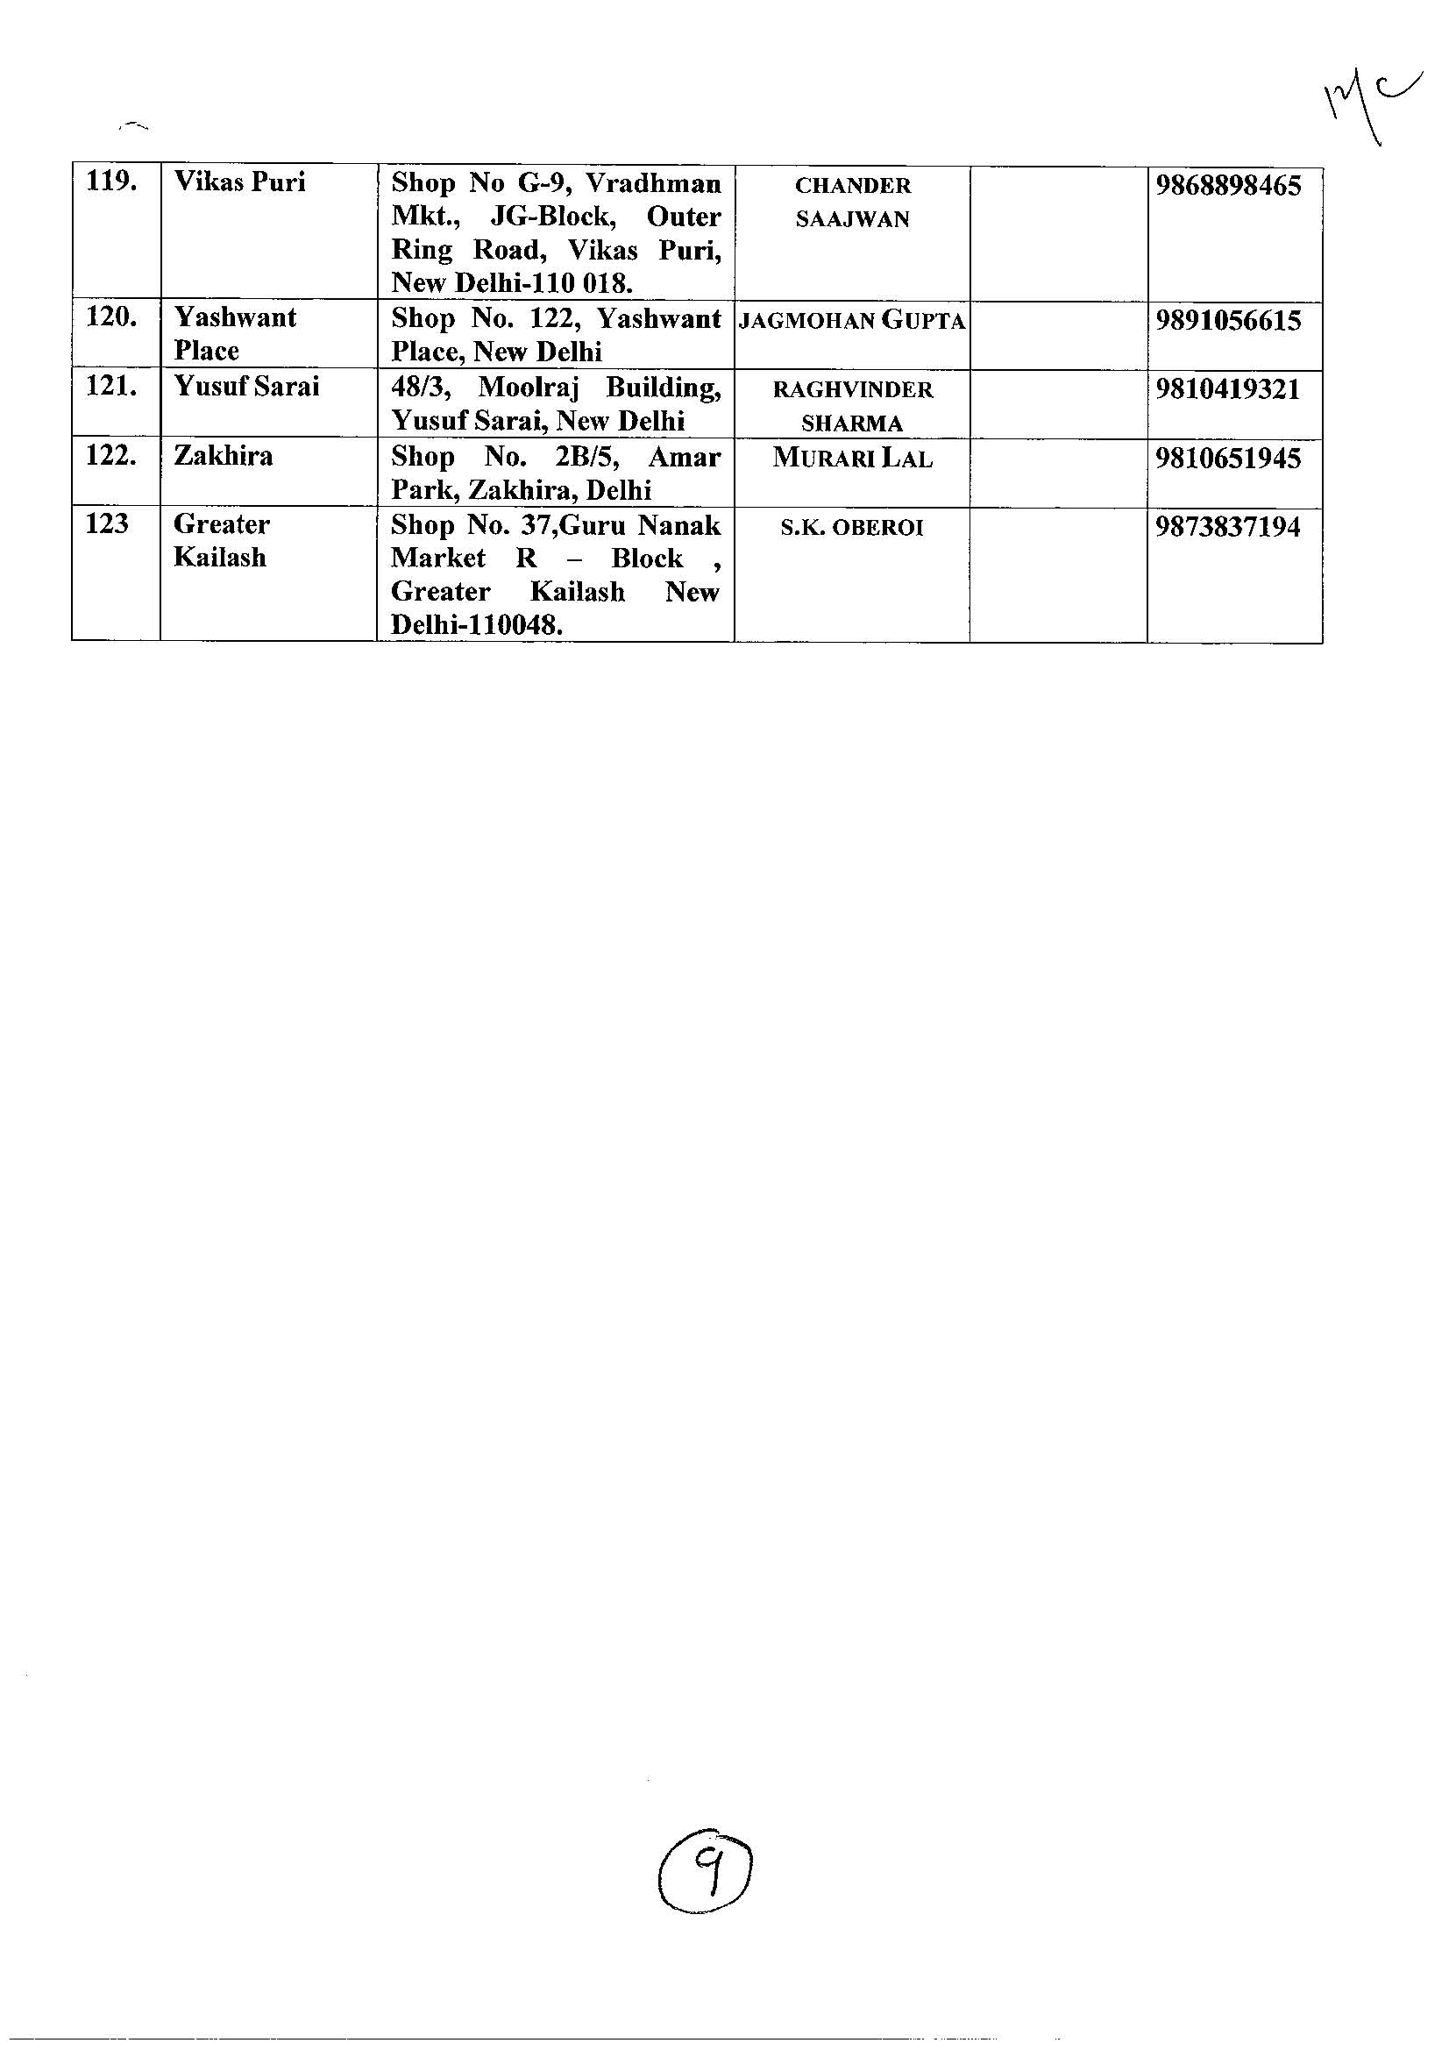
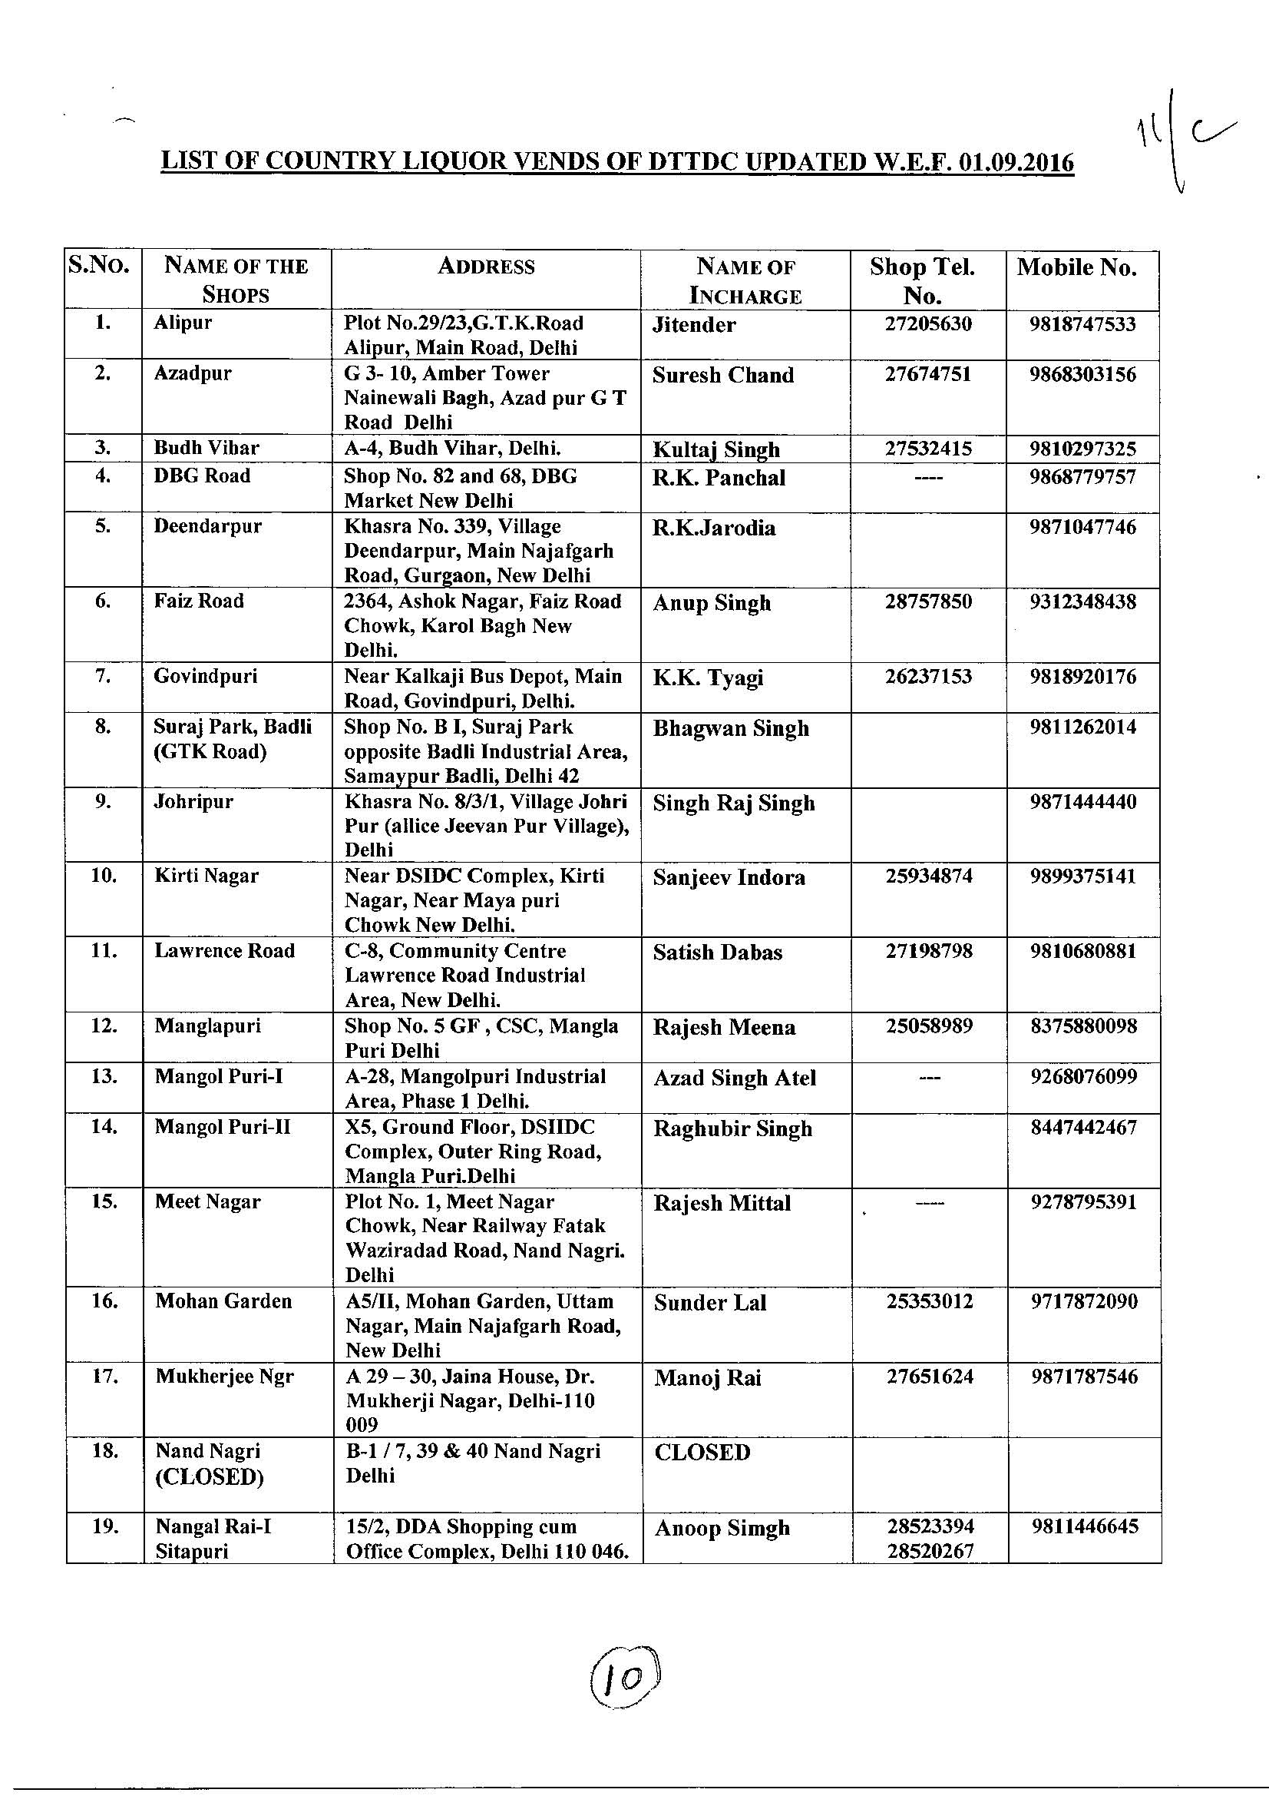
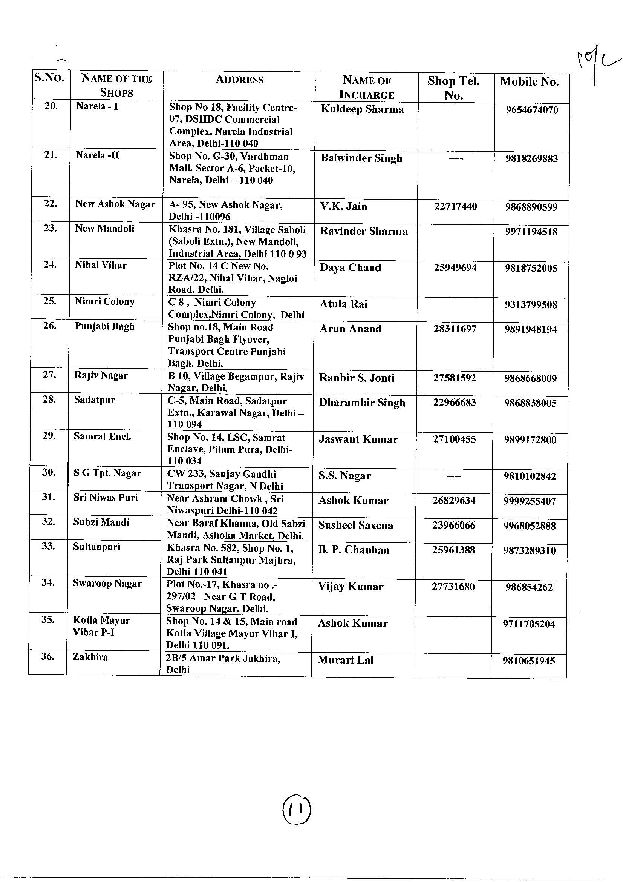
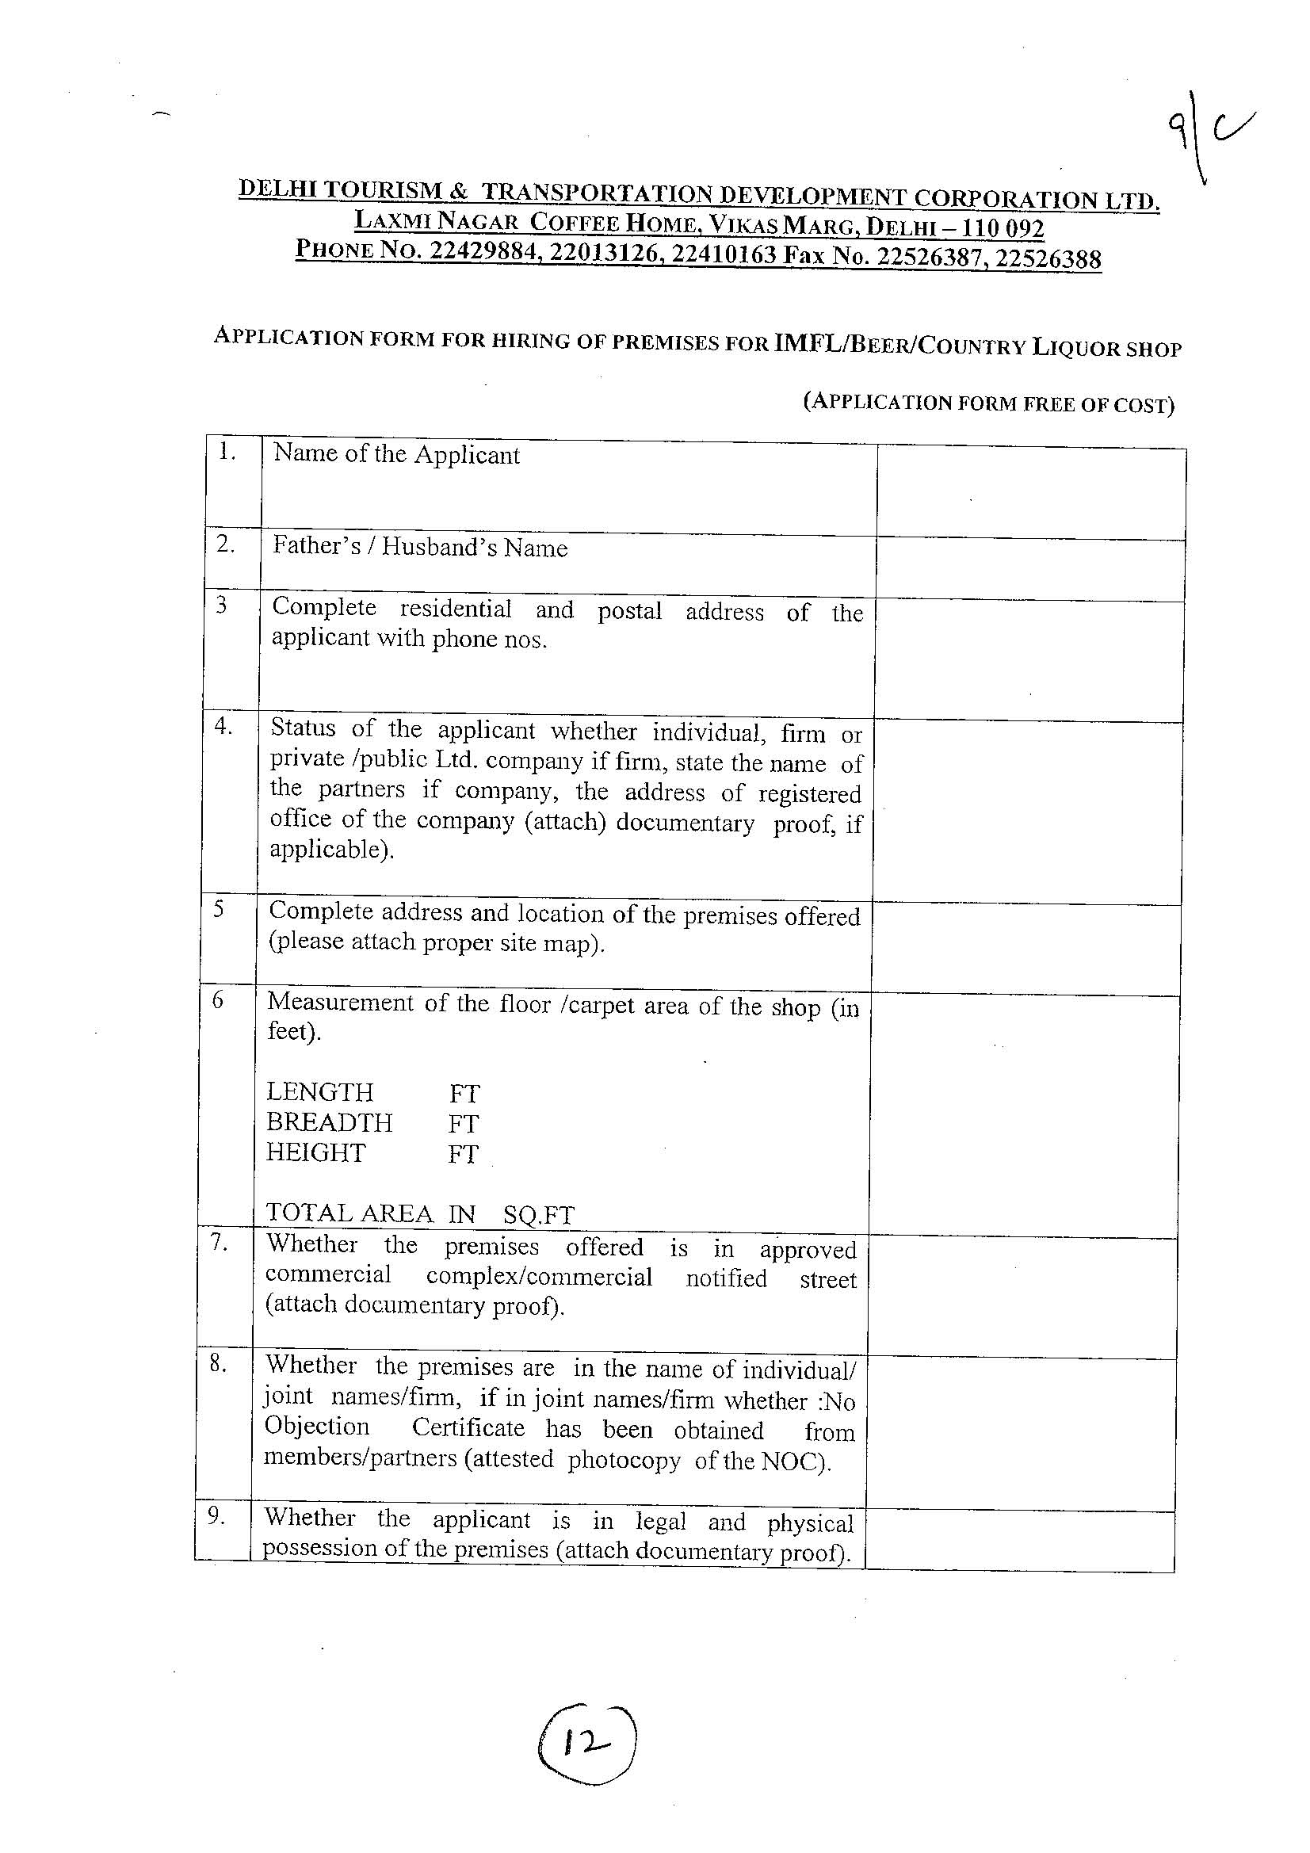
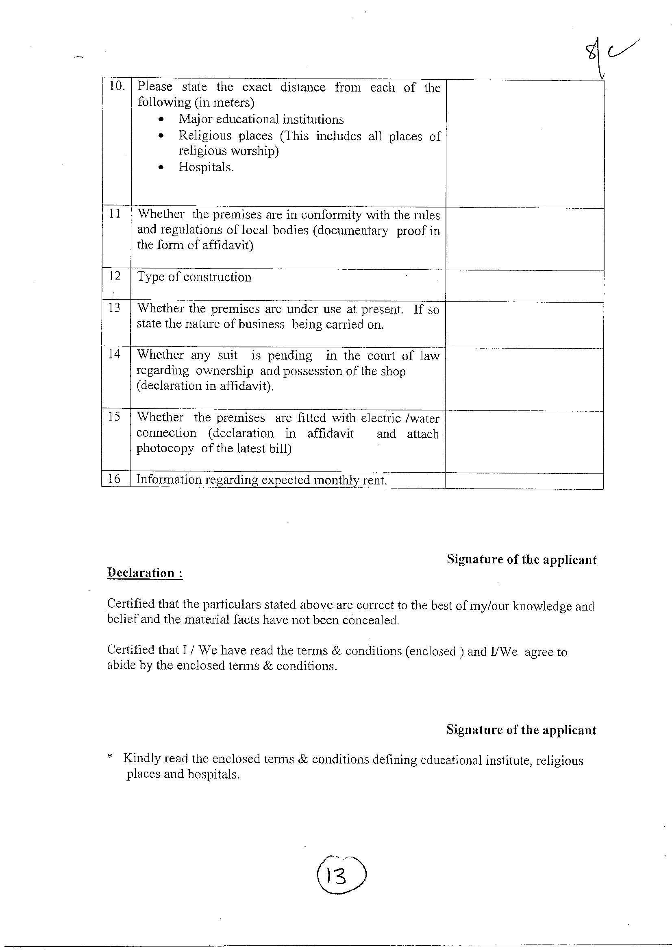
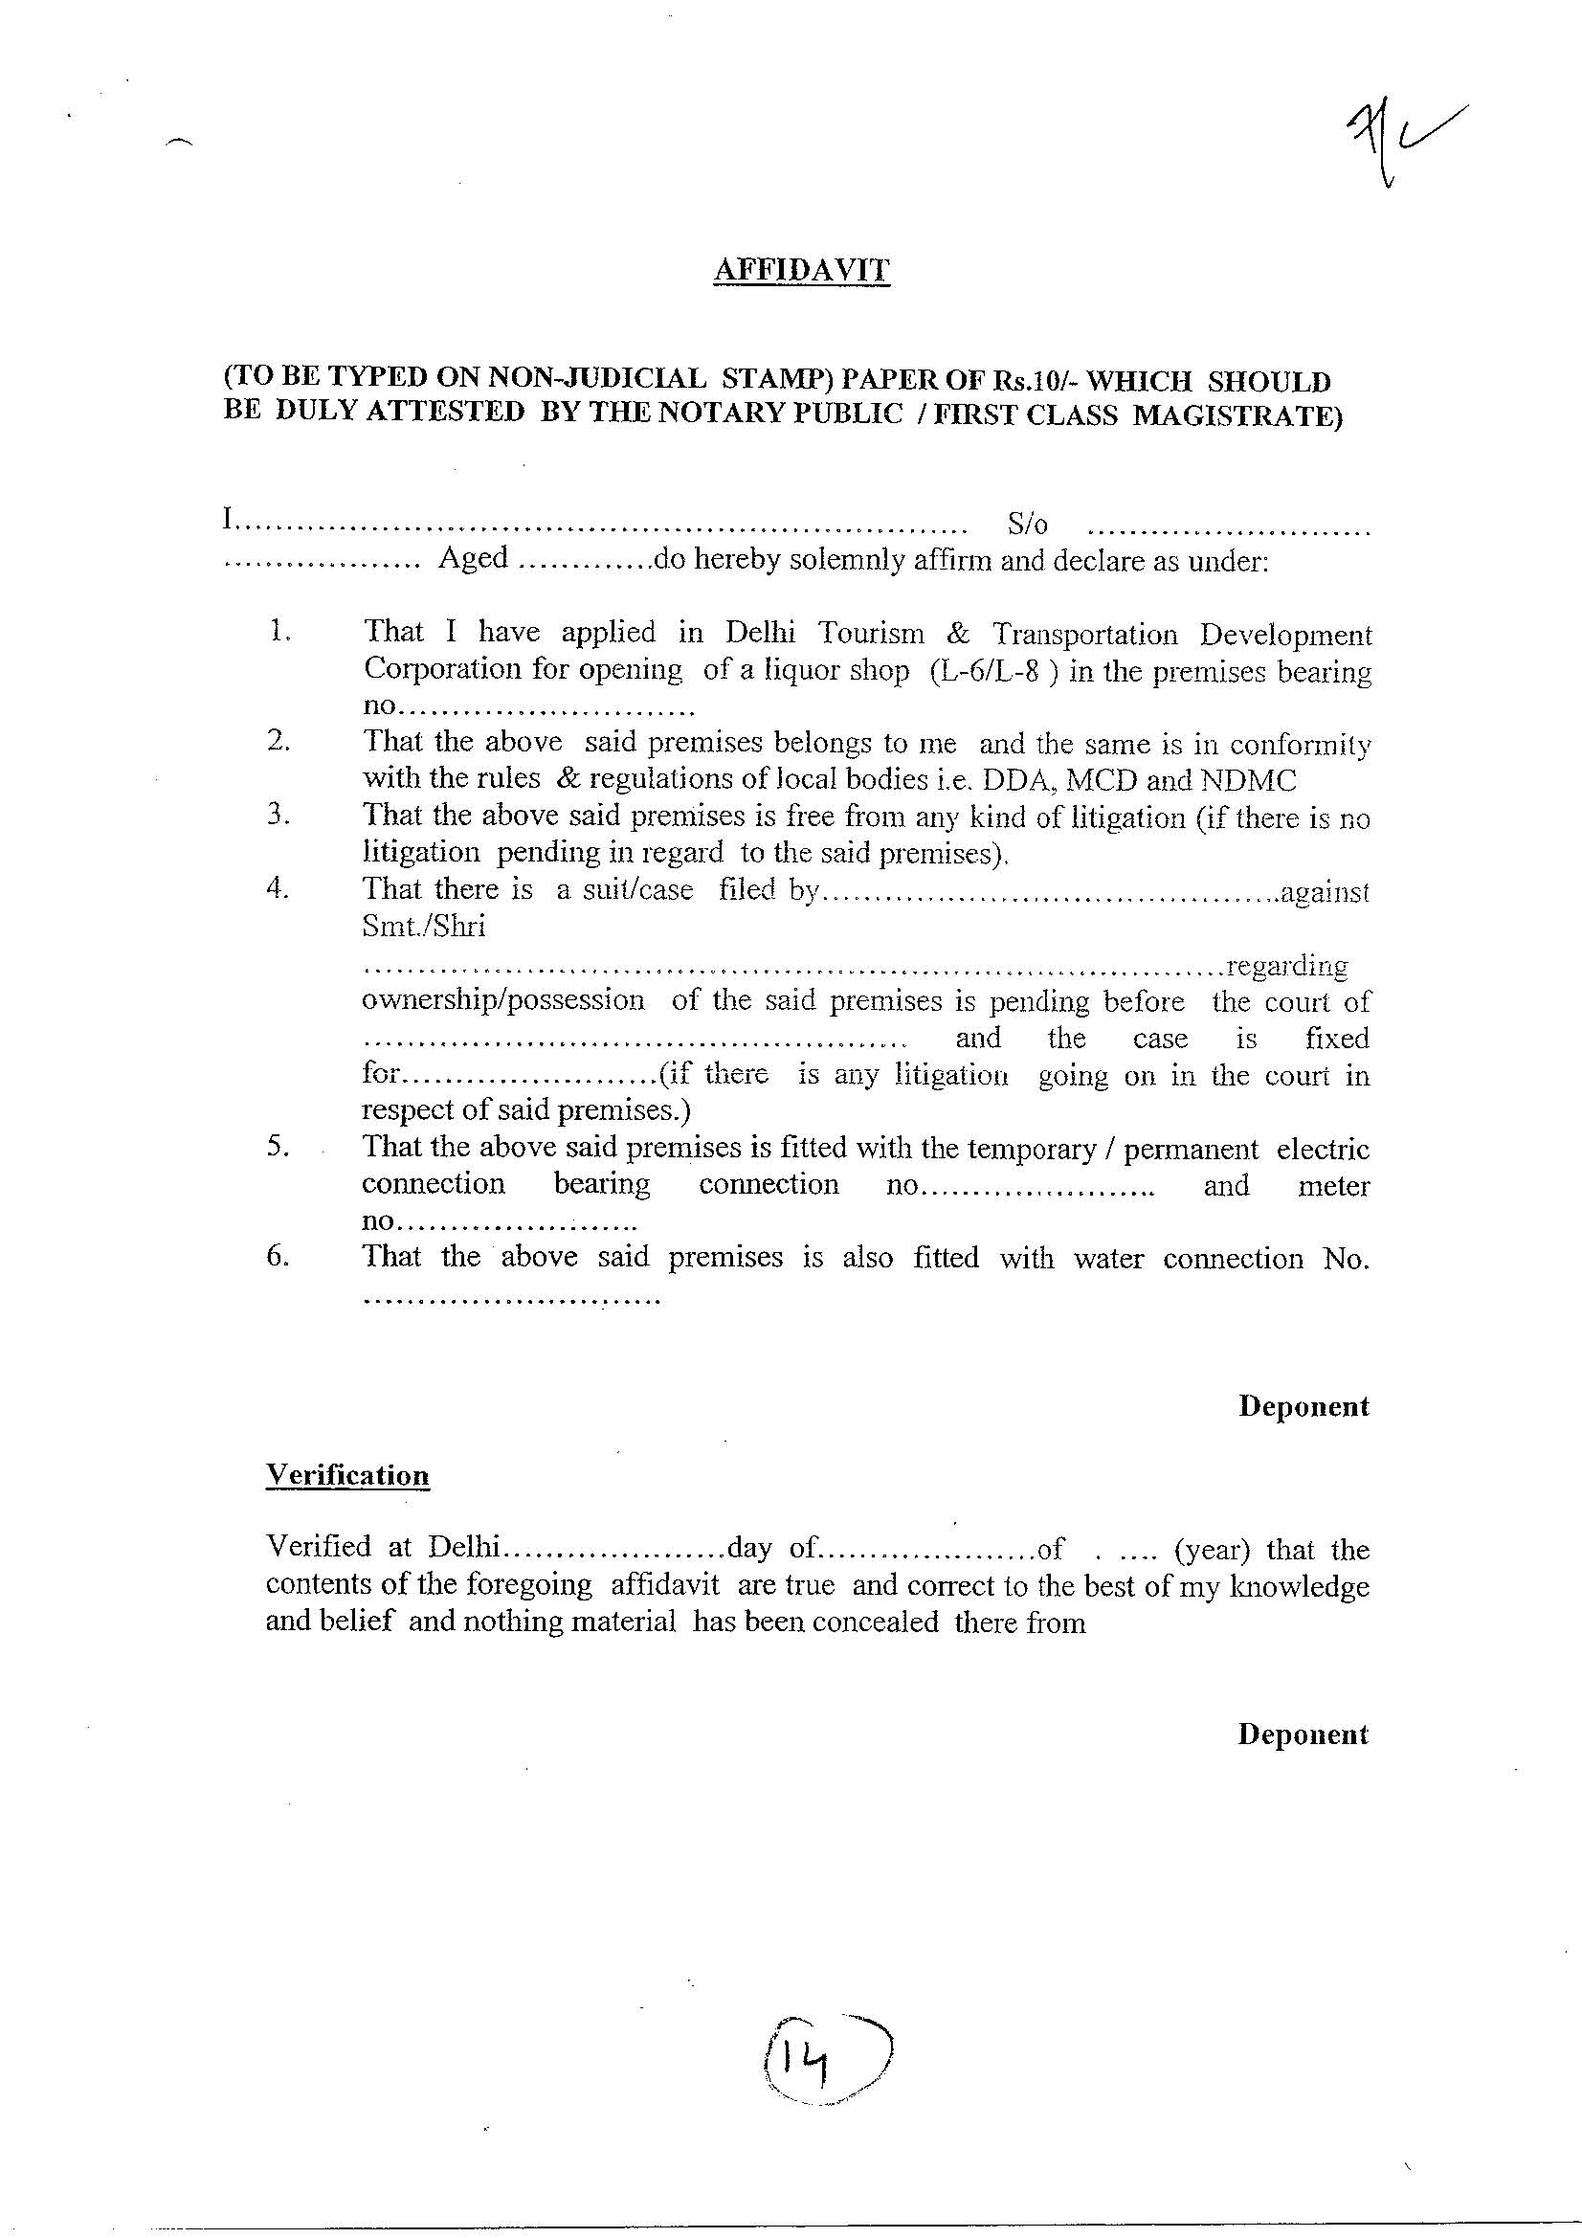
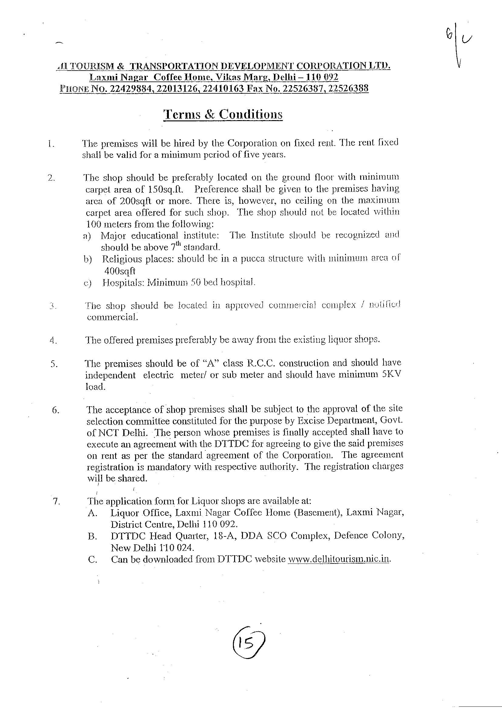
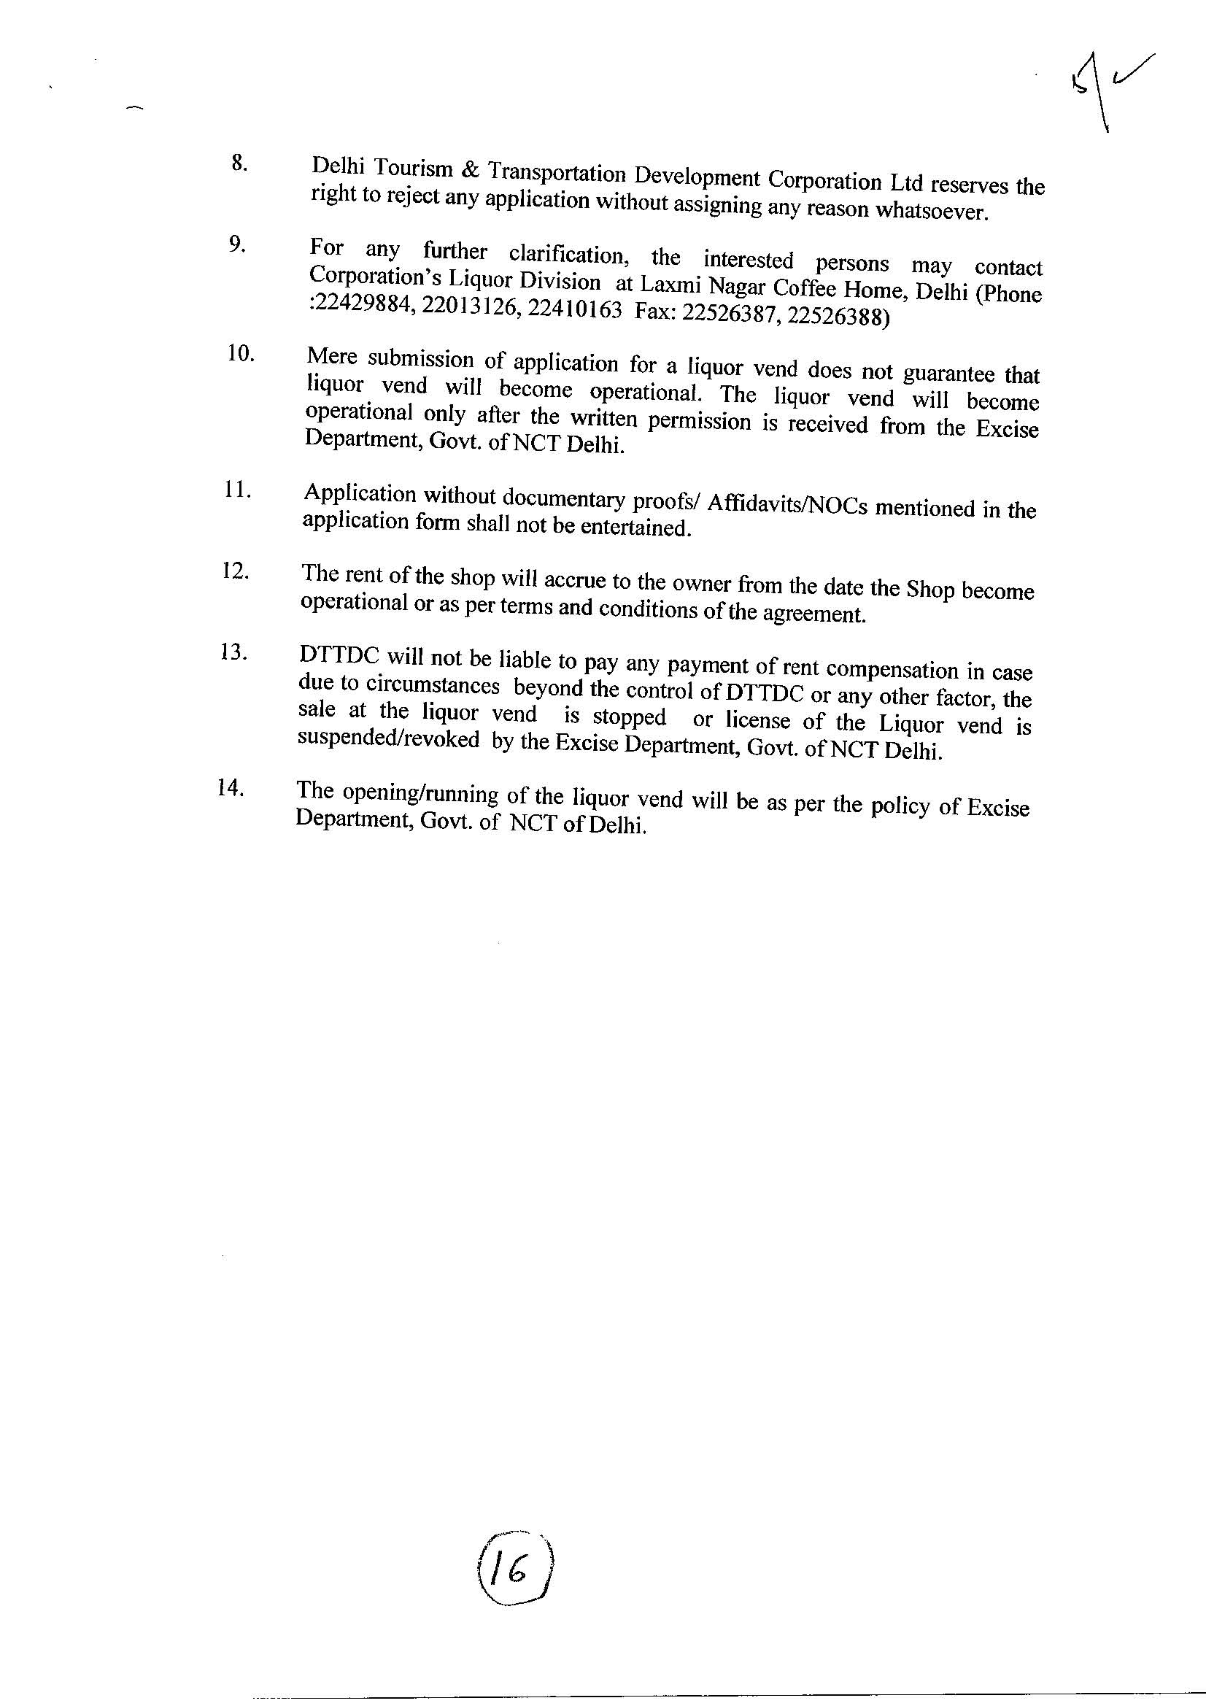
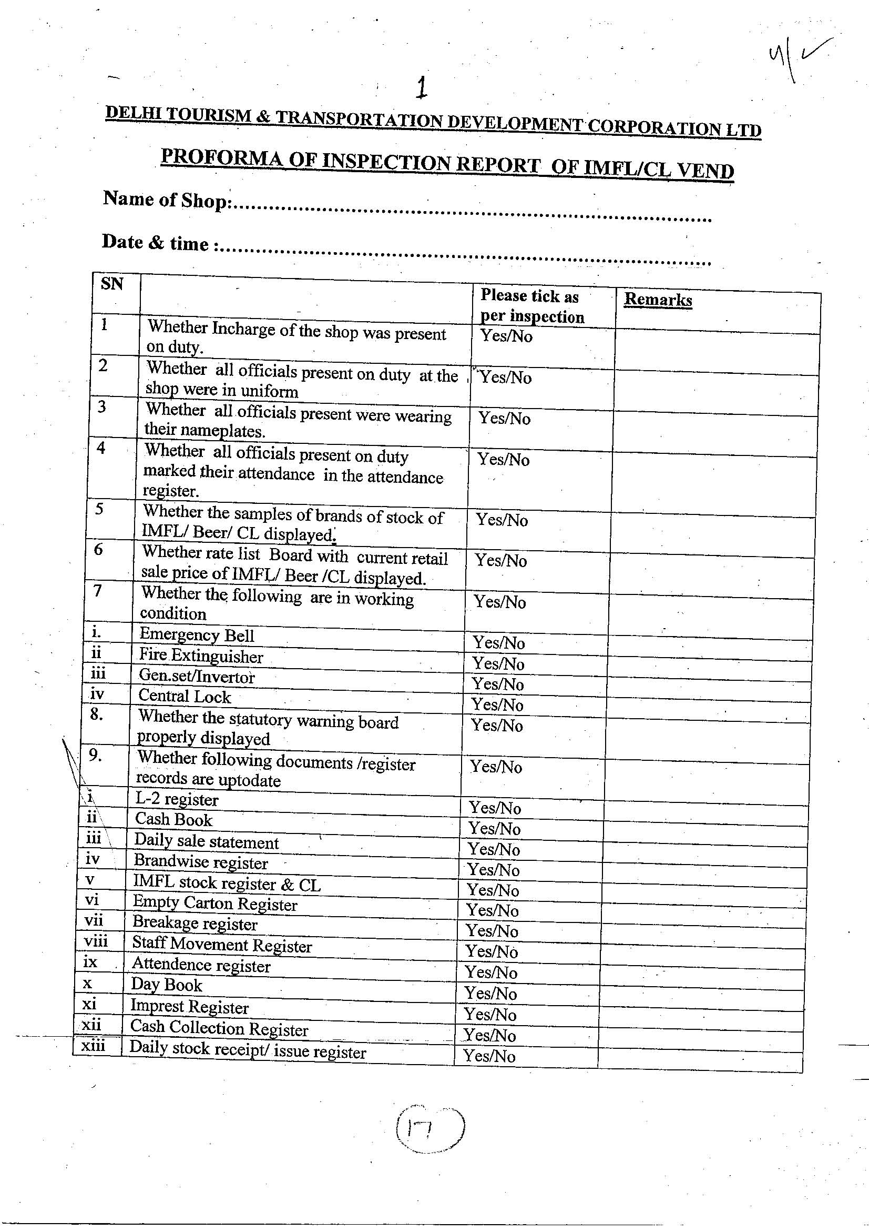
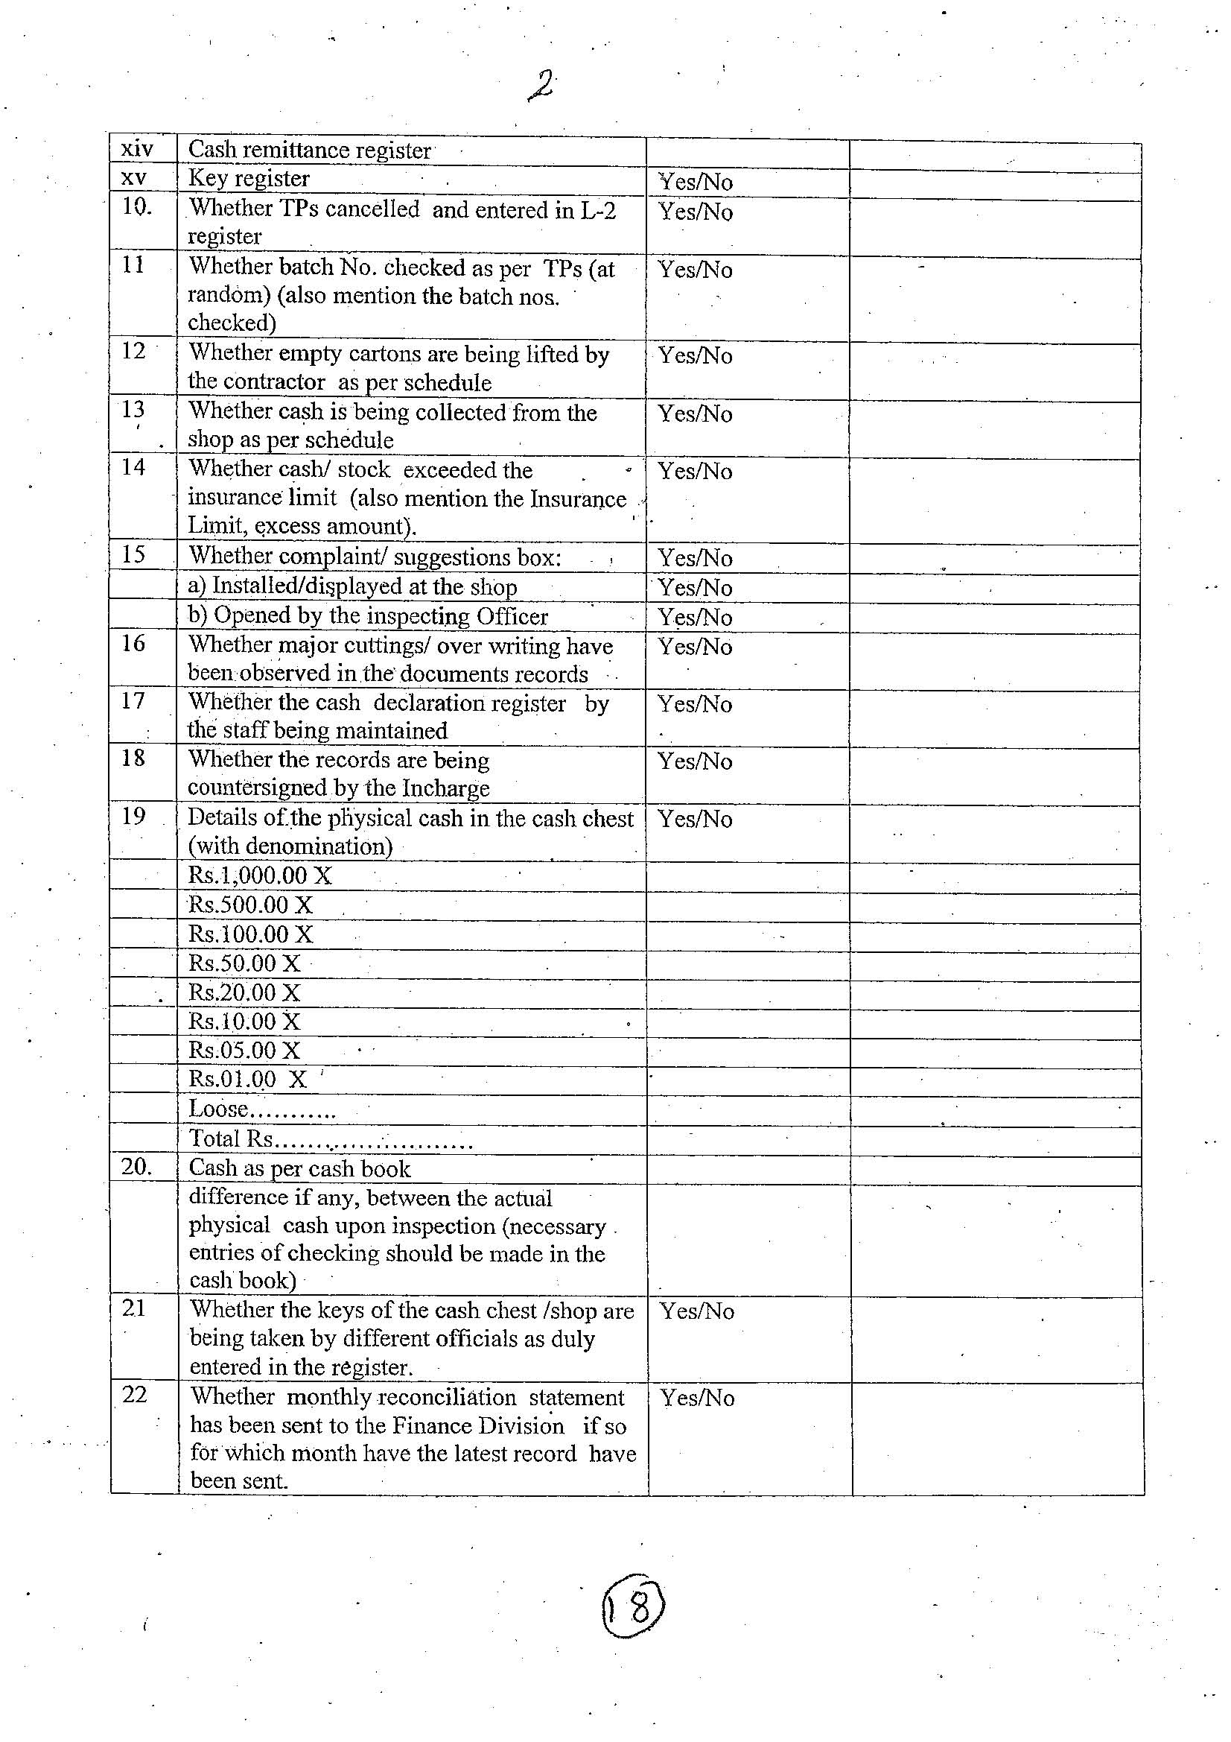
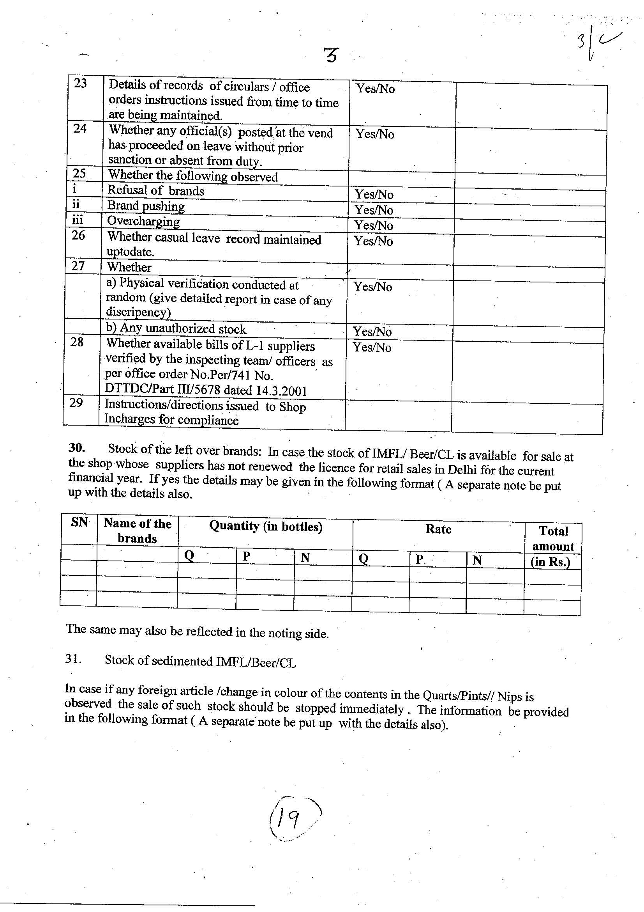
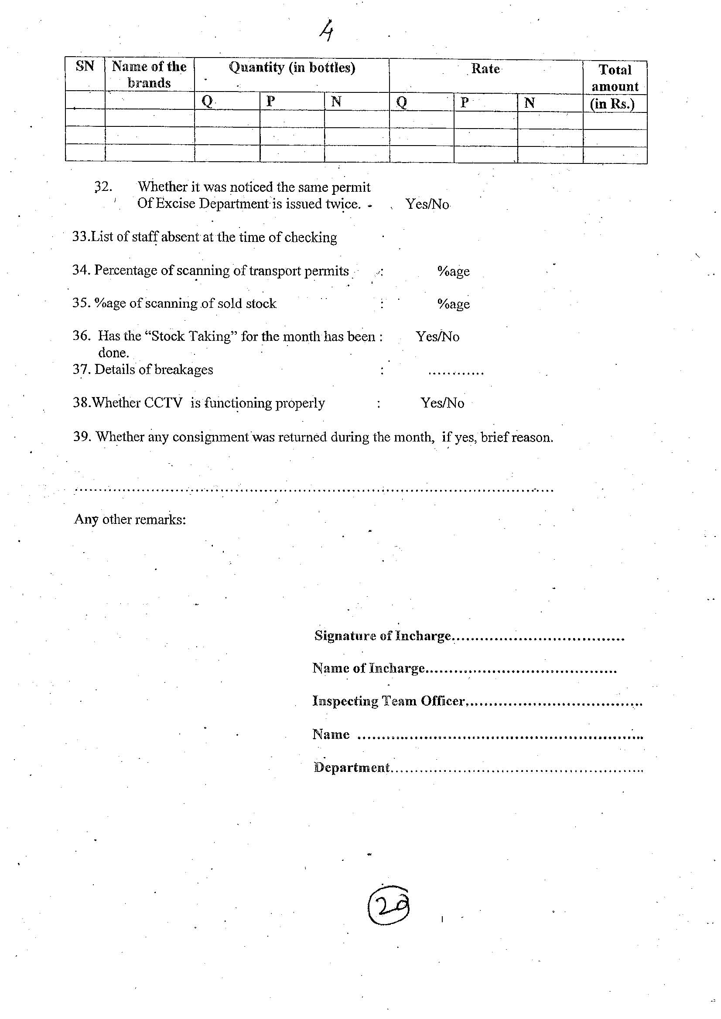
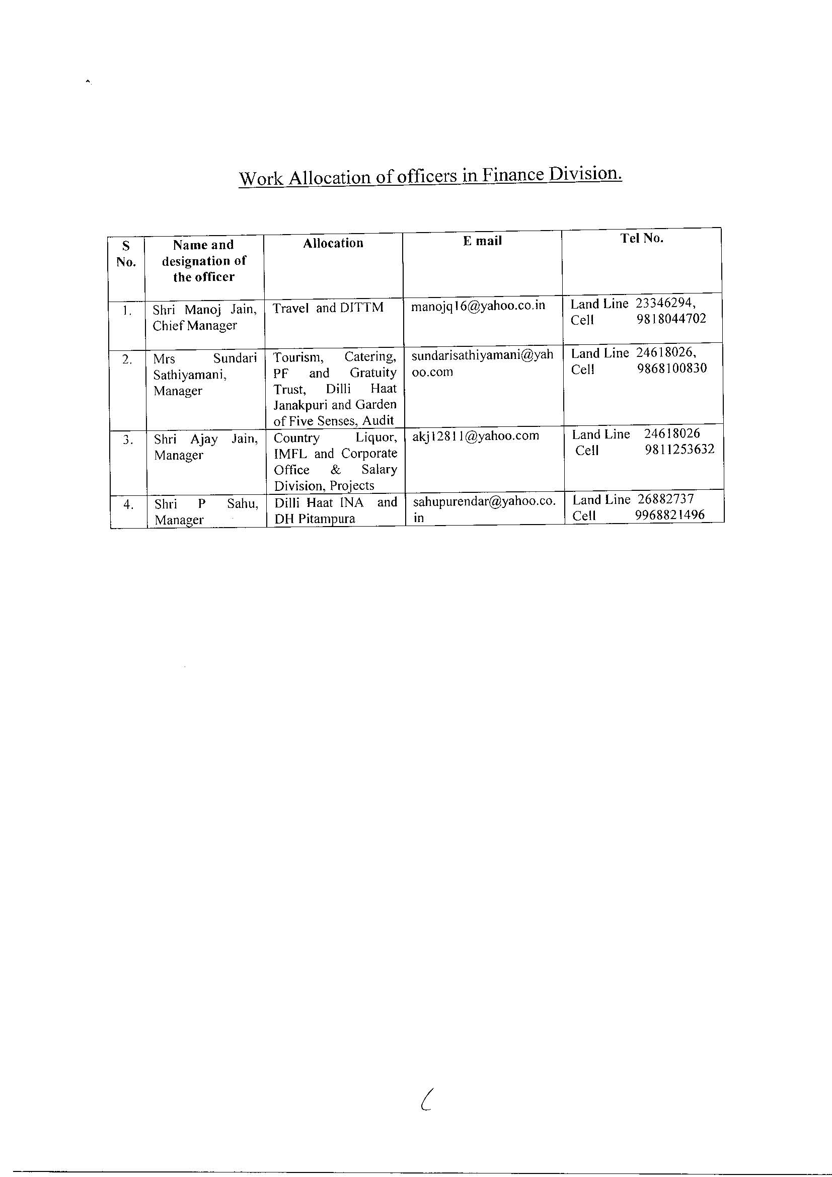
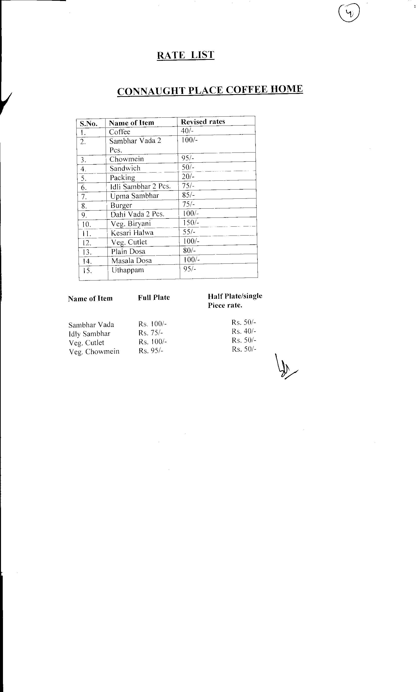
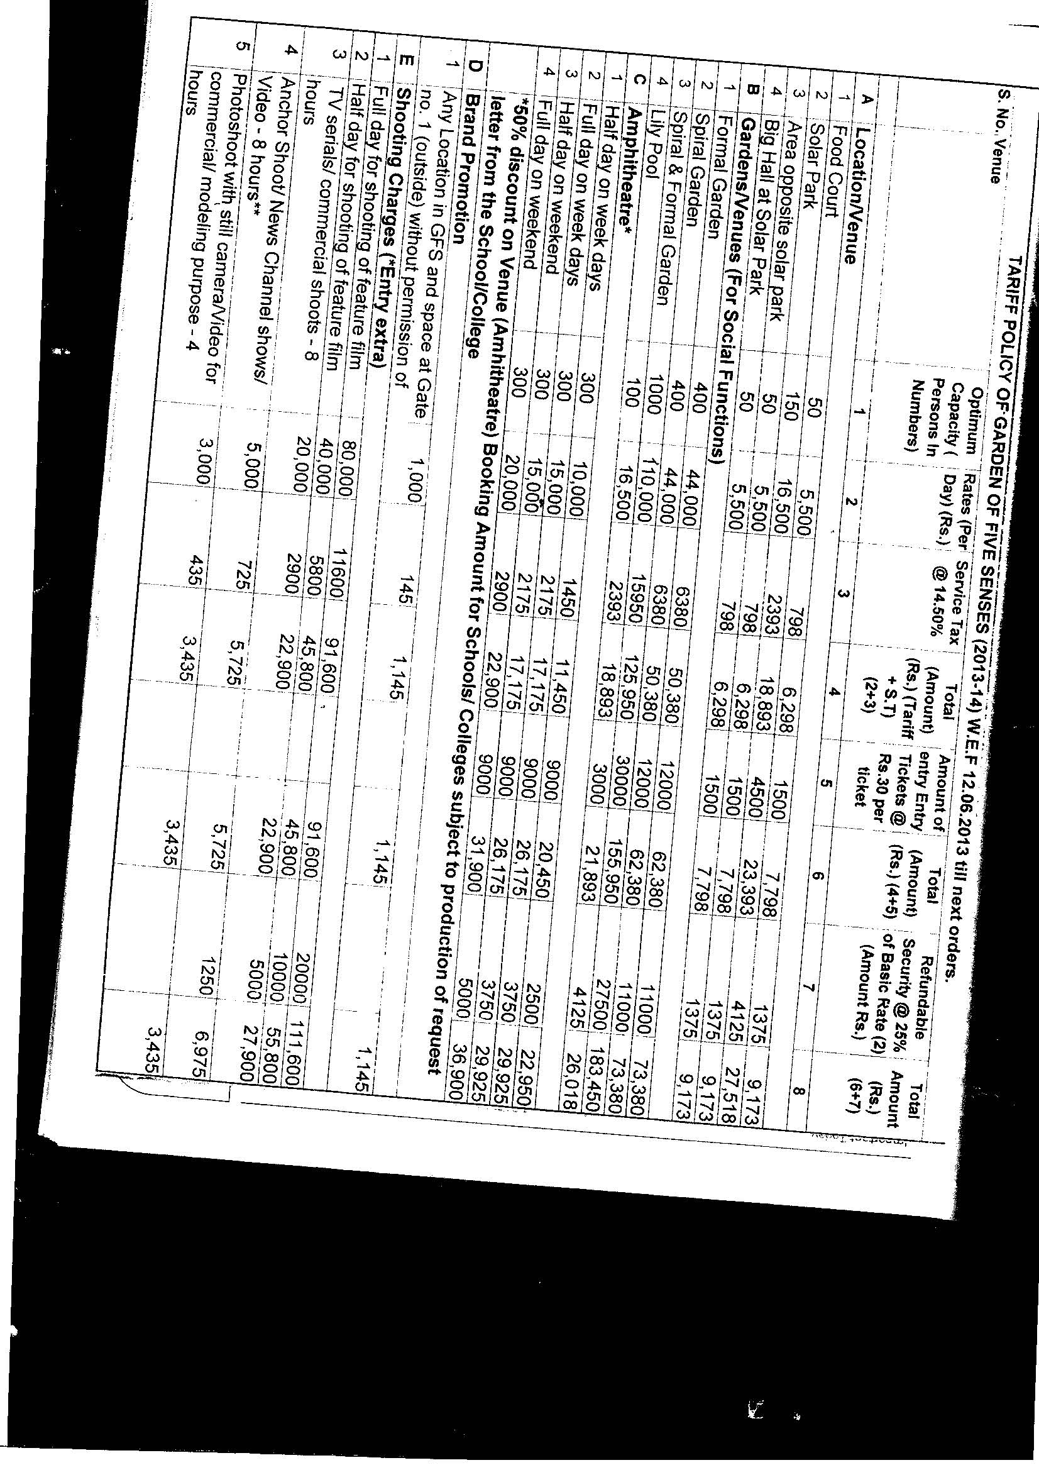
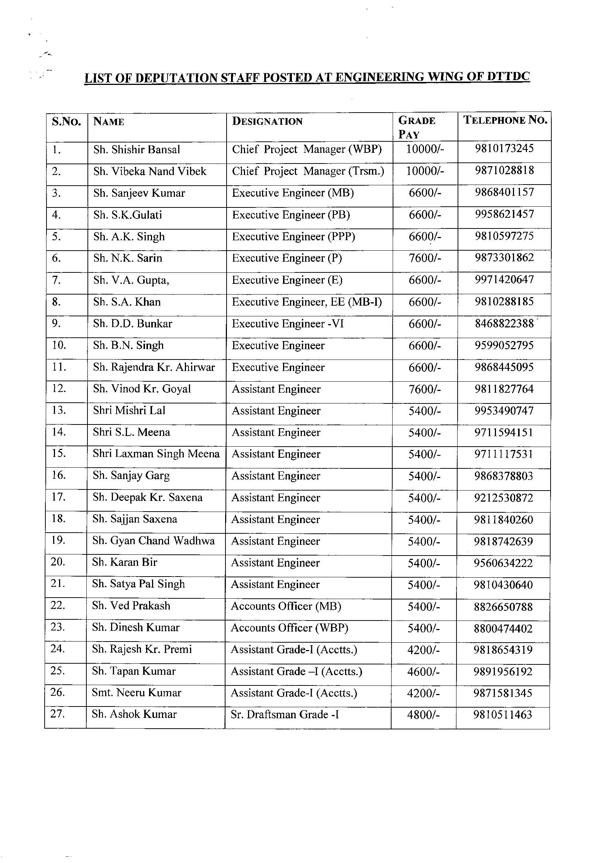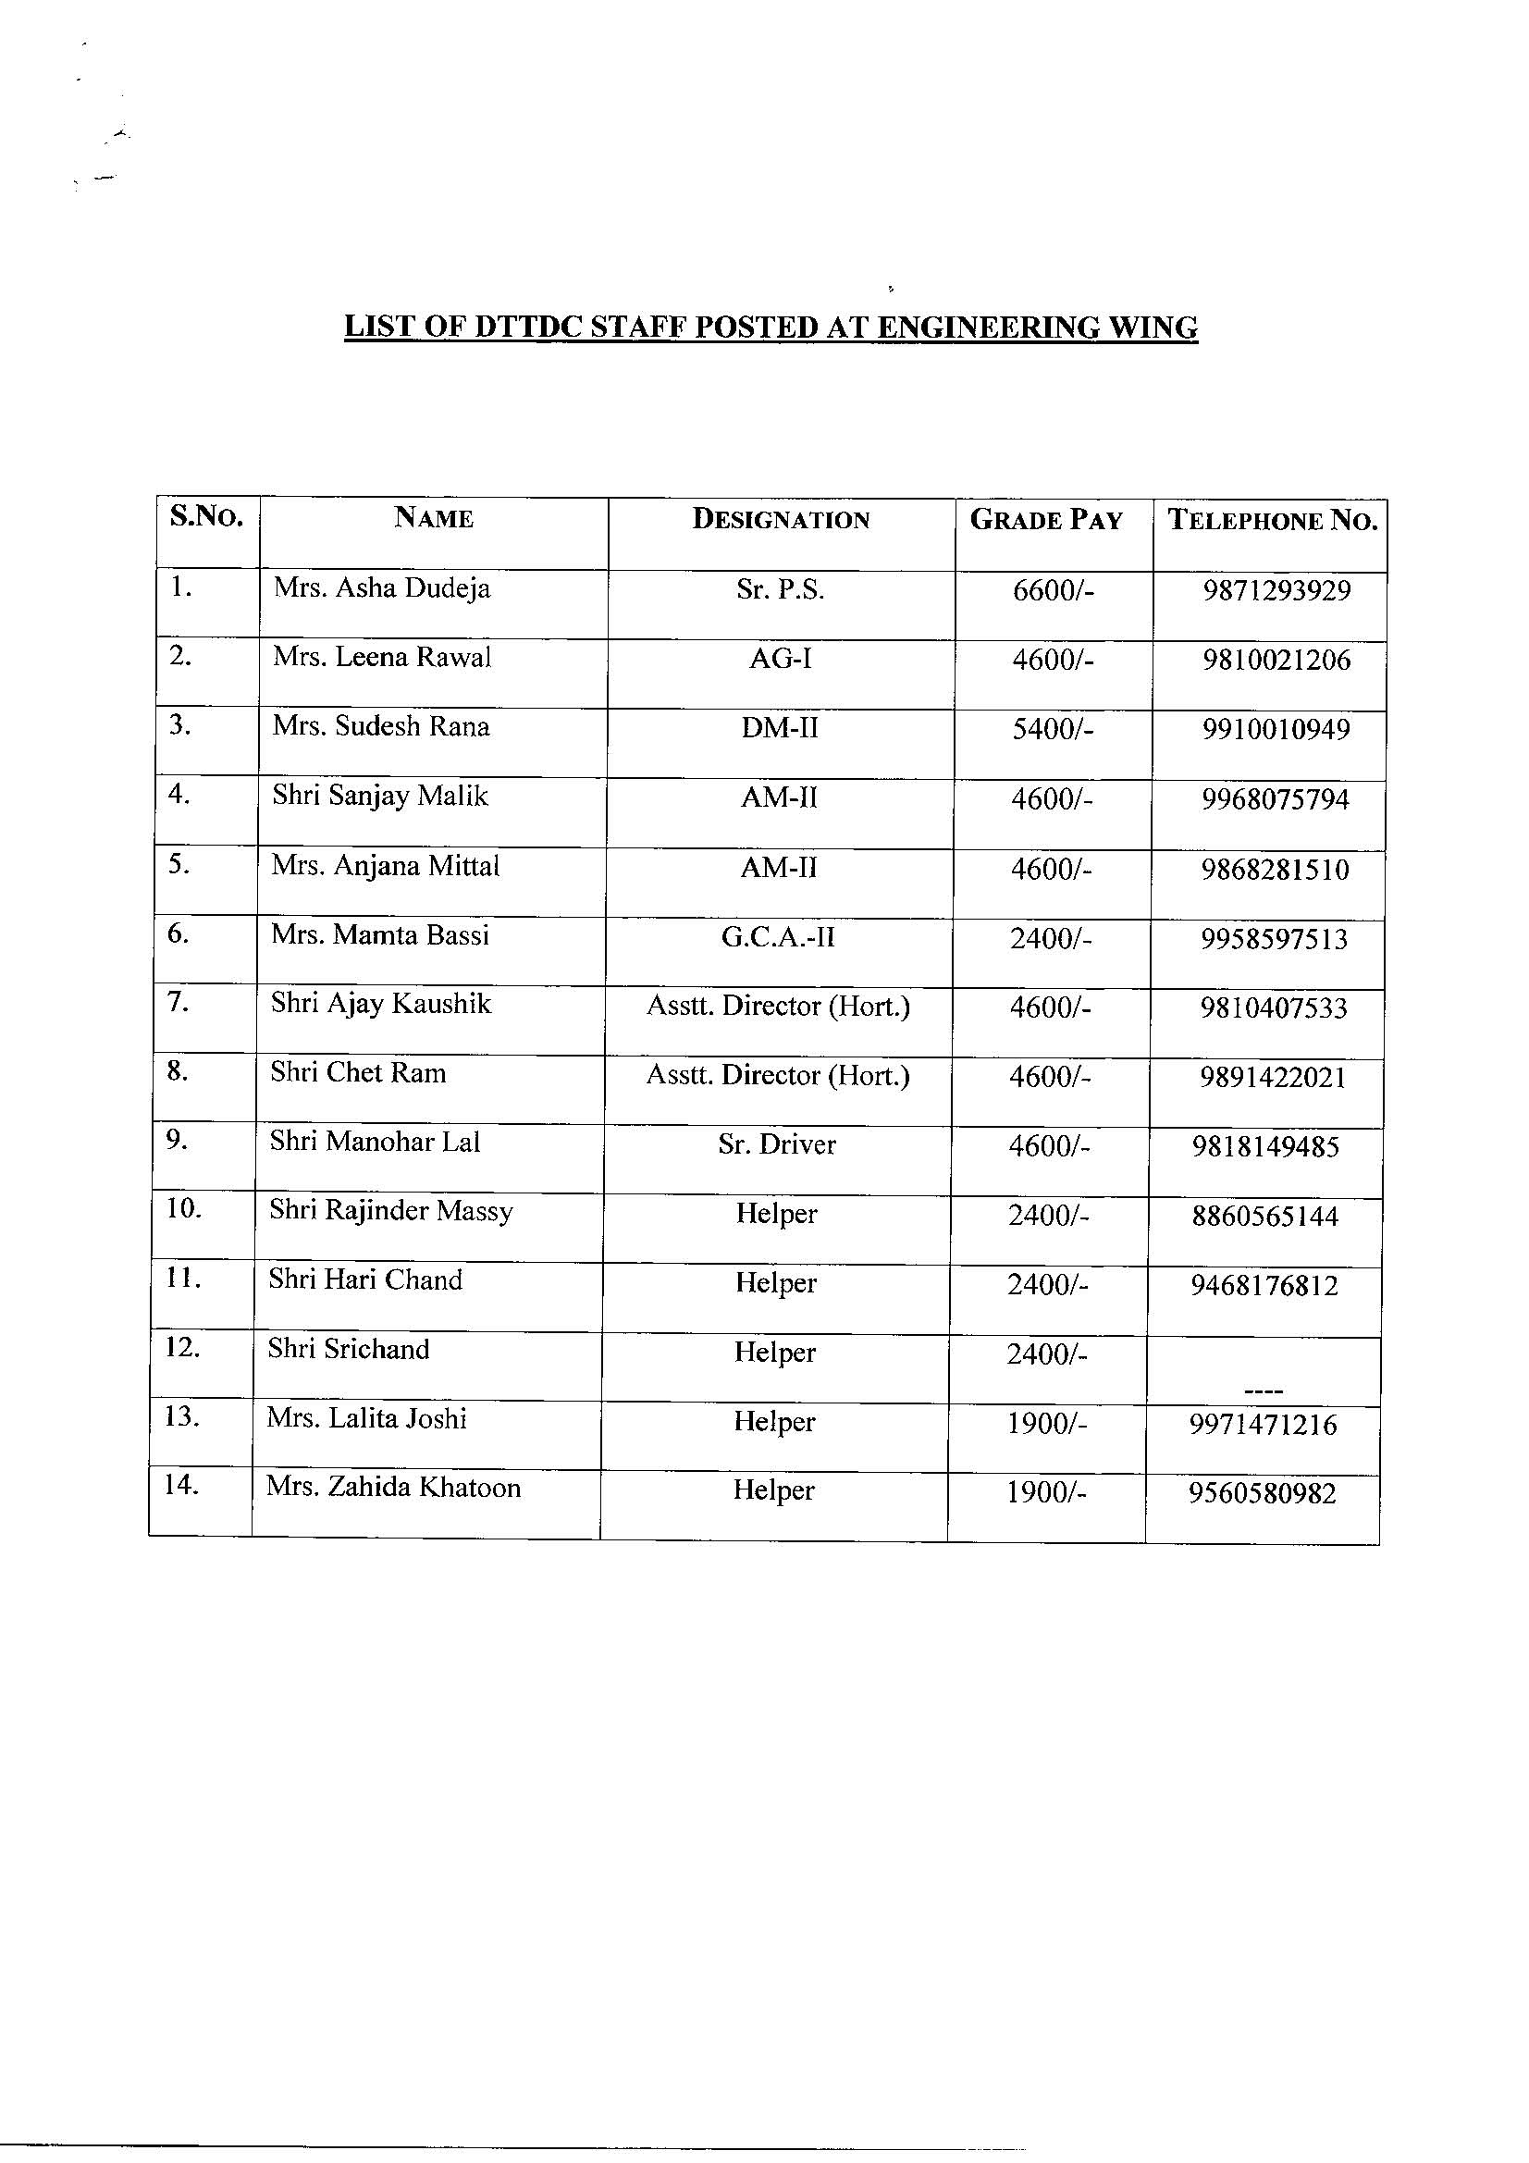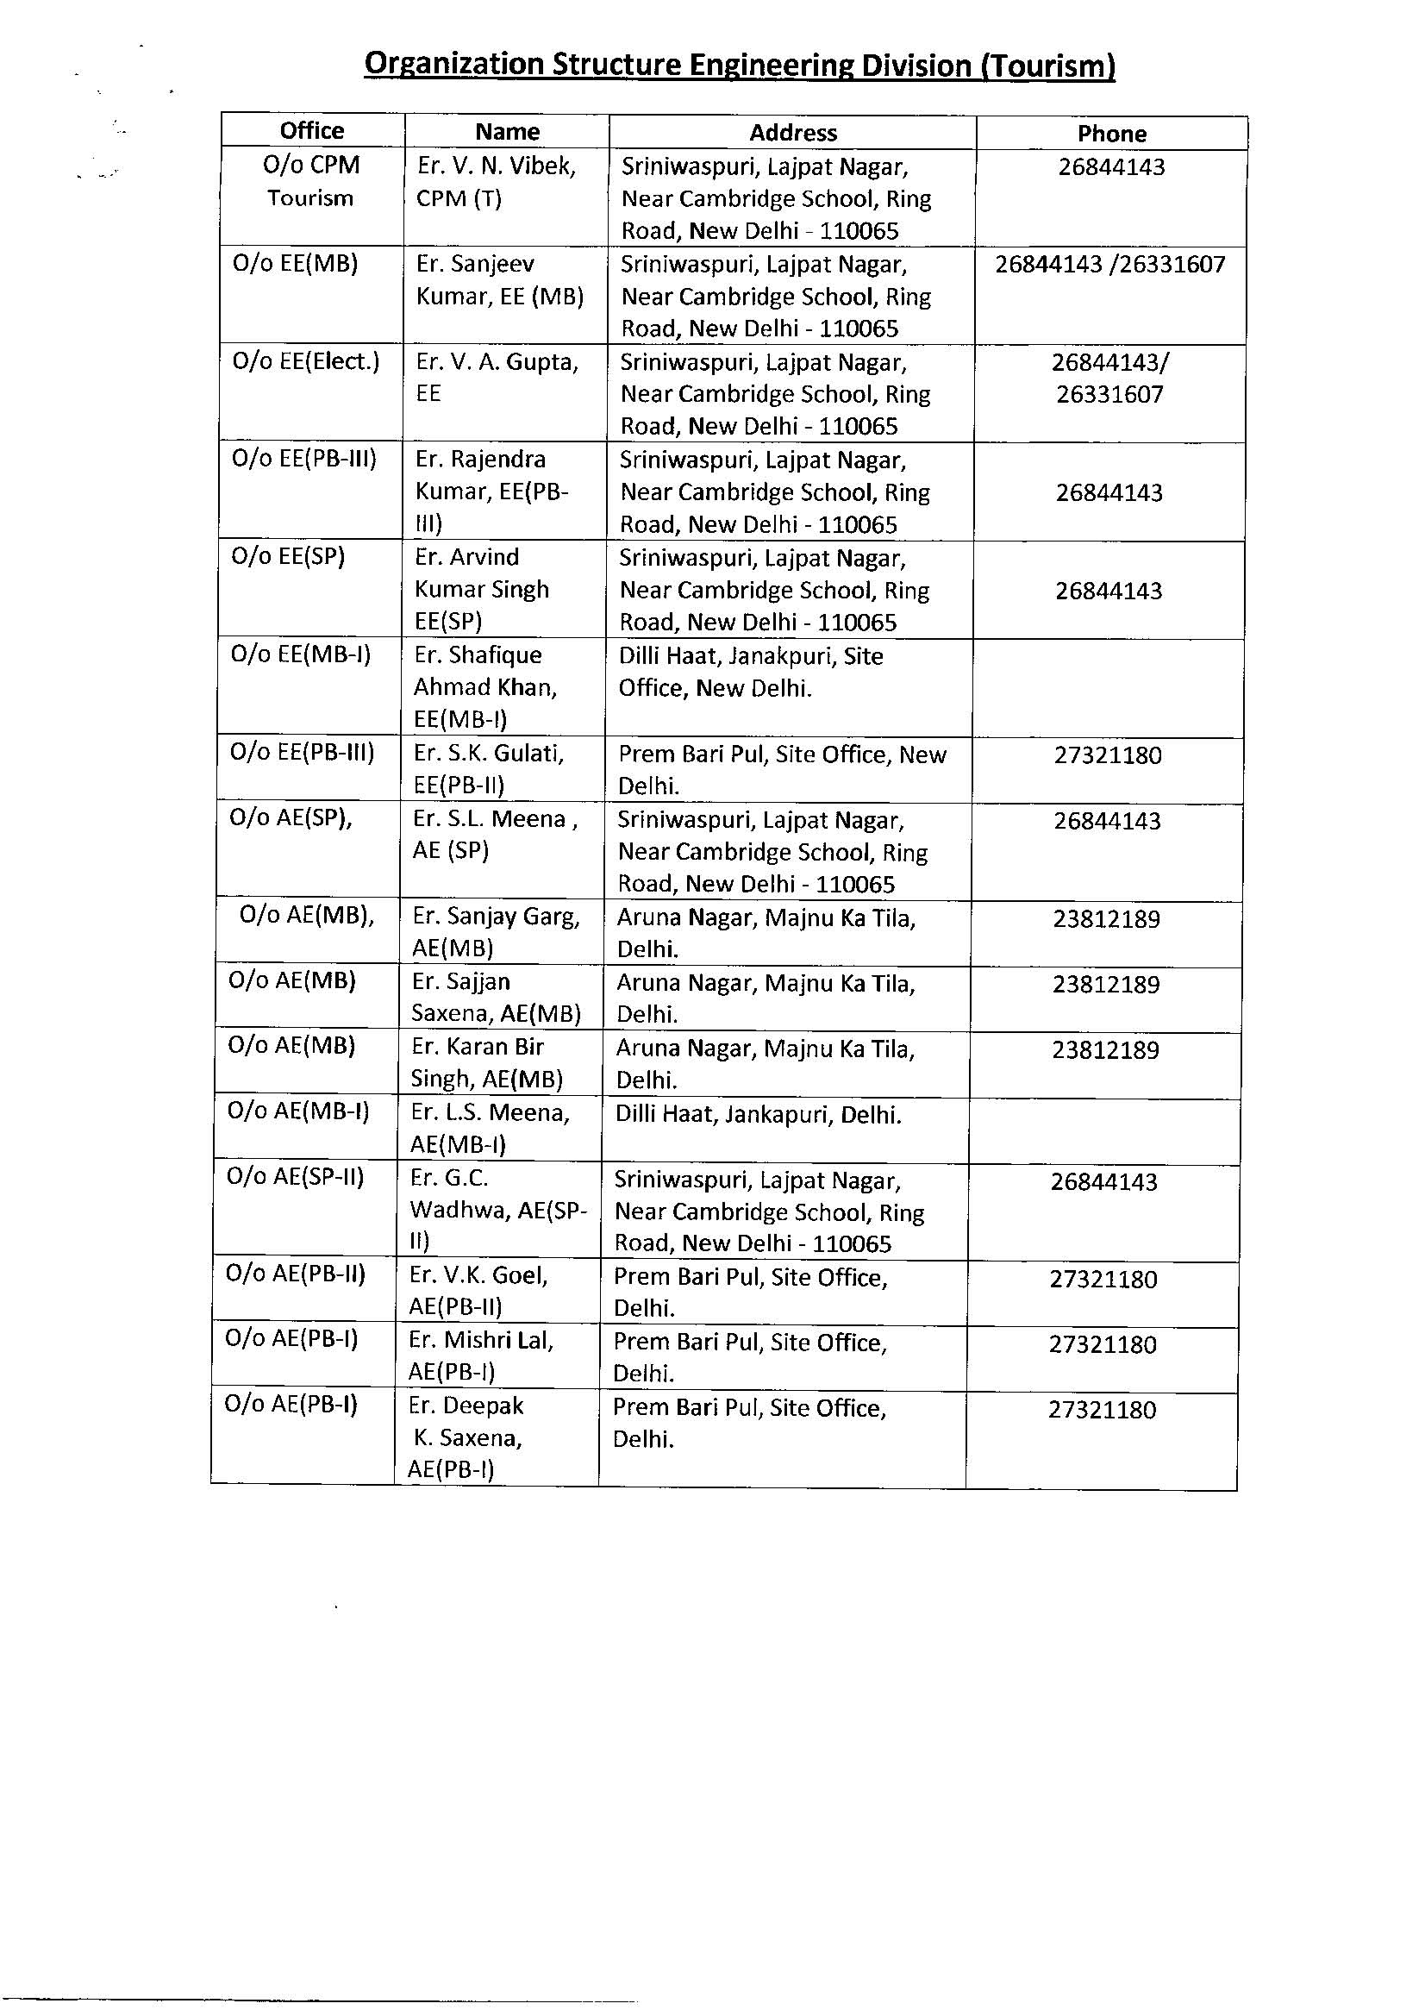
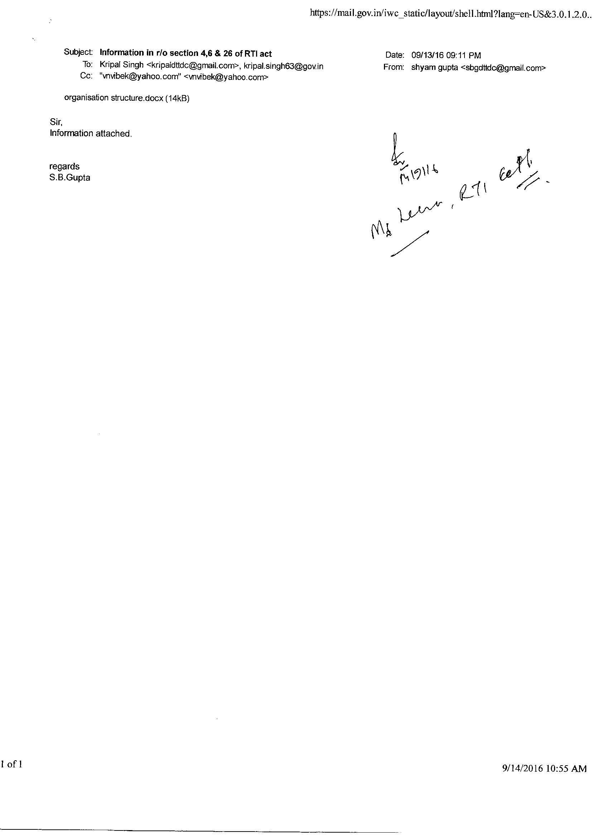
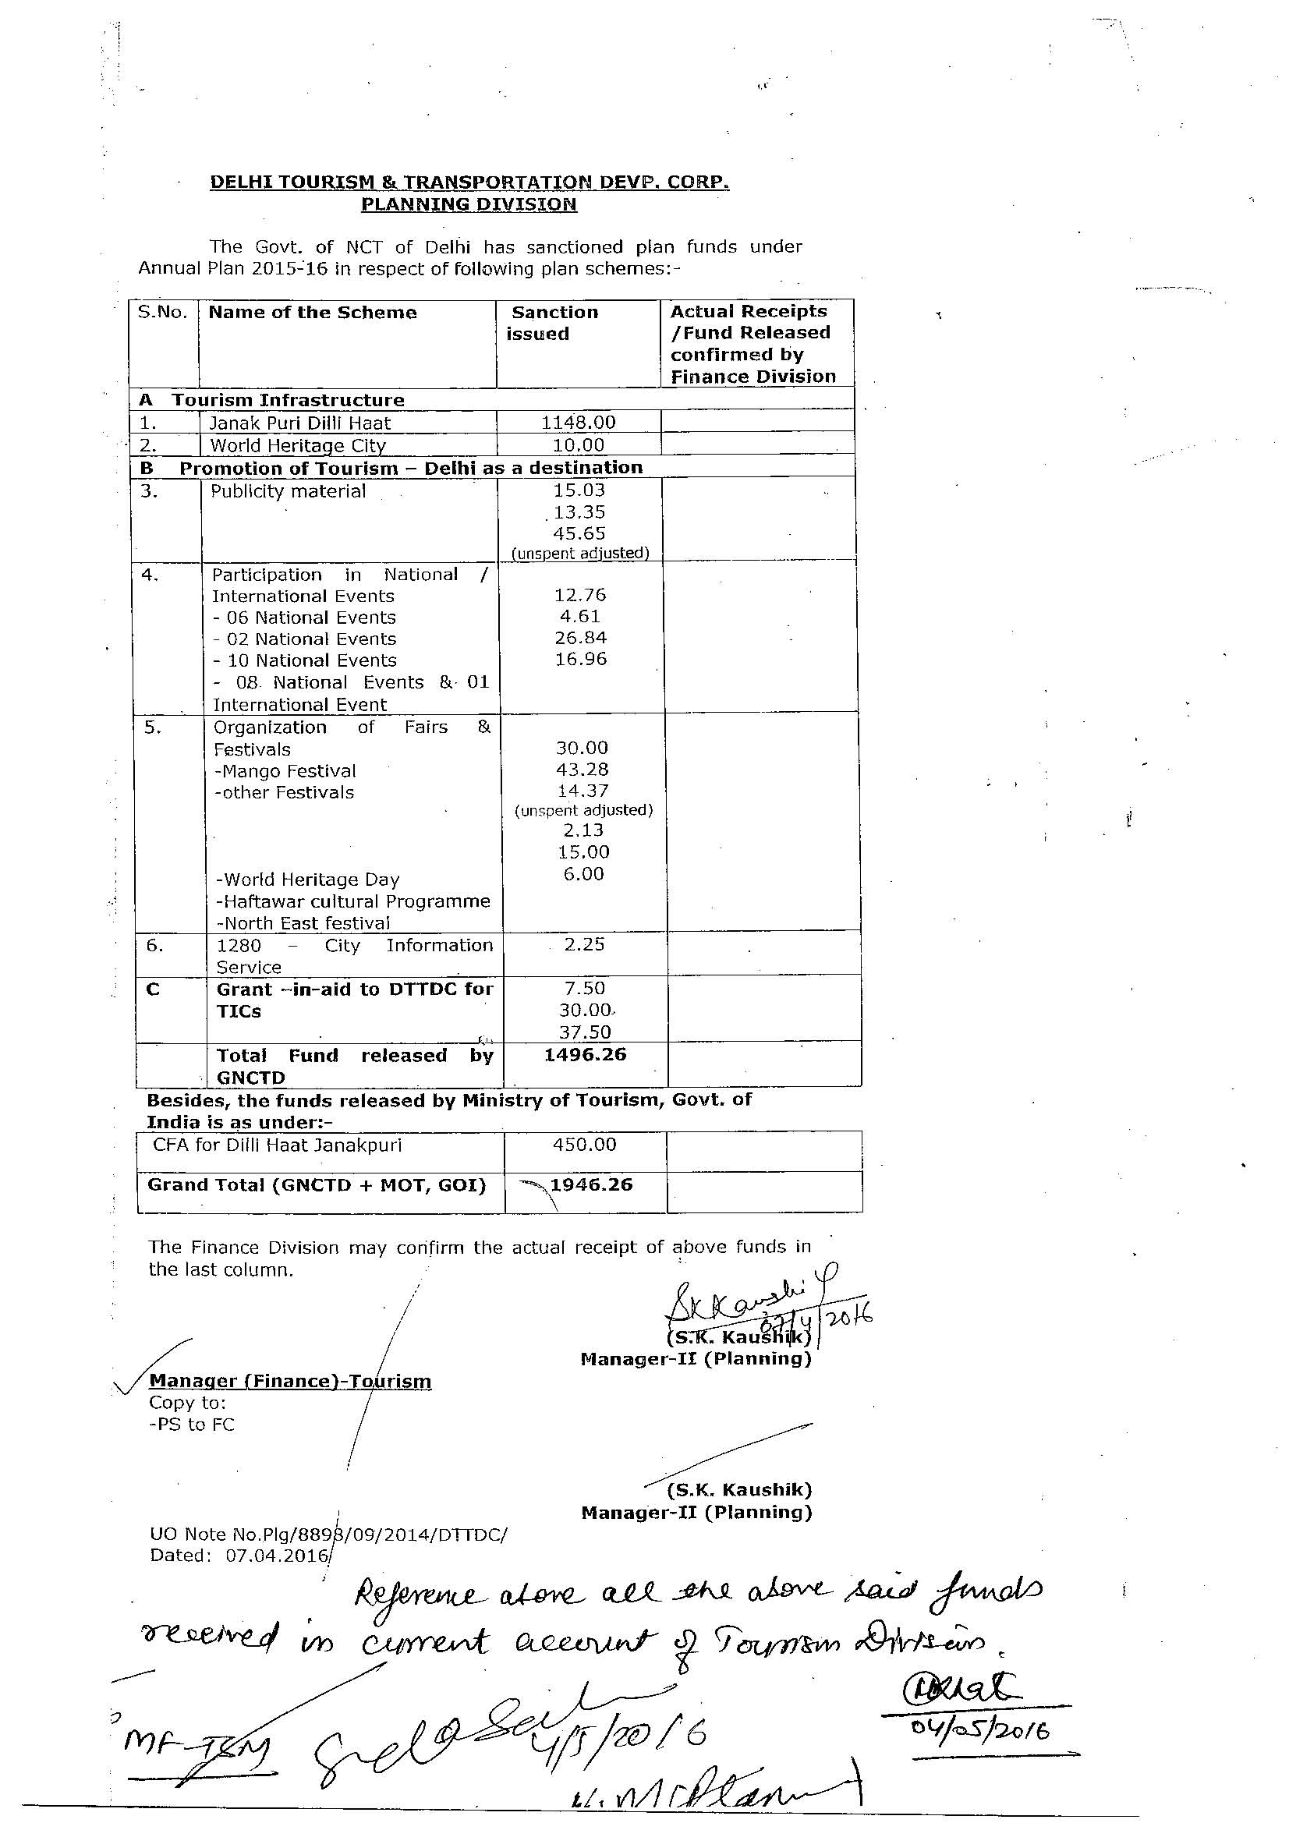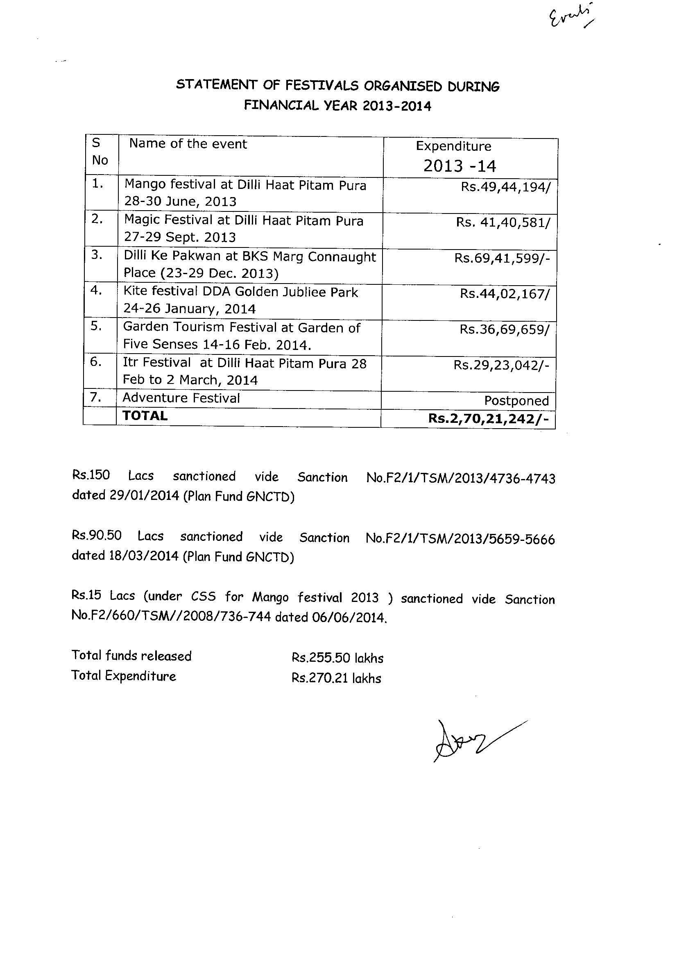
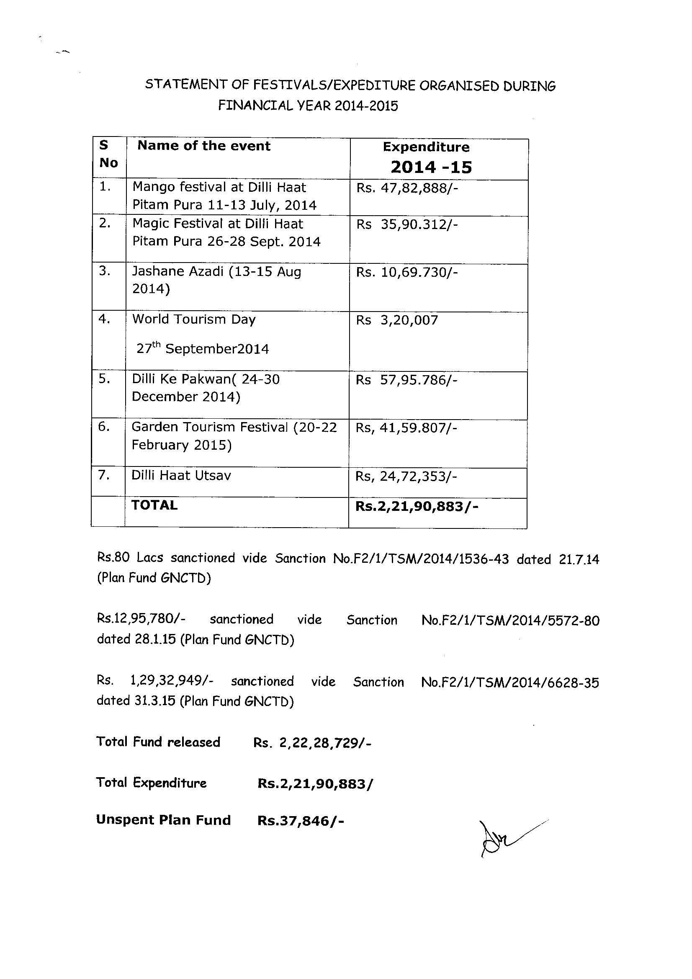
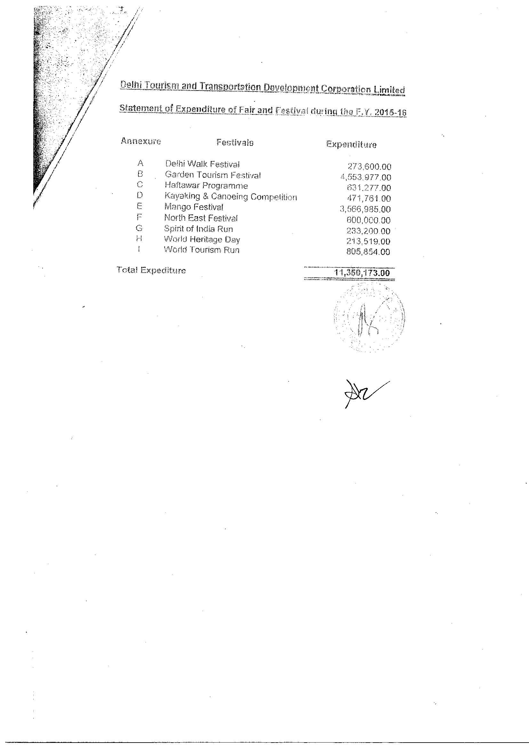

DEVELOPMENTALPROJECTDETAILS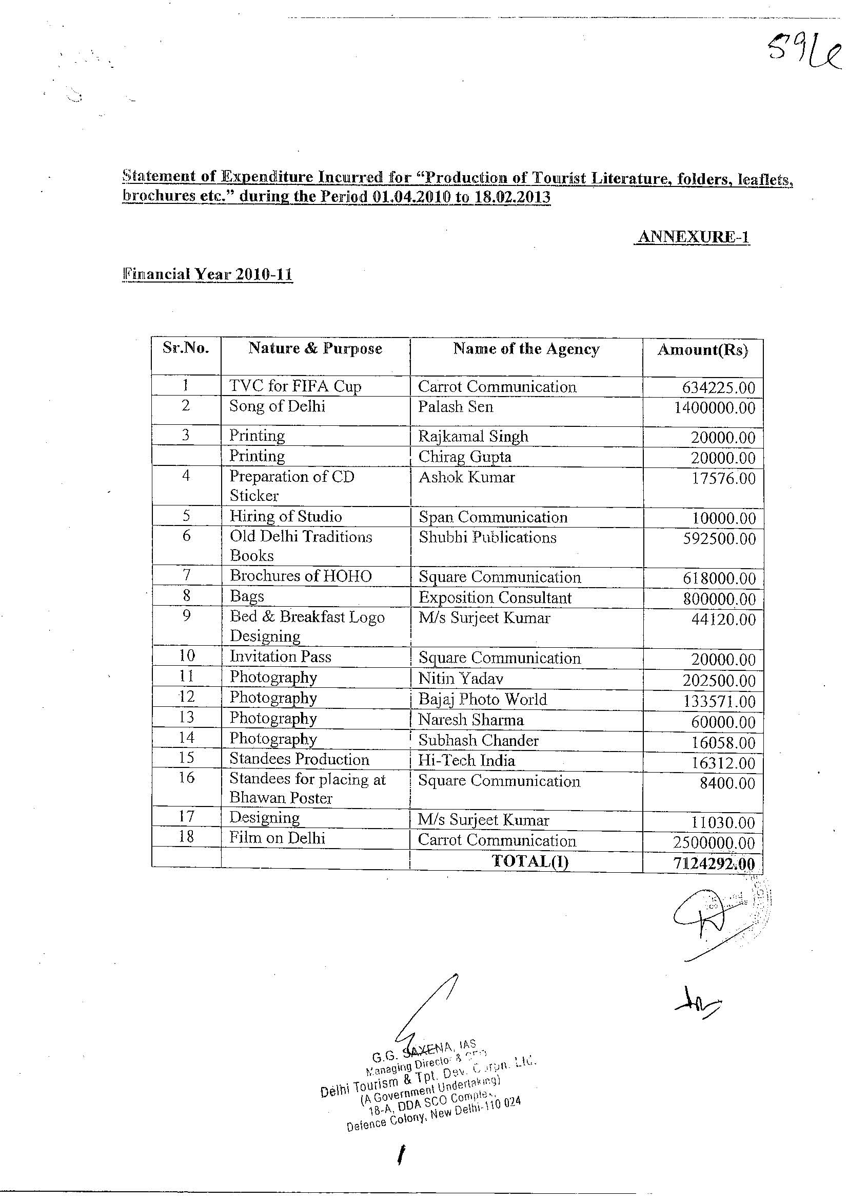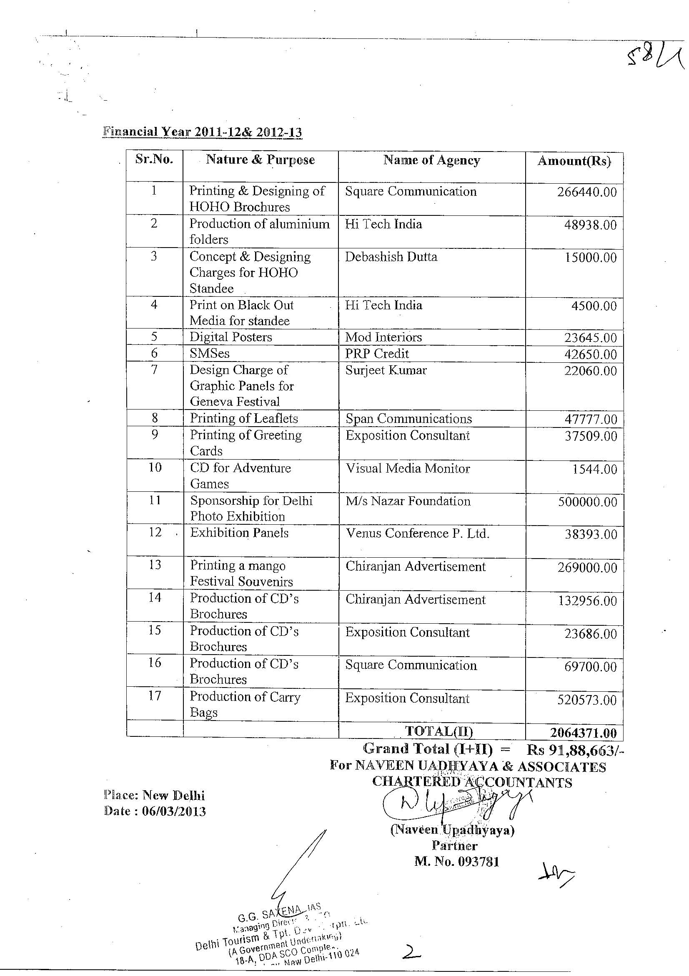
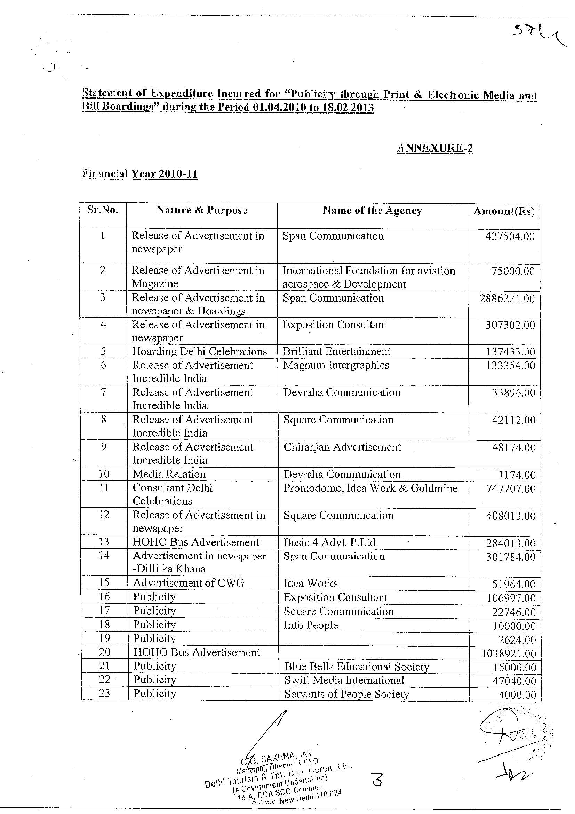
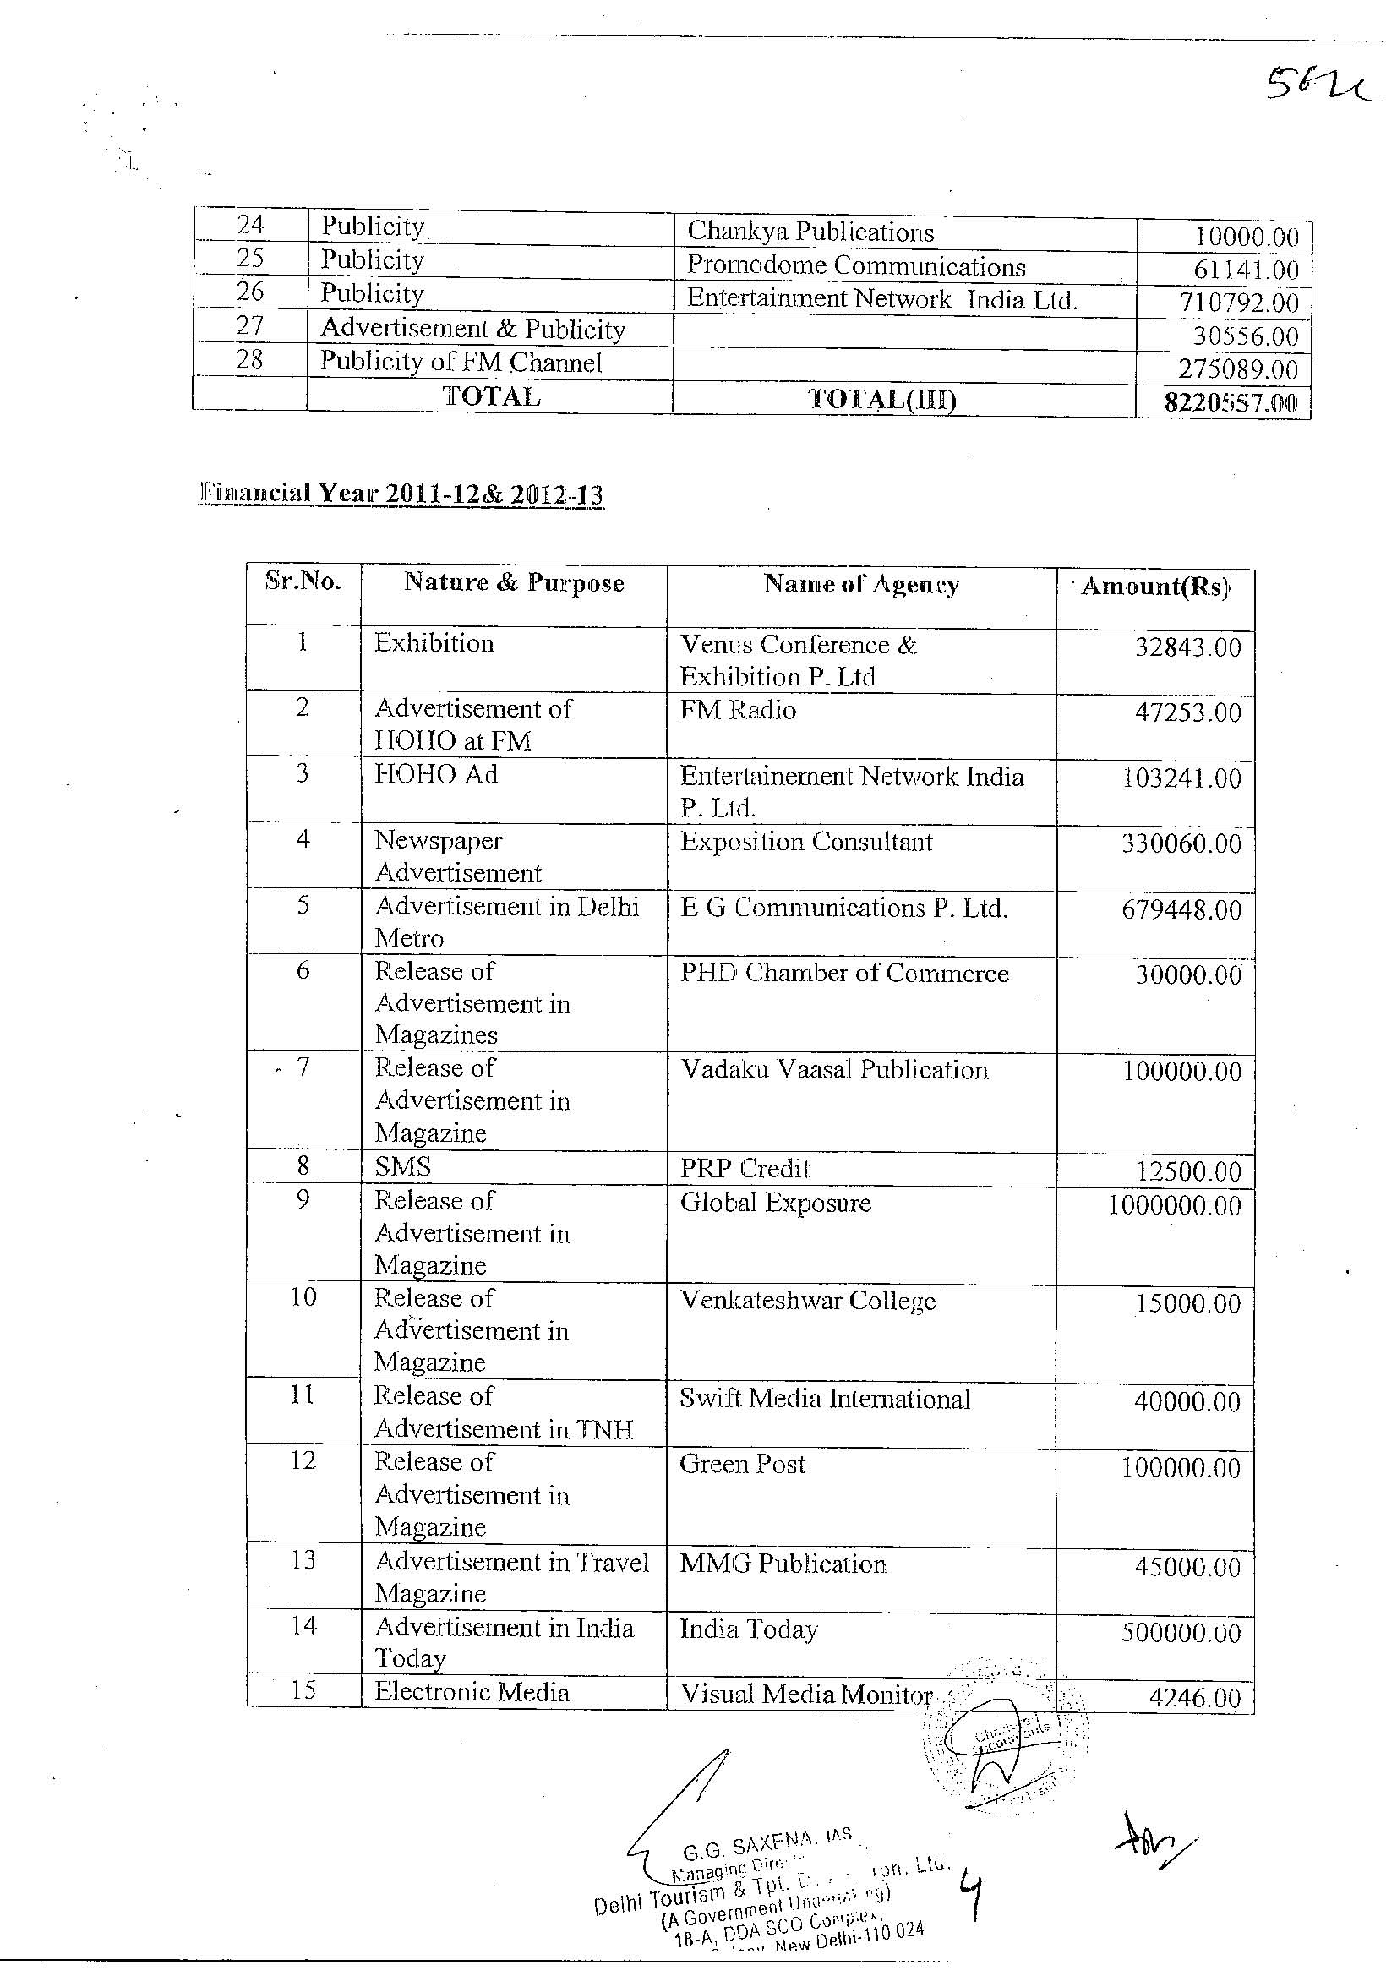
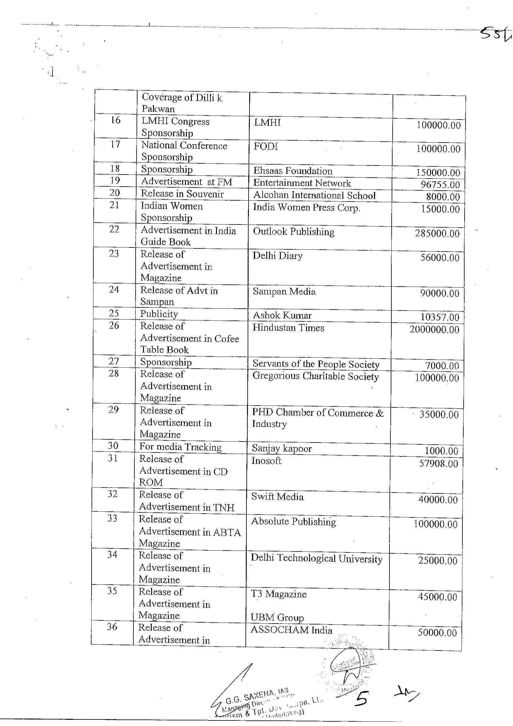
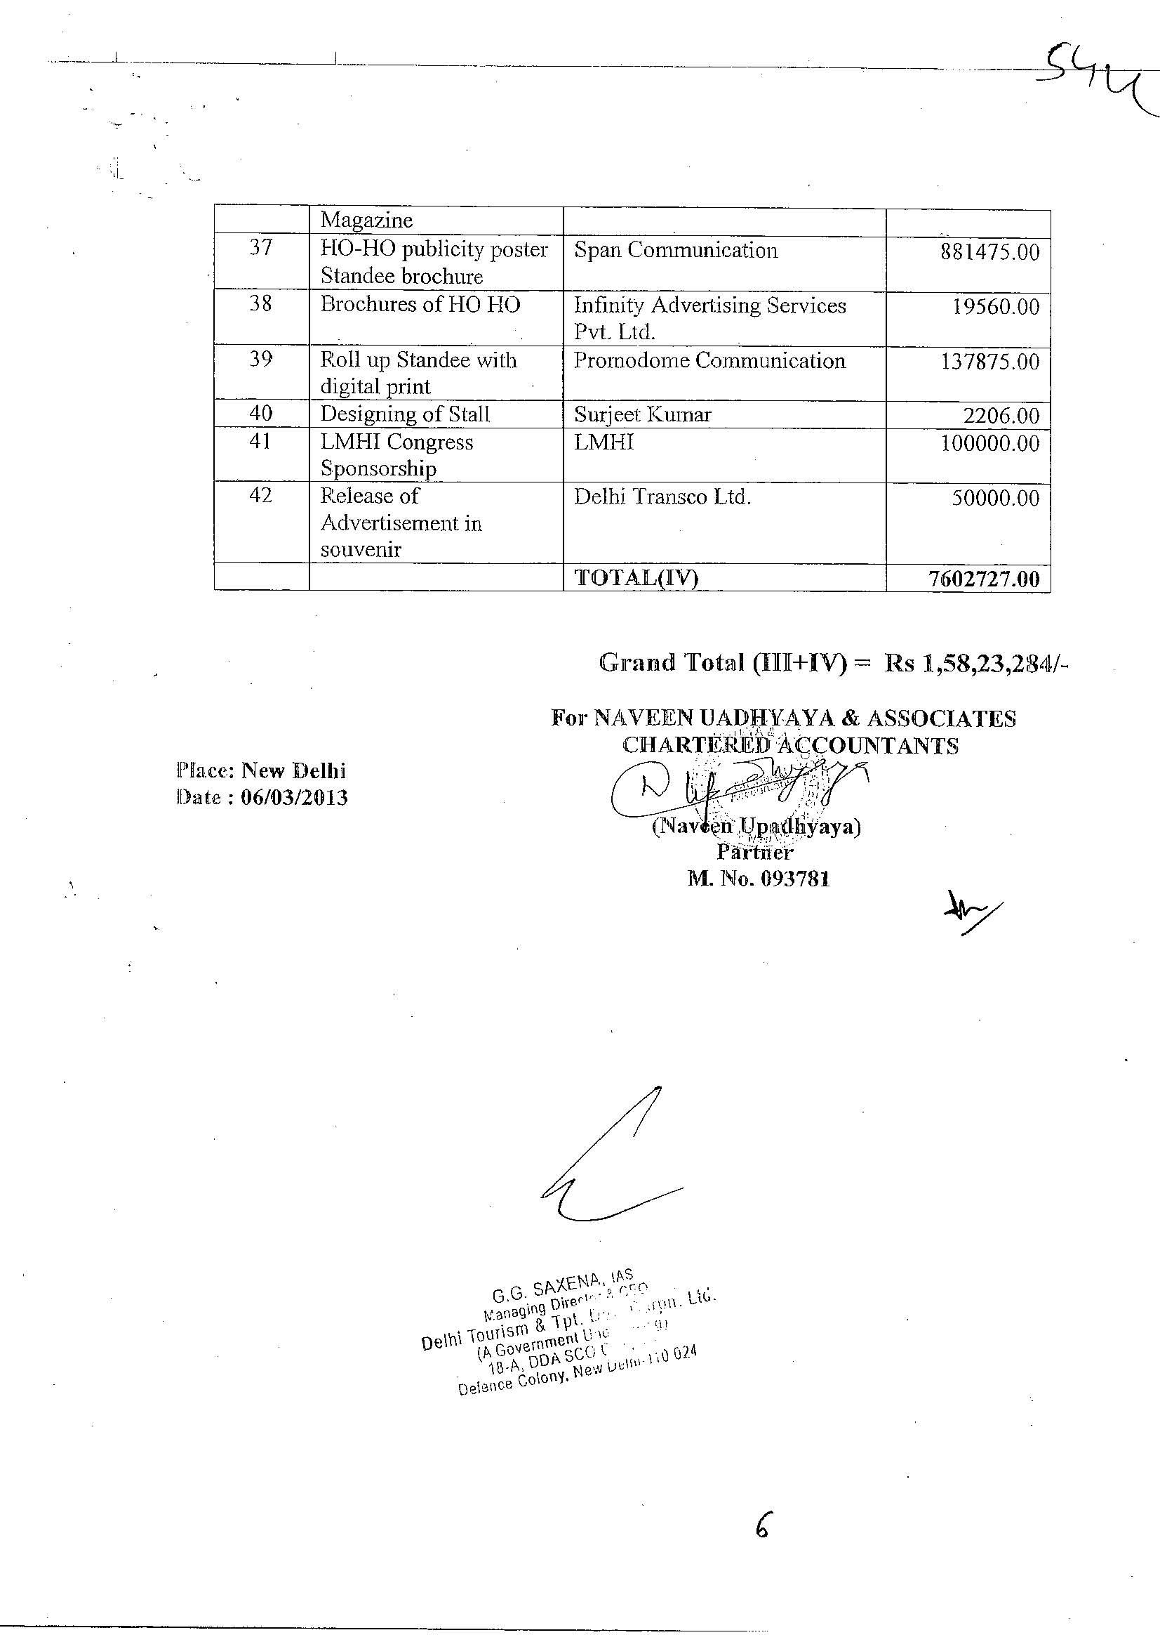
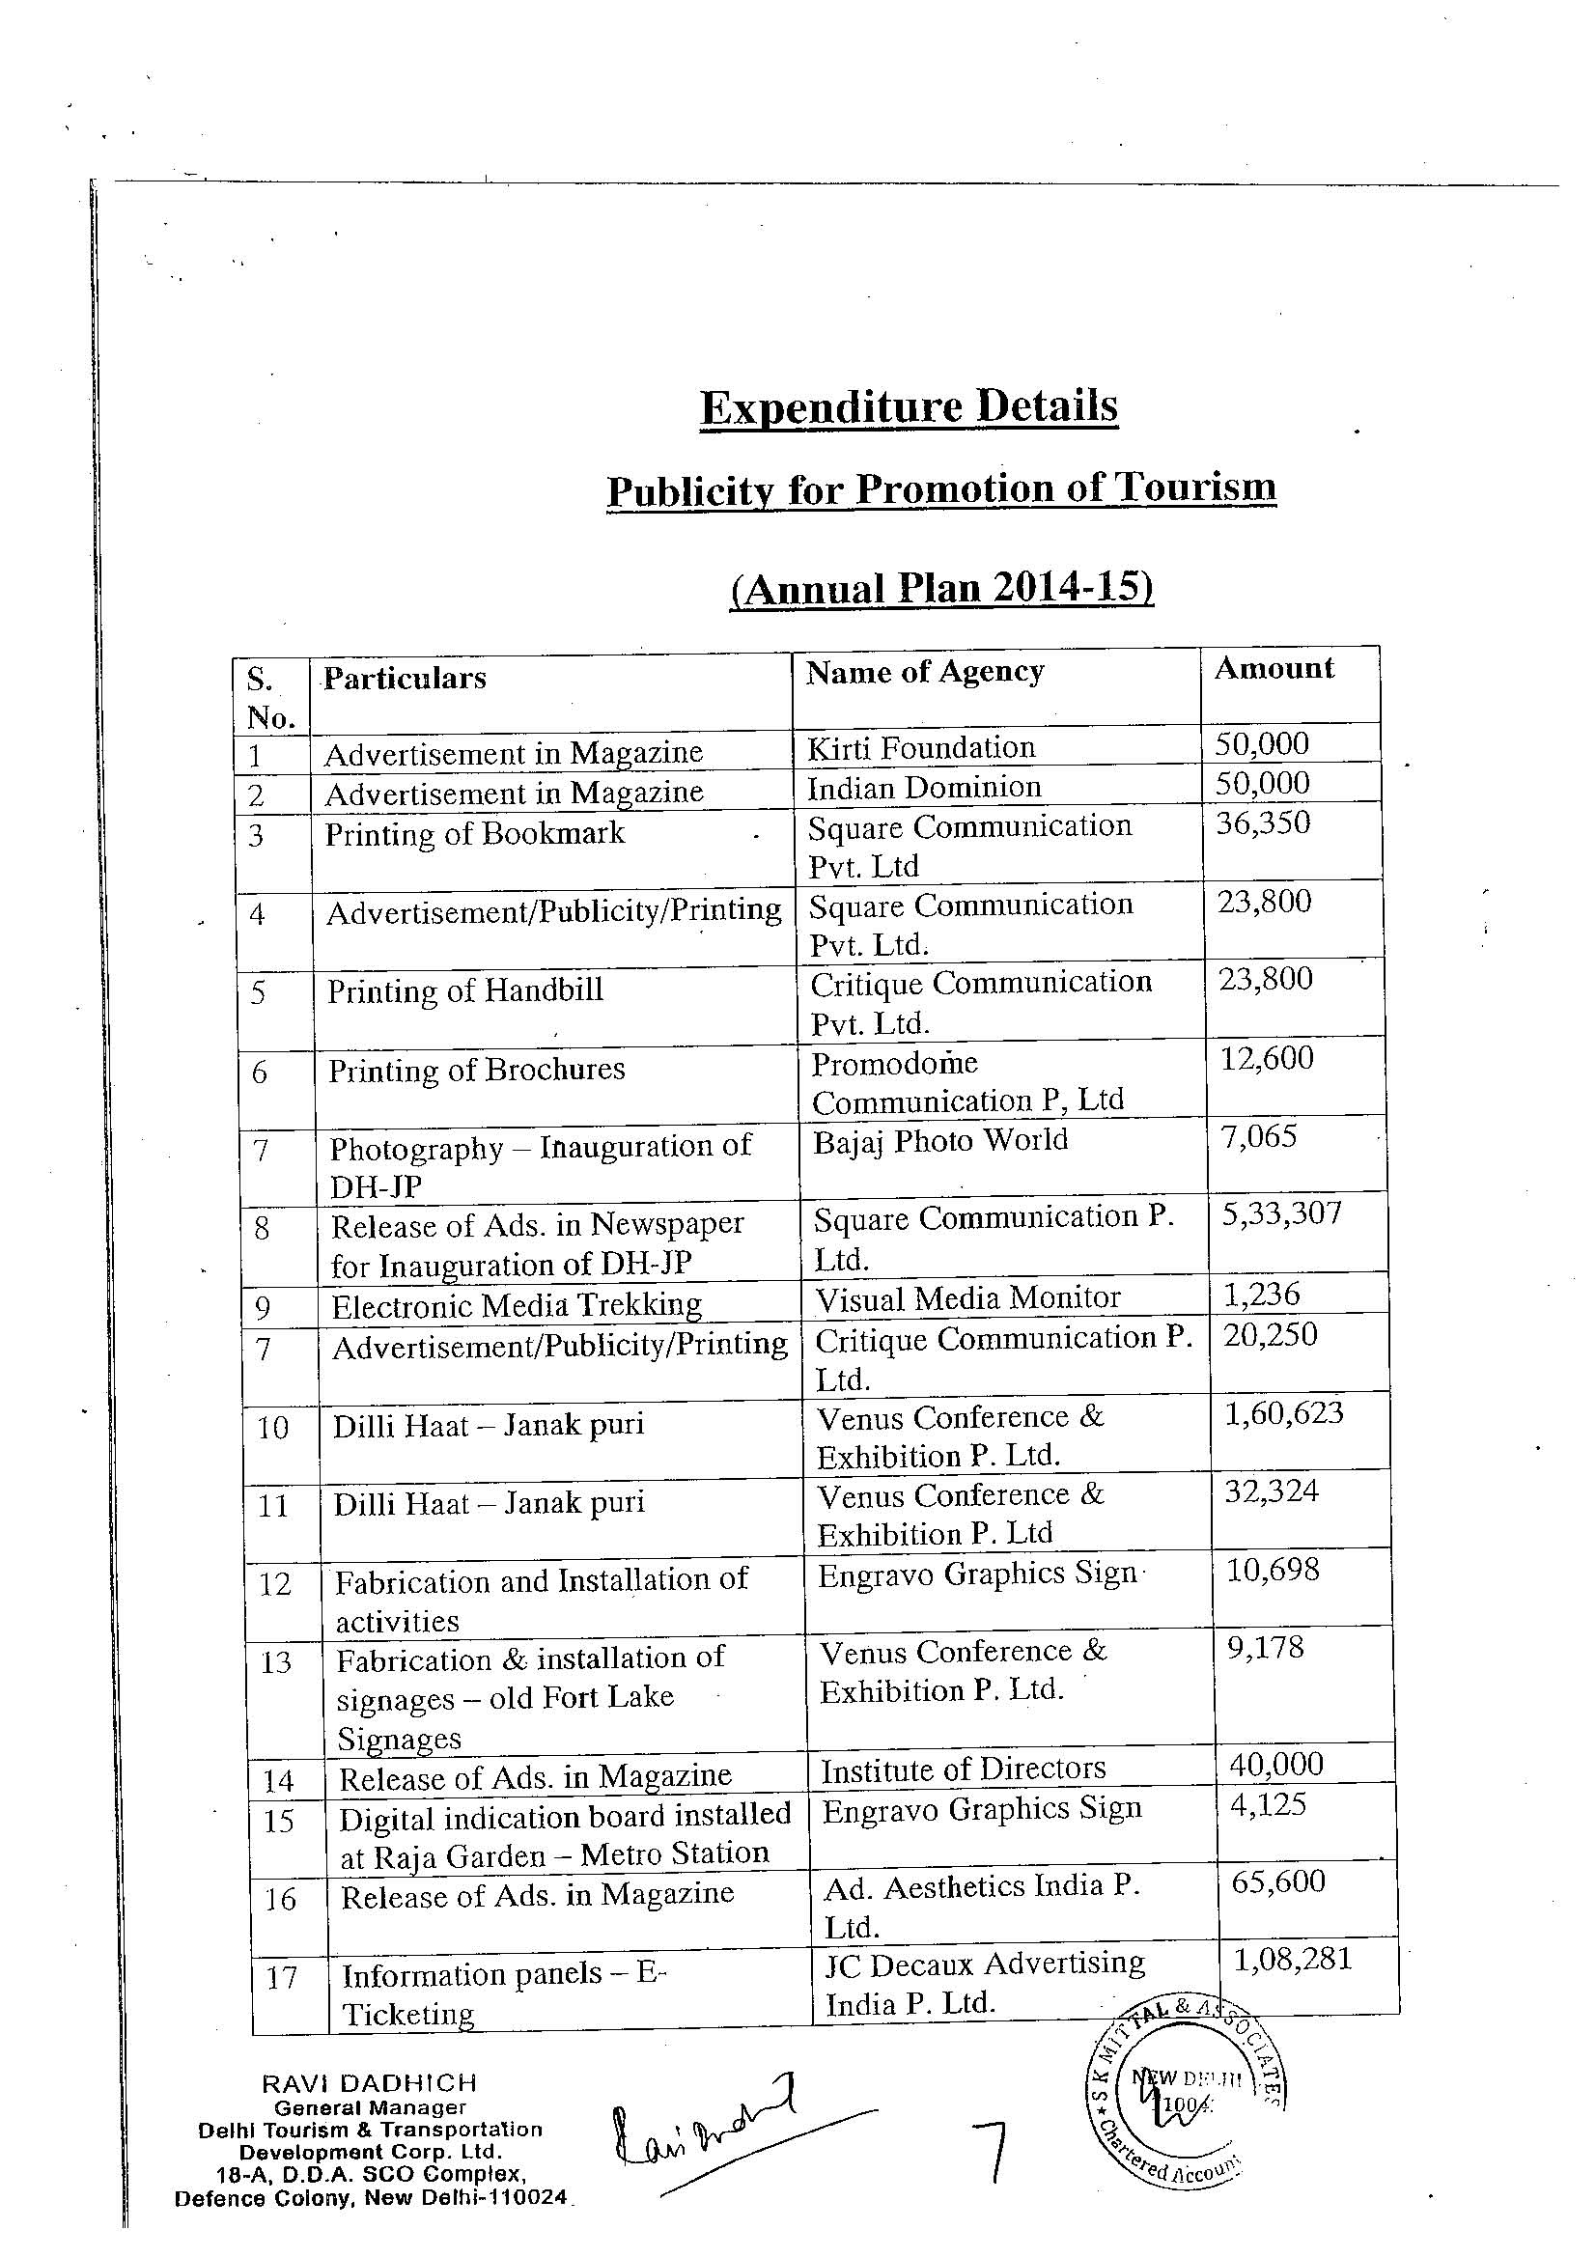
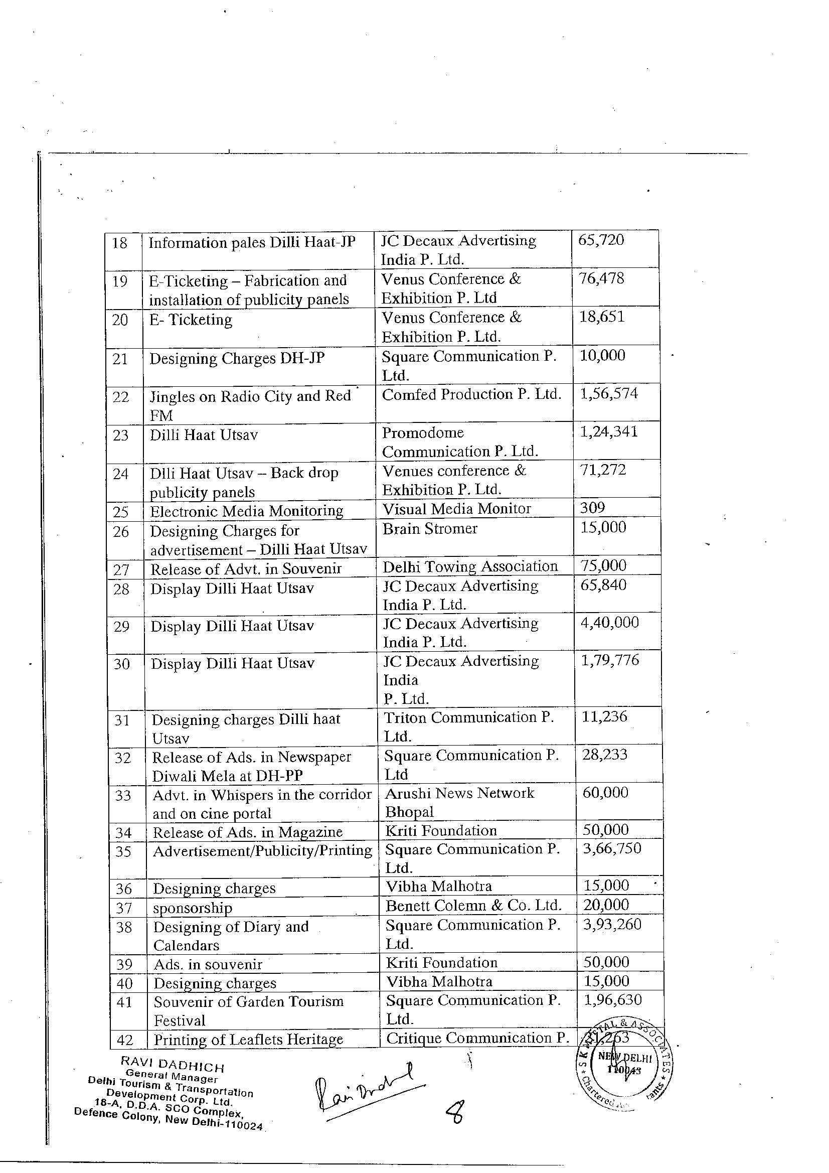
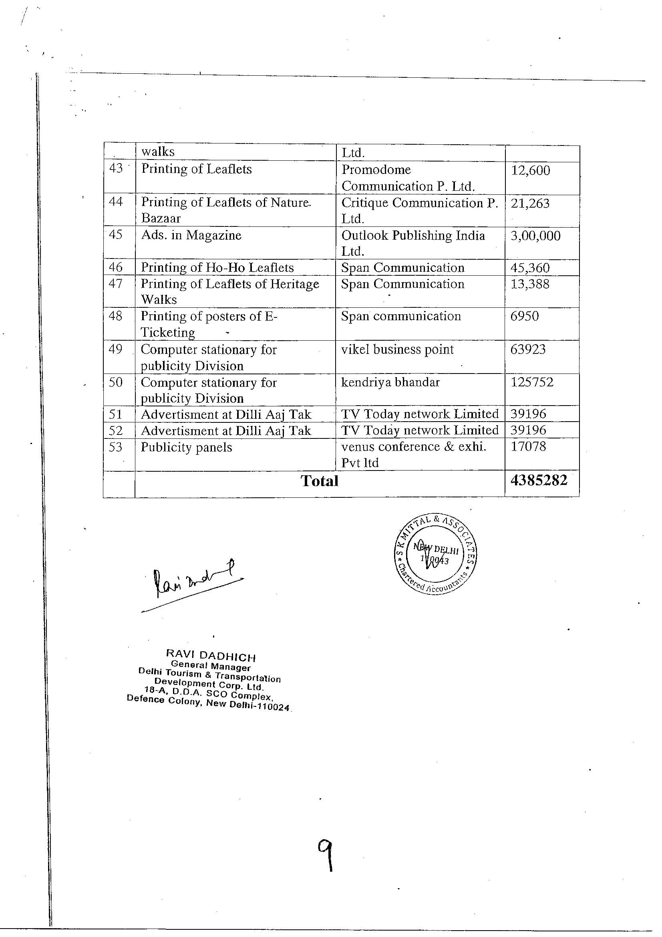
UnderAnnualPlan2010-11

Department | Name of Works | Amount Sanctioned | Amount Spent | Remarks
DTTDC | Bed &Breakfast Directory |  | 3,24,405 | To be reimbursed by Tourism Department GNCTD
 | Volunteer Training Programme CWG-Delhi 2010  Under Plan Scheme ‘Promotion of Tourism-Delhi-as a Destination |  | 48,35,000 | Payments accounted upto18.10.2010.  Total expenditure to remain within the sanctioned limit
 | Volunteer for Protocol  &Liasioning under Plan Scheme of Tourism Delhi as a Destination |  | 4,04,400 | - Less volunteers joined  - Less spent on transportation  - Less expenditure on misc. head
 | Control Room |  | 6,14,145
 | Conveyance to officer of DTTDC |  | 6,30,000
 | Designer Carry Bags |  | 8,00,000 | This bag was used for distributing tourist literature during the CWG
 | HOHO Brochures |  | 6,18,000 | The literature was widely distributed during the CWG
 | Exhibition Materials |  | 3,00,000 | This was used at various venues,

 | Standees, Posters etc. |  |  | Metro stations etc.
 | 30 Second TV Commercial for Ministry of Tourism, GOI |  | 13,00,000 | 30 seconds TVC was made specifically to welcome tourist to Delhi during CWG 2010 and telecast by the Ministry of Tourism during FIFA World Cup in Foreign TV Channels
 | Promotional Film on Delhi  6 Minutes  2 Minutes  60Seconds |  | 26,00,000 | One Minutes Film was telecast during opening and closing ceremony of CWG by OC and it was also telecast on various TV channels by DIP.
 | Delhi City Song |  | 12,75,000  (Tentative) | The song was formerly launched and provided to DIP for furtherairing on FM Channels and other occasions. A video film of this song was also telecast during the CWG Opening and Closing Ceremony
 | Advertisement through Hoardings and Billboard |  | 12,41,000 | This was done highlighting the various activities and cultural programmes under taken by DTTDC and Department of Art and Culture under Delhi Celebrations
 | Advertisement through |  | 23,57,000 | This was done highlighting launching

 | Newspapers |  |  | Of various programmelike websites, HOHO Bus Service, Opening of Cultural activities at various venue and every day schedule of cultural activities during the CWG
 | Consultant for communications and social networking |  | 7,50,000 | The agency were retained on monthly fee of Rs. 1.5 lakhs for three months only
 | Printing of cards and invitation |  | 2,00,000 | Used for various purpose.
 | International festival at Dilli Haat, Pitampura |  | 5,31,930
 | Web Site |  | 21,89,455
 | Dilli Haat, INA |  | 20,00,000
 | Shopping Festival |  | 40,000
 | Social media networking |  | 1,43,390
 | City Information System |  | 21,02,557
 | Security at Dilli Haat, INA and Dilli Haat, Pitampura |  | 6,80,424
 | Security at Incredible India at Baba Kharak Singh Marg |  | 6,81,608
 | Awaited Bills |  | 6,00,000
 |  | 3,00,00,000 | 272,18,314

(UnderCentralFinancialAssistance2010-11fromMinistryofTourism,GovernmentofIndia)

DTTDC | IncredibleIndiaFestival | 1,00,00,000 | 120,00,000  (Estimated) | ThisgrantissanctionedunderCentralFinancialAssistance. TheexpenditureiswithintheanticipatedexpenditureofRs125Lakhs.  DTTDChas earnedasumofRs 8.60lakhsonaccountof FoodStallrent.

Agreements

S.No. | Natureofwork. | DateofTender. | EstimatedValueofTender. | No.ofTenders whohadapplied. | NameofSuccessfulContractors. | Dateofawarding the work. | Estimatedlifeofthecompletedproject. | Totalamountpaidtothecontractor. | DateofCompletion of work. | Penalitiesleviedforthedelay. | Theperofdelay
1 | Renovation&upgradationofDilliHaatnearINA,NewDelhi.SubStationequipment:(SH:-Supply,Installation,Testing&Commissionof  (D.G.Sets). | 24/02/2007 | 11,19,613/- | Two | M/sS.D.  Enterprises. | 17/01/2008 | 15Years | 1249138/- | 29/11/2008
2. | UpgradationofDilliHaatnearINA,NewDelhi–PH-1(SH:C/o  NewStallsImprovementofServices,Toilets,Flooring,Signages,Land.Scaping,Internal  &ExternalWorks). | 15/11/2006 | 1,32,55,8330  0 | Two | M/sSwdashiConstructionCo. | 07/05/2007 | Thiswillmakegoodtopartiallydeteriorated conditionofvarioustemporarystructuresofHeatduetoweartearunderconstantandcontinuoususages. | 2,16,56,144/- | 21/04/2008 | EOTisapprovedwithoutlevyofcompensation. | N.A.
3. | UpgradationofDilliHaatnearINA,NewDelhi:(SH:-Supplying,Installation,Testing& commission of  CCiC&Commissionof | 04/01/2008 | 3352720/- | Eight | M/sEthikEnterprise | 13/02/2008 | 10Years | 4006500/- | 05/05/2008 | N.A. | Workiscompletwithintlimit.

 | NewPostToplanternforExternalLighting).
4. | Renovation&upgradationofDilliHaatnearINA,NewDelhi.(SH:-ExtensionofExisting Electrical Poles)  ElectricalPoles). | 26/02/2008 | 457050/- | Five | M/sDeepConstructionCorp. | 13/03/2008 | 20Years | 382500/- | 22/04/2008 | N.A. | Workis complete withintlimit.
5. | DevelopmentofSanjayLakeatMayurVihar,NewDelhi(SH:C/oTemporarybuildingsincludingW/s&  S/I, Drainage, Internal.ElectricalInstallations,LandscapingandExternalDevelopmentworks). | 11/01/2010 | 4,10,53,785/  - | Four | M/sSwdashiConstructionCo. | 27/04/2010 | 20years | Workinprogress. | 18/01/2011&  Stipulated | N.A. | N.A.
6. | Renovation ofDilliHaatatINA, NewDelhi(Phase-II)). (SH: C/o PaidToilets.ReplacementofVerandahRoofs,DevelopmentofChildrenPlay Area.DisabledParking.  Improvement ofExternalBrick Work  & Flooring.STPSumpandMiscellaneousRenovationWorks. | 31/05/2010 | 1,70,81,830 | Three | M/s SunehariBaghBuilders  (P) Limited. | 24/06/2010 | Thiswillmakegoodtopartiallydeterioratedcondition ofvarioustemporarystructures ofHeatdue towear tearunder constantandcontinuoususages . | Work inprogress. | 22/10/2010&  Stipulated | N.A. | N.A.

Detailsoftendersfordevelopmentworksforthelast5years.

Sl. | Natureof work | Dateof | Estimated | No.of | Nameof | Dateof | Estimated | Total | Dateof | Penalties | The
No. |  | Tender | Valueof | Tenderers | successful | awarding | life of the | Amount | Completion | levied | period
 |  |  | Tender | Whohad | contractors | thework | completed | paidtothe | ofwork | forthe | of
 |  |  |  | applied |  |  | project | contractor |  | delay | delay.
1 | C/oBridgeanditsApproachesoverRiverYamunaDownstreamofexistingBridgeatWazirabadDelhi.SH:Shifting ofDJBwatermainsof750,900and1100  mmdia. | 03.05.06 | 25785599 | 4 | M/sL.R .  Sharma&Co. | 26.05.06 | 20 | 34731621 | 24.03.08 | Nil | 17  Months8 days
2 | C/oBridgeanditsApproachesoverRiverYamunaDownstreamofexistingBridgeatWazirabadDelhi.SH:ShiftingofRawwaterintakeducts &other DJBwatermains. | 17.08.06 | 65635000 | 4 | M/sL.R .  Sharma&Co. | 11.10.06 | 20 | 87895609 | 30.03.09 | Nil | 21  Months  &16 days.
3 | C/oBridgeanditsApproachesoverRiverYamunaDownstreamofexistingBridgeatWazirabadDelhi.SH:C/o  Approaches. | 10.03.08 | 274.00Cr. | 6 | M/sGammonIndiaLtd. | 27.05.08 | 80 | 887078275 | InProgress | Nil | N.A.

4 | C/oBridgeanditsApproachesoverRiverYamunaDownstreamofexistingBridgeatWazirabadDelhi.SH:TrenchlessDucting. | 10.07.09 | 491400 | 6 | M/sL.R  Sharma&Co. | 15.07.09 | 20 | 758700 | 06.08.09 | Nil | 15  Days
5 | C/oBridgeanditsApproachesoverRiverYamunaDownstreamofexistingBridgeatWazirabadDelhi.SH:Shifting ofGAILGaspipe8"diainWesternApproaches | 11.08.09 | 775800 | 3 | M/sSumitGasAgencies  (P)Ltd. | 12.08.09 | 20 | 478508 | 30.12.09 | Nil | 3  Months  &12  Days
6 | C/oBridgeanditsApproachesoverRiverYamunaDownstreamofexistingBridgeatWazirabadDelhi.SH:MainBridge(CableStayed). | 15.04.09 | 4,650,000,000 | 5 | M/sGammonConstrutora- Cidade- TensacciaiJV. | 26.02.10 | 80 | Nil | InProgress | Nil | N.A.

Detailsoftendersfordevelopmentworksforthelast5years.
Sl.  No. | NatureofWork | Date ofTender | Estimated Value ofTender | No. of Tendererswho had applied | Name ofsuccessfulcontractor | Date ofawarding thework. | Estimated lifeofthecompleted project. | Totalamountpaid to thecontractor | Date ofActualCompletion of work. | Penaltiesleviedforthedelay. | The Period of Delay
1. | C/o UnderpassatMoolchandintersectionon RingRoadNewDelhi.  SH:Laying of undergroundcableforhighmastlighting | 14.09.05 | 11,80,472/- | 4 | M/s RameshElectricWorks. | 18.11.05 | 50 Years | 28,06,027/- | 04.12.06 | -do- | 7  month 25  days
2. | C/o UnderpassatMoolchandintersectionon RingRoadNewDelhiSH:  Providing&fixingoverheadsignages. | 12.06.06 | 22,02,482/- | 9 | Sh. SanjeevSoni | 11.07.06 | 15 Years | 17,78,548/- | 08.01.07 | -do- | 1  month 7days
3. | C/o UnderpassatMoolchandintersectionon RingRoadNewDelhiSH: C/oElectricsubstationbuilding | 12.06.06 | 4,85,221/- | 2 | M/s R.K.  Construction Company. | 19-07-06 | 50 Years | 9,71,475/- | 04.11.06 | -do- | 1  month 16  days
4 | C/o | 01.09.06 | 5,98,050/- | 7 | M/s Muskan | 26.09.06 | 10 Years | 6,46,321/- | 16.12.06 |  | -NIL-

 | UnderpassatMoolchandintersectionon RingRoadNewDelhiSH:  ProvidingandfixingRoadSafetydevices. |  |  |  | Safety solutionprivate ltd. |  |  |  |  | –
5. | C/o UnderpassatMoolchandintersectionon RingRoadNewDelhiSH: SITC of  landscapeirrigationsystem | 06.09.06 | 22,09,431/- | 4 | M/s Harvellirrigationprivate ltd. | 15.09.06 | 5 Years | 17,01,809/- | 04.04.07 | 0.5%of Tenderedamounti.e.Rs. 9126/- | 2  month 28  days
6. | C/o under pass atMoolchandintersectionon RingRoadNewDelhi.  SH: P/f M.S.  GrillonCentralmedian. | 28.12.06 | 9,10,718/- | 10 | M/s GuptaBuilders | 09.01.07 | 20 Years | 17,76,384/- | 10.04.07 | E.O.T.  Grantedbycompetentauthoritywithout levyof compensation | 24  days
7. | C/o ROB& RUBatrailwaylevel | 12.12.08 | 64,02,86,270/- | 2 | M/s GammonIndiaLtd. | 21.04.09 | 50 Years | 58 Crores | In Progress | – | –

 | CrossingatRoad No. 68.NearNandNagriDelhi -93
8. | C/o under pass atMoolchandintersectionon RingRoadNewDelhi.  SH:C/o steelwallways&steelfins. | 09.08.06 | 44,03,528/- | 4 | M/s PanchalEngineers&Fab.Regd.,40, Hindonvihar,vishwakarmamarg,DelhiMeerutRoad,Ghaziabad-201003 | 30.08.06 | 20 Years | 39,03,628/- | 05.02.07 | E.O.T.  Grantedby  S.E. withoutlevyofcompensation | 2  month 15  days
9. | C/o under pass atMoolchandintersectionon RingRoadNewDelhi.  SH: Supplyandinstallationoflightfixtures. | 09.08.06 | 9,29,485/- | 8 | M/s ArkayRadios opp.Powerhouse,4162,NayaBazar,Delhi-110006 | 29..08.06 | 1 Years | 6,71,600/- | 18.11.06 | – | NIL

10. | C/o under pass atMoolchandintersectionon RingRoadNewDelhi.  SH: P/F  Polycarbonate sheetRoofingon subways  &walkways. | 25.09.06 | 53,40,339/- | 18 | Sh. Anil GambhirG-53,west  PatelNagar,New Delhi-08 | 05.11.06 | 5 Years | 29,07,294/- | 21.05.07 | E.O.T.  grantedby  S.E. withoutlevyofcompensationRs. 1000/- | 4  Months 17  days.
11. | C/o under pass atMoolchandintersectionon RingRoadNewDelhi.  SH:  RehabilitationofRCC slaboverdrainnearDefencecolony. | 18.12.06 | 9,38,513/- | 6 | Sh. Anil Gambhir  G-53,westPatelNagar,New Delhi-08 | 02.01.07 | 15 Years | 7,88,904/- | 23.03.07 | – | Nil
12. | UpgradationofDilliHattnearINANewDelhi.SH:- S.I.T.C.  of New Postlanternforexternallighting. | 24.12.07 | 33,52,720/- | 8 | M/s EthikEnterprisesBM-4,  DilkhushindustrialEstate.G.T.KarnalRoadDelhi -110033 | 07.03.08 | 5 Years | 40,06,500/- | 06.05.08 | – | Nil

Sub:-Sui MotodisclosureofinformationregardingTendersissuedforCommonWealthGames&OtherDevelopmentWorks.

S.  No  . | NatureofWork. | DateofTender. | Estimated Value of Tender. | No.ofTenderers whohad applied. | NameofSuccessful Contractors  . | Dateofawarding the work. | Estimatedlifeofthecompleted project. | Totalamountpaid tothecontractor  . | DateofCompletion of work. | Penalties leviedforthedelay. | Theperiodof delay.
1 | Landscaping | 19/08/201 | Rs. | Two(2) | ShriManoj | 28/08/201 | Itis a | No | Workin | N.A. | N.A.
 | and | 0 | 7,89,020/ |  | Kumar | 0 | horticulture | running | Progress.
 | Beautification |  | - |  |  |  | Workand | payment
 | ofRaja |  |  |  |  |  | requires | Madetill
 | Garden |  |  |  |  |  | continuous | date.
 | Flyover(SH: |  |  |  |  |  | maintenance
 | Horticulture |  |  |  |  |  | .
 | Work).

TendersSale

Sl.No  . | NameofWork | DateofTender | EstimatedValueofTender | No.ofTendererswhohadapplied | Nameofsuccessfulcontractors | Dateofawardingthework | Estimated life ofthecompletedproject | Totalamountpaidtothecontractor | Dateofcompletionofwork | Penaltiesleviedfordelay | Theperiod of delay
(1  ) | (2) | (3) | (4) | (5) | (6) | (7) | (8) | (9) | ( 10) | ( 11) | ( 12)
 | Year2005-06
1 | C/o Dilli | 7/11/20 | 5704954 | 13Nos. | M/s | 14/2/0  7 |  | 4242073  /- | 3/9/200  7 | NIL | 2  Months
 | Haat at |  |  |  | Reliance
 | Pitampura, |  |  |  | Fire
 | New |  |  |  | protection
 | Delhi(SH: |  |  |  | systems
 | SITCoffire |  |  |  | M/sHindustanConstructionCorp.
 | hydent and
 | sprinkler
 | system.)
 |  |  |  |  | M/sIndianFireExtinguisherSystems
 |  | 06 | /-
 |  |  |  |  | M/sFirecoalEngineers
 |  |  |  |  | M/sFireprotection systems
 |  |  |  |  | M/sD.DawnandCo.
 |  |  |  |  | M/sFireRemedy

 |  |  |  |  | systems
 |  |  |  |  | M/sFireGuardEngineers
 |  |  |  |  | M/sInfernoPacifiersPvt.Ltd.
 |  |  |  |  | M/sAhluwaliaFireProtectionEngineers
 |  |  |  |  | M/sYogiIndustries
 |  |  |  |  | M/sAdvanceFireProtection Systems
 |  |  |  |  | M/sTriParulexFireprotection Systems.
2 | C/o Dilli | 6/11/20 | 2048709 | 4Nos. | M/sIonic
 | Haat at |  |  |  | Permutit
 | Pitampura, |  |  |  | System
 | New Delhi |  |  |  | Pvt.Ltd
 | (SH:SITCof |  |  |  | M/sMigraniEnvirotechEngineersPvt.Ltd.
 | Hydopneuma
 | tic Pumping | 06 | /-
 | System.)
 |  |  |  |  | M/sIonsHydroPvt.Ltd.

 |  |  |  |  | M/sYashpumpingEngineers
3 | C/o Dilli  Haat at  Pitampura,NewDelhi(SH:SITC of  Substationsequipmentsi/cDGSets.) |  |  | 4Nos. | M/sBudhirajaElectricals
 |  |  |  |  | M/sShivElectric
M/sRelianceElectricwork
ORKOR ork
 |  |  |  |  | M/sEnterprises
4 | C/o Dilli  Haat at  Pitampura,NewDelhi(SH:PFTCofexternallighting,  cable laying  andfeederpillars.) |  |  | 7Nos. | M/sRameshElectricWork
 |  |  |  |  | M/sBhardwajBrothers
M/sS.D.
Enterprises
 |  |  |  |  | M/sEthikEnterprises
 |  |  |  |  | M/sS.CEnterprises
 |  |  |  |  | M/sShivElectric
 |  |  |  |  | M/SGoelElectricWorks

5 | C/o Dilli  Haat at  Pitampura,NewDelhi(SH:HorticultureWork.) |  |  | 4Nos. | M/s Greenways Nursery
 |  |  |  |  | M/sSamakLandscapePvt.Ltd.
 |  |  |  |  | M/sBehtHorivisionPvt.Ltd.
 |  |  |  |  | M/sGrotech
6 | C/o Dilli  Haat at  Pitampura,NewDelhi(SH:SITCof  SewageTreatmentplant.) |  |  | 2Nos. | M/sEnhancedWappsystem(I)Pvt.Ltd
 |  |  |  |  | M/sTexlaTechnologiesandoxidationPvt.Ltd
7 | C/oDilliHaatatPitampura,NewDelhi(SH:WatertreatmentPlantandpumpingmachineryi/coperation |  |  | 4Nos. | M/sIONS  FiltechPvt.Ltd..
M/sIONS
HydroPvt.Ltd.
 |  |  |  |  | M/sHyperFilterationPvt.Ltd.
 |  |  |  |  | M/sRenaissance

 | Andcomprehensionsitefor3years.) |  |  |  | AquaSportsPvt.Ltd.
8 | ConstructionandDevelopmentofDilliHaatatPitampura,NewDelhi(SH:  ProvidingandinstallationofDustbins.) |  |  | 1No. | M/sSaflowProductsPvt.Ltd.
9 | ConstructionandDevelopmentofDilliHaatatPitampura,NewDelhi(SH.  SupplyingandinstallationofModularOfficeFurnitureworkstations,partitionsandstorageetc. |  |  | 7Nos. | M/sDebonoflexicom(I)Ltd.
 |  |  |  |  | M/s MansarovrIndustriesCorp.
 |  |  |  |  | M/sSh.YogeshSikka
 |  |  |  |  | M/sDeliteKomLtd.
 |  |  |  |  | ConstructionskillsCo.
 |  |  |  |  | Jitinterioranddecorators
 |  |  |  |  | Precisionmetalindustries

10 | Construction andDevelopmentofDilliHaatatPitampura,NewDelhi(SH:PARTA-  SITCofclosecircuit TVsystem withaccessoriesPART B -  ComprehensiveAMC forclose circuitTV systemwithaccessorieswith3yrs. |  |  | 5Nos. | HitechAudioSystems  (P)Ltd.
 |  |  |  |  | SonalEnterprises
 |  |  |  |  | BharatRadioCentre
 |  |  |  |  | EssconIntegratedSecuritysolutionsPvt.Ltd.
 |  |  |  |  | UnishilpelectronicsPvt.Ltd.
11 | ConstructionandDevelopmentofDilliHaatatPitampura,NewDelhi(SH:SITCof  ductabletypeAC and  Ventilationsystem) |  |  | 2Nos. | M/sEnvirotechEngineersandconsultants
 |  |  |  |  | SkylineAirconditioningEngineersPvt.Ltd.
12 | ConstructionandDevelopmentofDilliHaat |  |  | 2Nos. | UniqueBuilders
 |  |  |  |  | Sh.ShyamEnterprise

 | AtPitampura,NewDelhi(SH:  Improvement ofdrainagesystematupperplazaandglazeddooratfireexit) |  |  |  | s

WAZIRABADBRIDGEPROJECT
DELHITOURISM&TRANSPORTATIONDVP.COR.LTD.
ARUNANAGAR,MAJNUKATILLA,ADJ.INDIANOILPETROLPUMP,OUTERRINGROADNEWDELHI–110054

Sub:-Suomoto disclosure ofinformation regarding Tender s issued for Commonwealth Games and otherdevelopment works.

Reference:LetterNo.F.13/8/05/AR//8838-8997/Cdated13.08.2010

Withreference to thelettermentionedabovethe requisiteinformation is given as under:

  - Detailsoftendersfordevelopmentworksfor the lastfive years.
  - Measurestaken tofulfilldisclosureobligationsunderSection4 includingmakinginformationavailableonyourofficialwebsite.
  - Measuresputinplacetoensureregularupdatingoftheinformationuploadedon the websites.
Asperlistattached.

Action tobetaken atH.Qr.Level.

Tenders informationw illbe
Furnishedonmonthlybasistothe H.Qtr.

WemayforwardtheaboveinformationtoSPIOfor consolidation and onward submission in respect ofwhole oftheEngineeringWing.

Submitted please
AG-I
AO, WEP,

Detailsoftendersfordevelopmentworksforthelast5years.
Sl. | Nature ofwork | Date of | Estimated | No. of | Name of | Date of | Estimated | Total | Date of | Penalties | Theperiod
No. |  | Tender | Value of | Tenderer | Successful | awarding | Lifeofthe | amount paid | Completi | Leviedfor | of delay
 |  |  | Tender | s who | Contractors | thework. | completed | tothe | on of | thedelay.
 |  |  |  | had |  |  | project | contractor | work.
 |  |  |  | applied
1. | C/oBridgeanditsApproachesoverRiverYamunaDownstream ofexistingBridgeat WazirabadDelhi.  SH:Shifting ofDJBwatermainsof750,900and1100mmdia | 03.05.06 | 25785599 | 4 | M/sL .R.  Sharma&Co. | 26.05.06 | 20 | 34731621 | 24.03.08 | Nil | 17 months 8days
2. | C/oBridgeanditsApproachesoverRiverYamunaDownstreamof existingBridgeat WazirabadDelhi.  SH:ShiftingofRaw waterintakeducts&otherDJBwatermains. | 17.08.06 | 65635000 | 4 | M/sL .R.  Sharma&Co. | 11.10.06 | 20 | 87895609 | 30.03.09 | Nil | 21 months  &16 days
3. | C/oBridgeanditsApproachesoverRiverYamunaDownstreamofexistingBridgeat WazirabadDelhi.  SH: C/oApproaches | 10.03.08 | 274.00Cr. | 6 | M/sGammonIndiaLtd. | 27.05.08 | 80 | 887078275 | Inprogress | Nil | N.A
4. | C/oBridgeanditsApproachesoverRiver YamunaDownstreamofexisting Bridgeat WazirabadDelhi.  SH: Trench lessDucting. | 10.07.09 | 491400 | 6 | M/sL.R.  Sharma&Co. | 15.07.09 | 20 | 758700 | 06.08.09 | Nil | 15 days
5. | C/oBridgeanditsApproachesoverRiverYamunaDownstreamofexistingBridgeat WazirabadDelhi.  SH:ShiftingofGAILGaspipe8”diainWesternApproaches. | 11.08.09 | 775800 | 3 | M/sSumit Gas Agencies  (P)Ltd. | 12.08.09 | 20 | 478508 | 30.12.09 | Nil | 3 months&12 days

6. | C/oBridgeanditsApproachesover RiverYamunaDownstreamofexisting Bridgeat Wazirabad Delhi.  SH: MainBridge(Cable Stayed). | 15.04.09 | 465000000  0 | 5 | M/sGammon-Construtora  -Cidade-TensacciaiJV. | 26.02.10 | 80 | Nil | InProgress | Nil | N.A

